Team Members: Mohammedamaan Iqbal Shaikh & Marc Nicolas Oliva

DSA555NSB Assignment 1 Part 1

list.insert(begin(), 25)

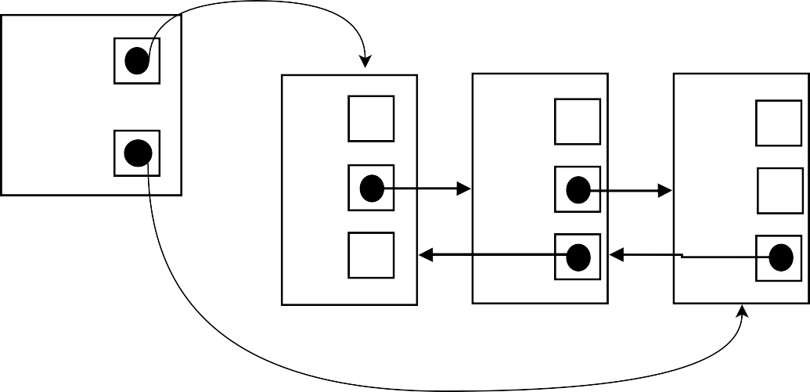

front_

data_

20

data_ 10

data_ 30

back_

next_

next_

next_

0

prev_ 0

prev_

prev_

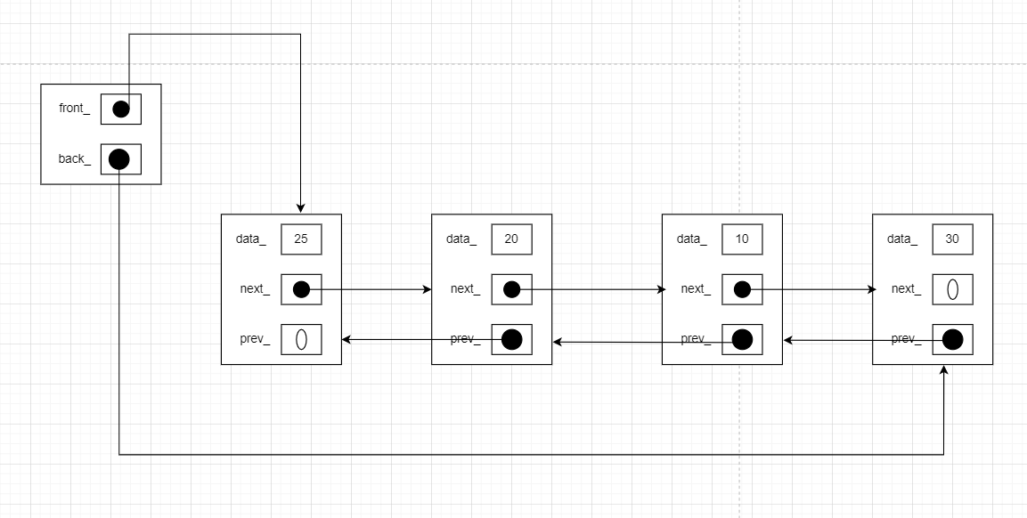

list.insert(loc, 25)



front_

back_



data_ 10

next_

prev_

loc

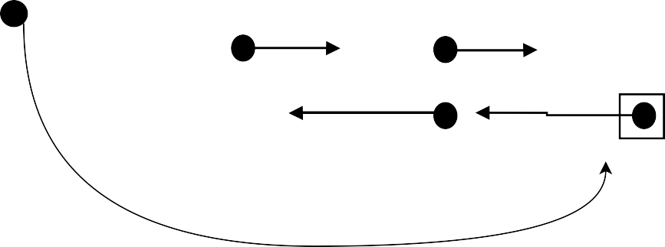

data_

20

next_

prev_ 0

data_ 30

next_

0

prev_

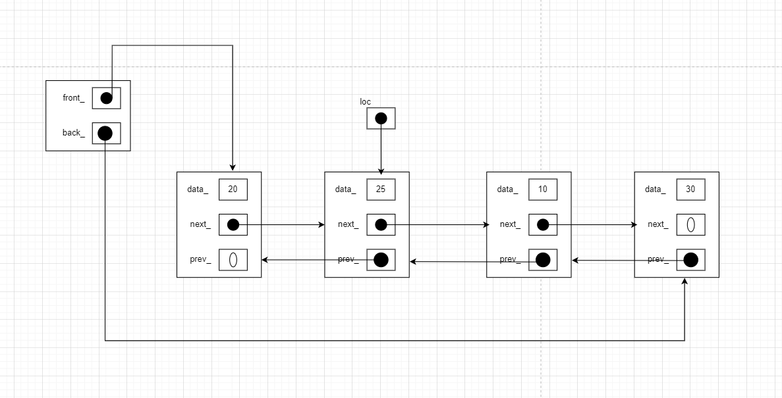

list.insert(end(), 25)



front_

back_

data_ 10

next_

prev_

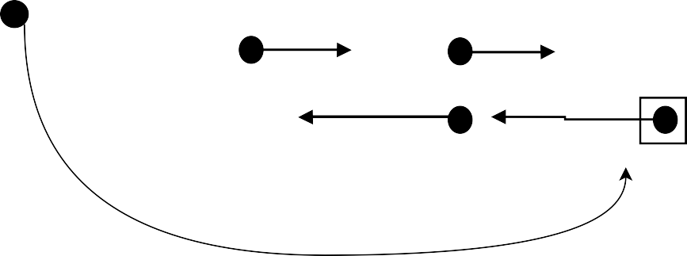

data_

20

next_

prev_ 0

data_ 30

next_

0

prev_

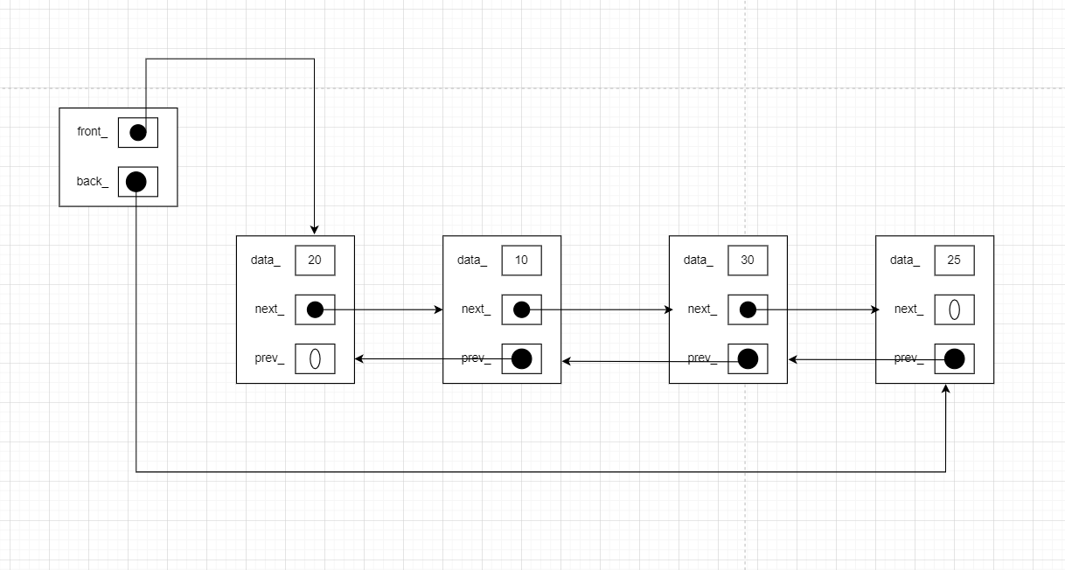

list.insert(end(), 25)

front_

0

back_

0

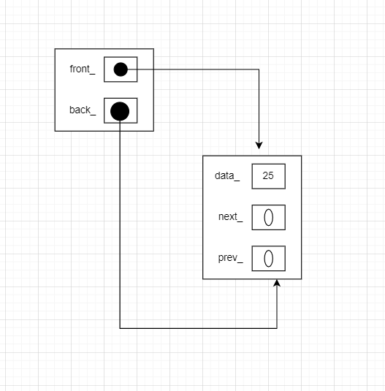

list.insert(begin(), 25)

front_

0

back_

0



list.erase(loc)

loc

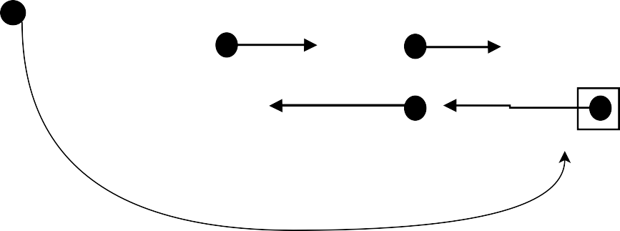

data_

20

next_

prev_ 0

data_ 30

next_

0

prev_



front_

back_

data_ 10

next_

prev_

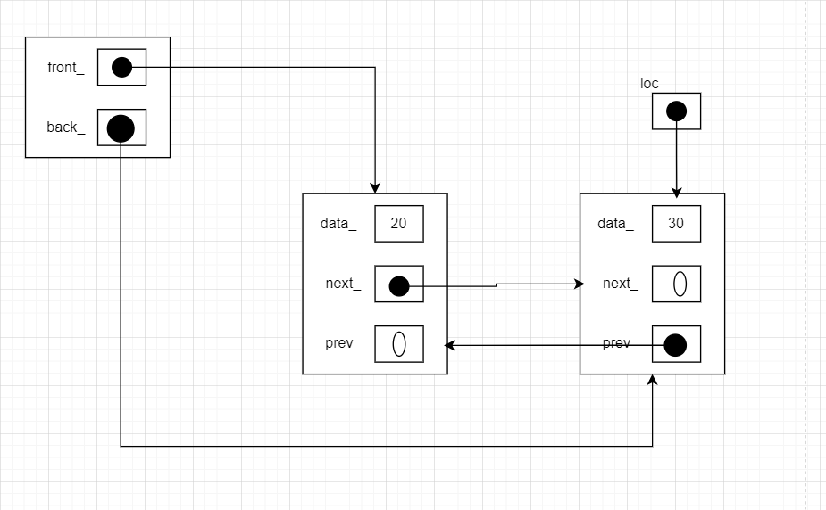

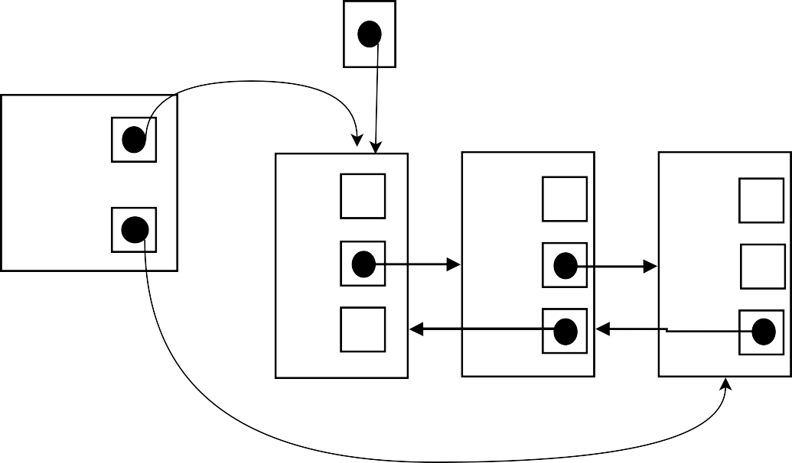list.erase(loc)

loc

front_

back_

data_ 20

next_ prev_ 0

data_

next_

prev_

10 data_ 30

next_ 0

prev_

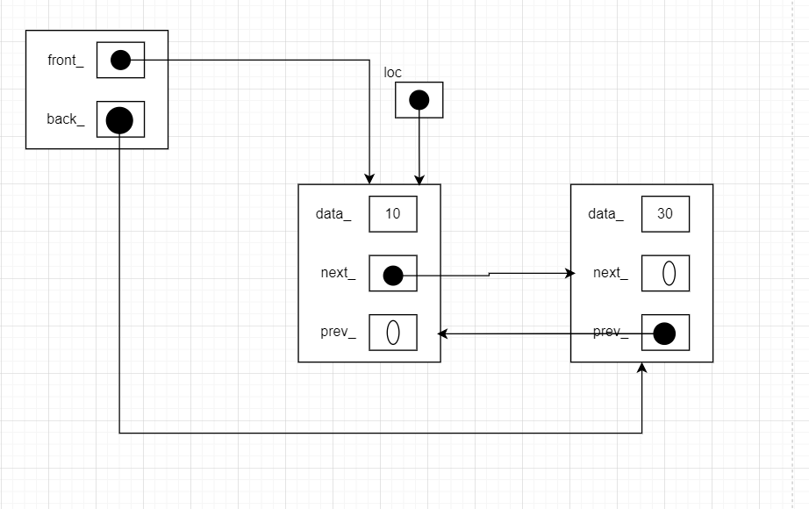

list.erase(loc)

loc



front_

back_

data_ 10

next_

prev_

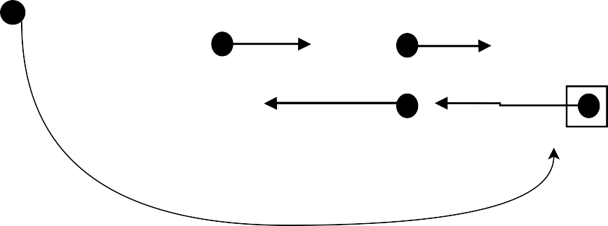

data_

20

next_

prev_ 0

data_ 30

next_

0

prev_

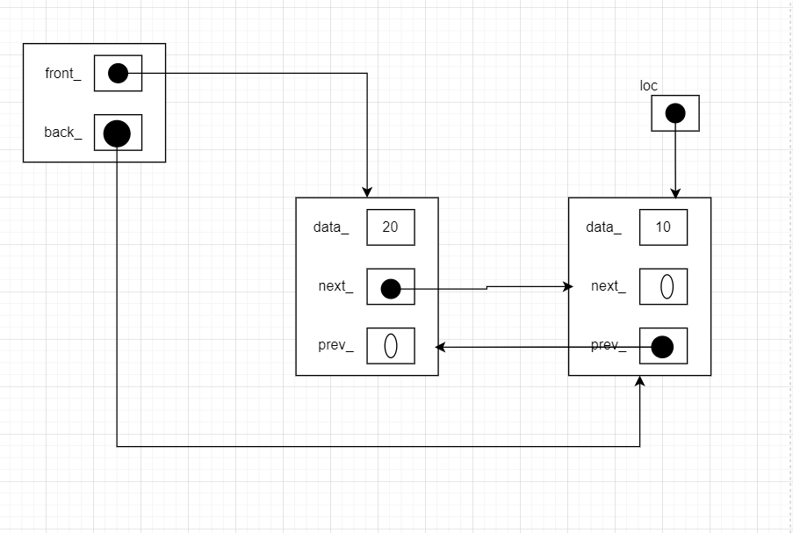

list.sort(begin(), end())

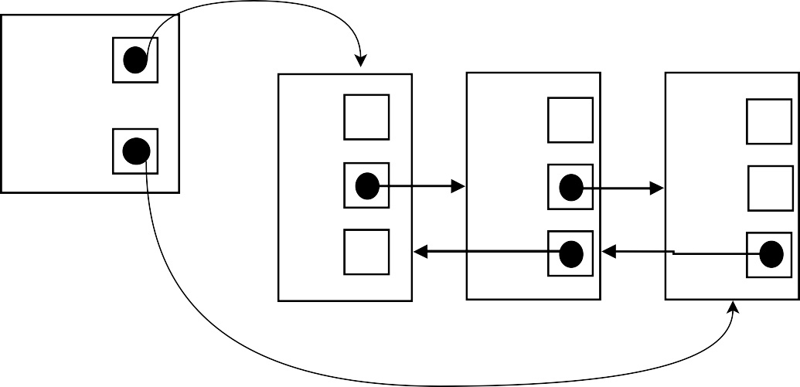

front_

data_

30

data_ 20

data_ 10

back_

next_

next_

next_

0

prev_ 0

prev_

prev_

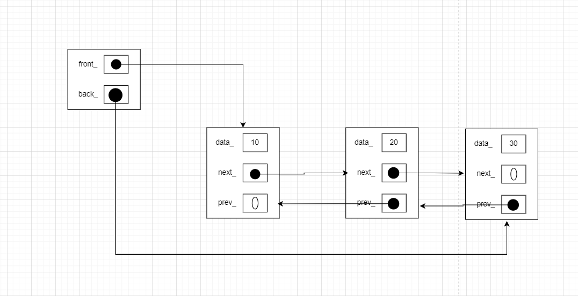

list.sort(begin(), loc)

loc



front_

back_

data_ 10

next_

prev_

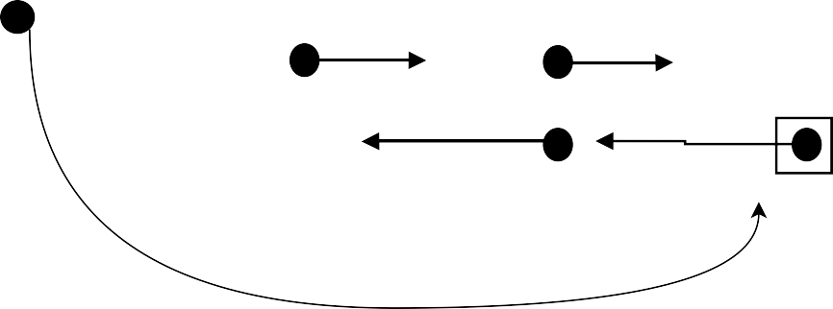

data_

20

next_

prev_ 0

data_ 30

next_

0

prev_

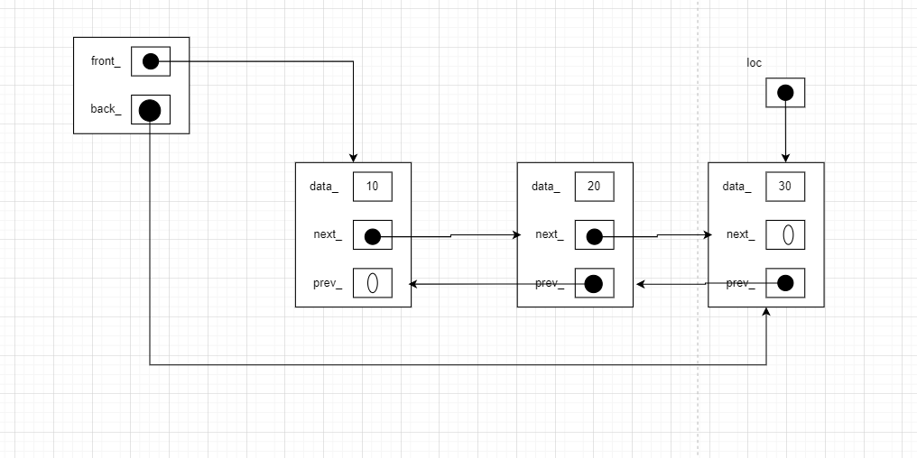

copy constructor - alter rhs and/or current object as appropriate

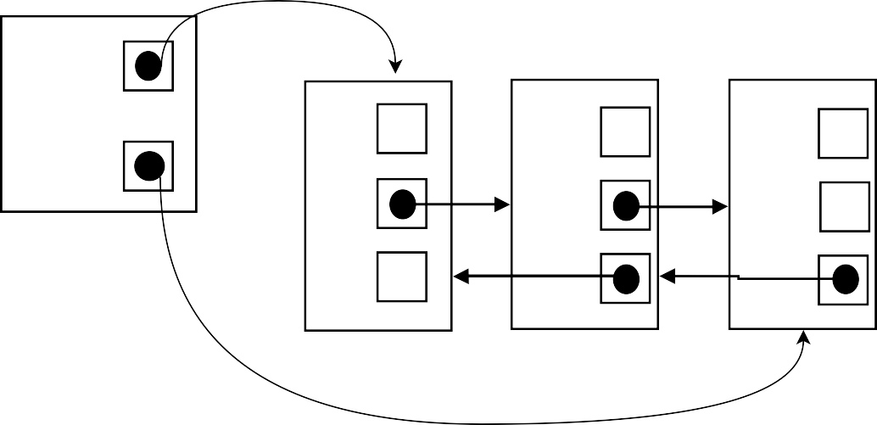

front_

data_

20

data_ 10

data_ 30

back_

next_

next_

next_

0

rhs

prev_

0

prev_

prev_

Current object is initialized with the RHS values

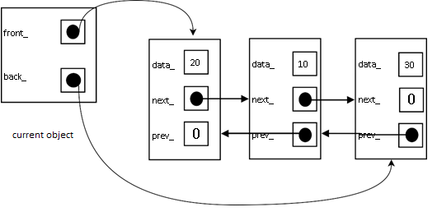

copy assignment operator - alter rhs and/or current object as appropriate

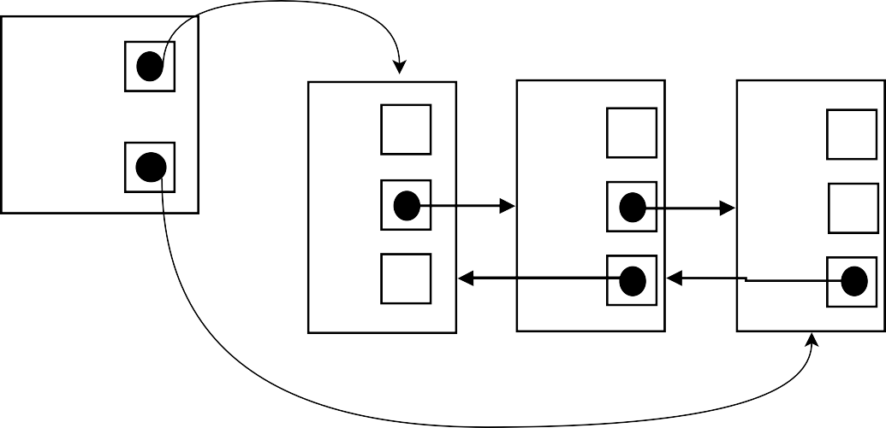

front_

data_

20

data_ 10

data_ 30

back_

next_

next_

next_

0

rhs

prev_

0

prev_

prev_

RHS is copied into current object

current object



front_

data_

20

data_ 10

data_ 30

back_

next_

next_

next_

0

prev_

0

prev_

prev_

move constructor - alter rhs and/or current object as appropriate

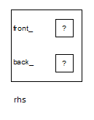



front_

data_

20

data_ 10

data_ 30

back_

next_

next_

next_

0

rhs

prev_

0

prev_

prev_



front_

?

back_

?

current object

move assignment operator - alter rhs and/or current object as appropriate



front_

data_ 15

back_

next_

0

current object

prev_



front_

data_

20

data_ 10

data_ 30

back_

next_

next_

next_

0

rhs

prev_

0

prev_

prev_



|  |  |  |
| --- | --- | --- |
| data_  next_  prev_ | 5 |  |
| 0 |  |

