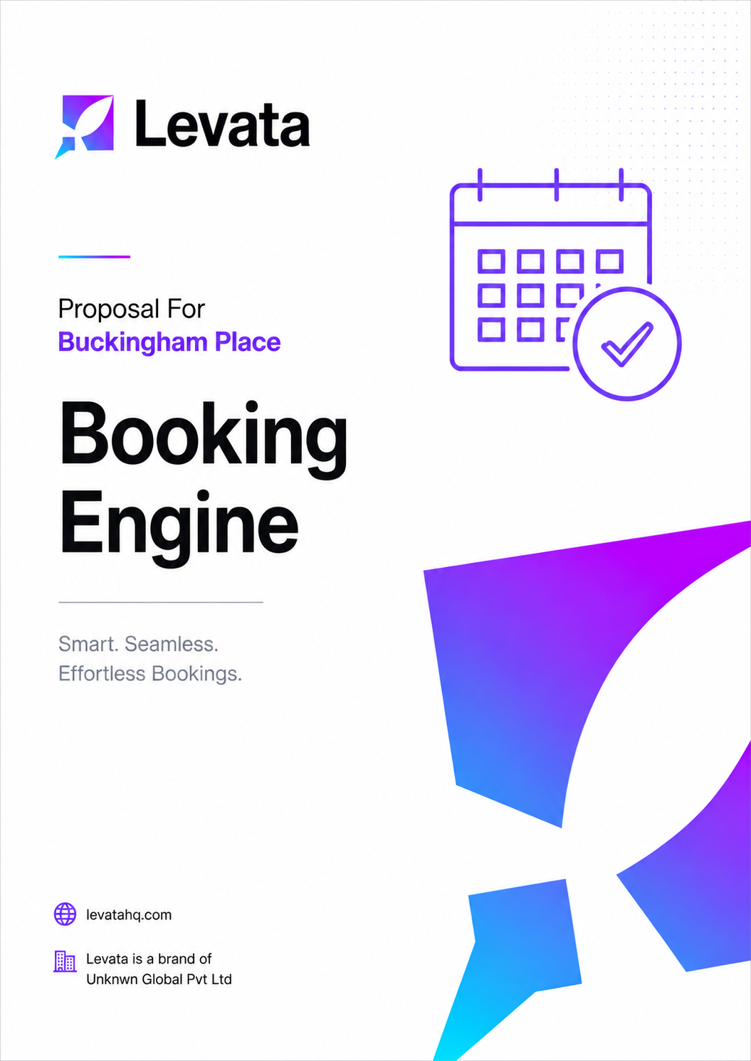

COST PROPOSAL
Booking Engine and Payment Gateway
Prepared for: Buckingham Place, Tangalle
Intelligence, Built.

Date: 6th May 2026 Project ID: PID: 223
levatahq.com | hello@levatahq.com

1. PROJECT OVERVIEW

This proposal outlines the scope and investment for developing a custom booking engine and payment gateway for Buckingham Place. The system will enable the property to accept direct reservations through its own website, reducing dependency on third-party platforms and giving guests a trusted, frictionless booking experience from the moment they decide to stay.
This component can be deployed independently of, or in parallel with, the website development project.
2. UNDERSTANDING OF CLIENT VISION

Buckingham Place is built on warmth, intimacy, and the gift of unhurried time. Guests arrive wanting to leave the noise behind. The last thing they should encounter on the journey to that feeling is a booking process that feels generic, uncertain, or rushed.
The system Levata builds will carry the same quiet confidence as the property itself. It will be clean and intuitive, reassuring in its security, and thoughtful in the way it guides a guest from intention to confirmed reservation. There will be no friction, no unnecessary steps, and nothing that undermines the calm, homely tone the property has worked to create.
Booking a stay at Buckingham Place should feel like the beginning of the experience, not an administrative task before it.
3. PROJECT OBJECTIVES

- Enable direct room reservations via the property's website, reducing reliance on OTA platforms
- Provide guests with a flexible, secure, and intuitive payment experience
- Give the property full operational control over pricing, availability, and promotions
- Reinforce brand credibility through a professional, purpose-built booking flow
- Deploy a standalone system that can go live independently of the website development timeline
4. SCOPE OF WORK

4.1 Booking and Availability
- Real-time room availability search based on guest-selected dates
- Support for multiple rooms under a single reservation
4.2 Pricing and Promotions
- Seasonal and off-season pricing management
- Coupon code functionality for promotional offers and direct booking incentives
4.3 Payment Integration
- Integration with a client-provided payment gateway
- Secure payment processing compliant with standard protocols
- Flexible payment options: full payment, partial payment, and token or advance payment
4.4 Guest Management
- Secure storage of guest information
- Full booking records management and history
4.5 User and Admin Access
- Role-based user account system for staff and management
- Backend dashboard for managing bookings, pricing, availability, and promotional offers
4.6 Operational Features
- Guest arrival form generation with print functionality
5. LEVATA APPROACH

We design booking systems with the guest experience as the primary measure of success and the property's operational needs as the supporting framework.
- Planning: system architecture, booking flow design, and UI planning
- Development: core booking engine, admin dashboard, and payment gateway integration
- Testing: end-to-end flow validation, payment processing verification, and cross-device QA
- Deployment: live environment setup, staff walkthrough, and documentation handover
6. DELIVERABLES

- Fully functional booking engine system
- Integrated and tested payment gateway
- Admin dashboard with complete booking management capability
- Basic documentation and staff system walkthrough
7. EXCLUSIONS

The following items are not included in this scope unless explicitly agreed in writing:
- Integration with third-party booking platforms or OTAs
- Channel manager integrations
- Advanced analytics and reporting dashboards
- SMS or email automation beyond basic confirmation setup
- Ongoing hosting or server management
8. TIMELINE

Estimated duration: 17 Days .

Phase | Activity
6 Days | Planning, system architecture, and UI flow
8 Days | Development and payment gateway integration
3 Days | Testing, revisions, and deployment

9. INVESTMENT

Total Investment
LKR XXX,000

Payment Schedule
50% due at project kickoff
50% due upon deployment

Terms
- Domain and hosting fees are not included and remain the responsibility of the client.
10. NEXT STEPS

- Review and sign this proposal
- Submit the 50% advance payment to initiate the project
- Kickoff session to confirm payment gateway details and system requirements

This proposal is valid until 15th May 2026. Payments are made by bank transfer to the details provided in the invoice upon sign-off.

SIGN-OFF

Shameer Refai  Co-Founder, Levata  Date: 05 / 05 / 2026 |  | Mr. Nick Buckingham  Buckingham Place  Date: ___ / ___ / 2026

