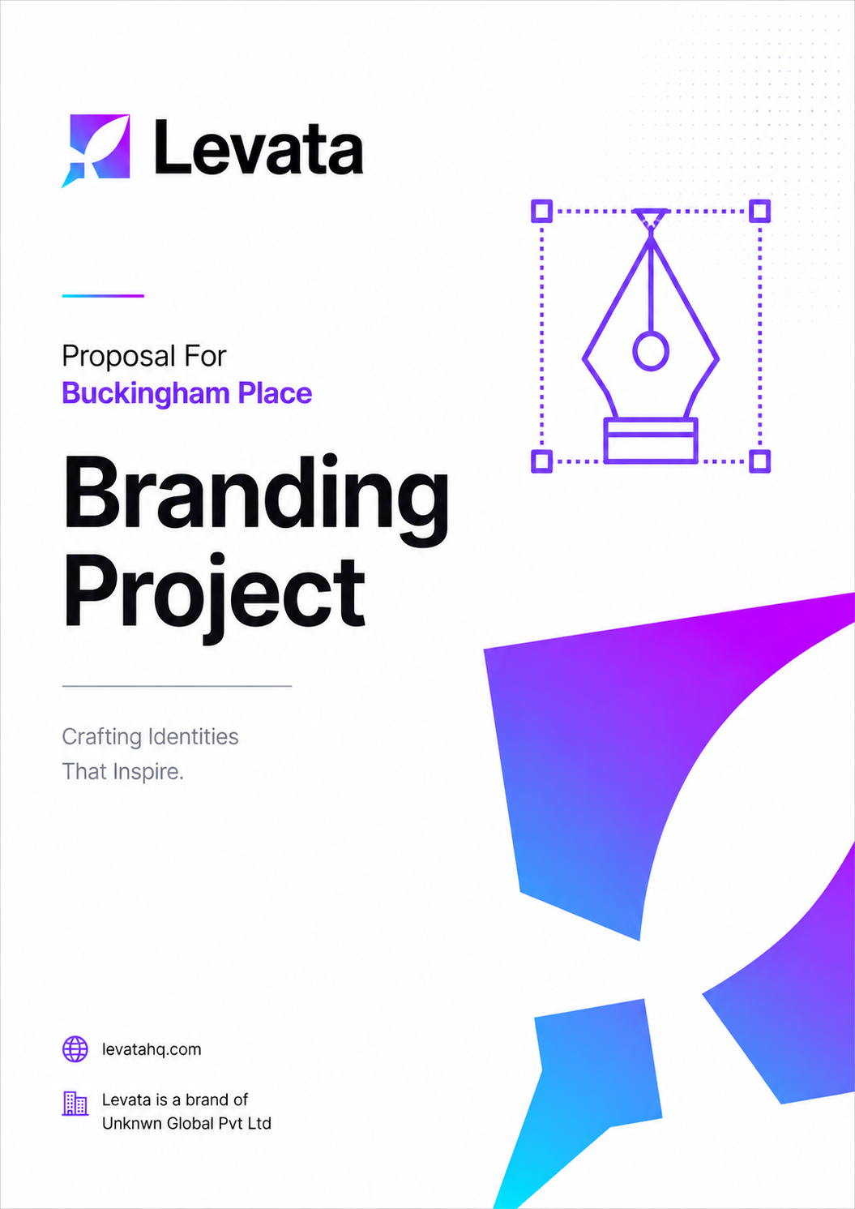
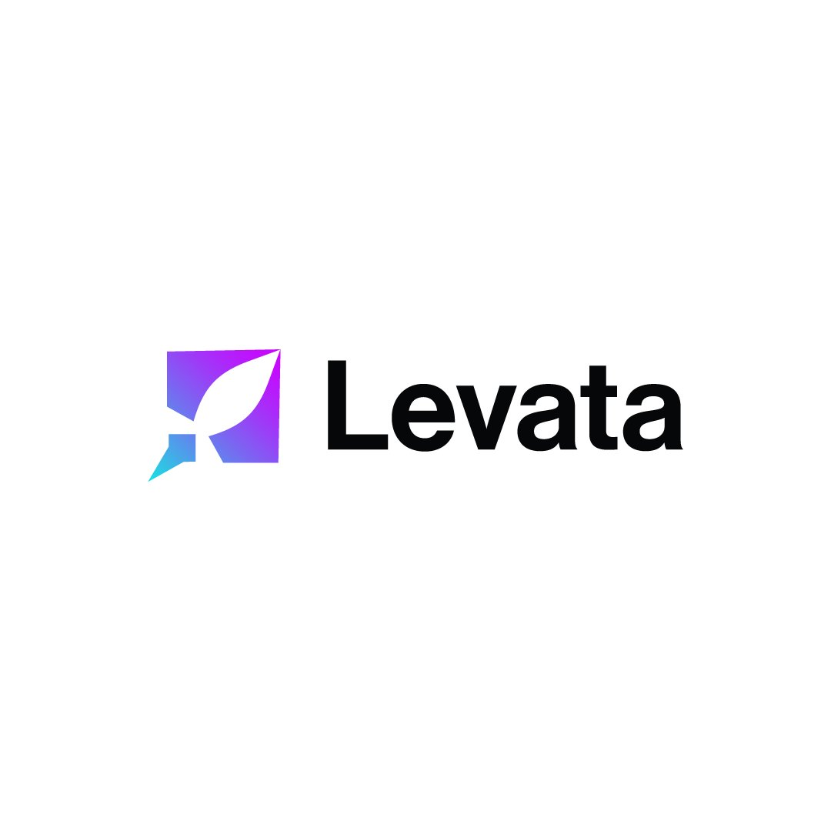

COST PROPOSAL
Branding
Prepared for: Buckingham Place, Tangalle
Intelligence, Built.

Date: 6th May 2026 Project ID: PID: 221
levatahq.com | hello@levatahq.com

1. PROJECT OVERVIEW

This proposal outlines the scope and investment for developing a comprehensive brand identity for Buckingham Place. Working from the client's existing logo as the confirmed foundation, Levata will build a complete, elegant brand world around it, ensuring every touchpoint communicates a consistent and distinctive identity.
2. UNDERSTANDING OF CLIENT VISION

Buckingham Place is a place where time moves differently. It sits between the sea and the lagoon in Tangalle, offering guests something increasingly difficult to find: genuine rest. Not the manufactured stillness of a spa menu, but the real, unstructured quiet of a place that was built to feel like home.
Guests come here for lazy mornings with no obligations, for afternoons so slow they lose their shape, for the warmth of an environment that asks nothing of them. It is a sanctuary in the true sense. Calm, intimate, deeply personal, and absolutely unhurried.
The brand we develop will carry that same character. It will not be loud or decorative. It will feel like the property: warm without being informal, elegant without being cold, and quietly confident in what it offers. Every element, from typography to colour to tone, will be designed to evoke the experience before a guest even arrives.
3. PROJECT OBJECTIVES

- Develop a cohesive, premium brand identity
- Create a complete brand world that reflects the calm, warm, and intimate character of the property
- Deliver comprehensive brand guidelines to ensure consistency across all future applications
- Provide practical brand assets ready for immediate use across digital and print channels
4. SCOPE OF WORK

4.1 Logo System
The client's existing logo serves as the confirmed creative foundation. Levata will build a full brand system around it, ensuring the logo is presented and supported consistently across all contexts. Deliverables include:
- Three logo variations: primary, secondary(mono-tone), and icon
- Brand guidelines document covering the full rules of usage
- Complementary colour palette, developed to work harmoniously with the logo
- Typography guidelines covering primary and secondary typefaces
- Social media icon and avatar specification derived from the existing logo mark
- Logo usage guide including clear do's and don'ts to protect brand integrity
- Branding template - Envelope, letterhead, business card
- Branded Pattern

4.2 Full Brand System
In addition to the logo documentation, the complete brand system will include:
- Colour specifications in HEX, RGB, and CMYK formats
- Typography pairings and hierarchy rules for all applications

5. LEVATA APPROACH

We begin with understanding, not drawing. Our branding process is collaborative and iterative, ensuring the final system feels genuinely owned by the client.
- Brand Discovery: understanding the property, its guests, and its aspirations in depth
- Direction Setting: establishing the visual and tonal direction, reviewed before design begins
- Design Development: creating the logo system and brand elements in close reference to the existing logo
- Refinement: incorporating client feedback across focused rounds of revision
- Delivery: final assets, guidelines, and handover in all required formats

6. INVESTMENT

Total Investment
LKR XXX,000

Payment Schedule
50% advance due before project commencement
50% balance due within 7 days of project completion

Payment Methods
Payments may be made via cash, bank deposit, or wire transfer.
7. NEXT STEPS

- Review and sign this proposal
- Submit the 50% advance payment
- Participate in the brand discovery session to begin the process

SIGN-OFF

Shameer Refai  Co-Founder, Levata  Date: 05 / 05 / 2026 |  | Mr. Nick Buckingham  Buckingham Place  Date: ___ / ___ / 2026

