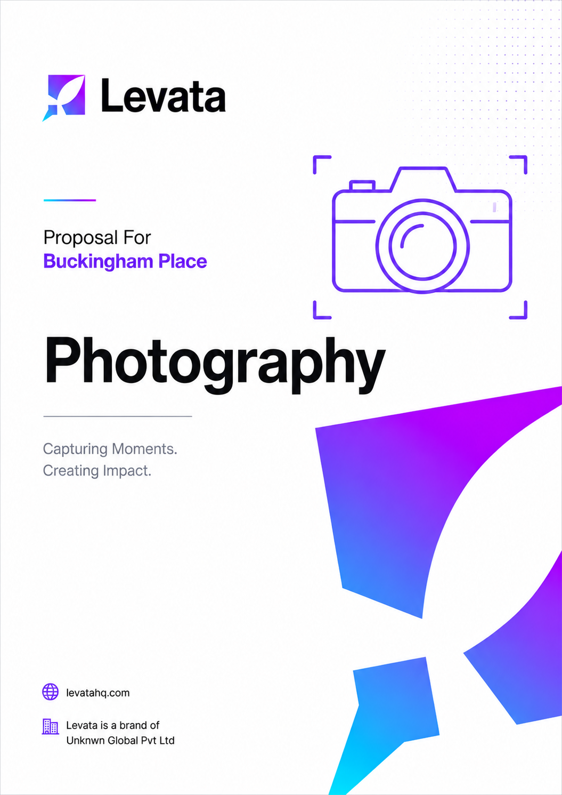


COST PROPOSAL
Photography and Content Production
Prepared for: Buckingham Place, Tangalle
Intelligence, Built.

Date: 6th May 2026 Project ID: PID: 224
levatahq.com | hello@levatahq.com

1. PROJECT OVERVIEW

This proposal outlines the scope and investment for a dedicated photography and content production shoot at Buckingham Place, Tangalle. Spanning three full days on location, the shoot will produce a comprehensive, professionally edited image library aligned with the new website and brand direction. The objective is a cohesive visual world that communicates the atmosphere, spaces, and guest experience of the property with honesty and depth.
2. UNDERSTANDING OF CLIENT VISION

Buckingham Place is a sanctuary. Positioned between the Indian Ocean and the Rekawa lagoon, it is a place built for unhurried time: warm mornings without agenda, long lazy afternoons, the quiet pleasure of doing nothing in particular and doing it beautifully.
The photography must carry exactly that feeling. Not staged perfection, but genuine atmosphere. The light through the rooms, a breakfast that has time to linger, the stillness of a space between guests. Every image in this library should make a prospective guest feel the calm before they arrive, creating desire not through spectacle, but through the kind of quiet, homely warmth that is genuinely rare.
3. PROJECT OBJECTIVES

- Produce a comprehensive, professionally edited image library aligned with the new website and brand identity
- Capture the atmosphere, spaces, dining, and surroundings of the property with authenticity and care
- Deliver images optimised for use across the website, OTAs, and social media platforms
- Provide a cohesive visual foundation for all current and future marketing activity
4. SCOPE OF WORK

4.1 Pre-Production
- Initial consultation to align on objectives, visual direction, and key deliverables
- Development of a detailed shot list based on website structure and content requirements
- Location recce to assess spaces, lighting conditions, and optimal shoot timings
- Creative direction planning covering mood, tone, and visual storytelling approach
- Scheduling and shoot planning to maximise efficiency across all three shoot days
- Coordination with the client on access, space availability, and location readiness
- Identification of any additional requirements such as props or styling prior to production
4.2 Production (On Location)
- Professional photographer and supporting crew including assistants and on-site coordination
- Up to 10 hours of shoot coverage per day across 3 full days
- Approximately 110 planned shots aligned with the website structure and content requirements
- Use of professional photography equipment including cameras, lenses, lighting, and stabilisation gear
- On-site art direction to maintain consistency in visual storytelling and brand tone
- Scheduling to capture optimal natural lighting conditions including sunrise and sunset where relevant
- Basic styling using existing on-site elements such as rooms, dining setups, and surroundings

4.3 Post-Production
- Colour and tone correction to achieve a consistent, cohesive visual aesthetic
- Retouching including minor blemish and distraction removal
- Adjustments to brightness, contrast, and saturation
- Cropping and resizing based on platform requirements
- Image optimisation for web performance without compromising quality
- Delivery in both high-resolution and web-ready formats
5. DELIVERABLES

Total Images: 110 high-resolution, fully edited photographs
Format: JPEG
Usage Rights: Digital use
Recommended Placements: Website, OTAs, and social media platforms
6. ESTIMATED SHOT ALLOCATION

The following breakdown is an estimate that represents the planned distribution of images across the key content areas. Final allocation will be confirmed during pre-production.

Content Area | Shots
Accommodation rooms | 50
Food and drinks | 10
Experiences | 10
Oceanfront restaurant | 5
Activities | 10
People | 5
Outdoor and surroundings | 7
Aerial or general property | 13
Total | 110
7. EXCLUSIONS

The following items are not included within this scope and will be costed separately if required:
- Talent and models: professional models, lifestyle talent, casting, coordination, styling, and talent usage rights are not included
- Props and external styling: any props, furniture, decor, or styling elements sourced externally are excluded from this scope
- Additional revisions: the proposal includes a defined number of post-production revision rounds. Extensive rework or edits beyond this will be subject to additional charges
- Accommodation and meals: crew accommodation and meals are to be arranged and covered by the client for the duration of the shoot

8. TIMELINE

Total shoot duration: 3 full days on location. Pre-production and post-production timelines will be confirmed following project kickoff.
9. INVESTMENT

The investment below covers pre-production planning, 3 full days of on-location photography, crew, equipment, and complete post-production editing and delivery of 110 images.

Total Investment
LKR XXX,000

Payment Terms
- 50% advance due at project kickoff
- 50% balance due upon delivery of final edited images

10. NEXT STEPS

- Review and sign this proposal
- Submit the 50% advance payment to initiate the project
- Pre-production consultation to finalise the shot list and schedule

This proposal is valid until 15th May 2026. Payments are made by bank transfer to the details provided in the invoice upon sign-off.

SIGN-OFF

Shameer Refai  Co-Founder, Levata  Date: 05 / 05 / 2026 |  | Mr. Nick Buckingham  Buckingham Place  Date: ___ / ___ / 2026

