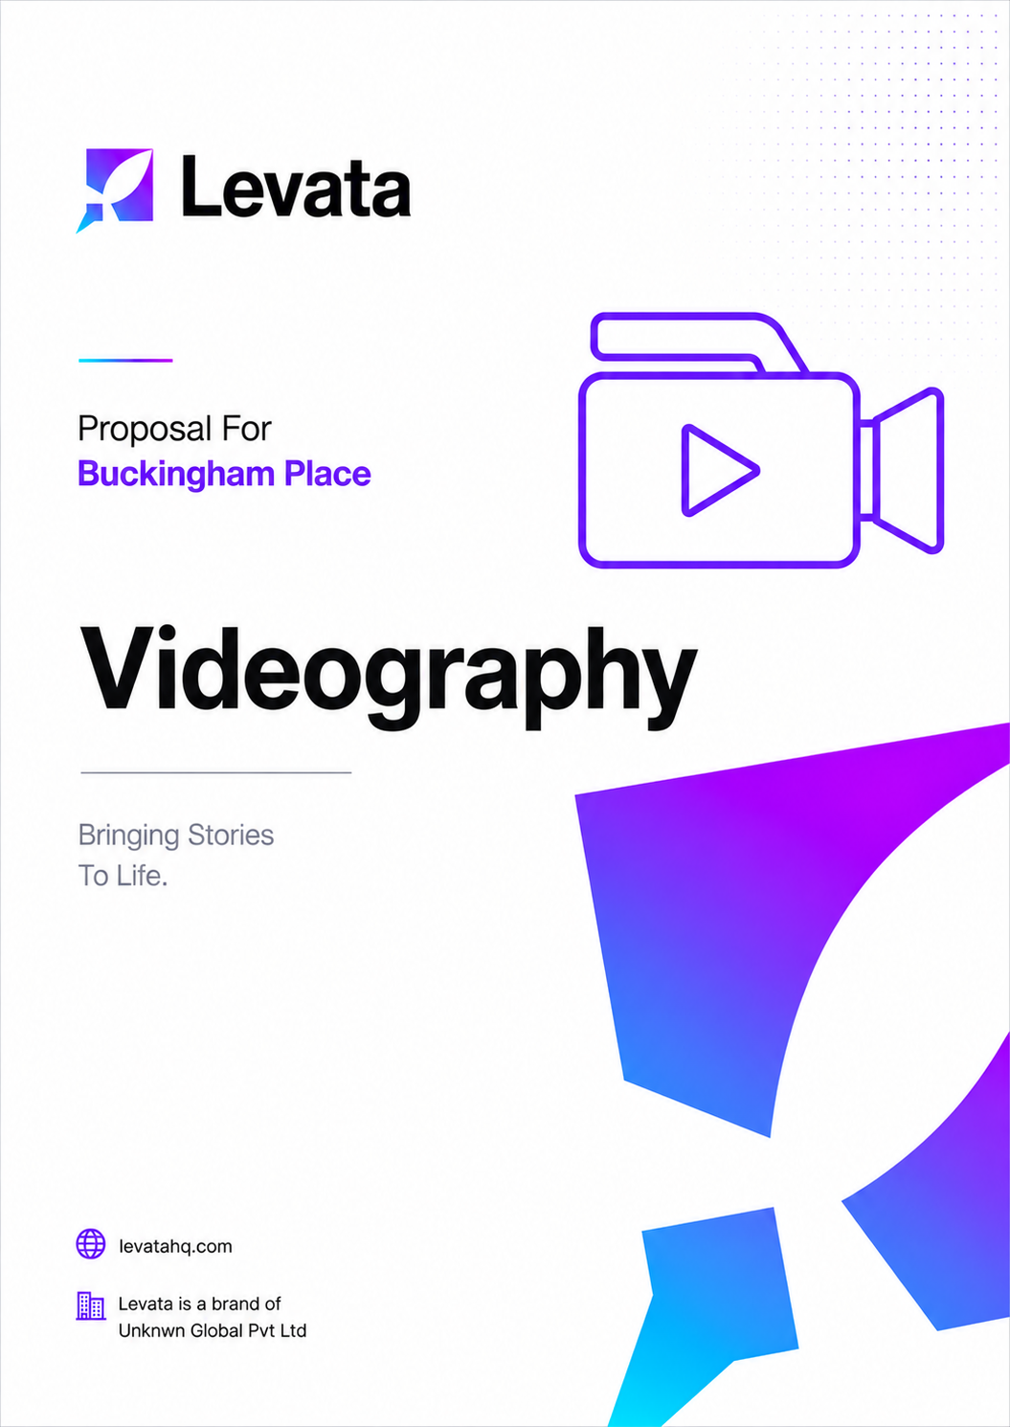
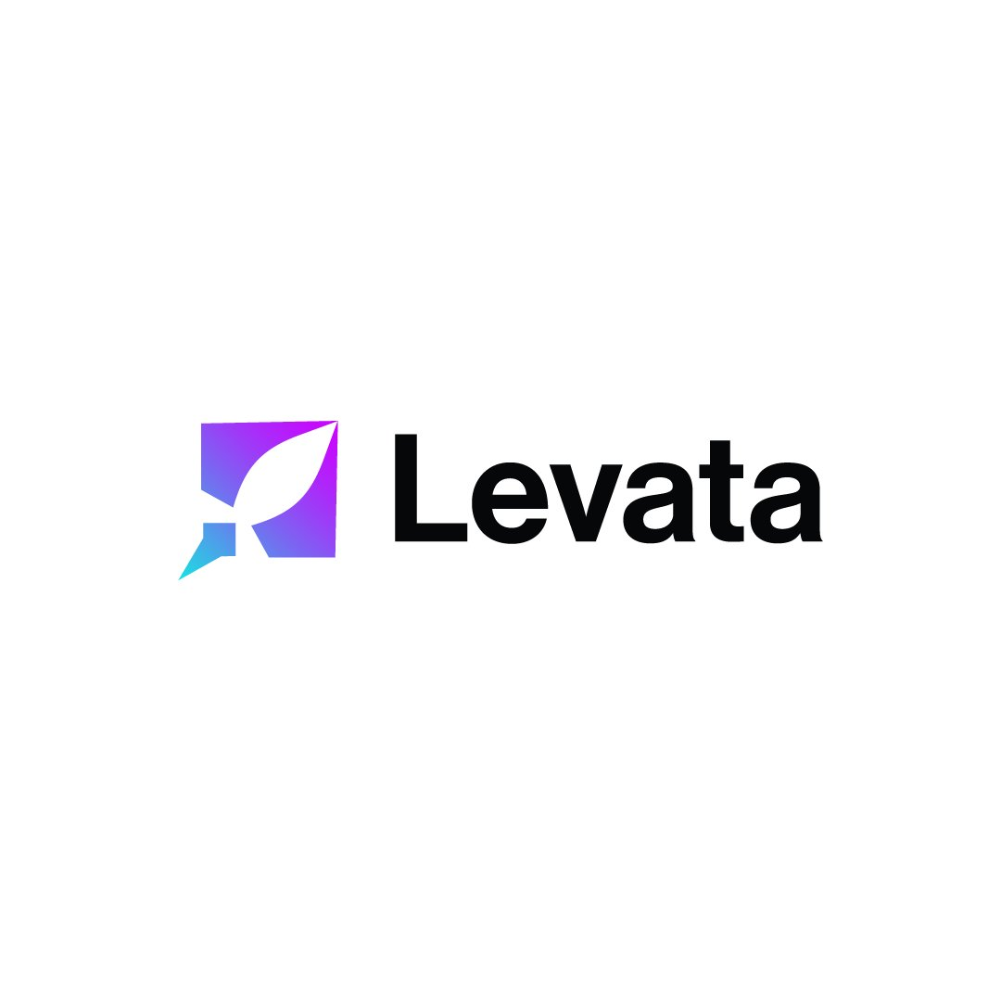

COST PROPOSAL
Video Production
Prepared for: Buckingham Place, Tangalle
Intelligence, Built.

Date: 6th May 2026 Project ID: PID: 225
levatahq.com | hello@levatahq.com

1. PROJECT OVERVIEW

This proposal outlines the scope and investment for a dedicated video production shoot at Buckingham Place, Tangalle. Spanning two full days on location, the production will capture the essence of the property and the experience it offers, delivering a suite of cinematic marketing assets for use across digital channels including the website, social media, and wider marketing materials.
2. UNDERSTANDING OF CLIENT VISION

Buckingham Place is not easily described. It is the feeling of stepping out of time. Between the Indian Ocean and the lagoon, it is a place of deep, unhurried calm. Warm, intimate, and homely in the most generous sense, it is a sanctuary where guests arrive to slow down, to linger, to indulge in the quiet pleasure of doing very little, very well.
That is precisely what the video must communicate. Not a highlight reel of amenities, but a genuine sense of place. The light in the morning. The stillness of the water. A meal that has nowhere to be. The feeling of a space that holds you without any expectation. The camera should follow the rhythm of the property, unhurried, observational, and deeply atmospheric, drawing the viewer in before a single word is spoken.
When someone watches this film, they should feel it. And they should want to be there.
3. PROJECT OBJECTIVES

- Capture the atmosphere, essence, and guest experience of Buckingham Place through cinematic video
- Produce premium marketing assets that communicate the property's identity authentically and compellingly
- Deliver content optimised for the website, social media platforms, and digital marketing campaigns
- Create a versatile visual foundation that supports the brand across multiple formats and placements
4. DELIVERABLES

The production will deliver the following edited video assets:

Deliverable | Duration | Primary Use
Main Brand Film | Up to 2 minutes | Website, OTAs, campaigns
Short Edit | Up to 1 minute | Social media, digital ads, reels

Format: High-resolution digital files suitable for web and social media
Aspect Ratios: Landscape (16:9) for website and other digital mediums
Usage Rights: Full digital use across owned and paid channels
Music: Licensed background score aligned with the visual tone

5. SCOPE OF WORK

5.1 Pre-Production
- Initial creative consultation to align on vision, tone, and key narratives to capture
- Development of a shot list and shooting schedule across both production days
- Location recce to assess spaces, movement, lighting conditions, and optimal timings
- Coordination with the client on space access, location readiness, and any logistical requirements
- Identification of any additional requirements such as talent, props, or styling prior to production
5.2 Production (On Location)
- Professional videographer and production crew including camera operators, assistants, and on-site coordination
- Up to 10 hours of shoot coverage per day across 2 full production days
- Cinematic camera and lens package including stabilisation, drone camera and pilot, and lighting equipment where applicable
- On-site creative direction to maintain consistency in visual storytelling and brand tone throughout
- Capture across all key areas: accommodation, dining, outdoor spaces, lagoon and ocean frontage, and experiential moments
- Ambient and atmospheric capture to bring the sense of place to life, including natural sound recording
- Basic styling using existing on-site elements such as rooms, dining setups, and surroundings
5.3 Post-Production
- Professional edit of all captured footage into the defined deliverable formats
- Free licensed music selection and integration across all deliverables
- Sound design including ambient audio refinement and audio mixing
- On-screen text and title treatment where required
- Format and resolution optimisation for each intended platform and placement
- Two rounds of revisions included per deliverable
6. EXCLUSIONS

The following items are not included within this scope and will be costed separately if required:
- Talent and on-screen talent: professional actors, models, or lifestyle talent including casting, coordination, and usage rights are not included
- Props and external styling: any props, furniture, decor, or styling elements sourced externally are excluded
- Voiceover or scripted narration: any scripted content, voiceover recording, or narration services are not included
- Additional revisions beyond two rounds: extensive rework or edits beyond the included revision rounds will be subject to additional charges
- Paid music licensing above a standard digital use license: specialist or premium music licensing requirements will be quoted separately
- Accommodation and meals: crew accommodation and meals are to be arranged and covered by the client for the duration of the shoot

7. TIMELINE

Total production duration: 2 full days on location. Post-production and delivery timelines will be confirmed following project kickoff.
8. INVESTMENT

The investment below covers pre-production planning, 2 full days of on-location video production, crew, equipment, and complete post-production editing and delivery of all agreed assets. Transportation costs for the crew are included.

Total Investment
LKR XXX,000

Payment Terms
- 50% advance due at project kickoff
- 50% balance due upon delivery of final edited assets

9. NEXT STEPS

- Review and sign this proposal
- Submit the 50% advance payment to initiate the project
- Pre-production creative consultation to finalise the shot list, schedule, and visual direction
This proposal is valid until 15th May 2026. Payments are made by bank transfer to the details provided in the invoice upon sign-off.

SIGN-OFF

Shameer Refai  Co-Founder, Levata  Date: 05 / 05 / 2026 |  | Mr. Nick Buckingham  Buckingham Place  Date: ___ / ___ / 2026

