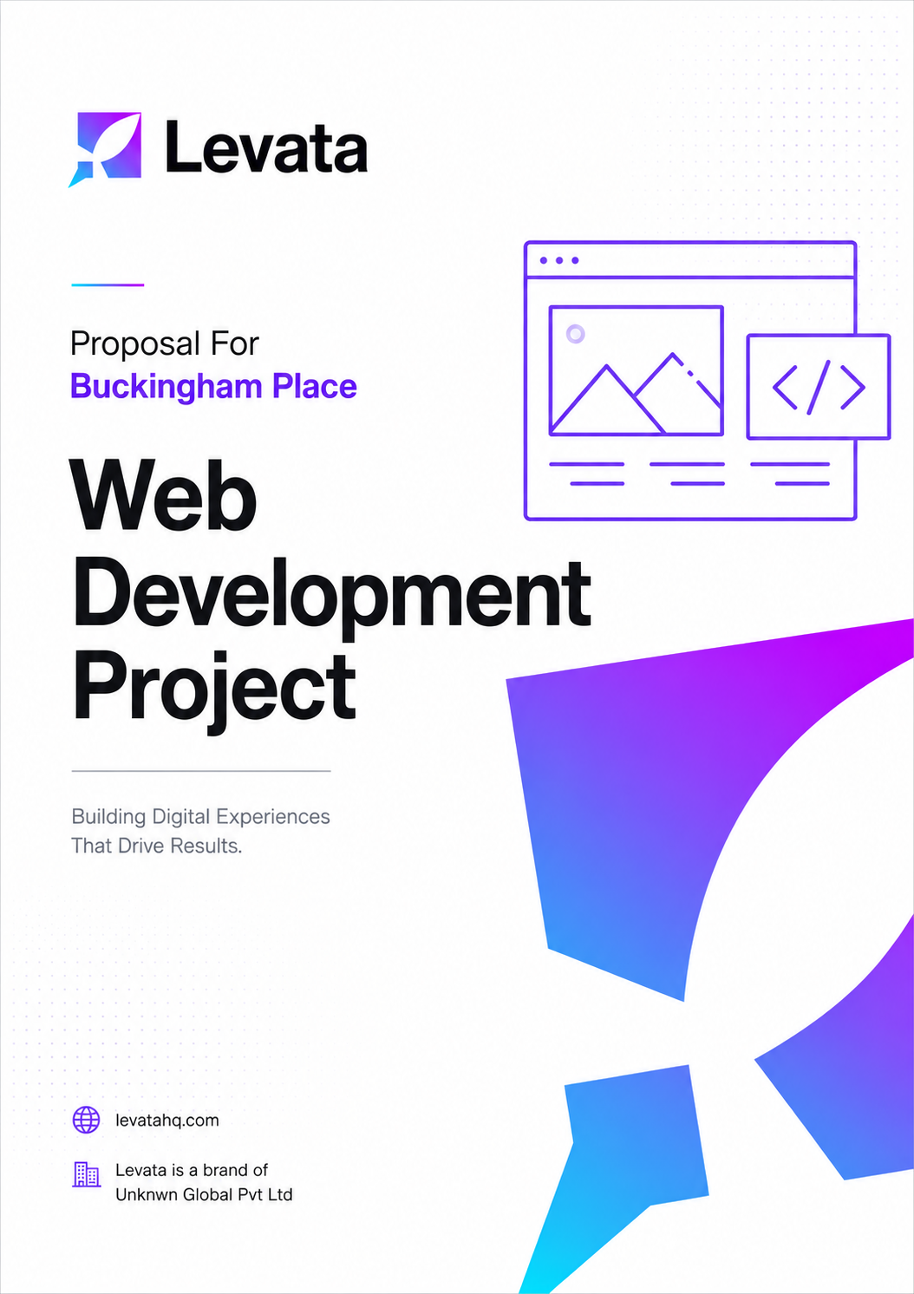
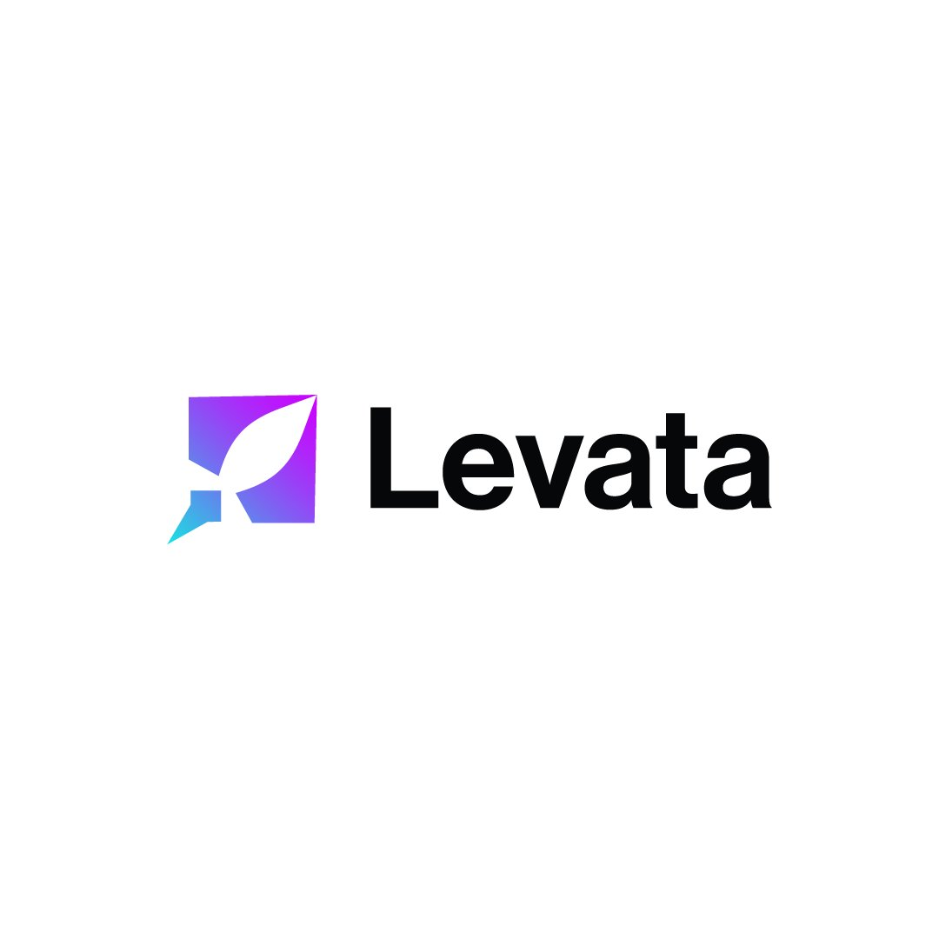

COST PROPOSAL
Web Development
Prepared for: Buckingham Place, Tangalle
Intelligence, Built.

Date: 6th May 2026 Project ID: PID: 097
levatahq.com | hello@levatahq.com

1. PROJECT OVERVIEW

This proposal outlines the scope and investment for designing and developing a new website for Buckingham Place. The result will be a refined, conversion-focused platform that tells the story of the property with clarity and emotional resonance, guiding every visitor from first impression to confident booking.
2. UNDERSTANDING OF CLIENT VISION

Buckingham Place is not a hotel. It is a sanctuary. Positioned between the Indian Ocean and the Rekawa lagoon in Tangalle, it offers something that the modern world rarely makes time for: the permission to do nothing, slowly, and without apology.
This is a place for warm mornings with no agenda, for long lunches that drift into afternoons, for the particular joy of lying in the shade and watching the light change. It is homely in the deepest sense, quiet without being austere, and intimate in a way that no larger property could replicate. Guests do not visit Buckingham Place to see Sri Lanka. They come to feel it, unhurried and completely.
Every decision on this website will be guided by that feeling. The site will not announce itself loudly. It will draw people in quietly, build desire through atmosphere and detail, and make the journey from discovery to booking feel as effortless and unhurried as the stay itself.
3. PROJECT OBJECTIVES

- Create a website that communicates the Buckingham Place experience with authenticity and emotional depth
- Build a conversion-focused platform that moves visitors naturally from discovery to direct booking
- Deliver a site that is fast, responsive, and reliable across all devices and screen sizes
- Establish a strong digital foundation to support future marketing and direct booking growth
- Reflect the property's character through considered storytelling and refined visual design
4. SCOPE OF WORK

4.1 Site Map and Architecture
The website will comprise 12 to 15 pages, structured to guide visitors naturally from first contact toward booking. Pages include:
- Home Page: the first emotional touchpoint, featuring an immersive hero, positioning statement, room teasers, experience highlights, and a inquire Availability call-to-action
- Rooms and Suites: detailed room-by-room breakdowns with strong visuals, clear differentiation, and direct booking prompts
- Experiences: shifts the focus from rooms to feeling, highlighting nature, dining, wellness, and the slow living ethos of the property
- Dining: conveys the culinary philosophy and dining formats through rich visual storytelling
- Location: contextualises the property's intentional remoteness, with directions, travel times, and nearby points of interest
- Promotions and Offers: showcases curated packages, seasonal deals, and honeymoon offerings
- About: builds trust and human connection through the founder's story and the philosophy behind the property
- Contact: includes phone, WhatsApp, email, enquiry form, map, and social links
- Gallery: a curated visual journey across the key spaces and surroundings
- Terms and Policies: all standard legal and compliance pages

4.2 Strategic Layout Plan
A strategic layout plan will be developed before design begins to map the user journey from entry to conversion. Each page will be structured to build desire progressively, with calls to action and social proof placed at moments of peak intent.
4.3 Wireframes
Wireframes will be produced for all key pages to define layout, hierarchy, and content placement before design begins. This enables early feedback and reduces revision cycles downstream.
4.4 Visual Design
The design will translate the property's identity into a cohesive visual language across typography, imagery, colour, and layout. The aesthetic will be calm, refined, and emotionally considered. A mobile-first approach will be applied throughout.
4.5 Development
The approved design will be built on NodeJS and NextJS, covering all pages, features, and functionality. This includes plugin integration, responsive development, content population, and performance optimisation.
4.6 Content
Written content will be developed from existing site material as a foundation, refined in tone and structure to align with the new design. Authentic guest reviews from Google and TripAdvisor will be woven in as social proof.
Photography will be planned as a separate scope once the design direction is confirmed, with a dedicated quotation provided at that stage.
4.7 Quality Assurance
Comprehensive QA testing will cover all browsers and devices, including functionality, booking flow, performance, navigation, and content accuracy.
5. LEVATA APPROACH

Our process is built around partnership. We keep clients informed and in control at every stage while our team manages the complexity of execution.
- Discovery: aligning on vision, audience, goals, and competitive context
- Architecture: defining site structure and content requirements
- Wireframing: mapping layout and user flow for early client review
- Design: developing the visual system and page designs
- Development: building the fully functional website on WordPress
- QA and Testing: validating functionality, performance, and content
- Deployment: go-live, handover, and staff walkthrough
6. TIMELINE

Estimated duration: 5 to 6 weeks, subject to timely client feedback and content supply.

Phase | Activity
Weeks 1 to 2 | Site architecture, wireframes, and visual design
Weeks 3 to 5 | Development and content integration
Week 6 | QA, revisions, and deployment
7. INVESTMENT

This cost covers the full scope as outlined, inclusive of 12 to 15 pages.

Total Investment
LKR XXX,000

Payment Schedule
50% due at project kickoff
50% due upon deployment

Exclusions
- Domain registration and hosting fees, billed separately to the client
- Photography and visual content production, treated as a separate scope
- Payment gateway and booking engine integrations, covered under a separate proposal
- Premium or paid third-party plugins
8. NEXT STEPS

- Review and sign this proposal
- Submit the 50% advance payment to initiate the project

This proposal is valid until 15th May 2026. Payments are made by bank transfer to the details provided in the invoice upon sign-off.

SIGN-OFF

Shameer Refair  Co-Founder, Levata  Date: 05 / 05 / 2026 |  | Mr. Nick Buckingham  Buckingham Place  Date: ___ / ___ / 2026

