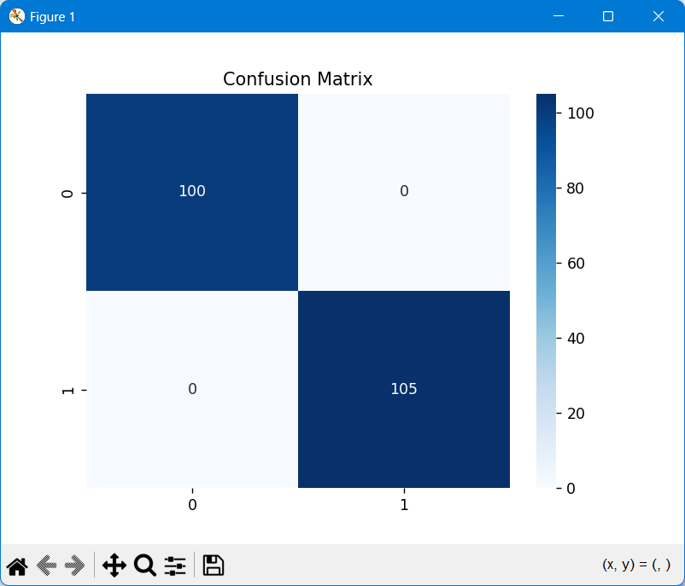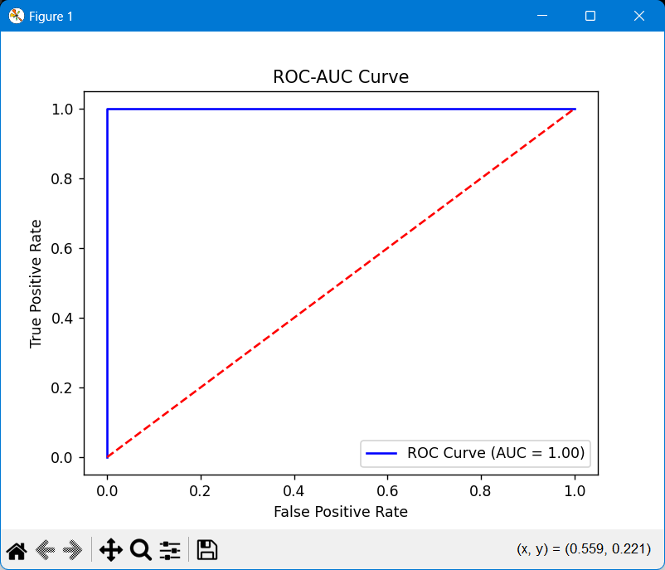

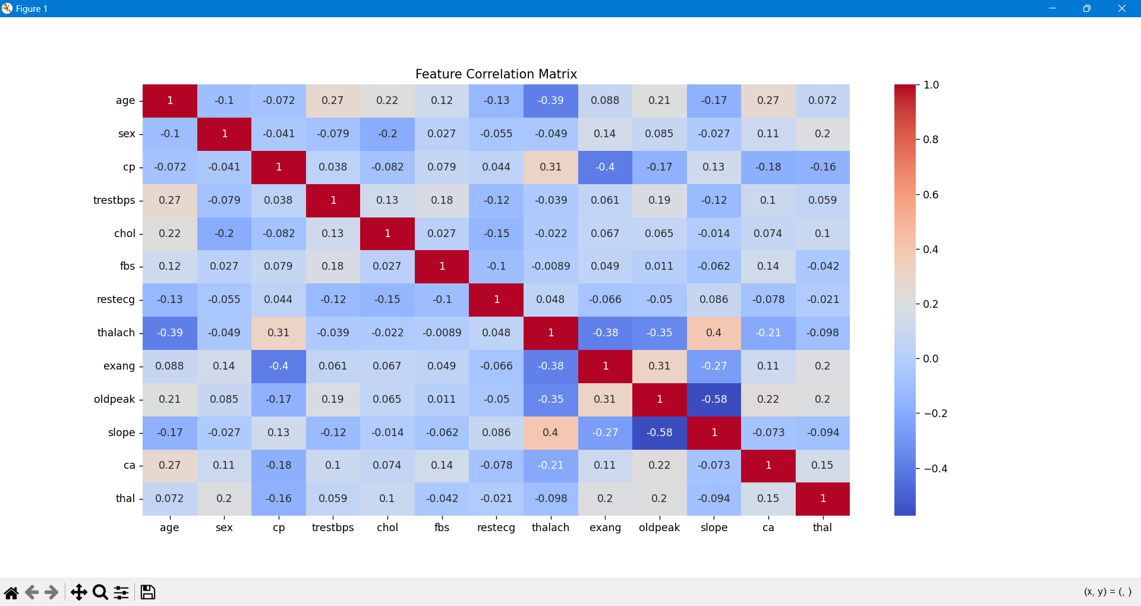

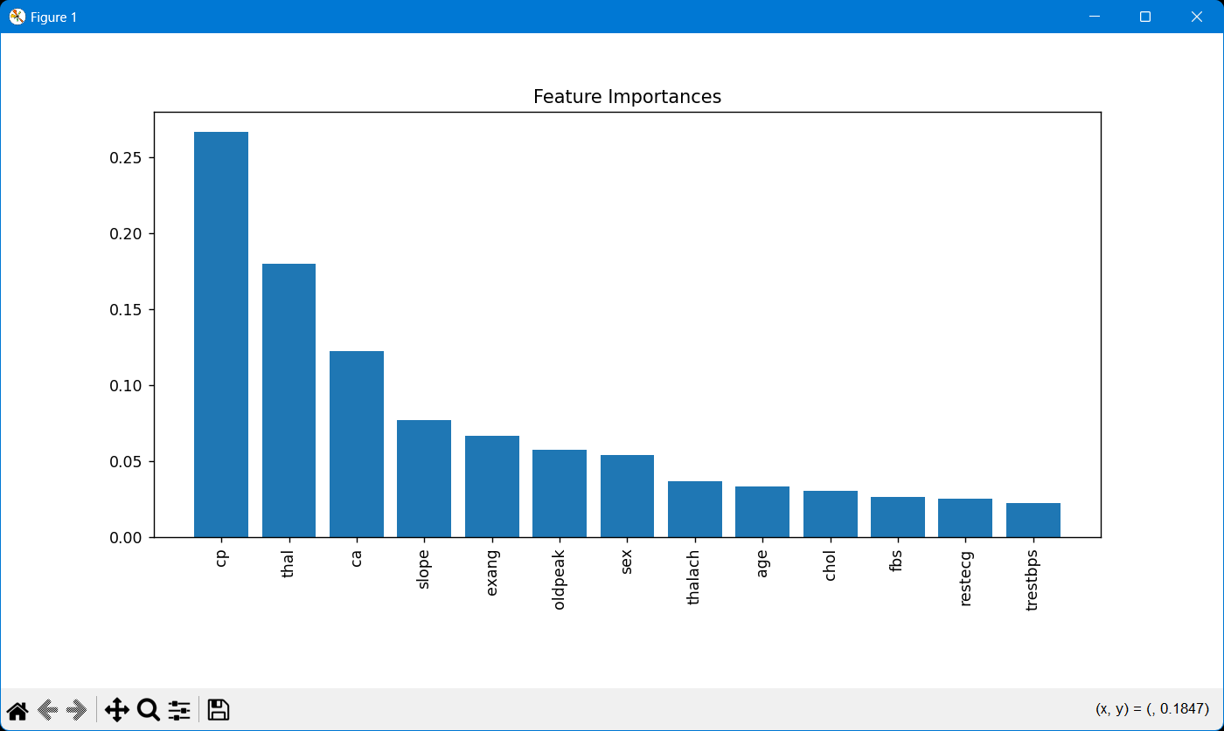

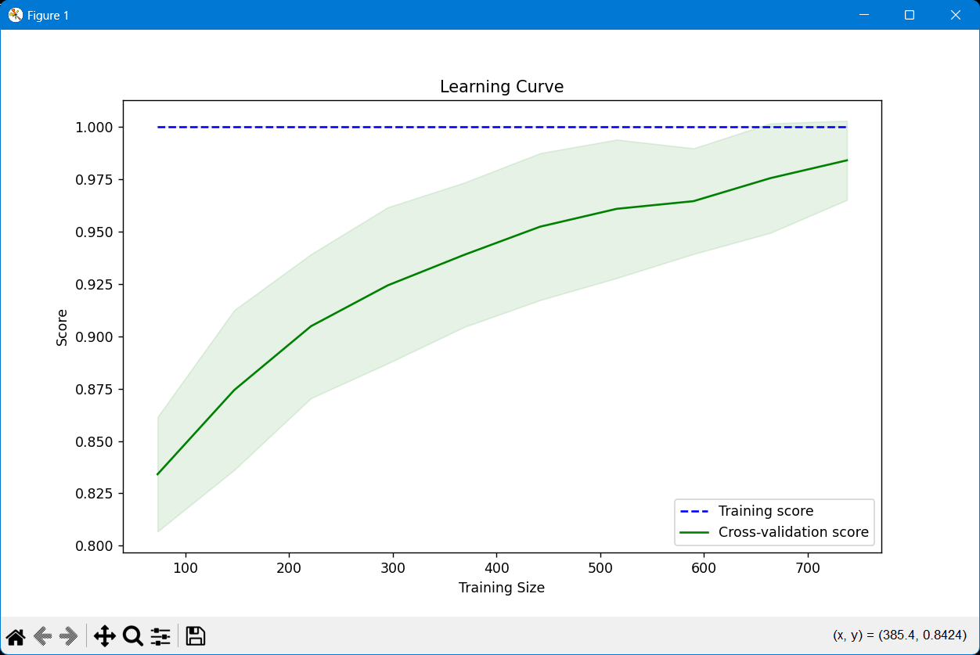

**Accuracy: 98.54%**

**precision recall f1-score support**

**0 0.97 1.00 0.99 102**

**1 1.00 0.97 0.99 103**

**accuracy 0.99 205**

**macro avg 0.99 0.99 0.99 205**

**weighted avg 0.99 0.99 0.99 205**

**ROC-AUC Score: 1.00**

**Cross-Validation Accuracy: 98.41%**

**Test Accuracy: 98.54%**

**precision recall f1-score support**

**0 0.97 1.00 0.99 102**

**1 1.00 0.97 0.99 103**

**accuracy 0.99 205**

**macro avg 0.99 0.99 0.99 205**

**weighted avg 0.99 0.99 0.99 205**

**Class Distribution:**

**target**

**1 526(Heart Disease)**

**0 499(No Heart Disease)**

**Name: count, dtype: int64**

**Accuracy: 1.0**

**Precision: 1.0**

**Recall: 1.0**

**F1-Score: 1.0**