Strut Phase 1 AI Editor Shell Report
AI Editor Shell And Design System | 2026-06-05

Summary
Phase 1 replaced the scattered studio surface with a coherent AI edit-mode shell while keeping generation behavior intact. The new first viewport now has a top project/status bar, left AI edit rail, right preview workspace, stable empty/generated preview states, selection-aware placeholder affordances, and a consistent design system across light and dark modes.
Area | Result
Scope boundary | Phase 1 only. No dynamic generation planning engine, no agentic CLI mode, no fixed mascot/pet atlas.
Core UI | Left AI edit rail, right live preview workspace, top project/status bar, inspector, stable empty/generated states.
Design system | Off-white pastel light surfaces with muted mint accents; blackish/dark-grey dark mode with dark navy accents.
Generation behavior | Preserved existing generation/provider behavior; backend engine was not expanded in this phase.

Scope Completed
- Built an AI edit-mode shell with a left rail and right preview workspace.
- Added selected target label, selection outline placeholder, ask-AI-to-edit-selection placeholder, and disabled apply/reject operation controls.
- Standardized app chrome tokens, typography, spacing, borders, focus states, preview surface, and panel surfaces.
- Added focused smoke coverage for the AI editor shell and selection-aware placeholders.

Before And After Visual Evidence
Representative Browser screenshots are embedded below. The full screenshot inventory is saved under the report screenshots folder.

Main workspace light
Before
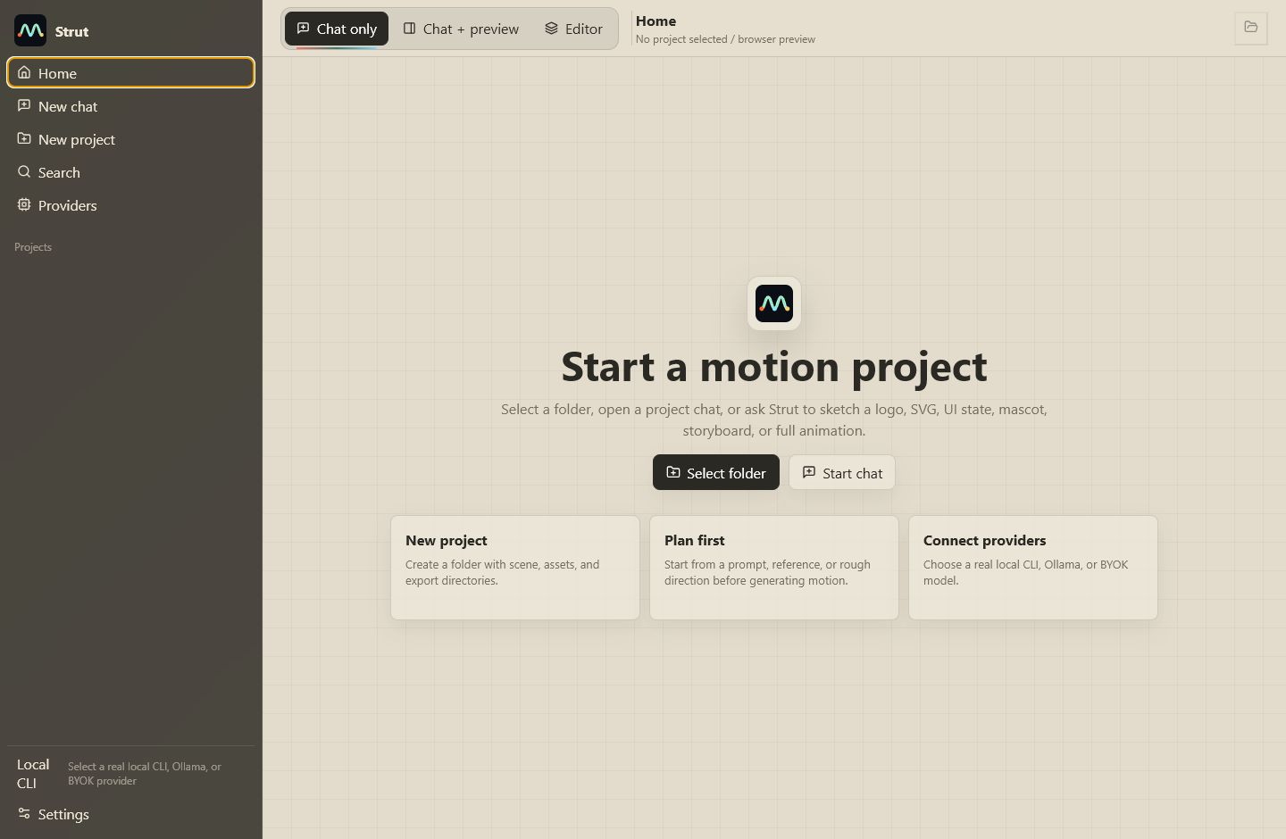
After
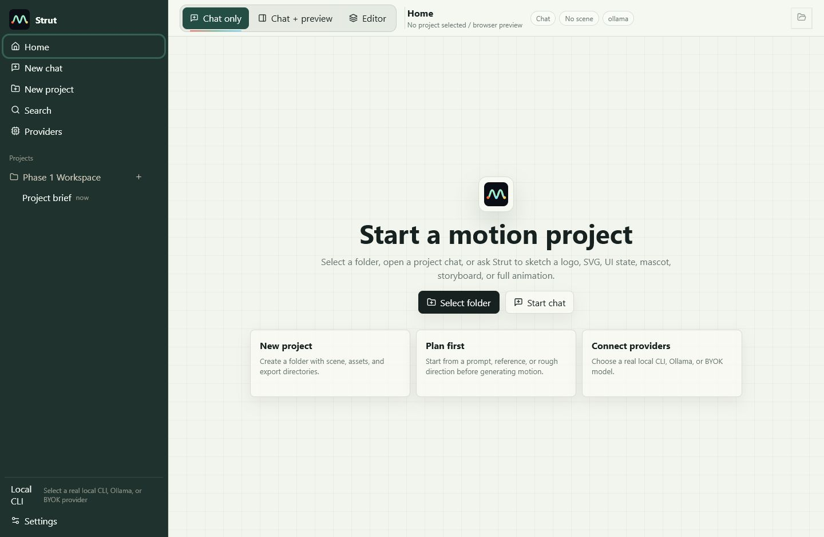

Empty preview light
Before
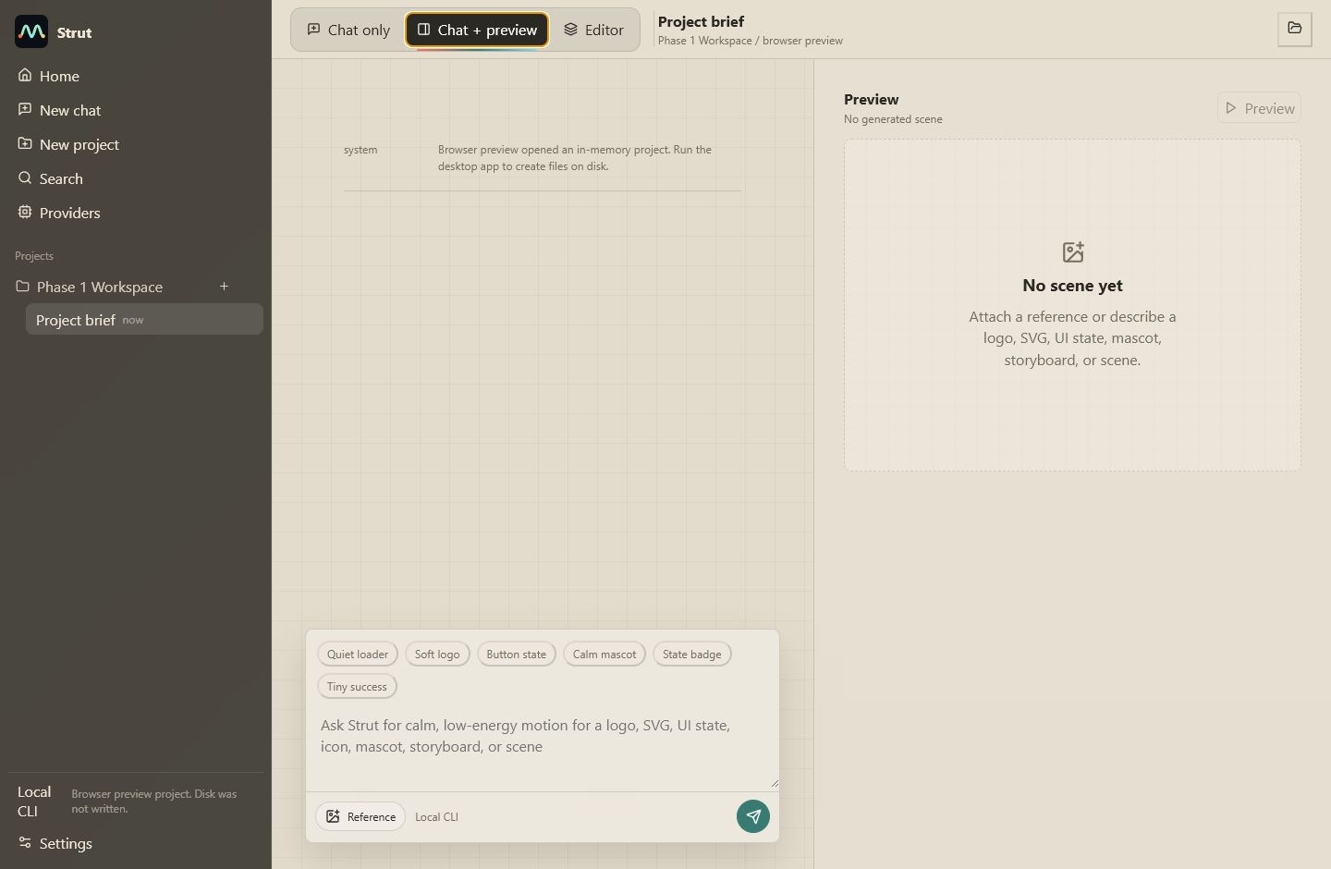
After
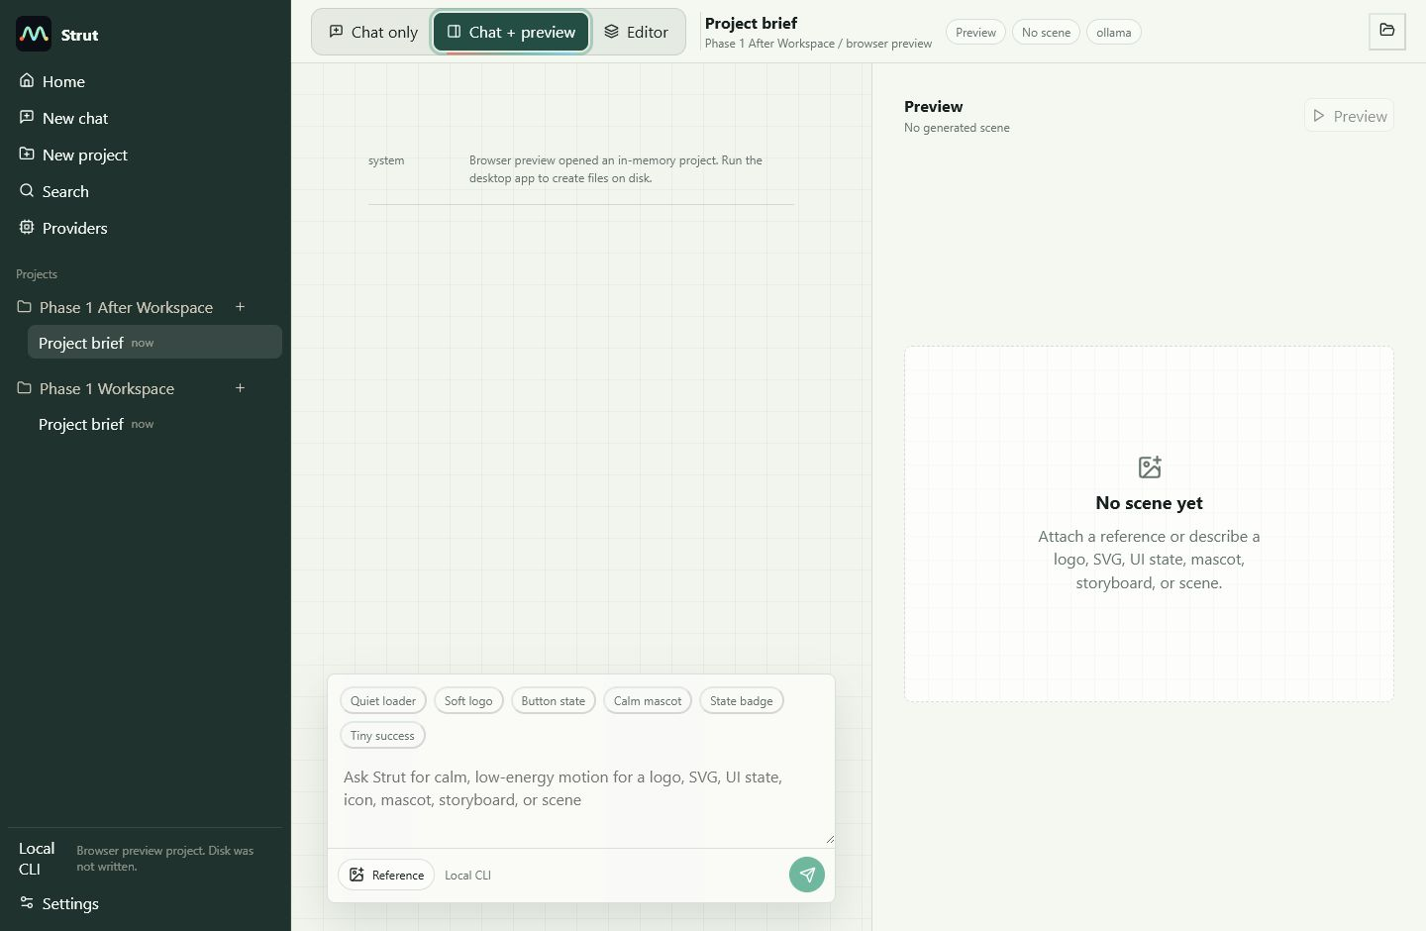

Editor shell light
Before
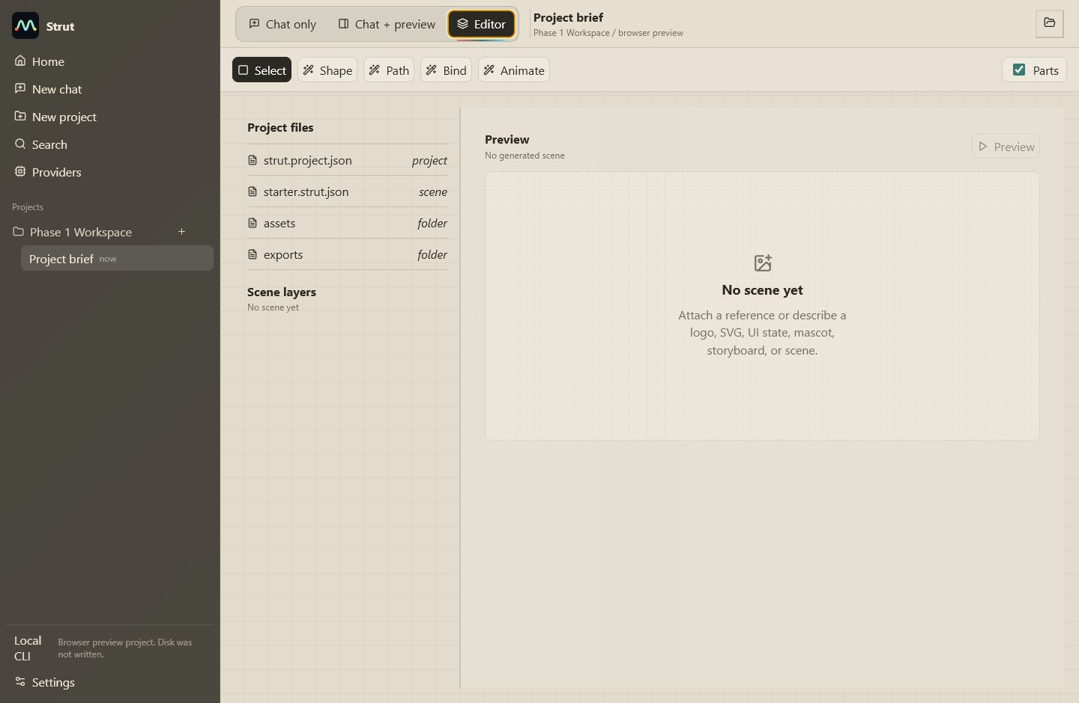
After
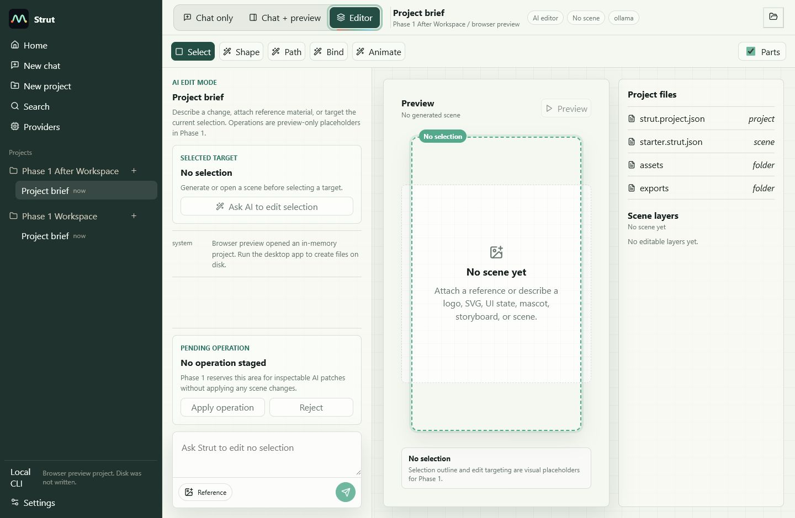

Settings light
Before
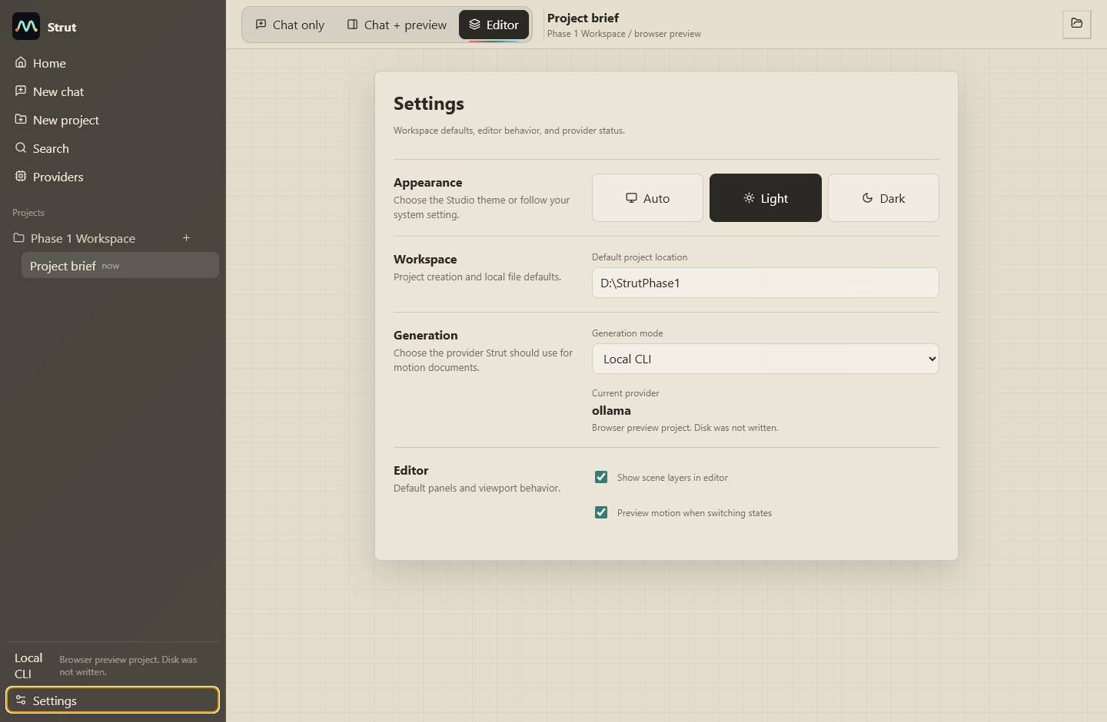
After
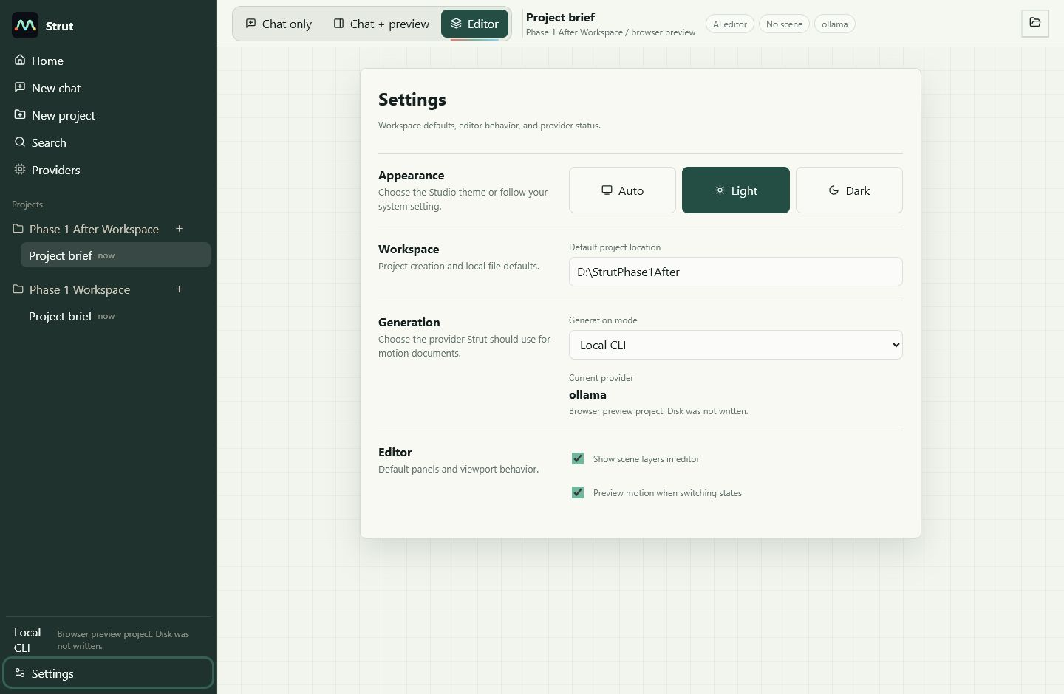

Settings dark
Before
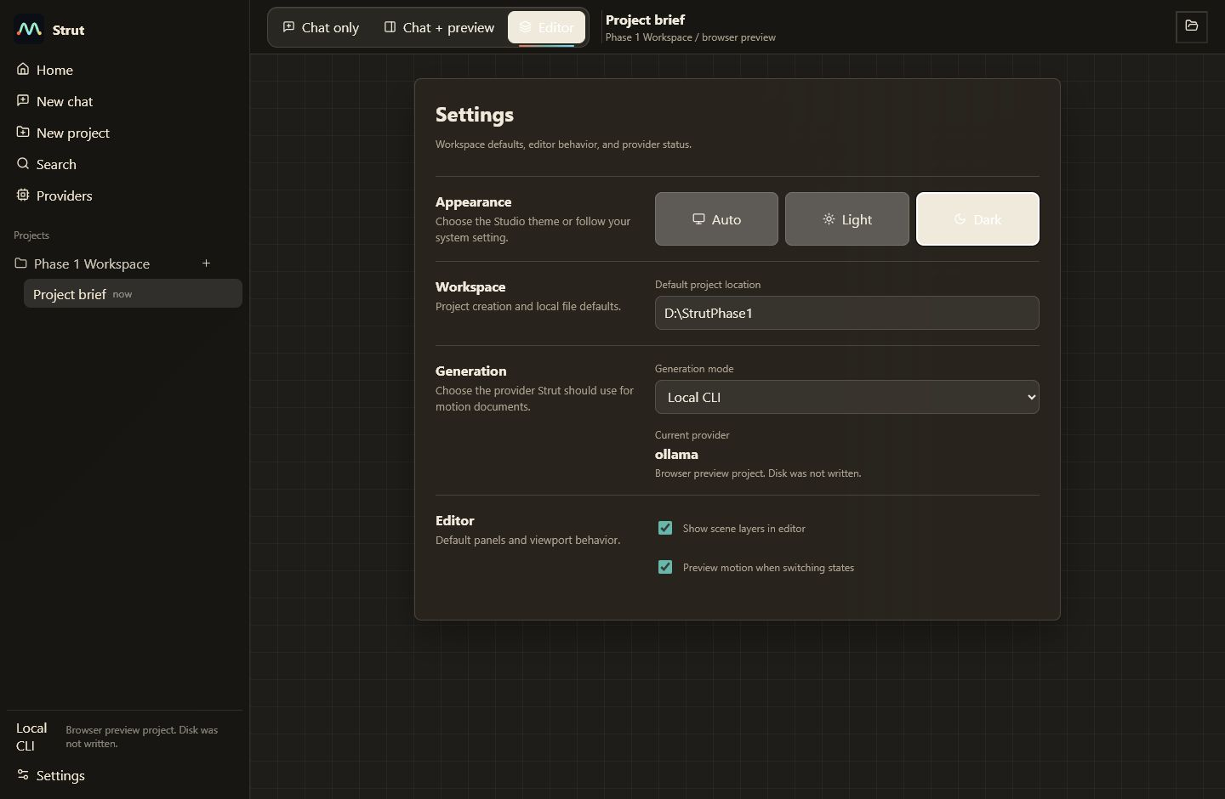
After
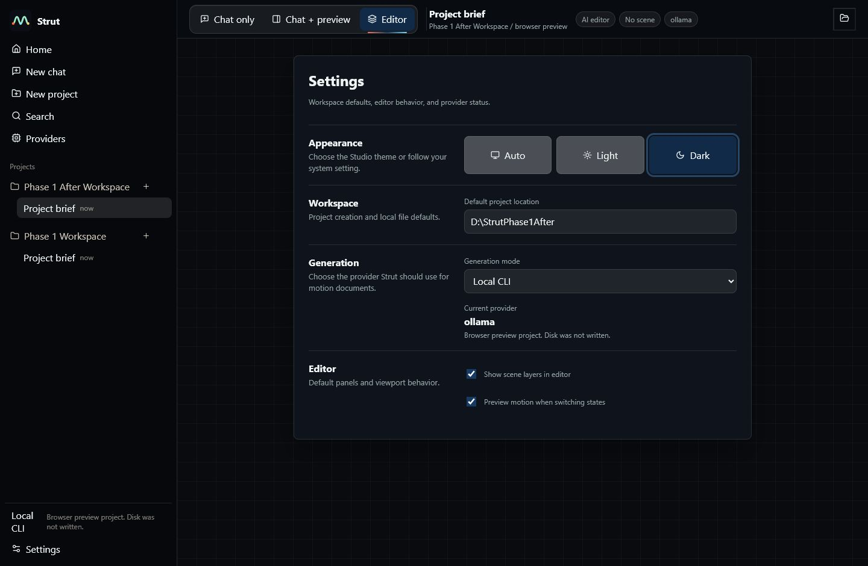

Narrow editor dark
Before
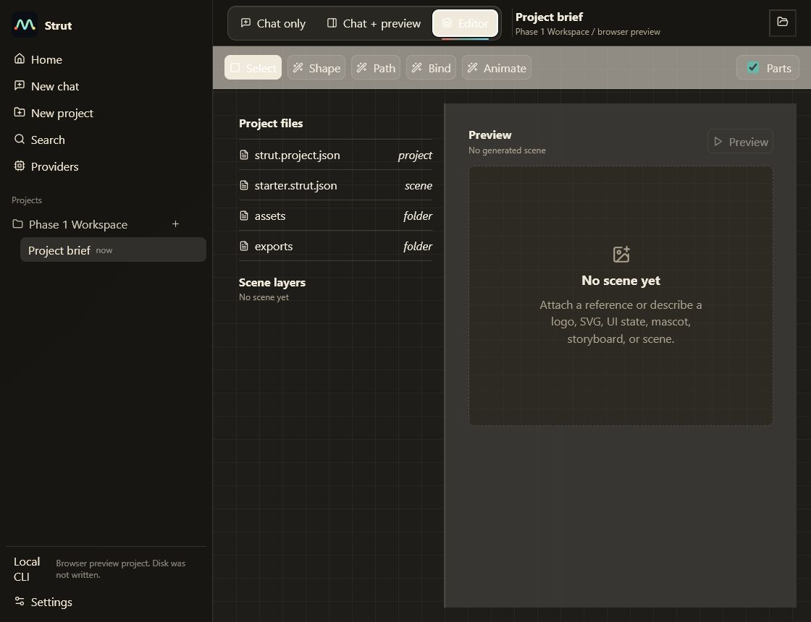
After
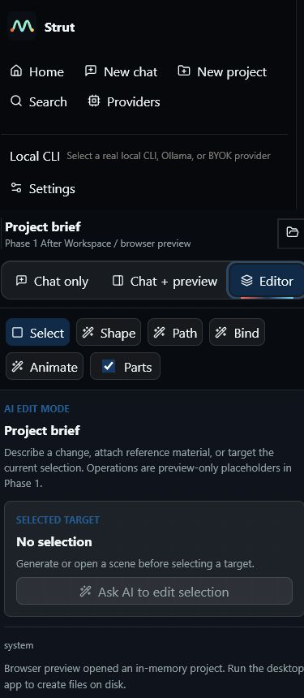

Generated preview proof
After
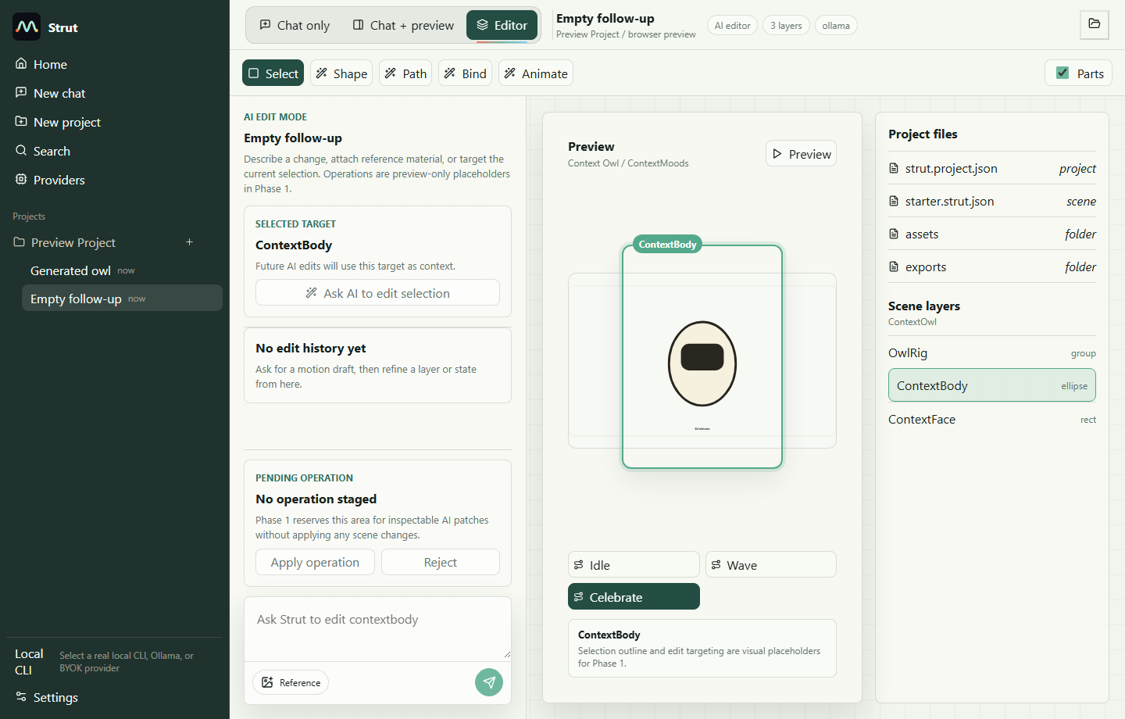

Changed Files
Purpose | Files
Studio shell and theme | apps/studio/src/App.tsx  apps/studio/src/App.css
Focused smoke coverage | tests/ui/studio_bot_smoke.py
Phase report evidence | docs/reports/phase-1-ai-editor-shell/baseline.md  docs/reports/phase-1-ai-editor-shell/screenshots/before/*  docs/reports/phase-1-ai-editor-shell/screenshots/after/*  docs/reports/phase-1-ai-editor-shell/phase-1-ai-editor-shell-report.docx

Commit Log
Commit | Subject | Explanation
a0ae012 | docs(report): capture phase 1 before screenshots | Recorded the initial dirty tree and Browser baseline screenshots.
6f909ec | style(studio): add strut theme tokens | Introduced the off-white/mint light theme, blackish/navy dark theme, focus states, and shell tokens.
96f45e0 | feat(studio): introduce ai editor shell | Added the AI edit rail, preview workspace, status chips, inspector, and local selection placeholder state.
4ac2b31 | test(studio): cover ai editor shell smoke | Expanded the studio smoke around the AI shell, selected target, operation placeholder, and generated preview selection.
bb024cd | feat(studio): add selection-aware edit placeholders | Tightened responsive shell behavior, selection outline styling, and themed scroll/root chrome.

Verification Commands
Command | Result | Notes
npm run check | PASS | TypeScript checks for studio/runtime packages and cargo check completed.
cargo test --workspace | PASS | All Rust workspace tests passed: 1 + 4 + 5 + 1 + 14 passed; one authenticated Gemini CLI test remained intentionally ignored.
python tests/ui/studio_bot_smoke.py | PASS | Studio browser smoke passed, including Phase 1 shell assertions and seeded generated preview selection.
Browser visual QA | PASS | Captured desktop light/dark, narrow light/dark, empty preview, providers/settings, and editor shell screenshots. Generated preview proof used the seeded smoke because browser-only generation stops at the expected desktop-runtime fallback.

Visual QA Findings
- Desktop light/dark editor shell presents the AI rail, preview, and inspector without generated colors affecting app chrome.
- Empty preview state remains useful and does not look like a broken blank panel.
- Generated preview proof shows selected ContextBody, visible selection outline, active layer state, and disabled operation controls.
- Narrow layout stacks the shell and wraps toolbar controls without overlapping primary content in viewport capture.

Remaining Risks
- Selection is visual/contextual only. It does not yet produce validated document operations or operation history; that belongs in Phase 2.
- Browser-only generation still cannot create a generated document because real generation requires the Tauri desktop runtime/provider path.
- Some unrelated dirty docs/backend files from the initial worktree remain intentionally preserved and uncommitted.
- The existing App.tsx remains large; deeper Phase 2 work should consider extracting shell, rail, preview, and inspector components before adding real operation state.

Next Phase Recommendation
- Phase 2 should add a real scene selection model shared by preview, layers, inspector, and AI context.
- Add inspectable operation preview data before enabling Apply/Reject.
- Keep dynamic generation planning and CLI work out of Phase 2 unless the phase boundary is explicitly reopened.

Render Export Note
DOCX render export was blocked locally: LibreOffice/soffice was unavailable, and Microsoft Word COM PDF export hung twice before producing a PDF. The DOCX package passed structural inspection and embeds the screenshot evidence; the Browser screenshot gallery under screenshots/ is the visual proof artifact for Phase 1.

