Phase 4 Persistence And Undo Report
Strut Studio - Document-First Persistence Around Validated Operations
Date: 2026-06-08 | Branch: codex/phase-1-ai-editor-shell

Summary
- Phase 4 is implemented and verified. Strut Studio now treats validated scene/project documents and operation batches as the durable source of truth for the editor workflow.
- Canonical native files: strut.project.json, scenes/main.strut, operations/operation-batches.json, and ui/studio-state.json.
- Phase 5 agentic CLI mode was not started.

Scope Completed
- Operation batch persistence records with stable ids, source type, validation result, revision id, metadata, operations, and timestamps.
- Native save/load around validated .strut packages and operation batch logs.
- Compatibility loading for legacy scenes/starter.strut.json payloads.
- Real Apply/Reject, undo/redo around validated operation batches, and chat messages linked to batch ids.
- Rust validation path for sprite-python generation-plan operation batches before persistence.

Canonical Persistence Model
File | Purpose
strut.project.json | Project manifest with paths for scene, operation log, and UI state.
scenes/main.strut | Validated Strut package written through Rust format validation.
operations/operation-batches.json | Durable operation batch log with source, validation, revision, metadata, operations, and timestamps.
ui/studio-state.json | Active state, selected node id, and layer UI persistence.

Changed Files
Schema and native persistence: apps/studio/src-tauri/src/lib.rs
Studio UI: apps/studio/src/App.tsx, apps/studio/src/App.css
Focused verification: tests/ui/studio_bot_smoke.py, tests/ui/studio_persistence_smoke.py, tests/ui/studio_tauri_persistence_smoke.py
Report artifacts: docs/reports/phase-4-persistence-undo/phase-4-persistence-undo-report.md, docs/reports/phase-4-persistence-undo/phase-4-persistence-undo-report.docx, docs/reports/phase-4-persistence-undo/screenshots/

Commits
- deb98c9 feat(schema): define operation batch persistence
- 0f743f1 feat(studio): add validated persistence and operation history
- 5fe55b3 test(studio): cover persistence undo and invalid documents
- 6b09521 test(studio): cover native persistence restart smoke
- 4a62db1 test(studio): refresh operation history smoke label
- chore(report): add phase 4 persistence evidence

Verification Commands
Command | Result
python -m pytest packages/strut-python/tests | PASS, 18 tests
$env:PYTHONPATH='src'; python -m strut_python.cli loader --json --out $env:TEMP\strut-loader-plan.json | PASS
cargo fmt --all --check | PASS
cargo test -p strut-studio | PASS, 25 passed, 1 ignored authenticated Gemini CLI test
cargo test --workspace | PASS
npm --workspace @strut/studio run check | PASS
npm run check | PASS
python tests/ui/studio_bot_smoke.py | PASS
python tests/ui/studio_persistence_smoke.py | PASS
python tests/ui/studio_tauri_persistence_smoke.py | PASS
git diff --check | PASS

Browser QA Result
- PASS using Playwright/Chromium because in-app Browser controls were not exposed by tool discovery.
- Covered dice save/reopen, Apply/Reject, undo/redo, invalid operation rejection, and selection/layers/inspector after reload.

Computer And Tauri QA Result
- PASS using Tauri launch plus WebView2 CDP fallback because Computer Use controls were not exposed by tool discovery.
- Native app launched, saved scenes/main.strut and operation-batches.json, restarted, reloaded from disk, preserved operation history, and passed undo/redo.

Remaining Risks
- Manual UI batch execution is intentionally narrow in Phase 4 and currently applies validated set_property operations.
- Browser mode uses local validation and browser snapshots because it cannot call native filesystem commands.
- Native save/load requires an active project path; richer file picker/open-project UI remains future work.
- Existing Rust dead-code warnings remain from earlier fallback/provider code.

Phase 5 Recommendation
- Proceed to agentic CLI mode only after review, using the same Rust validation and .strut persistence boundary.
- The CLI should inspect, validate, patch, render, and export without mutating files unless validation accepts the operation batch.
- Phase 5 CLI mode was not started in Phase 4.

Screenshot Evidence

before-phase-3b
- docs/reports/phase-4-persistence-undo/screenshots/before-phase-3b/browser-phase-3b-sprite-python-smoke.png
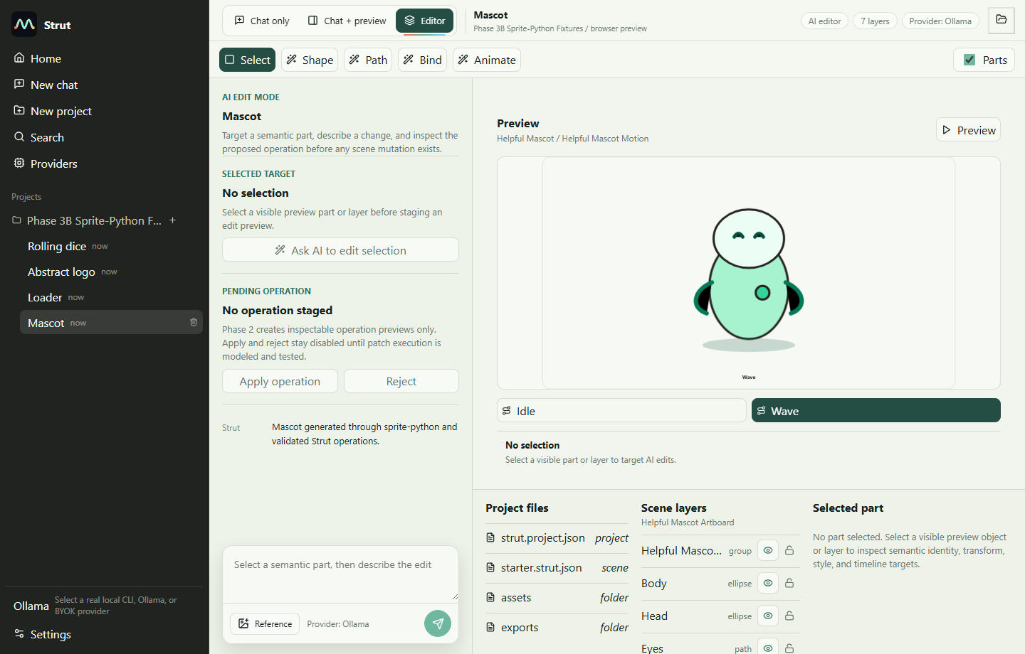
- docs/reports/phase-4-persistence-undo/screenshots/before-phase-3b/tauri-01-dice-selection.png
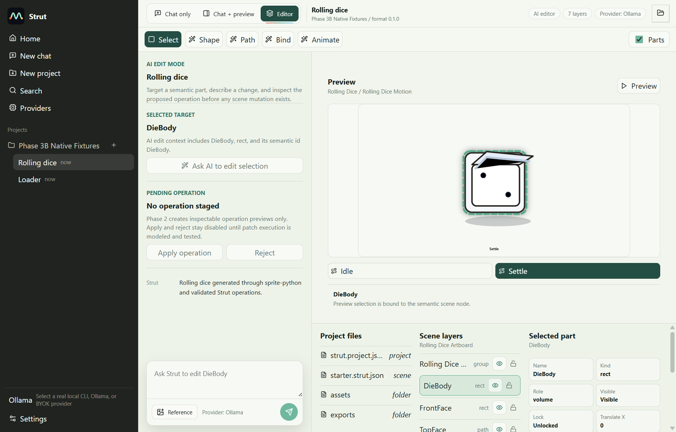
- docs/reports/phase-4-persistence-undo/screenshots/before-phase-3b/tauri-02-loader-selection.png
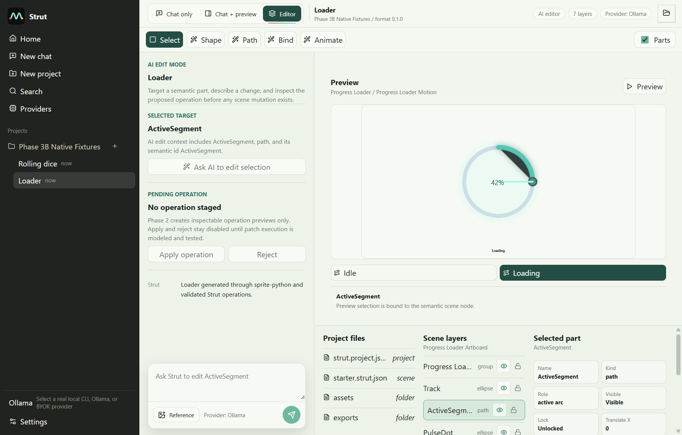

browser
- docs/reports/phase-4-persistence-undo/screenshots/browser/browser-01-dice-reopened.png
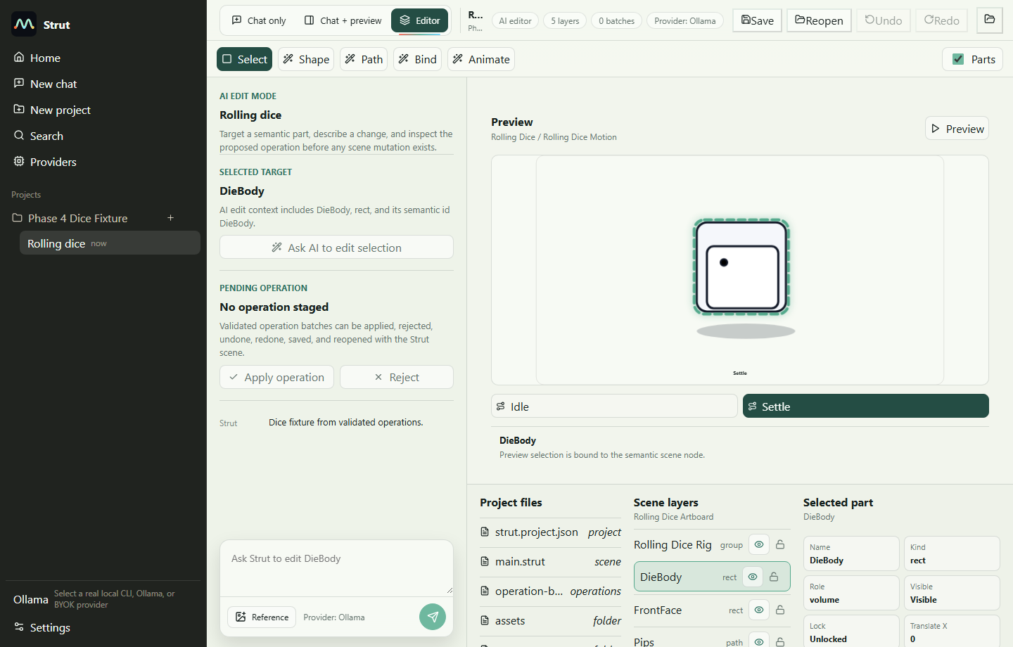
- docs/reports/phase-4-persistence-undo/screenshots/browser/browser-02-apply-ready.png
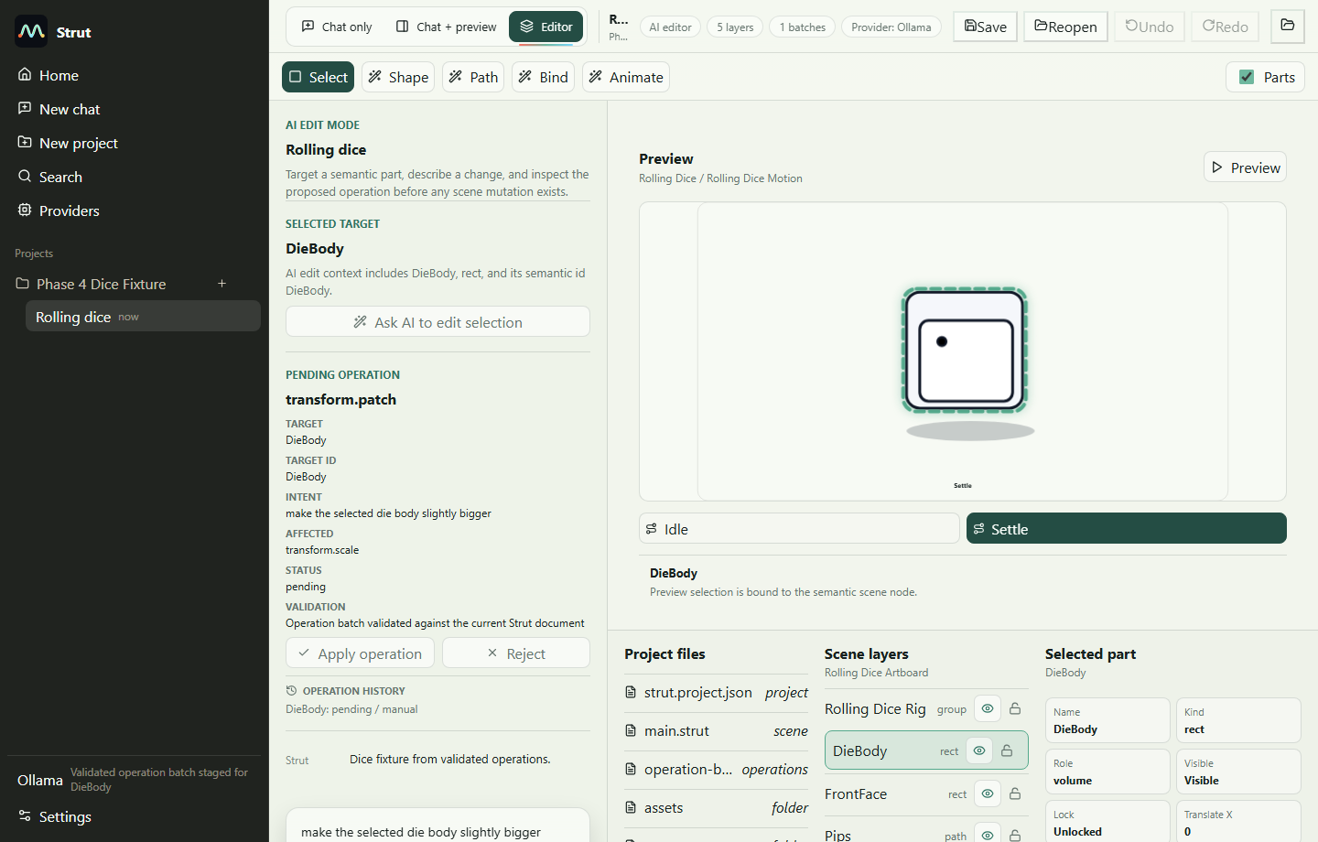
- docs/reports/phase-4-persistence-undo/screenshots/browser/browser-03-applied-history.png
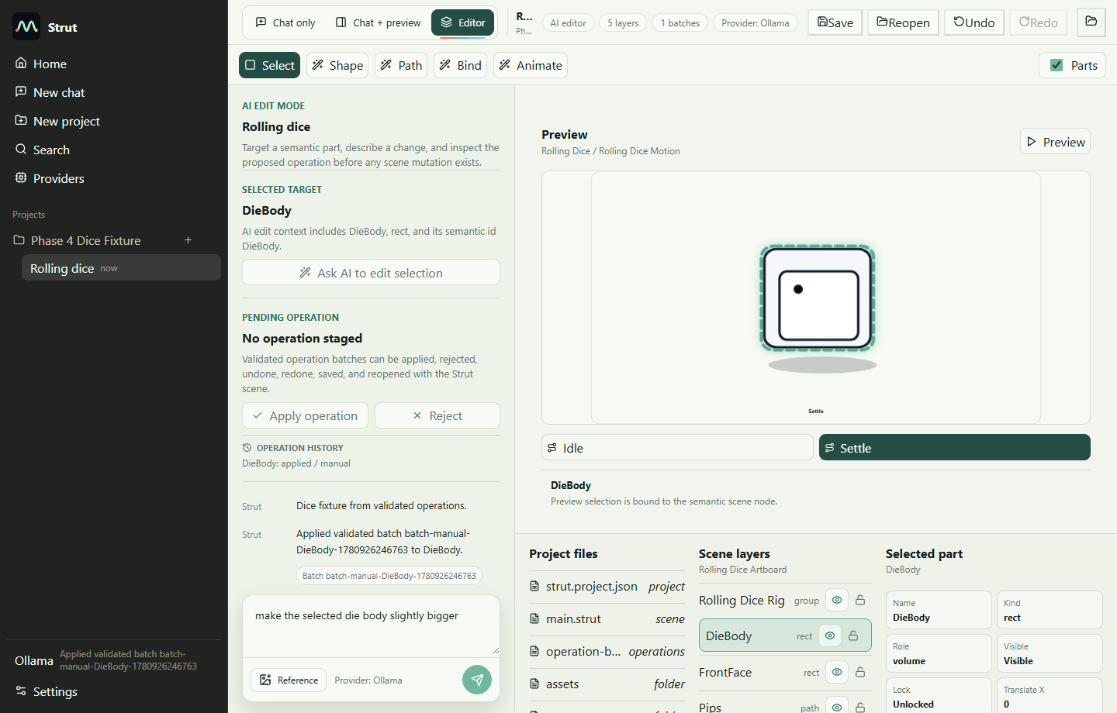
- docs/reports/phase-4-persistence-undo/screenshots/browser/browser-04-undo-redo.png
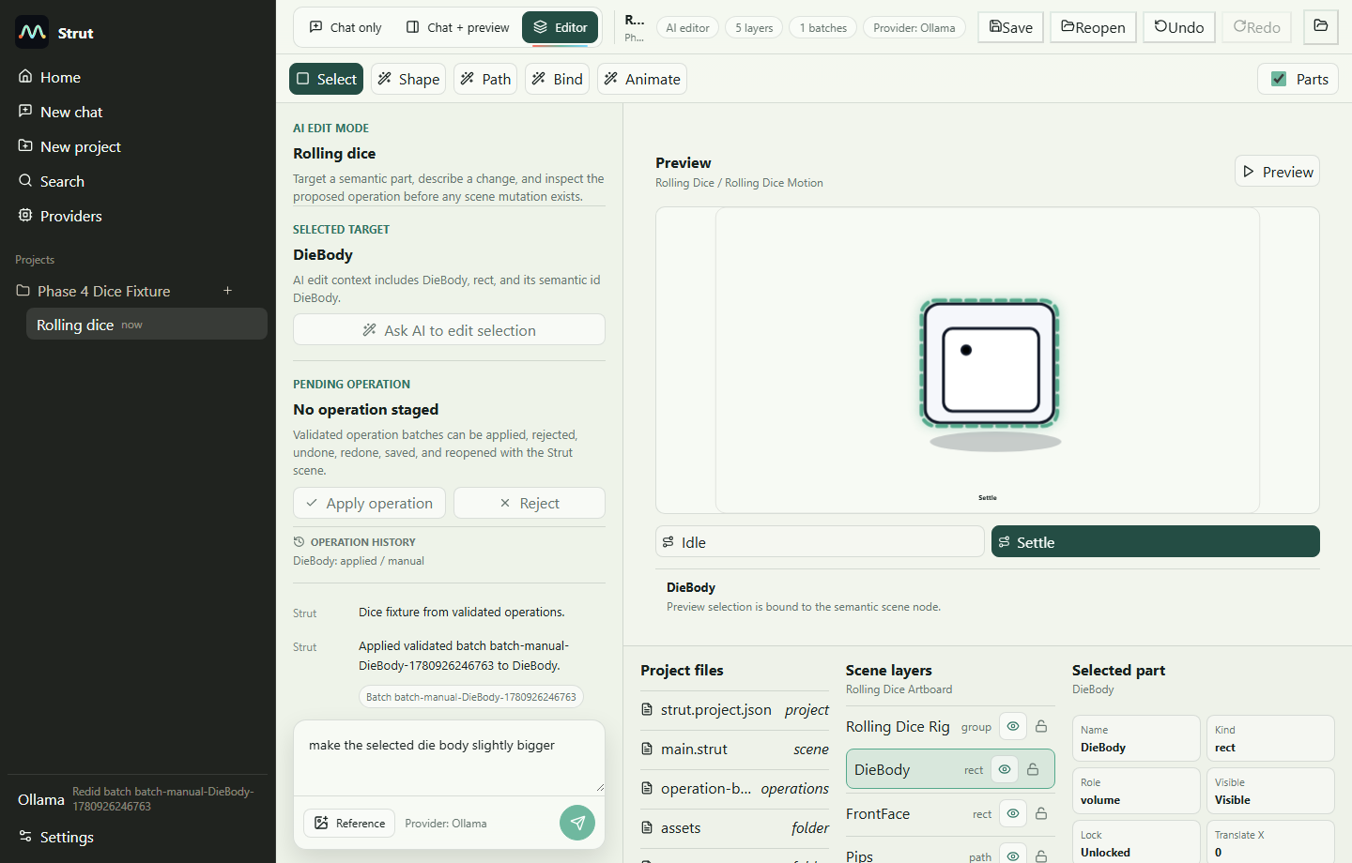
- docs/reports/phase-4-persistence-undo/screenshots/browser/browser-05-save-reopen.png
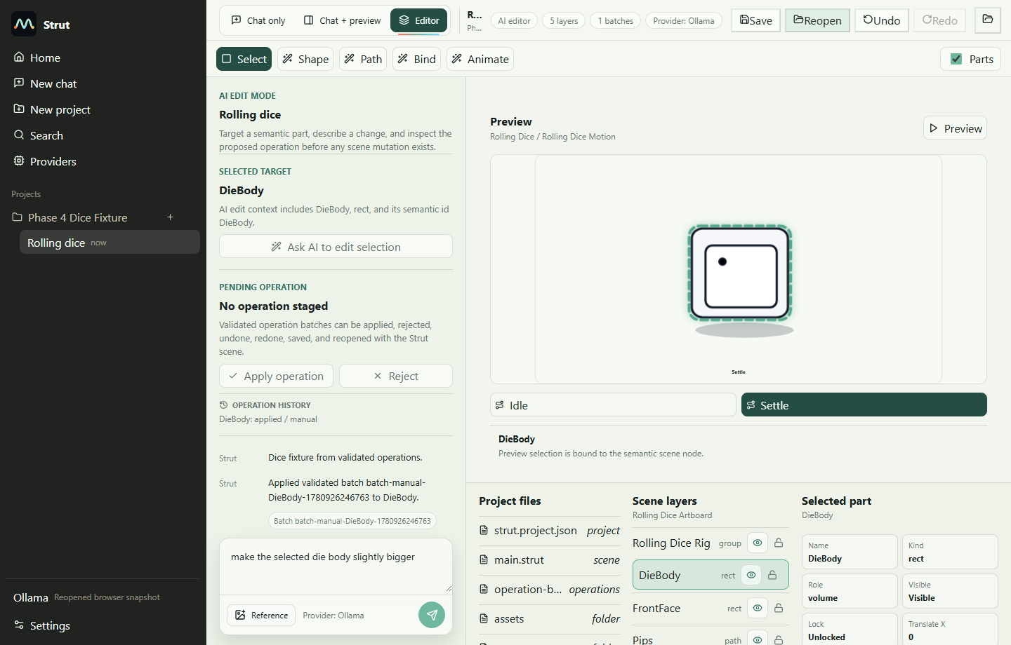
- docs/reports/phase-4-persistence-undo/screenshots/browser/browser-06-rejected-history.png
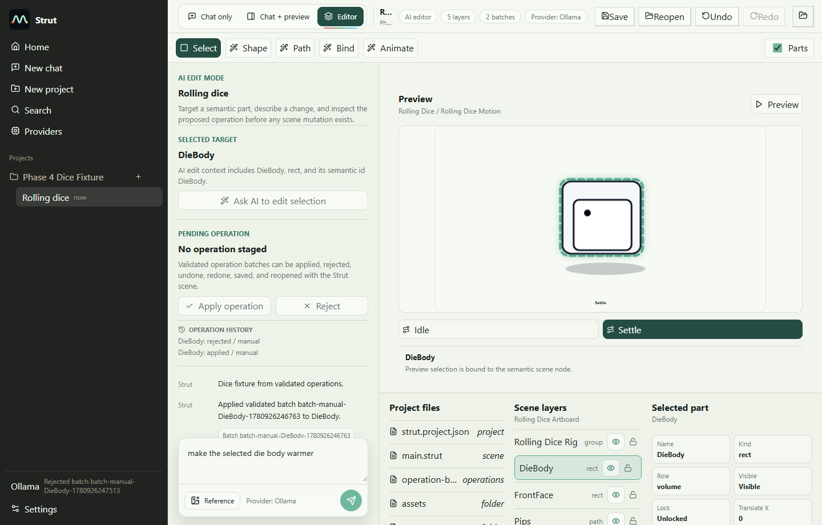
- docs/reports/phase-4-persistence-undo/screenshots/browser/browser-07-invalid-rejected.png
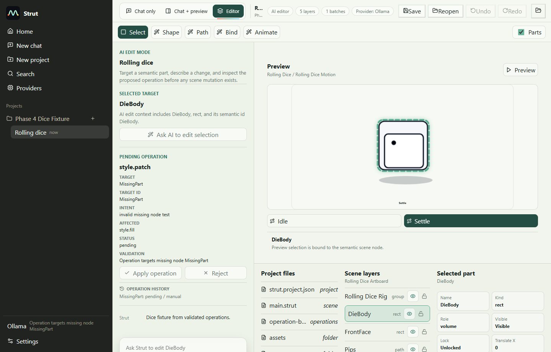

tauri
- docs/reports/phase-4-persistence-undo/screenshots/tauri/tauri-01-save-applied.png
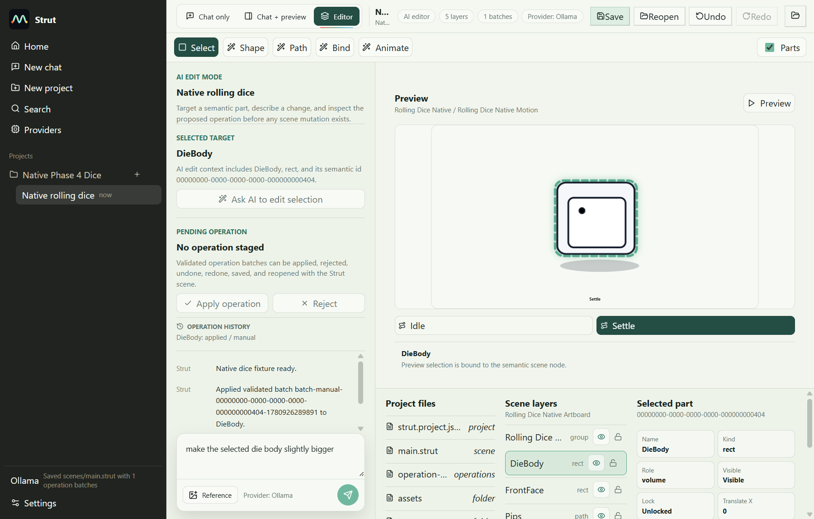
- docs/reports/phase-4-persistence-undo/screenshots/tauri/tauri-02-reopened-history.png
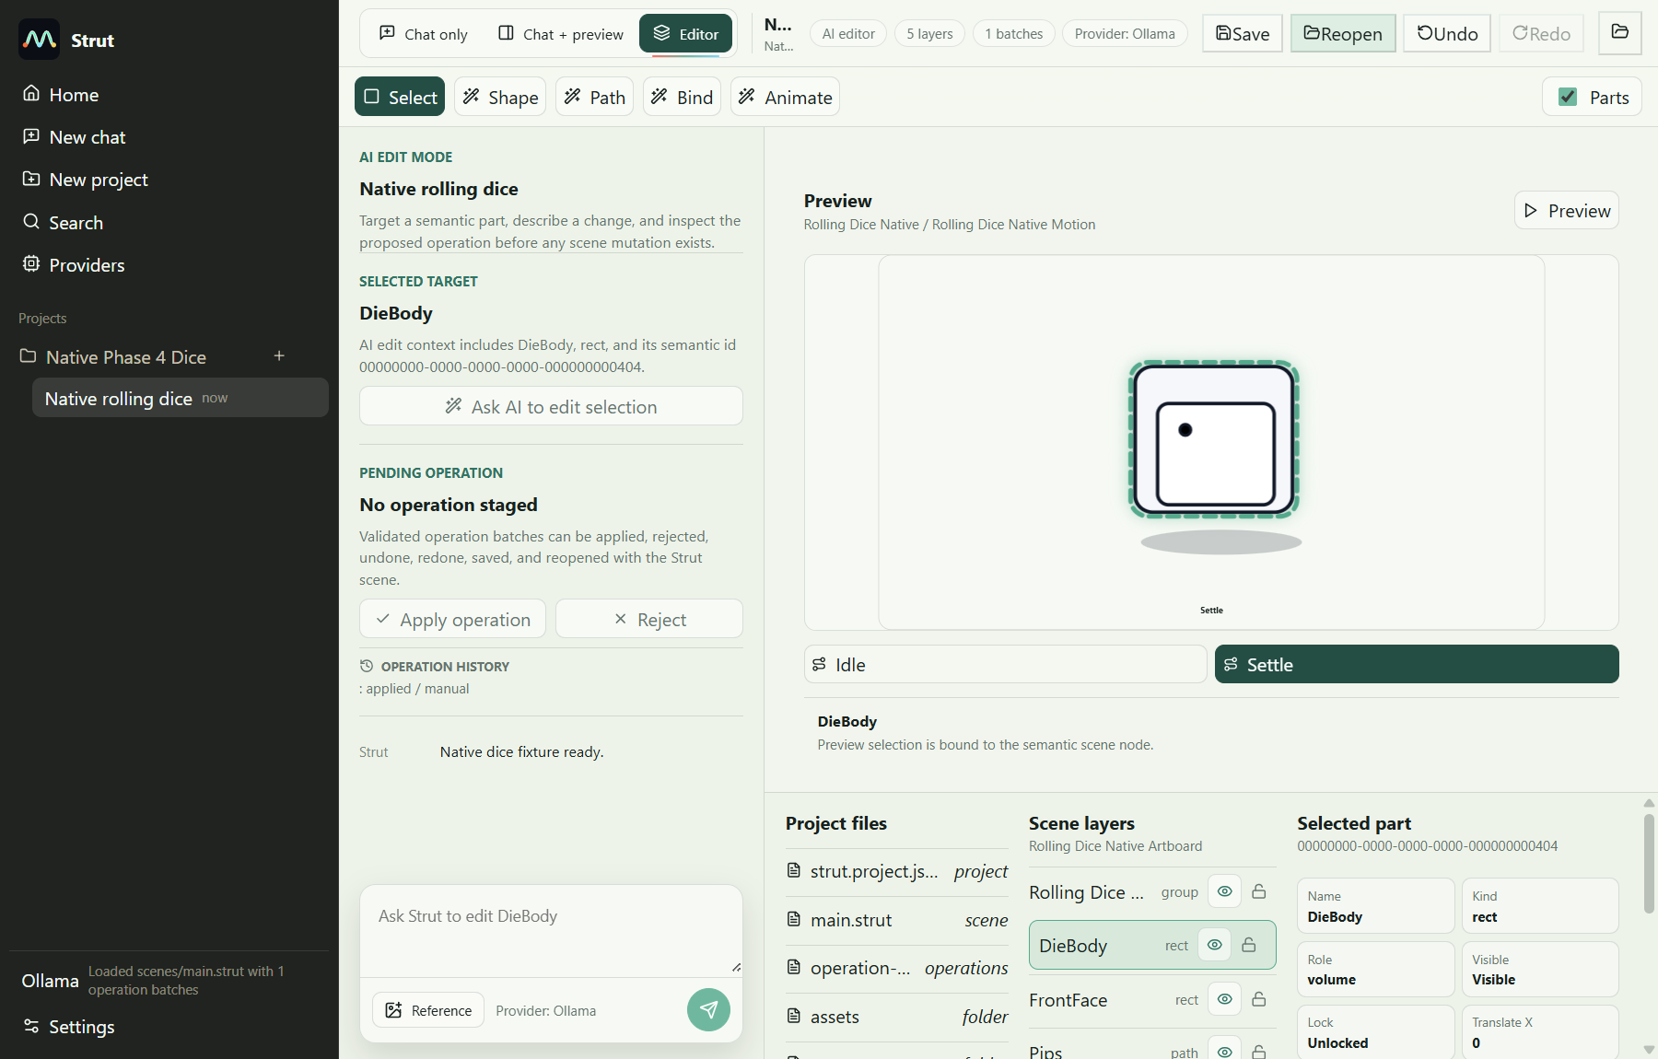
- docs/reports/phase-4-persistence-undo/screenshots/tauri/tauri-03-undo-redo.png
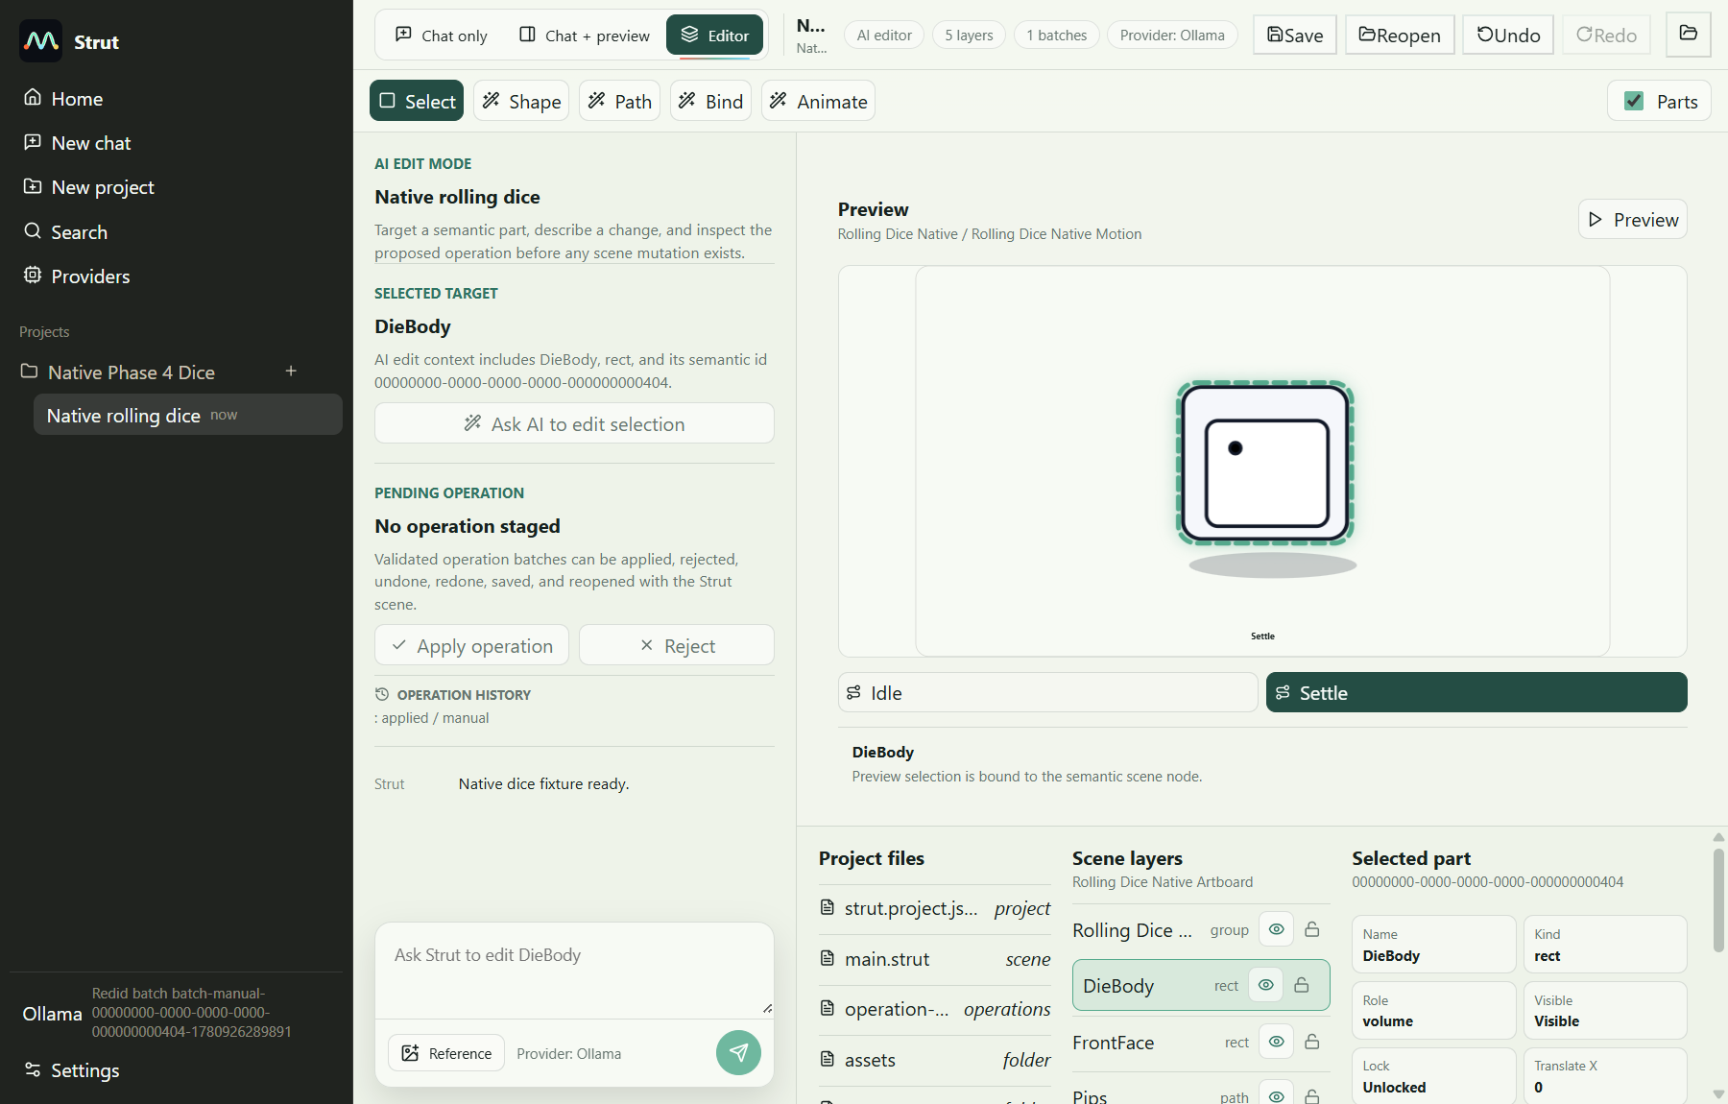

DOCX QA Note
DOCX render QA could not be completed because soffice/LibreOffice was not available on PATH. The document was generated structurally with python-docx using the compact_reference_guide preset.

