Phase 3B Sprite-Python Architecture Lock And Engine Spike Report
Date: 2026-06-08
Branch: codex/phase-1-ai-editor-shell

Summary
Phase 3B is complete. Strut now has a documented Rust/Tauri plus sprite-python split, a minimal deterministic Python sprite/vector authoring package, generated { plan, operations } fixtures for dice/logo/loader/mascot, and Rust tests proving those Python envelopes validate through the existing Phase 3A generation-plan and operation conversion path.
Python is an authoring/compiler layer only. It does not emit unchecked final .strut documents and does not bypass Rust validation.
Phase 4 persistence/undo and agentic CLI mode were not started.

Initial Dirty Files
Captured with git status --short --branch before edits:
## codex/phase-1-ai-editor-shell
M README.md
M docs/README.md
M docs/guides/generate-a-character.md
M docs/learn/first-animation.md
M docs/learn/quick-start.md
M docs/learn/what-is-strut.md
?? docs/learn/motion-language.md
?? docs/superpowers/
These pre-existing dirty files were preserved and not reverted.

Scope Completed
- Added `docs/internal/sprite-python-architecture.md` to lock the architecture boundary.
- Added `packages/strut-python/` with sprite/vector primitives:
- Scene, Sprite, Group, Rect, Ellipse, Path, Text
- Binding, State, Timeline, Keyframe
- Added motion primitives:
- idle_breathe, soft_bob, tiny_tilt, settle, reveal, pulse, progress_sweep, attention_nudge
- Added subject builders:
- rolling dice
- abstract logo reveal
- loader/progress animation
- mascot idle animation
- UI microinteraction prototype
- Added deterministic examples and committed generated plan fixtures for dice, logo, loader, and mascot.
- Added Python tests for determinism, JSON examples, subject classification, mascot anatomy rules, and the no-final-document invariant.
- Added Rust-side validation tests that read Python-generated fixtures and convert them through `document_from_generation_plan_text`.
- Updated the existing UI smoke fixture labels for Phase 3B sprite-python coverage without redesigning the UI.

Architecture Boundary
Locked flow:
prompt -> sprite-python authoring model -> Strut generation plan + operations -> Rust validation -> Strut document -> Studio preview/export
Rust/Tauri remains:
- desktop shell
- native filesystem and provider bridge
- validation and security boundary
- conversion from validated operations into Strut documents
- project workflow host
Sprite-python is:
- an agent-friendly authoring SDK
- a deterministic sprite/vector planning layer
- an emitter of inspectable generation plans and operations
Sprite-python is not:
- a persistence layer
- a CLI mode
- a final document writer
- a replacement for Rust validation
- a Codex pet or fixed mascot atlas importer

Changed Files
Architecture docs:
- `docs/internal/sprite-python-architecture.md`
Python package:
- `.gitignore`
- `packages/strut-python/pyproject.toml`
- `packages/strut-python/src/strut_python/__init__.py`
- `packages/strut-python/src/strut_python/model.py`
- `packages/strut-python/src/strut_python/motion.py`
- `packages/strut-python/src/strut_python/builders.py`
- `packages/strut-python/src/strut_python/cli.py`
- `packages/strut-python/examples/dice.py`
- `packages/strut-python/examples/logo.py`
- `packages/strut-python/examples/loader.py`
- `packages/strut-python/examples/mascot.py`
- `packages/strut-python/fixtures/dice.plan.json`
- `packages/strut-python/fixtures/logo.plan.json`
- `packages/strut-python/fixtures/loader.plan.json`
- `packages/strut-python/fixtures/mascot.plan.json`
Validation and smoke tests:
- `apps/studio/src-tauri/src/lib.rs`
- `packages/strut-python/tests/test_examples.py`
- `tests/ui/studio_bot_smoke.py`
Report artifacts:
- `docs/reports/phase-3b-sprite-python-engine/phase-3b-sprite-python-engine-report.md`
- `docs/reports/phase-3b-sprite-python-engine/phase-3b-sprite-python-engine-report.docx`
- `docs/reports/phase-3b-sprite-python-engine/screenshots/`
- `docs/reports/phase-3b-sprite-python-engine/rendered/README.md`

Commits
- `f00297f docs(arch): define sprite python engine boundary`
- `475899a feat(sprite-python): add authoring model prototype`
- `acc2967 test(sprite-python): validate generated subject fixtures`
- `c3926af test(studio): cover sprite python fixture smoke`
- report commit: `chore(report): add phase 3b sprite python evidence`

Verification Commands
- `python -m pytest packages/strut-python/tests` - passed, 18 tests.
- `python packages/strut-python/examples/dice.py --json` - produced deterministic JSON; piping to `Select-Object` ended with a non-semantic broken-pipe exit, so direct fixture generation was also verified through `python -m strut_python.cli dice --json --out ...`.
- `cargo test -p strut-studio` - passed, 21 passed, 1 ignored authenticated Gemini CLI test.
- `cargo test --workspace` - passed, workspace tests green, same 1 ignored authenticated Gemini CLI test.
- `npm --workspace @strut/studio run check` - passed.
- `npm run check` - passed.
- `python tests/ui/studio_bot_smoke.py` - passed.
- `git diff --check` - passed.
Rust warning note: strut-studio still emits existing unused-code warnings around legacy fallback helpers/fields, including CHARACTER_DOCUMENT_SYSTEM_PROMPT, EditabilityPlan.notes, SceneOperation.parent, and document_repair_prompt. These warnings predate Phase 3B behavior and do not fail verification.

Browser QA
The Codex in-app Browser control tools were not exposed by tool discovery in this thread, so browser visual QA used Playwright/Chromium through python tests/ui/studio_bot_smoke.py, followed by direct visual inspection of the resulting screenshot.
Evidence:
- `screenshots/browser/browser-phase-3b-sprite-python-smoke.png`
Result:
- Passed.
- Phase 3B sprite-python fixture project rendered in the Studio browser surface.
- Mascot preview was nonblank.
- Layers, state buttons, left AI rail, and inspector area were visible with no observed overlap.
- The fixture message states it was generated through sprite-python and validated Strut operations.

Computer And Tauri QA
Computer Use desktop controls were not exposed by tool discovery in this thread. Native QA was completed by launching Tauri with WebView2 remote debugging, seeding deterministic sprite-python fixture documents into the native WebView, and capturing screenshots from the running Tauri app.
Evidence:
- `screenshots/tauri/tauri-01-dice-selection.png`
- `screenshots/tauri/tauri-02-loader-selection.png`
Result:
- Passed.
- Native Tauri app launched.
- Dice fixture rendered, `DieBody` could be selected, and the inspector showed `volume`.
- Loader fixture rendered, `ActiveSegment` could be selected, and the inspector showed `active arc`.
- Layers and selection stayed synchronized in the native app.

Screenshot Gallery
Before evidence copied forward from Phase 3A:
- `screenshots/before-phase-3a/browser-01-dice-selection.png`
- `screenshots/before-phase-3a/browser-03-loader-selection.png`
- `screenshots/before-phase-3a/tauri-01-dice-selection.png`
After evidence from Phase 3B:
- `screenshots/browser/browser-phase-3b-sprite-python-smoke.png`
- `screenshots/tauri/tauri-01-dice-selection.png`
- `screenshots/tauri/tauri-02-loader-selection.png`

Remaining Risks
- The Python engine is a minimal spike, not a full production sprite compiler.
- UI microinteraction builder exists in the package but was not part of the four required deterministic fixture assertions.
- Rust validation functions are still private to `strut-studio`; Phase 4 or Phase 5 may want a shared validation crate API if CLI work starts.
- Browser and Computer Use plugin controls were unavailable in this thread, so Browser/Computer QA used Playwright and Tauri WebView2 CDP fallbacks.
- Existing Rust warnings remain around legacy fallback helpers and unused fields.

Phase 4 Recommendation
Start Phase 4 only after this report is reviewed. Build persistence around validated operation batches, not raw Python output or unvalidated documents.
Recommended Phase 4 shape:
- persist validated Strut documents created from operation batches
- store operation source metadata such as `sprite-python`, `ai`, or `manual`
- keep validation result and document revision ids with each batch
- implement Apply/Reject and undo/redo only for accepted operation batches
- keep Python output unable to mutate projects unless Rust validation accepts it

Boundary Confirmation
Phase 4 persistence/undo was not started. Agentic CLI mode was not started. The UI was not redesigned. Codex pets, pet atlas imports, and fixed mascot/face models were not introduced.

screenshots/browser/browser-phase-3b-sprite-python-smoke.png
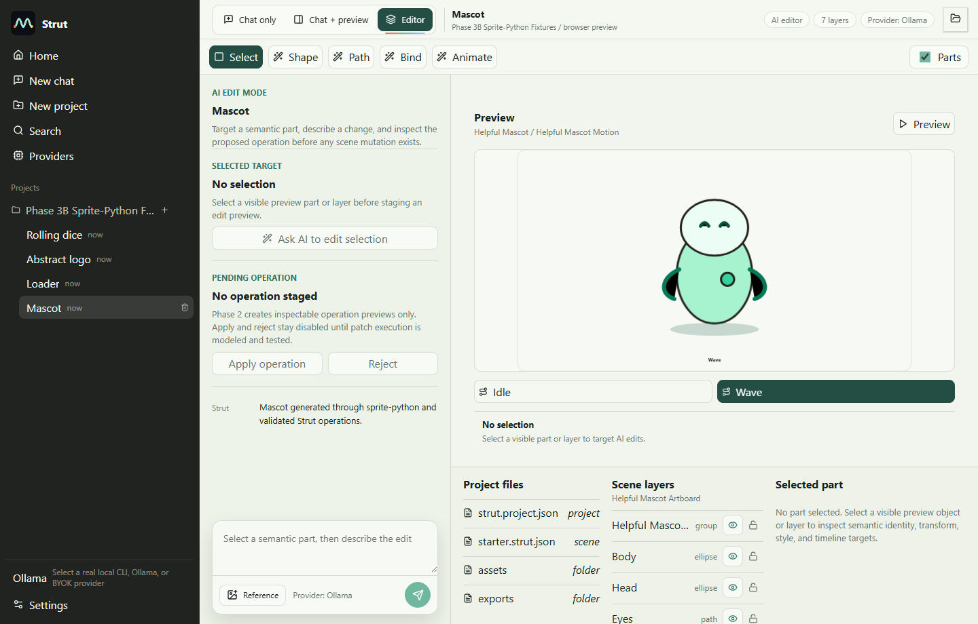

screenshots/tauri/tauri-01-dice-selection.png
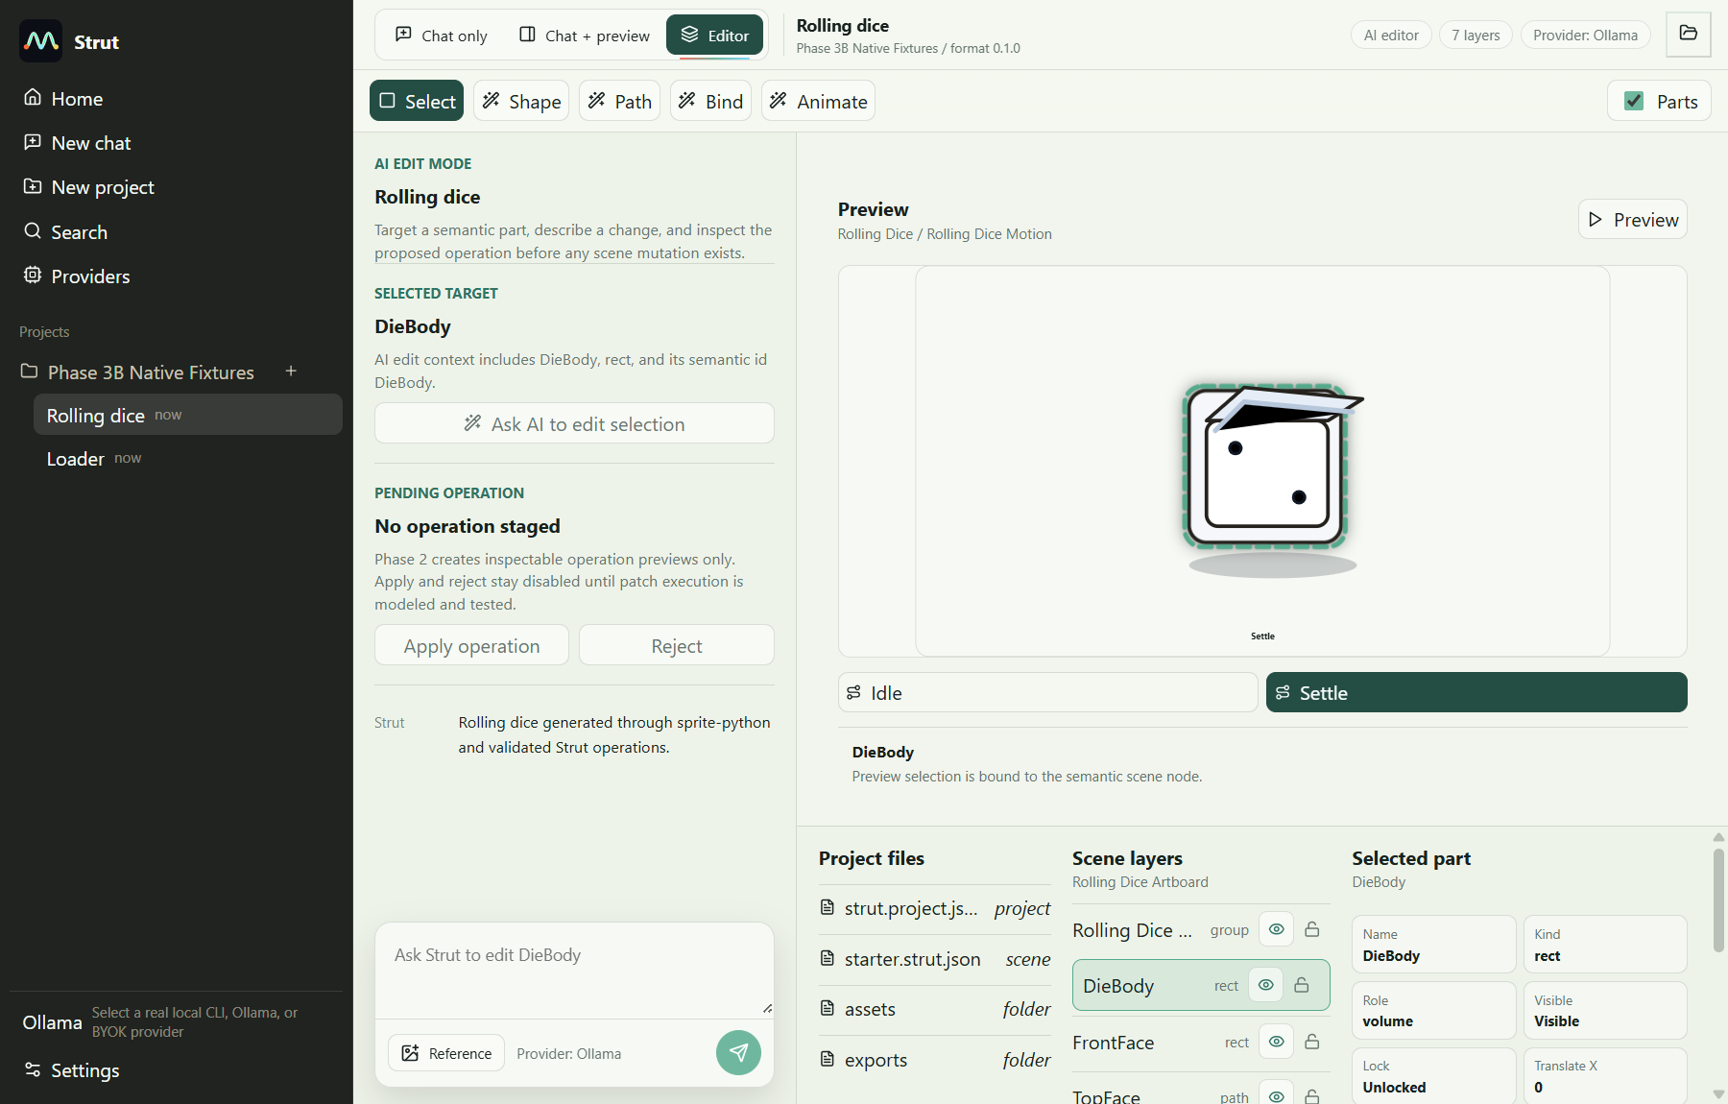

screenshots/tauri/tauri-02-loader-selection.png
