Phase 2 Selection, Layers, And Editable Scene Structure Report
Strut Studio Phase 2 evidence package | June 7, 2026

Summary
- Phase 2 completed semantic node selection, preview hit selection, layer metadata, read-only inspector, AI edit context, and preview-only operation records.
- Phase boundaries held: no Phase 3 dynamic generation planning, no full patch execution, and no agentic CLI mode.
- Apply and Reject remain disabled because no safe tested operation application model exists yet.
- Browser controls were unavailable in this thread, so localhost QA used Playwright fallback; native QA used the actual Tauri WebView2 shell with remote debugging.

Commits
Commit | Purpose
2c47162 | Shared scene selection surfaces and editor component extraction
c8ec236 | Phase 2 smoke coverage for selection, inspector, visibility, lock, operation preview, and reload persistence
e427599 | Layer-row hit-target separation after visual QA

Changed Files
- apps/studio/src/App.tsx
- apps/studio/src/App.css
- tests/ui/studio_bot_smoke.py
- docs/reports/phase-2-selection-layers/**

Implementation Notes
- Selection is persisted per active chat as selectedNodeId and drives preview, layers, inspector, and AI rail context.
- Layer visibility and lock are lightweight UI state; visibility hides nodes and clears selection, while lock prevents preview click targeting but still allows inspection from layers.
- Preview halos are precise for rect, ellipse, text, and group bounds; path halos use the path itself as a truthful approximation.
- The inspector shows id, name, kind, role, transform, style, opacity, visibility, lock, and timeline membership.
- Operation previews persist target id/name, intent, inferred operation type, affected properties, and recent history without mutating documents.

Verification Results
Command | Result
npm --workspace @strut/studio run check | PASS
npm run check | PASS
cargo test --workspace | PASS; authenticated Gemini CLI e2e remains intentionally ignored
python tests/ui/studio_bot_smoke.py | PASS
git diff --check | PASS

Browser QA Result
- Desktop light selection updates preview halo, layer row, inspector, and AI context.
- Desktop light operation preview shows target id/name, intent, operation type, affected properties, and disabled Apply/Reject.
- Desktop dark remains readable and consistent with Phase 1 theme tokens.
- Narrow layout remains readable with no horizontal overflow detected.
- Empty scene, providers, and settings surfaces remain consistent.

Computer / Tauri QA Result
- Native app launched with npm --workspace @strut/studio run tauri dev.
- Actual Tauri WebView2 shell was inspected using remote debugging because Computer Use controls were unavailable in this thread.
- Native preview selection, layer selection, inspector update, and operation preview were verified with seeded document state.
- Native provider generation was not exercised because credentials/auth were unavailable.

Screenshot Evidence
Phase 1 before evidence
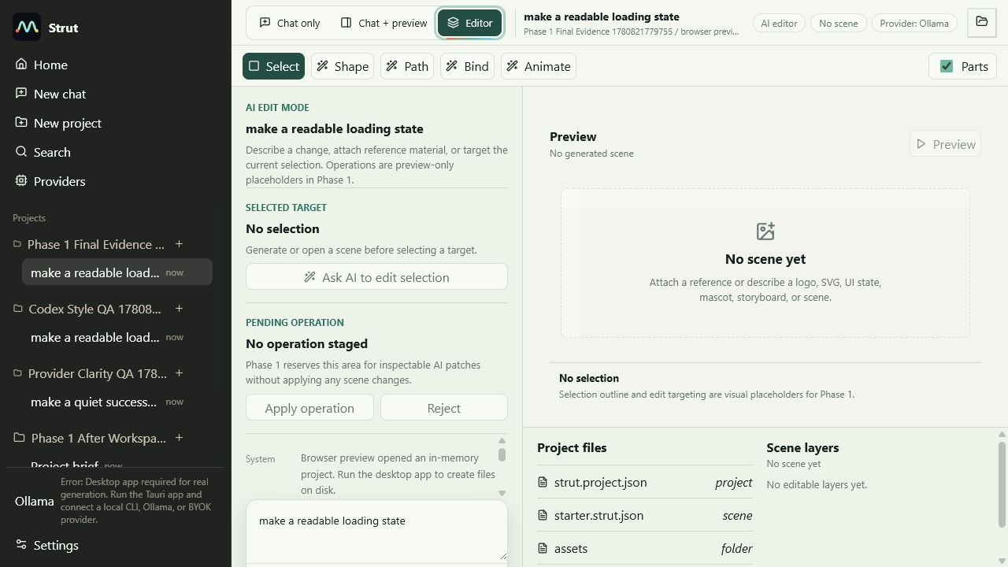
screenshots\before-phase-1\after-04-ai-editor-shell-light.png
Browser desktop light operation preview
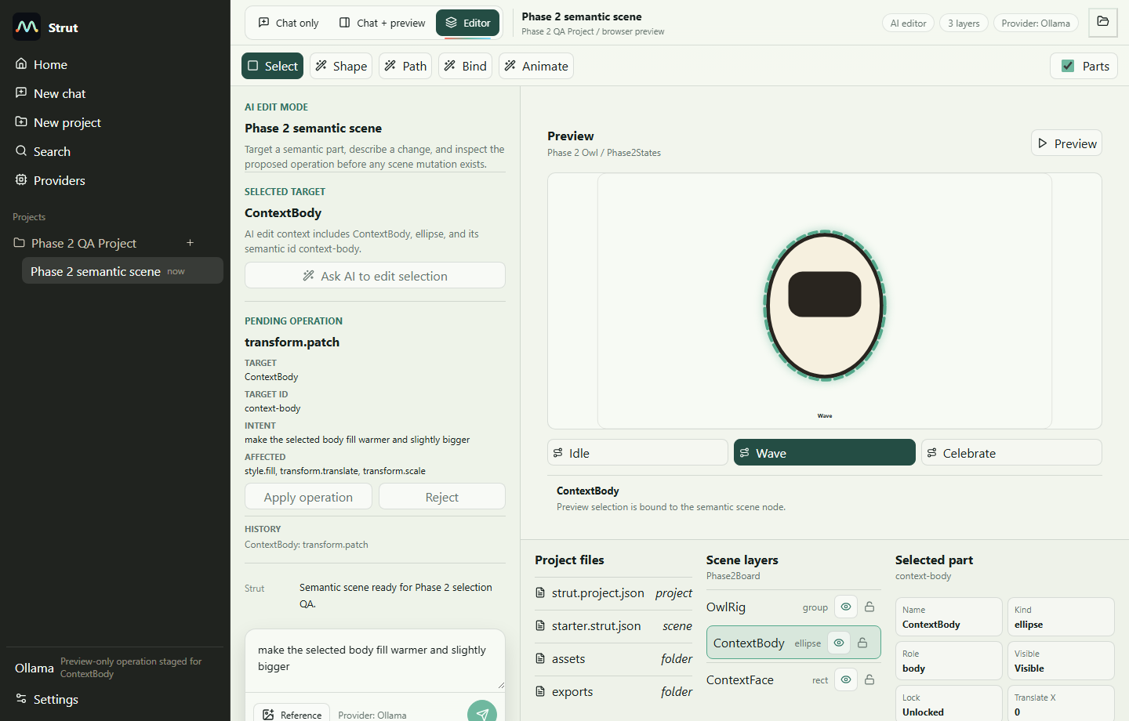
screenshots\browser\browser-02-desktop-light-operation-preview.png
Browser dark selection
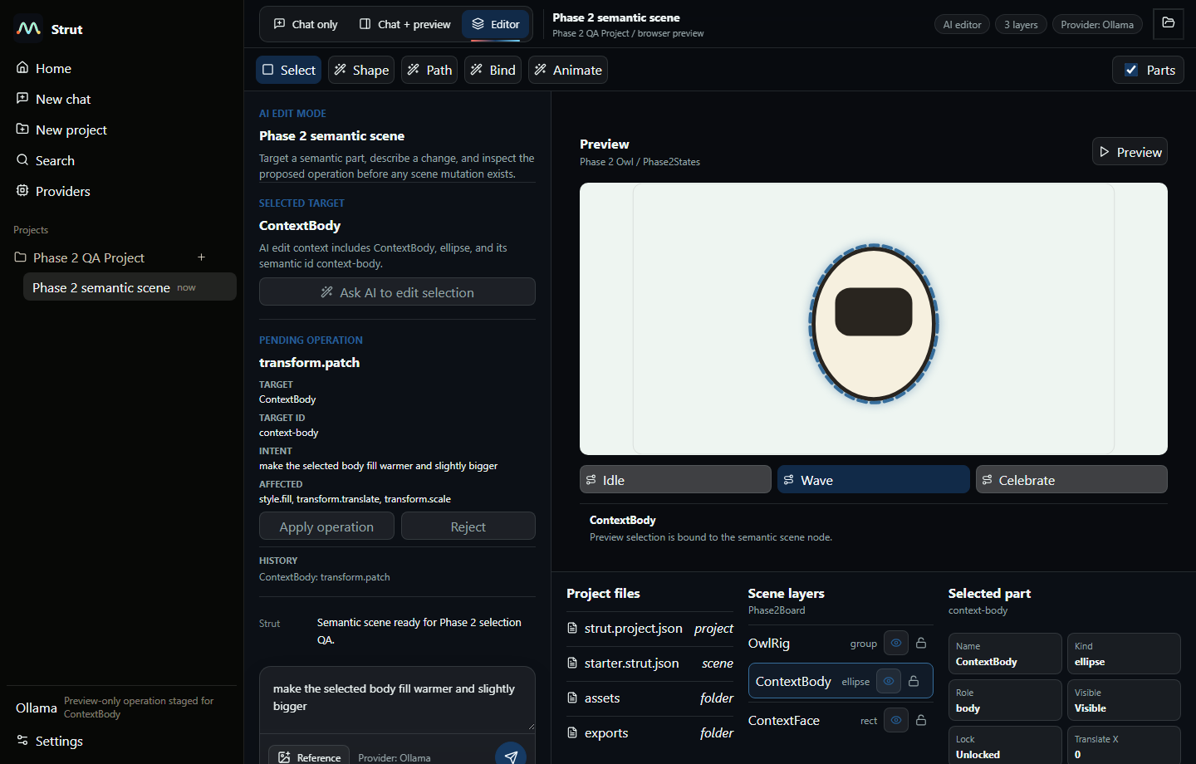
screenshots\browser\browser-04-desktop-dark-selection.png
Browser narrow selection
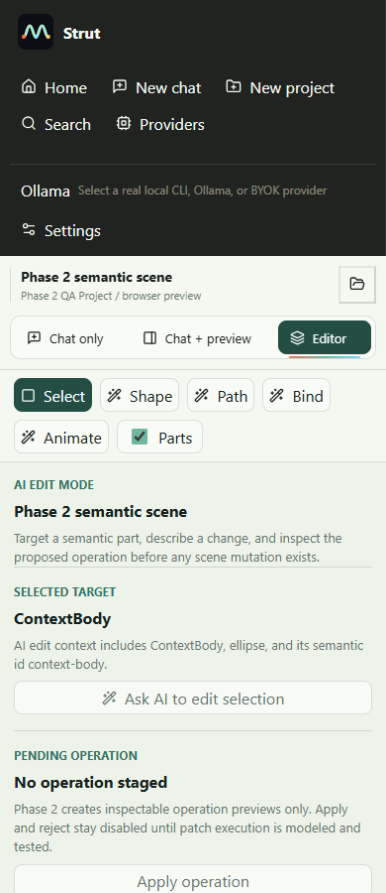
screenshots\browser\browser-07-narrow-light-selection.png
Native Tauri selection
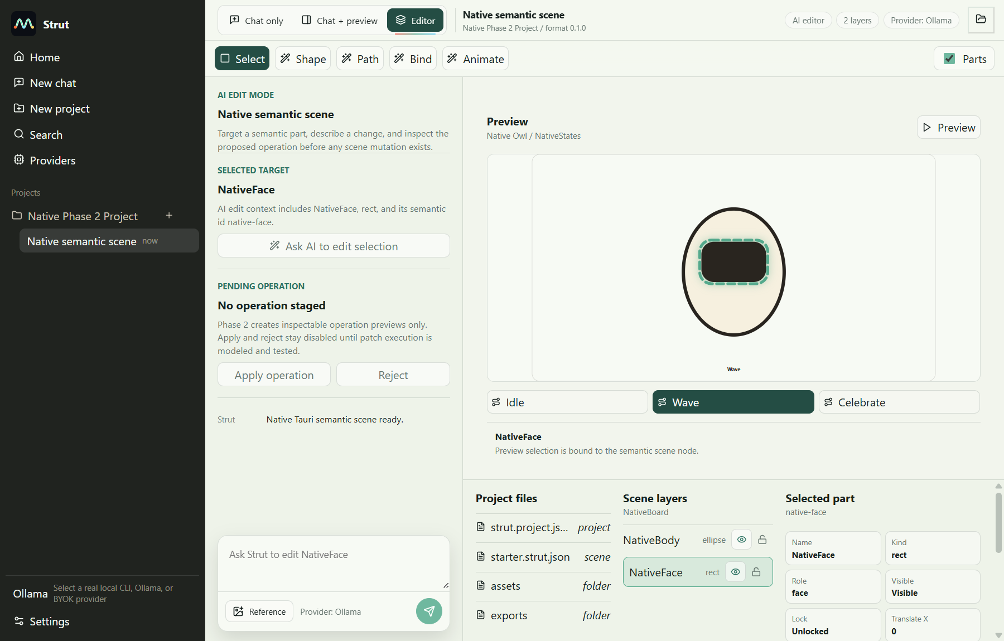
screenshots\tauri\tauri-01-native-preview-selection.png
Native Tauri operation preview
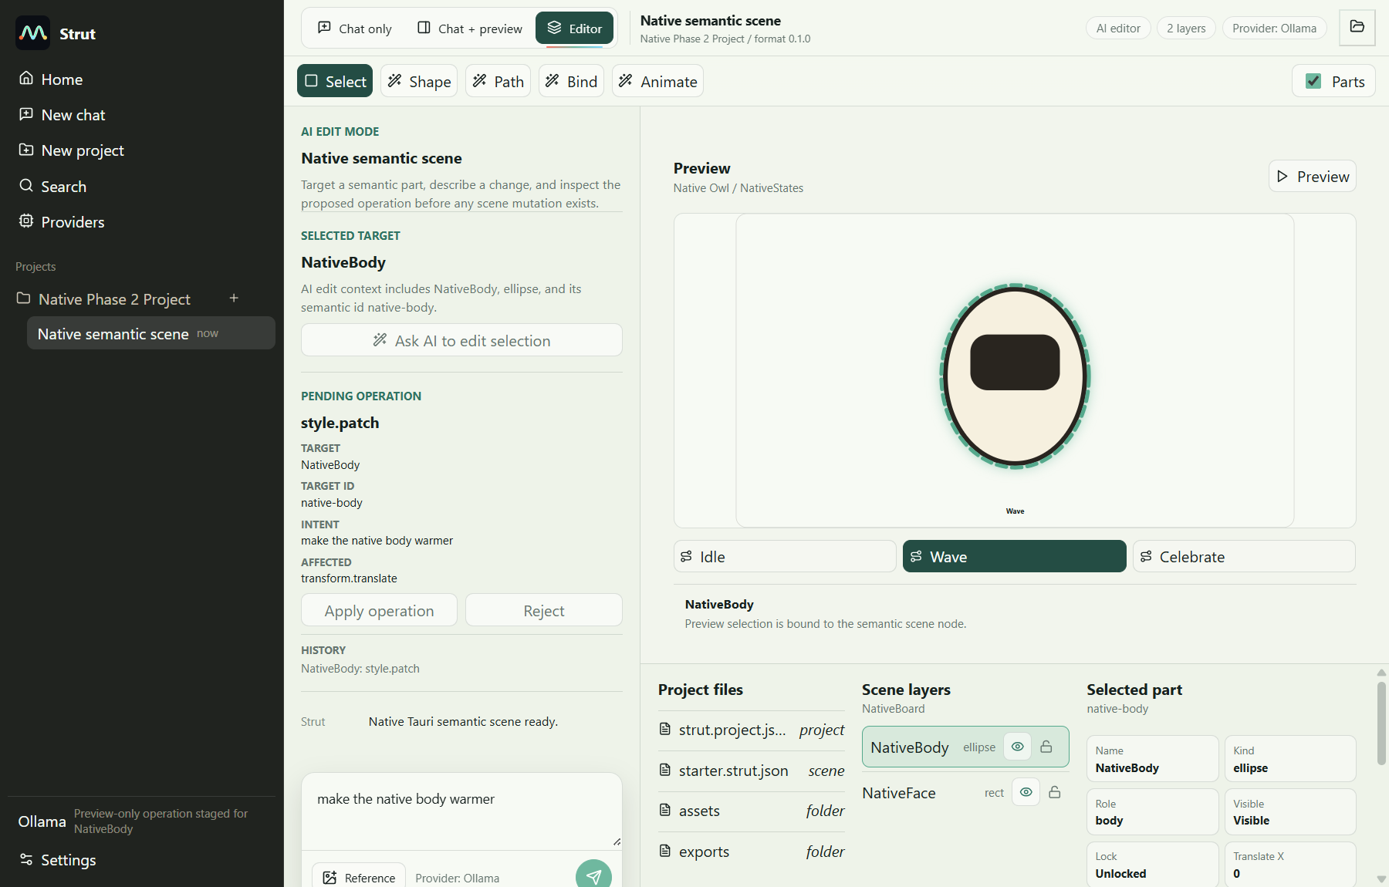
screenshots\tauri\tauri-02-native-operation-preview.png

Still Placeholder Or Deferred
- Apply/Reject are intentionally disabled and do not mutate scene documents.
- Operation previews are inspectable local records, not real AI patch execution.
- Dynamic generation planning, validated operation patches, operation replay, and agentic CLI mode remain deferred.
- Multi-selection was not implemented; Phase 2 exposes clear empty and single-selection states.
- Path bounds use a practical halo approximation where exact path geometry is unavailable.

Phase 3 Recommendation
Phase 3 should introduce a validated operation schema, patch planning, safe operation application/rejection, undoable operation history, and tests proving document mutation is explicit, reversible, and schema-validated. CLI mode should remain out of scope until the app and shared operation model are stable.

