Auditing PAC Forecast Targets During 40 Hz Auditory Stimulation
Amaar M. Chughtai
Valley Christian High School, San Jose, California, United States
amaardevx@gmail.com
Abstract: Fixed 40 Hz auditory stimulation protocols can be evaluated from the delivered sound schedule, but an adaptive protocol would need an EEG quantity that is available before each decision. This retrospective study tests whether frontal phase-amplitude coupling (PAC), the dependence of 38-42 Hz EEG amplitude on the phase of 4-8 Hz theta activity, can serve as a forecast target during 40 Hz auditory stimulation. Using 35 OpenNeuro ds005048 participants, seven frontal channels were split by participant into 24 training, 5 validation, and 6 held-out test participants. With PAC computed over complete stimulation/rest events and assigned to constituent two-second windows, a 12-feature temporal convolutional network (TCN) using PAC history and recorded stimulation timing reached held-out R-squared of 0.558, compared with -0.025 for a 73-feature candidate set and 0.606 mean R-squared across five seeds versus 0.104 for persistence. The central audit asked whether this result survived a target definition closer to online availability. Recomputing PAC from five-second backward-looking signal contexts increased unique held-out targets from 104 to 2,678, eliminated adjacent target repetition, and reduced TCN R-squared from 0.554 to 0.212, slightly below Ridge regression at 0.216. Offline replay then showed that forecast-driven decisions stimulated more below-median PAC periods but spared fewer above-median PAC periods than a reactive rule. These results make the next step specific: adaptive 40 Hz stimulation needs a streaming PAC estimator and controller calibration before any physiological or therapeutic claim is warranted.
Keywords: auditory stimulation, phase-amplitude coupling, EEG, temporal convolutional network, target-definition audit, retrospective replay

Introduction
Forty-hertz auditory stimulation is being studied because gamma-band activity and network synchrony are altered in Alzheimer’s disease models and dementia cohorts. In 5XFAD mice, experimentally induced 40 Hz activity reduced amyloid burden and altered microglial response [1]. The human dataset used here comes from Lahijanian et al., who recorded EEG during alternating 40 Hz auditory stimulation and rest in memory-clinic participants. Their analysis measured power at the stimulation frequency and phase-locking-value connectivity across frontal and parietal sites; they reported a 40 Hz stimulus-period power peak and increased 40 Hz frontoparietal synchronization during stimulation [2]. That prior work makes the recordings useful for a narrower engineering question: can an EEG-derived state variable be estimated early enough to inform future stimulation timing? It does not show that changing stimulation timing would improve physiology or symptoms.
A fixed auditory protocol defines what sound is delivered, not whether the participant's measured EEG response is strengthening, fading, or being dominated by artifact. Fixed schedules are therefore reproducible but blind to within-session state. Closed-loop neuromodulation instead requires a decision variable computed from recent measurements, a rule for when to stimulate or rest, and evidence that the variable can be estimated or forecast before the next decision [4].
This study uses frontal phase-amplitude coupling as that decision variable. PAC measures whether the amplitude of a faster oscillatory component changes systematically with the phase of a slower component. Here, the slower component is 4-8 Hz theta phase and the faster component is the 38-42 Hz amplitude envelope surrounding the 40 Hz stimulation frequency. A higher modulation index means that 40 Hz-band amplitude is concentrated in particular theta-phase bins; a lower value means the amplitude is distributed more evenly across the theta cycle. This is not treated as proof of therapeutic engagement, source-level gamma entrainment, or disease state. It is a compact frontal EEG timing variable that can be tested as a target for future adaptive control.
The low-PAC replay target follows from the controller question rather than from a clinical claim. If a controller is designed to deliver stimulation when the chosen EEG feature is low relative to that participant's recent or full-session distribution, then below-median PAC gives a concrete, participant-normalized timing objective. The analysis therefore asks whether a model can identify and forecast low-coupling periods better than fixed or reactive rules. It does not assume that low PAC marks therapeutic need, and it does not test whether stimulation raises PAC.
Forecasting is useful only if it changes the decision before a reactive threshold would. A reactive rule waits until the measured feature has already crossed a threshold. A forecaster could, in principle, initiate or withhold stimulation before a future low-PAC state. That claim has three requirements: the input features must be available at decision time, performance must generalize to participants excluded from training, and the controller must not gain low-PAC coverage by simply stimulating almost all the time. Those requirements motivated the target-availability audit and the offline replay metrics used here.
This study therefore contributes three linked analyses. First, it builds a participant-disjoint temporal benchmark using seven frontal EEG channels from 35 participants and tests whether compact PAC-history plus recorded-stimulation features predict stored PAC values five seconds ahead. Second, it audits the target definition by recomputing PAC from five-second backward-looking signal contexts instead of complete stimulation/rest events. This matters because complete-event PAC is stable but assigns the same summary value to early windows before all contributing EEG samples have occurred. Third, it uses offline replay to test whether forecasts improve decision alignment relative to fixed and reactive rules. The resulting conclusion is intentionally bounded: compact temporal features predict stored event-summary PAC, but the nonlinear advantage weakens under a target definition closer to online availability, and replay exposes a low-PAC coverage versus high-PAC sparing tradeoff that must be calibrated before live testing.

Data and Methods

Source EEG Dataset and Signal Conditioning
OpenNeuro ds005048 version 1.0.1 was selected because it contains the ingredients needed to ask a closed-loop timing question retrospectively: repeated 40 Hz auditory stimulation and rest blocks, event annotations, participant-level clinical labels, and continuous EEG from a memory-clinic cohort [3]. The dataset does not contain adaptive stimulation decisions, so every controller result below is a replay over recorded trajectories rather than evidence about counterfactual physiology.
The local BIDS release contains recordings from 35 participants. Participant labels include normal cognition, mild cognitive impairment, and Alzheimer's disease classifications; two participants have missing group labels. The source study recorded 19 monopolar EEG channels at 250 Hz during 40 Hz auditory stimulation trials interleaved with rest periods [2]. The source study's primary analysis focused on 40 Hz power, entrainment score, and phase-locking-value connectivity. This paper uses the same recordings for a different purpose: forecasting a scalar frontal PAC target from temporally ordered histories.
Seven frontal channels were selected: Fp1, Fp2, F7, F3, Fz, F4, and F8. The source study reports Makoto-pipeline preprocessing, including a 1 Hz high-pass filter, 50 Hz line-noise removal, artifact subspace reconstruction, average rereferencing, and ICA-based component rejection [2]. Released sidecar files independently report the 1 Hz high-pass filter, 50 Hz notch filter, and average reference. The local processing stage then applied an additional 0.5-80 Hz zero-phase band-pass filter, a 50 Hz zero-phase notch filter, absolute-amplitude masking above 100 microvolts, and common-average rereferencing. Masked samples were set to zero before rereferencing. Because frontal/frontopolar gamma-band EEG is vulnerable to ocular and facial-muscle activity [6], this deterministic conditioning should not be read as a validated artifact-removal pipeline for physiological PAC. Each event period was segmented into two-second windows with a one-second hop.

PAC Label Construction
Theta-gamma PAC was measured using the modulation index introduced by Tort et al. [5]. For each channel, theta phase was extracted from 4-8 Hz, gamma amplitude from 38-42 Hz, and the gamma amplitude distribution was summarized over 18 theta-phase bins. The normalized divergence from a uniform distribution produced a dimensionless modulation-index value. Values were averaged across the seven selected channels to create one scalar frontal timing target, not a spatial connectivity analysis.
These modulation-index values are used as retrospective EEG-derived targets. No surrogate correction or phase-clustering debiasing was applied, so the values should not be read as definitive evidence of physiological theta-gamma coupling, endogenous gamma activity, source-level entrainment, or therapeutic response [7].
PAC was computed over complete event periods rather than individual two-second windows because short windows provide too few theta cycles for stable phase binning. Most event periods lasted 20 or 40 seconds, with brief final rest periods also present. Each two-second window inherited the PAC value of its containing period. This stabilizes the label but has three consequences: labels repeat within periods, adjacent samples are not independent, and a PAC value assigned to an early window summarizes signal samples acquired later in that period. The present analysis is therefore retrospective; an online estimator must be evaluated before live use.

Temporally Ordered Forecasting Dataset
Each temporal sample used a 20-step lookback and a target five steps into the future. With a one-second hop, this corresponds to 20 stored-series seconds of history and a target five seconds after the sequence endpoint. Sequences were constructed separately within each participant so that no sequence crossed a participant boundary. Target indexing uses no later PAC-series entry as an input, but it does not resolve the online-availability limitation of the event-period PAC summaries.
The initial representation contained 73 candidate features per time step:
- 61 spectral features
- 7 PAC-history features: current PAC, trailing means over 2, 4, 8, and 16 steps, and differences over 1 and 4 steps
- 5 stimulation-context features: stimulation state, normalized time since switch, recent stimulation fraction, and sine/cosine protocol-phase terms.
An exploratory ablation identified the 12 PAC-history and stimulation-context features as the best-performing held-out test representation in this fixed split. Because representation choice was informed by this benchmark, the result should be treated as exploratory until repeated participant-level splits or nested model selection are run. The data were divided by participant into 24 training, 5 validation, and 6 test participants. The resulting temporal dataset contained 11,160 training, 2,605 validation, and 2,678 test sequences. Normalization statistics were fit on the training split only and then applied to all splits.

Backward-Looking PAC Stress Test
To test how strongly the event-summary target definition influenced the result, an additional benchmark reconstructed contiguous event segments from the overlapping windows and recomputed PAC at each timestamp from a five-second backward-looking context ending at that timestamp. The benchmark used the same 20-step lookback, five-step horizon, 12 features, participant splits, and train-only normalization. For contexts shorter than three seconds at segment boundaries, the PAC computation used 9 rather than 18 phase bins.
In this stress test, each input PAC value was computed without EEG samples after its own timestamp. However, the benchmark still used zero-phase filtering within each bounded context, and five-second PAC contexts provide limited theta-cycle support. It is therefore an information-boundary stress test that is closer to online availability than complete-event back-assignment, but it is not a validated streaming estimator.

Temporal Model
The selected forecaster is a lightweight temporal convolutional network (TCN), which applies temporal convolutions to ordered samples [8]. An input projection is followed by four residual depthwise-separable temporal blocks with kernel size 3 and dilations [1, 2, 4, 8]. Within the stored input sequence, left-only padding prevents later entries from entering an earlier temporal representation. Attention pooling summarizes the 20-step sequence before regression heads estimate future PAC and PAC change.
The primary forecasting study evaluated the selected 12-feature representation across five random seeds. For controller integration, a dual-head 12-feature checkpoint was trained separately with the same hidden-64 architecture. That architecture contains 27,139 trainable parameters. Forecasting-study, stress-test, and controller-replay results are reported separately because they come from distinct retraining or replay runs.

Retrospective Controller Replay
The integrated checkpoint was evaluated in offline replay on all 35 recorded PAC trajectories, including the training, validation, and test splits. This replay probes controller behavior; it is not an additional held-out forecasting test. The replay compared four strategies:
1. Fixed schedule: replay the nominal recorded stimulation schedule.
2. Reactive threshold: after a 10-sample warm-up, stimulate when current PAC is more than 0.5 standard deviations below its 30-sample rolling baseline; otherwise rest.
3. TCN predictive: stimulate or rest when normalized forecast PAC change crosses -0.3 or +0.3; otherwise use a current-PAC threshold fallback with a three-step minimum hold before switching state.
4. Alignment oracle: stimulate below each participant's full-trajectory median PAC and rest otherwise.
The oracle uses the entire recorded trajectory and is not a causal or deployable strategy. For each participant, low PAC was defined relative to that participant's full-trajectory median. The low-PAC stimulation rate measured the fraction of below-median PAC points assigned stimulation. The high-PAC rest rate measured the fraction of above-median PAC points assigned rest. Balanced alignment was their mean:
alignment = (low-PAC stimulation rate + high-PAC rest rate) / 2.
The replay evaluates decision alignment against recorded PAC. It does not estimate how PAC would physiologically change if counterfactual stimulation decisions were delivered. Because the stimulation-context features are computed from the nominal recorded protocol rather than the controller's decisions, replay does not model a closed feedback loop. It is an offline controller diagnostic, not a prospective experiment.

Results

Feature Selection Improved Held-Out Forecasting
Table I shows a single-seed TCN ablation on the same participant split. Adding the spectral feature set reduced held-out-participant generalization, while PAC history and stimulation context produced the strongest result.
TABLE I. ORIGINAL EXPLORATORY SINGLE-SEED FEATURE ABLATION AT A FIVE-SECOND HORIZON
Input representation | Features | Test R2
Spectral only | 61 | -0.420
All candidate features | 73 | -0.025
PAC trajectory only | 7 | 0.344
PAC trajectory + stimulation context | 12 | 0.558

The ablation does not prove a biological mechanism for the spectral features' failure. It shows that the larger spectral representation introduces variation that does not transfer effectively to the held-out participants in this dataset.
Across five seeds, the selected 12-feature TCN achieved mean test R-squared = 0.606, with a range from 0.558 to 0.647. At the same five-second horizon, a last-value persistence baseline achieved R-squared = 0.104.

Backward-Looking PAC Changed the Model-Selection Result
Figure 1 compares the event-summary benchmark with the backward-looking PAC stress test using the same TCN architecture at one random seed and one fixed split. Unique held-out targets increased from 104 to 2,678, and adjacent target repetition decreased from 96.2% to 0.0%. Persistence R-squared decreased from 0.104 to -0.897. The backward-looking target retained modest predictable structure, but the TCN did not outperform Ridge regression (0.212 versus 0.216). The event-summary result is a diagnostic of stored-series structure, not evidence that a nonlinear TCN is necessary for an online-compatible forecaster.
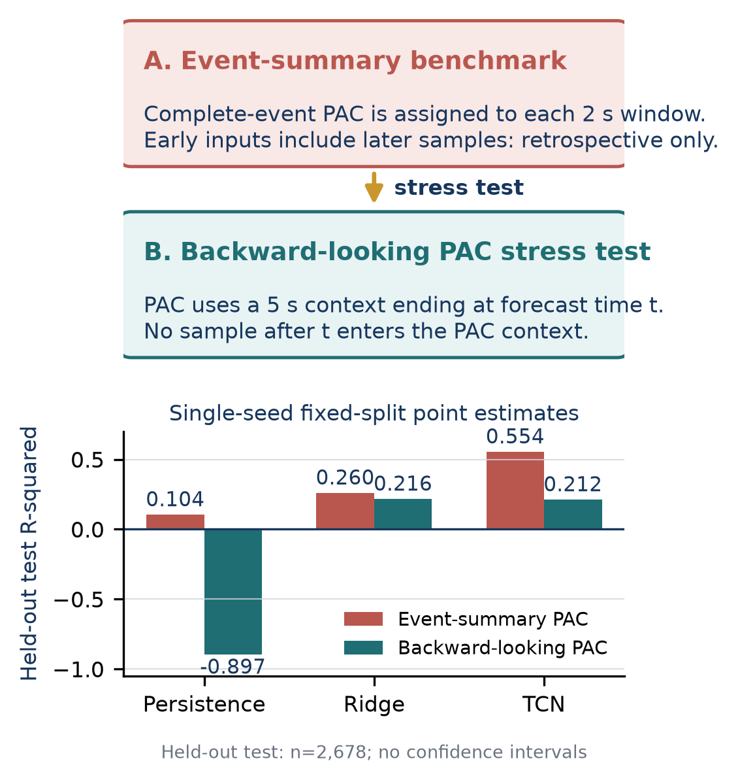
- Target-definition stress test. Complete-event PAC back-assignment includes later samples in early-window inputs; backward-looking PAC restricts each context to samples available by its timestamp. Bars show single-seed fixed-split R-squared on six held-out participants (2,678 sequences); no confidence intervals are shown.

Predictive Replay Increased Low-PAC Coverage but Did Not Improve Overall Alignment
Table II reports offline replay of the integrated 12-feature checkpoint across all 35 recorded trajectories. The predictive controller improved low-PAC stimulation coverage by 22.1 percentage points relative to reactive thresholding, assigning stimulation to more below-median PAC samples. However, the above-median-PAC rest rate decreased by 26.6 points. The predictive rule therefore found more low-PAC periods, but it did so by stimulating more often during periods that the replay metric would prefer to leave at rest.
TABLE II. RETROSPECTIVE CONTROLLER REPLAY ON 35 RECORDED TRAJECTORIES
Strategy | Bal. align. | Low stim. | High rest | MI gap x 10^-6
Fixed schedule | 45.0% | 61.4% | 28.6% | -6.55
Reactive threshold | 64.5% | 51.7% | 77.3% | 21.09
TCN predictive (12-feature) | 62.2% | 73.8% | 50.7% | 21.02
Alignment oracle | 100% | 100% | 100% | 33.36

The PAC gap is mean PAC during rest minus mean PAC during stimulation, reported in x 10^-6 modulation-index units. A positive value indicates that stimulation decisions are concentrated more strongly in lower-PAC periods. The predictive and reactive strategies produced nearly identical PAC gaps despite different action profiles.

Leakage Checks and Label-Resolution Caveat
The stored temporal dataset was audited for subject overlap, future-index ordering, and normalization contamination. No participant appeared in more than one split. Every target index was exactly five steps after the sequence endpoint. Recomputed training statistics matched the stored normalizers. A reduced-model permutation test produced approximately zero validation R-squared across five independent label shuffles.
The main caveat is how PAC labels were computed and assigned. Because PAC is computed over complete event periods, 82.2% of five-step sample pairs have identical current and target PAC values. Persistence still achieves only R-squared = 0.104 on the held-out test split and R-squared = -0.272 on cross-event transitions. However, event-period back-assignment means that the stored current-PAC input is not yet a validated online feature. The forecasting results evaluate retrospective temporal structure, not an end-to-end streaming predictor.

Discussion
The forecasting results show that stored PAC histories and stimulation context contain information that predicts PAC in held-out participants under the event-summary label definition. Feature selection mattered within that benchmark: the compact representation transferred to unseen participants more effectively than the larger candidate set. The target definition mattered more. When PAC was recomputed from backward-looking contexts, Ridge and TCN both had positive held-out R-squared, but the nonlinear advantage disappeared. This suggests that target construction should be benchmarked before adding model complexity.
The replay separates forecast quality from controller performance. The integrated checkpoint stimulates more low-PAC periods, but it also stimulates too frequently during above-median-PAC periods. A future controller should tune its objective for both low-PAC coverage and high-PAC sparing, evaluate thresholds on held-out participants, feed counterfactual actions back into stimulation-context features during simulation, and replace back-assigned PAC summaries with an online estimator. A corrected-target feature ablation should also separate PAC-only, stimulation-context-only, and combined inputs to distinguish biomarker dynamics from recorded schedule structure.
The study has seven main limitations:
1. The controller evaluation is retrospective replay, not a live intervention.
2. The replay cannot estimate physiological responses to counterfactual stimulation timing.
3. Primary PAC inputs are complete-event summaries assigned back to constituent windows and are not validated as streaming-available features.
4. The backward-looking stress test uses zero-phase filtering inside bounded contexts and is not a production streaming estimator.
5. PAC estimates may be sensitive to filtering, artifact handling, and finite-sample bias.
6. The 38-42 Hz amplitude band overlaps the auditory stimulation frequency, so PAC estimates may reflect stimulation-locked steady-state response or residual artifact rather than endogenous gamma coupling.
7. The dataset is single-site and modest in size; the current results use one fixed participant split.
Because of these limitations, this study should not make clinical or therapeutic efficacy claims. The next experiments should evaluate additional backward-looking PAC context lengths, implement a streaming-compatible PAC estimator, measure repeated participant-split performance, calibrate controller objectives using held-out participants, and then test a prospective streaming implementation.

Conclusion
In an event-summary benchmark, a 12-feature TCN predicted stored PAC-series entries on held-out participants more accurately than a larger 73-feature candidate representation. Across five training seeds on the same fixed split, mean forecasting performance reached R-squared = 0.606; this estimates initialization variability, not sensitivity to which participants are held out. A backward-looking PAC stress test then removed the repeated-target shortcut: the TCN retained positive held-out R-squared but did not exceed Ridge regression. Offline replay showed stronger low-PAC coverage without improved balanced alignment. The results support compact temporal features as a retrospective benchmark, but they also show that the PAC target definition controls the conclusion. A streaming PAC estimator, artifact sensitivity analysis, repeated participant-split validation, and a separately validated controller are required before live adaptive-stimulation testing.

References
- H. F. Iaccarino, A. C. Singer, A. J. Martorell, et al., "Gamma frequency entrainment attenuates amyloid load and modifies microglia," Nature, vol. 540, pp. 230-235, 2016. doi:10.1038/nature20587.
- M. Lahijanian, H. Aghajan, and Z. Vahabi, "Auditory gamma-band entrainment enhances default mode network connectivity in dementia patients," Scientific Reports, vol. 14, art. 13153, 2024. doi:10.1038/s41598-024-63727-z.
- M. Lahijanian, H. Aghajan, and Z. Vahabi, "40Hz Auditory Entrainment," OpenNeuro dataset ds005048, ver. 1.0.1. doi:10.18112/openneuro.ds005048.v1.0.1.
- G. Soleimani, M. A. Nitsche, T. O. Bergmann, et al., "Closing the loop between brain and electrical stimulation: towards precision neuromodulation treatments," Translational Psychiatry, vol. 13, art. 279, 2023. doi:10.1038/s41398-023-02565-5.
- A. B. L. Tort, R. Komorowski, H. Eichenbaum, and N. Kopell, "Measuring phase-amplitude coupling between neuronal oscillations of different frequencies," Journal of Neurophysiology, vol. 104, no. 2, pp. 1195-1210, 2010. doi:10.1152/jn.00106.2010.
- J. F. Hipp and M. Siegel, "Dissociating neuronal gamma-band activity from cranial and ocular muscle activity in EEG," Frontiers in Human Neuroscience, vol. 7, art. 338, 2013. doi:10.3389/fnhum.2013.00338.
- J. Aru, J. Aru, V. Priesemann, et al., "Untangling cross-frequency coupling in neuroscience," Current Opinion in Neurobiology, vol. 31, pp. 51-61, 2015. doi:10.1016/j.conb.2014.08.002.
- S. Bai, J. Z. Kolter, and V. Koltun, "An empirical evaluation of generic convolutional and recurrent networks for sequence modeling," arXiv:1803.01271, 2018.

