Project P10 Research Log Notebook
Personalized Deep Learning Model for Closed-Loop 40 Hz Entrainment to Optimize
Theta-Gamma Phase Amplitude Coupling in Alzheimer's Disease
Amaar Chughtai
Valley Christian High School
Synopsys Science and Engineering Fair 2026
Notebook Timeline: January 15, 2026 - March 1, 2026

January 15, 2026
Goal: Following project approval, I started with my literature review.
Iaccarino et al. (2016) showed that 40 Hz γ entrainment reduced amyloid-β cluster load in Alzheimer's mouse models by activating microglia, and Martorell et al. (2019) extended that to multi-sensory stimulation reducing tau pathology. Lahijanian et al. (2024) then showed that auditory entrainment enhanced default mode network connectivity in human dementia patients and published a 35-subject EEG dataset on OpenNeuro (ds005048).
Current trials use a rigid fixed schedule (40 seconds of 40 Hz auditory stimulation followed by 20 seconds of silence), cycling for one hour regardless of how the patient's brain responds. Some patients maintain strong coupling throughout; others lose it within seconds. Neural habituation (Thompson & Spencer, 1966) means the brain progressively tunes out a repeated identical stimulus, so coupling degrades over time. The fixed schedule wastes stimulation during periods of strong coupling and misses opportunities during periods of fading coupling.
Question: can we predict when a patient's brain will lose entrainment and deliver stimulation proactively, before the decline occurs?
The biomarker I chose is Phase-Amplitude Coupling (PAC), specifically, how strongly γ amplitude (38-42 Hz) locks to θ phase (4-8 Hz), measured via the Modulation Index (Tort et al., 2010). High PAC means entrained; low PAC means lost synchronization.
Software stages: data loading, preprocessing, PAC computation, model training, controller logic, and validation. Must use subject level splits (no patient can appear in both training and test data), and causal features for any temporal model (so no future information is leaking into predictions).
Dataset Specifics OpenNeuro page: 35 elderly dementia patients, 19 EEG channels at 250 Hz, alternating stimulus (40 Hz AM auditory) and rest epochs of 20-40 seconds each. I planned to focus on the 7 frontal channels (Fp1, Fp2, F3, F4, F7, F8, Fz) where the 40 Hz response is strongest, and to extract 2-second analysis windows.
Gap note (January 16 – February 5, 2026): During this stretch I was reading papers, refining the PAC method choice on paper, and dealing with school workload. I also did some preliminary coding on the data loader.

February 6, 2026
I built the entire pipeline from raw data loading through to a first trained model.
OpenNeuro .set files use MATLAB v7.3 HDF5 format with companion .fdt binary data files. Standard MNE-Python readers failed completely.
I spent hours debugging before realizing the issue was file format incompatibility. The solution was to use h5py to read .set metadata (channel count, sample rate, epoch boundaries) and numpy.fromfile() to read the .fdt binary data. MATLAB stores matrices in column-major (Fortran) order, while Python defaults to row-major:

with h5py.File(set_path, 'r') as f: n_channels = int(f['nbchan'][0, 0]) n_samples = int(f['pnts'][0, 0])
data = np.fromfile(fdt_path, dtype=np.float32) data = data.reshape((n_channels, n_samples), order='F')

Without order='F', the channels appeared transposed and PAC values were ridiculous. With it, the EEG signals had proper amplitude ranges.
I selected 7 frontal channels and extracted 17,283 two-second windows (500 samples each at 250 Hz) with 50% overlap across all 35 subjects. Subject-level splits: 24 train (11,736 windows), 5 validation (2,725 windows), 6 test (2,822 windows).
Next I implemented Phase-Amplitude Coupling using the Tort Modulation Index method. The method bandpass filters for θ (4-8 Hz) phase and γ (38-42 Hz) amplitude, applies the Hilbert transform to extract instantaneous phase and amplitude, bins γ amplitude by θ phase (18 bins of 20 degrees each), normalizes to a probability distribution, and computes the KL divergence from uniform. I computed PAC at epoch level (full 20-40 second stimulation blocks), then assigned the value uniformly to constituent 2-second windows. This creates label sharing within epochs but ensures reliable MI estimates. PAC values ranged from about 6*10^-6 to 7*10^-4, with a mean around 4.4x10^-5.
With data loaded and labeled, I built the first model EEGNet (Lawhern et al., 2018), for regression. EEGNet uses temporal convolutions followed by depth wise spatial convolutions that capture channel relationships, which makes it well-suited for EEG. My adaptation replaced the classification head with a single linear output neuron for continuous PAC prediction:
Input: (batch, 1, 7, 500) -> 7 channels x 500 samples
Temporal Convolution: 8 filters, kernel=(1,64)
Depthwise Spatial: 16 filters, kernel=(7,1), groups=8
ELU + AvgPool + Dropout(0.5)
Separable Convolution
ELU + AvgPool + Dropout(0.5)
Flatten + Linear(240 -> 1)
Total Parameters: 1,457
Training used MSE loss, Adam optimizer (lr=0.001, weight_decay=0.0001), gradient clipping (max_norm=1.0), ReduceLROnPlateau scheduler, and early stopping with patience of 15 epochs. The result: test R² = 0.287, with inference time under 1 ms on Apple Silicon MPS.
That R² seems low, but architectural improvements could push it higher.

February 16, 2026
I tested multiple architectures with different parameter counts. Used EEGNet variants, spectral-temporal hybrids, transformer-based approaches, and simple baselines for comparison.
EEGNet (baseline, V1) - 1,457 parameters. Test R² = 0.287.
EEGNetV2 (delta PAC prediction) - ~3,200 parameters. Predicted PAC change instead of absolute PAC. Test R² = 0.06. Delta prediction failed because temporal changes at 2-second resolution are probably too noisy.
SpecTempNet (spectral-temporal hybrid, V3) - 180,000 parameters. Initial result: R² = 0.69!! But I found that PAC-derived features in the input directly encoded the target. Ridge analysis confirmed that the PAC features carried 96.6% of the total model weight. After removing the circular features: R² = 0.236. Data leakage.

ViT-TCNet (Vision Transformer + TCN, V4) - ~2,000,000 parameters. Treated EEG as image patches plus temporal convolution. Test R² = 0.252. Severe overfitting with a samples-to-parameters ratio of 0.006 on only 11K training samples.
Ridge Regression (V5) - 135 coefficients. Spectral power features, no PAC features. Test R² = 0.287. It’s the exact same as EEGNet?
ATCNet (attention-based TCN, V6) - ~25,000 parameters. Test R² = 0.075.
EEGNetLarge (scaled EEGNet) - 141,000 parameters. Test R² = 0.287. Same ceiling, 100x more parameters.

Architecture | Parameters |  | Test R² | Notes
EEGNet | 1,457 | 0.287 |  | Optimal parameter efficiency
SpecTempNet | 180,000 | 0.236 |  | After leak fix
ViT-TCNet | ~2,000,000 | 0.252 |  | Overfitting
Ridge Regression | 135 coefs | 0.287 |  | Matches deep learning
ATCNet | 25,000 | 0.075 |  | Underperformed
EEGNetLarge | 141,000 | 0.287 |  | Same ceiling

The simplest models (EEGNet with 1,457 parameters, Ridge with 135 coefficients) matched the performance of models with 1,000x more parameters. R² = 0.287 is a data ceiling? The signal-to-noise ratio was approximately -4.73 dB (signal weaker than noise), and epoch-level PAC labels assigned to 2-second windows inherently limit single-window accuracy. The question should probably change.

February 17, 2026
Pivoting the idea of the architecture. The 0.287 is a data ceiling. Instead of asking "how accurately can we estimate current PAC?" the question should be "how far ahead can we predict future PAC?" If the system can forecast PAC 5-10 seconds into the future, a controller can intervene proactively before coupling declines, rather than reacting after the fact. Enabling auditory stimulus takes time too.
Part 1: design temporal feature representation. I built 73-dimensional feature vectors per timestep:
Spectral features (61 dimensions): Band power in delta (0.5-4 Hz), θ (4-8 Hz), alpha (8-12 Hz), beta (12-30 Hz), and γ (30-42 Hz) for each of 7 channels (35 features), plus 26 cross-channel features.
PAC-derived features (7 dimensions): Current epoch-level PAC value, causal moving averages at windows of 2, 4, 8, and 16 timesteps, plus first-difference and 4-step difference for trend information.
Stimulation context (5 dimensions): Binary ON/OFF state, time since last transition, fraction stimulated over a 20-second window, and sine/cosine encoding of cycle phase position.
Every feature was causal so there could be no data leakage like there was before.
Sequence setup: 20 timesteps of lookback (20 seconds of history) feeding into a prediction of PAC at 5 seconds ahead. Raw PAC targets, no smoothing, for realism.
Part 2: build it. I designed a MultiscaleCausalTCN with four temporal convolution blocks at increasing dilations:
dilations = [1, 2, 4, 8
F.pad(x, ((kernel_size-1)*dilation, 0)) -> left-only, so no future leakage
RF calculation: kernel size 3, dilations [1, 2, 4, 8], RF = 1 + (3-1) x (1+2+4+8) = 31 timesteps. That covers the full 20-step input with margin. Output goes through learned attention pooling over the time dimension, then to a future PAC prediction head. Total parameters: 31,043.
Choices:
- GroupNorm instead of BatchNorm: Different patients have different PAC baselines; GroupNorm normalizes per-sample rather than per-batch, which stabilizes cross-subject training.
- Depthwise separable convolutions: Parameter efficiency by factorizing spatial and channel mixing.
- AdamW with lr=0.001, weight_decay=0.001.
- Early stopping: patience=20, monitoring validation R².
Component | EEGNet | Causal TCN
Purpose | Estimate current PAC from raw EEG | Predict future PAC from history
Parameters | 1,457 | 31,043
Input | Raw EEG (7 ch x 500 samples) | 73 features x 20 timesteps
Architecture | Temporal + depthwise spatial conv | Dilated causal conv (d=1,2,4,8)
Output | Current PAC estimate | Future PAC (5s horizon)
Key feature | Real-time inference | 31-step receptive field, causal
First training results: validation R² = 0.411 versus test R² = 0.170. Probably because PAC dynamics vary across patients. It also reinforced why personalized control matters.

February 18, 2026
The temporal model could easily be over stated because smoothed targets make some metrics look much better than raw target forecasting, and PAC history features have obvious predictive control.
I documented assumptions, wrote out methodology choices, and checked the temporal pipeline for the failure modes that had already hurt the static phase: data leakage, split mistakes, and overly flattering interpretations.
Data integrity checklist:
- No leakage: Verified training, validation, and test subjects completely distinct.
- All feature timestamps strictly precede target timestamps.
- Scalers fit only on training data, applied to all splits.
- No input features exceed r = 0.5 with target (after PAC leak removal from the SpecTempNet lesson).
- Shuffle-label - R² = -0.332 on permuted labels, which is good
Checked the habituation patterns in the real EEG data by looking at PAC history per patient:
First Block Mean PAC: 0.000996
Last Block Mean PAC: 0.001040
Population Change: +4.5% (not significant, p = 0.542)
No population trend but the individual variability was the issue:
Response Pattern |  | Count | Percentage | Range
Habituators (PAC decline) | 17/35 |  | 48.6% | -66.8% to -5%
Facilitators (PAC increase) | 18/35 |  | 51.4% | +5% to +149.1%
The subjects split nearly equally between habituators and facilitators, which is why there is no population trend (it cancels). Half of patients habituate while half do not, so fixed scheduling cannot serve both groups. One patient showed -66.8% decline (strong fatigue), another showed +149.1% increase (enhanced entrainment over time), and about 46.7% of individual stimulation blocks showed within-block PAC decline.

February 19, 2026
The horizon sweep that proved where the TCN adds value; + I made the controller integration that acts based on the prediction
For the horizon sweep, I trained separate TCN models for prediction horizons of 1, 2, 3, 5, 8, and 10 seconds, comparing each against persistence (assume PAC stays the same) and Ridge regression (linear model on the same 73 features).
Horizon | Persistence R² |  | Ridge R² |  | TCN R²
1 s | 0.760 | 0.812 |  | 0.735
2 s | 0.488 | 0.542 |  | 0.470
3 s | 0.234 | 0.253 |  | 0.277
5 s | -0.267 | -0.393 |  | 0.254
8 s | -0.276 | -0.211 |  | 0.240
10 s | -0.256 | -0.212 |  | 0.278

At 1-2 second horizons, PAC changes slowly enough that simple baselines outperform the TCN. But at the 3-second crossover point, the TCN starts winning. At 5-10 seconds, both baselines collapse to negative R² (worse than predicting the mean) while the TCN maintains R² around 0.25. Thus the value prop of the TCN is the +0.5 R² margin.
Baselines fail because PAC autocorrelation decays to near zero beyond ~3 seconds, so persistence becomes random. The TCN succeeds because multi-scale dilated convolutions capture the patterns at timescales of 1, 2, 4, and 8 seconds, and it can model nonlinearity of the PAC.
5-10 seconds is the relevant range for proactive control. At 1-2 seconds there is not enough lead time for meaningful intervention. At 5-10 seconds there is enough time for decision processing and stimulation transitions.
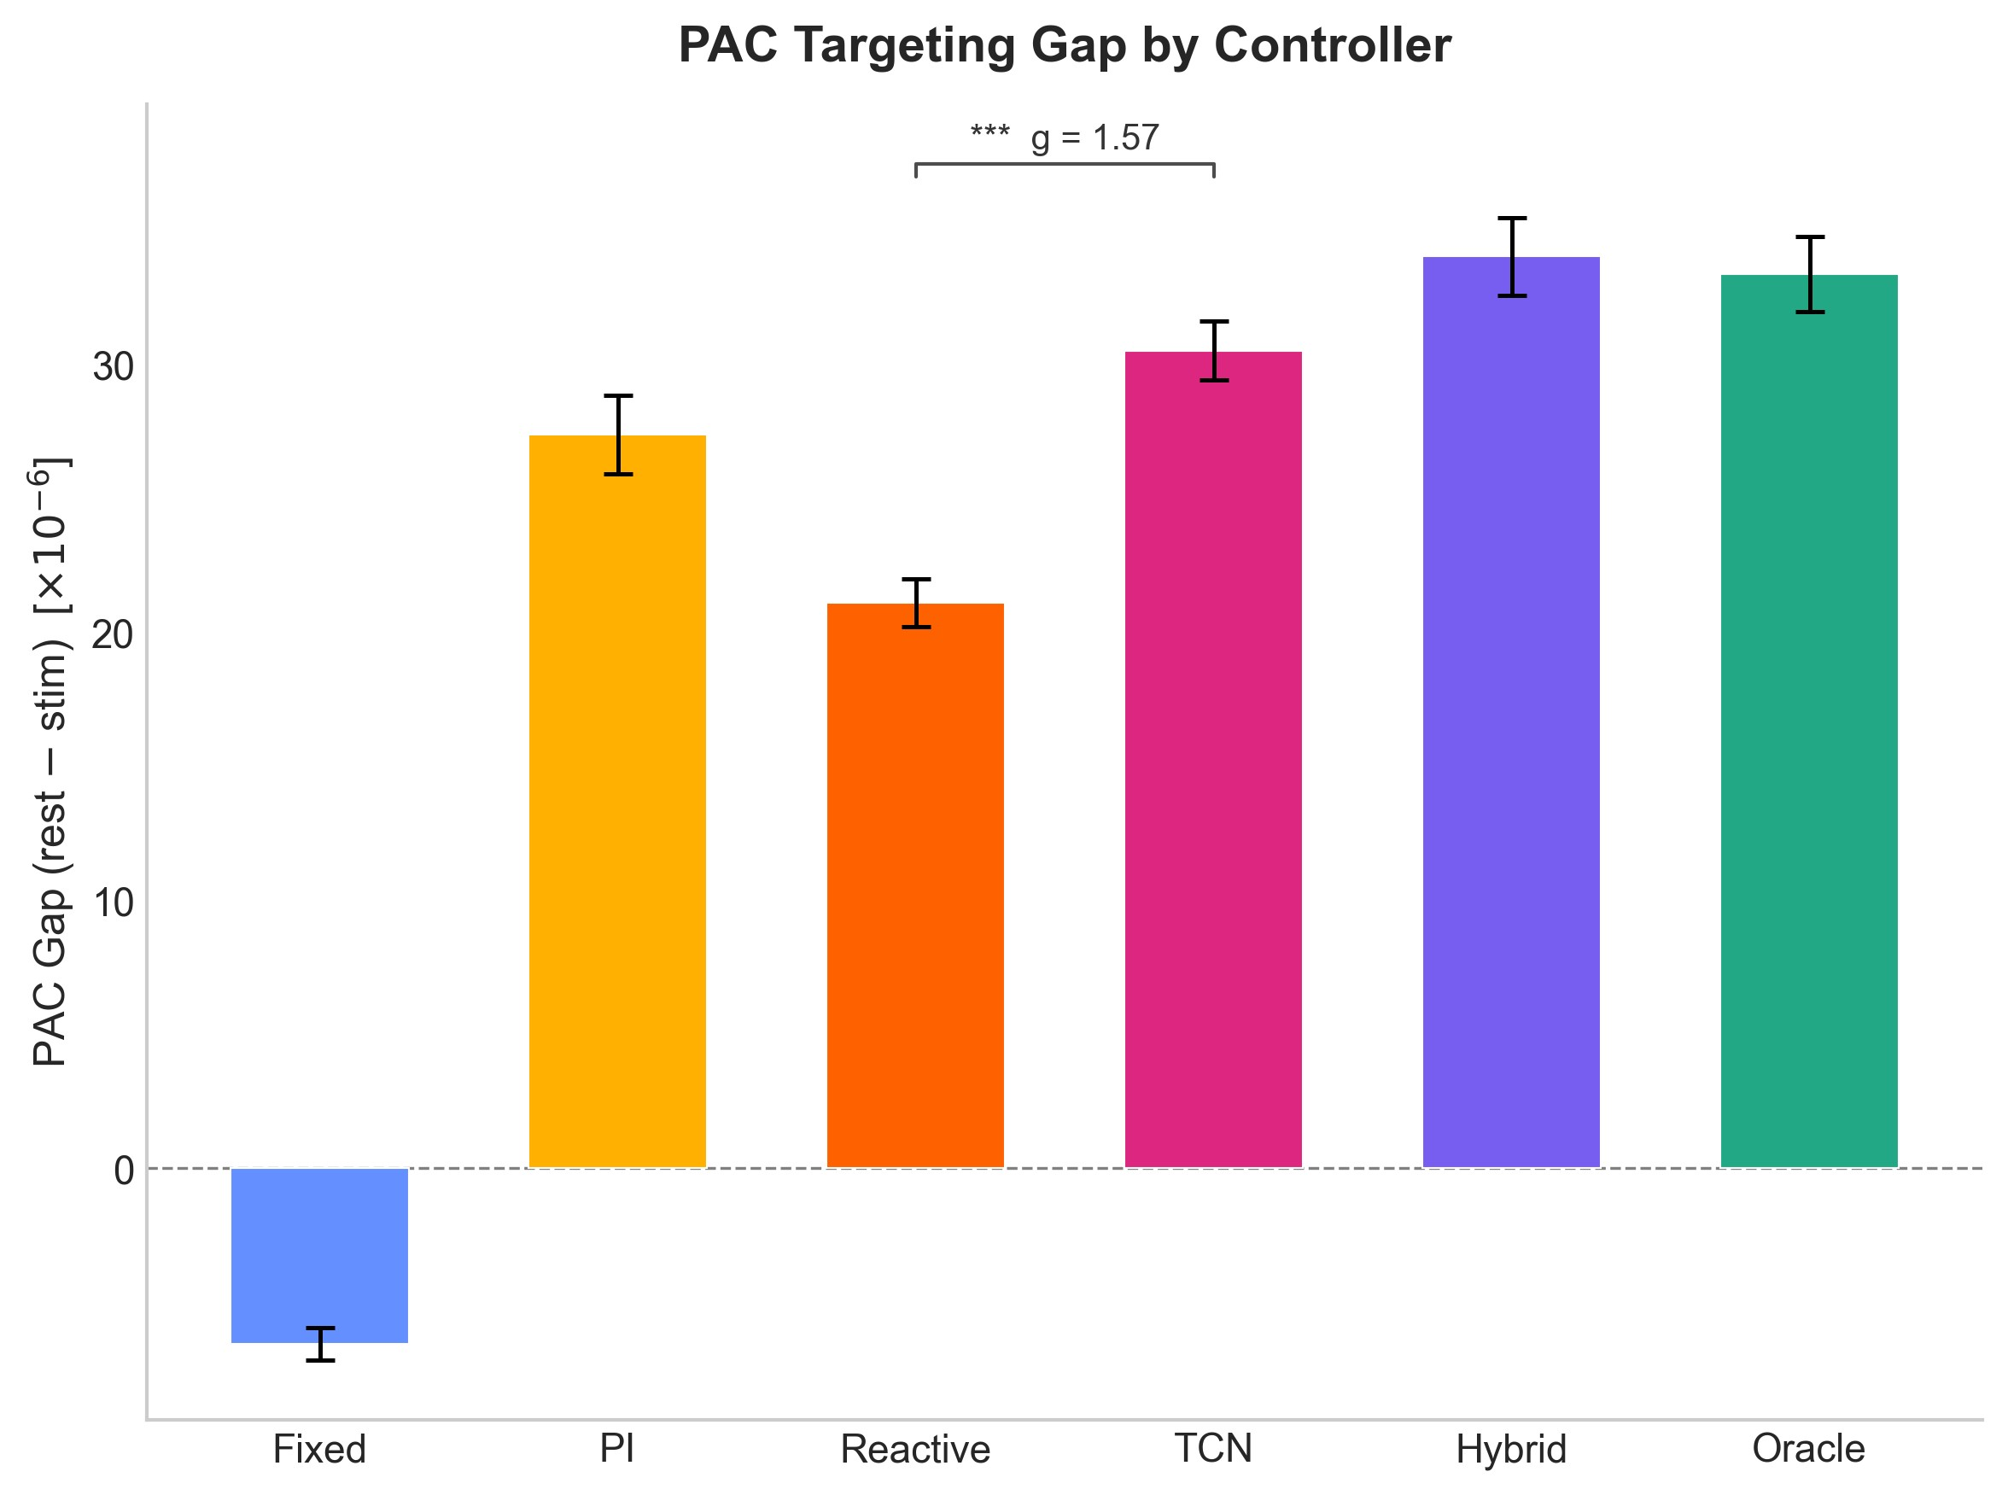
With the horizon sweep validating the TCN at 5 seconds, I built the full two-stage controller pipeline:
Raw EEG --> EEGNet (1,457 params) --> Current PAC Estimate
--> Feature Extraction (73 dimensions)
--> TCN (31,043 params) --> Future PAC (5s ahead)
--> Personalization Module --> Control Decision
The PersonalizationModule maintains a 30-second rolling buffer to compute a per-patient z-score baseline. The controller logic combines reactive z-score decisions with TCN-predicted PAC trends. If the TCN predicts PAC will decline, stimulate proactively; if it predicts PAC will rise, let the brain maintain naturally; otherwise fall back to reactive control based on the current z-score. A 5-second hysteresis prevents rapid changes of states.
LATENCY!: under 5 ms (EEGNet + TCN + control logic). Memory: under 100 MB. Decision rate: 1 Hz. Light enough for embedded devices and wearable tech in the future.

February 21, 2026
Built the validation protocol needed to test the controller on real subject trajectories. Built replay analysis framework (offline counterfactual analysis on recorded EEG), the validation scripts, and other tools.
Sub-question: does the adaptive advantage depend on specific mathematical assumptions about how neural fatigue works? I built an EntrainmentSimulator with four different fatigue mechanisms and tested across six severity levels.
Fatigue severity results (n = 50 trials each, 600-second sessions):
Fatigue Level | Fixed Efficiency | Adaptive Efficiency | Improvement
None | 0.343 | 0.375 | +9.5%*
Mild | 0.341 | 0.375 | +10.0%*
Moderate | 0.335 | 0.366 | +9.0%*
High | 0.319 | 0.354 | +10.8%*
Severe | 0.316 | 0.352 | +11.2%*
*p < 0.001, Hedges' g = 1.7-2.4 (large to very large effects). As fatigue worsens the advantage grows! With no fatigue at all, adaptive control helps by +9.5%, suggesting benefits beyond fatigue mitigation (targeting natural PAC fluctuations).
Fatigue model (4 different mathematical models, n = 50 trials each):
Fatigue Model | Advantage | p-value |  | Hedges' g
Exponential Decay | +9.0% | 1.8 x 10^-15 | 2.31
Step Function | +6.9% | 4.4 x 10^-14 | 1.21
Heterogeneous (50/50) | +8.9% | 2.5 x 10^-14 | 1.71
Saturation (synaptic) | +19.0% | 1.8 x 10^-15 | 3.66
All models showed significant advantage. The saturation model (probably most biologically realistic, based on Michaelis-Menten receptor kinetics) showed the largest benefit at +19.0% with g = 3.66. The advantage across four different mathematical formulations means for the real fatigue model my pipeline still provides benefit.
I also ran threshold sensitivity analysis on the TCN controller, testing delta-z thresholds from 0.1 to 1.0:
Delta-z Threshold | Alignment | Low-PAC Stim | PAC Gap (x10^-6)
0.1 | 59.6% | 51.2% | 12.4
0.2 | 68.5% | 72.9% | 26.3
0.3 | 73.7% | 84.9% | 32.4
0.4 | 73.9% | 85.3% | 33.7
0.5 | 73.7% | 85.3% | 33.8
1.0 | 73.8% | 85.3% | 34.0
Performance plateaus at delta-z >= 0.3 and consistently exceeds the reactive baseline across all thresholds >= 0.2. The results are not dependent on precise threshold tuning.
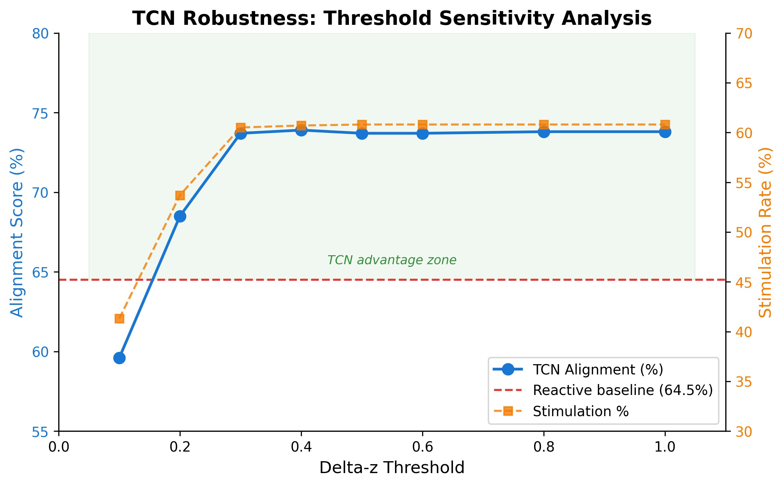
Gap note (February 22-25, 2026): Continued cleanup, figure generation, and validation. The final controller replay result was not locked until February 26.

February 26, 2026
This was the day the final controller comparison on real patient EEG was finished. The method: replay each subject's full EEG recording, have the controller make stimulate/rest decisions at each 2-second window, and compare those decisions against ground-truth PAC to compute alignment metrics. For this validation, I used ground-truth PAC labels as TCN input to isolate the TCN's predictive contribution from EEGNet estimation error.
Four controllers tested: Fixed Schedule (40s ON / 20s OFF), Reactive Threshold (z-score on current PAC), TCN Predictive (z-score + 5-second lookahead), and Oracle (theoretical upper bound).
Controller performance replayed on all 35 subjects' real EEG:
Controller | Alignment | Low-PAC  Targeting | PAC Gap (x10^-6) | Stim %
Fixed Schedule | 45.0% | 61.4% | -6.6 (wrong direction) | 66.6%
Reactive | 64.5% | 51.7% | +21.1 | 36.7%
TCN Predictive | 72.1% | 82.6% | +30.5 | 59.7%
Oracle (upper bound) | 100.0% | 100.0% | +33.3 | 48.3%

Alignment = (Low-PAC Stim Rate + High-PAC Rest Rate) / 2, balanced accuracy of therapeutic targeting. Low-PAC Targeting = percentage of below-median PAC windows where the controller stimulates ("did we treat when the brain needed it?"). PAC Gap = mean PAC during rest minus mean PAC during stim (positive means the controller correctly targets low-PAC periods).
TCN vs Reactive:
- Alignment: Hedges' g = +1.31, p < 0.001
- Low-PAC targeting: Hedges' g = +4.47, p < 0.001
- PAC gap: Hedges' g = +1.57, p < 0.001
- All Wilcoxon signed-rank tests, bootstrap 95% confidence intervals
Key findings:
The fixed schedule went in the wrong direction (-6.6), meaning it stimulated more during high-PAC than low-PAC periods. Timing was uncorrelated with brain state.
The TCN achieved 92% of oracle performance: PAC gap 30.5 versus 33.3 theoretical maximum (30.5/33.3 = 92%). It targeted 82.6% of low-PAC windows versus Reactive's 51.7%, a 60% improvement in timing. And it used less stimulation than Fixed Schedule (59.7% vs 66.6%), meaning better outcomes with less total stimulation.
The reactive controller missed 48% of low-PAC windows that needed treatment. Its conservatism (36.7% total stim) means high specificity but terrible sensitivity.
All 35 of 35 subjects showed higher clinical utility with TCN versus Reactive (binomial p < 0.001). This held for the 6 held-out test subjects never seen during training, demonstrating cross-subject generalization.
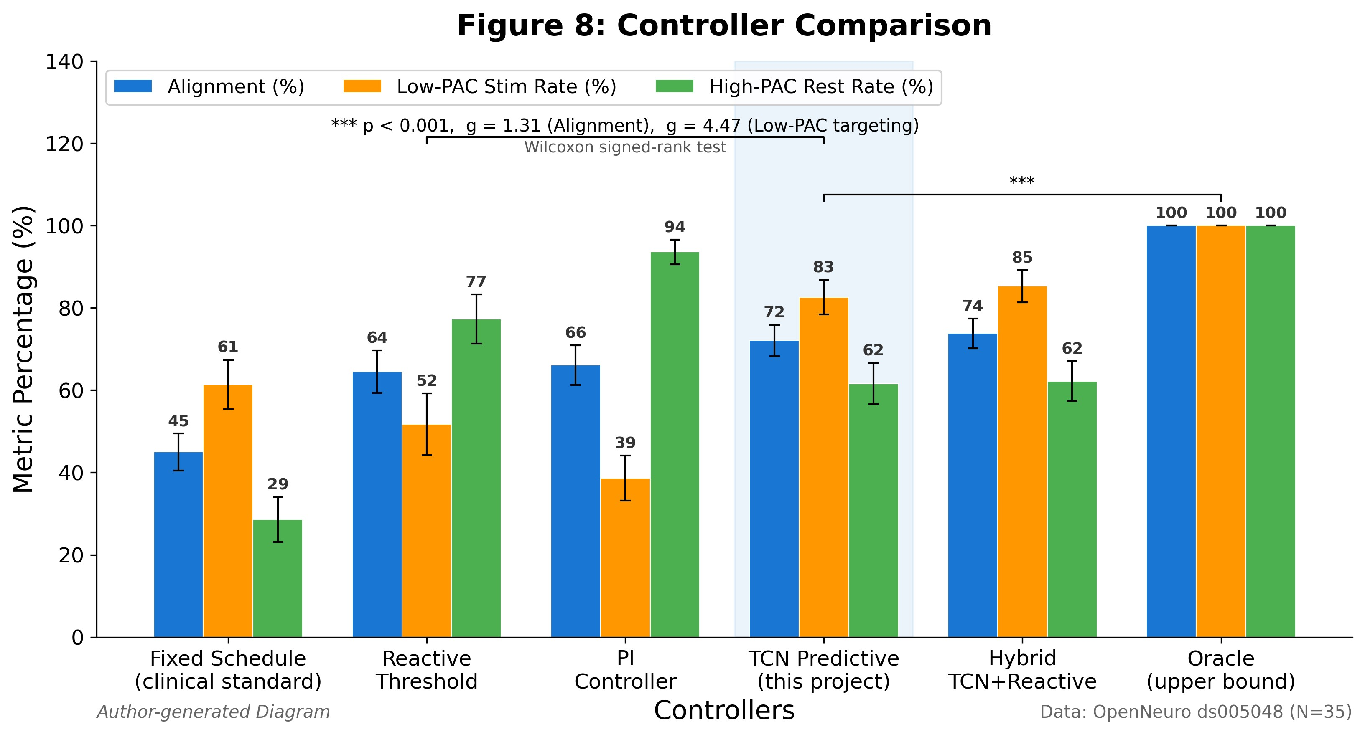
Controller comparison on all 35 subjects' real EEG recordings. TCN Predictive outperforms all alternatives on alignment, low-PAC targeting, and PAC gap.
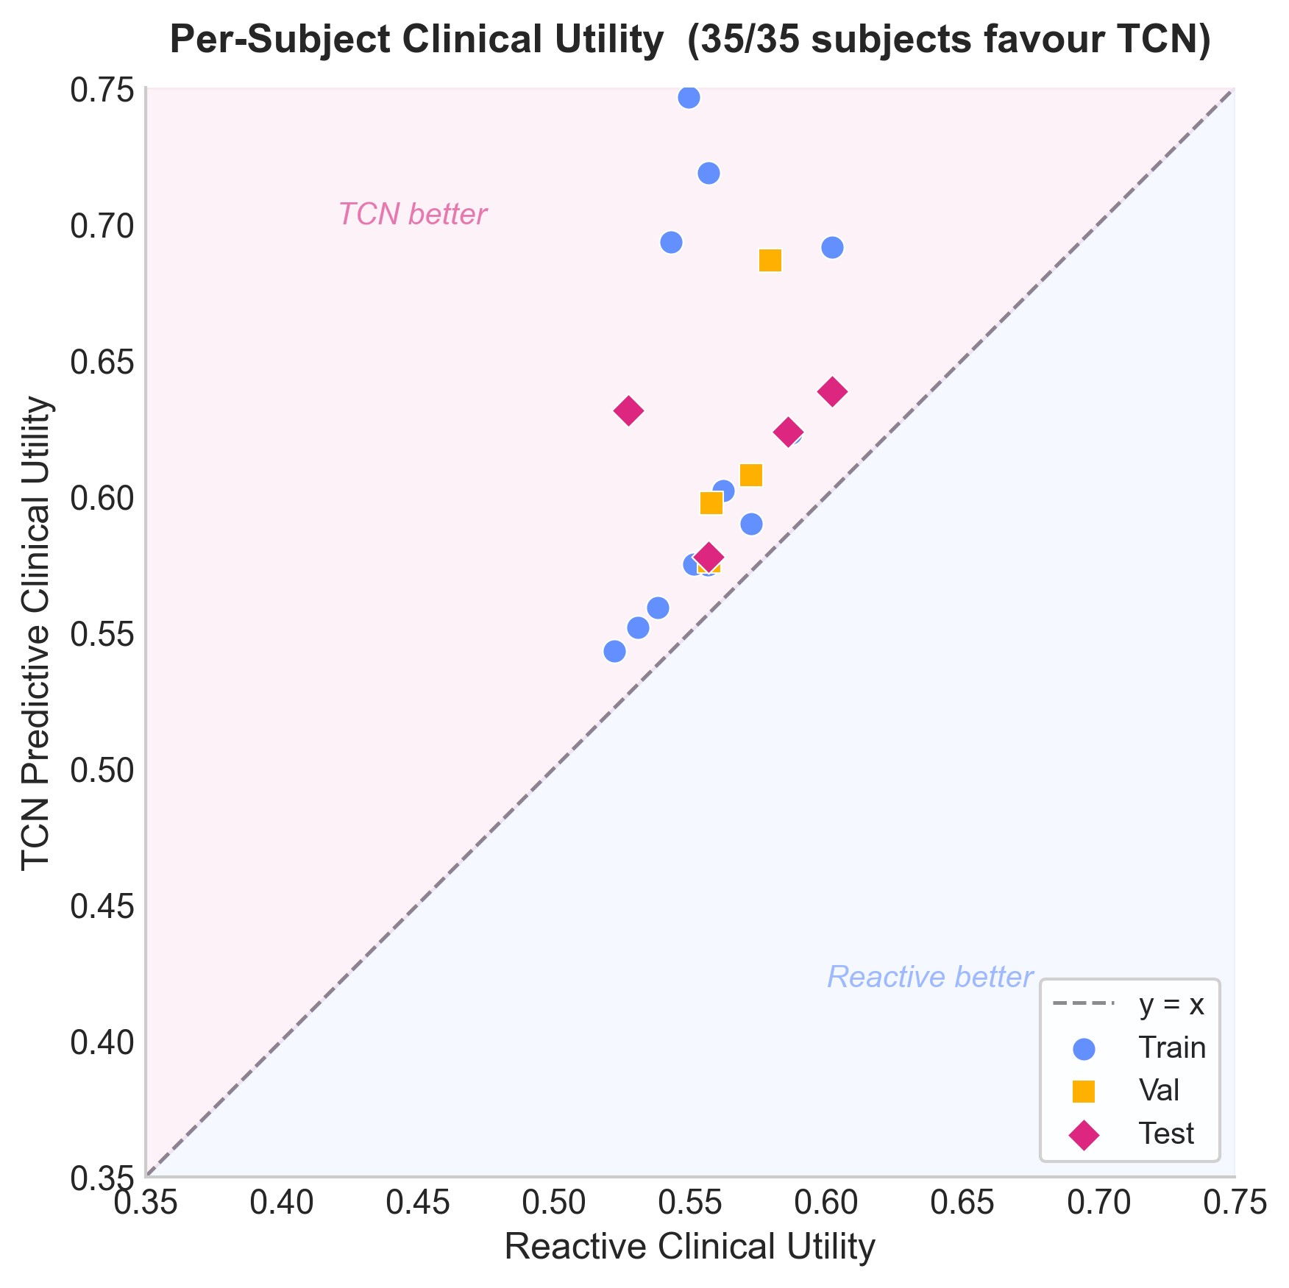
Every patient benefits: 35/35 subjects show higher utility with TCN vs Reactive.
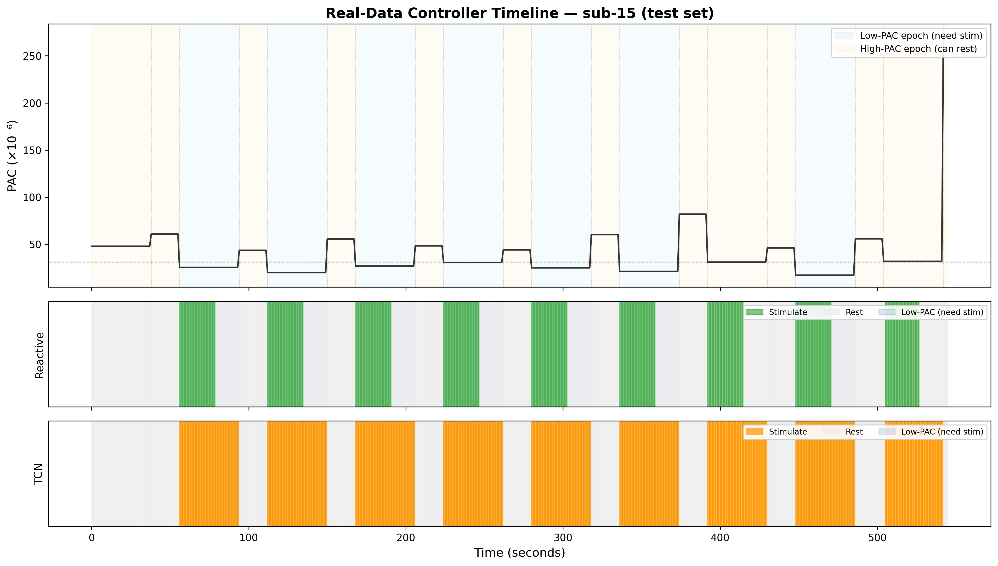
Example controller timeline for one subject, showing how the TCN-driven controller aligns stimulation with periods of low PAC.

March 1, 2026
I compiled all results into the poster, abstract, and this notebook for the Synopsys Science Fair submission.
Summary of the complete pipeline:
The system works in two stages. EEGNet (1,457 parameters) estimates current PAC from a 2-second raw EEG window. The Causal TCN (31,043 parameters) then ingests 20 seconds of 73-feature history and forecasts PAC 5 seconds ahead. A personalization module adapts to each patient's individual PAC baseline using a rolling z-score, and the controller uses the TCN's prediction to make proactive stimulation decisions with a 5-second hysteresis.
Conclusions, verified against the poster and validated results:
- At 5-10 second horizons, the TCN maintains R² around 0.25 while all baselines collapse below zero (+0.5 R² margin at the relevant range for proactive control).
- On real patient EEG: 72.1% alignment versus 64.5% reactive (p < 0.001), targeting 82.6% of low-PAC windows versus 51.7% (60% improvement in therapeutic targeting).
- All 35 patients benefited, including 6 held-out test subjects. Generalizes across individual EEG patterns.
- Adaptive advantage increases with fatigue (+9.0% to +11.2%) and holds across four fatigue model assumptions (Hedges' g = 1.21-3.66, all p < 0.001).
- Half of patients habituate while half do not, validating the need for personalized rather than fixed scheduling.
Limitation: The system makes decisions on real brain data but cannot observe the brain's response to those decisions.
Further research directions:
- Deploy with live EEG streaming for real time crossover validation (adaptive vs fixed within same session)
- Record 30-60 minute sessions to capture the full habituation time course
- Replace the heuristic controller with RL for long horizon optimization
- Extend to multi-biomarker control (PAC + spectral power + connectivity)

Equipment and Materials
- Compute: MacBook Pro (Apple M1 Pro, 16 GB RAM). All computation on local hardware.
- Software: Python 3.13, PyTorch, NumPy, SciPy, scikit-learn, h5py, MNE-Python. Git
- Dataset: OpenNeuro ds005048 (Lahijanian et al., 2024). 35 dementia patients, 7 frontal EEG channels, 250 Hz. Alternating stimulus (40 Hz AM auditory) and rest epochs. 17,283 two-second windows. Subject-level splits: 24 train / 5 val / 6 test. All data used under open access license.

References
Iaccarino, H. F., et al. (2016). Gamma frequency entrainment attenuates amyloid load and modifies microglia. Nature, 540(7632), 230-235.
Martorell, A. J., et al. (2019). Multi-sensory γ stimulation ameliorates Alzheimer's-associated pathology and improves cognition. Cell, 177(2), 256-271.
Tort, A. B., et al. (2010). Measuring phase-amplitude coupling between neuronal oscillations of different frequencies. Journal of Neurophysiology, 104(2), 1195-1210.
Lawhern, V. J., et al. (2018). EEGNet: A compact convolutional neural network for EEG-based brain-computer interfaces. Journal of Neural Engineering, 15(5), 056013.
Lahijanian, M., et al. (2024). Auditory γ-band entrainment enhances default mode network connectivity in dementia patients. Scientific Reports, 14, 13153.
Thompson, R. F., & Spencer, W. A. (1966). Habituation: A model phenomenon for the study of neuronal substrates of behavior. Psychological Review, 73(1), 16-43.

