**WaM-DaM Workshop**

Discover what water management data is available to run a WEAP model

Wednesday, July 15, 2015

(4:00 – 4:20 pm)

By

Adel Abdallah - [amabdallah@aggiemail.usu.edu](mailto:amabdallah@aggiemail.usu.edu)

David Rosenberg - [david.rosenberg@usu.edu](mailto:david.rosenberg@usu.edu)

WaM-DaM Repository

<https://github.com/amabdallah/WaM-DaM>

Workshop Material

Includes copies of this document, all data and scripts used in the workshop, as well as WaM-DaM documentation

<https://goo.gl/TT5sGh>

**As part of the**

**CI-WATER Tethys-ADHydro Workshop**

Wednesday, July 15, 2015

1:30 - 5:00 PM

3rd CUAHSI Conference on Hydroinformatics

Model and Data Interoperability: From Theory to Practice

July 15-17, 2015, Tuscaloosa, AL

**Summary**

This 20-minute workshop will introduce the Water Management Data Model (WaM-DaM) and demonstrate some WaM-DaM capabilities to search and discover water management data for use in water resources modeling.

**What is WaM-DaM?**

WaM-DaM is a persistent data model for water management data that overcomes semantic and syntactic heterogeneities of data sources and provides metadata important to correctly interpret data values. WaM-DaM synthesizes disparate water management data and allow users to discover and use data in their modeling.

You can use WaM-DaM if:

1. Your data are for nodes (points) and/or links (connections between nodes; Figure 1).
2. You have one or more data types such as binary, numeric parameters, seasonal, parameters, file-based, rules, time series, or multi-column arrays.

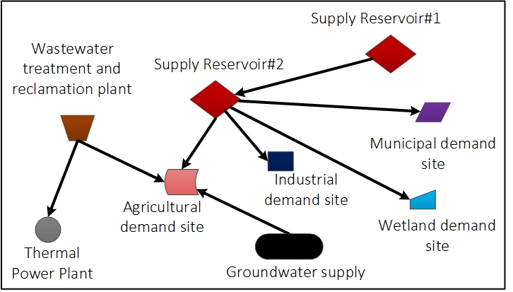

**Figure 1:** Node and link water management objects

Think of WaM-DaM as a repository of water management data (blue cylinder) plus translators between numerous data sources and your model(s) (Figure 2). WaM-DaM translates both the data syntax and semantics.

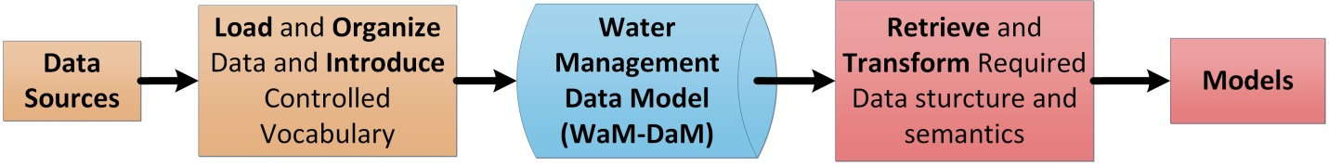

**Figure 2:** WaM-DaM serves as a data repository and translator between data sources and models

**Activity**

You will use a pre-populated WaM-DaM database in SQLite and ready SQL scripts to search and discover data to use in a Water Evaluation and Planning (WEAP) model. The WaM-DaM database is already loaded with data from five sources: National Dams dataset, National Waterbodies dataset, National Streams Network dataset, CUAHSI sites for the Bear River Basin, and a WEAP model for the Lower Bear River basin, Utah (Figure 3).

Below, activity instructions include software setup (Step 0, to be completed before the start of the workshop), and SQL queries, and discussion of results. In a bonus exercise, you will retrieve water management data for the Tuscaloosa basin of Alabama.

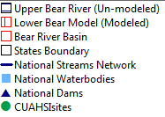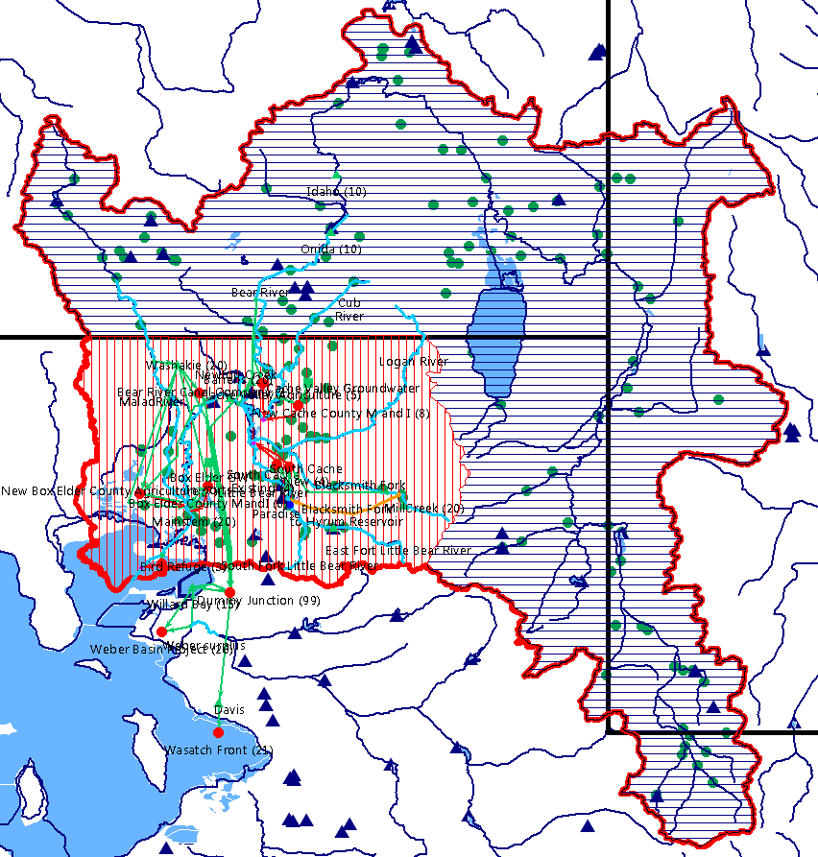

**Utah**

**Idaho**

**Wyoming**

**Figure 3:** Bear River Watershed and schematic of the Lower Bear River Model in WEAP

**Step 0. Set Up (to be completed prior to start of the workshop)**

Required software:

Mozilla Firefox: <https://www.mozilla.org/en-US/firefox/new>

1. **Download and set up the required software**
2. Install the free Mozilla Firefox web browser that is appropriate to your machine, if you don’t have it already

<https://www.mozilla.org/en-US/firefox/new/>

1. Launch Firefox and install the SQLite Manager
2. Copy and paste this link below into Firefox to install the SQLite Manager Add-on to Mozilla Firefox. It does not work to install the Add-On from Google Chrome <https://addons.mozilla.org/en-US/firefox/addon/sqlite-manager/>
3. Add the SQLite Manager to Firefox Menu as follows: Click on Firefox Settings >> Customize >> drag the blue SQLite Manager cylinder to the Firefox menu on the right as shown on the snapshot (Figure 4).

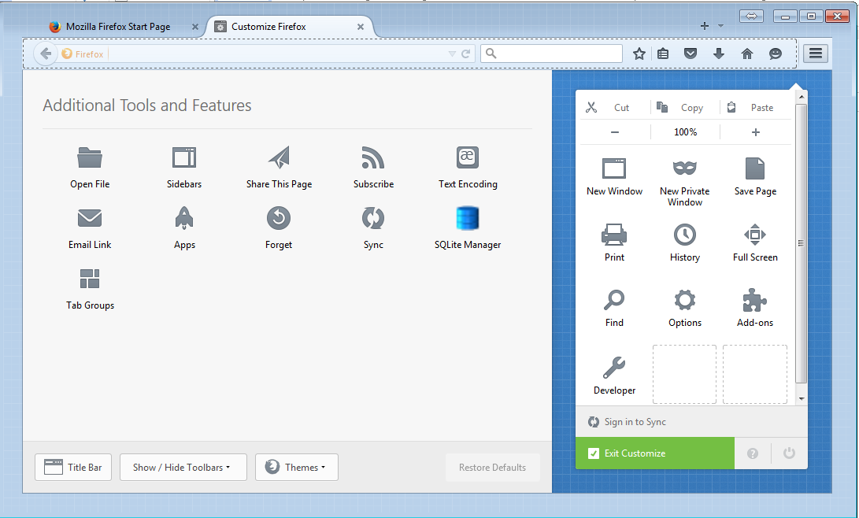

3. Drag the SQLite Manager it to here

1. Setting

2. Customize

**Figure 4:** screenshot of the process to add the SQLite Manager to Firefox

1. While Firefox is open, launch the SQLite Manager in Firefox by clicking on Settings >> click on the blue Manager cylinder. Now you can close Firefox and just keep the Manager’s interface that you will use to access WaM-DaM database.
2. Download one of these WaM-DaM SQLite database instances at your convenience and save it to a place that you can later navigate to like the Desktop

* WaMDaM.sqlite [67 MB] – best if you have a fast internet connection <https://goo.gl/KPEO2Z>
* WaMDaMzip.zip [30 MB] –requires WINZIP to unzip it <https://goo.gl/ZRBTSC>
* WaMDaM.rar [8 MB] – requires WINRAR to unzip it <https://goo.gl/KMVhXs>

1. **Open the WaM-DaM database.**
2. Launch Firefox
3. Click Firefox Setting at the top right corner, then click on the blue cylinder of SQLite Manager which will launch the Firefox SQLite Manager in a separate window.
4. In the SQLite Manager window, click on Database >> Connect Database. Navigate to the location where you saved WaM-DaM instance. Or you can click Open and then select WaM-DaM database.
5. Check out WaM-DaM tables. For example, select the AggregationStatistic table on the left side bar. Click on Browse and Search Button in the top middle of the Manager’s window to see the data values of the table you selected in the left side bar as shown in the screen snapshot (Figure 5).

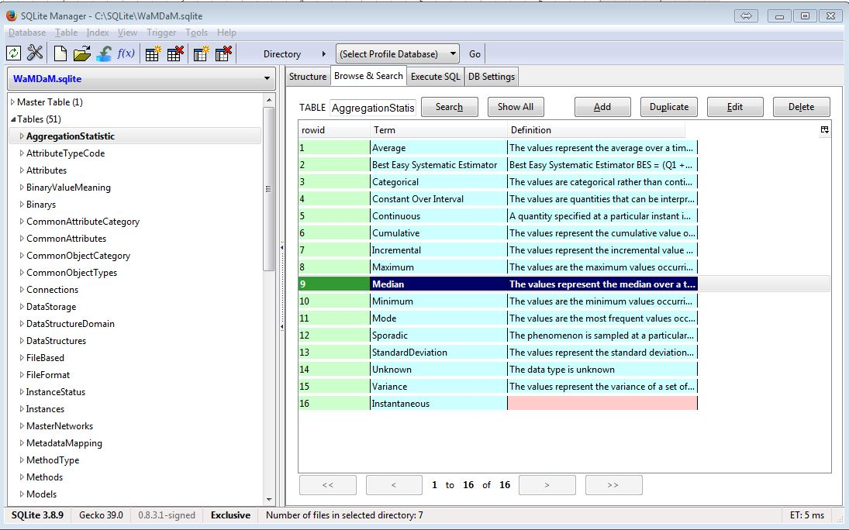

1. WaM-DaM tables

2. Browse and Search data

3. Data in the selected table

**Figure 5:** Screenshot of the SQLite Manager, WaM-DaM tables, and data for the AggregationStatistic table

**Step 1. Discover data**

Use SQL scripts to discover data in WaM-DaM.

1. **What are the required attributes for** **the WEAP model?**
2. Instructions: In the Enter SQL window, paste the command you find at this link <https://goo.gl/4L57yI> Then click Run SQL
3. Results: this screenshot shows the list of example Object Types that WEAP requires, their topology as node or link, and their list of attributes (Figure 6). The full list is provided in the query result.

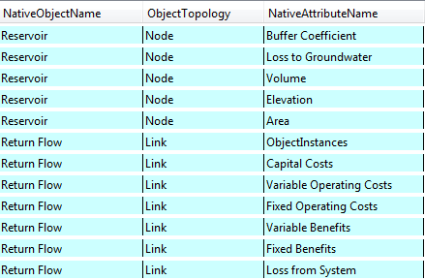

**Figure 6:** Screenshot of the SQL result of the example required attributes of the WEAP model

1. Discussion: this query summarizes the required data that users need to find to populate a specific instance of a WEAP model. For example, users need to look for data values of attributes like buffer coefficient that describe reservoirs and cost values for return flows in their model. WaM-DaM stores these objects and their attributes and associates them with the WEAP model.
2. **Discover** **available data to expand the Lower Bear River Model to the entire basin**
3. Instructions: In the Enter SQL window, paste the command you find at this link <https://goo.gl/c0hkp7>. Then click Run SQL. The search is based on a boundary of coordinates provided in the SQL script for instances in the upper Bear River Watershed . Users need to only change these coordinates in the provided SQL script to discover data in other regions.
4. Results: The query returns the available instances, their objects, and attributes along with their network and network source.
5. Discussion: Look at the results you generated in step ii. For what objects did WaM-DaM discover instances? How many instances did WaM-DaM find of a Reservoir Object? What are the networks in which WaM-DaM found these data? What is the next step a user should take to populate their WEAP model with this available data?

**Step 2. Bonus Activity. Discover available data for a WEAP model in the** **Tuscaloosa Region, AL**

1. Instructions: In the Enter SQL window, paste the command you find at this link <https://goo.gl/BCPZoq>. Then click Run SQL. This query is similar to the first question in searching for data for a WEAP model. However, this question uses different boundary of coordinates around the Tuscaloosa Region, AL.
2. Results: How many objects are available in the Tuscaloosa Region for a WEAP model? How many Reservoir instances are available to consider in the model?
3. Discussion: How can a user build a schematic of the existing instances?

**Workshop Feedback**

Please return to Adel Abdallah

*Please answer these questions to help us understand and then better serve your needs. You may alternatively provide feedback online at* [*https://goo.gl/SLS8vD*](https://goo.gl/SLS8vD)

1. What are your research interests and what water management data do you use in your research?
2. How do you currently organize and manage your water resources data? (e.g., text files, spreadsheets, a specific data management system, other)
3. From what you saw today, how can WaM-DaM help meet your data management needs?
4. How can we improve WaM-DaM to better serve your water management data needs?
5. Other comments or feedback?