**CRI 190 DISPUTE RESOLUTION AND CRISES/INCIDENT MANAGEMENT**

**Negotiation**

* Negotiation is a process where two parties in a conflict or disagreement try to reach a resolution together.
* “The reason to negotiate is to produce something better than the results that you can obtain without negotiation” (Fisher et al., 1991).
* The goal is to reach an agreement that is acceptable to all parties, to which they remain committed, and which they indeed implement.

**Mediation**

* Mediation is a process where a neutral person assists the parties in discussing the matter and reaching a resolution.
* A neutral person is a person who does not support either party in the conflict. This person is called the **mediator**, and they help the parties communicate.
* A mediator ensures that communication between the parties is fair and honest.
* The mediator can assist the parties in reaching an agreement between them but will **not** force the parties into a solution during mediation. Mediation takes place in private and the decisions made are private. Mediation can take place in person where parties meet face-to-face for discussions.
* After mediation, the parties can sign a **Memorandum of Agreement** (MOA). A MOA is a cooperative agreement written between the parties to obey the agreed terms and conditions.

**Mediation** is a mode of dispute resolution, where an amicable decision arises with the help of a third party known as a 'mediator,' without recourse to the court of law. It is a voluntary process, and unlike arbitration, it is more flexible; therefore, the parties to the dispute are under no obligation to agree to the settlement.

**Characteristics of Mediation:**

* Promotes communication and cooperation
* Provides a basis for you to resolve disputes on your own
* Voluntary, informal and flexible
* Private and confidential, avoiding public disclosure of personal or business problems
* Can reduce hostility and preserve ongoing relationships
* Allows you to avoid the uncertainty, time, cost and stress of going to trial
* Allows you to make mutually acceptable agreements tailored to meet your needs
* Can result in a win-win solution

**Advantages of mediation:**

* Parties have complete control over the settlement.
* Less stress as compared to litigation and arbitration.
* The relationship between the parties isn't overly damaged.
* Mediation proceedings are confidential.
* The process resolves the dispute quickly.

**Disadvantages of mediation:**

* Since the decision is at the discretion of the parties, there is the possibility that a settlement between the parties may not arise.
* It lacks the support of any judicial authority in its conduct.
* The absence of formality- Mediation proceedings are lacking in any procedural formality since they are not based on any legal principle.
* The truth of an issue may not be revealed.

**Litigation**

An action brought in court to enforce a particular right. The act or process of bringing a lawsuit in and of itself; a judicial contest; any dispute. When a person begins a civil lawsuit, the person enters into a process called litigation.

**Characteristics of Litigation:**

* Involuntary - a defendant must participate (no choice)
* Formal and structured rules of evidence and procedure
* Each party has the opportunity to present its evidence and argument and cross-examine the other side - there are procedural safeguards
* Public - court proceedings and records are open
* The decision is based on the law
* The decision can be final and binding
* Right of appeal exists
* Losing party may pay costs

**Advantages of Litigation in Dispute Resolution**

* Public Record
* Cooperation
* Precedent Value his is an ever-present advantage of litigation as it allows speedier dispute resolution where similar claims are made.
* Appeals can be either a pro or con depending on your circumstance.
* Evidence In the courts, the rules of what constitutes evidence are much stricter.
* In many circumstances, litigation can be a more cost-effective option, especially if it is a small dispute that could be resolved in court quickly.

**Arbitration**

* Arbitration is a process where a neutral third party makes a decision.
* The decision-makers in arbitration are called **arbitrators**. There can be one arbitrator or multiple.
* The arbitrator will arrange a meeting between the parties to determine what issues need to be resolved during the arbitration.
* Arbitral decisions are sometimes called **Awards**. Arbitral awards are generally final and compulsory. An award may be filed in court and enforced as if it were a court judgment.

**General principles of arbitration are as follows:**

* The object of arbitration is to obtain a fair resolution of disputes by an impartial third party without unnecessary expense or delay.
* Parties should be free to agree how their disputes are resolved, subject only to such safeguards as are necessary in the public interest.
* Courts should not interfere.

**Reconciliation**

* It is a method of facilitating frank engagements between minority communities, police and other authorities that allow them to address historical tensions, grievances, and misconceptions, and reset relationships.

**Principles of Reconciliation**

1. The United Nations Declaration on the Rights of Indigenous Peoples is the framework for reconciliation at all levels and across all sectors of Canadian society.

2. First Nations, Inuit, and Métis peoples, as the original peoples of this country and as self-determining peoples, have Treaty, constitutional, and human rights that must be recognized and respected.

3. Reconciliation is a process of healing of relationships that requires public truth sharing, apology, and commemoration that acknowledge and redress past harms.

4. Reconciliation requires constructive action on addressing the ongoing legacies of colonialism that have had destructive impacts on Aboriginal peoples’ education, cultures and languages, health, child welfare, the administration of justice, and economic opportunities and prosperity.

5. Reconciliation must create a more equitable and inclusive society by closing the gaps in social, health, and economic outcomes that exist between Aboriginal and non-Aboriginal Canadians.

6. The perspectives and understandings of Aboriginal Elders and Traditional Knowledge

Keepers of the ethics, concepts, and practices of reconciliation are vital to long-term reconciliation.

7. Supporting Aboriginal peoples’ cultural revitalization and integrating Indigenous knowledge systems, oral histories, laws, protocols, and connections to the land into the reconciliation process is essential.

8. Reconciliation requires political will, joint leadership, trust building, accountability, and transparency, as well as a substantial investment of resources.

**Retributive Justice vs. Restorative Justice**

The Criminal Justice System is retributive and focuses on establishing guilt and punishing the person who broke the law. Retributive justice is based on three questions:

1. What law was broken?
2. Who broke the law?
3. What is the punishment?

On the other hand, restorative justice is a dialogue-driven approach that restores victims, offenders and community members who have been harmed by crime. Ideally, each stakeholder should be actively involved in the justice process. Restorative justice is based on a different set of questions:

1. What is the harm?
2. How do we repair the harm?
3. Who is responsible for repairing the harm

| *RETRIBUTIVE JUSTICE* | *RESTORATIVE JUSTICE* |
| --- | --- |
| Crime is a violation of the law and state | Crime is a violation of people and relationships |
| Violations create guilt and require someone to blame | Violations create obligations |
| Justice requires the state to determine guilt and impose punishment | Justice require victims, offenders and community members in an effort to make the right things |
| Central focus: offenders get what they deserve | Central focus: meet needs of a person harmed, primarily by the person who caused the harm |

**Basic Concept of Crises and Incident Management**

**What is Crisis?**

Crisis, came from the Greek word crisis, which means to separate. As defined by Wagnalls, crisis is a turning point in the progress of an affair or a series of events.

**Peace and Order Council** - shall primarily act on the crisis situation which arises out of man-made emergencies.

**National Action Committee on Anti-Hijacking and Anti-Terrorism (NACAHT)-** principally deal with the crisis situation which results from aircraft hijacking, disturbances in the civil aviation or terrorism that has a national significance.

**National Disaster Coordinating Council -** primarily address crises as a result of natural disasters or calamities.

**The 4P Crisis Management Model Crisis incidents** occur when they are least expected. What make these incidents crises situations is when they go out of control and cause destruction to lives property or endanger public safety.

The **4P Crisis Management Model** is envisioned dress crises situations in two-phases the Proactive and the Reactive in four Prediction, Prevention, Preparation and Performance

**Phases of Crisis Management**

Crisis management is continuing activity that has two distinct phases: The May and the Re-active phase.

**a. The Proactive Phase**.

This phase is designed to predict or prevent the probability of occurrence the same time prepare to handle them when they occur. It encompasses 3Ps of the 4P Crisis Management Model prediction, prevention

**(1) Prediction**

This stage involves foretelling of the likelihood of crises occurring or manmade through the continuous assessment of the all-possible threats and threats groups, as well as the analysis of developing or reported events and incidents. Crises incidents can be predicted through updated inputs from intelligence reports as well as the continuous monitoring and analysis of the confluence of related events.

**(2) Prevention**

When most man-made crises/emergencies, this stage involves the institution of passive and active security measures, as well as the remedy or solution of destabilizing factors and/insecurity flaws leading to such crises/emergencies.

**(3) Prepare**

Preparation for crises/emergencies entails planning, organization, training and stockpiling of equipment and supplies needed for such crises/emergencies. Simulated drills at unspecified days and times test the effectiveness of preparations, bring out flaws and weaknesses, and corrections/remedies effected to heighten levels of readiness of systems, procedures, organization, equipment and logistics to better cope with actual crises/emergencies.

**b. The Reactive Phase**

Performance This phase covers the last of the 4Ps, Performance, which is the actual execution or implementation of any of contingency plan when a crisis situation occurs despite the pro-active measures. The objectives in this stage are: to ensure a high probability of success in neutralizing the perpetrator(s); to minimize, or cushion the adverse effects of the crisis incident; and, to ensure a smooth and speedy rehabilitation or return to normalcy

**Nature of Crises**

Crises events (Ex. unexpected, high uncertainty, cascading dynamics, limited time to act) pose from an institutional point of view, quite different challenges than those normally addressed by the global environmental governance research community. These are related to the need for early warnings, multilevel networked responses, and improvisation. In addition, crises force us to reconsider the way we look at communication technologies in global environmental governance. (Ex. Pandemic)

**Crisis Defined**

Crisis refers to sudden unplanned events which cause major disturbances in the organization and trigger a feeling of fear and threat amongst the employees.

**Types of Crisis**

1. **Natural Crisis -** Disturbances in the environment and nature lead to natural crisis. Such events are generally beyond the control of human beings. Tornadoes, Earthquakes, Hurricanes, Landslides, Tsunamis, Flood, Drought all result in natural disaster.
2. **Confrontation Crisis -** arise when employees fight amongst themselves. Individuals do not agree to each other and eventually depend on non-productive acts like boycotts, strikes for indefinite periods and so on.

3. **Crisis of Organizational Misdeeds -** arise when management takes certain decisions knowing the harmful consequences of the same towards the stakeholders and external parties.

**4. Sudden Crisis -** such situations arise all of a sudden and on an extremely short notice.

**5. Smoldering Crisis -** Neglecting minor issues in the beginning lead to smoldering crisis later.

**6. Crisis of Malevolence -** Organizations face crisis of malevolence when some notorious employees take the help of criminal activities and extreme steps to fulfill their demands.

**7. Technological Crisis -** arises as a result of failure in technology. Problems in the overall systems lead to technological crisis. Breakdown of machine, corrupted software and so on give rise to technological crisis.

**8. Crisis due to Workplace Violence -** Such a type of crisis arises when employees are indulged in violent acts such as beating employees, superiors in the office premises itself.

**9. Crisis Due to Rumors -** Spreading false rumors about the organization and brand lead to crisis. Employees must not spread anything which would tarnish the image of their organization.

**Importance of Crisis Management**

The best way for your organization to deal with a crisis is to take the time to plan for one before it happens. A proactive approach will serve your organization and your brand well. Here are four key strategies for effective Crisis Management:

**Be Prepared**

Take the time to be proactive and get ahead of the story. The time spent planning for what might happen will help to streamline your response and protect your brand when a crisis happens.

* Assemble a Crisis Communications Team
* Brainstorm with your team all possible crisis scenarios – if it can go wrong, it will go wrong
* Designate a spokesperson to ensure consistency in your communication
* Train your team on what their specific response will be based on their title/role within the organization

Planning ensures that everyone in your organization is on the same page making your response more effective.

**Act Quickly**

Get ahead of the situation as quickly as possible to help diffuse negative response. Apologize, if necessary, and communicate effectively. The longer it takes for your organization to respond, the harder it will be to overcome all negative thoughts and feelings regarding the situation.

**Monitor Social Media and Other Messages**

Keep a pulse on social media and other media outlet responses in order to stay ahead of the story. You can communicate most effectively when you know what is being said and by whom.

**Be Transparent and Accountable**

Be honest in your response. The best way to rebuild and maintain trust is to be honest and transparent throughout the situation. Acknowledge what has happened, accept responsibility, and communicate the steps your organization will take to move forward.

**Essential Features of Crisis Management**

* Crisis Management includes activities and processes which help the managers as well as employees to analyse and understand events which might lead to crisis and uncertainty in the organization.
* Crisis Management enables the managers and employees to respond effectively to changes in the organization culture.
* It consists of effective coordination amongst the departments to overcome emergency situations.
* Employees at the time of crisis must communicate effectively with each other and try their level best to overcome tough times. Points to keep in mind during crisis
* Don’t panic or spread rumors around. Be patient.
* At the time of crisis, the management should be in regular touch with the employees, external clients, stake holders as well as media.
* Avoid being too rigid. One should adapt well to changes and new situations.

**Preparation and Prevention of Crises**

* Security and Safety Risk Analysis
* Integrated Prevention Systems Solutions
* Crisis Incident Management Response
* Plan Testing and Evaluation
* Resource sourcing and acquisitions

**Methods, Techniques and Strategies of Negotiation and Mediation.**

**What are strategies and technique?**

Strategies can be thought of as goals that you can use to prioritize and focus your efforts in creating and implementing your design. Techniques are concrete ways of accomplishing those goals.

**Strategies and Technique of Mediation**

A good mediator uses many strategies and tactics to help the parties reach agreement. These include:

1. [**Ripeness-Promoting Strategies**](https://www.beyondintractability.org/essay/ripeness-promoting-strategies)**:** strategies to convince people that negotiation is preferable to continued confrontation.

2. [**Convening Processes**](https://www.beyondintractability.org/essay/convening-processes)**:** The role of convening is to bring disputants to a preliminary meeting where they will discuss the issues of a conflict and consider options for its resolution. Tasks involved include assessing the conflict situation, identifying key stakeholders and participants, introducing options for a resolution process, and considering ground rules.

3. [**Conflict Assessment**](https://www.beyondintractability.org/essay/conflict-assessment)**:** The process of determining what is going on, who is involved, what options for resolution might be possible, what procedural approaches might work.

4. [**Ground Rules**](https://www.beyondintractability.org/essay/ground-rules)**:** Safe places in communication also tend to be created and sustained when the ground rules of the encounter are clearly set forth and agreed upon at the first meeting. Rules such as no interrupting, giving every participant equal opportunity to speak, and not pressuring individuals to speak who do not yet feel comfortable doing so are some commonly used rules.

5. [**Codes of Conduct for Intervenors**](https://www.beyondintractability.org/essay/codes-conduct-intervenors)**:** Just as ground rules set the codes of conduct for participants, mediators also have codes of conduct. While some are negotiated on a case-by-case basis, others are fairly standard and are specified in various existing documents.

6. [**Sequencing Strategies and Tactics**](https://www.beyondintractability.org/essay/issue-segmentation)**:** Mediators dealing with very large social conflicts have to skilfully manage a very [complex](https://www.beyondintractability.org/essay/complexity) and diverse set of challenges. In order to do that, these people must think about the best way to order or sequence the issues involved in their conflict. This essay describes some sequencing models and tactics.

7. [**Creating Safe Spaces for Communication**](https://www.beyondintractability.org/essay/safe-spaces)**:** Due to [misunderstandings](https://www.beyondintractability.org/essay/misunderstandings), [distrust](https://www.beyondintractability.org/essay/distrust), and [prejudice](https://www.beyondintractability.org/essay/prejudice), communication between parties is often difficult. This essay discusses various obstacles to effective communication and explores how to create a supportive climate in which parties feel comfortable discussing their differences.

8. [**Reframing**](https://www.beyondintractability.org/essay/joint-reframing)**:** Parties enter into mediation with their own interpretation of the problem: what issues are in dispute, why the problem has arisen, and how best to resolve it. One of the first things a mediator does is to get the parties to explain their view of the problem so that each side sees how the other is framing the conflict. The mediator then helps disputants to redefine the way they think about the dispute and work toward a common definition of the problem.

9. [**Option Identification**](https://www.beyondintractability.org/essay/option-identification)**:** Option identification is an essential step in the process of resolving any conflict. Once all parties to the conflict have identified the issues under contention, they should systematically list ALL options that they see available to them for advancing their interests. Often this is the most creative step of the mediation process.

10. [**Focusing on Commonalities**](https://www.beyondintractability.org/essay/commonalities)**:** Working towards a solution often requires that parties both understand their differences and yet focus on their commonalities. This essay outlines some strategies for locating common ground.

11. [**Caucus**](https://www.beyondintractability.org/essay/caucus)**:** Caucuses are meetings that mediators hold separately with each side of a dispute in order to keep mediation moving forward. They can be called by the mediator or by one of the parties to work out problems that occur during the process. This essay outlines the basic steps of a caucus and their role in effective mediation processes. It also discusses the downsides of caucusing.

**Different negotiation technique and strategy in different cases/scenario**

***Negotiating Strategies for Schizophrenic Individuals***

* Avoid convincing them of the reality;
* Avoid entering the unreal;
* Attempt to understand;
* Avoid getting the services of the hostage-taker’s family as intermediaries;
* Avoid getting the services of health professionals because schizophrenic

individuals have a negative view of them; and

* Avoid staring or getting too close

***Negotiating Strategy for Antisocial Individuals***

* Be reminded of the subjects’ egocentricity;
* Keep the subject busy;
* Convince the subject that safe releases are to his advantage;
* Be reality-oriented; and
* Avoid non-police intermediaries.

***Negotiating Strategy for Inadequate Individuals***

* Try to find a way of resolving the situation to avoid failure;
* Try to talk more about success; and
* Try to raise self-esteem.

***Negotiating Strategy for Depressed Individuals***

* Be patient for replies;
* Avoid getting friends of the depressed individuals to assist since their presence may escalate guilt;
* Beware of sudden improvements;
* Do not crowd and avoid small body space;
* Beware suicide by cop;
* Discuss “real world” vs. “abstract”;
* Postpone action instead of changing mood; and
* Empathy

**Republic Act No. 9285**

**AN ACT TO INSTITUTIONALIZE THE USE OF AN ALTERNATIVE DISPUTE RESOLUTION SYSTEM IN THE PHILIPPINES AND TO ESTABLISH THE OFFICE FOR ALTERNATIVE DISPUTE RESOLUTION, AND FOR OTHER PURPOSES**

**CHAPTER 1 - GENERAL PROVISIONS**

**SECTION 1. Title.** - This act shall be known as the "Alternative Dispute Resolution Act of 2004."

**SEC. 3. Definition of Terms.** - For purposes of this Act, the term:

**(a) "Alternative Dispute Resolution System"** means any process or procedure used to resolve a dispute or controversy, other than by adjudication of a presiding judge of a court or an officer of a government agency, as defined in this Act, in which a neutral third party participates to assist in the resolution of issues, which includes arbitration, mediation, conciliation, early neutral evaluation, mini-trial, or any combination thereof;

**(b) "ADR Provider"** means institutions or persons accredited as mediator, conciliator, arbitrator, neutral evaluator, or any person exercising similar functions in any Alternative Dispute Resolution system. This is without prejudice to the rights of the parties to choose non accredited individuals to act as mediator, conciliator, arbitrator, or neutral evaluator of their dispute. Whenever referred to in this Act, the term "ADR practitioners" shall refer to individuals acting as mediator, conciliator, arbitrator or neutral evaluator;

**(c) "Authenticate"** means to sign, execute or adopt a symbol, or encrypt a record in whole or in part, intended to identity the authenticating party and to adopt, accept or establish the authenticity of a record or term;

**(d) "Arbitration"** means a voluntary dispute resolution process in which one or more arbitrators, appointed in accordance with the agreement of the parties, or rules promulgated pursuant to this Act, resolve a dispute by rendering an award;

**(e) "Arbitrator"** means the person appointed to render an award, alone or with others, in a dispute that is the subject of an arbitration agreement;

**(f) "Award"** means any partial or final decision by an arbitrator in resolving the issue in a controversy;

**(g) "Commercial Arbitration"** An arbitration is "commercial if it covers matter arising from all relationships of a commercial nature, whether contractual or not;

**(h) "Confidential information"** means any information, relative to the subject of mediation or arbitration, expressly intended by the source not to be disclosed, or obtained under circumstances that would create a reasonable expectation on behalf of the source that the information shall not be disclosed. It shall include (1) communication, oral or written, made in a dispute resolution proceedings, including any memoranda, notes or work product of the neutral party or non-party participant, as defined in this Act; (2) an oral or written statement made or which occurs during mediation or for purposes of considering, conducting, participating, initiating, continuing of reconvening mediation or retaining a mediator; and (3) pleadings, motions manifestations, witness statements, reports filed or submitted in an arbitration or for expert evaluation;

**(i) "Convention Award"** means a foreign arbitral award made in a Convention State;

**(j) "Convention State"** means a State that is a member of the New York Convention;

**(k) "Court"** as referred to in Article 6 of the Model Law shall mean a Regional Trial Court;

**(l) "Court-Annexed Mediation"** means any mediation process conducted under the auspices of the court, after such court has acquired jurisdiction of the dispute;

**SEC. 4. Electronic Signatures in Global and E-Commerce Act.** - The provisions of the Electronic Signatures in Global and E-Commerce Act, and its implementing Rules and Regulations shall apply to proceeding contemplated in this Act.

**SEC. 5. Liability of ADR Provider and Practitioner.** - The ADR providers and practitioners shall have the same civil liability for the Acts done in the performance of then duties as that of public officers as provided in Section 38 (1), Chapter 9, Book of the Administrative Code of 1987.

**SEC. 6. Exception to the Application of this Act.** - The provisions of this Act shall not apply to resolution or settlement of the following: (a) labor disputes covered by Presidential Decree No. 442, otherwise known as the Labor Code of the Philippines, as amended and its Implementing Rules and Regulations; (b) the civil status of persons; (c) the validity of a marriage; (d) any ground for legal separation; (e) the jurisdiction of courts; (f) future legitime; (g) criminal liability; and (h) those which by law cannot be compromised.

**CHAPTER 2 MEDIATION**

**SEC. 8. Application and Interpretation.** - In applying construing the provisions of this Chapter, consideration must be given to the need to promote candor or parties and mediators through

confidentiality of the mediation process, the policy of fostering prompt, economical, and amicable resolution of disputes in accordance with the principles of integrity of determination by the parties, and the policy that the decision-making authority in the mediation process rests with the parties.

**SEC. 9. Confidentiality of Information.** - Information obtained through mediation proceedings shall be subject to the following principles and guidelines:

**(a)** Information obtained through mediation shall be privileged and confidential.

**(b)** A party, a mediator, or a nonparty participant may refuse to disclose and may prevent any other person from disclosing a mediation communication.

**(c)** Confidential Information shall not be subject to discovery and shall be inadmissible if any adversarial proceeding, whether judicial or quasi-judicial, However, evidence or information that is otherwise admissible or subject to discovery does not become inadmissible or protected from discovery solely by reason of its use in a mediation.

**(d)** In such an adversarial proceeding, the following persons involved or previously involved in a mediation may not be compelled to disclose confidential information obtained during mediation: (1) the parties to the dispute; (2) the mediator or mediators; (3) the counsel for the parties; (4) the nonparty participants; (5) any persons hired or engaged in connection with the mediation as secretary, stenographer, clerk or assistant; and (6) any other person who obtains or possesses confidential information by reason of his/her profession.

**(e)** The protections of this Act shall continue to apply even of a mediator is found to have failed to act impartially.

**(f)** a mediator may not be called to testify to provide information gathered in mediation. A mediator who is wrongfully subpoenaed shall be reimbursed the full cost of his attorney's fees and related expenses.

**SEC. 14. Participation in Mediation.** - Except as otherwise provided in this Act, a party may designate a lawyer or any other person to provide assistance in the mediation. A lawyer of this right shall be made in writing by the party waiving it. A waiver of participation or legal representation may be rescinded at any time.

**SEC. 15. Place of Mediation.** - The parties are free to agree on the place of mediation. Failing such agreement, the place of mediation shall be any place convenient and appropriate to all parties.

**SEC. 16. Effect of Agreement to Submit Dispute to Mediation Under Institutional Rules.** - An agreement to submit a dispute to mediation by any institution shall include an agreement to be bound by the internal mediation and administrative policies of such institution. Further, an agreement to submit a dispute to mediation under international mediation rule shall be deemed to include an agreement to have such rules govern the mediation of the dispute and for the mediator, the parties, their respective counsel, and non-party participants to abide by such rules.

**CHAPTER 3 - OTHER ADR FORMS**

**SEC. 18. Referral of Dispute to other ADR Forms.** - The parties may agree to refer one or more or all issues arising in a dispute or during its pendency to other forms of ADR such as but not limited to (a) the evaluation of a third person or (b) a mini-trial, (c) mediation-arbitration, or a combination thereof.

**CHAPTER 5 - DOMESTIC ARBITRATION**

**SEC. 32. Law Governing Domestic Arbitration.** - Domestic arbitration shall continue to be governed by Republic Act No. 876, otherwise known as "The Arbitration Law" as amended by this Chapter. The term "domestic arbitration" as used herein shall mean an arbitration that is not international as defined in Article (3) of the Model Law.

**SEC. 33. Applicability to Domestic Arbitration.** - Article 8, 10, 11, 12, 13, 14, 18 and 19 and 29 to 32 of the Model Law and Section 22 to 31 of the preceding Chapter 4 shall apply to domestic arbitration.

**CHAPTER 8 - MISCELLANEOUS PROVISIONS**

**SEC. 49. Office for Alternative Dispute Resolution.** - There is hereby established the Office for Alternative Dispute Resolution as an attached agency to the Department of Justice (DOJ) which shall have a Secretariat to be headed by an executive director. The executive director shall be appointed by the President of the Philippines. The objective of the office is:

**(a)** to promote, develop and expand the use of ADR in the private and public sectors; and

**SEC. 50. Powers and Functions of the Office for Alternative Dispute Resolution.** - The Office for Alternative Dispute Resolution shall have the following powers and functions:

**(a)** To formulate standards for the training of the ADR practitioners and service providers;

**(b)** To certify that such ADR practitioners and ADR service providers have undergone the professional training provided by the office;

**(c)** To coordinate the development, implementation, monitoring, and evaluation of government ADR programs;

**(d)** To charge fees for their services; and

**(e)** To perform such acts as may be necessary to carry into effect the provisions of this Act.

**SEC. 53. Applicability of the Katarungan Pambarangay.** - This Act shall not be interpreted to repeal, amend or modify the jurisdiction of the Katarungan Pambarangay under Republic Act No. 7160, otherwise known as the Local Government Code of 1991.

**Police Critical Incident Management**

**Characteristics of critical incidents** **Police response**

* Incident Management Team
* Duties and Responsibilities, it is the primary responsibility of the Incident Management Team (IMT) to:
* As the overall in-charge of on-scene response decisions;
* Manage all resources checked-in;
* Receive and implement the directives of the RO;
* Ensure the safety of all personnel and other resources deployed for operations;
* Manages the provision of logistical requirements to support the conduct of the operations;
* Documents and reports all situation updates and actions taken to the RO through the EOC;
* Requests for additional resources from the RO through the EOC; and
* Facilitates the complete process on demobilization of resources.
* Qualifications of an IMT Member
* Must come from a government agency/office, local government unit, civil society organization or private sector, or a private individual with authorization to operate in the area;
* Preferably must have completed the ICS training requirements and standards set by the OCD; and
* Must be allowed by the sending agency/ office/ unit/ organization to be deployed as an IMT member immediately even on short notice from the RO.

**Selection of IMT Members**

* The RO shall select the IC through Delegation of Authority
* The IC shall select the appropriate members of the Command and General Staff to compose the whole IMT;
* All selected IMT members shall temporarily be relieved from their regular office duties and responsibilities to perform in full-time the expected functions of their respective IMT positions.

**PHILIPPINE NATIONAL POLICE- (Maneuver Forces; SAF, RPSB, PPSC)**

**1. Pre-Incident: Preparation Phase**

a. Establish coordination with other agencies and conduct horizon scanning for situational awareness and information sharing to predict, prevent and prepare for terrorism-related disasters;

b. Test and validate Contingency Plan for terrorism-related disasters through scenario-based TTX;

c. Conduct inventory of resources;

d. Conduct inter-agency target hardening operations and other terrorism prevention measures;

e. Institutionalize inter-operability with other agencies thru scenario-driven or scenario-based drills/exercises

f. Alert SRR units upon receipt of NDRRMC Warning Order (WARNO) or alert status (transition phase).

g. In coordination with BFP, AFP, PNRI and DOH, conduct detection operations using pooled resources.

**2. During-Incident: Response Operations Phase**

a. Deploy Units for SRR operations;

b. Conduct CBRNE response operations in coordination and in support of other agencies (BFP, PNRI, DOH, AFP and DENR);

c. Support DOH Operations on Contact Tracing of victims;

d. Provide emergency medical services;

e. Conduct decontamination of responders and victims; and

f. Turn-over rescued victims and recovered remains/bodies (transition phase).

**3. Post-Incident: Early Recovery Phase**

a. Hand-over cleared area in coordination with EMB, DENR; and PNRI, DOST;

b. Consolidate and reorganize forces/units;

c. Demobilize forces/units; and

d. Conduct inter-agency after SRR operations review

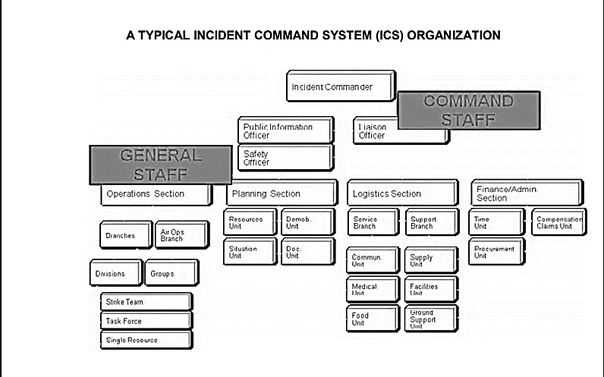

**Types, Characteristics and Phases of Critical Incident Management**

Three phases of critical incident management

An incident which has the likelihood to escalate into a critical incident should be addressed promptly and efficiently. Reassuring and maintaining confidence is fundamental to managing a CI, as is restoring confidence where it has been lost. A three-phased approach is set out in this module. When managing a CI, this advice should be read in conjunction with other relevant advice and guidance.

**1. Preparing for critical incidents**

* This requires chief officers to consider current management structures ensuring, where possible, that:
* staff are trained effectively
* resources are available
* the overall quality of the police response reflects a competent and accountable standard of incident management.

**2. Managing critical incidents**

This considers how to identify critical incidents early on. It includes processes to ensure incidents are notified to the most appropriate person, and that they are managed effectively.

**3. Restoring public confidence**

This considers incidents that have had a significant impact on public confidence but were not identified when the incident was live, and how confidence may be rebuilt through community engagement, resolution or a public inquiry.

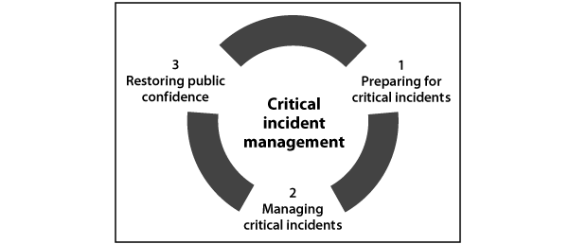

**Types of critical incidents**

The cases used in the review could suggest that critical incidents are usually high profile, serious or related to homicide. It is important to remember that this is not always the case and some involve incidents such as missing persons or bullying.

**Anti-social behaviour**

The deaths of Fiona Pilkington and her daughter Francecca in October 2007 and the death of David Askew in March 2010 demonstrate that critical incidents are still occurring and that they can have their origins in a wide range of incidents. These cases were both linked to repeated and persistent anti-social behaviour (ASB).

**Hate crime**

Other incidents, e.g., racism on Channel Four’s *Big Brother*, which may not involve violence or threats of violence, can also develop into a critical incident if not managed appropriately.An incident can escalate to a CI when the police response to crime, disorder or anti-social behaviour (ASB) fails to meet the expectations of the victim, their family and/or the community.

**Community impact**

A CI may have a significant and potentially long-term impact on community engagement and neighborhood policing. It may also generate insecurity among vulnerable members of the community and increase fear of crime and disorder. There is an additional risk that by failing to provide an effective response, the police may cause repeat victimization.

**Types, Characteristics, Phases, and methods of Critical incident**

**What is Critical Incident Method?**

Critical incident method or critical incident technique is a performance appraisal tool in which analyses the behavior of employee in certain events in which either he performed very well and the ones in which he could have done better.

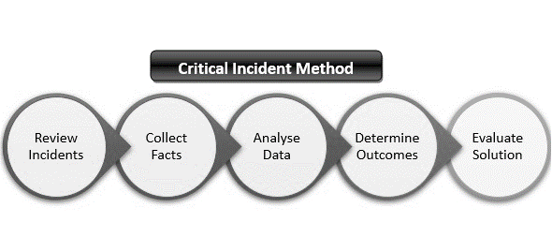

**Crisis versus Emergency**

**What is the difference between Crisis and Emergency?**

Crisis and emergency are two words that typically refer to crucial, unstable or dangerous situations. A crisis can be simply defined as a decisive and unstable situation whereas an emergency is a situation that poses an immediate risk to life and property. The key difference between crisis and emergency is that anemergency requires immediate interventions and assistance whereas a crisis may or may not require intervention.

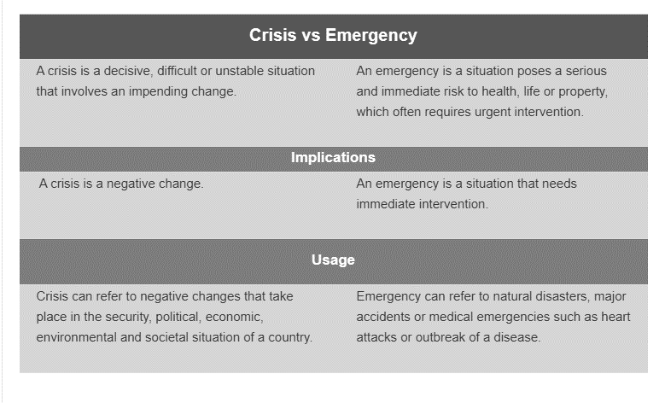

**Crisis, Incident and Disaster Management**

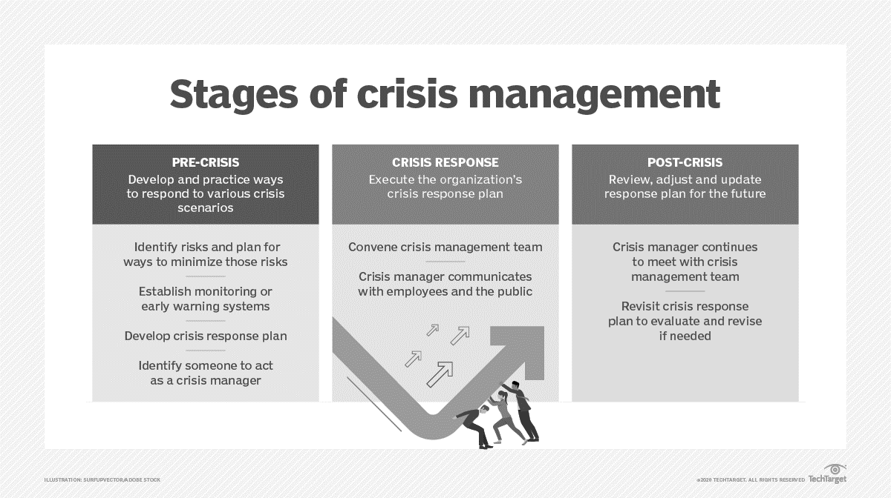

**Disaster Management Cycle**

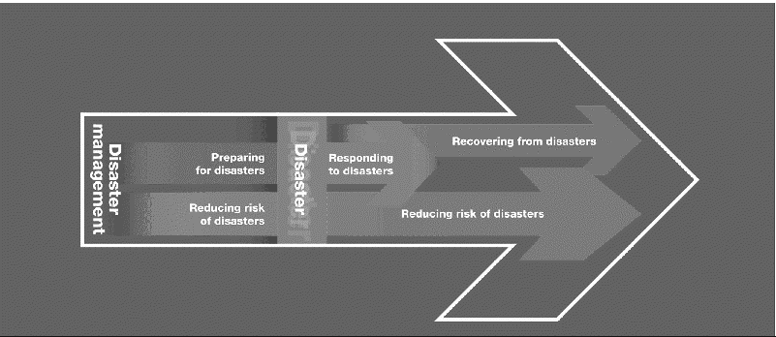

**Types of Disaster**

Disasters can take many different forms, and the duration can range from an hourly disruption to days or weeks of ongoing destruction. Below is a list of the various types of disasters - both natural and man-made or technological in nature – that can impact a community.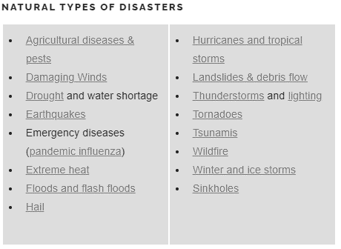

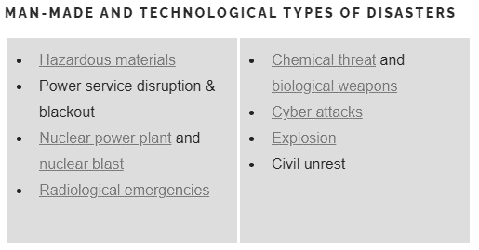

**Assessment of Crisis Management**

Although a growing number of organizations now recognize the importance of having a [crisis response plan](https://www.rockdovesolutions.com/blog/will-your-crisis-response-plan-protect-your-organizations-reputation) in place, unfortunately many of these companies still do not have a truly operational plan one that will enable them to respond to a crisis quickly and effectively. In fact,[a 2016 survey](http://www2.deloitte.com/au/en/pages/risk/articles/a-crisis-of-confidence.html) found that 70 percent of organizations that had experienced a crisis needed up to three years to fully recover their operations and reputation. This indicates that organizations may not truly be prepared for a crisis, even if they have developed strategic emergency plans.

**Organizations should take the following steps to assess the crisis/disaster management plan:**

**1. Examine accountabilities.**

**2. Consider potential vulnerabilities.**

**3. Conduct mock crisis scenarios.**

**4. Examine previous crisis responses.**

**5. Drive a Constructive Analysis**

**6. Make the Evaluation Actionable**