Student Name: Ansh Rana UID: 24BAI70892
Branch: AIT-CSE (AIML) Section/Group: 24AIT_KRG-G2
Semester: 4
Subject Name: Database Management System Subject Code: 24CSH-298

Experiment 9 – Design of a PL/SQL Package with Procedures and Shared Cursor (Enterprise Applications)
Experiment
Designing and implementing a PL/SQL package that contains procedures and a shared cursor to fetch and display employee details. This experiment demonstrates modular programming, code reusability, and efficient data handling using packages in PL/SQL.
Aim
To create and implement a PL/SQL package consisting of a package specification and package body that includes procedures and a shared cursor for retrieving and displaying employee data.
Objective
- To understand the concept and structure of PL/SQL packages
- To differentiate between package specification and package body
- To implement procedures inside packages
- To use shared cursors for efficient data retrieval
- To develop modular and reusable database programs
Software Requirements
Database Management System:
Oracle Database Express Edition (Oracle XE) / PostgreSQL
Database Administration Tool:
Oracle SQL Developer / pgAdmin
Problem Statement
In enterprise-level database applications, related operations must be grouped together for better maintainability, performance, and reusability. A PL/SQL package provides a structured approach to organize procedures and shared cursors, ensuring efficient data retrieval and modular program design.
Practical / Experiment Steps
- Create an employee table with relevant attributes
- Insert sample data into the table
- Create package specification declaring procedures and cursor
- Create package body defining logic for procedures and cursor
- Use a shared cursor to fetch employee records
- Execute the package procedure
- Display the output
Procedure
- Open Oracle SQL Developer and connect to the database
- Create the employee table
- Insert sample records
- Create package specification
- Create package body
- Compile the package successfully
- Execute package procedure
- Display employee details output
Input / Output Details
Input
Table: employee (id, name, gender, salary)
Step-wise Output
Step 1 – Create Employee Table
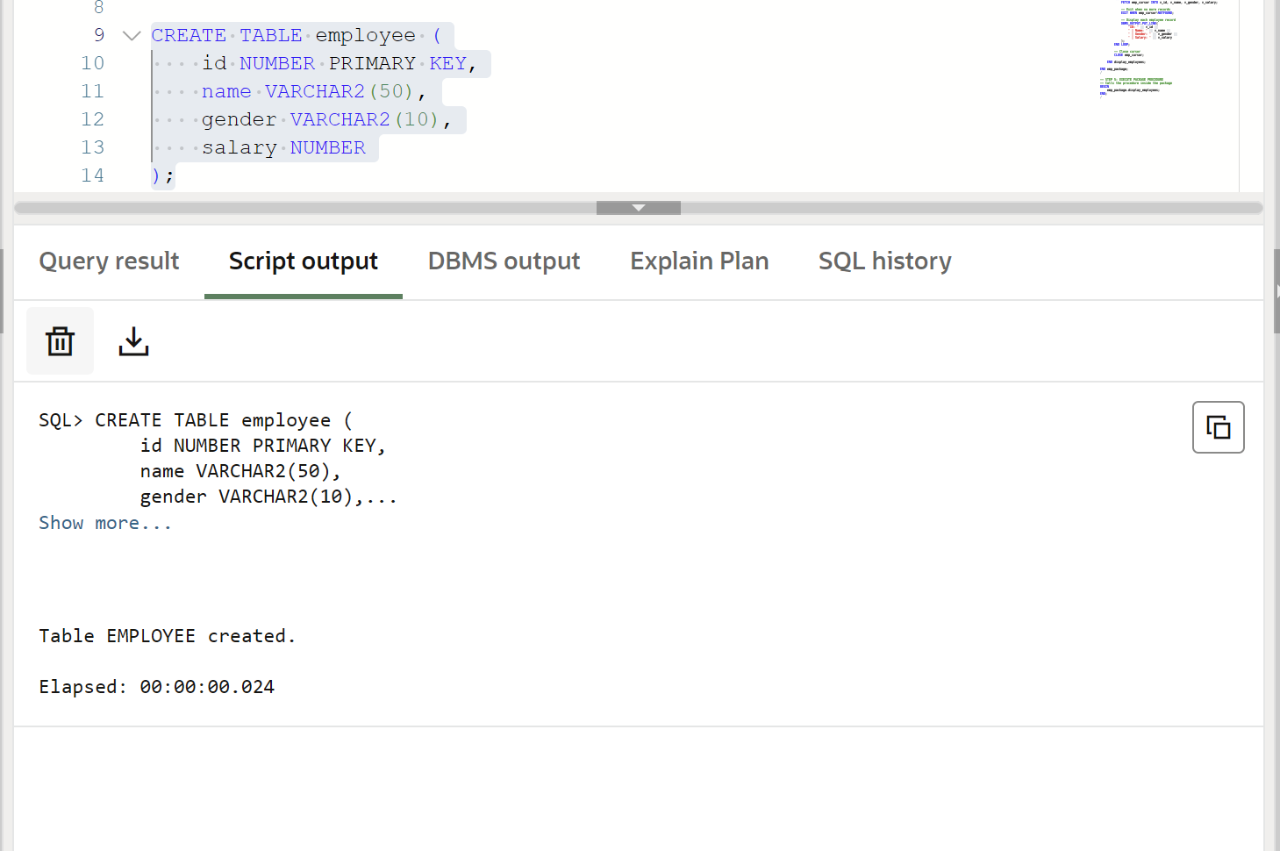
Step 2 – Insert Sample Data
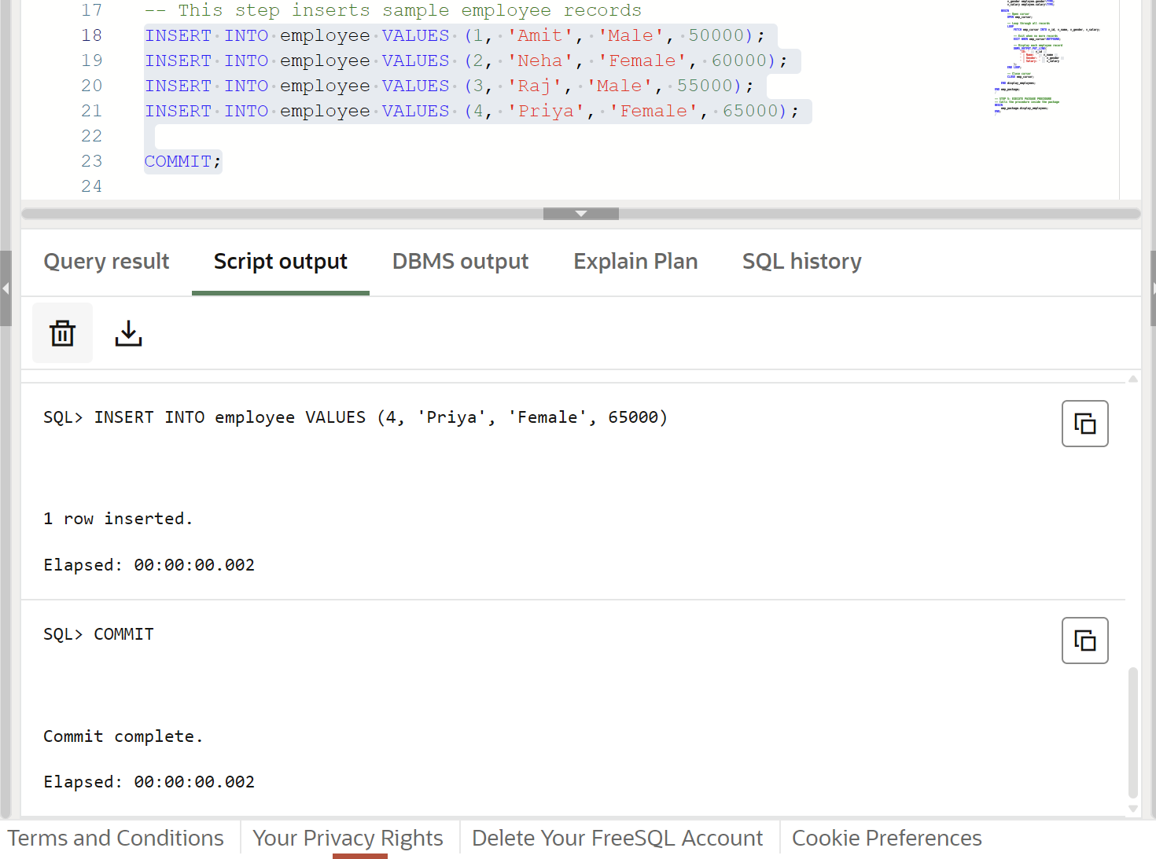Step 3 – Create Package Specification
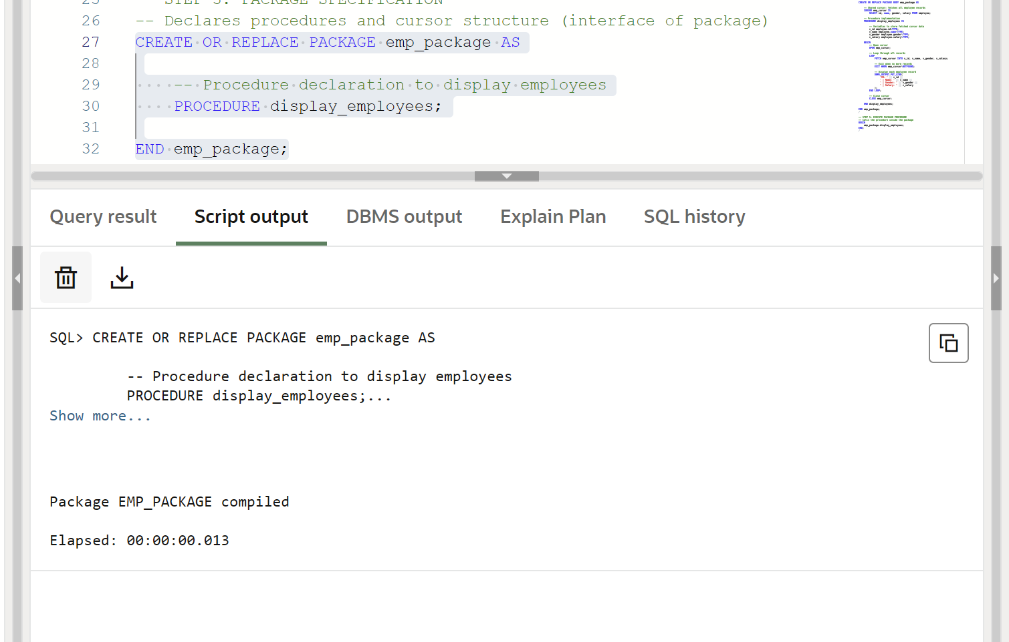
Step 4 – Create Package Body
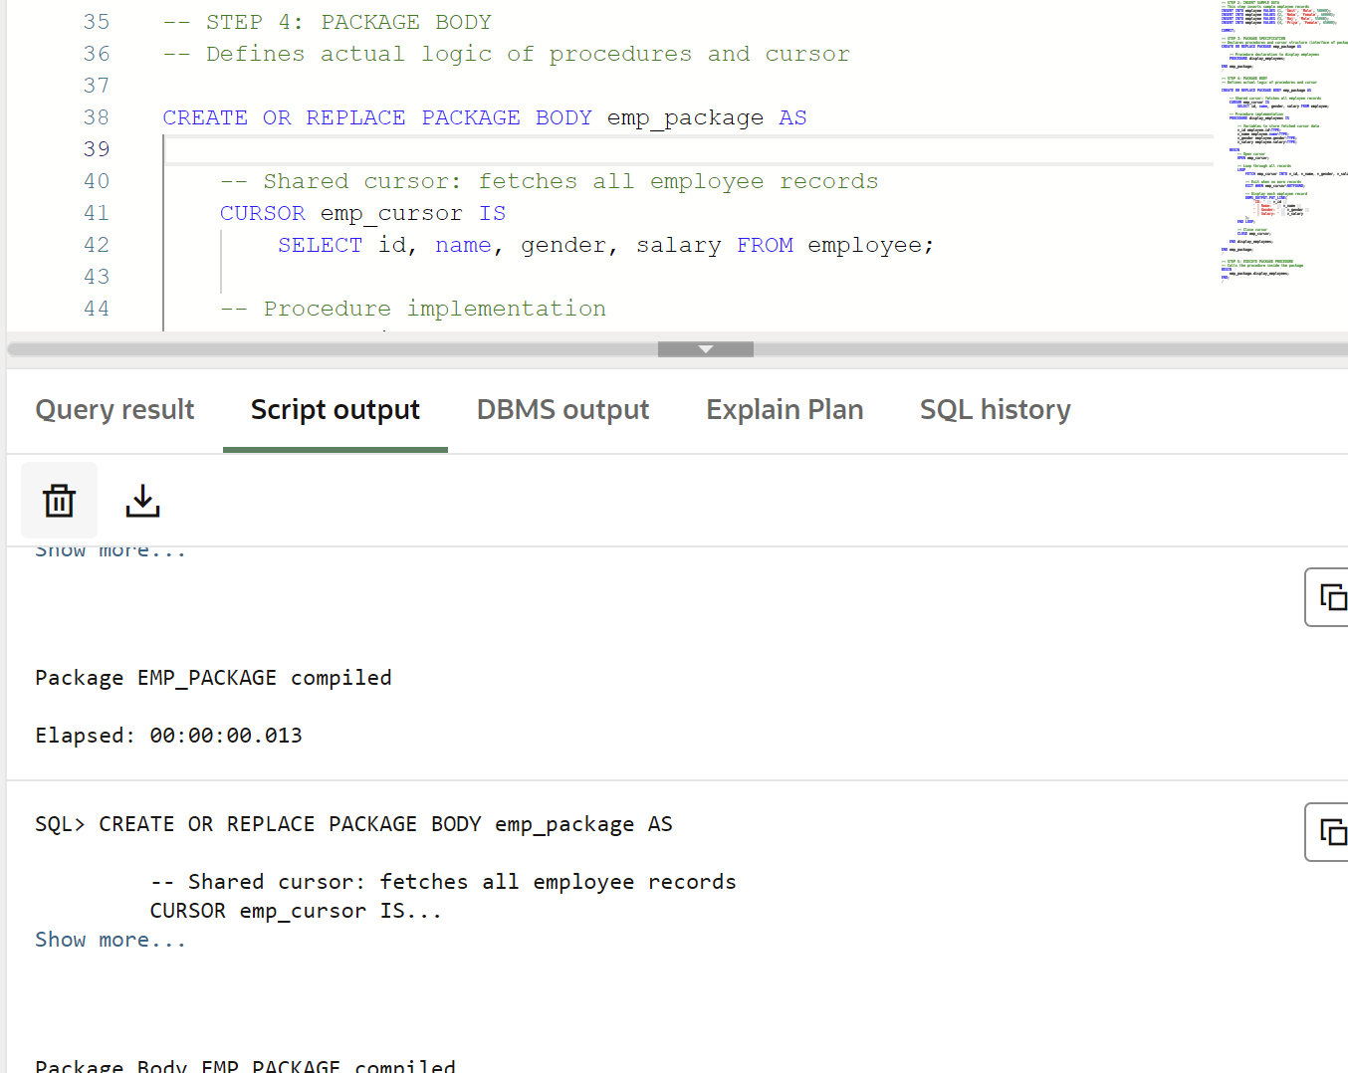Step 5 – Execute Package Procedure
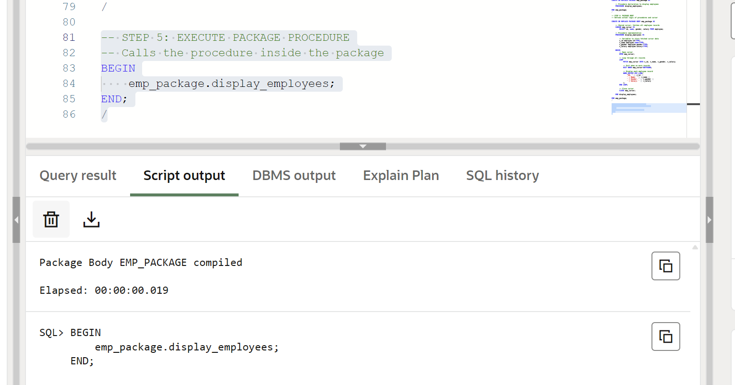
Learning Outcome
After completing this experiment, the learner will be able to:
- Understand the structure of PL/SQL packages
- Create package specification and package body
- Use shared cursors inside packages
- Implement modular and reusable database logic
- Apply package concepts in enterprise applications

