# Steps to setup:

1. Install the latest version of python https://www.python.org/downloads/

2.Install virtualenv globally using the next command in command line :

pip install virtualenv

3. In the project directory launch the file setup.bat to setup local environment.

4. The project was developed for Firefox browser, so geckodriver should be installed and configured. It can be downloaded by link https://github.com/mozilla/geckodriver/releases . How to setup it globally you can find here: http://toolsqa.com/selenium-webdriver/how-to-use-geckodriver/

5. In the project directory launch the file run.bat to execute script.

# How to use scripts

1. After run.bat file was executed Firefox browser will be opened on Zillow.com

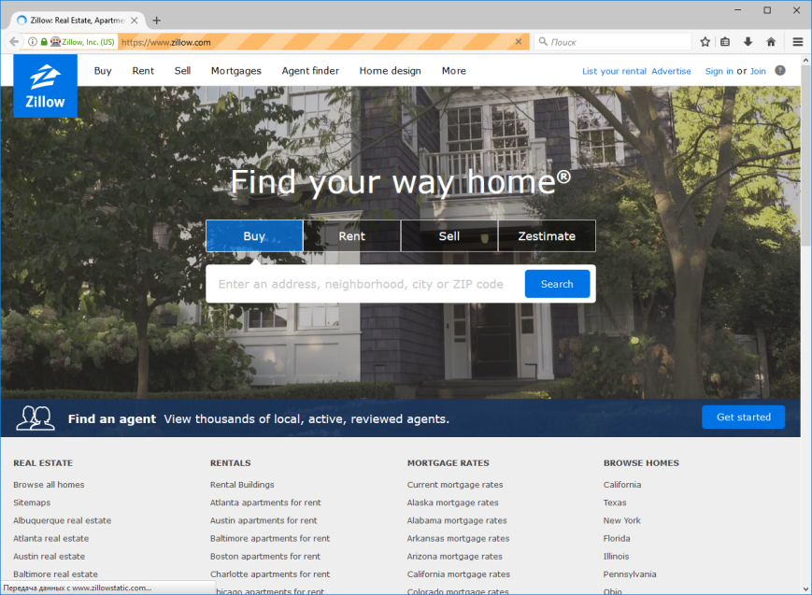

2. When the map is opened, the control button will appears. Set radius value in the input field and press start button (If the map still was not zoomed in, the button click will not work. Zoom In the map and press again to start). If radius value is 0, only the selected area will be handled.

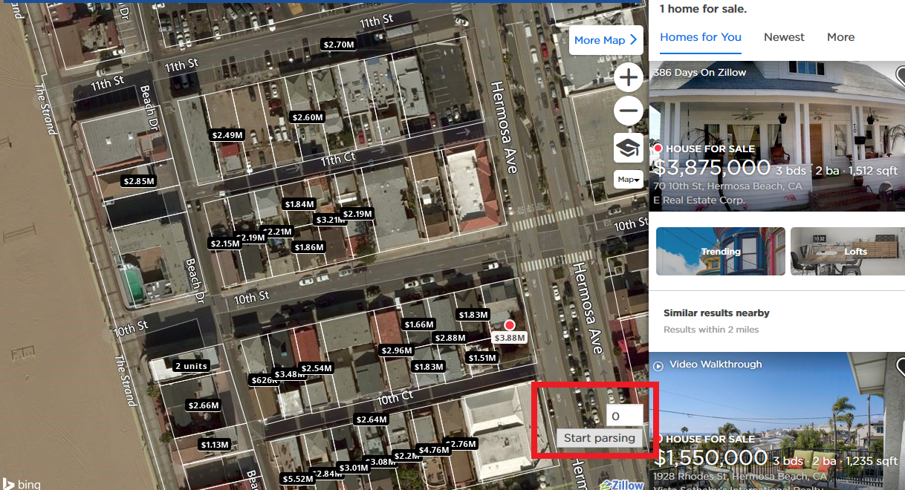

3. Wait for parsing completing. 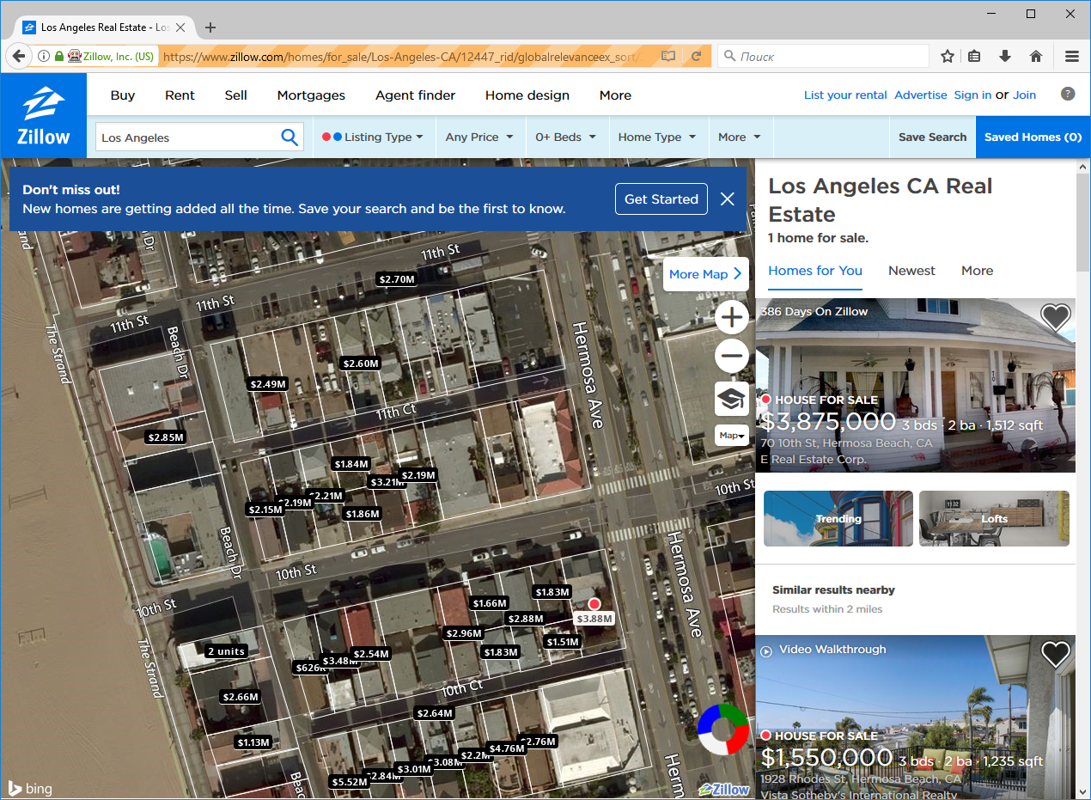

4. Open project directory and take a look at the file result.csv. All parsed data should be saved in it (New parsing cycle will not replace old data, the script will add new rows).