We created buckets with assignments from each class as well as tasks from Project 1.

The left hand side of the board (“Buckets - Min 3 Each:”) shows how we determined story points based on previous assignments.

The right hand side (“Project 2:”) shows how we determined story points based on the tasks for Project 2.

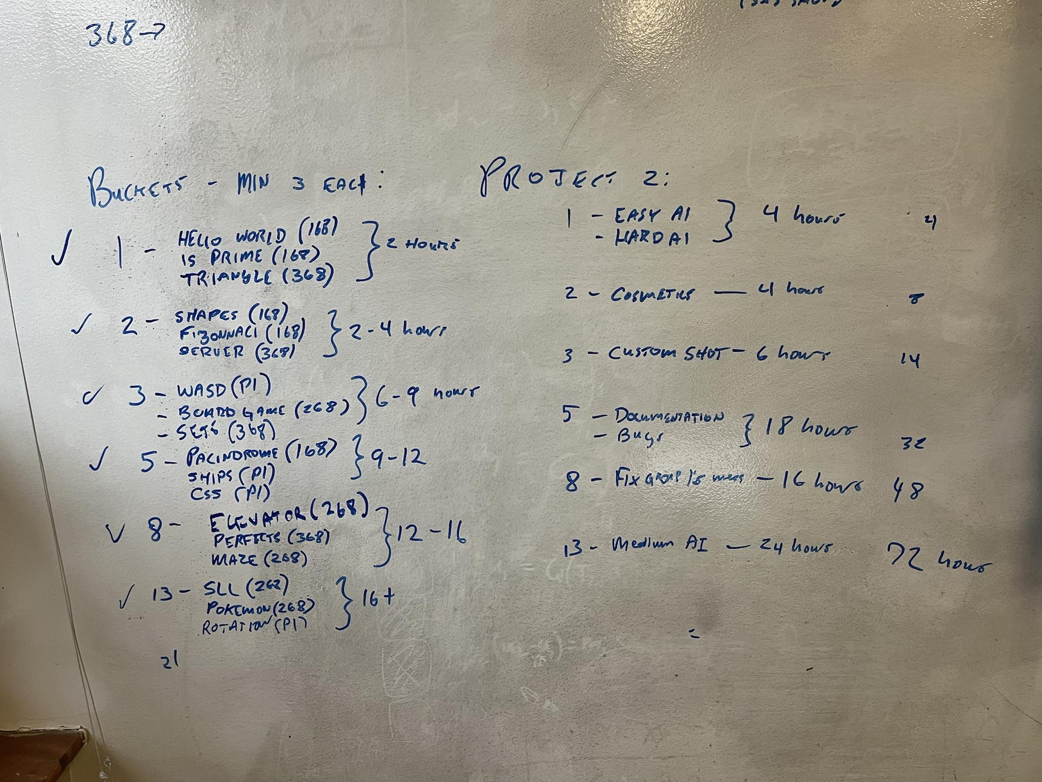

We converted story points to hours by estimating how much time we spent on each of the stories from previous classes and project 1. For example, group one was assigned “2 hours”, meaning 2 hours per task. We then used those numbers to estimate the time for each task in Project 2 (for example 2 \* 2 tasks in bucket 1 = 4 hours).

The total number of hours for Project 2 was estimated to be 72 hours.