Pfizer Transition to MadCap Flare

Andrea MacGown

December 12, 2020

Middlesex Community College Technical Information Certificate Program, Fall 2020

Writing and Managing Effective Information

Purpose 2

Problems with PDOCS and MS Word 2

Strengths of MadCap Flare 3

Intuitive User Interface 3

Content Reuse 6

Variables 6

How to Access to the Variables Folder: 7

Another Way to Access the Variables Folder 8

Creating Subfolders 9

How to Create a Variable 10

How to Update a Variable 14

Snippets 15

How to Create a Snippet 16

How to Use Snippets 17

How to View Different Outputs 19

Final Thoughts 21

Index 22

Purpose

I am proposing that Pfizer conduct a trial introduction to MadCap Flare for internal documentation. This solution is an attempt to address the many issues I encounter with:

* Pfizer’s proprietary content management system (PDOCS)
* Microsoft Word (MS Word)
* Relational problems between PDOCS and Microsoft Word

In this proposal, I will list these issues and introduce and explain features from MadCap Flare that I believe would facilitate a more streamlined content creation process.

Problems with PDOCS and MS Word

|  |  |
| --- | --- |
| **PDOCS** | **MS Word** |
| Confusing interface with steep learning curve | Unpredictable formatting |
| Prone to user error | PDF renditions when uploaded in PDOCS are not the same |
| Internet access required | Every procedure change requires a lengthy individual Word file change |
| Each user must upload their own local MS Word copy | Updating the Table of Contents creates a differently formatted one than the original SOP |

Strengths of MadCap Flare

MadCap Flare is a single-source content management software that produces an interconnected system of information. Instead of toggling back and forth between MS Word and PDOCS, references and SOPs would all be located in the MadCap Flare ecosystem for quick access.

I will discuss these MadCap Flare features below:

* Intuitive layout
* Content reuse
* Previewing output

Intuitive User Interface

MadCap Flare would be easy to transition to because of its simple user interface. It is visually similar to MS Word and maintains many structural elements.

* Similar formatting layout  
  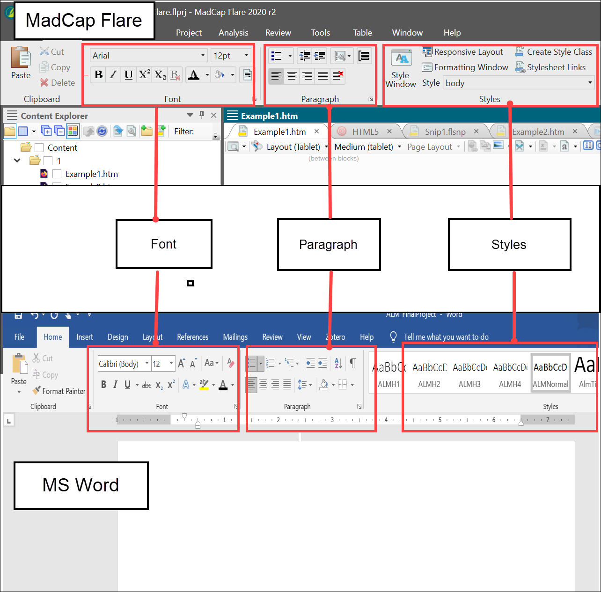
* The  **Toggle Show Tags** icon displays viewer preferences  
  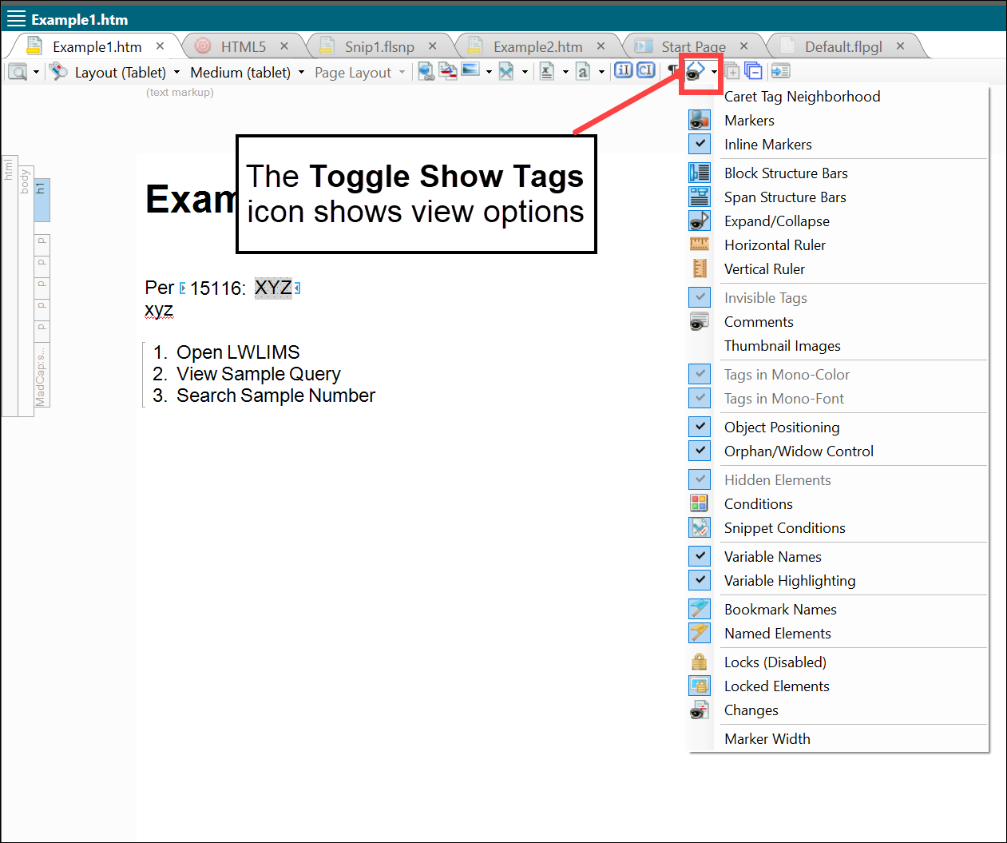
* Sidebars show which style of XML the text is using (although you do not need to know how to use XML to use MadCap Flare)  
  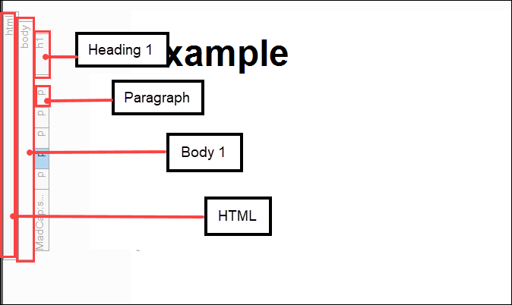

Content Reuse

One of MadCap Flare’s greatest strengths is its capacity for content reuse. Pfizer has a long list of SOPs, change drivers, CAPAs, and procedures existing in different places that are updated constantly that require a long revision process.

MadCap Flare has two powerful features that would bypass the need to individually change each document:

* Variables
* Snippets

Both Variables and Snippets are located in the Project Organizer view.

Variables

* A variable is a placeholder for a short string of text.
* They are defined in a single place and applied to the entire project.
* They are good for project names, version numbers, references, short strings of text that will change.
* They adopt the style of the topic they are placed in.

Variables are located in the **Project Organizer** view.

How to Access to the Variables Folder:

1. Click **View.**
2. Click **Project Organizer.**
3. Click **Variables.**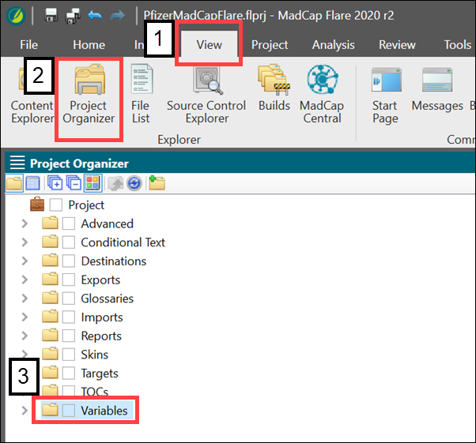

Another Way to Access the Variables Folder

1. Click **Project Organizer** at the bottom of the View window.
2. Click **Variables.**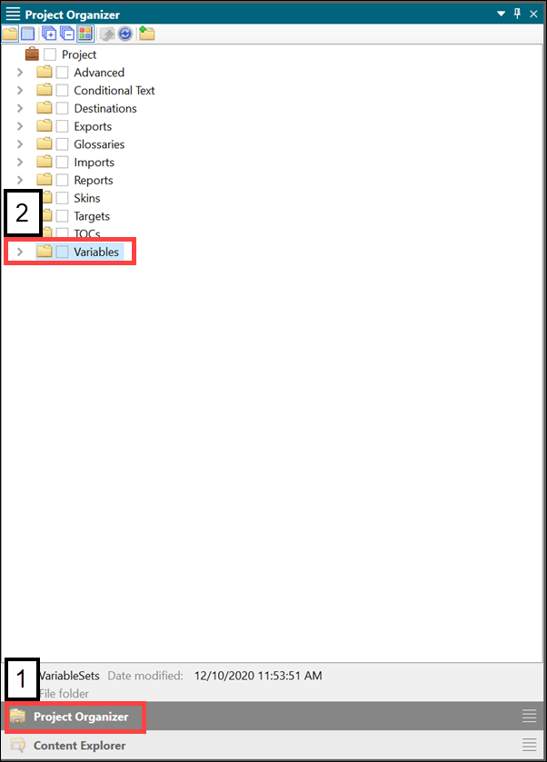

Creating Subfolders

I will create a folder in the variable folder to place all of the SOP number Variables I create in the next section in one place. Use these steps to create folders throughout the project.

1. Right-click the **Variables** folder.
2. Click **Folder.**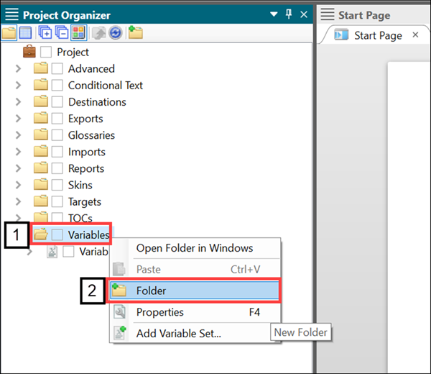
3. Create a title for the new folder.  
   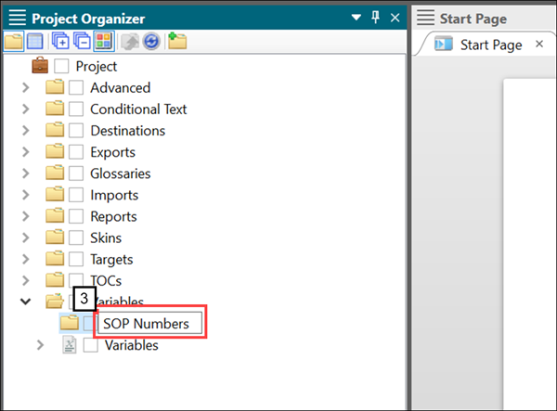

How to Create a Variable

1. Right-click the **SOP Numbers** folder.
2. Click **Add Variable Set…**  
   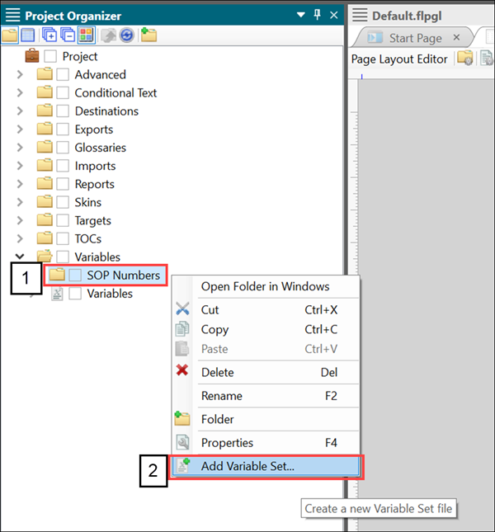
3. Choose a file name.
4. Click **Add.**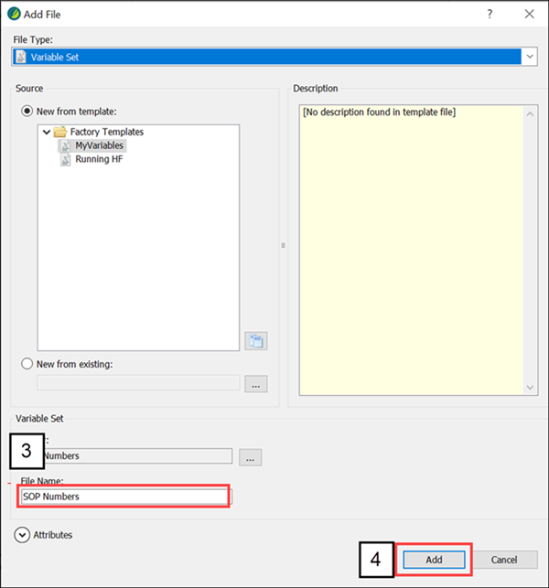
5. Click  to add a Variable.  
   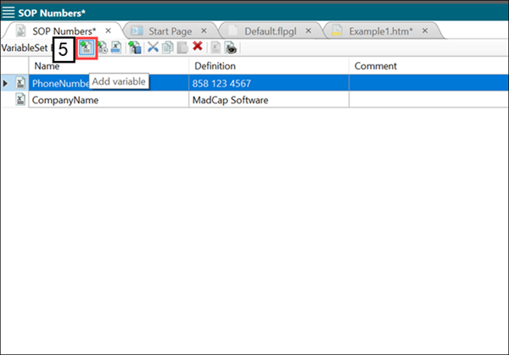
6. Double-click inside the **Name** and **Definition** cells to define them.   
   **Name:** the shortcut text you type that inserts the **Definition.** The **Name** is set to “15116”.   
   **Definition:** the text that will appear when you type the **Name**. The **Definition** is “SOP-15116”.   
   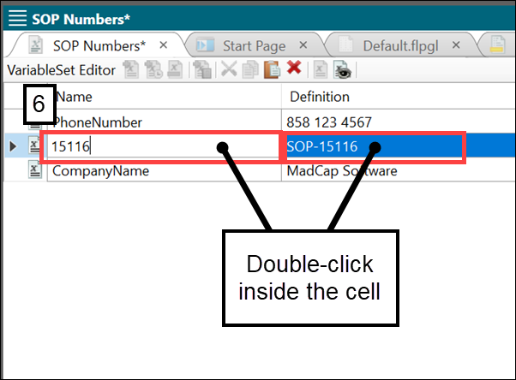
7. Save this change to the project.
8. When you start to type the **Definition** defined in Step 8, a pop-up appears giving you the option of using the Variable. Press the Return key or click on the Variable to use it.   
   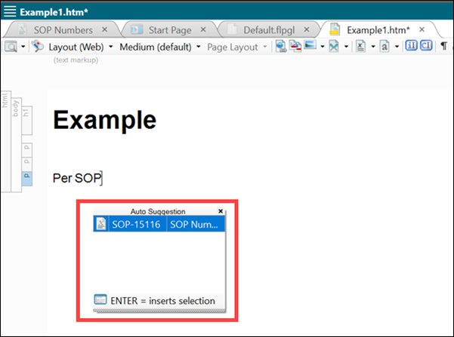

The Variable appears in the file surrounded by brackets.  
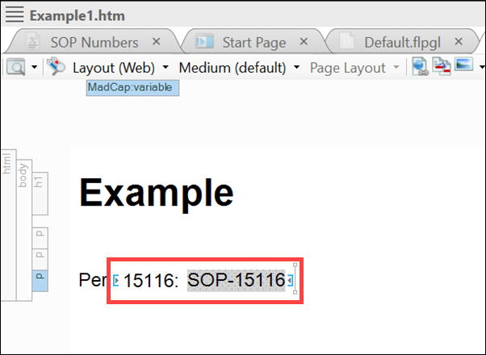

How to Update a Variable

If you need to change the Variable, it can be updated throughout all the places it was used.

1. Open the Variable Set where the Variable is defined in.   
   For this project, it is found in **Project Organizer > Variables > SOP Numbers** (folder) **> SOP Numbers** (Variable Set).  
   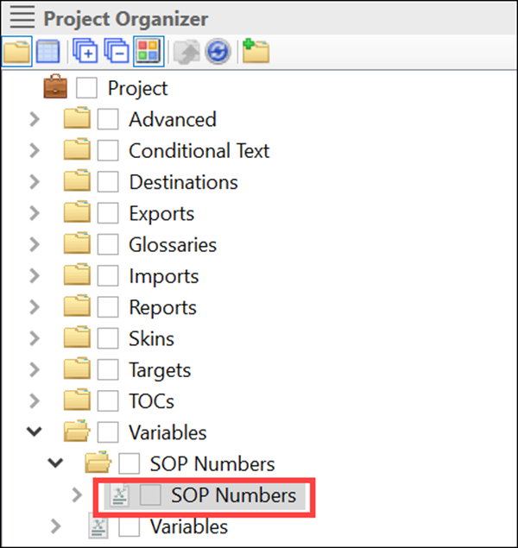
2. Double-click the **Definition** cell of the Variable you want to change and enter a new term.   
   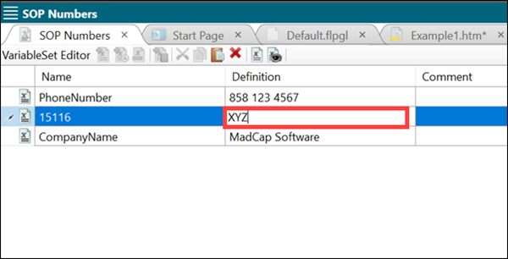
3. Save this change. The Variables will not update without saving.

Wherever the Variable is used, it changes to the new set definition. The updated pop-up will appear when the new definition is typed.

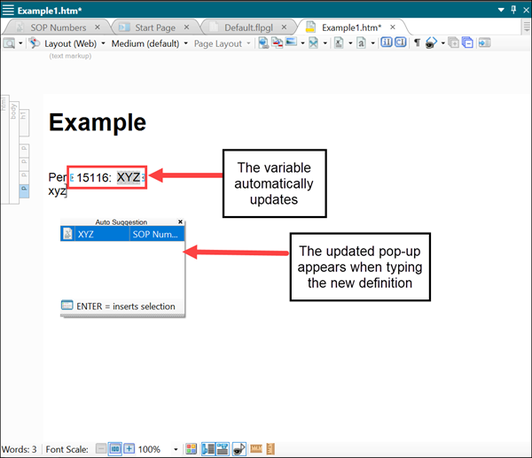

Snippets

* A Snippet reuses larger pieces of content.
* They are good for notes, warnings, procedural steps, tables with data.
* They are inserted into topics by reference.
* Snippets are different than Variables:
  + They can contain images, tables, anything that a topic can have.
  + They can have their own styles.
  + They are like subtopics and do not stand alone. They supplement topics.

How to Create a Snippet

1. Highlight the text you want to create into a Snippet.
2. Click **Create Snippet.**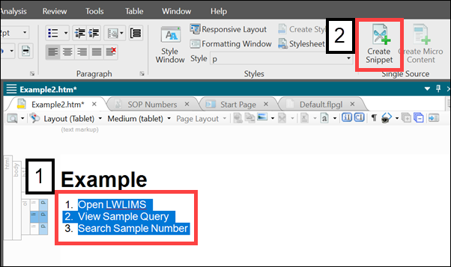
3. Select a name for the Snippet.
4. Click Create.  
   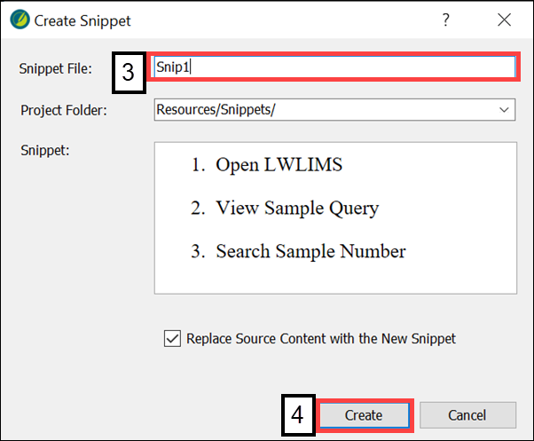

How to Use Snippets

1. In the Content Explorer view, click the **Resources** folder dropdown.
2. Click the **Snippets** folder dropdown.   
   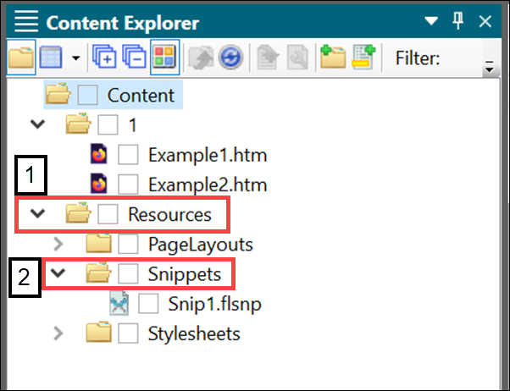
3. Drag and drop the Snippet into the topic file.   
   The red vertical line indicates that the Snippet can be placed there.   
   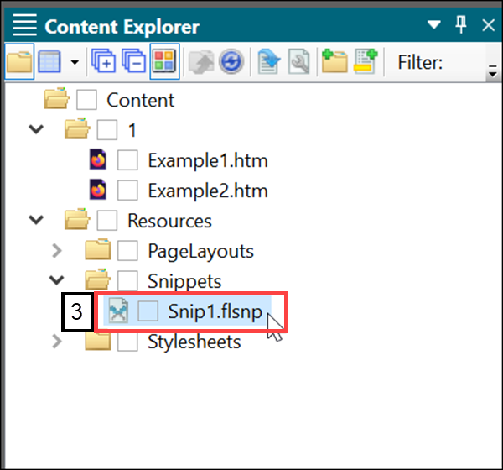  
   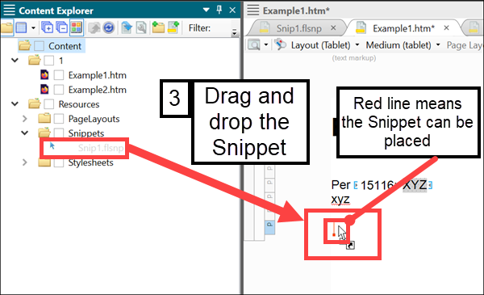

Here is the Snippet inserted into the topic.

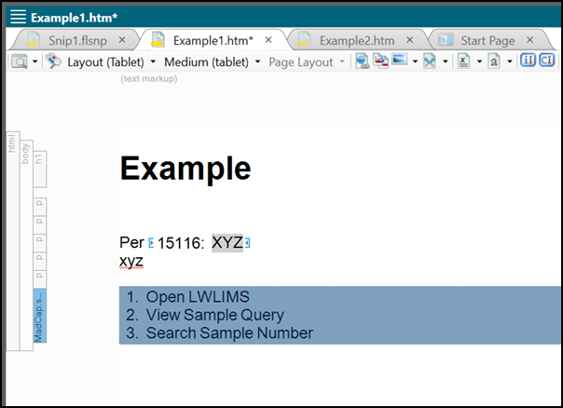

How to View Different Outputs

MadCap Flare allows you to preview the content in the output you plan to publish.

1. Click the **Project** tab.
2. Click **Primary Target.**  
   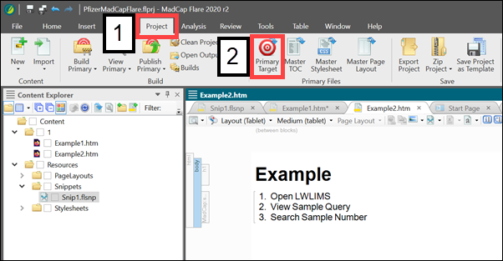
3. Click the **Output Type** dropdown.
4. Click **View.**  
   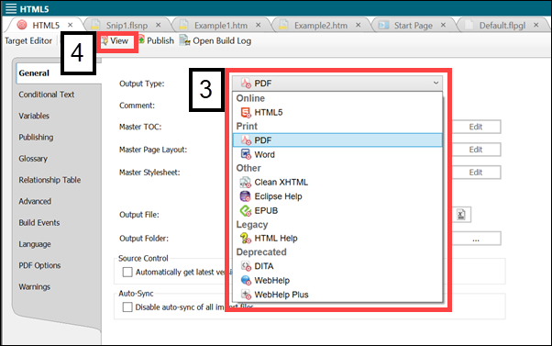
5. Click the created PDF document under Builds.  
   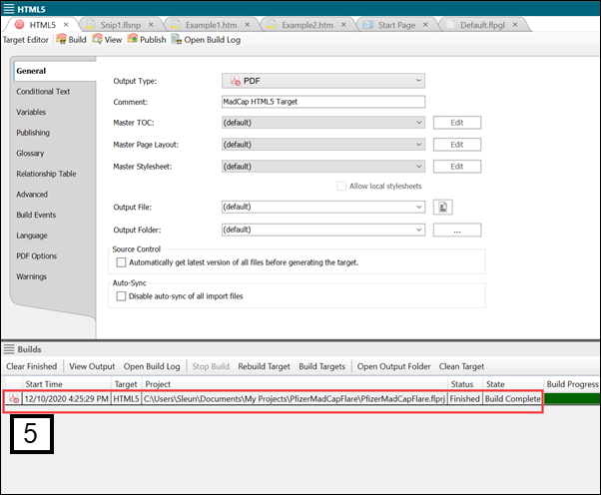

This is the PDF rendition created by MadCap Flare.

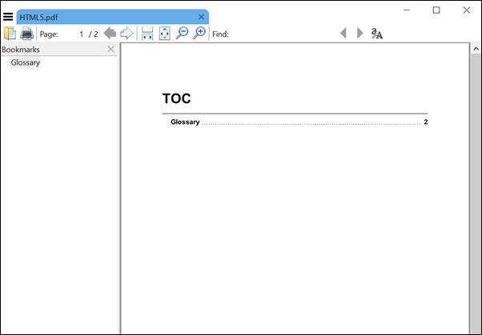

Final Thoughts

What I have included is a small slice of MadCap Flare. It is very extensive and has much to offer to improve Pfizer’s documentation process. I propose this change be run in a trial stages in my department, Quality Control Microbiology, for 3 months. I am not proposing this as an all-powerful solution, but as an option to help improve the many problems I encounter when publishing SOPs.

Index

C

Content Explorer 16

D

**Definition** 11

M

MadCap Flare 2

Microsoft Word 2

MS Word 2

N

**Name** 11

O

output 18

P

PDOCS 2

Project Organizer 5

S

Snippet 14

Snippets 5

Subfolders 8

V

Variables 5

X

XML 5