1.
The baseline produced a balanced result. The mountain, lake, and cabin structure were preserved while visible painterly textures were transferred to the target image.
- content_weight = 1
- style_weight = 1e6
- lr = 0.003
- steps = 2000

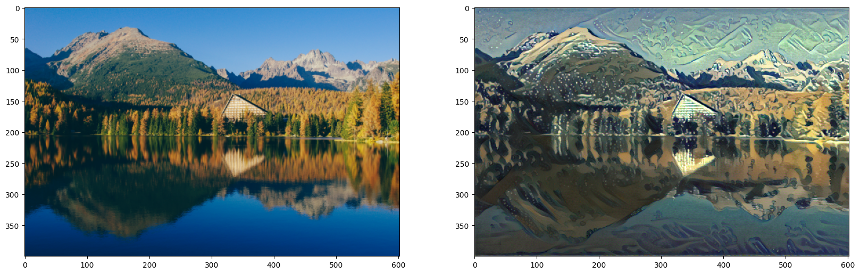

2.
Changed style_weight to 5e6 and steps to 1000
Observation: Increasing style weight made the artistic textures much stronger. However, some of the original scene details became less clear compared to the baseline.
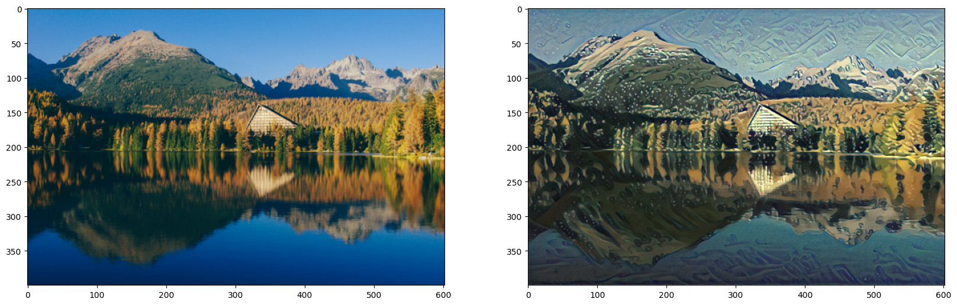

3.
Changed back style_weight to baseline which is original: 1e6 and changed content_weight to 10 keeping steps as 1000
Observation: Increasing content weight preserved the structure of the original image more strongly, but reduced the intensity of the transferred style.

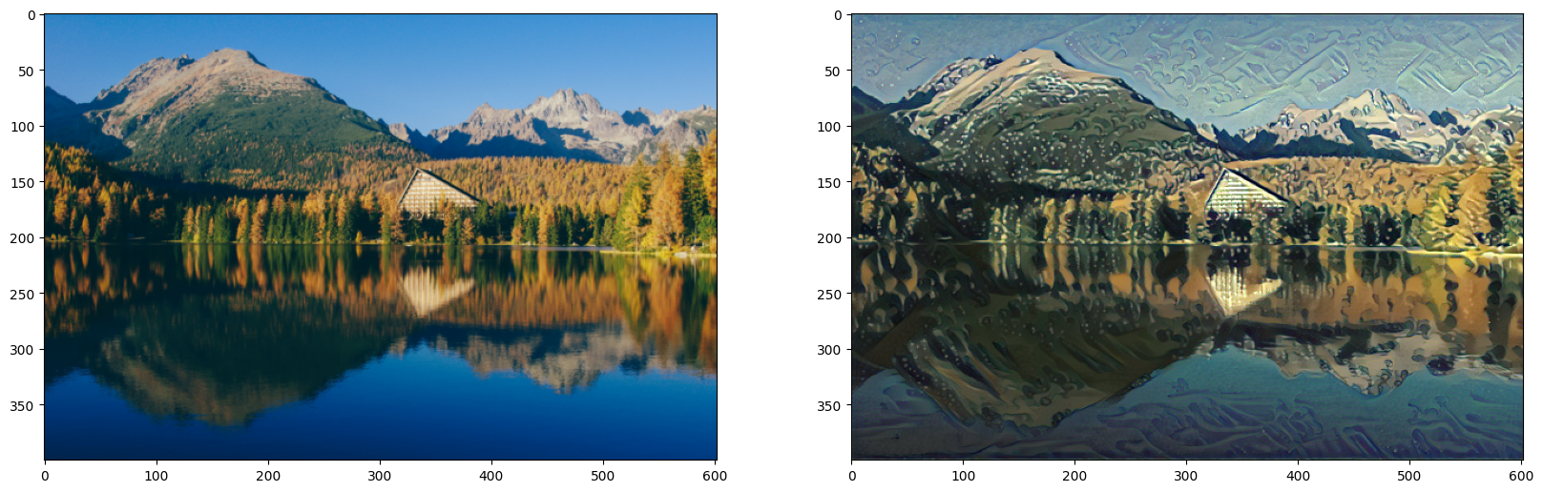

4.
Changed everything back to baseline, content_weight = 1, style_weight=1e6 except making steps =500
Observation:
Reducing the number of optimization steps significantly decreased runtime, but the output looked less refined and the style transfer was not as fully developed.
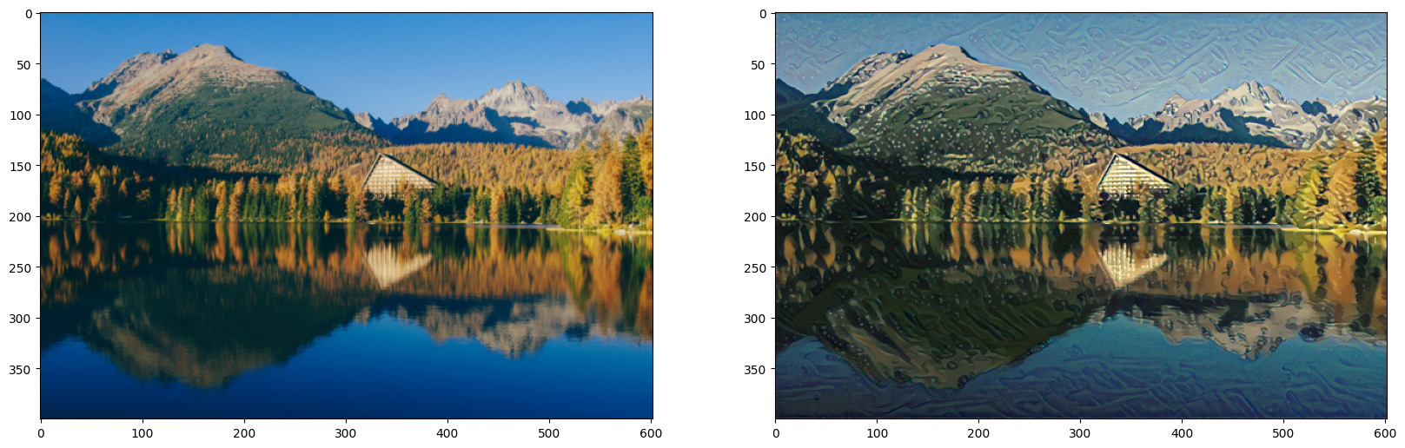

5:
content_weight = baseline
style_weight = baseline
change lr = 0.001
use steps = 1000
observation: A smaller learning rate made the optimization more gradual. The output was more stable, but style transfer developed more slowly within the same number of iterations.
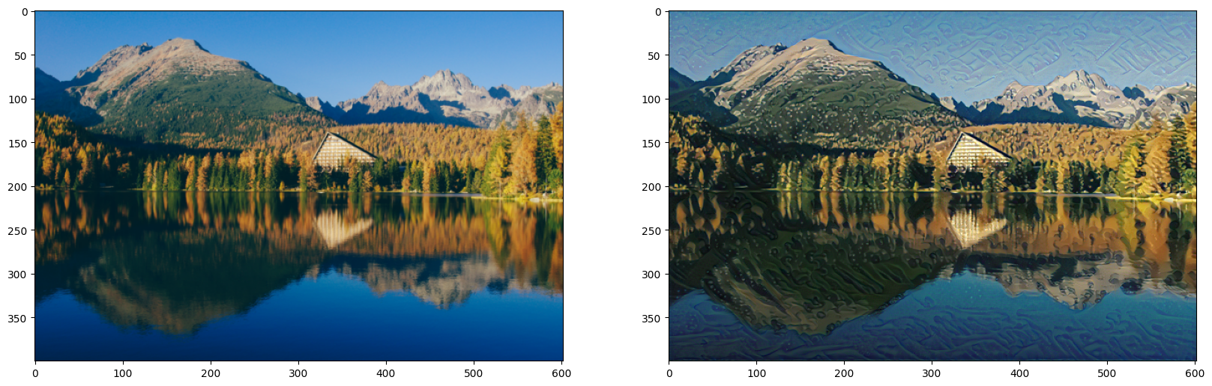

Summary:
Run | content_weight | style_weight | lr | steps | Main observation

Baseline | actual value | actual value | 0.003 | 2000 | Balanced result

High style | same | 5x baseline | 0.003 | 1000 | Stronger style, less content detail

High content | 10x baseline | baseline | 0.003 | 1000 | More content preserved, weaker style

Low steps | baseline | baseline | 0.003 | 500 | Faster but less refined

Low LR | baseline | baseline | 0.001 | 1000 | Slower, smoother optimization

