**TBANLT 510 A BUSINESS ANALYTICS**

**AUTUMN 2019**

**ASHRITH MADAN**

**12/03/2019**

**FINAL PLACEMENTS OF PLAYERS IN EVENT**

**GAMING INDUSTRY**

**BUSINESS ANALYSIS**

I Certify that I have completed this assignment within the Academic Integrity guidelines presented in the UW General Catalog. Further, I certify that I do not have any knowledge of any other individual(s) violating these guidelines.

Contents

1. Tutorial 3

1.1 Executive Summary 3

1.2 Background: 4

1.3 Data Description: 4

1.3.1 How to download the Dataset: 4

1.3.2 Data Types: 4

1.3.3 Data Considered: 4

1.4 Data Prep: (Tableau Prep and Excel) 5

1.4.1 Connecting to Data on Tableau Prep: 5

1.4.2 Opening and Selecting Fields 5

1.4.3 Joining Multiple Tables: 6

1.4.4 Output Excel File: 7

1.4.5 Preparation in Excel: (Optional) 8

1.5 Learning Objectives of the Tutorial: 8

1.6 Deliverable 1 – Dashboard 8

1.6.1 Scenario: 9

1.6.2 Purposes/Questions/Applications: 9

1.7 Deliverable 2:StoryBoard: 11

1.7.1 Scenario: 13

1.7.2 Purposes/Questions/Application 13

1.7.3 Procedure: 14

1.8 Results/Insights/Conclusions: 14

# Tutorial

## Executive Summary

Every Visualization tells a story. In this tutorial, I would narrate a story about what attributes are contributed towards getting that “Winner Winner Chicken Dinner” in one of the world’s most favorite video games PLAYER UNKNOWN’S BATTLEGROUND. In this document, we can learn how to Extract the Data, Prepare the Data, Explore the Data and come up with a possible solution for our problem.

This tutorial explains procedures to Extract data with the use of open resources like Kaggle.com. Preparing the Data with the use of Tableau Prep Builder and MS Excel. Exploring the Data for Creating Dashboard and Storyboard analysis from a business perspective. Provide a Solution from the above mentioned analysis.

This tutorial also contains learning objectives from this tutorial with set activities and Limitations with our analysis from this data. This tutorial provides a brief description of how to untangle raw data into readable result-oriented data with the help of Tableau Visualizations.

## Background:

PLAYER UNKNOWN’S BATTLEGROUND, more commonly known as ‘PUBG’ is a Battle Royale Style video game created by Tencent Games that has millions of monthly active users. In a $140 Billion Gaming Industry, PUBG was rated as the fifth best selling video game of all time. The Game has been launched on several platforms such as PC, XBOX, Playstation and even available on Mobile Devices. It is a multiplayer game where 100 players are dropped onto an island empty-handed who must explore, scavenge and terminate other players to become a winner. The game can be played in 3 modes. Namely, Solo(1 player), Duo(team of 2 players) and Squad(team of 4 players). The game has 4 maps: Erangel(8Kms*8Kms), Miramar(8Kms*8Kms), Sanhok(6Kms*6Kms) and Vikendi(6Kms*6Kms). Furthermore, the play area keeps shrinking as time goes on(Blue Zone) and certain areas are targeted for destruction(Red Zone). The player/team who eliminates all enemies and keeps themselves safe can only achieve ‘WINNER WINNER CHICKEN DINNER’.

The Data we are exploring today is primarily PUBG players data collected during an event organized by Tencent Games. The data is an extract of in-game stats collected via PUBG API for the purpose of a Kaggle competition during the gaming event. The purpose of this assignment is to predict which game

## Data Description:

The Data extracted for the purpose of this assignment is to be extracted from [Kaggle.com](https://www.kaggle.com/jeanmidev/pubgevents#pubg_events_logplayerkill.csv). The data is provided in Comma Separated Value (CSV) format. The tables that I selected are ‘pubg_events_logplayerkill’ and ‘pubg_events_loggamestateperiodic’. The dataset contains over 400,000 rows and has 96 columns combined from 2 MS Excel files. Each row represents a player and each column represents the In-Game stats/attributes of that player. The data contains several values that aren’t necessary for our purpose.

### How to download the Dataset:

To download a dataset, login/register on Kaggle.com. Select the appropriate dataset. If the dataset is provided in many formats, select the file which is in CSV format. Click on the download option and save it onto your system in a suitable location.

### Data Types:

The data Consists of several descriptive data types. To name a few, the dataset consisted of String Characters, Decimals, Boolean, Integer, ID and a UUID. Several columns had null values which would have created an error if it is loaded without preparation.

### Data Considered:

Due to large amounts of inconsistencies in data, let us have the downloaded dataset ready for preparation. I have reduced my dataset from over 70 columns to as low as 40 columns. The reduced dataset contains Boolean characters, String, Decimals, ID and Integer. It is important to choose only the columns related to our assignment

## Data Prep: (Tableau Prep and Excel)

During this assignment, I have used both Tableau Prep and MS Excel to prep the Data. Below are the steps taken in Data Preparation for this assignment:

### Connecting to Data on Tableau Prep:

Firstly, let us load the dataset onto the Tableau Prep App. To do so, open the Tableau Prep Application and select Connections:

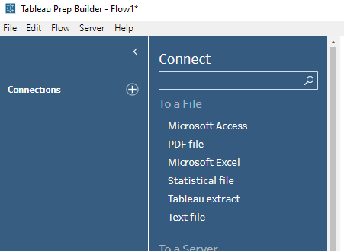



### Opening and Selecting Fields

A pop up tab opens up which asks you to locate the source data. Locate it.

Once the file is opened, drag the desired table onto the FLOW area. (from 1 to 2 as shown below)

Select columns appropriate to our usage in the INPUT area labelled 3 below.

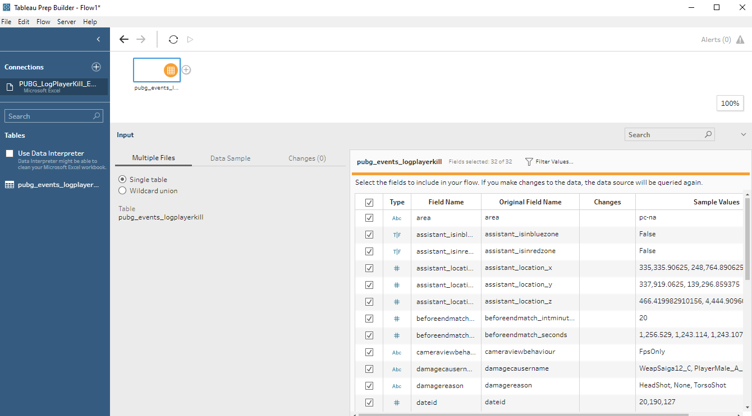



### Joining Multiple Tables:

Suppose, there is extra useful data in another dataset and you would like to use it in this assignment, connect to that dataset. Upon connecting, drag and drop the other table onto the FLOW area. Upon adding it to the FLOW, you can create a join to merge datasets together.

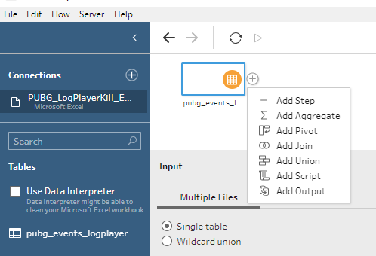



Make sure to select Wildcard Union when merging 2 tables. Select columns necessary.

### Output Excel File:

Upon selecting necessary columns, you need to extract the merged columns into a single Excel File. To do so, Select Add Output





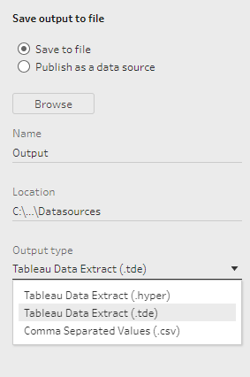



Once the data file has gathered all tables into its output box, select Comma Separated Values(CSV) format and Save the file. After completion of this step, the data is ready to be used in a single Excel File.

### Preparation in Excel: (Optional)

For the comfort of use, I have cleaned some data in Excel as per my needs. Some examples are as follows:

* Changing Names of columns.
* Merging of Multiple repetitive variables into one common name.
* Removing rows with many missing values.

After complete Data Preparation, I have narrowed down my file to 105,000 rows and 37 rows. Happy Data Exploration from now on!

## Learning Objectives of the Tutorial:

* Creating Tableau Visualizations for Diagnostic Analysis
* Learn to analyze business problems
* Helping readers understand the data at a glance

## Deliverable 1 – Dashboard

The KPI I am concentrating on in this tutorial is to measure the performance of our Game in different Maps. Due to an increase in Maps, Erangel (first map) has a lower number of players compared to the newer maps (Sanhok & Vikendi). To understand how the game fares on all maps, the competition(Event) was held. The development team wanted to understand how players think hence their focus was on player performances that could enable them to understand what attributes can be made better for players to survive longer and play more PUBG.

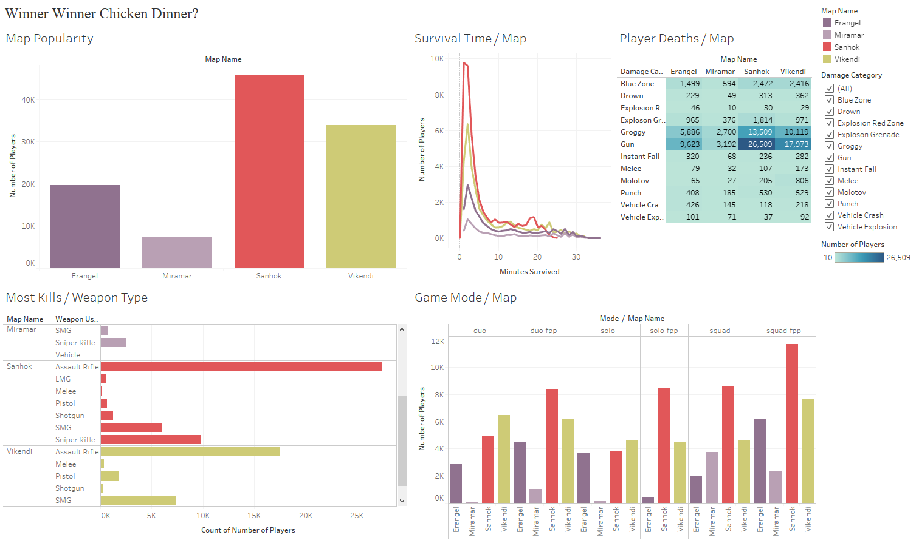

Link to Dashboard: https://public.tableau.com/views/Tableau_FinalExam/WinnerWinnerChickenDinner?:display_count=y&:origin=viz_share_link

### Scenario:

Tencent Games is a game development company that has made a fortune with their bestselling Battle Royale style Video Game Player Unknown’s Battleground (PUBG). You are the Chief Development Officer for North American Division of Tencent Games and you are required to hire good players depending on the Final Placement of Players during the competition. The top 5 players get a spot on your Game Development team.

### Purposes/Questions/Applications:

To analyze effectively, analyzing methods are the key. Purpose of this Dashboard:

* Diagnostic Analysis
* Predicting Player performances based on heir history.
* Objects to be added into the game for better development.

Questions that may arise are:

* What maps are losing popularity and how to regain it?
* What obstructions must the players overcome to win the chicken dinner?
* What attributes affect players from the beginning till the end?
* What Developments can arise to increase survival rate of the player?
* Who has a better chance of survival in these games?

Applications:

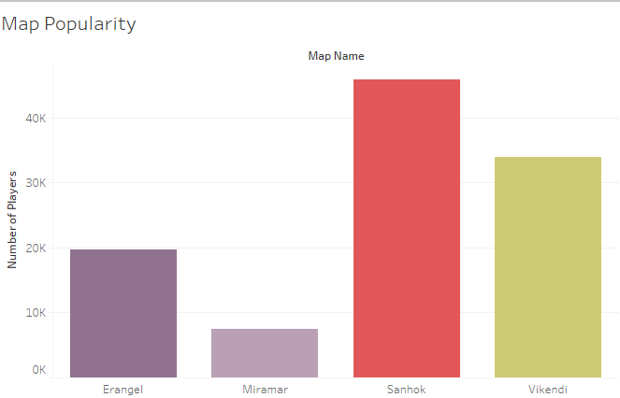

The above image represents popularity of maps. Smaller maps(Sanhok and Vikendi) are newer and more popular than older maps(Erangel & Miramar)

* What qualities must the players possess in order to win the game as frequently as possible?

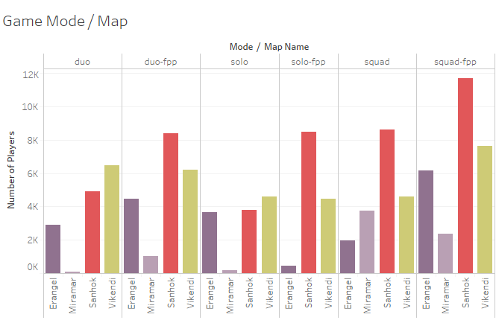

Players prefer to play with a squad to ensure a victory. Playing with a squad ensures support and assistance when needed at most times.

## Deliverable 2:StoryBoard:

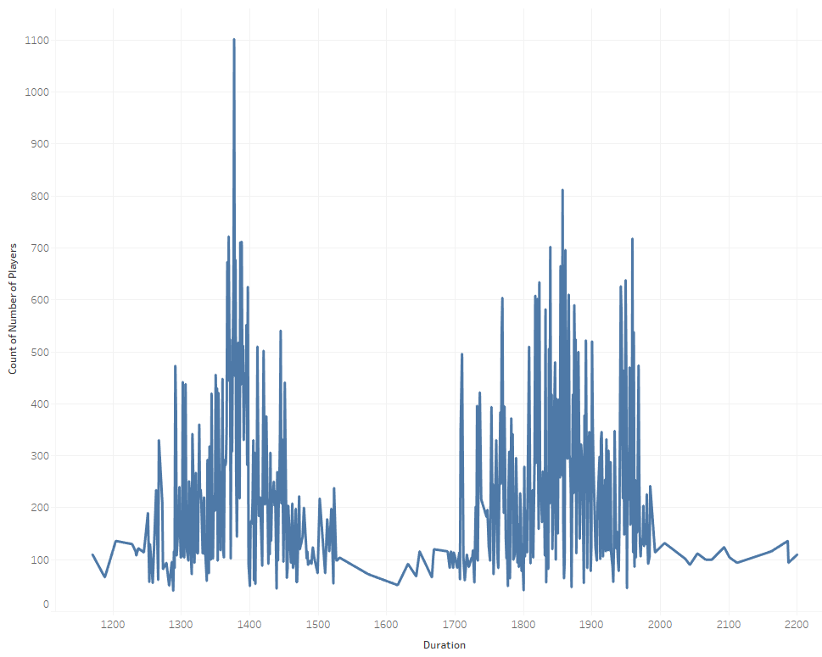

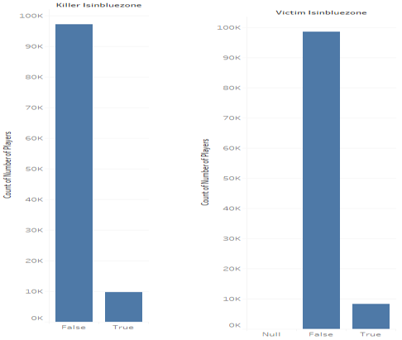

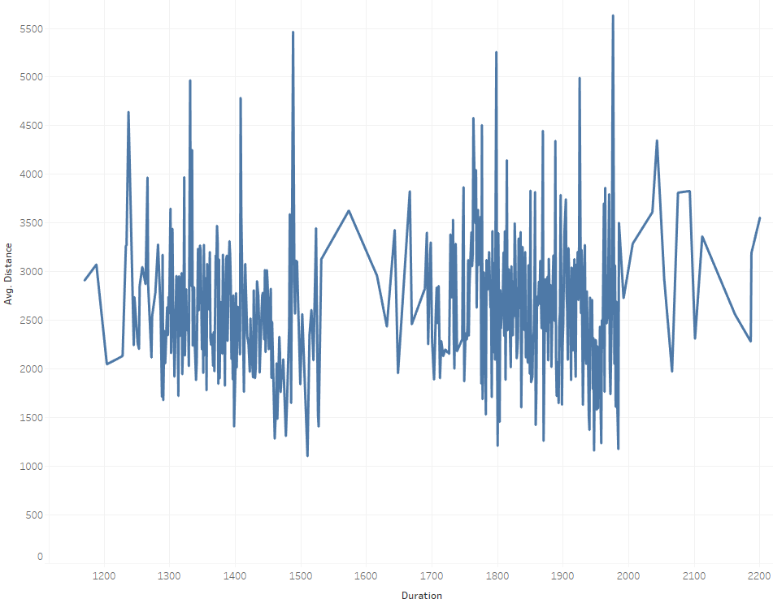

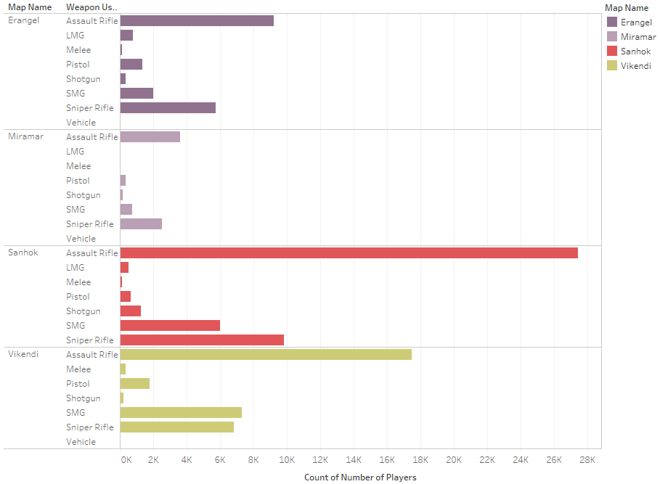

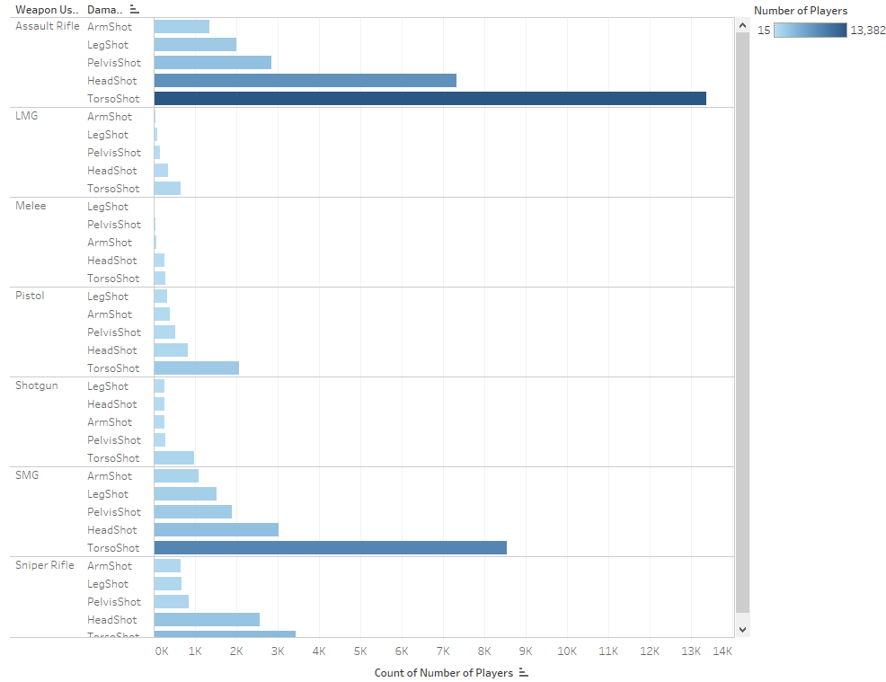

Link to storyboard: https://public.tableau.com/shared/8DCKBBZPY?:display_count=y&:origin=viz_share_link

### Scenario:

Tencent Games is a game development company that has made a fortune with their best selling Battle Royale style Video Game Player Unknown’s Battleground (PUBG). You are the Chief Development Officer for North American Division of Tencent Games and you are required to hire good players depending on the Final Placement of Players during the competition. The top 5 players get a spot on your Game Development team.

### Purposes/Questions/Application

Purpose of this storyboard is to analyze minor criteria that would affect survivability of the players.

Questions:

Would staying outside of the blue zone create a losing streak for the player?

### Procedure:

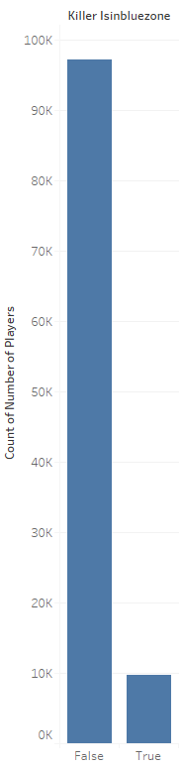 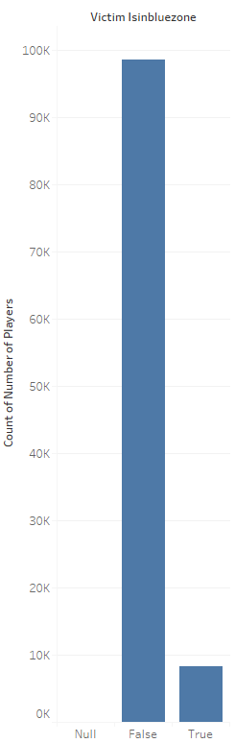

All players try to keep away from the blue zone falling on them. Staying in the blue zone depreciates the player’s health rapidly.

Also, having gathered weapons early in the match gives the players a better chance of survival at the beginning. While scavenging, it is also important for the players to know that the aim should be true while firing the weapon as they have a high chance of survival if it hits major areas like head or torso.

## Results/Insights/Conclusions:

The Player survivability, a.k.a Winning the game would definitely increase if the following criteria is met:

* Player gets to scavenge weapons first (mainly Assault Rifles) as they have a better chance of survival.
* Stay out of the blue zone
* Stay out of the red zone
* Playing with a Squad definitely increases odds of winning the game