**Solution File**

For the purpose of this assignment, a data connection needs to be established in Tableau. To do so,

1. Open Tableau

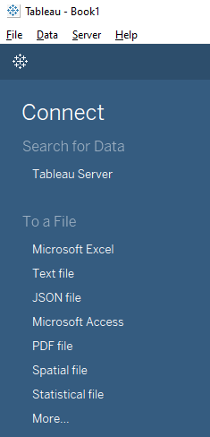



1. Click on Connect to a file> Microsoft Excel>Select necessary Excel File and open

**Question 1:Heatmap of Players Eliminating in Erangel**

1. Download map of Erangel on to your computer (<https://pubgmap.io/erangel.html?/v2/30/4ftla8/BLeG>)
2. Open New sheet>Goto Maps>Select Background Images and choose the option that follows

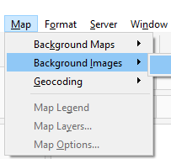

1. In Background Images>Select Add Image>

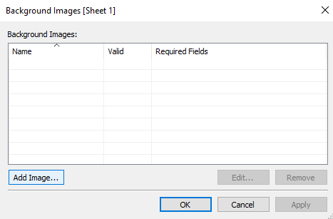



1. In Add background Image > Select Location of Image you want for background > Enter Field names for X and Y Axis > Enter values of X axis and y axis as below (appropriate to your chosen map) > then select options > check the box named ‘ Always show entire image’ > Apply

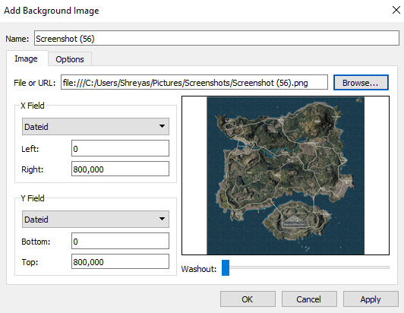



1. In the sheet > Select the x axis and y axis fields into row and column area. > Select Dimension

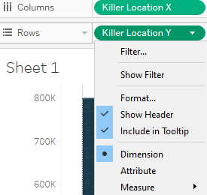

1. Enter a third measure >Select count > add color to it.

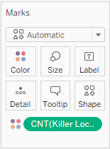

1. Results

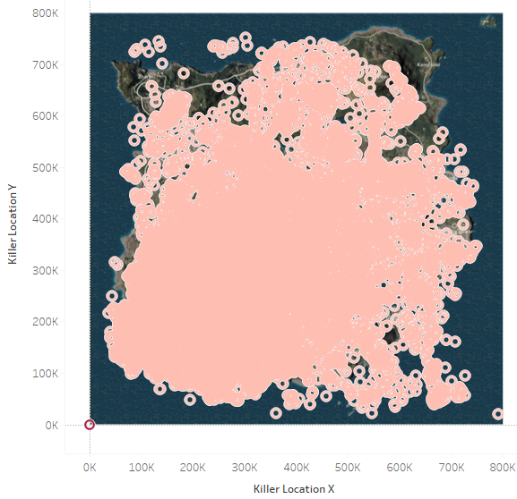

Question 2: Dashboard for Different Terrains that the Players have traveled

1. Add Sheet > Select Distance on Feet for Column as Dimension > Select Number of Players with count measure > add chart of your choosing.

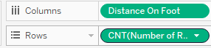

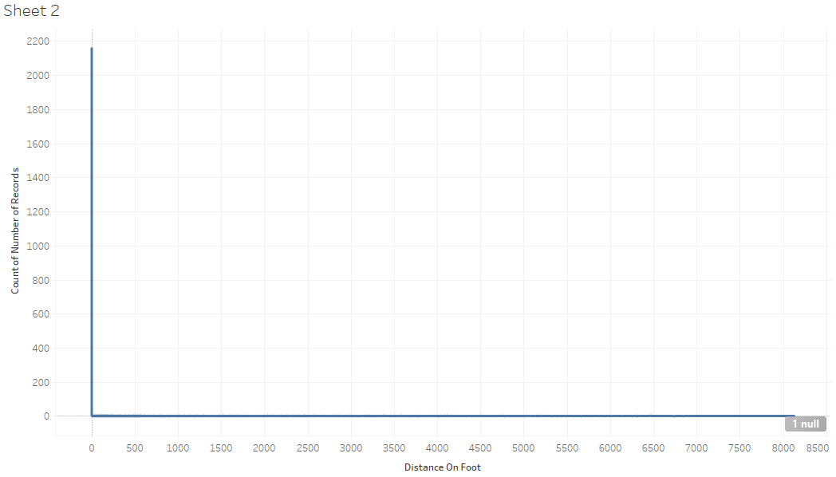

1. Create 4 more such sheets with Row value being same and column values for distance in freefall, parachute, vehicle, swim being Dimensions
2. Upon completion of all sheets suggested above > Select option New Dashboard > Drag and drop sheets into the dashboard

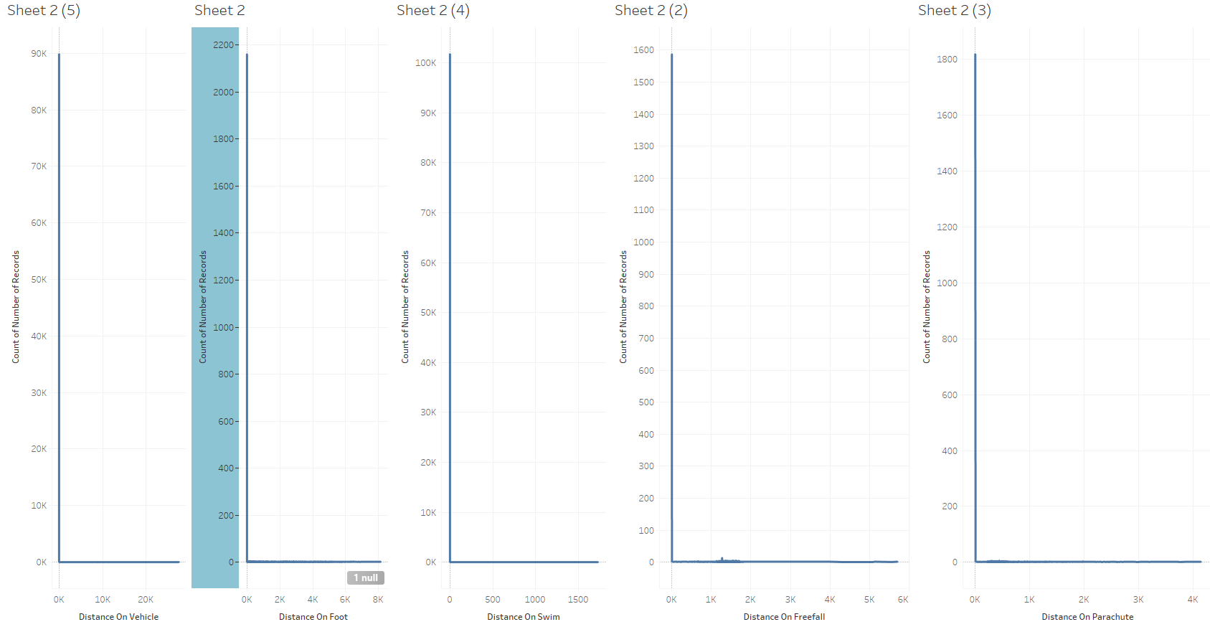

Question 3: Storyboard to show presence/absence of players in blue zone / red zone in all 4 maps

1. Add a Sheet > Select Rows and Columns as below > Choose a map of your choosing

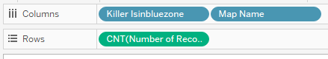

1. Add more sheets for killer in red zone, Assistant in red zone, blue zone, Victim in Red Zone and Blue Zone Keeping Map Names and Number of records (Count) same.
2. Select New Story > Drag and drop a Sheet into the story > write a caption > select add blank story point

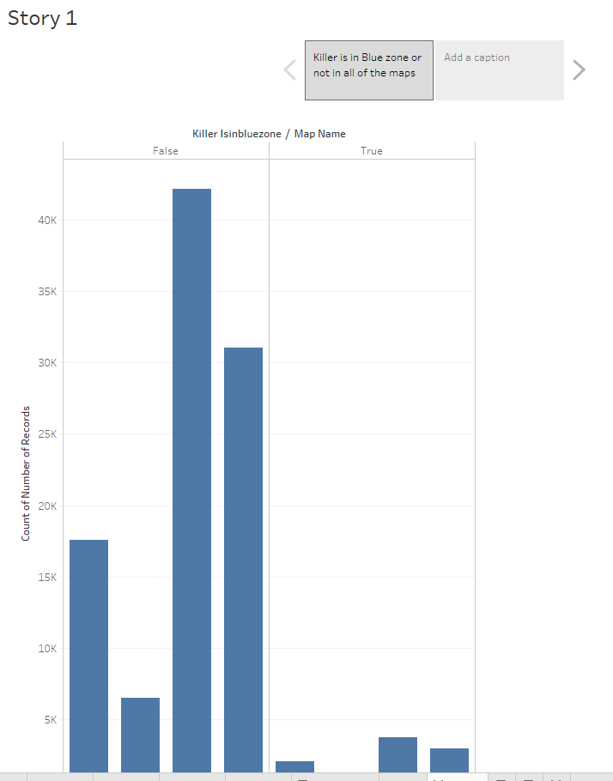

1. Add all sheets made for this question and Post storyboard.

This concludes the solution part of the assignment file.