I. INTRODUCTION AND SUMMARY

Radio absorptivity data for planetary atmospheres obtained from spacecraft radio occultation experiments, entry probe radio signal absorption measurements, and earth-based or spacecraft-based radio astronomical (emission) observations can be used to infer abundances of microwave absorbing constituents in those atmospheres, as long as reliable information regarding the microwave absorbing properties of potential constituents is available. The use of theoretically-derived microwave absorption properties for such atmospheric constituents, or the use of laboratory measurements of such properties taken under environmental conditions that are significantly different than those of the planetary atmosphere being studied, often leads to significant misinterpretation of available opacity data. Additionally, even if laboratory measurements have previously been conducted, improvements in the sensitivity of new space-based and earth-based microwave sensors may require higher precision laboratory measurements to achieve their basic science goals.

As improved laboratory instrumentation has become available, it is possible to achieve the higher precisions necessary to support such sensors. For example, development of one of our new laboratory systems was completed recently by Hanley and Steffes (2007) under our predecessor grant (NNG06GF34G, 9/15/06-9/14/10), and was used to conduct measurements of the 1-20 cm opacity of ammonia under simulated Jovian conditions with accuracies as precise as 2%. The over-2000 data points taken using this new system have led to development of a new model for ammonia microwave opacity under Jovian conditions (Hanley et al., 2009, jointly supported by the Juno mission). This model has been applied to data from the microwave opacity data from the Galileo entry probe and will be applied to microwave opacity data retrieved from the Cassini Radio Occultation and Cassini Radar experiments at Saturn. It will also impact planning of the Juno (Jupiter) mission and interpretation of a host of earth-based radio astronomical measurements of the microwave emission from all four of the Jovian planets.

The recognition of the need to make such laboratory measurements of simulated planetary atmospheres over a range of temperatures and pressures which correspond to the altitudes probed by radio occultation experiments, entry probe radio link experiments, and radio astronomical observations, and over a range of frequencies which correspond to those used in both spacecraft experiments and in radio astronomical observations, has led to the development of a facility at Georgia Tech which is capable of making such measurements. It is the goal of this investigation to conduct such measurements and to apply the results to a wide range of planetary observations, both spacecraft and earth-based, in order to determine the identity and abundance profiles of constituents in those planetary atmospheres.

In the 4-year program proposed, key activities will include applying recent new laboratory measurements of the millimeter-wave properties of ammonia to recent observations of the outer planets. Additionally, new laboratory measurements of the millimeter-wavelength absorption of gaseous sulfuric acid and sulfur dioxide will be conducted over an extended range of frequencies (75-150 GHz, or 2-4 mm) under simulated conditions for the atmosphere of Venus. These measurements will make it possible to interpret the source of variations in Venus millimeter-wavelength emissions reported in previous radio astronomical observations and those currently planned, by using a new radiative transfer model which will employ our new lab measurements. These measurements will be conducted using a new millimeter-wavelength laboratory system developed under our predecessor grant (NNG06GF34G, 9/15/06-9/14/10). A second group of laboratory measurements of the centimeter-wavelength properties of sulfur dioxide under conditions simulating the deep atmosphere of Venus will be conducted using yet another new system capable of maintaining pressures up to 100 Bars and temperatures up to 600 K. These results will be used in interpreting recently-observed spatial variations in the microwave emissions from Venus originating from the deep atmosphere and potential future measurements from two Discovery class missions currently being proposed.

II. RELEVANCE TO NASA’S OBJECTIVES

An aggressive program of laboratory measurements of the millimeter-wave properties of gaseous sulfuric acid and sulfur dioxide under simulated Venus conditions and laboratory measurements of the centimeter-wave properties of sulfur dioxide under simulated conditions for the very deep atmosphere of Venus is proposed. These measurements are directly relevant to the Planetary Atmosphere Program in that “the scope of the Planetary Atmospheres Program includes laboratory investigations that supply basic physical measurements that are currently needed to interpret planetary data, including measurements and calculations of spectroscopic, optical, and thermodynamic properties of materials found in planetary atmospheres.”

Specifically, the millimeter-wavelength radiative transfer studies proposed (employing our recently completed laboratory measurements pertinent to the atmosphere of Jupiter) will be applied to earth-based millimeter-wavelength observations of Jupiter, and can directly support the NASA Juno mission by providing contextual images of Jovian tropospheric ammonia. Moreover, the new laboratory measurements of the millimeter-wavelength properties of sulfur-bearing gases under simulated Venus conditions and their application to currently available millimeter-wavelength maps of Venus using our radiative transfer model will help “Determine abundances of greenhouse gases and other species that play a role in cloud formation,” which is identified as a priority science goal in the 2007 VEXAG Report (VEXAG, 2007). Similarly, the laboratory measurements of the microwave opacity of sulfur dioxide under simulated conditions for the deep atmosphere of Venus will provide the ability to “Characterize volcanic outgassing” which is likewise listed as a priority in the 2007 VEXAG Report.

II. RECENTLY COMPLETED LABORATORY MEASUREMENTS

A. Centimeter-Wavelength Laboratory Measurements of Ammonia under Simulated Conditions for the Outer Planets

In work conducted under our predecessor grant (NNG06GF34G, 9/15/06-9/14/10) development of one of our new laboratory systems was completed by Hanley and Steffes (2007), and was used to conduct measurements of the 1-20 cm opacity of ammonia under simulated Jovian conditions (H₂/He atmosphere with 0.125-12 Bars total pressure, and 183-450K temperature), with accuracies as precise as 2%. The over-2000 data points taken using this new system have led to development of a new model for ammonia microwave opacity under Jovian conditions (Hanley et al., 2009, jointly supported by the Juno mission). Results of these measurements were also presented at the October 2007 and October 2008 AAS/DPS meetings in Orlando, FL and Ithaca, NY (Hanley and Steffes, AAS/DPS 2007 and Hanley et al., AAS/DPS 2008) and at the January 2008 National Radio Science Meeting in Boulder, CO (Hanley and Steffes 2008). As shown in Figure 1, it appears as if none of the previously existing models best predicts the 4-20 cm opacity from NH₃ in an H₂/He atmosphere in the 8 Bar pressure range at 450K. The new model (Hanley and Steffes, shown as a “dotted” line) fits data well at all temperatures and pressures.

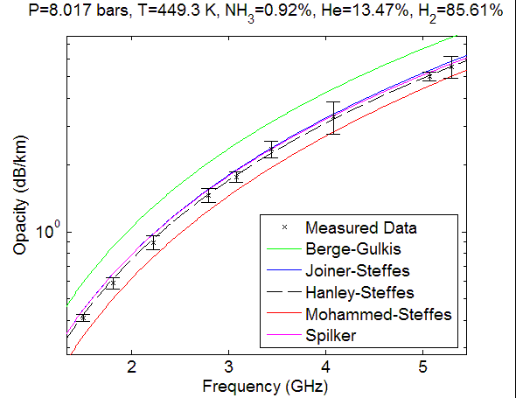
Figure 1: Measurement results for the opacity of ammonia under simulated Jovian conditions compared with existing models and the new model from Hanley et al. (2009).

This model has been applied to the microwave opacity data derived from monitoring the uplink signal from the Galileo entry probe (Folkner et al., 1997) and will be applied to microwave opacity data retrieved from the Cassini Radio Occultation experiments and Cassini Radar (passive radiometric) experiments at Saturn. It will also impact planning of the Juno (Jupiter) mission and interpretation of a host of earth-based radio astronomical measurements of the microwave emission from all four of the Jovian planets, such as our recent observation of the July 2009 asteroidal impact with Jupiter (Devaraj et al., 2010).

Additionally, multiple measurements of the 1.3-20 cm opacity of water vapor in an H₂/He atmosphere were conducted at pressures from 1-12 Bars and at temperatures from 350-450 K. However, the opacity from water vapor is quite small under these conditions, and only limited insights into a proper model for the centimeter-wave opacity from water vapor under Jovian conditions was provided (Hanley and Steffes, 2008). As a result, a new, ultra-high pressure system capable of maintaining pressures up to 100 Bars in the 300-525 K temperature range has been built in our laboratory with support from the Juno mission. This system was recently used to complete measurements of the 5-21 cm (1.4-6 GHz) opacity from water vapor under pressures up to 100 Bars under simulated Jovian conditions. (These measurements were fully supported by the Juno mission.) Additionally, the new high-pressure system will be used to conduct measurements of the 1.4-6 GHz opacity of ammonia under conditions of the deep atmosphere of Jupiter, so as to verify the accuracy of the Hanley and Steffes (2009) model under more extreme conditions. (These measurements will also be fully supported by the Juno mission, and no support for them is requested here.)

B. Laboratory Measurements of Millimeter-Wavelength Continuum Absorption Spectrum of Ammonia under simulated Conditions for the Outer Planets

Under our predecessor grant (NNG06GF34G, 9/15/06-9/14/10), we also completed an extensive measurement campaign of the 2-4 mm continuum absorption spectrum of ammonia in a hydrogen-helium atmosphere using a new millimeter-wavelength measurement system described in presentations at the 2007 and 2008 AAS-DPS Meetings in Orlando, FL and Ithaca, NY, at the 2008 National Radio Science Meeting in Boulder, CO, and in a new paper recently submitted to the journal, Radio Science (See Devaraj and Steffes, 2007, 2008a, 2008b, and 2010a.) This system is shown in Figure 2.

Results for the continuum opacity from ammonia in a hydrogen/helium atmosphere are shown in Figures 3 and 4. Most noteworthy is that these measurements provide coverage over an extensive wavelength range, rather than at just one or two wavelengths as in previous measurements. (See, e.g., Mohammed and Steffes, 2004 or Joiner and Steffes, 1991.) Additionally, the sensitivity of the systems used for these measurements have been dramatically improved. As a result, it is now possible to detect the contribution of the υ₂ vibrational line of ammonia (140 GHz) for both pure ammonia at low pressure and when pressure broadened by hydrogen and helium. The results indicate that none of the existing models for ammonia opacity correctly predict the 2-4 mm opacity from ammonia under simulated Jovian conditions. A new model has been developed (shown in black in Figures 3 and 4) to match the over-1000 millimeter-wave data points taken under the predecessor grant, using the latest, revised line catalog from the JPL/Spec database. This work was presented at the 2009 AAS/DPS meeting and at the May 2010 EGU Meeting, and is included in a new paper submitted to the journal, ICARUS (Devaraj and Steffes, 2009, 2010b, and 2010c).

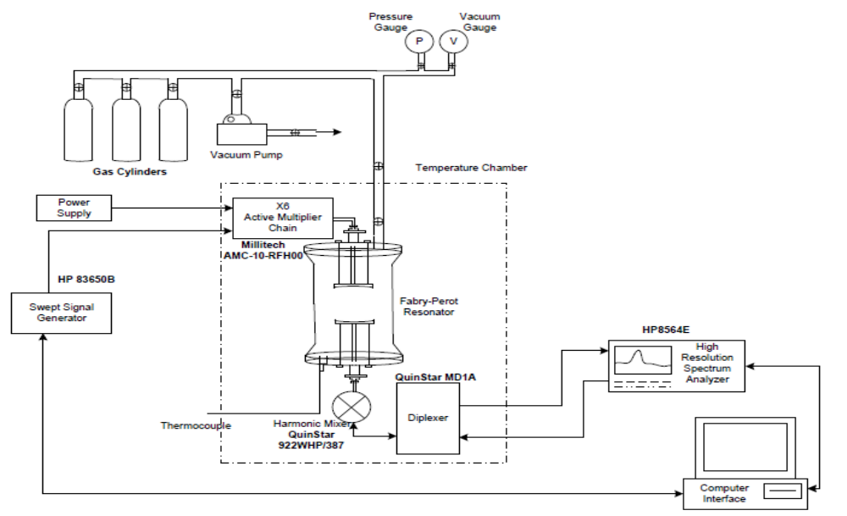
Figure 2: Millimeter-wavelength measurement system for studying gas properties under simulated planetary conditions.
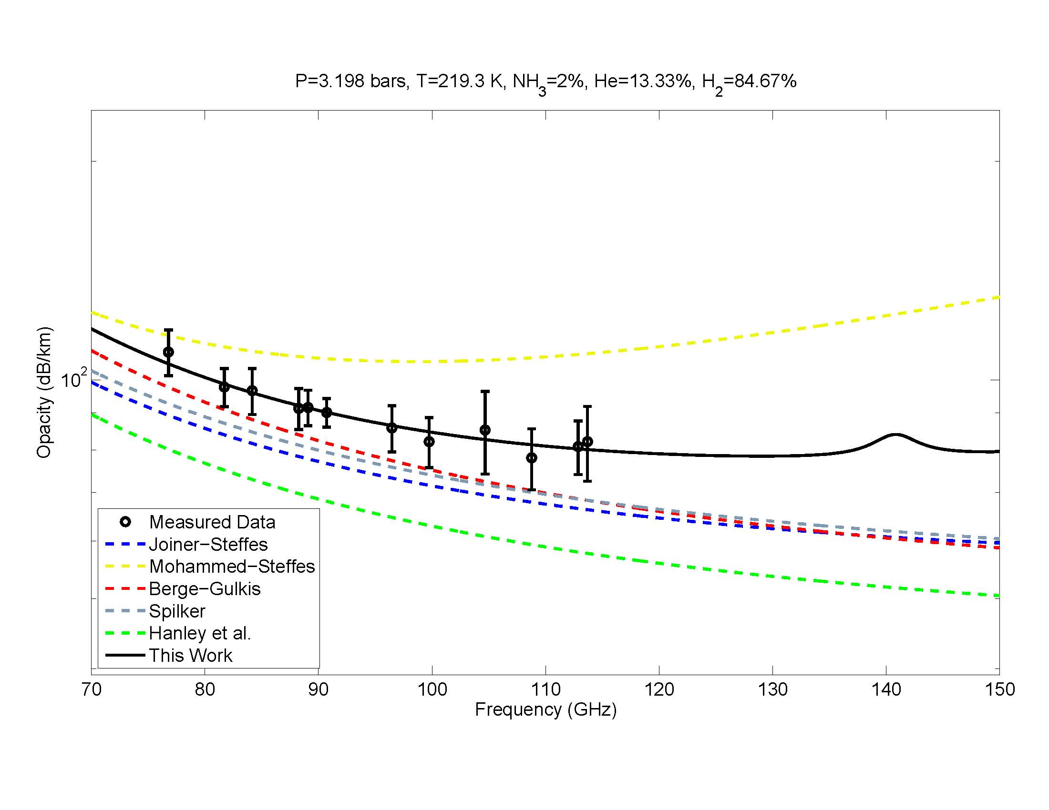
Figure 3: Laboratory measurements of the 75-115 GHz opacity of ammonia in an H₂/He atmosphere under simulated Jovian conditions. (Devaraj and Steffes, 2010b)
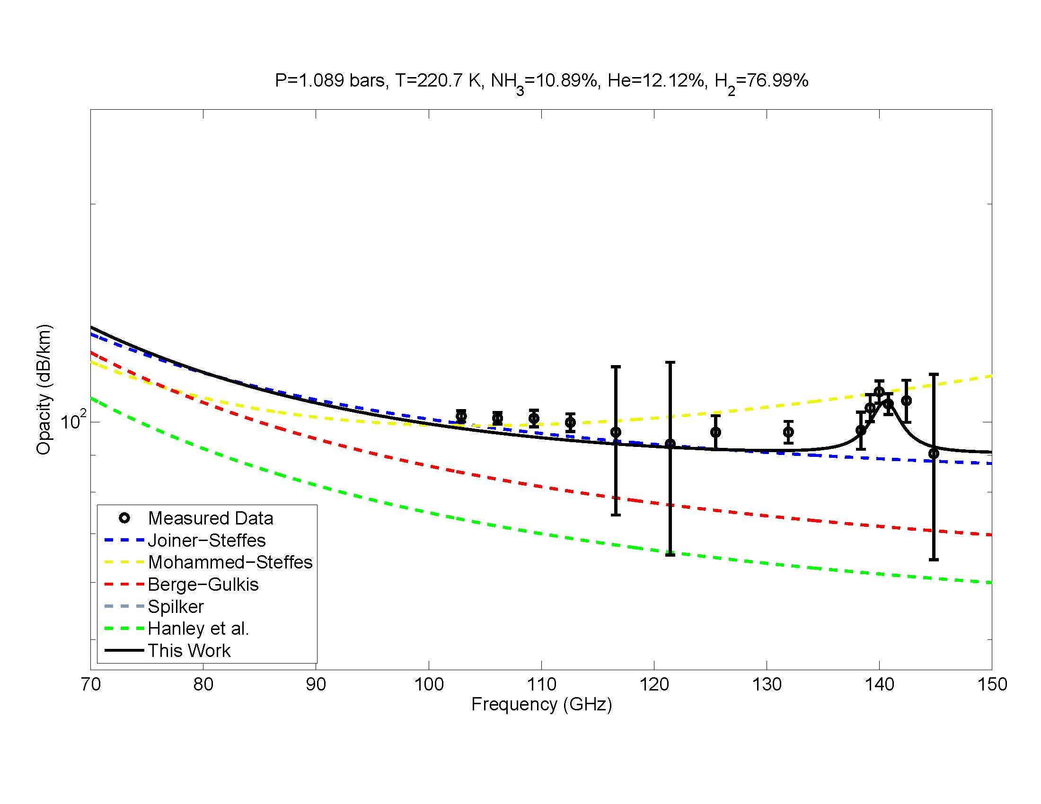
Figure 4: Laboratory measurements of the 105-145 GHz opacity of ammonia in an H₂/He atmosphere under simulated Jovian conditions. (Devaraj and Steffes, 2010b)

The results of these measurements are significant, in that they provide insight into interpreting the millimeter-wave emission spectra of the outer planets. Interpretive studies of observations of the millimeter-wave spectra of the outer planets (see, e.g., Van der Tak et al., 1999, Orton et al., 1986, Hesman et al., 2007) are currently ongoing, and will benefit directly from these measurements. Moreover, our measurement of the 140 GHz vibrational line has motivated observers at Observatoire de Paris (Moreno et al.) to observe Jupiter in August 2010 with the IRAM 30-meter millimeter-wave telescope (the largest single aperture millimeter-wave telescope in the world) so as to detect this resonance and allow our use of the new data in modeling variabilities in upper tropospheric ammonia.

One of the first activities in the proposed program is to use our updated millimeter-wavelength radiative transfer program (using these new laboratory results) to retrieve magnitudes and variations of upper tropospheric ammonia abundances in the Jovian atmosphere. Initial development of this radiative transfer model was conducted by Karpowicz (2010) under our predecessor grant. The ability to demonstrate this capability will be of high value to the upcoming Juno mission, since earth-based observations will be used to set the context for the mission’s microwave observations.

III. PROPOSED LABORATORY MEASUREMENTS

- Sulfuric Acid and Sulfur Dioxide in the Venus Atmosphere

For nearly 30 years, sulfuric acid vapor (H₂SO₄) has been recognized as a major source of the microwave absorption in the atmosphere of Venus (Steffes and Eshleman, 1982). Through radio occultation measurements from both the Pioneer-Venus and Magellan, it has been possible to retrieve abundance profiles of gaseous H₂SO₄ in the atmosphere of Venus (Jenkins and Steffes, 1991 and Jenkins et al., 1994). Laboratory measurements of the centimeter-wavelength opacity of gaseous H₂SO₄ in a CO₂ atmosphere (Kolodner and Steffes, 1998) dramatically increased the precision of retrievals from both radio occultation experiments (conducted at 3.6 and 13 cm) and from radio emission measurements conducted at 1.3 and 2.0 cm (Jenkins et al., 2002). Recently, observations of Venus with the Nobeyama millimeter-wave array conducted at 103 GHz (~3mm) showed substantial variation (~25%) in the millimeter-wave brightness with position on the disk (Sagawa, 2008). While maps of the 1.3 and 2.0 cm emission from Venus have indicated dark (~3%) polar regions consistent with increased sulfuric acid vapor abundance due to vaporization of cloud condensate from the downwelling characteristic of Hadley cell circulation (Jenkins et al., 2002), the 3 mm maps show much stronger variations over a range of different locations, with some indication of diurnal variation. de Pater et al. (1991a) also reported significant variations (10%) in the 2.6 mm emission maps of Venus made with the Hat Creek Interferometer. Sagawa (2008) attributes the variations to spatial variations in the abundances of gaseous H₂SO₄ and SO₂ in a range of altitudes from just below the lower cloud base to the top of the lower cloud (pressures 0.7-2 Bars). However his attribution involves use of models for the millimeter-wavelength opacities of these constituents which were extrapolated from previous centimeter-wavelength measurements. Additionally, Sagawa has suggested that the effects of the two constituents could be distinguished based on differences in frequency (wavelength) dependencies of the millimeter-wave absorption from both constituents, but those wavelength dependencies are uncertain. Specifically to date, the millimeter-wave absorption from SO₂ at these pressures has only been measured at one frequency (3.2 mm wavelength) (Fahd and Steffes, 1992) and that from gaseous H₂SO₄ is even more speculative, since very few of the 40,000 microwave and millimeter-wave lines contained in the JPL line catalog (Pickett et al., 1998) have ever been measured.

In Figure 4, we show our calculations of the predicted opacity from sulfur dioxide and sulfuric acid vapor in a CO₂ atmosphere under conditions simulating the cloud base region of Venus. The model for sulfur dioxide is derived using a microwave opacity model (Suleiman et al., 1996) based on the JPL line catalog(Pickett-Poynter-Cohen, 1998), the model for sulfuric acid vapor was derived using the JPL (Pickett-Poynter-Cohen, 1998) catalog and assuming a line broadening parameter estimated by Fahd (1992). Both models indicate a strong absorption spectrum which can be measured in the 2-4 mm wavelength range by use of a 1-meter long absorption cell. (This precludes exposing the confocal Fabry-Perot resonator shown in Figure 2 to hot sulfur gases.) However, the ultrastable sources and detectors used for the previous measurements of ammonia in the 75-110 GHz and 110-150 GHz ranges can be used external to the temperature chambers to provide continuum measurements of the opacity from 75-150 GHz (2-4 mm).
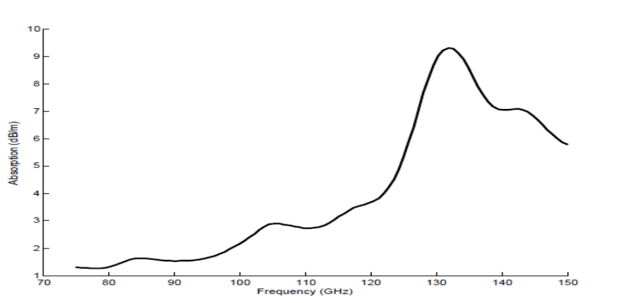
- ↑ b↓
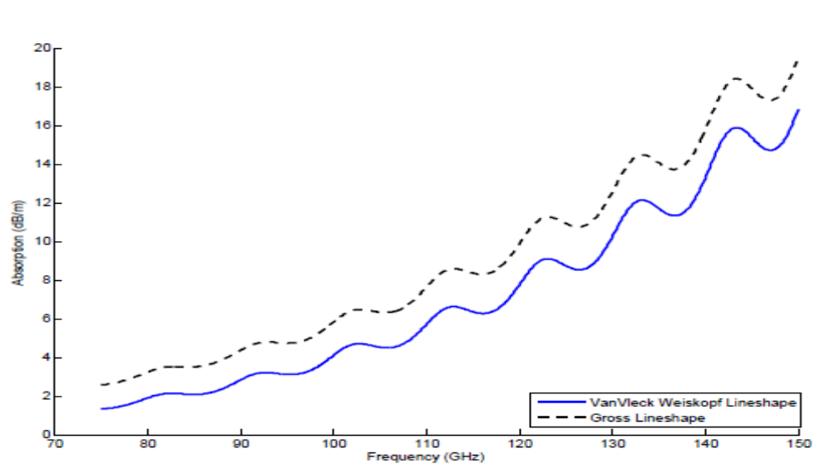
Figure 4: Modeled normalized absorption spectrum 1% SO₂ (a) and 1% gaseous H₂SO₄ (b) in a CO₂ atmosphere under laboratory conditions simulating the middle troposphere of Venus.(T=400 K and P=1Bar).

We propose to conduct a series of laboratory measurements of the millimeter-wavelength opacity from both SO₂ and gaseous H₂SO₄ in a CO₂ atmosphere at wavelengths from 2-4 mm (75-150 GHz), at temperatures from 375-525 K, and pressures from 0.5-2 Bars. Because no resonant structure is used in the transmission cell, continuous spectral coverage will be provided. Block diagrams for the two systems to be used are shown in Figures 5a and 5b. (A similar architecture was used by Fahd (1992) to make a single measurement of the 3.2 mm opacity of H₂SO₄ in a CO₂ atmosphere, but the crude instrumentation at the time only allowed measurement at a single frequency, with relatively low precision.) We expect to achieve precisions of better than 10% at the lowest frequencies, and better than 5% at the highest frequencies, assuming the estimated opacities in Figure 4. The results will be used in our radiative transfer model for Venus (Jenkins et al., 2002) in order to retrieve information regarding the variability of both SO₂ and H₂SO₄ in the atmosphere of Venus near the cloud base from the 3-mm maps of Sagawa (2008) and de Pater et al. (1991).
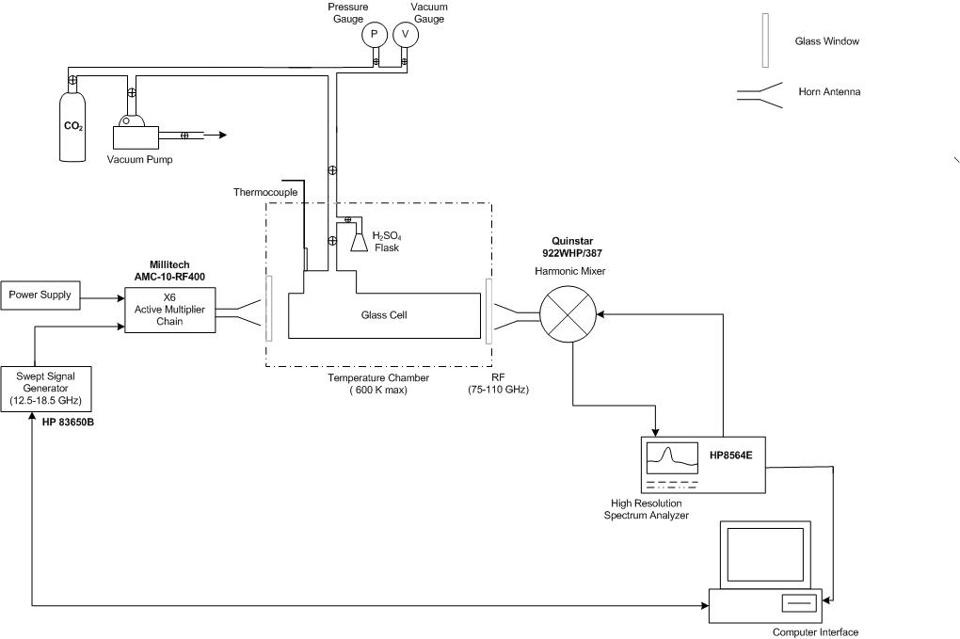Figure 5a (above): Measurement system for sulfur dioxide and sulfuric acid vapor under simulated Venus conditions for the 75-110 GHz frequency range.

Figure 5b (below): Measurement system for the 110-150 GHz frequency range.

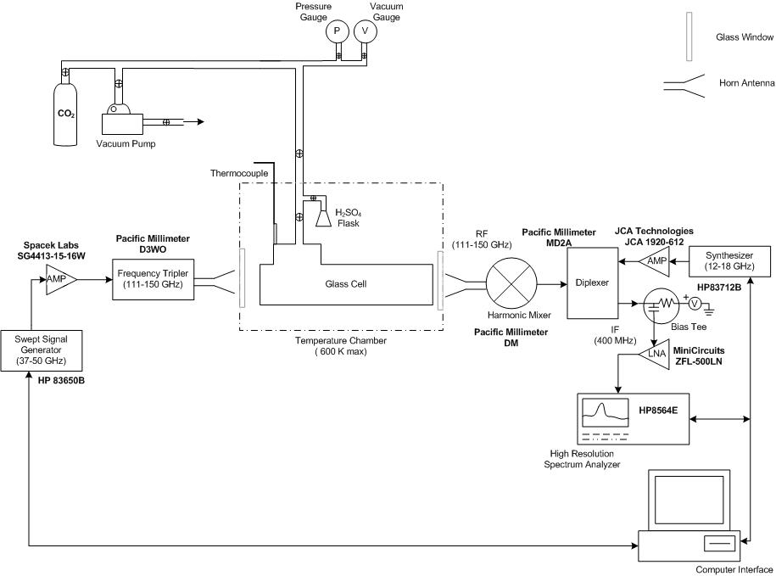

Additionally, upon completion of these measurements, we plan to request time on the CARMA (Combined ARray for Millimeter-wavelength Astronomy) to conduct additional 3-mm measurements, so as to further constrain temporal differences of the abundances of these gases at the cloud base.

Sulfur Dioxide in the Deep Atmosphere of Venus

Two sulfur-bearing compounds dominate the centimeter-wave emission from Venus: sulfur dioxide (SO₂) and gaseous sulfuric acid (H₂SO₄). (See, for example, Butler et al., 2001, or Jenkins et al., 2002.) At altitudes below 35 km, H₂SO₄ thermally dissociates, forming H₂O and SO₃, both of which exhibit relatively small amounts of microwave absorption at the abundance levels present in the Venus atmosphere. Thus, in the deep atmosphere, only SO₂, and to a lesser extent OCS have the potential to affect the observed microwave emission. (Note that the collisionally-induced absorption from CO₂ has a significant effect on the microwave emission from Venus, but it is not in any way localized since CO₂ is the dominant atmospheric constituent.) On April 5, 1996, maps were made of the 1.3 cm and 2.0 cm emission from Venus using the NRAO Very Large Array, which indicated dark (~3%) polar regions consistent with increased sulfuric acid vapor abundance due to vaporization of cloud condensate from the downwelling characteristic of Hadley cell circulation (Jenkins et al., 2002). This conclusion was also consistent with the weighting functions at these wavelengths, which peak well above the surface or boundary layer. Recently, new observations of Venus at 3.6 cm were taken on July 7, 2009 (by Georgia Tech graduate student Kiruthika Devaraj, under support from our predecessor grant) to create a map of the 3.6 cm emission from Venus. As shown in Figure 6 (upper image), the total disk emission (average 710 K) appears as a relatively uniform, limb darkened disk. However, after being reference to a radially-averaged, limb-darkened disk (Figure 6, lower image) significant structure is visible. Of note are the dark regions in the north and south limb. As with our 1996 images at shorter wavelengths, these correspond to the increased abundance of microwave-opaque sulfuric acid vapor below the cloud base, caused by the downwelling characteristic of Hadley cell circulation, in the areas in and surrounding the polar vortices. (At angles far from disk center, the weighing functions correspond to such altitudes.) However, the features in the center of the disk, correspond to variations in either temperature or sulfur dioxide abundance in the deepest part of the troposphere, as can be seen from the X-Band (or 3.6 cm) “weighting function” shown in Figure 7.

In order to determine the amount of sulfur dioxide required to create such a feature, an accurate expression for the 3.6 cm opacity of SO₂ under conditions for the deep atmosphere of Venus is required. To date, very few laboratory measurements of potential Venus microwave absorbers have been made under pressures and temperatures characteristic of the deepest layers of the Venus atmosphere. Over 40 years ago, Ho et al. (1966) conducted laboratory measurements of the 3 cm opacity of CO₂, N₂, and H₂O under pressures up to 100 Bars and temperatures up to 500K. However those measurements were all conducted at only one frequency, so that the frequency

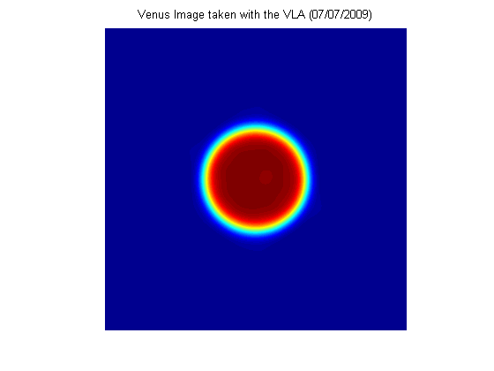

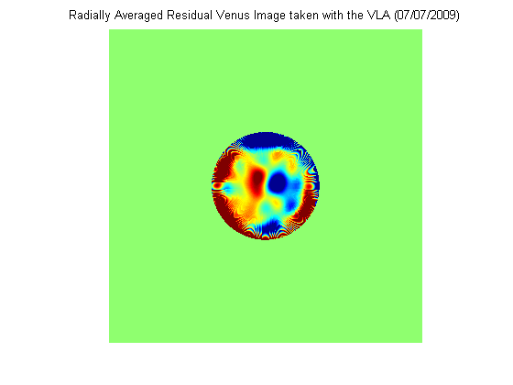

Figure 6: Image of 3.6 cm emission from Venus derived from VLA data taken on July 7, 2009. Upper image is total emission and lower image is residual brightness relative to reference atmosphere.

dependences of the opacities were not measured, and all were assumed to be f-squared. Additionally, no sulfur compounds were measured.

The most accurate laboratory measurements of the centimeter-wavelength opacity of sulfur dioxide under Venus atmospheric conditions were conducted by Suleiman et al. (1996). However, the highest pressure measured in their experiments was only 4 Bars. Thus, we propose to use the ultra-high pressure measurement system developed for the Juno project (Figures 8a and 8b) in order to measure the centimeter-wavelength (1.4-8.5 GHz, 3.5-21 cm) opacity from a SO₂/ CO₂ mixture over a range of pressures from 6-100 Bars, and a range of temperatures from 300-600K. (Note that while the Venus surface is 750K, our system will not achieve that actual temperature. However, the temperature dependence derived will provide a reliable model for the conditions at the surface and boundary layer. It should also be noted that our measurements will be conducted under hotter conditions than those of Ho et al., 1966.) It should be noted that at such high pressures, the broadening gas (CO₂) will itself exhibit collisionally-induced microwave absorption. This will be separated from the absorption of SO₂ by conducting differential measurements of the microwave absorption between the SO₂/CO₂ mixture and an equivalent density of pure CO₂. Also note that high-pressure measurement at higher frequencies is not necessary, since the weighting functions at those higher frequencies (shorter wavelengths) penetrate far less deep into the Venus atmosphere.

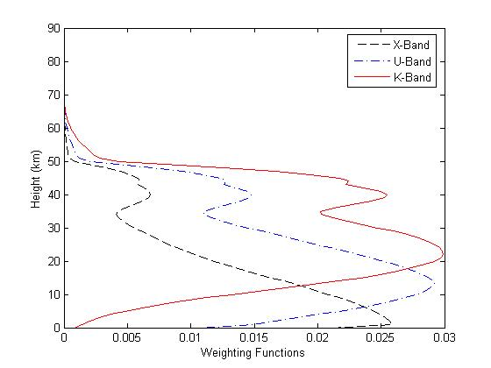

Figure 7:

Weighting functions for center of Venus disk at 3.6 cm (X-Band), 2 cm (U-Band) and 1.3 cm (K-Band).

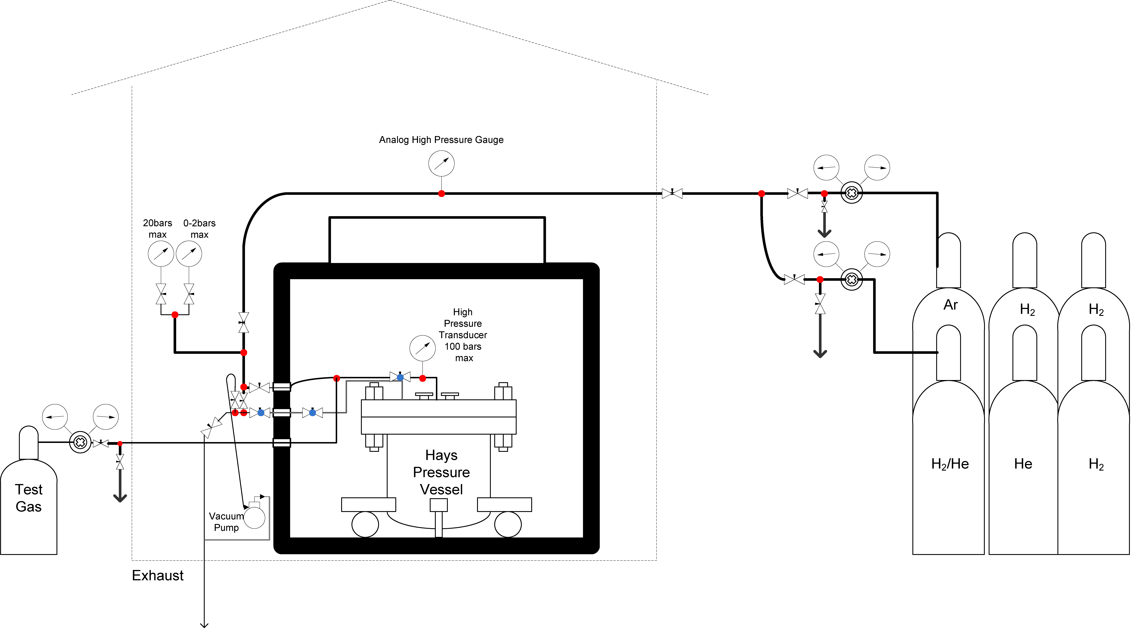

Figure 8a (above): Gas handling system for the ultra-high pressure simulator

Figure 8b (below): Microwave/electronic measurement system

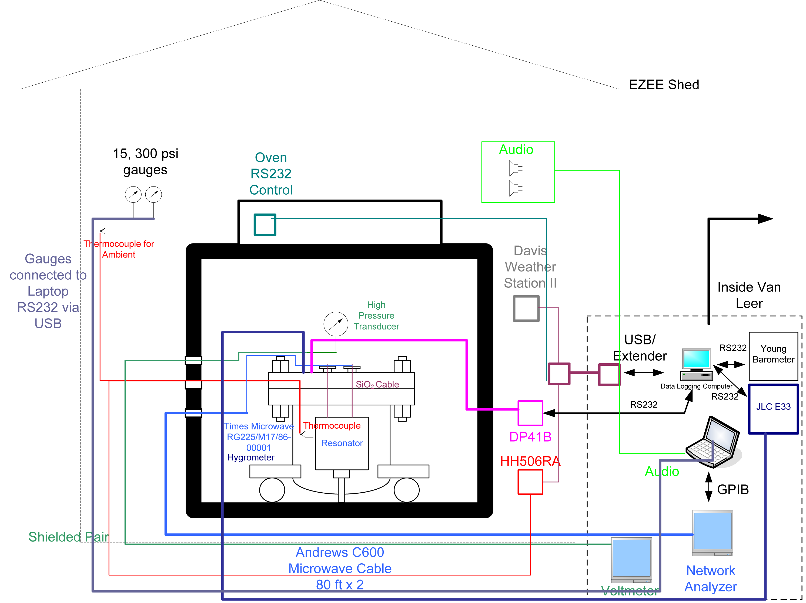

Since the upgraded system is functional at a number of resonant frequencies in the 3.5-21 cm wavelength range, the opacity from various mixtures will be measured 10 different wavelengths. The mole fractions for each constituent will be adjusted so as to derive the effects of self-broadening from SO₂,, as well as the foreign gas broadening from carbon

dioxide. These measurements will represent the first laboratory measurements ever conducted of a sulfur-bearing gas under simulated conditions for the deep atmosphere of Venus. It will also be the first time ever that the frequency (wavelength) dependence of the microwave opacity of deep atmospheric constituents will be measured under the conditions of the deep Venus atmosphere. Results from these measurements will be integrated into our existing radiative transfer model (Jenkins et al., 2002) so as to retrieve potential abundance variations of sulfur dioxide from the moderate-resolution X-Band (3.6 cm) emission maps already developed by students in our program. This will also require an upgrade to our model to account for variations in surface emissivity which contribute to the overall emission measured at this wavelength. (Note that emissivity maps from Magellan will be used to make this correction.) Of special note is the value of these measurements relative to the recent paper by Smrekar et al. (2010), where the authors suggest the possible presence of recent hot-spot volcanism on Venus. The ability to detect sulfur dioxide (presumably related to volcanism) in the boundary layer is of significant importance. Additionally, this laboratory work could enable passive radiometric measurements from spacecraft X-band radars orbiting Venus (two such missions are being proposed to the current Discovery AO) which would provide detailed information regarding the presence of sulfur dioxide in the boundary layer, which could potentially serve as a marker for active volcanism.

IV. PROPOSED PROCEDURE AND LEVEL OF EFFORT

An aggressive program of microwave remote sensing studies and laboratory measurements of the millimeter-wave properties of gaseous sulfuric acid and sulfur dioxide under simulated Venus conditions and laboratory measurements of the centimeter-wave properties of sulfur dioxide vapor under simulated conditions for the very deep atmosphere of Venus is proposed. The millimeter-wave experiments will enable us to retrieve constituent variations near the cloud base, thought to be the source of variations in Venus millimeter-wavelength emissions reported by radio astronomical observers, and will also illuminate the ability of new ground-based millimeter-wave arrays (such as ALMA) to provide planet-wide maps of atmospheric constituents comparable in sensitivity and resolution to those obtained with spacecraft instruments. The centimeter-wave experiments will be used in interpreting spatial variations in the observed microwave emissions of Venus originating from the deep atmosphere.

Key activities involve:
YEAR 1: Apply new model for millimeter-wavelength ammonia opacity of ammonia to our existing radiative transfer model for Jupiter. Retrieve ammonia abundance variations at the cloud base from existing millimeter-wave maps, and from new observation at IRAM. Complete modification of the existing 2-4 mm laboratory system to allow measurement of the 75-110 GHz (2.7-4mm) opacity from SO₂ and gaseous H₂SO₄ in a CO₂ atmosphere under simulated conditions for the Venus atmosphere in the 0.5-2 Bar pressure range. Conduct measurements of the SO₂/CO₂ under the 0.5-3 Bar and 375-525K ranges.

YEAR 2: Complete measurements of the 2.7-4 mm opacity of H₂SO₄ in a CO₂ atmosphere under simulated conditions for the Venus atmosphere. Subsequently, modify system so as to conduct measurements in the 110-150 GHz (2-2.7 mm) range. Complete opacity measurements of SO₂ and gaseous H₂SO₄ in a CO₂ atmosphere under simulated conditions for the Venus atmosphere in the 0.5-2 Bar pressure range.

YEAR 3: Develop opacity models for SO₂ and gaseous H₂SO₄ and apply results to our radiative transfer model. Retrieve abundance variations at the cloud base from existing millimeter-wave maps and plan additional observation. Modify ultra-high pressure centimeter-wave system to allow measurement of opacity from sulfur dioxide under conditions for the deep Venus atmospheres. Begin measurements.

YEAR 4: Complete measurements of the 3.5-21 cm opacity of SO₂ under simulated conditions for the 6-100 Bar pressure regime in the Venus atmosphere. Develop opacity model and apply results to our radiative transfer model. Retrieve abundance variations in the deep atmosphere from 3.6 cm maps.

The level of effort for the scientific research for this four year grant (January 1, 2011 through December 31, 2014) will involve one professor (P.G. Steffes, Professor and Associate Chair of Electrical and Computer Engineering) at 25% time (3.0/months/year), and one graduate student (Graduate Research Assistant) at 50% time. (Note that 50% is the maximum support level for Ph.D. students, with the remaining 50% considered as registered academic thesis research. Professor Steffes is authorized to commit up to 50% time (total) for research in space sciences and engineering.) Support is requested for laboratory supplies and gases, and for travel of the PI and the graduate student to attend and present results at the annual AAS/DPS Meetings.

In addition to the participation in the program by Professor Steffes and the paid graduate research assistant, contributions to the program from both graduate and undergraduate students working on special projects for academic credit have been substantial. Likewise, in the spirit of the NASA Graduate Student Researchers Program, and in conjunction with Georgia Space Grant Consortium, we continue to seek out talented underrepresented minority students and involve them in our program.

The amount of collaborative work we have conducted in both our Venus atmospheric studies and in our studies of the outer planets has demonstrated a need for a reference source of information regarding the microwave and millimeter-wave absorption properties of planetary atmospheres. At the suggestion of Dr. Reta Beebe (NMSU) who is responsible for the Planetary Atmospheres node of the Planetary Data System (PDS), we created a web page which allows direct access to references of laboratory results for the microwave and millimeter-wave absorptive and refractive properties of planetary atmospheric constituents, both from our group and from others in the world. The URL for this page is http://users.ece.gatech.edu/~psteffes/palpapers/ .

V. REFERENCES

Butler, B.J., P.G. Steffes, S.H. Suleiman, M.A. Kolodner, and J.M. Jenkins 2001. Accurate and consistent microwave observations of Venus and their implications. Icarus 154, 226-238.

DeBoer, D.R. and P.G. Steffes 1994. Estimates of the tropospheric vertical structure of Neptune based on microwave radiative transfer studies. Icarus 123, 324-335.

de Pater, I., F.P. Schloerb, A. Rudolph 1991a. Venus imaged with the Hat Creek Interferometer in the J=1-0 CO line. Icarus 90, 282-298.

de Pater, I., P.N. Romani, S. Atreya 1991b. Possible microwave absorption by H₂S gas in Uranus’and Neptune’s atmospheres. Icarus 91, 220-233.

Devaraj K. and P.G. Steffes 2007. “Preliminary Results for the 2-4 Millimeter Wavelength Continuum Opacity of Ammonia based on New Laboratory Measurements under Simulated Jovian Conditions,” Bulletin of the American Astronomical Society, vol. 39, no. 3, p. 447. Presented at the 39th Annual Meeting of the Division for Planetary Sciences of the American Astronomical Society, Orlando, FL, October 9, 2007.

Devaraj, K. and P.G. Steffes 2008a. “Laboratory Measurements of W-band Continuum Opacity of Ammonia Using a Fully Confocal Fabry-Perot Resonator,” International Union of Radio Science Programs and Abstracts: 2008 National Radio Science Meeting, pp. J1-4. Presented at the 2008 URSI National Radio Science Meeting, Boulder, CO, January 3, 2008.

Devaraj, K. and P.G. Steffes 2008b. “A New Laboratory System for Measurement of the Millimeter-Wave Properties of Gases and Preliminary Results for the Continuum Opacity of Ammonia,” Bulletin of the American Astronomical Society, vol. 40, no. 3, p. 497. Presented at the 40th Annual Meeting of the Division for Planetary Sciences of the American Astronomical Society, Ithaca, NY, October 14, 2008.

Devaraj, K. and P.G. Steffes 2009. “The 2-4 Millimeter-Wave Opacity of Ammonia: Extensive Laboaratory Measurements and a New Model,” Bulletin of the American Astronomical Society, vol. 41, no. 3, 2009, p. 1049. Presented at the 41st Annual Meeting of the Division for Planetary Sciences of the American Astronomical Society, Fajardo, PR, October 7, 2009.

Devaraj, K., B. Butler, B. Hesman, P. G. Steffes, and R. Sault 2010. "VLA Observations of the Jupiter Impact", EGU General Assembly, Geophysical Research Abstracts, Vol. 12, 7661, May 2010, Vienna, Austria.

Devaraj K. and P.G. Steffes 2010a. “The Georgia Tech Millimeter Wavelength Measurement System and Some Applications to the Study of the Planetary Atmospheres” submitted to Radio Science, May 2010.

Devaraj, K., and P. G. Steffes 2010b, “The 2-4 Millimeter-Wavelength Opacity of Ammonia,” EGU General Assembly, Geophysical Research Abstracts, Vol. 12, 7675, May 2010, Vienna, Austria.

Devaraj K. and P.G. Steffes 2010c, “The 2-4 Millimeter-Wave Opacity of Ammonia: Extensive Laboratory Measurements and a New Model,” submitted to Icarus, June 2010.

Fahd, A.K. 1992. Study and Intepretation of the Millimeter-wave Spectrum of Venus. Ph.D. Thesis, Georgia Institute of Technology, Atlanta, GA.

Fahd, A.K. and P.G. Steffes 1992. Laboratory Measurements of the Microwave and Millimeter-Wave Opacity of Gaseous Sulfur Dioxide (SO₂) under Simulated Conditions for the Venus Atlmosphere. Icarus 97, 200-210.

Fegley, R., D. Gautier, T. Owen and R.G. Prinn 1991. Spectroscopy and chemistry of the atmosphere of Uranus. In Uranus (J.T. Bergstralh, E.D. Miner, and M.S. Matthews eds.) 147-203. Univ. of Az. Press, Tucson.

Folkner, W.M., R. Woo, and S. Nandi 1998. Ammonia abundance in Jupiter’s atmosphere derived from the attenuation of the Galileo Probe’s signal. Journal of Geophysical Research (Planets) 103, 22,847-22,855.

Hanley, T.R. and P.G. Steffes 2007. A High-Sensitivity Laboratory System for Measuring the Microwave Properties of Gases under Simulated Conditions for Planetary Atmospheres. Radio Science, vol 42, no. RS6010, pp.1-12.

Hanley, T.R. and P.G. Steffes 2007. “New High-Precision Laboratory Measurements of the Hydrogen and Helium Broadened Microwave Opacity of Ammonia under Simulated Deeper Atmospheric Jovian Conditions,” Bulletin of the American Astronomical Society, vol. 39, no. 3, p. 447. Presented at the 39th Annual Meeting of the Division for Planetary Sciences of the American Astronomical Society, Orlando, FL, October 9, 2007.

Hanley, T.R. and P.G. Steffes 2008. “New Laboratory Measurements of the Microwave Absorption Coefficient of Ammonia and Water Vapor under Jovian Conditions,” International Union of Radio Science Programs and Abstracts: 2008 National Radio Science Meeting, pp. J1-5. Presented at the 2008 URSI National Radio Science Meeting, Boulder, CO, January 3, 2008.

Hanley, T.R., P.G. Steffes, and B.M. Karpowicz 2008. “A New Model of the Hydrogen and Helium-Broadened Microwave Opacity of Ammonia Based on Extensive Laboratory Measurements,” Bulletin of the American Astronomical Society, vol. 40, no. 3, p. 497. Presented at the 40th Annual Meeting of the Division for Planetary Sciences of the American Astronomical Society, Ithaca, NY, October 14, 2008.

Hanley, T.R., P.G. Steffes, and B.M. Karpowicz 2009. A new model of the hydrogen and helium-brodened microwave opacity of ammonia based on extensive laboratory measurements.
Icarus 202, 316–335.

Hesman, B.E., G.R. Davis, H.E. Matthews, and G. S. Orton 2007. The abundance profile of CO in Neptune’s atmosphere Icarus 186, 342–353.

Ho, W., I.A. Kaufman, and P. Thaddeus 1966. Laboratory measurement of microwave absorption in models of the atmosphere of Venus. Journal of Geophysical Research 71, 5,091-5,108.

Jenkins J.M. and P. G. Steffes 1991. Results for 13 cm Absorptivity and H2SO4 Abundance Profiles from the Season 10 (1986) Pioneer-Venus Orbiter Radio Occultation Experiment. Icarus, vol. 90, pp. 129-138.

Jenkins, J.M., P. G. Steffes, J. Twicken, D. P. Hinson, and G. L. Tyler 1994. Radio Occultation Studies of the Venus Atmosphere with the Magellan Spacecraft 2. Results from the October 1991 Experiment. Icarus, vol. 110, pg. 79-94.

Jenkins, J.M., M.A. Kolodner, B.J. Butler, S.H. Suleiman, and P.G. Steffes 2002. Microwave remote sensing of the temperature and the distribution of sulfur compounds in the Venus atmosphere. Icarus 158, 312-328.

Joiner, J. and P.G. Steffes 1991. Modeling of Jupiter’s millimeter wave emission utilizing laboratory measurements of ammonia (NH₃) opacity. Journal of Geophysical Research (Planets) 96, 17,463-17,470.

Kolodner, M.A. and P. G. Steffes 1998. The microwave absorption and abundance of sulfuric acid vapor in the Venus atmosphere based on new laboratory measurements. Icarus 132, 151-169.

Mohammed, P.N. and P.G. Steffes 2004. Laboratory Measurements of the W-band (3.2 mm) Properties of Phosphine (PH₃) and Ammonia (NH₃) Under Simulated for the Outer Planets. Journal of Geophysical Research - Planets 109, no. E07S13, pp 1-9.

Orton, G. S., M. J. Griffin, P. A. R. Ade, I. G. Nolt, J. V. Radostitz, E. I. Robson, and W. K. Gear 1986. Submillimeter and millimeter observations of Uranus and Neptune, Icarus 67, 289-304.

Pickett, H.M., Poynter, R.L, Cohen, E.A., Delitsky, M.L, Pearson, J.C., and Muller, H.S.P. 1998.
Submillimeter, millimeter, and microwave spectral line catalog. J. Quant. Spectrosc. Radiat. Trans. 60, 883-890.

Sagawa, H. 2008. Terahertz remote sensing of the Venusian atmosphere: Observations using the Nobeyama Millimeter Array. Journal of the National Institute of Information and Communications Technology (Japan) 55, 149-157.

Smrekar, S.E., E.R. Stofan, N. Mueller, A. Treiman, L. Elkins-Tanton, J. Helbert, G. Piccioni, and P. Drossart 2010. Recent Hotspot Volcanism on Venus from VIRTIS Emissivity Data. Science 328, 605-608.

Steffes, P.G. and V. R. Eshleman 1982. Sulfuric Acid Vapor and Other Cloud-Related Gases in the Venus Atmosphere: Abundances Inferred from Observed Radio Opacity. Icarus, vol. 51, pp. 322-333.

Suleiman, S.H., M. A. Kolodner, and P. G. Steffes 1996. Laboratory Measurement of the Temperature Dependence of Gaseous Sulfur Dioxide (SO2) Microwave Absorption with Application to the Venus Atmosphere. Journal of Geophysical Research, Vol. 101, Number E2, pp. 4623-4635.

Van der Tak, F., I. dePater, A. Silva, and R. Millan 1999. Time variability in the radio brightness distribution of Saturn. Icarus 142, 125-147.

VEXAG 2007. Venus Scientific Goals, Objectives, Investigations and Priorities: 2007. J. Luhmann and S. Atreya.

VI. FACILITIES

The specific laboratory measurements described in this proposal will be conducted at the Planetary Atmospheres Laboratory and the accompanying Remote Sensing Laboratory, which are located within the School of Electrical and Computer Engineering at Georgia Tech. Over the past 26 years, this laboratory has become a world leader in the laboratory measurement of the microwave and millimeter-wave properties of simulated planetary atmospheres. A description of the equipment being used for these measurements is given in Section III of this proposal. As described in Part III of this proposal, significant upgrades to our centimeter and millimeter-wave systems have just been completed. Most of these upgrades have been supported by internal Georgia Tech resources, but major upgrades to the centimeter-wave systems were supported by the NASA-Juno Mission.

For support of the required data analysis and computing activities, a wide range of computing services for education, research, and administration is provided by the Georgia Tech Office of Information Technology. Numerous personal computers and a new laboratory-laptop are also available to support this project.

VII. BIOSKETCH

Dr. Paul Steffes. Professor and Associate Chair for Research

Georgia Institute of Technology, School of Electrical and Computer Engineering

Role in Proposed Work – Principal Investigator

Experience Related To The Responsibilities For the Study of Planetary Atmospheres:
For 30 years, Professor Steffes has worked directly in conducting laboratory measurements to support microwave remote sensing of planetary atmospheres, and in the execution of spacecraft-based radio occultation measurements and earth and space-based radio astronomical measurements. Over the past 26 years, his laboratory has become a world leader in the laboratory measurement of the microwave and millimeter-wave properties of simulated planetary atmospheres. For over 30 years he has been an active member of the Division for Planetary Sciences of AAS. In 1996, he was awarded the IEEE Judith Resnik Award, “For contributions to an understanding of the Venus atmosphere through innovative microwave measurements," In January 2004, he was named a Fellow of the Institute of Electrical and Electronics Engineers (IEEE), “for contributions to the understanding of planetary atmospheres.” He is currently a science team member for the Juno Mission, and is a Lifetime National Associate of the National Academies.

Relevant Publications:

--- J. M. Jenkins and P. G. Steffes, "Results for 13 cm Absorptivity and H2SO4 Abundance Profiles from the Season 10 (1986) Pioneer-Venus Orbiter Radio Occultation Experiment," Icarus, vol. 90, pp. 129-138, March 1991.
---D. R. DeBoer, and P.G. Steffes, "Laboratory Measurements of the Microwave Properties of H2S under Simulated Jovian Conditions with an Application to Neptune", Icarus, Vol. 109, pp. 352-366, June 1994.
---P. G. Steffes, J. M. Jenkins, R. S. Austin, S. W. Asmar, D. T. Lyons, E. H. Seale, and G. L. Tyler, "Radio Occultation Studies of the Venus Atmosphere with the Magellan Spacecraft. 1. Experiment Description and Performance," Icarus, vol. 110, pg. 71-78, July 1994.
--- J. M. Jenkins, P. G. Steffes, J. Twicken, D. P. Hinson, and G. L. Tyler, "Radio Occultation Studies of the Venus Atmosphere with the Magellan Spacecraft 2. Results from the October 1991 Experiment" Icarus, vol. 110, pg. 79-94, July 1994.
---D. R. DeBoer and P. G. Steffes, "Estimates of the Troposheric Vertical Structure of Neptune Based on Microwave Radiative Transfer Studies," Icarus, vol. 123, pp. 324-335, October 1996.
---M. A. Kolodner and P.G. Steffes 1998. "The Microwave Absorption and Abundance of Sulfuric Acid Vapor in the Venus Atmosphere based on New Laboratory Measurements," Icarus, vol.132, pp. 151-169, March 1998.
---J. P. Hoffman, P.G. Steffes, and D.R. DeBoer, “Laboratory Measurements of Phosphine’s Microwave Opacity: Implications for Planetary Radio Science,” Icarus, vol. 140, pp. 235-238, July 1999.
---J.P. Hoffman, P.G. Steffes, and D.R. DeBoer, “The Microwave Absorption and Abundance of Phosphine in the Atmospheres of Saturn and Neptune Based on New Laboratory Measurements.” Icarus, vol. 152, pp. 172-184, July 2001.
---B.J. Butler, P.G. Steffes, S.H. Suleiman, M.A. Kolodner and J.M. Jenkins, “Accurate and Consistent Microwave Observations of Venus and Their Implications.” Icarus, vol. 154, pp. 226-238, December 2001.
---J.M. Jenkins, M.A. Kolodner, B.J. Butler, S.H. Suleiman, and P.G. Steffes, “Microwave Remote Sensing of the Temperature and Distribution of Sulfur Compounds in the Lower Atmosphere of Venus.” Icarus, vol. 158, pp. 312-328, August 2002.
---P.N. Mohammed and P.G. Steffes, “Laboratory Measurements of the Ka-band (7.5mm to 9.2mm) Opacity of Phosphine (PH₃) and Ammonia (NH₃₎ under Simulated Conditions for the Cassini-Saturn Encounter.” Icarus, vol. 166, pp. 425-435, December 2003.
---P.N. Mohammed and P.G. Steffes, “Laboratory Measurements of the W-band (3.2 mm) Properties of Phosphine (PH₃) and Ammonia (NH₃) under Simulated Conditions for the Outer Planets.” Journal of Geophysical Research, vol 109, no. E07S13, pp 1-9, July 2004.
---T. R. Hanley and P.G. Steffes, “A High-Sensitivity Laboratory System for Measuring the Microwave Properties of Gases under Simulated Conditions for Planetary Atmospheres,” Radio Science, vol 42, no. RS6010, pp.1-12, November-December 2007.
---T. R. Hanley, P.G. Steffes, and B.M. Karpowicz, “A New Model of the Hydrogen and Helium-Broadened Microwave Opacity of Ammonia Based on Extensive Laboratory Measurements,” Icarus, vol. 202, pp. 316-335, July 2009.
---K. Devaraj and P.G. Steffes “The Georgia Tech Millimeter Wavelength Measurement System and Some Applications to the Study of the Planetary Atmospheres” submitted to Radio Science, May 2010.
---K. Devaraj and P.G. Steffes, “The 2-4 Millimeter-Wave Opacity of Ammonia: Extensive Laboratory Measurements and a New Model,” submitted to Icarus, June 2010.

VIII. Current and Pending Supportfor Principal Investigator (Paul G. Steffes)

- Current Support:

1. National Aeronautics and Space Administration - Grant NNG06GF34G,
“Laboratory Evaluation and Application of Microwave Absorption
Properties under Simulated Conditions for Planetary Atmospheres,”
$345,000 for the three year period (9/15/06 - 9/14/10, includes one-year NCE).
P.I. time commitment: 25% (3 person-months per CY).
(This proposal is for renewal/continuation of research conducted under this predecessor grant.)

2. Southwest Research Institute – Subcontract 699054X, from NASA Contract
NNM06AA75C, Juno-MWR (Microwave Radiometer) Team Member
$ 988,373 for the seven-year period (1/23/06 – 9/30/12). P.I. time commitment:
25% (3 person-months per CY).

B. Pending Support Other than this proposal:

None

Principal Investigator: Paul G. Steffes (Georgia Institute of Technology)
Title: Laboratory Evaluation and Application of Microwave Absorption Properties under Simulated Conditions for Planetary Atmospheres

IX. BUDGET

The level of effort for the scientific research for this four year grant (January 1, 2011 through December 31, 2014) will involve one professor (P.G. Steffes, Professor and Associate Chair of Electrical and Computer Engineering) at 25% time (3.0/months/year), and one graduate student (Graduate Research Assistant) at 50% time. (Note that 50% is the maximum support level for Ph.D. students, with the remaining 50% considered as registered academic thesis research. Thus, the Ph.D. student supported on this project will work full-time on this project which includes dissertation research. Professor Steffes is authorized to commit up to 50% time (total) for research in space sciences and engineering.) Support is requested for laboratory supplies and gases, and for travel of the PI and the graduate student to attend and present results at the annual AAS/DPS Meetings.

