- Зайти в базу данных под своим пользователем
Пользователь: dbde35XX
Пароль:35XX
- Выполнить скрипт для импорта данных в БД
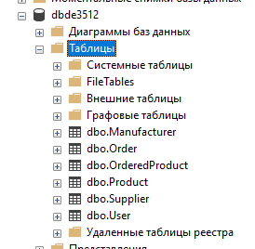
- Создание проекта
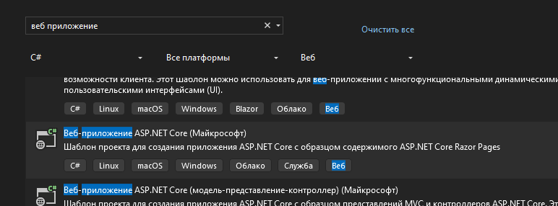
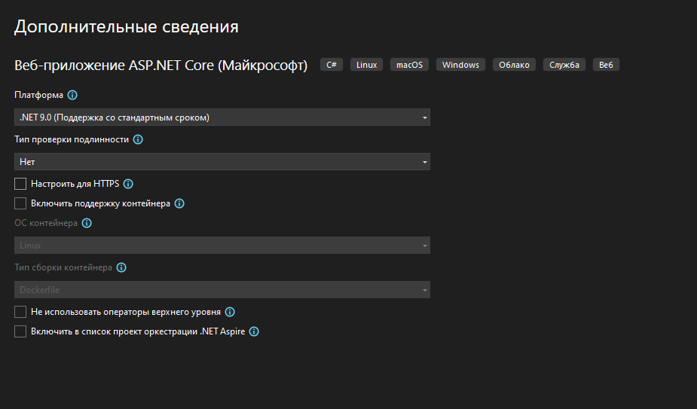
- Установка библиотек
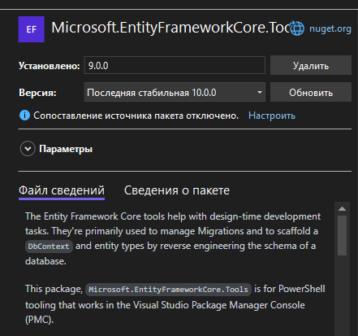

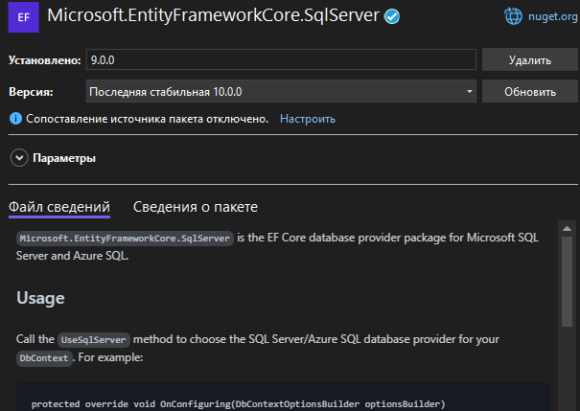

- Подключиться к базе данных
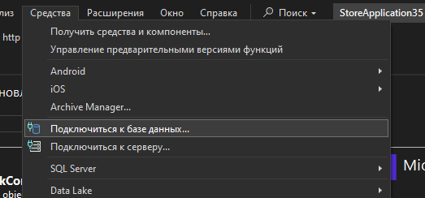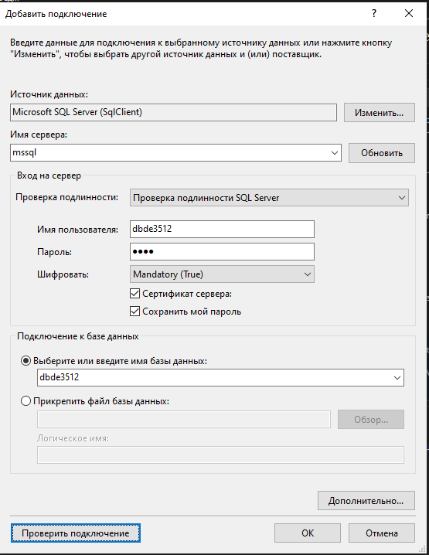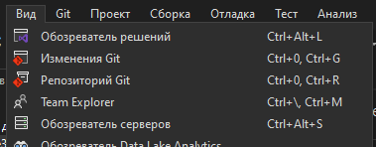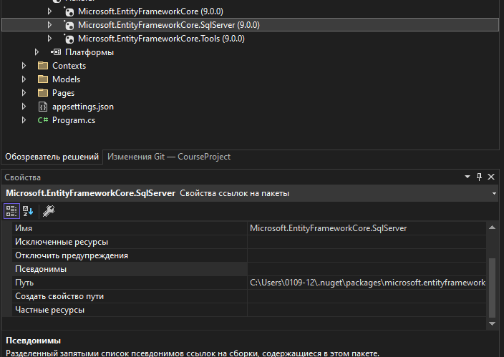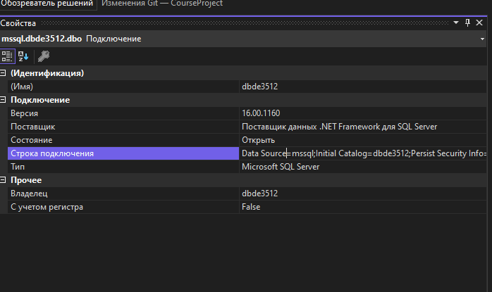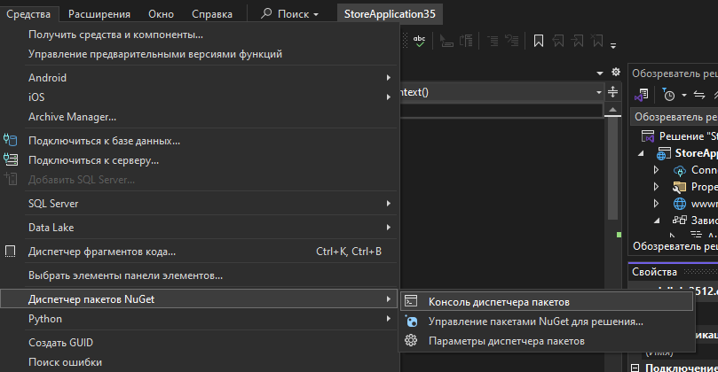
Строка подключения: Data Source=mssql;Initial Catalog=dbde3512;Persist Security Info=True;User ID=dbde3512;Password=3512;Trust Server Certificate=True
Scaffold-DbContext "Data Source=mssql;Initial Catalog=dbde3512;Persist Security Info=True;User ID=dbde3512;Password=3512;Trust Server Certificate=True" Microsoft.EntityFrameworkCore.SqlServer -ContextDir Contexts -OutputDir Models
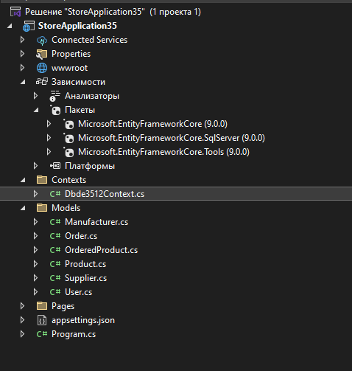
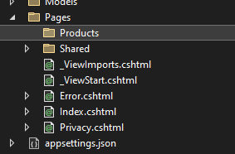
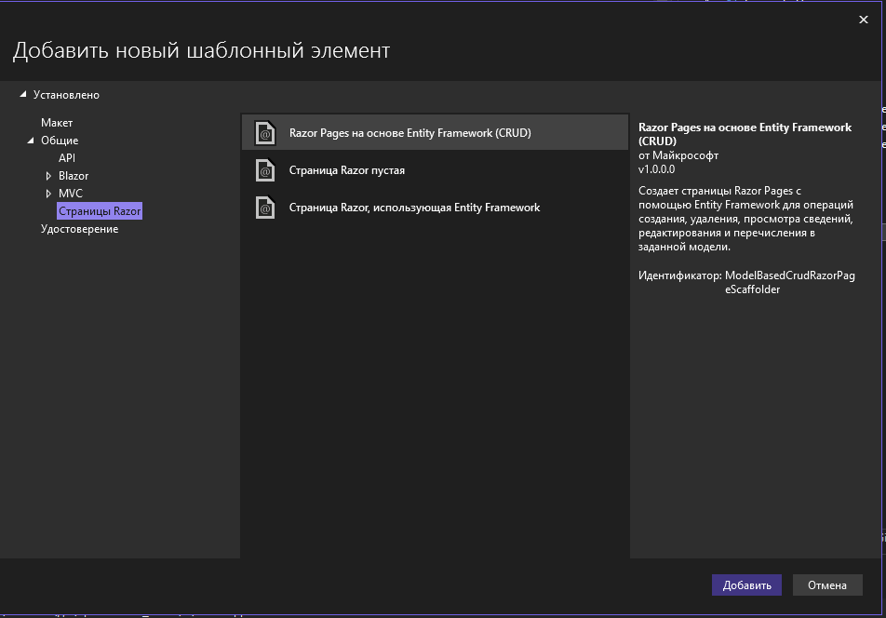
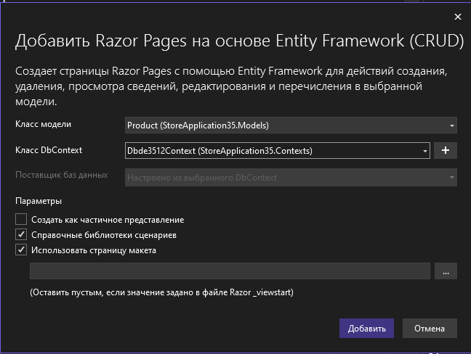
Удалить Details
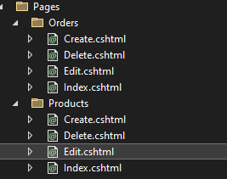
Добавить папку images
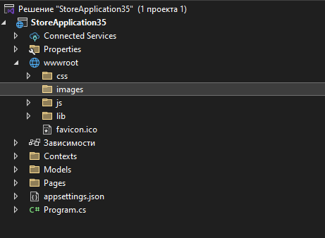
Добавить картинку
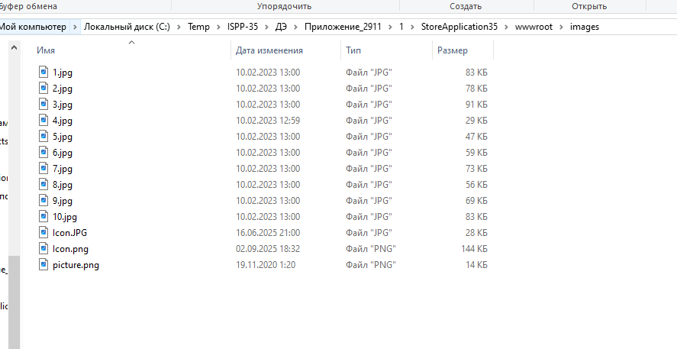
wwwroot
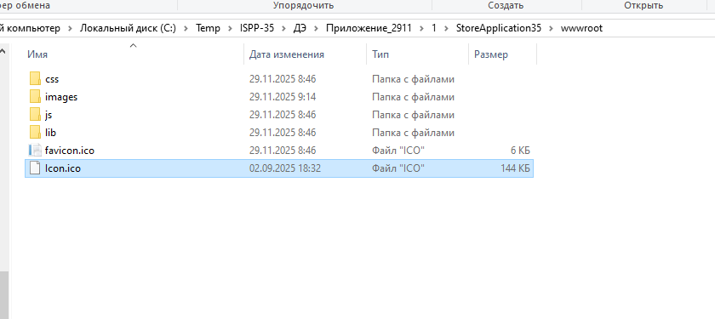
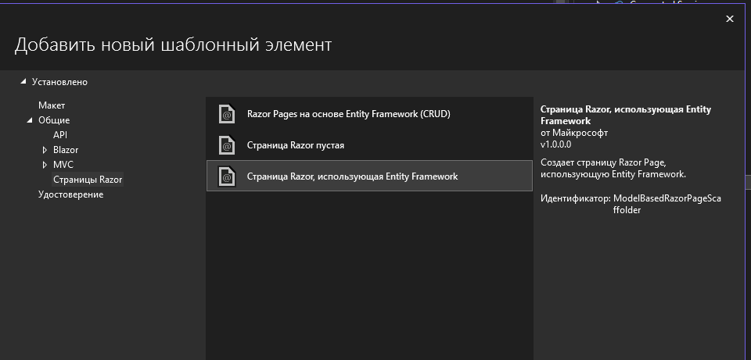
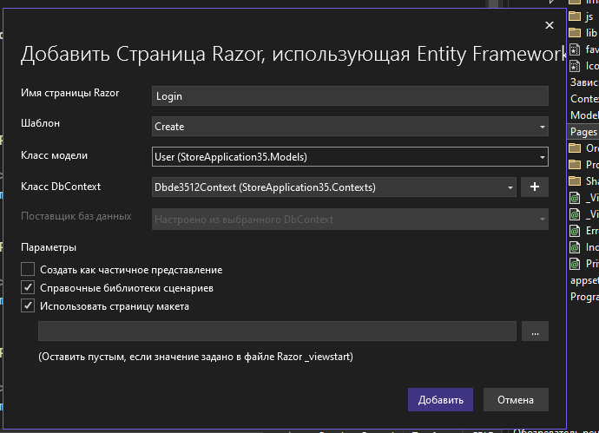
Program.cs
using StoreApplication35.Contexts;
using System.Globalization;

var builder = WebApplication.CreateBuilder(args);

// Add services to the container.
builder.Services.AddRazorPages();
builder.Services.AddDbContext<Dbde3512Context>(); //+ добавляет контекст
builder.Services.AddSession(); //+ сессия для логина
builder.Services.AddHttpContextAccessor(); //+ для отображения данных сессии

var app = builder.Build();

//+ настройка отображения вещественный чисел
CultureInfo.DefaultThreadCurrentCulture = new CultureInfo("ru-RU")
{
NumberFormat = {NumberDecimalSeparator = "."}
};

// Configure the HTTP request pipeline.
if (!app.Environment.IsDevelopment())
{
app.UseExceptionHandler("/Error");
}

app.UseRouting();

app.UseAuthentication(); //+добавили аутентификацию
app.UseSession(); //+добавить сессию
app.UseAuthorization();

app.MapStaticAssets();
app.MapRazorPages()
.WithStaticAssets();

app.Run();
Models/Product.cs
using System;
using System.Collections.Generic;
using System.ComponentModel.DataAnnotations;

namespace StoreApplication35.Models;

public partial class Product
{
public int Id { get; set; }

[Display(Name = "Артикул")]
public string Article { get; set; } = null!;

[Display(Name = "Наименование товара")]
public string Title { get; set; } = null!;

[Display(Name = "Единица измерения")]
public string Unit { get; set; } = null!;

[Display(Name = "Цена")]
public decimal Price { get; set; }

[Display(Name = "Поставщик")]
public int SupplierId { get; set; }

[Display(Name = "Производитель")]
public int ManufacturerId { get; set; }

[Display(Name = "Категория товара")]
public string Category { get; set; } = null!;

[Display(Name = "Действующая скидка")]
public int Discount { get; set; }

[Display(Name = "Кол-во на складе")]
public int Amount { get; set; }

[Display(Name = "Описание товара")]
public string Description { get; set; } = null!;

[Display(Name = "Фото")]
public string? Photo { get; set; }

[Display(Name = "Производитель")]
public virtual Manufacturer Manufacturer { get; set; } = null!;

public virtual ICollection<OrderedProduct> OrderedProducts { get; set; } = new List<OrderedProduct>();

[Display(Name = "Поставщик")]
public virtual Supplier Supplier { get; set; } = null!;
}
Pages/Products/Index.cshtml
@page
@model StoreApplication35.Pages.Products.IndexModel

@{
ViewData["Title"] = "Товары";
}

<h1>Товары</h1>

<p>
<a asp-page="Create" class="btn btn-primary">Создать</a>
</p>
<table class="table">
<thead>
<tr>
<th>
@Html.DisplayNameFor(model => model.Product[0].Article)
</th>
<th>
@Html.DisplayNameFor(model => model.Product[0].Title)
</th>
<th>
@Html.DisplayNameFor(model => model.Product[0].Unit)
</th>
<th>
@Html.DisplayNameFor(model => model.Product[0].Price)
</th>
<th>
@Html.DisplayNameFor(model => model.Product[0].Category)
</th>
<th>
@Html.DisplayNameFor(model => model.Product[0].Discount)
</th>
<th>
@Html.DisplayNameFor(model => model.Product[0].Amount)
</th>
<th>
@Html.DisplayNameFor(model => model.Product[0].Description)
</th>
<th>
@Html.DisplayNameFor(model => model.Product[0].Photo)
</th>
<th>
@Html.DisplayNameFor(model => model.Product[0].Manufacturer)
</th>
<th>
@Html.DisplayNameFor(model => model.Product[0].Supplier)
</th>
<th></th>
</tr>
</thead>
<tbody>
@foreach (var item in Model.Product) {
<tr>
<td>
@Html.DisplayFor(modelItem => item.Article)
</td>
<td>
@Html.DisplayFor(modelItem => item.Title)
</td>
<td>
@Html.DisplayFor(modelItem => item.Unit)
</td>
<td>
@Html.DisplayFor(modelItem => item.Price)
</td>
<td>
@Html.DisplayFor(modelItem => item.Category)
</td>
<td>
@Html.DisplayFor(modelItem => item.Discount)
</td>
<td>
@Html.DisplayFor(modelItem => item.Amount)
</td>
<td>
@Html.DisplayFor(modelItem => item.Description)
</td>
<td>
@Html.DisplayFor(modelItem => item.Photo)
</td>
<td>
@Html.DisplayFor(modelItem => item.Manufacturer.Name)
</td>
<td>
@Html.DisplayFor(modelItem => item.Supplier.Name)
</td>
<td>
<a asp-page="./Edit" asp-route-id="@item.Id" class="btn btn-primary">Изменить</a>
<a asp-page="./Delete" asp-route-id="@item.Id" class="btn btn-primary">Удалить</a>
</td>
</tr>
}
</tbody>
</table>
Create.cshtml.cs
using System;
using System.Collections.Generic;
using System.Linq;
using System.Threading.Tasks;
using Microsoft.AspNetCore.Mvc;
using Microsoft.AspNetCore.Mvc.RazorPages;
using Microsoft.AspNetCore.Mvc.Rendering;
using StoreApplication35.Contexts;
using StoreApplication35.Models;

namespace StoreApplication35.Pages.Products
{
public class CreateModel : PageModel
{
private readonly StoreApplication35.Contexts.Dbde3512Context _context;

public CreateModel(StoreApplication35.Contexts.Dbde3512Context context)
{
_context = context;
}

public IActionResult OnGet()
{
ViewData["ManufacturerId"] = new SelectList(_context.Manufacturers, "Id", "Id");
ViewData["SupplierId"] = new SelectList(_context.Suppliers, "Id", "Id");
return Page();
}

[BindProperty]
public Product Product { get; set; } = default!;

// For more information, see https://aka.ms/RazorPagesCRUD.
public async Task<IActionResult> OnPostAsync()
{
//Удалить код ниже
//if (!ModelState.IsValid)
//{
// return Page();
//}

_context.Products.Add(Product);
await _context.SaveChangesAsync();

return RedirectToPage("./Index");
}
}
}
Edit.cshtml.cs
using System;
using System.Collections.Generic;
using System.Linq;
using System.Threading.Tasks;
using Microsoft.AspNetCore.Mvc;
using Microsoft.AspNetCore.Mvc.RazorPages;
using Microsoft.AspNetCore.Mvc.Rendering;
using Microsoft.EntityFrameworkCore;
using StoreApplication35.Contexts;
using StoreApplication35.Models;

namespace StoreApplication35.Pages.Products
{
public class EditModel : PageModel
{
private readonly StoreApplication35.Contexts.Dbde3512Context _context;

public EditModel(StoreApplication35.Contexts.Dbde3512Context context)
{
_context = context;
}

[BindProperty]
public Product Product { get; set; } = default!;

public async Task<IActionResult> OnGetAsync(int? id)
{
if (id == null)
{
return NotFound();
}

var product = await _context.Products.FirstOrDefaultAsync(m => m.Id == id);
if (product == null)
{
return NotFound();
}
Product = product;
ViewData["ManufacturerId"] = new SelectList(_context.Manufacturers, "Id", "Id");
ViewData["SupplierId"] = new SelectList(_context.Suppliers, "Id", "Id");
return Page();
}

// To protect from overposting attacks, enable the specific properties you want to bind to.
// For more information, see https://aka.ms/RazorPagesCRUD.
public async Task<IActionResult> OnPostAsync()
{
//Удалить
//if (!ModelState.IsValid)
//{
// return Page();
//}

_context.Attach(Product).State = EntityState.Modified;

try
{
await _context.SaveChangesAsync();
}
catch (DbUpdateConcurrencyException)
{
if (!ProductExists(Product.Id))
{
return NotFound();
}
else
{
throw;
}
}

return RedirectToPage("./Index");
}

private bool ProductExists(int id)
{
return _context.Products.Any(e => e.Id == id);
}
}
}
Create.cshtml.cs
public async Task<IActionResult> OnPostAsync()
{
//Удалить код ниже
//if (!ModelState.IsValid)
//{
// return Page();
//}

Product.Id = _context.Products.Max(p => p.Id) + 1;
_context.Products.Add(Product);
await _context.SaveChangesAsync();

return RedirectToPage("./Index");
}
Delete
@page
@model StoreApplication35.Pages.Products.DeleteModel

@{
ViewData["Title"] = "Delete";
}

<h1>Delete</h1>

<h3>Are you sure you want to delete this?</h3>
<div>
<h4>Product</h4>
<hr />
<dl class="row">
<dt class="col-sm-2">
@Html.DisplayNameFor(model => model.Product.Article)
</dt>
<dd class="col-sm-10">
@Html.DisplayFor(model => model.Product.Article)
</dd>
<dt class="col-sm-2">
@Html.DisplayNameFor(model => model.Product.Title)
</dt>
<dd class="col-sm-10">
@Html.DisplayFor(model => model.Product.Title)
</dd>
<dt class="col-sm-2">
@Html.DisplayNameFor(model => model.Product.Unit)
</dt>
<dd class="col-sm-10">
@Html.DisplayFor(model => model.Product.Unit)
</dd>
<dt class="col-sm-2">
@Html.DisplayNameFor(model => model.Product.Price)
</dt>
<dd class="col-sm-10">
@Html.DisplayFor(model => model.Product.Price)
</dd>
<dt class="col-sm-2">
@Html.DisplayNameFor(model => model.Product.Category)
</dt>
<dd class="col-sm-10">
@Html.DisplayFor(model => model.Product.Category)
</dd>
<dt class="col-sm-2">
@Html.DisplayNameFor(model => model.Product.Discount)
</dt>
<dd class="col-sm-10">
@Html.DisplayFor(model => model.Product.Discount)
</dd>
<dt class="col-sm-2">
@Html.DisplayNameFor(model => model.Product.Amount)
</dt>
<dd class="col-sm-10">
@Html.DisplayFor(model => model.Product.Amount)
</dd>
<dt class="col-sm-2">
@Html.DisplayNameFor(model => model.Product.Description)
</dt>
<dd class="col-sm-10">
@Html.DisplayFor(model => model.Product.Description)
</dd>
<dt class="col-sm-2">
@Html.DisplayNameFor(model => model.Product.Photo)
</dt>
<dd class="col-sm-10">
@Html.DisplayFor(model => model.Product.Photo)
</dd>
@* <dt class="col-sm-2">
@Html.DisplayNameFor(model => model.Product.Manufacturer)
</dt>
<dd class="col-sm-10">
@Html.DisplayFor(model => model.Product.Manufacturer.Id)
</dd>
<dt class="col-sm-2">
@Html.DisplayNameFor(model => model.Product.Supplier)
</dt>
<dd class="col-sm-10">
@Html.DisplayFor(model => model.Product.Supplier.Id)
</dd> *@
</dl>

<form method="post">
<input type="hidden" asp-for="Product.Id" />
<input type="submit" value="Delete" class="btn btn-danger" /> |
<a asp-page="./Index">Back to List</a>
</form>
</div>
Скопировать строку
<a asp-page="./Index">Back to List</a>
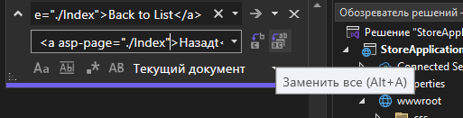
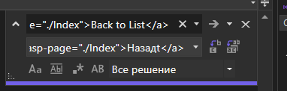
Поменять заголовки
_Layout.cshtml
<footer class="border-top footer text-muted">
<div class="container">
&copy; 2025 - StoreApplication35@* - <a asp-area="" asp-page="/Privacy">Privacy</a> *@
</div>
</footer>
удалить страницу Privacy
<div class="navbar-collapse collapse d-sm-inline-flex justify-content-between">
<ul class="navbar-nav flex-grow-1">
<li class="nav-item">
<a class="nav-link text-dark" asp-area="" asp-page="/Products/Index">Товары</a>
</li>
<li class="nav-item">
<a class="nav-link text-dark" asp-area="" asp-page="/Orders/Index">Заказы</a>
</li>
</ul>
</div>
Edit.cshtml
<div class="form-group">

<label asp-for="Order.OrderDate" class="control-label"></label>
<input asp-for="Order.OrderDate" class="form-control" type="date"/>
<span asp-validation-for="Order.OrderDate" class="text-danger"></span>
</div>
<div class="form-group">

<label asp-for="Order.DeliveryDate" class="control-label"></label>
<input asp-for="Order.DeliveryDate" class="form-control" type="date"/>
<span asp-validation-for="Order.DeliveryDate" class="text-danger"></span>
</div>
_Layout.cshtml
<nav class="navbar navbar-expand-sm navbar-toggleable-sm navbar-light bg-white border-bottom box-shadow mb-3">
<div class="container">
<a class="navbar-brand" asp-area="" asp-page="/Index">
<img src="~/images/Icon.png" width="50px" />
ООО "Обувь"
</a>
<button class="navbar-toggler" type="button" data-bs-toggle="collapse" data-bs-target=".navbar-collapse" aria-controls="navbarSupportedContent"
aria-expanded="false" aria-label="Toggle navigation">
<span class="navbar-toggler-icon"></span>
</button>
<div class="navbar-collapse collapse d-sm-inline-flex justify-content-between">
<ul class="navbar-nav flex-grow-1">
<li class="nav-item">
<a class="nav-link text-dark" asp-area="" asp-page="/Products/Index">Товары</a>
</li>
<li class="nav-item">
<a class="nav-link text-dark" asp-area="" asp-page="/Orders/Index">Заказы</a>
</li>
</ul>
</div>
</div>
</nav>
Product Index
<td>
@Html.DisplayFor(modelItem => item.Description)
</td>
<td>
<img src="~/images/@Html.DisplayFor(modelItem => item.Photo)"
width="50px"
onerror="this.src='/images/picture.png';"/>
</td>
<td>
@Html.DisplayFor(modelItem => item.Manufacturer.Name)
</td>
<td>
@Html.DisplayFor(modelItem => item.Supplier.Name)
</td>
<td>
<a asp-page="./Edit" asp-route-id="@item.Id" class="btn btn-primary">Изменить</a>
<a asp-page="./Delete" asp-route-id="@item.Id" class="btn btn-primary">Удалить</a>
</td>
</tr>
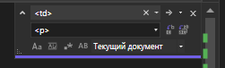
Product
Index
@page
@model StoreApplication35.Pages.Products.IndexModel

@{
ViewData["Title"] = "Товары";
}

<h1>Товары</h1>

<p>
<a asp-page="Create" class="btn btn-primary">Создать</a>
</p>

@foreach (var item in Model.Product) {
<div class="card" style="margin: 10px">
<p>
@Html.DisplayFor(modelItem => item.Article)
</p>
<p>
@Html.DisplayFor(modelItem => item.Title)
</p>
<p>
@Html.DisplayFor(modelItem => item.Unit)
</p>
<p>
@Html.DisplayFor(modelItem => item.Price)
</p>
<p>
@Html.DisplayFor(modelItem => item.Category)
</p>
<p>
@Html.DisplayFor(modelItem => item.Discount)
</p>
<p>
@Html.DisplayFor(modelItem => item.Amount)
</p>
<p>
@Html.DisplayFor(modelItem => item.Description)
</p>
<p>
<img src="~/images/@Html.DisplayFor(modelItem => item.Photo)"
width="50px"
onerror="this.src='/images/picture.png';"/>
</p>
<p>
@Html.DisplayFor(modelItem => item.Manufacturer.Name)
</p>
<p>
@Html.DisplayFor(modelItem => item.Supplier.Name)
</p>
<p>
<a asp-page="./Edit" asp-route-id="@item.Id" class="btn btn-primary">Изменить</a>
<a asp-page="./Delete" asp-route-id="@item.Id" class="btn btn-primary">Удалить</a>
</p>
</div>
}
</tbody>
Product Index
Меняем Разметку (Карточка для ботинка)
@page
@model StoreApplication35.Pages.Products.IndexModel

@{
ViewData["Title"] = "Товары";
}

<h1>Товары</h1>

<a asp-page="Create" class="btn btn-primary">Создать</a>
<br/>

@foreach (var item in Model.Product) {

decimal price = item.Price * (100 - item.Discount) / 100;

<div class="card" style="margin: 10px">

<div style="display: flex">
<div class="card" style="width: 300px; display: flex">
<img src="~/images/@Html.DisplayFor(modelItem => item.Photo)"
width="200px"
onerror="this.src='/images/picture.png';" />
<br/>
</div>

<div class="card" style="width: 100%">

@Html.DisplayFor(modelItem => item.Category)
|
@Html.DisplayFor(modelItem => item.Title)
<br/>

Описание товара: @Html.DisplayFor(modelItem => item.Description)
<br/>

Производитель: @Html.DisplayFor(modelItem => item.Manufacturer.Name)
<br/>

Поставщик: @Html.DisplayFor(modelItem => item.Supplier.Name)
<br/>

Цена:@item.Price.ToString("C")
Новая цена: @price.ToString("C")
<br/>

Единица измерения: @Html.DisplayFor(modelItem => item.Unit)
<br/>

Количество на складе: @Html.DisplayFor(modelItem => item.Amount)
<br/>
</div>

<div class="card" style="width: 200px;display: flex; justify-content: center">

Скидка: @Html.DisplayFor(modelItem => item.Discount) %
<br/>

<a asp-page="./Edit" asp-route-id="@item.Id" class="btn btn-primary">Изменить</a>
<a asp-page="./Delete" asp-route-id="@item.Id" class="btn btn-primary">Удалить</a>
<br/>
</div>
</div>
</div>
}
Авторизация
Index.cshtml.cs
using Microsoft.AspNetCore.Mvc;
using Microsoft.AspNetCore.Mvc.RazorPages;

namespace StoreApplication35.Pages
{
public class IndexModel : PageModel
{
private readonly ILogger<IndexModel> _logger;

public IndexModel(ILogger<IndexModel> logger)
{
_logger = logger;
}

public IActionResult OnGet()
{
return RedirectToPage("Login");
}
}
}
Login.cshtml
@page
@model StoreApplication35.Pages.LoginModel

@{
ViewData["Title"] = "Login";
}

<h1>Login</h1>

<h4>User</h4>
<hr />
<div class="row">
<div class="col-md-4">
<form method="post">
<div asp-validation-summary="ModelOnly" class="text-danger"></div>
<div class="form-group">
<label asp-for="User.Login" class="control-label"></label>
<input asp-for="User.Login" class="form-control" />
<span asp-validation-for="User.Login" class="text-danger"></span>
</div>
<div class="form-group">
<label asp-for="User.Password" class="control-label"></label>
<input asp-for="User.Password" class="form-control" />
<span asp-validation-for="User.Password" class="text-danger"></span>
</div>
<div class="form-group">
<input type="submit" value="Войти" class="btn btn-primary" />
</div>
</form>
<form method="post">
<div class="form-group">
<input type="submit" value="Войти как гость" class="btn btn-primary" />
</div>
</form>
</div>
</div>

@section Scripts {
@{await Html.RenderPartialAsync("_ValidationScriptsPartial");}
}
Login cs
using System;
using System.Collections.Generic;
using System.Linq;
using System.Threading.Tasks;
using Microsoft.AspNetCore.Mvc;
using Microsoft.AspNetCore.Mvc.RazorPages;
using Microsoft.AspNetCore.Mvc.Rendering;
using StoreApplication35.Contexts;
using StoreApplication35.Models;

namespace StoreApplication35.Pages
{
public class LoginModel : PageModel
{
private readonly StoreApplication35.Contexts.Dbde3512Context _context;

public LoginModel(StoreApplication35.Contexts.Dbde3512Context context)
{
_context = context;
}

public IActionResult OnGet()
{
return Page();
}

[BindProperty]
public User User { get; set; } = default!;

//// For more information, see https://aka.ms/RazorPagesCRUD.
//public async Task<IActionResult> OnPostAsync()
//{
// if (!ModelState.IsValid)
// {
// return Page();
// }

// _context.Users.Add(User);
// await _context.SaveChangesAsync();

// return RedirectToPage("./Index");
//}

// логин
public async Task<IActionResult> OnPostLoginAsync()
{
var user = _context.Users.FirstOrDefault(u => u.Login == User.Login);
if (user != null && user.Password == User.Password)
{
HttpContext.Session.SetString("UserRole", user.Role);
HttpContext.Session.SetString("UserName", user.FullName);
return RedirectToPage("Products/Index");
}
return Page();
}
// вход гостя:
public IActionResult OnPostGuest()
{
HttpContext.Session.Clear();
HttpContext.Session.SetString("UserRole", "Guest");
return RedirectToPage("Products/Index");
}
// выход
public IActionResult OnGetLogout()
{
HttpContext.Session.Clear();
return RedirectToPage("Products/Index"); // return Page();
}
}
}

_Layout
@using Microsoft.AspNetCore.Http;
@inject IHttpContextAccessor HttpContextAccessor;

<!DOCTYPE html>
<html lang="en">
<head>
<meta charset="utf-8" />
<meta name="viewport" content="width=device-width, initial-scale=1.0" />
<title>@ViewData["Title"] - StoreApplication35</title>
<script type="importmap"></script>
<link rel="stylesheet" href="~/lib/bootstrap/dist/css/bootstrap.min.css" />
<link rel="stylesheet" href="~/css/site.css" asp-append-version="true" />
<link rel="stylesheet" href="~/StoreApplication35.styles.css" asp-append-version="true" />
</head>
<body>
<header>
<nav class="navbar navbar-expand-sm navbar-toggleable-sm navbar-light bg-white border-bottom box-shadow mb-3">
<div class="container">
<a class="navbar-brand" asp-area="" asp-page="/Index">
<img src="~/images/Icon.png" width="50px" />
ООО "Обувь"
</a>
<button class="navbar-toggler" type="button" data-bs-toggle="collapse" data-bs-target=".navbar-collapse" aria-controls="navbarSupportedContent"
aria-expanded="false" aria-label="Toggle navigation">
<span class="navbar-toggler-icon"></span>
</button>
<div class="navbar-collapse collapse d-sm-inline-flex justify-content-between">
<ul class="navbar-nav flex-grow-1">
<li class="nav-item">
<a class="nav-link text-dark" asp-area="" asp-page="/Products/Index">Товары</a>
</li>
<li class="nav-item">
<a class="nav-link text-dark" asp-area="" asp-page="/Orders/Index">Заказы</a>
</li>
</ul>
</div>

@if (HttpContextAccessor.HttpContext.Session.GetString("UserRole") != null)
{
<h3>@HttpContextAccessor.HttpContext.Session.GetString("UserName")</h3>
<h3>@HttpContextAccessor.HttpContext.Session.GetString("UserRole")</h3>
<a asp-page="../Login" asp-page-handler="Logout" class="btn btn-primary">Выйти</a>

}
</div>
</nav>
</header>
<div class="container">
<main role="main" class="pb-3">
@RenderBody()
</main>
</div>

<footer class="border-top footer text-muted">
<div class="container">
&copy; 2025 - StoreApplication35@* - <a asp-area="" asp-page="/Privacy">Privacy</a> *@
</div>
</footer>

<script src="~/lib/jquery/dist/jquery.min.js"></script>
<script src="~/lib/bootstrap/dist/js/bootstrap.bundle.min.js"></script>
<script src="~/js/site.js" asp-append-version="true"></script>

@await RenderSectionAsync("Scripts", required: false)
</body>
</html>

Product cs
using System;
using System.Collections.Generic;
using System.Linq;
using System.Threading.Tasks;
using Microsoft.AspNetCore.Mvc;
using Microsoft.AspNetCore.Mvc.RazorPages;
using Microsoft.EntityFrameworkCore;
using StoreApplication35.Contexts;
using StoreApplication35.Models;

namespace StoreApplication35.Pages.Products
{
public class IndexModel : PageModel
{
private readonly StoreApplication35.Contexts.Dbde3512Context _context;

public IndexModel(StoreApplication35.Contexts.Dbde3512Context context)
{
_context = context;
}

public IList<Product> Product { get;set; } = default!;

public string UserRole { get; set; }

public async Task<IActionResult> OnGetAsync()
{
UserRole = HttpContext.Session.GetString("UserRole");
if (string.IsNullOrEmpty(UserRole))
{
return RedirectToPage("../Login");
}

Product = await _context.Products
.Include(p => p.Manufacturer)
.Include(p => p.Supplier).ToListAsync();
return Page();
}
}
}
Product html
@page
@model StoreApplication35.Pages.Products.IndexModel

@{
ViewData["Title"] = "Товары";
}

<h1>Товары</h1>

<a asp-page="Create" class="btn btn-primary">Создать</a>
<br/>

@foreach (var item in Model.Product) {

decimal price = item.Price * (100 - item.Discount) / 100;

<div class="card" style="margin: 10px">

<div style="display: flex">
<div class="card" style="width: 300px; display: flex">
<img src="~/images/@Html.DisplayFor(modelItem => item.Photo)"
width="200px"
onerror="this.src='/images/picture.png';" />
<br/>
</div>

<div class="card" style="width: 100%">

@Html.DisplayFor(modelItem => item.Category)
|
@Html.DisplayFor(modelItem => item.Title)
<br/>

Описание товара: @Html.DisplayFor(modelItem => item.Description)
<br/>

Производитель: @Html.DisplayFor(modelItem => item.Manufacturer.Name)
<br/>

Поставщик: @Html.DisplayFor(modelItem => item.Supplier.Name)
<br/>

Цена:@item.Price.ToString("C")
Новая цена: @price.ToString("C")
<br/>

Единица измерения: @Html.DisplayFor(modelItem => item.Unit)
<br/>

Количество на складе: @Html.DisplayFor(modelItem => item.Amount)
<br/>
</div>

<div class="card" style="width: 200px;display: flex; justify-content: center">

Скидка: @Html.DisplayFor(modelItem => item.Discount) %
<br/>
@if (Model.UserRole == "Администатор")
{
<a asp-page="./Edit" asp-route-id="@item.Id" class="btn btn-primary">Изменить</a>
<a asp-page="./Delete" asp-route-id="@item.Id" class="btn btn-primary">Удалить</a>
}
<br/>
</div>
</div>
</div>
}

