EMOTIX : AI SYSTEM FOR EMPLOYEE ASSISTANT AND MENTAL WELLNESS

Abstract—EMOTIX: AI System For Employee Assistant and Mental Wellness project is a proposed project that is an intelligent, privacy-conscious smart workplace ecosystem to enhance employee wellness, concentration, stress awareness, and system security in contemporary online workspaces. The system will combine several artificial intelligence modules, such as adaptive routine monitoring using TinyML, focus detection using computer vision, stress recognition using deep learning, AI chatbot support, and cybersecurity protection by deception. The adaptive routine module trains individual work patterns like the time of entry, break time, lunch time, and work completion time with Raspberry Pi edge devices, and provides privacy by processing on-site and updating routine with consent. The focus detection element is an eye tracking -blink rate analysis-gaze estimation-environmental sensing algorithm used to produce real-time focus scores indicating employee attention and fatigue. Simultaneously, a safe stress detection pipeline is established on the basis of Convolutional Neural Networks (CNN) and Long Short-Term Memory (LSTM) to track trends in facial emotion with time and calculate dynamic stress scores through valence-arousal mapping. An AES-256-GCM encryption and HMAC-SHA256 authentication are employed in order to protect emotional data and ensure their confidentiality and integrity, and an AI-based honeypot is used to prevent cyber threats to the IoT infrastructure. In general, EMOTIX offers a human-friendly, scaled, and safe AI platform of intelligent workplace wellness support, which will be a part of the smart office and employee assistance systems in the future.
Keywords— Workplace wellness, TinyML, focus detection, stress recognition, computer vision, CNN-LSTM, AI chatbot, honeypot security, edge computing, privacy-preserving AI.

Introduction
The use of modern digital workplaces adds pressure, mental exhaustion, multitasking pressure, and defocusing to employees because of too much time on screens and constant connectivity. Conventional wellness solutions tend to use passive notifications, handwritten reporting, and wearable gadgets, or cloud-based monitoring, which offer fewer possibilities of real-time assistance and pose a risk to privacy, autonomy, and monitoring at work [1], [2], [3]. EMOTIX: AI System of Employee Assistant and Mental Wellness solves these problems by an integrated approach that combines AI, edge computing, computer vision, cybersecurity, and human-friendly interaction. The system consists of adaptive routine monitoring with TinyML, AI-focus detection with gaze tracking and environmental sensing, chatbot-assisted wellness support, and secure stress detection with CNN-LSTM models with AES-256-GCM encryption and HMAC-SHA256 protection. Another layer of security that prevents attacks on the IoT infrastructure is a honeypot cybersecurity module that is deception-based. EMOTIX offers a scalable, secure and privacy-conscious smart workplace wellness solution [1], [2], [3].
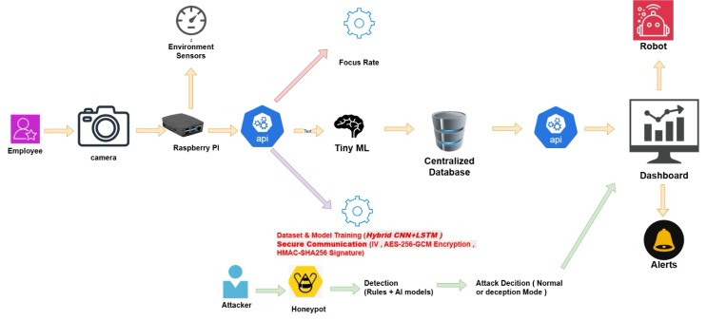
Figure 1: Overall System Architecture of the EMOTIXAI System for Employee Wellness and Monitoring

Litreture review
The fast expansion of digital workplaces has had a profound impact on the manner in which employees relate with technology, work systems, and wellness programs. A rise in screen time, cognitive load, multitasking, and improper management of routine have been cited as significant contributors to decreasing focus, increasing stress, and deteriorating mental health, particularly in knowledge workers in technical settings [1]. Consequently, AI-based workplace wellness systems have been receiving robust research interest due to their capability of offering adaptive monitoring, personalized feedback, and real-time behavioral support [1], [6].
One of the key research directions is the AI-based workplace wellness and embedded monitoring systems. The primary types of traditional wellness platforms rely on predetermined notifications, wearable biosensors, and self-recorded activity logs that are not always able to capture the evolving individual work patterns [2], [5]. Recent researches favor adaptive machine learning systems that autonomously model behavior of employees [6], [7]. But there are numerous systems that update routines automatically without the approval of employees, which cause privacy and trust issues in the workplace setting [3], [9]. EMOTIX closes this gap by offering adaptive routine monitoring using TinyML with human-int-the-loop consent to enable employees to accept permanent modifications in their routine and be reminded of their wellness.

The other significant literature stream is the computer vision-based focus and productivity monitoring. The old systems primarily monitor employee attendance but not their true focus. Recent systems like OpenCV and MediaPipeFaceMesh allow gaze tracking, blink detection, fixation and eye aspect ratio (EAR) to measure focus, fatigue, and distraction. Research indicates that the direction of gaze and the frequency of blinking are good predictors of attention [6]. Nonetheless, most of the available systems disregard the environmental conditions such as lighting, noise and temperature. EMOTIX enhances this with eye tracking and environmental sensing to ensure a more precise focus scoring.
Wellness systems also utilize AI-based conversational assistants. It has been demonstrated that context-sensitive chatbots enhance usability, interaction, and compliance among users by transforming technical analytics into comprehensible suggestions [6], [8]. EMOTIX implements this by giving customized recommendations like break notifications and workspace changes.
The focus of stress-detecting studies has moved beyond the invasive wearable devices such as EEG and ECG to non-invasive facial emotion recognition with CNN and LSTM networks [3]. EMOTIX integrates CNN-based emotion recognition, LSTM time analysis, valence-arousal model, and encrypted transmission based on AES-256-GCM and HMAC-SHA256. Also, honeypot cybersecurity and Isolation Forest anomaly detection which rely on deception enhance the security of IoT, so EMOTIX can be a safe and privacy-conscious workplace wellness ecosystem [14], [15], [18].

Methodology
The approach to methodology of the EMOTIX: AI System for Employee Assistant and Mental Wellness project is a modular experimental system design, which involves artificial intelligence, computer vision, TinyML, cybersecurity, and privacy-preserving edge computing to enhance employee wellness, focus, stress awareness, and system security. The general approach is designed into seven key steps that relate to functional modules of the project.

A. Data Acquisition and User Identification
The initial methodological step is the gathering of actual multimodal information in the workplace in real-time by non-obtrusive sensors on the employees. Facial expression, eye movements, direction of gaze, rate of blinking, and presence at the workstation are captured using camera feeds. Environmental sensors record environmental variables like light level, temperature and ambient noise levels. In the case of adaptive routine modules, individual users are identified by secure employee logins, and behavioral data obtained are linked to the appropriate profile. This identification method that uses logins enhances the integrity of data in multi-user systems and prevents the use of biometric identity mechanisms where not necessary.

B. Adaptive Routine Monitoring using TinyML
The second step is the normal method of learning. Within a preliminary observation phase of one or two weeks, the Raspberry Pi edge device continuously logs the time of presence of the employees, such as the work start time, breaks, lunch and end-of-day trend. These measurements are locally gathered and processed by a TinyML model that learns the routine of each employee on a baseline. The model uses statistically derived tolerance limits with μ + max(1.5(sigma), 45min) in order to differentiate normal routine variations and major changes in behavior. This gives the system the ability to detect significant changes and still allows natural human flexibility. Processing is done locally and thus privacy is maintained and exposure of raw data is minimized.

C. AI-Based Focus Detection
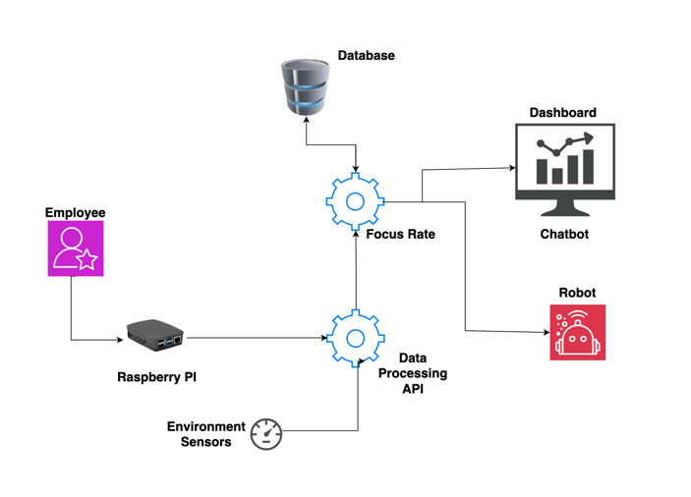
The third methodology step involves the execution of focus monitoring through computer vision. Facial landmarks are identified in video streams in real time using OpenCV and MediaPipeFaceMesh. To identify blink patterns and fatigue indicators, the Eye Aspect Ratio (EAR) is determined, whereas the direction of gaze and the duration of fixation are needed to assess the sustained attention. A focus score in real-time is obtained through the application of weighted penalties on any distraction events which include non-center gaze, high frequency blinking and a short duration of fixations. The scoring engine incorporates environmental variables to enhance the accuracy of the context. This hybrid methodology of attention guarantees a scalable focus assessment model that is non-obtrusive.
Figure 2: Focus detection system showing the processing of visual and environmental data to compute focus rate and deliver results to the dashboard and chatbot system.

D. AI Chatbot Recommendation Engine
The fourth phase brings in the AI chatbot assistance approach. The outputs of the focus detection and environmental monitoring modules are fed into a rule based conversational engine that produces individualized user instructions. As an example, the low scores in focus activate concentration reminders, whereas high scores in the blink rate produce wellness-related break requests. Poor lighting or high noise levels generate workspace adjustment recommendations. This step converts raw analytical outputs into readable and practical feedback, making it easier to use and engaging to the user.
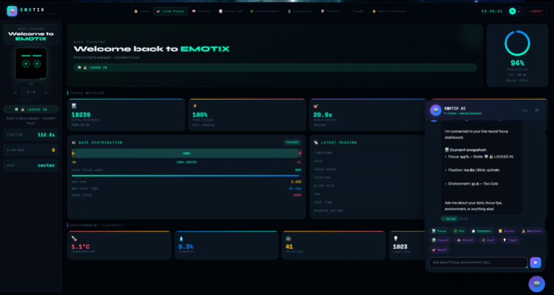
Figure 3: Real-time focus monitoring interface with AI chatbot providing personalized recommendations.

E. Deep Learning-Based Stress Detection
The fifth stage of methodology is dedicated to safe AI stress detection. The facial images are preprocessed into grayscale 48×48 normalized inputs and then fed into a CNN model that has been trained on the FER+ dataset to determine five emotions. The resulting probability vectors are held up in a 15 frame sliding time buffer. An LSTM model is used to analyze emotional transitions and predict values of valence and arousal depending on the Russell Circumplex Model as soon as the buffer is full. The normalized score of stress is then obtained using the following formula:
This time-based deep learning framework helps make stress estimations stronger than the estimation made with a single frame of emotion recognition.
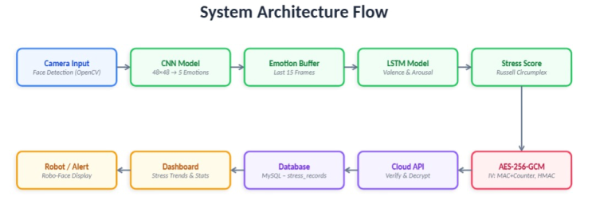
Figure 4: CNN-LSTM based stress detection model showing emotion recognition, temporal analysis, and stress score generation.

F. Security and Privacy Protection
The sixth level provides safety in data transmission and infrastructure. AES-256-GCM is used to encrypt stress and emotional analytics, and integrity and tamper detection is guaranteed by HMAC-SHA256. IV reuse vulnerabilities are avoided by having a structured IV generation strategy, where the device MAC address and message counters are used. The system also implements an AI-based honeypot module based on rule-based detection and Isolation Forest anomaly detection to track internet traffic (via HTTP and MQTT) directed towards the IoT ecosystem.

G. Evaluation and Validation
The last phase is testing the entire EMOTIX system, based on various performance indices, such as the accuracy of the presence detector, the accuracy of focus classifier, the accuracy of stress predictor, the reliability of deviation detector, the API latency, and the feedback of the users. Both technical performance and practicality in the workplace are verified using controlled simulations, real-time test cases and usability surveys. This makes the proposed system accurate, privacy friendly, scalable and deployable in the real life smart workplace environment.
Figure 5: Dashboard visualization of employee presence status and routine monitoring system.

Data analysis
The analytical part of data analysis of the EMOTIX: AI System of Employee Assistant and Mental Wellness project is aimed at assessing the efficiency, precision, and dependability of the incorporated AI modules. The analysis process will be based on a multi-layer analytical framework since the project is a combination of routine monitoring, focus detection, stress prediction, chatbot interaction, and cybersecurity defense, which will evaluate system performance on all components.

A. Presence and Routine Pattern Analysis
The primary data analysis level is dedicated to the employee presence time and regular patterns of behavior registered at the preliminary observation stage. The system captures the time of work commencement, periods of breaks, lunch periods and the time of logout at the end of the days with a period of one to two weeks. The establishment of the routine of each employee is done through descriptive statistics methods including mean, standard deviation and variance. The learned baseline is then contrasted with real-time observations in order to detect deviations. The tolerance model μ +maximum (1.5 σ, 45 min) is used to categorize the behaviors as normal variation or major routine change. This discussion is useful to assess the extent to which the TinyML model replicates individual habits without compromising the inherent flexibility of nature.
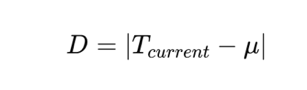
D = deviation from normal routine
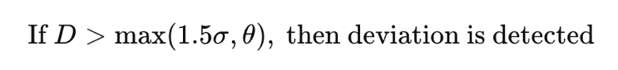
Tcurrent​ = current observed time
μ = average (mean) routine time
σ = standard deviation
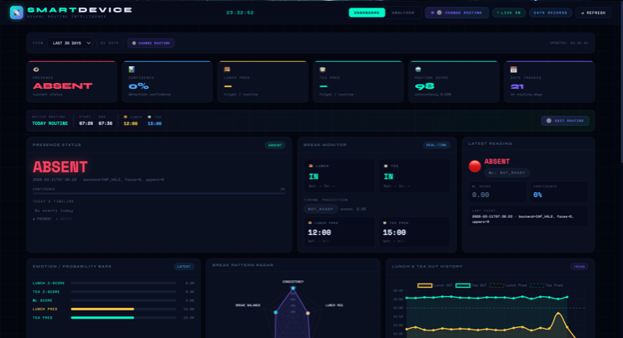
θ = minimum allowed tolerance

B. Focus Score and Eye Tracking Analysis
The second analysis step is the evaluation of AI-based focus detection. Eye tracking produces real-time data such as Eye Aspect Ratio (EAR), frequency of blink, direction of gaze, fixation time and total time of engagement with the face. The analysis of these variables is performed on the basis of threshold-based and weighted scoring to obtain a normalized focus score in the range of 0 to 1. The focus score is computed as:
Focus = w₁(1 − B) + w₂G + w₃F + w₄E
where B represents the normalized blink rate, G denotes gaze alignment, F indicates fixation duration, and E represents the environmental score. The parameters w₁, w₂, w₃, and w₄ are weighting factors such that w₁ + w₂ + w₃ + w₄ = 1.
Comparison of high-focus and distraction states is done statistically to determine the reliability of classification. Focus state detection is validated by metrics like accuracy, precision, recall, and F1-score. The analysis of time-series is also used to monitor the change in attention during the long working sessions to be able to identify the fatigue patterns and the maximum distraction.
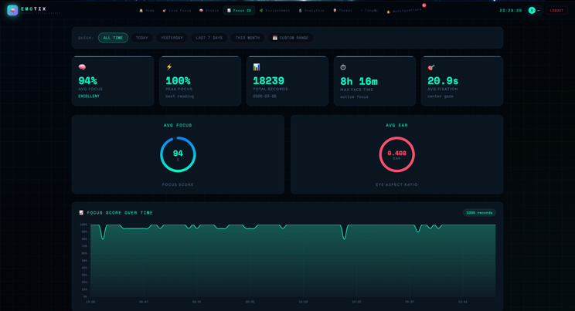
Figure 6: Focus score analysis dashboard showing gaze distribution, fixation metrics, and focus trends over time.

C. Environmental Context Analysis
The third layer of analysis integrates data of environmental sensors, such as noise, light intensity, and temperature. The correlation analysis will be conducted to determine the relationship between the focus score changes and the environmental conditions. As an example, one can predict that the higher the level of noise, the more the fixation duration would be negatively correlated, whereas the worse the lighting, the higher the rates of blinking and the lower the level of attention. This contextual analysis makes the focus detection engine valid since it shows that employee attention is not only behavior-based but also environmentally conditioned.

D. Stress Detection and Deep Learning Output Analysis
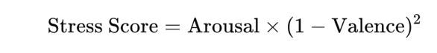
The fourth step examines the outputs of CNN-LSTM stress detection pipeline. CNN model produces a five-class emotion probability vector of each frame, whereas the LSTM model produces temporal valence and arousal values of a 15 frame sequence buffer. These outputs are statistically processed in order to establish emotional changes over time. The resultant stress score,

is taken as the main dependent variable of stress intensity. The analysis of stress scores on a trend basis is performed during the work sessions to identify the high-stress periods. Classification accuracy, confusion matrix analysis, precision, recall and temporal consistency validation are used to evaluate model performance.
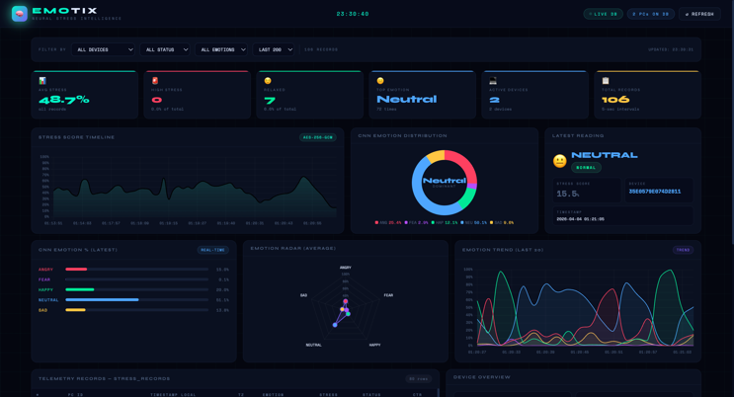
Figure 7: Stress monitoring dashboard showing emotion distribution, stress score timeline, and real-time analytics.

E. Chatbot Interaction and User Response Analysis
The fifth stage of analysis looks at the interventions and responses generated by the chatbot. Break, refocus and environmental adjustment logs that contain recommendations like break, refocus and environmental adjustments are reviewed to identify the effectiveness of the responses. The feedback and behavioral changes after chatbot interventions are assessed by the measures of user acceptance based on surveys and behavioral change. The comparative analysis is made to find out whether chatbot prompts have an impact on increasing the focus recovery rates and decreasing the time spent in the distracted state.

F. Cybersecurity Threat and Honeypot Analysis
The sixth stage is concerned with the AI honeypot cybersecurity module. Frequency distributions and comparative rule-based and AI-based metrics of detection are used to analyze frequency distributions and MQTT traffic, anomaly scores, and deception mode activations. The effectiveness of the Isolation Forest anomaly model is validated by using True Positive Rate (TPR), False Positive Rate (FPR), and detection latency. This analysis makes sure that the larger EMOTIX ecosystem is not vulnerable to cyber attacks that target its embedded infrastructure.

G. Overall System Performance Evaluation
The last phase incorporates all analytical deliverables to assess the general EMOTIX ecosystem performance. The routine deviations, focus levels, and stress scores, and chatbot interventions are compared through cross-module analysis to reveal interdependencies between the indicators of employee wellness. Trend visualization on the dashboard, usability testing, and accuracy by module are united to verify system scalability, privacy protection, and real-life applicability. This is a detailed data analysis model that guarantees that the project deliverables are technically robust, scientifically quantifiable and practically applicable to intelligent workplace wellness conditions.

Discussion
The EMOTIX: AI System of Employee Assistant and Mental Wellness is a complex and efficient way of addressing the key issues in the workplace including productivity, employee mental health, privacy, and smart help. It integrates workplace wellness, computer vision, deep learning, cybersecurity, edge AI, and human-computer interaction into a single adaptive platform. It discusses the main issues of current surveillance systems in the workplace, such as the absence of personalization, excessive reliance on wearable devices, inadequate privacy protection, and ineffective interventions in real-time.
EMOTIX has one of its strongest points in the adaptive routine tracking which is fueled by TinyML. In contrast to the conventional methods which rely on a set of schedules and reminders, EMOTIX is able to learn personal working behaviors like login time, breaks, and work done by doing local processing with Raspberry Pi. The system is human-in-the-loop, requiring employee approval prior to routines being changed, which enhances trust, autonomy, and ethical acceptance. It also offers wellness cues prior to proposing behavior change, making it a friendlier system to employees.
Focus detection is an AI-based module that enhances productivity analysis in workplaces by taking into account real attention rather than mere presence. The system captures a focus score based on eye tracking, gaze direction, frequency of blinking, length of fixation and sensing the environment which includes lighting, noise and temperature to indicate employee concentration and fatigue. This will form a closer picture of engagement at the workplace.
The AI chatbot turns technical analytics into easy wellness advice and offers individualized suggestions, including taking breaks or making changes, to the environment. The CNN-LSTM stress detection system also improves the reliability through the analysis of emotional patterns rather than expressions of individual frames. Together with robust security measures such as AES-256-GCM encryption and HMAC-SHA256 verification, EMOTIX will provide privacy- and security-guaranteed workplace wellness monitoring.
The honeypot cybersecurity system, which is based on deception, enhances EMOTIX by securing its IoT and embedded system against both HTTP and MQTT attacks. It supports a scalable and lightweight model of security with rule-based detection and Isolation Forest anomaly detection to support Raspberry Pi and similar devices. This guarantees the wellness and stress data and behaviors of employees. By merging employee wellness, smart monitoring, privacy engineering, and cybersecurity, EMOTIX manages to create a single platform that is secure. Enhancements in future are multimodal sensing, federated learning, voice-based assistants, HR system integration, explainable AI, and mobile cross-platform support to enhance the usability and scalability.

Conclusion
EMOTIX: AI System of Employee Assistant and Mental Wellness is a new application to address the issues of employee stress, concentration, time management, and privacy at work. The platform is a smart system that integrates adaptive routine monitoring, AI-controlled attention detection, stress-detection, wellness chatbot assistance, and cybersecurity protection. It operates on TinyML, edge AI, computer vision, CNN-LSTM models, and valence-arousal analysis to offer wellness monitoring of employees in a privacy-friendly and non-invasive manner. Human-in-the-loop consent enhances trust and ethical acceptance. The security is enhanced by AES-256-GCM encryption, HMAC-SHA256 integrity protection, and AI-based honeypot defense. All in all, EMOTIX provides a human-centered, scalable, and secure workplace wellness platform, which opens considerable prospects to further studies in the field of AI-based smart offices.

System Demonstration

The developed EMOTIX system is deployed as a web-based dashboard and can be accessed via the following link:https://emotix.sereanigolanka.com/
Access to the system is restricted and requires authorized employee login credentials. The dashboard provides real-time monitoring of focus levels, stress analytics, environmental conditions, and personalized AI-based recommendations.
Demo access credentials can be provided upon request for evaluation purposes.

References
[1] C. Fernandez-Llatas, V. Traver, T. Martinez-Millana, and J. Benedi, “The role of artificial intelligence in improving workplace well-being: A systematic review,” Healthcare, vol. 4, no. 3, pp. 1–24, 2024.
[2] K. Robertson, “Wellness programs raise privacy concerns over health data,” SHRM, Dec. 2023. [Online]. Available: https://www.shrm.org/topics-tools/news/technology/wellness-programs-raise-privacy-concerns-health-data . [Accessed: Sep. 19, 2025].
[3] A. Dimitriou, “The challenge of wearable neurodevices for workplace monitoring: An EU legal perspective,” Frontiers in Human Dynamics, vol. 6, 2024.
[4] J. Smith, “The top 8 employee monitoring trends happening in 2024,” Jul. 2024. [Online]. Available: https://www.activtrak.com/blog/employee-monitoring-trends/ . [Accessed: Sep. 19, 2025].
[5] M. Johnson, “The state of employee privacy and surveillance in 2024,” 2024. [Online]. Available: https://www.getkisi.com/blog/state-employee-privacy-surveillance . [Accessed: Sep. 19, 2025].
[6] P. Martinez et al., “AI-enabled adaptive learning systems: A systematic mapping of the literature,” Computers and Education: Artificial Intelligence, vol. 2, 2021.
[7] S. Chen, “Adaptive and intelligent systems for collaborative learning support: A review of the field,” IEEE Transactions on Learning Technologies, vol. 4, no. 1, pp. 3–30, 2011.
[8] R. Williams, “Learning-aided adaptation: A case study from wellness ecosystem,” in Wellness Ecosystem. Springer, 2023.
[9] American Bar Association, “The legal and social ramifications of pandemics: Workplace surveillance,” Business Law Today, Mar. 2024. [Online]. Available: https://www.americanbar.org/groups/business_law/resources/business-law-today/2024-march/legal-social-ramifications-pandemics/ . [Accessed: Sep. 19, 2025].
[10] Consumer Reports, “Are workplace wellness programs a privacy problem?,” Consumer Reports, 2024. [Online]. Available: https://www.consumerreports.org/health/health-privacy/are-workplace-wellness-programs-a-privacy-problem-a2586134220/ . [Accessed: Sep. 19, 2025].
[11] WorkTime, “Employee monitoring trends 2024: Top 17 insights,” WorkTime, 2024. [Online]. Available: https://www.worktime.com/employee-monitoring-software-industry-trends . [Accessed: Sep. 19, 2025].
[12] SBS HRS, “Workplace monitoring: What’s allowed, what’s off limits?,” SBS HRS, 2024. [Online]. Available: https://sbshrs.adpinfo.com/blog/workplace-monitoring-whats-allowed-whats-off-limits . [Accessed: Sep. 19, 2025].
[13] I. Software, “Healing the ailing workplace,” IEEE Software, 1997.
[14] N. Provos and T. Holz, Virtual Honeypots: From Botnet Tracking to Intrusion Detection, 1st ed. Boston, MA, USA: Addison-Wesley, 2007.
[15] L. Spitzner, Honeypots: Tracking Hackers, 1st ed. Boston, MA, USA: Addison-Wesley, 2003.
[16] K. Scarfone and P. Mell, “Guide to intrusion detection and prevention systems (IDPS),” NIST Special Publication 800-94, 2007.
[17] S. Antonatos, K. G. Anagnostakis, and E. P. Markatos, “Generating realistic workloads for network intrusion detection systems,” in Proc. ACM Workshop on Software and Performance, 2004, pp. 207–215.
[18] M. Nawrocki, M. Wählisch, T. Schmidt, and C. Keil, “A survey on honeypot software and data analysis,” IEEE Communications Surveys & Tutorials, vol. 18, no. 4, pp. 2734–2757, 2016.
[19] EMOTIX Neural Focus System, Available: https://emotix.sereanigolanka.com/. [Accessed: Apr. 2026].

