FINAL PROJECT REPORT
AgriPrice Alert System
A Digital Public Good for Agricultural Market Price Alerts

Table of Contents
1. Executive Summary 3
2. System Overview & SDG Alignment 4
3. Software Development Life Cycle (SDLC) 5
4. System Architecture Design 7
5. UML Diagrams 9
6. Prototype Development (UI/UX) 13
7. Git & GitHub Integration 15
8. Project Management Plan 16
9. Software License 18
10. References 19

1. Executive Summary
The AgriPrice Alert System is a web-based Digital Public Good designed to empower smallholder farmers and agricultural communities in Sierra Leone and across Sub-Saharan Africa. The system provides real-time and historical agricultural commodity price data, enabling farmers to make informed decisions about when and where to sell their produce, reducing exploitation by middlemen, and contributing directly to United Nations Sustainable Development Goal 2 (Zero Hunger).
This report presents the complete software design documentation including the chosen Software Development Life Cycle (SDLC) model, system architecture, UML diagrams, prototype design plan, project management timeline, and licensing information.

2. System Overview & SDG Alignment
2.1 Problem Statement
Millions of smallholder farmers in developing countries lack access to timely and accurate market price information. This information asymmetry causes farmers to sell their goods at prices far below market value, perpetuating cycles of poverty and food insecurity. In Sierra Leone, most farmers rely on word-of-mouth or travel to distant markets to check prices, which is both costly and inefficient.

2.2 Proposed Solution
The AgriPrice Alert System is a digital platform that aggregates, displays, and delivers agricultural commodity price alerts to farmers and stakeholders via a web interface and SMS notifications. Users can view price trends, compare prices across different markets, and subscribe to alerts for specific commodities.

2.3 SDG Alignment
This project directly aligns with UN Sustainable Development Goal 2: Zero Hunger, specifically:
- Target 2.3: Double agricultural productivity and income of smallholder farmers
- Target 2.c: Adopt measures to ensure proper functioning of food commodity markets
- Target 2.a: Increase investment in agricultural infrastructure and technology

2.4 Key Features
- Real-time commodity price dashboard for rice, cassava, maize, groundnuts, and palm oil
- Price comparison across regional markets (Freetown, Bo, Kenema, Makeni)
- Historical price trend charts and analytics
- SMS and in-app price alert subscription system
- Admin panel for market data officers to update prices
- Multi-language support (English and Krio)

3. Software Development Life Cycle (SDLC)
3.1 Chosen SDLC Model: Agile (Scrum Framework)
The AgriPrice Alert System will be developed using the Agile SDLC model, specifically the Scrum framework. Agile was chosen because it allows for iterative development, continuous user feedback, and flexibility to adapt to changing requirements — all of which are critical for a public-facing digital good serving a diverse user base.

Agile is appropriate for this project because the needs of farmers and agricultural stakeholders will evolve over time, new commodity types may need to be added, and the system must be responsive to feedback from field users including non-technical farmers and data entry officers.

3.2 SDLC Phases for AgriPrice Alert System

Phase 1: Planning
In this phase, the project scope is defined. The team identifies stakeholders including farmers, market vendors, agricultural officers, and NGOs. Key deliverables are outlined: a web application, SMS notification module, and admin dashboard. A project plan with a Gantt chart and network diagram is created. Technology stack is selected (React.js frontend, Node.js backend, PostgreSQL database, Twilio for SMS). The project is registered on GitHub and a repository is created.

Phase 2: Requirements Analysis
In this phase, functional and non-functional requirements are gathered through interviews with farmers and agricultural ministry officers. Use cases are documented. The team identifies: which commodities to track, which markets to cover, what types of users will access the system, and what alert thresholds mean to users. User stories are written in Agile format (e.g., “As a farmer, I want to see today’s price for rice in Freetown so that I can decide whether to sell today or wait”).

Phase 3: System Design
In this phase, the system architecture is designed using a three-tier model (Presentation, Logic, Data). UML diagrams are created including Use Case, Class, Sequence, and Activity diagrams. Database schema is designed. UI wireframes are produced in Figma for all key screens. API endpoints are defined for the backend.

Phase 4: Implementation (Sprints)
Development is carried out in two-week sprints. Sprint 1 covers user authentication and admin dashboard. Sprint 2 covers commodity price display and filtering. Sprint 3 covers price alert subscription and SMS integration. Sprint 4 covers historical charts and analytics. Each sprint includes coding, code review, and unit testing. All code is committed to the GitHub repository with meaningful commit messages.

Phase 5: Testing
Unit testing is performed on all modules using Jest (for JavaScript). Integration testing ensures that the frontend, backend, and database communicate correctly. User Acceptance Testing (UAT) is conducted with a sample group of five farmers and two agricultural officers in Bo District. Bug tracking is managed through GitHub Issues. Performance testing ensures the system handles at least 500 concurrent users.

Phase 6: Deployment
The system is deployed on a cloud server (e.g., AWS or DigitalOcean). A domain name is registered and SSL certificate applied. The database is migrated to the production server. An automated CI/CD pipeline using GitHub Actions is configured to deploy updates automatically on push to the main branch.

Phase 7: Maintenance
After launch, the team monitors the system for bugs and performance issues. New commodity types and market locations are added based on user feedback. Price data is updated daily by authorised data officers. Security patches are applied regularly. Monthly sprint retrospectives review system usage and user satisfaction.

4. System Architecture Design
4.1 Architecture Overview
The AgriPrice Alert System follows a Three-Tier Architecture pattern, which separates the application into three distinct layers: the Presentation Layer (frontend), the Application Logic Layer (backend), and the Data Layer (database). This architecture ensures scalability, maintainability, and separation of concerns.

4.2 Architecture Diagram
The diagram below illustrates the complete system architecture including all components, layers, and their interactions:

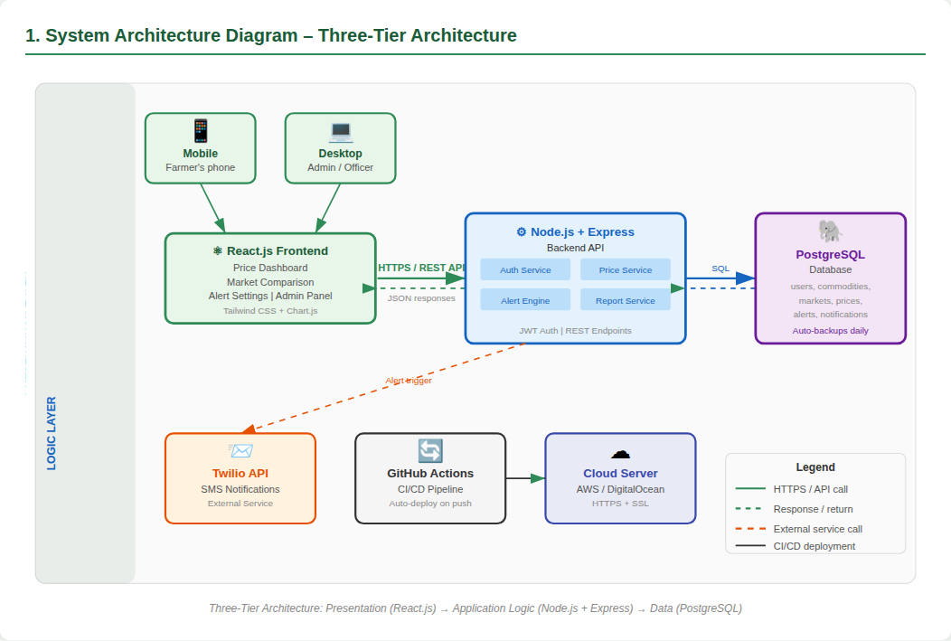
Figure 1: Three-Tier System Architecture – AgriPrice Alert System

4.3 Architecture Components

Presentation Layer (Frontend)
- Technology: React.js with Tailwind CSS
- Responsible for all user interface rendering
- Communicates with the backend via RESTful API calls over HTTPS
- Key pages: Dashboard, Price Listings, Alerts, Market Comparison, Admin Panel

Application Logic Layer (Backend)
- Technology: Node.js with Express.js framework
- Handles all business logic including price calculations, alert triggers, and user management
- Exposes REST API endpoints consumed by the frontend
- Integrates with Twilio API for SMS notifications
- Implements JWT-based authentication and role-based access control

Data Layer (Database)
- Technology: PostgreSQL relational database
- Stores commodity prices, market locations, user accounts, and alert subscriptions
- Accessed exclusively through the backend layer for security
- Regular automated backups to cloud storage

4.4 Component Interaction
A farmer opens the web application on their phone or computer. The React.js frontend sends an HTTP GET request to the Node.js backend API (e.g., GET /api/prices?commodity=rice&market=freetown). The backend queries the PostgreSQL database for the latest rice prices in Freetown. The database returns the results to the backend. The backend formats the data as JSON and returns it to the frontend. The frontend renders the price information on the dashboard. If a farmer has set a price alert for rice above 50,000 SLL/bag, the backend’s alert engine detects this threshold and triggers the Twilio SMS API to send a notification to the farmer’s phone.

5. UML Diagrams
This section presents all four UML diagrams developed for the AgriPrice Alert System. Each diagram provides a different perspective of the system design.

5.1 Use Case Diagram
The Use Case Diagram shows the interactions between four actors and the AgriPrice Alert System. Actors include: Farmer, Market Data Officer, System Administrator, and the Twilio SMS Gateway (external system). Use cases include viewing the price dashboard, searching by commodity, comparing markets, setting price alerts, receiving SMS alerts, adding price records, managing users, and generating reports.

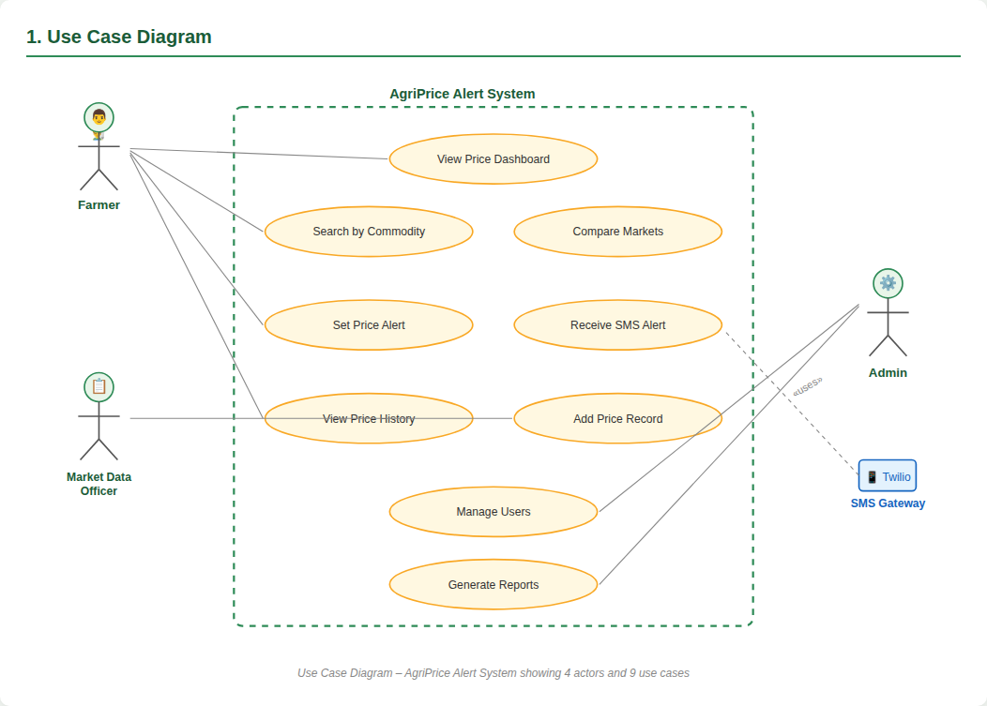
Figure 2: Use Case Diagram – 4 actors and 9 use cases

z5.2 Class Diagram
The Class Diagram models the six main entities of the system and their relationships. The classes are: User, Commodity, Market, PriceRecord, Alert, and Notification. Each class contains attributes (data fields) and methods (operations). Key relationships include User having many Alerts (one-to-many), Alert linked to one Commodity, PriceRecord associated with one Commodity and one Market, and Alert generating Notifications.

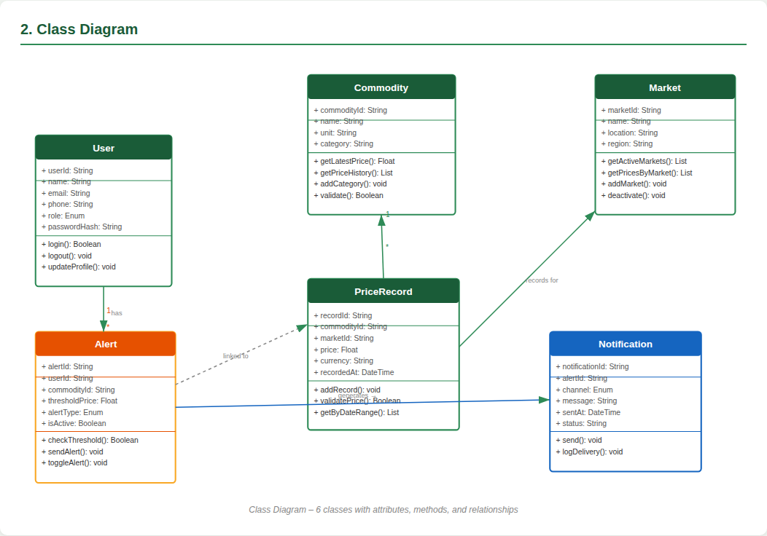
Figure 3: Class Diagram – 6 classes with attributes, methods, and relationships

5.3 Sequence Diagram
The Sequence Diagram illustrates the complete message flow for the ‘Set Price Alert and Receive SMS’ use case. It shows interactions between five lifelines: Farmer, React.js Frontend, Node.js Backend API, PostgreSQL Database, and Twilio SMS API. The diagram captures 13 steps from the farmer opening the alert settings page to the final SMS delivery and notification logging.

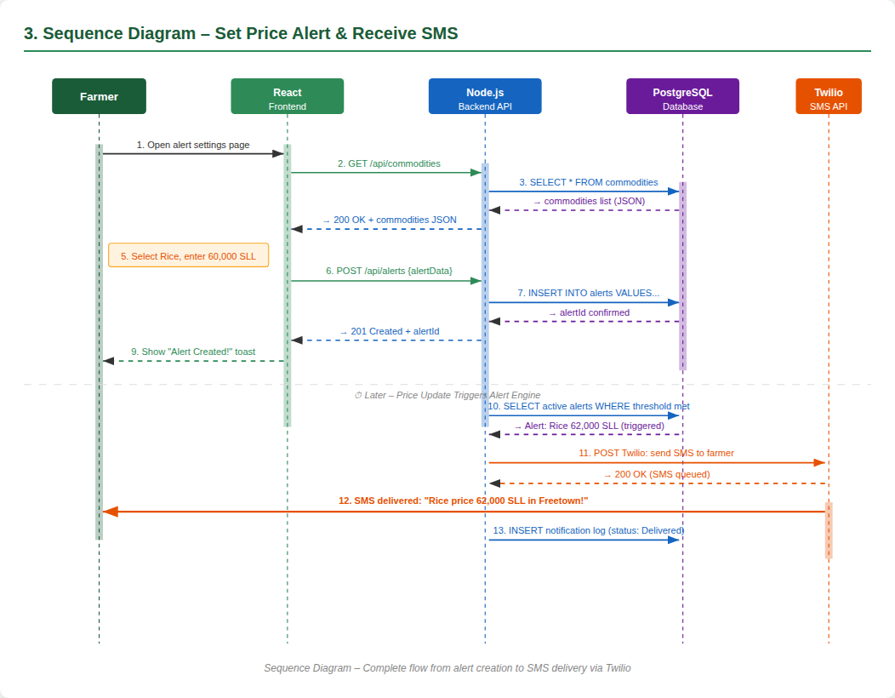
Figure 4: Sequence Diagram – Alert creation to SMS delivery (13 steps)

5.4 Activity Diagram
The Activity Diagram models the workflow for the ‘View Price Dashboard’ activity. It includes a start node, decision nodes (Is user logged in? Compare markets?), activity nodes (load dashboard, filter commodity, display chart), a merge node, and an end node. The diagram captures both authenticated and unauthenticated user flows.

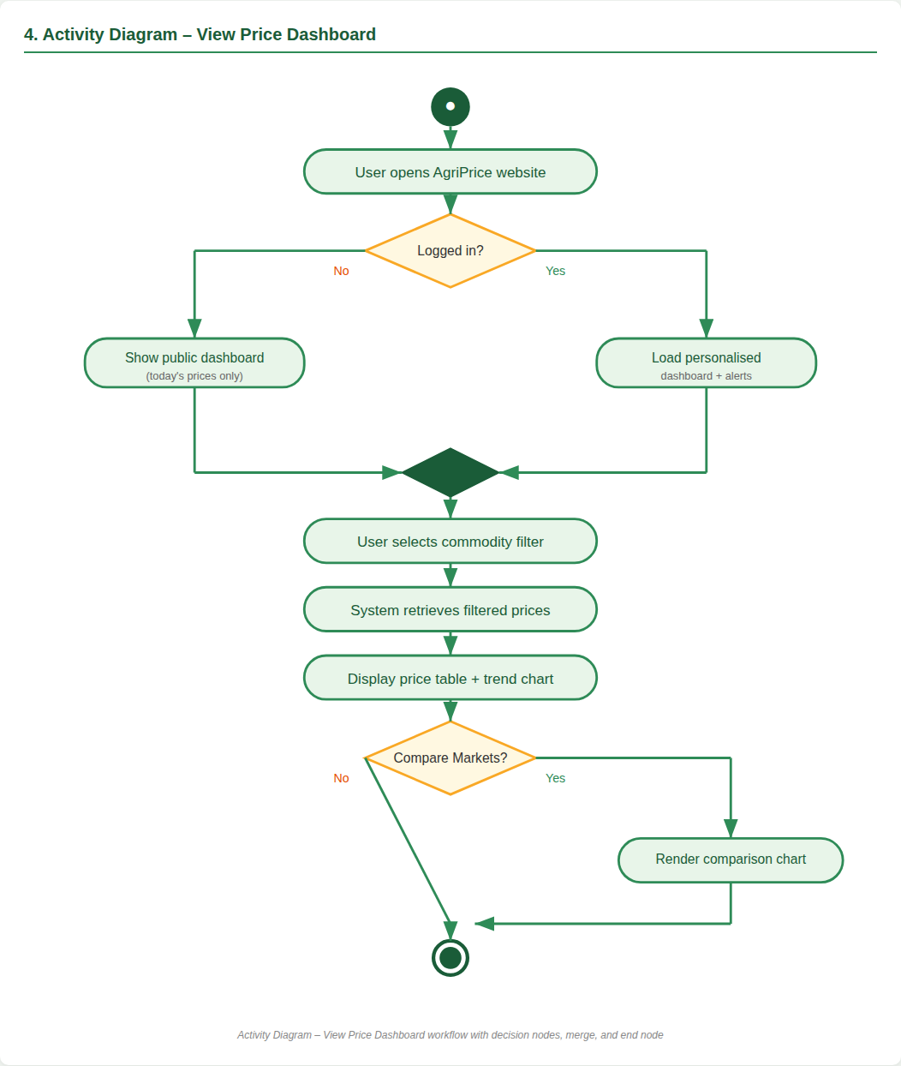
Figure 5: Activity Diagram – View Price Dashboard workflow

6. Prototype Development (UI/UX)
6.1 Design Approach
The prototype for the AgriPrice Alert System is designed using Figma, following a mobile-first approach since the majority of target users in Sierra Leone access the internet via smartphones. The design uses a clean green color scheme reflecting agricultural themes, with high contrast for readability in outdoor lighting conditions.

6.2 Key Screens Designed (Minimum 10)
1. Splash Screen – Dark green loading screen displaying the AgriPrice Alert logo, app name, tagline (“Empowering Farmers with Real-Time Prices”), and a loading bar
2. Onboarding Screen – Introductory screen with an illustration, the headline “Know Your Market,” a short explanatory description, page indicator dots, a Skip option, and a Next button
3. Registration Screen – Sign-up form collecting Full Name, Phone Number, Region/District, Password and Confirm Password, with a Create Account button and a link to the Login screen
4. Login Screen – Simplified sign-in form with Phone Number and Password fields, a Forgot Password link, and a Login button
5. Main Dashboard – Personalised home screen greeting the farmer (“Good Morning, Farmer 👋”), a search bar, and four commodity price cards (Rice, Maize, Groundnuts, Palm Oil) each showing the current price and market
6. Commodity Price List – A searchable, filterable list of all tracked commodities and their prices across markets, with filter chips (All, Rice, Maize, More) and a five-row price table
7. Price Alert History – A chronological list of previously triggered alerts, showing which commodity crossed its threshold, the price reached, the market, and how long ago it happened
8. Profile & Settings – Displays the farmer’s profile photo, name, phone number and district, with toggles for notifications, a language selector (English/Krio), Change Password and About App links, and a Logout button
9. Set Price Alert – Form allowing a farmer to choose a commodity, choose a market, select an alert type (Above/Below), enter a target price, and provide a phone number to receive the SMS alert
10. My Alerts – A management screen listing all of the farmer’s created alerts with ON/OFF toggle switches, plus an “Add New Alert” action
11. Admin: Add Price Record – A data-entry form used by Market Data Officers to log a new commodity price, capturing commodity, market, price, unit and date before saving to the database
12. Help & Support – A FAQ and contact screen answering common farmer questions (e.g. how to set an alert, how often prices update) alongside phone and email contact details and a Chat with Support button

6.3 Design Principles Applied
- Simplicity: Minimal text, icon-based navigation for low-literacy users
- Consistency: Uniform color palette (green #2E8B57, white, light grey), typography (sans-serif), and button styles
- Accessibility: Large tap targets (minimum 44px), high color contrast ratio (WCAG AA compliant)
- Feedback: Loading indicators, success/error toast notifications after every user action
Note: The Figma prototype link is included in the GitHub repository README file.

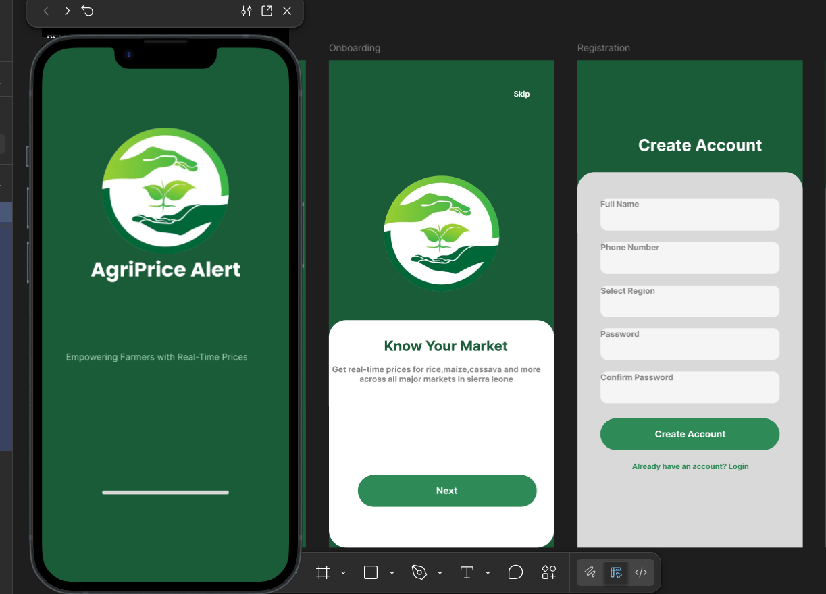
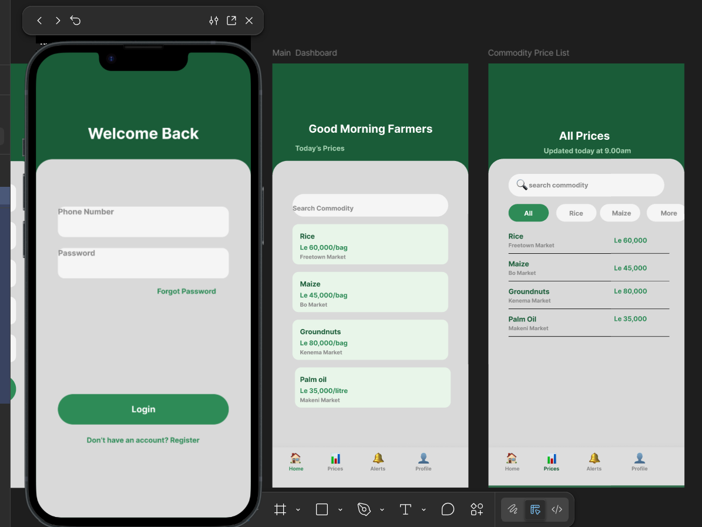

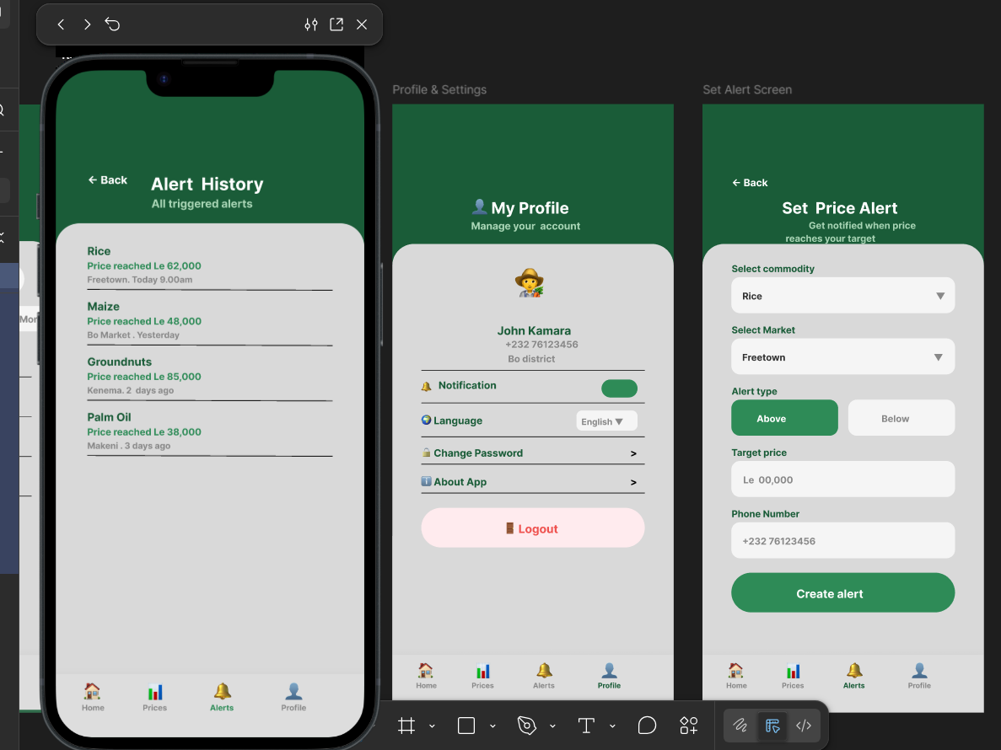
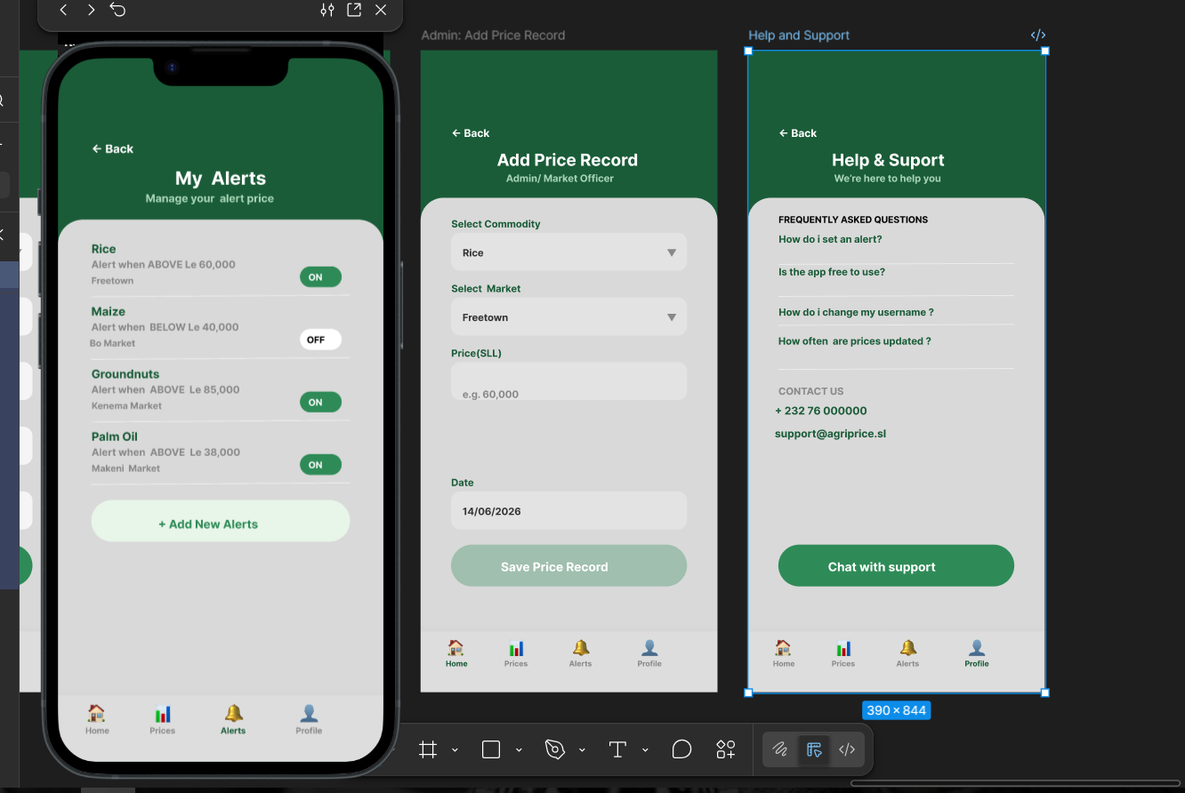

7. Git & GitHub Integration
7.1 Repository Structure
A GitHub repository named agriprice-alert-system has been created. The repository follows a standard structure:
- /frontend – React.js application source code
- /backend – Node.js + Express API source code
- /database – SQL schema files and seed data
- /diagrams – All UML diagrams (PNG and source files)
- /docs – Final project report, Gantt chart, and Network diagram
- /prototype – Figma export screenshots
- README.md – Project description, setup instructions, Figma link, and team info
- LICENSE – MIT License file

7.2 Branching Strategy
The project uses a Git Flow branching strategy:
- main: Production-ready code only; protected from direct pushes
- develop: Integration branch for completed features
- feature/[name]: Individual feature branches (e.g., feature/price-alerts, feature/admin-panel)
- hotfix/[name]: Emergency bug fixes applied directly to main

7.3 Collaboration Practices
- All team members commit code with descriptive messages following the format: feat: add price alert subscription endpoint
- Pull Requests (PRs) are used for all merges into develop and main
- GitHub Issues are used to track bugs, feature requests, and tasks
- GitHub Actions CI/CD pipeline runs automated tests on every PR

8. Project Management Plan
8.1 Gantt Chart
The Gantt chart below illustrates the complete 11-week project timeline, showing all phases and their durations from Week 1 (March 2026) to Week 11 (July 2026). GitHub commits run continuously throughout all phases.

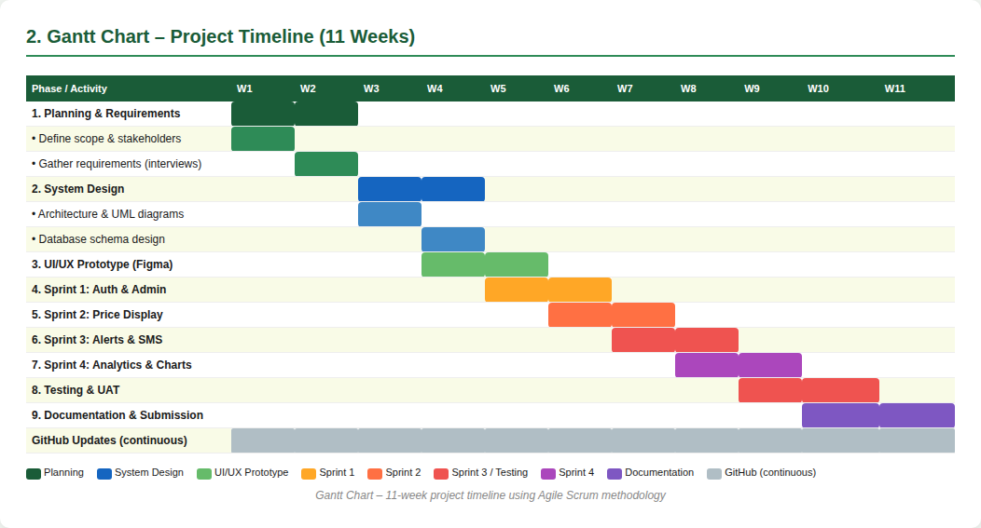
Figure 6: Gantt Chart – 11-week project timeline across all phases

8.2 Network Diagram (Critical Path Method)
The network diagram below applies the Critical Path Method (CPM) to identify the longest sequence of dependent activities. The critical path is highlighted in red and determines the minimum project duration of 11 weeks. Non-critical activities (UI/UX Prototype and Sprint 4 Analytics) run in parallel and have float time available.

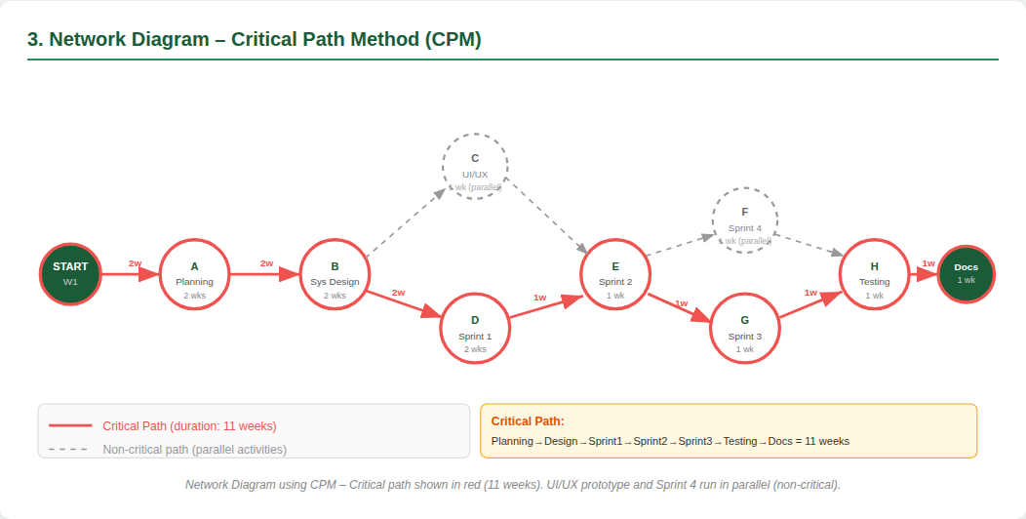
Figure 7: Network Diagram – Critical path shown in red (Planning → Design → Sprint 1 → Sprint 2 → Sprint 3 → Testing → Docs = 11 weeks)

8.3 Critical Path Summary
Planning (2w) → System Design (2w) → Sprint 1: Auth & Admin (2w) → Sprint 2: Price Display (1w) → Sprint 3: Alerts & SMS (1w) → Testing & UAT (1w) → Documentation (1w) = 11 weeks total.
Parallel activities (not on critical path): UI/UX Prototype (Week 4–5), Sprint 4: Analytics (Week 8–9).

9. Software License
9.1 Selected License: MIT License
The AgriPrice Alert System is released under the MIT License. This license was selected because:
- It is a permissive open-source license that allows anyone to use, copy, modify, merge, publish, distribute, and sublicense the software
- It aligns with the Digital Public Good (DPG) standard which requires open-source licensing
- It encourages adoption by NGOs, government agricultural ministries, and other developers who may want to adapt the system for their own regions
- It requires only that the original copyright notice and license text be included in any copies or substantial portions of the software

9.2 MIT License Text
MIT License
Copyright (c) 2026 AgriPrice Alert System Team
Permission is hereby granted, free of charge, to any person obtaining a copy of this software and associated documentation files (the "Software"), to deal in the Software without restriction, including without limitation the rights to use, copy, modify, merge, publish, distribute, sublicense, and/or sell copies of the Software.

9.3 Attribution of External Resources
- React.js: MIT License – Copyright (c) Meta Platforms, Inc.
- Node.js: MIT License – Copyright Node.js contributors
- Express.js: MIT License – Copyright (c) TJ Holowaychuk
- PostgreSQL: PostgreSQL License – Copyright The PostgreSQL Global Development Group
- Twilio SDK: MIT License – Copyright (c) Twilio Inc.
- Tailwind CSS: MIT License – Copyright (c) Tailwind Labs Inc.
- Chart.js: MIT License – Copyright (c) Chart.js Contributors

10. References
United Nations. (2015). Transforming our world: The 2030 Agenda for Sustainable Development. United Nations General Assembly. https://sdgs.un.org/goals/goal2
Digital Public Goods Alliance. (2023). DPG Standard Version 1.0. https://digitalpublicgoods.net/standard/
Food and Agriculture Organization of the United Nations (FAO). (2022). Agricultural market information systems: A guide for practitioners. FAO.
Pressman, R. S., & Maxim, B. R. (2020). Software Engineering: A Practitioner’s Approach (9th ed.). McGraw-Hill Education.
Sommerville, I. (2016). Software Engineering (10th ed.). Pearson Education.
Fowler, M. (2003). UML Distilled: A Brief Guide to the Standard Object Modeling Language (3rd ed.). Addison-Wesley.
Twilio Inc. (2024). Twilio SMS API Documentation. https://www.twilio.com/docs/sms
React Documentation. (2024). React – A JavaScript library for building user interfaces. https://reactjs.org
GitHub. (2024). GitHub Actions Documentation. https://docs.github.com/en/actions
Sierra Leone Ministry of Agriculture, Forestry and Food Security. (2023). Annual Agricultural Statistics Report 2023. Government of Sierra Leone.

