**Blockchain.io: Decentralized Cryptocurrency exchange for Internet of Values**

# 1.0 Overview of Blochchain.io

Blockchain.io is conceived to offer internet of values in a decentralized cryptocurrency exchange, trusted settlement of transactions, and offering liquidity services such as the initiation and execution of agreed ICO campaigns, token listing and marketing services. The three main pillars of the platform is illustrated in the next diagram .

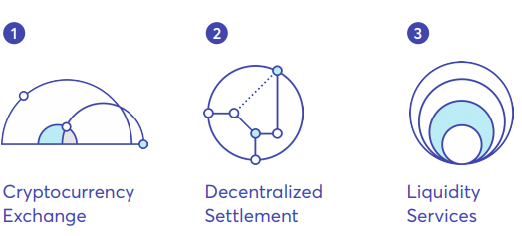

In Blockchain.io, cryptocurrencies will be traded against each other in the Blockchain.io ecosystem. There will be no need for a trusted third party due to implementation of low latency using an improved trustless but cross chain trading protocols, payment networks such as Lightening and Raiden to settle trades. In another vein, the blockchain operates a multiple value network where internet users could exchange values instantly the same way information is been exchange today.

The improvements of Blockchain.io overcome the scalability challenges common to decentralized blockchains, and facilitate transactions in a heterogeneous blockchains, while increases the speed and reduces cost of transactions.

# 2.0 Technical Features and Solutions of Blockchain.io

Individuals, investors, and traders should consider the distinctive characteristic of the blochchain.io to include the following.

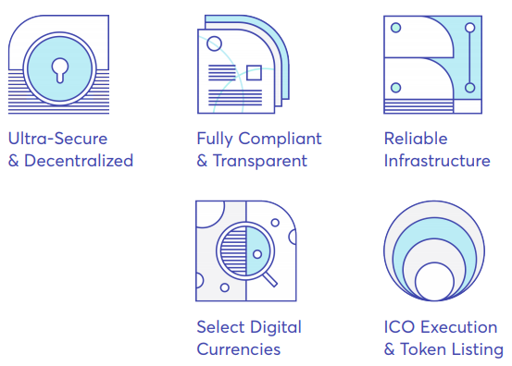

**Ultra-Secure & Decentralized**

* A highly secure exchange with cryptocurrencies held in cold storage and cryptographic proof of reserve.
* It requires multiple signatures to access the cold wallet, while its private key are in several vaults residing at different locations.
* Security measures adopts periodic technical and financial audit, and timestamped logs to detect tampering of accounting database.
* It further matches records of liabilities with proven cryptographic rules.
* Decentralized settlement utilizes a fair exchange protocol, which allows atomic swaps of cryptocurrencies to eliminate third party risk.

**Fully Compliant & Transparent**

* Blockchain.io conform on standards and regulations of the European Union.
* Independent auditors performs balance and check of inventory of coins, while cryptographic proofs of transactions are published at block interval for users’ verification.

**Reliable Infrastructure**

* Downtime operations will be minimal and restricted to restricted to server maintenance, systems upgrades and migrations.
* It will accommodate and scale high volume transactions, traffics, and against DDos attack.
* No technical debt resulting from taking shortcut on known practices.

**Select Digital Currency**

* The exchange will adopt high performance matching orders, basic and advance orders.
* Listing of cryptocurrencies will follow standardized vetting and review in terms of: sustainability, technical, and deep protocol.
* Regular updates though publications, reviews and market analysis.

**ICO Execution and Token Listing**

* Support and incentives will be given to entrepreneurs and technologist in the planning and execution of ICO campaigns.
* Newly created tokens are listed on Blockchain.io to provide liquidity to investors and traders.

# 3.0 Blockchain.io Roadmap

The development roadmap expands from 3rd quarter of 2017 to second quarter of 2020 as illustrated in the next diagram.

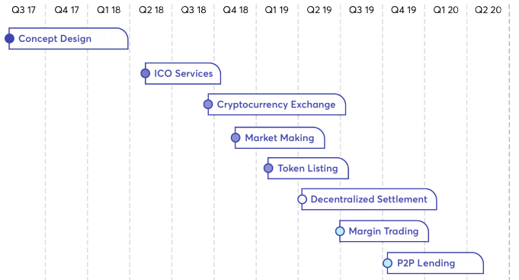

For more information, visit:

Website : https://lancer.network

Whitepaper : https://lancer.network/docs/LancerNetwork-WP.pdf

Facebook : https://www.facebook.com/LancerNetwork/

Twitter : https://twitter.com/lancernetwork

Telegram : https://t.me/LancerNetwork

ANN : https://bitcointalk.org/index.php?topic=3389713.msg35511131#msg35511131

Bitcointalk Profile : https://bitcointalk.org/index.php?action=profile;u=1423439