Correlation of variables.

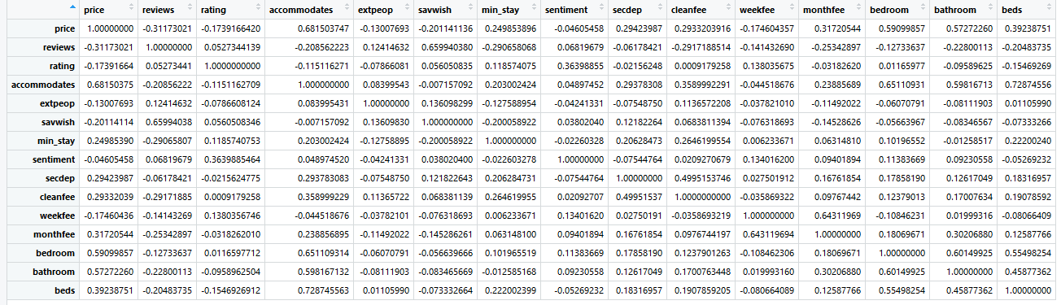

#we see that savwish and reviews are correlated.(Directly)

#we see that beds, bathroom, bedroom and accommodates are correlated. (Directly)

#we see monthfee and weekfee are correlated.(Directly)

MODEL WITH AVV VARIABLES:

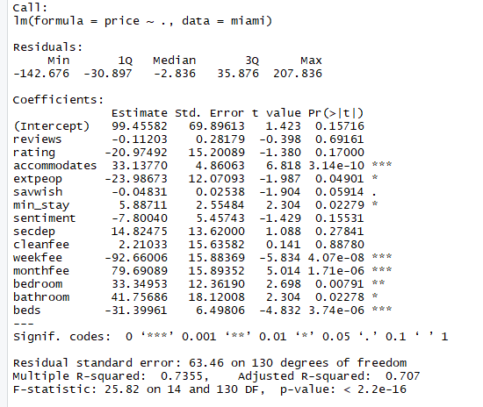

MOEDL2  
#Now let's run a model with only the sigificant variables

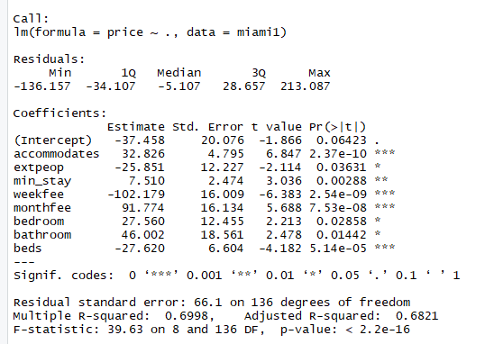

MODEL3:

using the correlation matrix we remove savwish and bathroom as they are less significant.

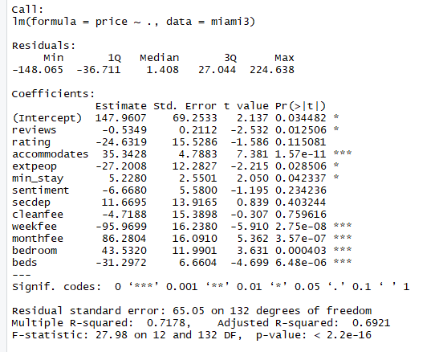

Even though the adj. R value has decreased ut the number of significant variables has increased.

#By removing cleanfee and secdep non significant variable we see that the adj. R sq value has increased.

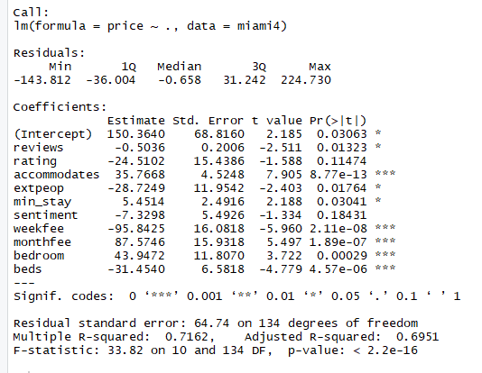

Thus I choose model 4 instead of model1 even when it has a lower adj. R squared Value but still it has more significant variables.

Paris

Correlation

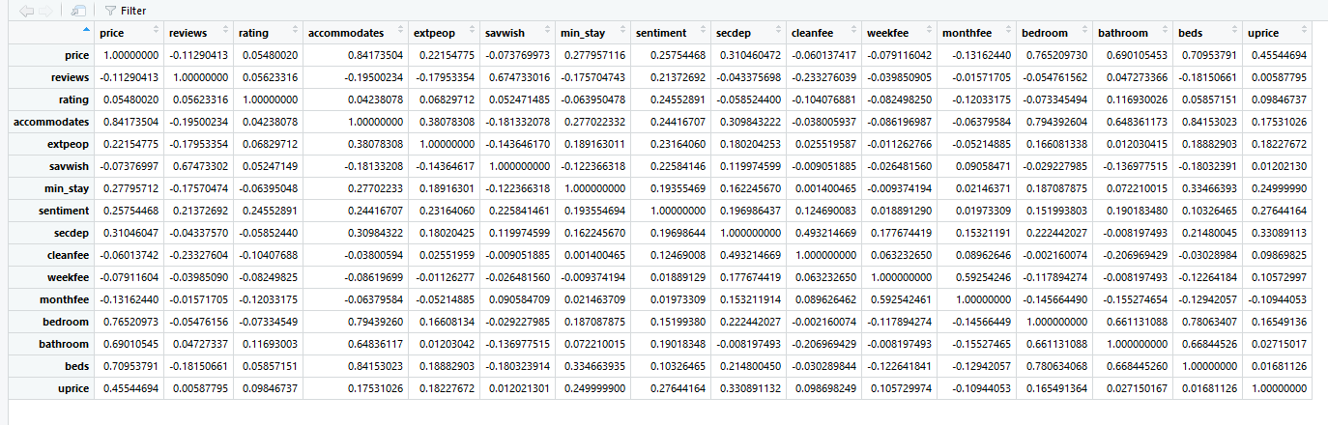

#we see that savwish and reviews are correlated.(Directly)

#we see that beds, bathroom, bedroom and accommodates are correlated. (Directly)

#we see monthfee and weekfee are correlated.(Directly)

MODEL1: All Variables

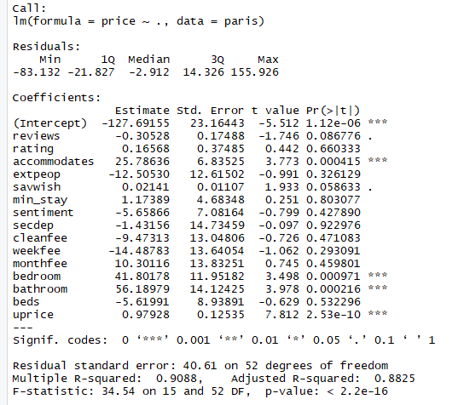

Model 2: Only with significant variables

