**Machine Learning**

**Problem 1:**

**Matlab code:**

**Part a**

clear; clc; close all;

[x,sr]=audioread('D:\AsamMahmood\New Folder\dft.wav');

%[x,sr]=audioread('sa1.wav');

td=1/sr;

%soundsc(x,sr)

lx=length(x);

t=[0:lx-1]*td;

figure

plot(t,x)

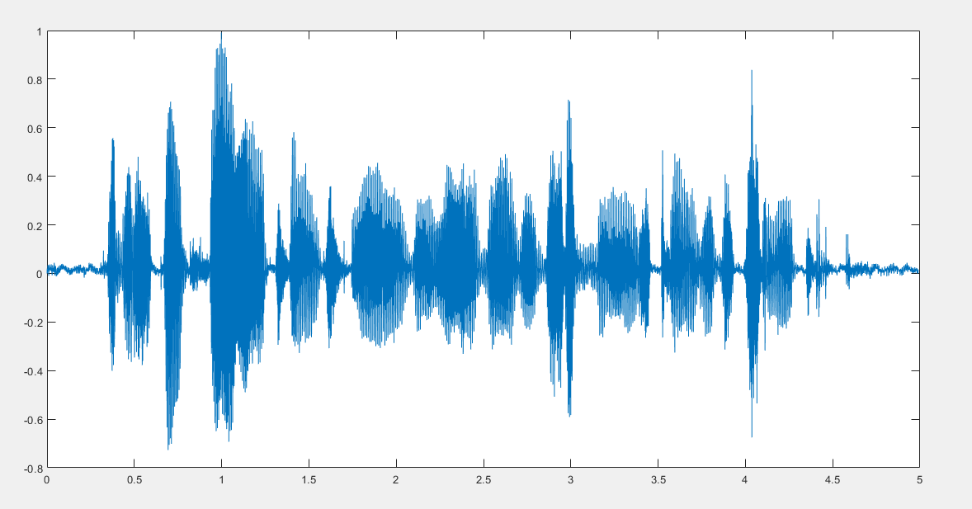

**Part b**

%[x, sr]=frame2im(x, 125, 0.9, sr);

nof=size(x,2);

lof=size(x,1);

nfft_fr=2^11;

fxm=fft(x,nfft_fr);

afxm=abs(fxm(1:nfft_fr/2,:));

t_fr=[0:nof-1]*sr;

f=[0:nfft_fr/2-1]/nfft_fr*sr;

figure

imagesc(t_fr,f,20*log10(afxm)), axis xy, colormap(jet), colorbar

M=20; %no of lags acf

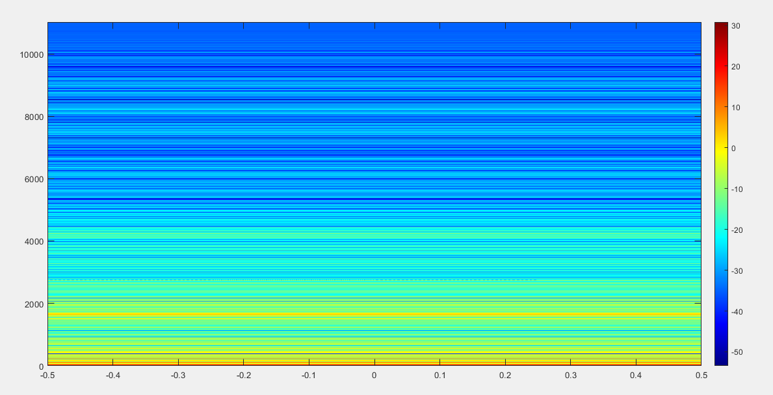

**Part c**

r=zeros(M,M);

dy=M/sr*1e3; %duration (ms) of a frame with M samples

V=zeros(M,M,nof);

D=zeros(M,nof);

VV=V;

Dv=D;

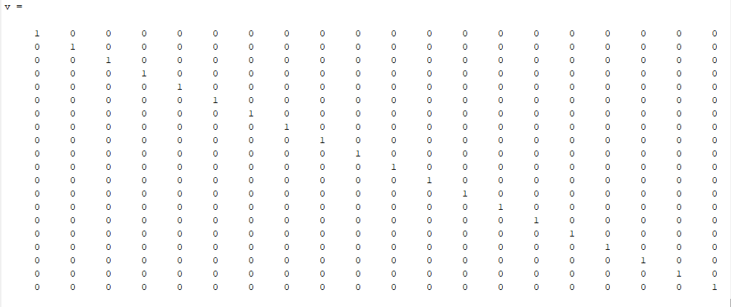

**Part d**

for k=1:1:nof

y=x(:,k);

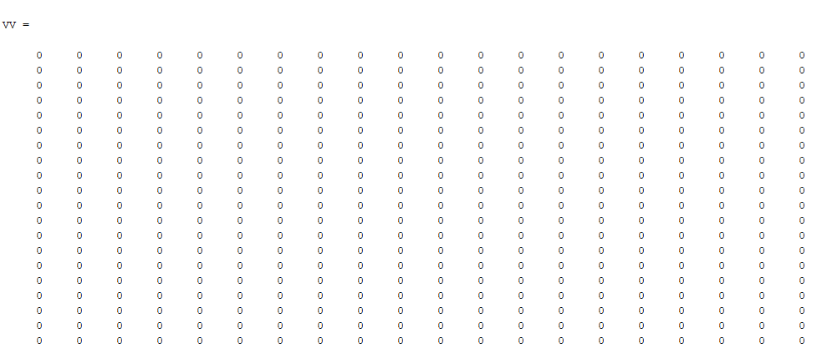

**Part e**

[ym, hty]=frames(y,dy , 0.9, sr);%Divide each frame into 10 sample frames with 9 sample overlap

nofy=size(y,2);

r=x.*x; %acf estimate /nof

R=r.’

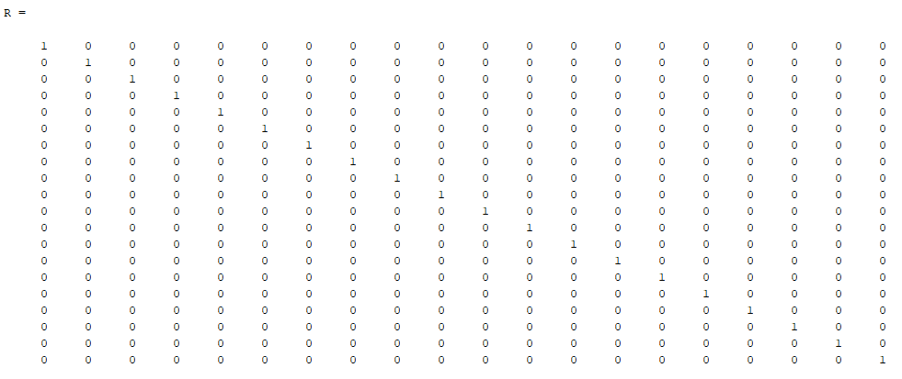

**Part f**

[v d]=eig(V);

V(:,:,k)=v;

RV=vym;

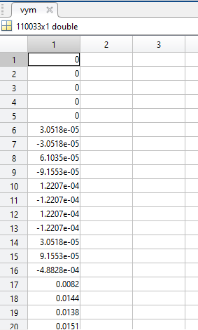

**Part g**

lambda=diag(d);

D(:,k)=lambda;

We take the inverse transform of the vym do that we can generate the ym and we add some weights to the as the eigon vectors to ym we get the same result because the inverse of the identity matrix is also a identity matrix.

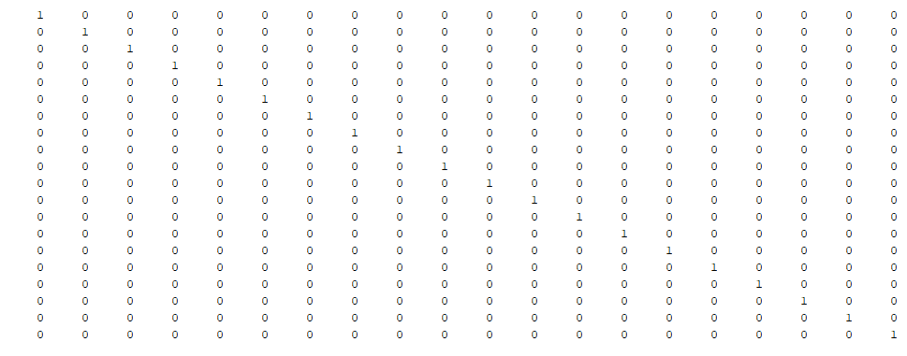

**Part h**

vym=y;

rv=vym; %acf estimate /nofy

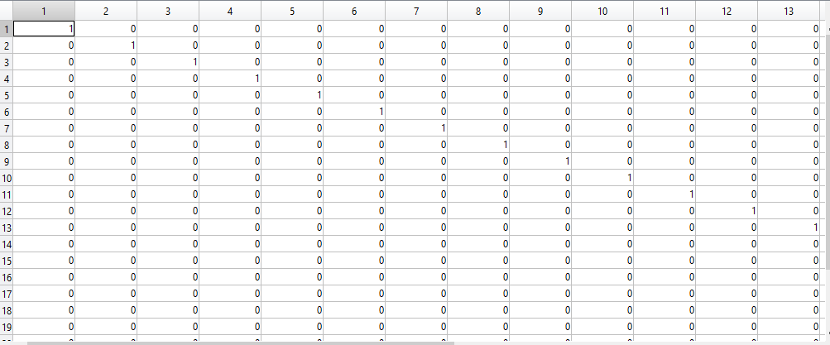

**Part i**

[vv dv]=eig(VV);

Vv(:,:,k)=vv;

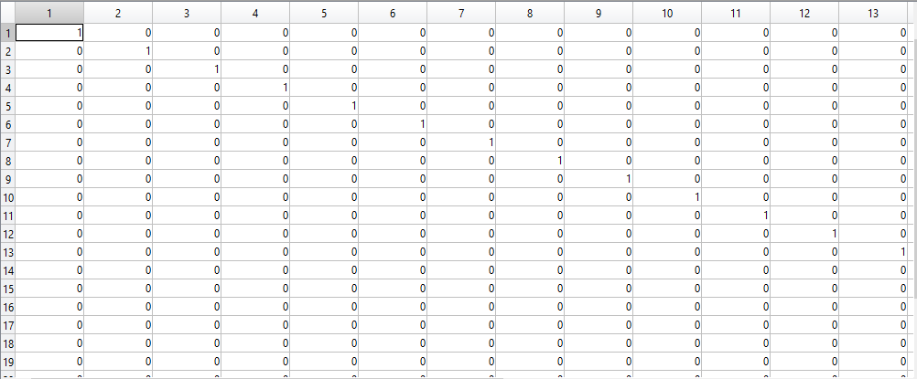

**Part j**

lambdav=v;

subplot(311),stem(lambda), hold, pause(0.3), stem((rv)), legend('eigs','diag rv'), hold off

subplot(312), plot(y)

subplot(313), plot(v)

end

figure

plot(D)

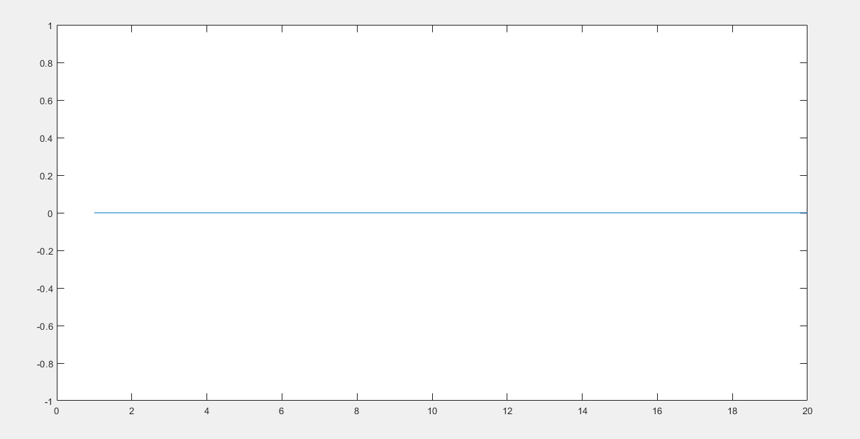

**Part k**

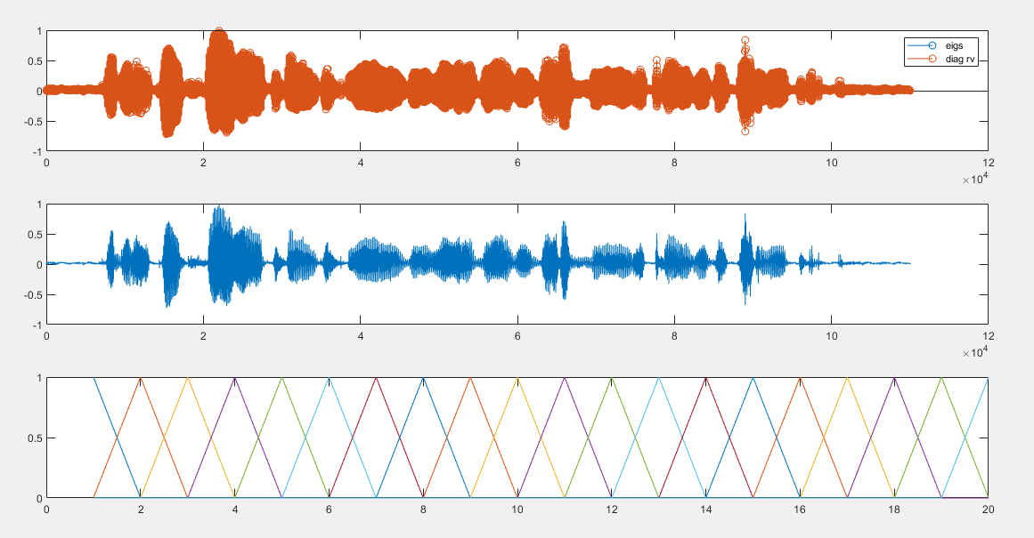

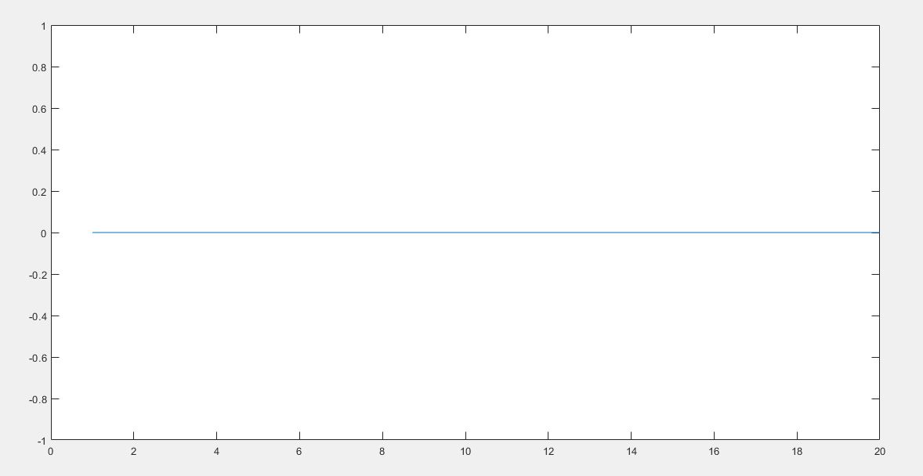

**Part l**

1. Matlab code

[y,fs]=audioread('D:\AsamMahmood\New Folder\sa1.wav');

y = y(:,1);

dt = 1/fs;

t = 0:dt:(length(y)*dt)-dt;

plot(t,y); xlabel('Seconds'); ylabel('Amplitude');

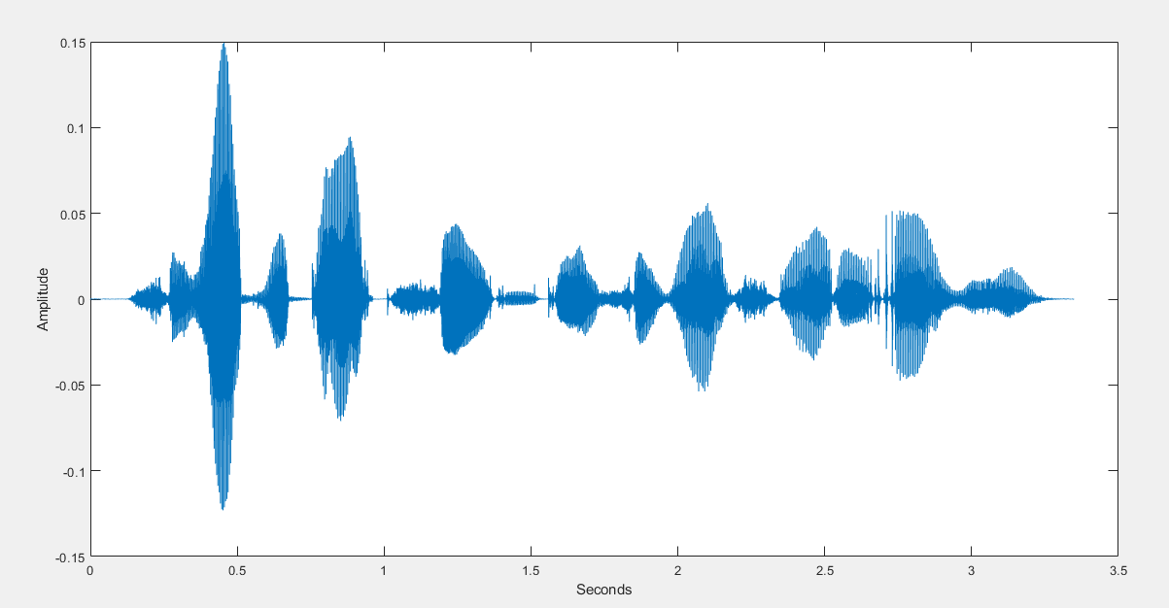

1. Matlab Code

figure

plot(psd(spectrum.periodogram,y,'Fs',fs,'NFFT',length(y)));

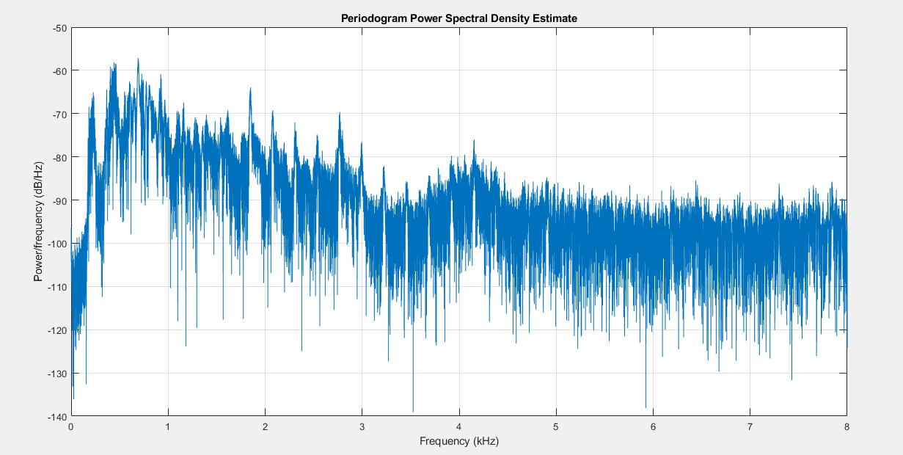

1. Matlab code

nof=size(y,2);

lof=size(y,1);

nfft_fr=2^11;

fxm=fft(y,nfft_fr);

afxm=abs(fxm(1:nfft_fr/2,:));

t_fr=[0:nof-1]*sr;

f=[0:nfft_fr/2-1]/nfft_fr*sr;

figure

imagesc(t_fr,f,20*log10(afxm)), axis xy, colormap(jet), colorbar

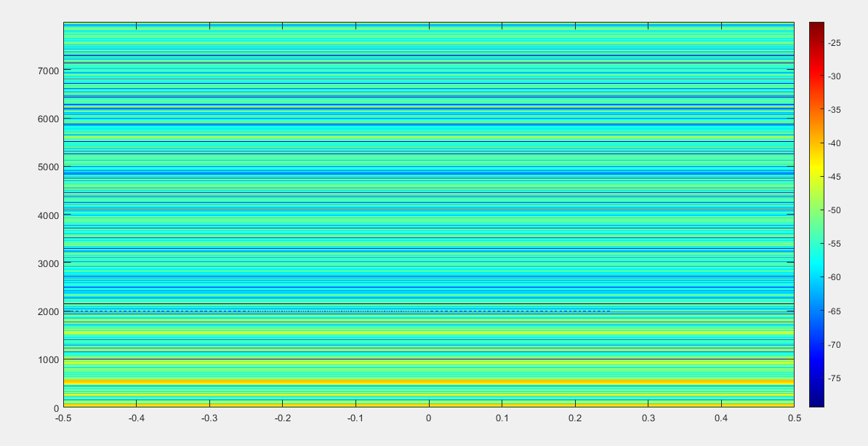

1. Matlab code

M=20; %no of lags acf

r=zeros(M,M);

dy=M/sr*1e3; %duration (ms) of a frame with M samples

V=zeros(M,M,nof);

D=zeros(M,nof);

VV=V;

Dv=D;