[Advanced Regression lecture](https://drive.google.com/file/d/1M039H_UeeY1WL9aFQuVew1oRkvttXYmL/view?usp=sharing)

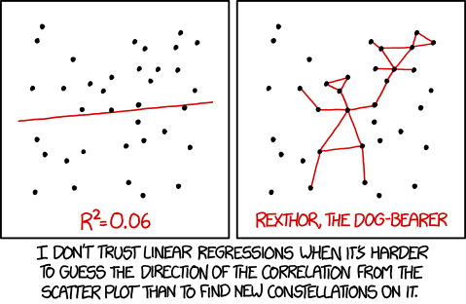

In this module you will learn about advanced regression methods.

To learn these methods successfully, you need:

1. Regression module
2. Knowledge of regularized regression methods
3. Knowledge of classification methods:
   * KNN
   * Decision Tree
   * Ensembles (Random Trees, Boosting algorithms)
   * SVM

There are a lot of different regression types besides usual linear and polynomial regression. Some of those types are inferred from known classification methods.

Also, there is an important topic for understanding regularization better.

Now, for the materials:

**Regularization**

[Probabilistic view on Linear Regression](https://bjlkeng.github.io/posts/a-probabilistic-view-of-regression/)

[Probabilistic explanation of regularization](http://bjlkeng.github.io/posts/probabilistic-interpretation-of-regularization/)

**Advanced techniques**

[Exploring and Stacking](https://towardsdatascience.com/a-guide-to-ensemble-learning-d3686c9bed9a)

KNN: [towardsdatascience,](https://towardsdatascience.com/the-basics-knn-for-classification-and-regression-c1e8a6c955)  [saedsayad](https://www.saedsayad.com/k_nearest_neighbors_reg.htm)

Decision Tree Regressor: [medium](https://medium.com/@bhartendudubey/decision-tree-regression-e202008c2df)

Random Forest: [towardsdatascience](https://towardsdatascience.com/random-forest-and-its-implementation-71824ced454f)

Boosting: [MLMastery,](https://machinelearningmastery.com/gentle-introduction-gradient-boosting-algorithm-machine-learning/) [wiley](https://besjournals.onlinelibrary.wiley.com/doi/epdf/10.1111/j.1365-2656.2008.01390.x)

SVM: [towardsdatascience](https://towardsdatascience.com/an-introduction-to-support-vector-regression-svr-a3ebc1672c2), [saedsayad](https://www.saedsayad.com/support_vector_machine_reg.htm)

[A Comprehensive Guide to Advanced Regression](https://www.kaggle.com/eraaz1/a-comprehensive-guide-to-advanced-regression) - full guide for different models and methods, highly recommended

**Multi Target Regression**

As well as in classification, there are problems where we need to predict multiple targets based on the data.

[How to develop multi-output Regression models with Python](https://machinelearningmastery.com/multi-output-regression-models-with-python/)