What is Block ?

- The minimum amount of data that can be read or write to the file system.
- Every file system is associated with a block size.
- Eg : for ext2 - 1kb
- Eg : ext3 – 4Kb
- A file system block size is an integer multile of disk block size

Block Size in HDFS ?

- The size of block in HDFS is larger compared to File System block.
- In Hadoop 1 it was 64MB by default
- In Hadoop 2 it is 128MB by default
- Although the size by default is same as bove it can be increased or decreased depending on user`s needs.
- In HDFS files are split into block sized pieces or chunks.
- HDFS blocks are placed into Datanode.

Comparison b/w HDFS and Normal File System Blocks

Normal File System
- Block size is small
- All files are placed in same disks.

HDFS
- Larger block size
- Blocks will be placed to different datanodes/hosts.
- HDFS block will consume only the files`s actual size if it is less than the block size not entire block size.

Seek Time
- The time needed to search and locate the block.
- Once file is found the transfer speed is based on disk throughput.
- Disk Throughhput is based in disk model.
- Max throughput is only achieved by small seek time.
- Using large blocks reduces the number seeks and then overall seektime involved.
- Blocks are replicated to ensure availability.

Changing Block Size

hdfs-site.xml

- Configuration file.
- Handles replications and storage locations of blocks physically in the datanodes
- We need at add a property in HDFS
- name=dfs.block.size
- value = the acutual value we need
- value must be provided as the value we get by product of actual size in MB and 1024 and 1024
- eg : If we want 128 MB we should provide it as
- 128*1024*1024 = 134217728
- This will be only applicable to new and upcoming blocks . Old blocks will remain having old size which is 128 or 64MB.

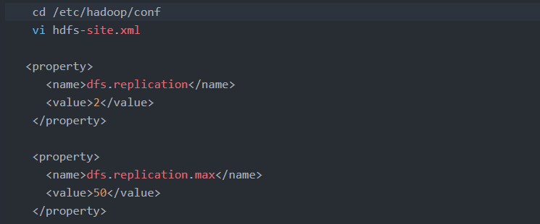

For 1 specific file
- At the time of loading of file itself we can specify the block size.
- Hadoop fs-Ddfs.blocksize=value followed by put command and path of file
- Hadoop fs-Ddfs.blocksize=134217728 -put/ home/hdmyadmin/mydata/test.text/input

steps:
1. open in vim mode the config file

vim etc/hadoop/conf/hdfs-site.xml

2. Add the new property

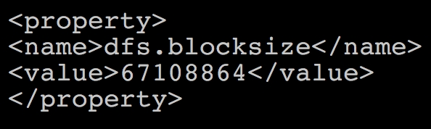

3. Restart hdfs services.

cd /etc/init.d/

./hadoop-hdfs-namenode restart
./hadoop-hdfs-datanode restart

