TechTrek Technical Documentation
  - Lecture & Event Booking Platform
Contents
1 Executive Summary 2
2 Technology Stack 3
3 Architecture Overview 5
4 Project Structure 9
5 Data Model 12
6 Security Architecture 21
7 Backend Architecture 24
8 API Endpoints Reference 30
9 Key Business Flows 36
10 Frontend Architecture 39
11 Database Migrations 43
12 Testing 44
13 Deployment 46
14 Appendix 48

1 Executive Summary
TechTrek is a full-stack web application for booking seats at tech lectures and multi-session events. Built as a FastAPI monolith with server-rendered Jinja2 templates, it provides interactive theatre-style seat selection, Razorpay payment processing, QR-coded ticket generation, and real-time live polls via Server-Sent Events. The platform encrypts personally identifiable information at rest using Fernet symmetric encryption and supports four distinct user roles: attendees, supervisors, speakers, and administrators.
The application manages the full event lifecycle from creation through attendance tracking, including multi-session event packaging, tiered seat pricing, coupon-based discounts, paid add-ons, waitlist management, certificate generation, and structured feedback collection. A dedicated admin panel provides CRUD operations for all entities, CSV exports, per-event management hubs, and an audit trail. Speakers have their own portal for editing session content, managing polls, and viewing calendar schedules.
Aspect | Detail
Purpose | Event booking platform for tech conferences and campus lectures
Users | Attendees, Supervisors (check-in staff), Speakers, Administrators
Core Flow | Browse events, select seats, hold for 5 minutes, pay via Razorpay, receive QR ticket
Data Model | 37 SQLAlchemy models across 22 module files
Codebase | 7 routers, 9 services, 82 Jinja2 templates, 4 JS modules
Deployment | Single Python process (Uvicorn), PostgreSQL, optional SMTP and Razorpay
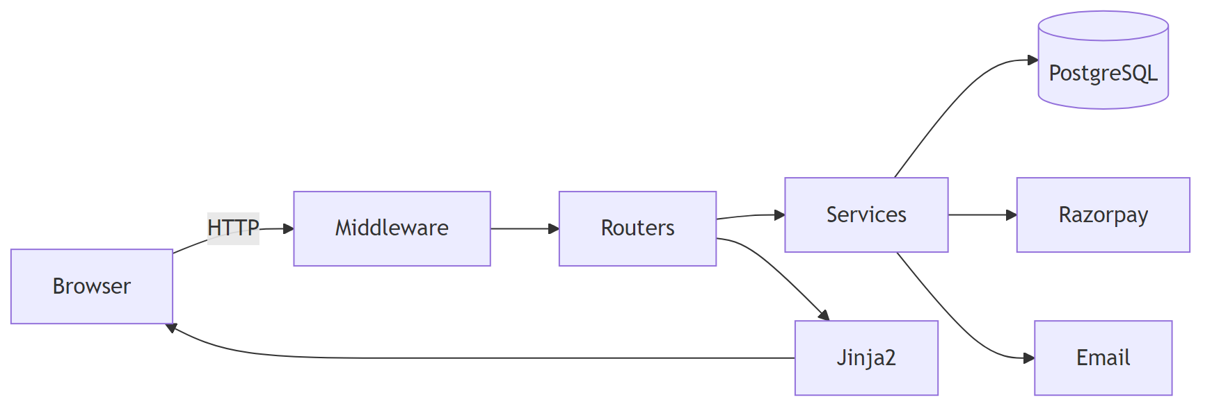

2 Technology Stack
TechTrek follows a traditional server-rendered architecture. The backend handles all routing, rendering, and business logic in a single Python process. The table below summarises every technology in use and its role.
Layer | Technology | Role
Web Framework | FastAPI | ASGI server, routing, middleware, dependency injection
ASGI Server | Uvicorn | Production and development HTTP server
ORM | SQLAlchemy 2.x | Database models, relationships, queries via DeclarativeBase
Migrations | Alembic | Schema versioning with 24 revision files
Database | PostgreSQL | Primary data store via psycopg2-binary
Templating | Jinja2 | Server-side HTML rendering (82 templates)
Config | pydantic-settings | Type-safe settings with .env file loading
Auth | bcrypt + Starlette Sessions | Password hashing and signed cookie sessions
OAuth | Authlib | Google OAuth 2.0 sign-in
Tokens | itsdangerous | Time-limited password reset and invite tokens
PII Encryption | cryptography (Fernet) | Field-level encryption and HMAC-SHA256 lookups
Payments | Razorpay SDK | Order creation, payment verification, refunds, webhooks
PDF Generation | ReportLab | Invoices and attendance certificates
QR Codes | qrcode + Pillow | Ticket and group QR code images
QR Scanner | html5-qrcode (CDN) | Browser camera scanning for venue check-in
CSRF | Custom middleware | Session-stored tokens with form enforcement
i18n | Babel | Extraction config ready; locale switching planned
Rate Limiting | slowapi | Listed in dependencies; not yet wired
Testing | pytest + httpx | Integration tests with TestClient and SQLite
Frontend | Vanilla HTML/CSS/JS | No SPA framework; custom design system with dark and light themes
PWA | Service Worker + Manifest | Offline fallback and install prompt

3 Architecture Overview
This section presents the system architecture at multiple levels of abstraction, from the high-level component layout through the per-request processing pipeline to the data-layer separation and template inheritance tree.

3.1 System Architecture
The application follows a layered client-server-data pattern. The browser communicates with the FastAPI server over HTTP. Requests pass through security headers middleware and session middleware before reaching route handlers. Routers delegate business logic to service modules, which interact with PostgreSQL and external services (Razorpay, SMTP). Jinja2 templates render the response HTML. A background async task loop processes post-event feedback and certificate notifications every 15 minutes.
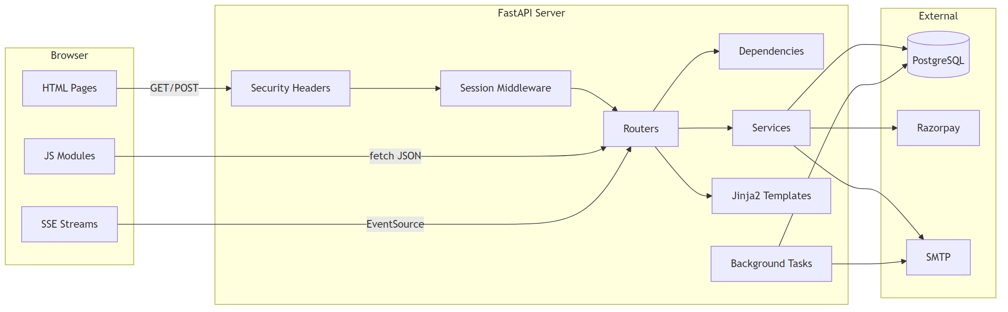

3.2 Request Lifecycle
Every HTTP request flows through the middleware stack, then into a router where FastAPI dependencies resolve the database session, current user, and template context. The router calls service functions for business logic, renders a Jinja2 template, and returns the completed HTML page.
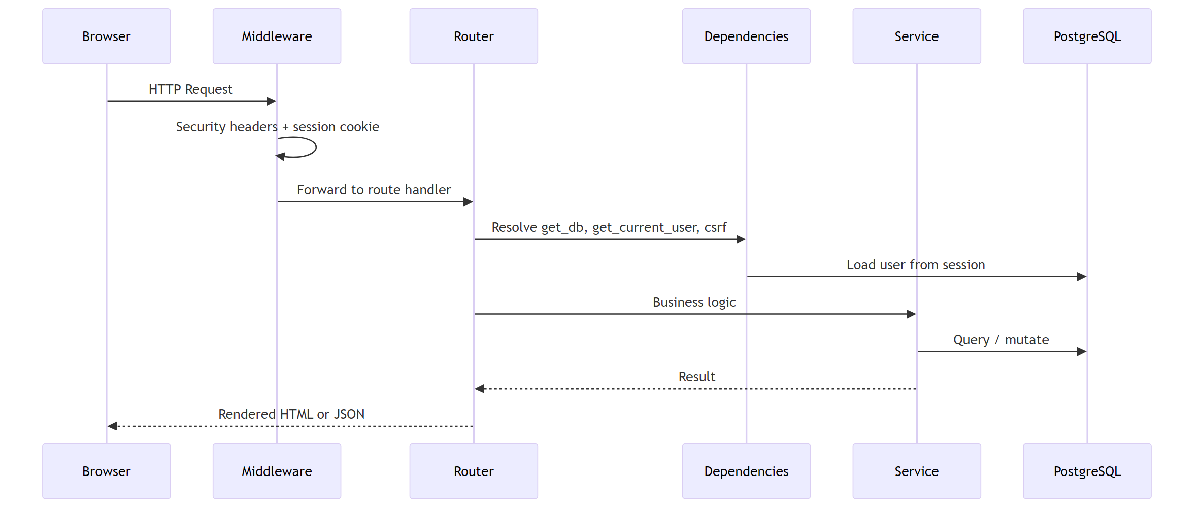

3.3 User Flow
The attendee journey spans browsing, seat selection, payment, and venue check-in. If an event is sold out, the user can join a waitlist and receive priority access when capacity is added.

3.4 Booking State Machine
A booking record progresses through a strict set of states. Seats are held for five minutes. If payment completes, a ticket is issued. Paid bookings can be checked in at the venue or cancelled for a partial refund. Expired holds release seats automatically.
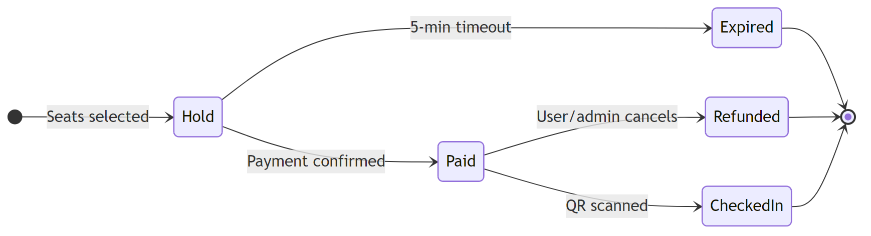

3.5 Data Layer Separation
The data model separates content (what a session is) from scheduling (when and where an event happens) and transactions (bookings, feedback, payments). An Event groups multiple Sessions, each with speakers and agenda items. Bookings link users to events and seats.
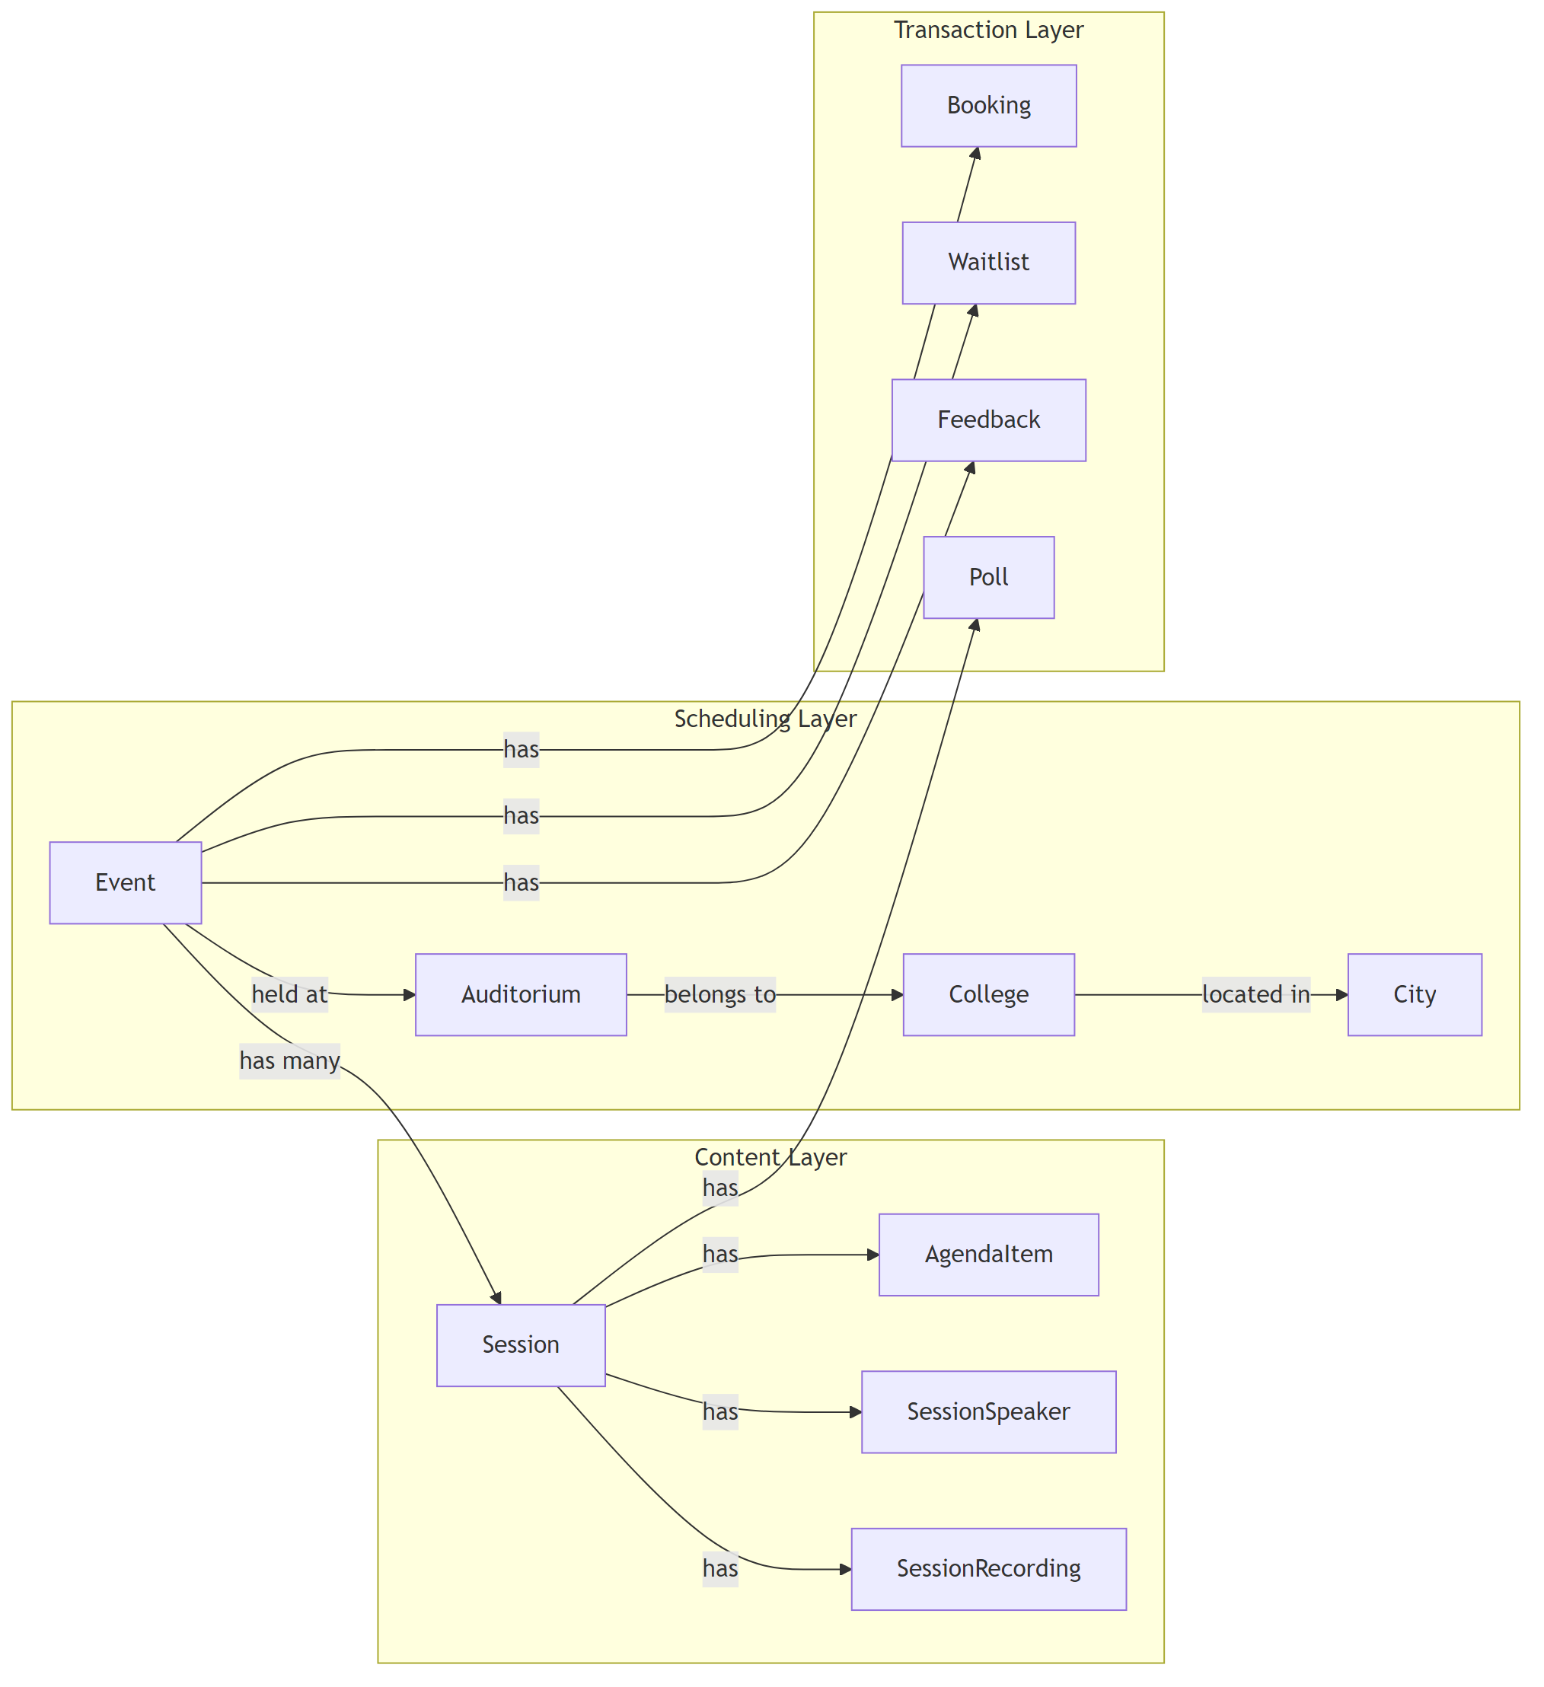

3.6 Template Inheritance
Templates use Jinja2 inheritance with three base layers. Public, auth, booking, speaker, and error templates extend base.html directly. Admin templates add a sidebar layer via base_admin.html. The event management hub adds a third layer via base_hub.html. Supervisor templates use their own base extending base.html.
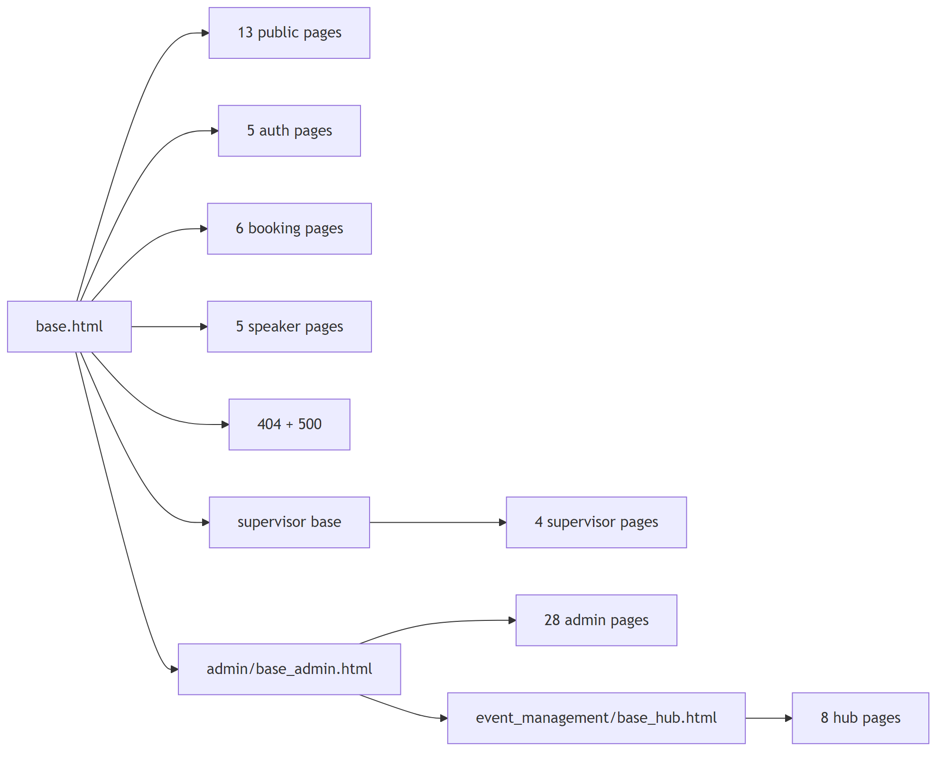

4 Project Structure
The codebase is organised as a flat Python project with the main application under app/, database migrations under alembic/, and tests under tests/.
techtrek_minim/
├── app/
│ ├── __init__.py
│ ├── main.py # FastAPI app, middleware, router registration
│ ├── config.py # Pydantic-settings configuration
│ ├── database.py # SQLAlchemy engine, session factory, Base
│ ├── dependencies.py # Auth, DB session, template context, flash
│ ├── crypto.py # Fernet encryption + HMAC hashing
│ ├── csrf.py # CSRF token generation and verification
│ ├── utils.py # IST timezone helper
│ ├── models/ # 22 model files, 37 ORM classes
│ │ ├── __init__.py # Re-exports all models
│ │ ├── user.py # User + EncryptedStr TypeDecorator
│ │ ├── event.py # Event (multi-session container)
│ │ ├── session.py # Session (talk content)
│ │ ├── booking.py # Booking lifecycle
│ │ ├── auditorium.py # Venue with seat grid layout
│ │ ├── seat.py / seat_type.py
│ │ ├── speaker.py / session_speaker.py
│ │ ├── agenda.py # Ordered agenda items
│ │ ├── college.py / city.py # Location hierarchy
│ │ ├── coupon.py # Discount coupons
│ │ ├── poll.py # Polls, options, votes
│ │ ├── feedback.py # Event feedback + session ratings
│ │ ├── feedback_template.py # Structured feedback templates
│ │ ├── event_addon.py # Paid add-ons
│ │ ├── event_break.py # Schedule breaks
│ │ ├── event_alert.py # Event notifications
│ │ ├── ticket_share.py # Ticket sharing tokens
│ │ ├── newsletter.py # Newsletter campaigns
│ │ ├── testimonial.py # Testimonials + subscribers
│ │ ├── session_recording.py # Video recordings
│ │ ├── gallery_image.py / uploaded_image.py
│ │ ├── activity_log.py # Admin audit trail
│ │ ├── webhook_log.py # Payment webhook records
│ │ └── site_setting.py # Key-value platform config
│ ├── routers/ # 7 router modules
│ │ ├── auth.py # /auth — login, register, OAuth, profile
│ │ ├── public.py # / — home, events, sessions, polls, tickets
│ │ ├── booking.py # /booking — seat selection through confirmation
│ │ ├── admin.py # /admin — full admin panel + event mgmt hub
│ │ ├── supervisor.py # /supervisor — college-scoped check-in
│ │ ├── speaker.py # /speaker — speaker portal
│ │ └── webhook.py # /webhooks — Razorpay payment webhooks
│ ├── services/ # 9 service modules
│ │ ├── booking.py # Seat map, holds, payments, cancellations
│ │ ├── razorpay.py # Razorpay orders, verification, refunds
│ │ ├── email.py # SMTP transactional emails
│ │ ├── invoice.py # PDF invoice generation (ReportLab)
│ │ ├── certificate.py # PDF attendance certificates
│ │ ├── feedback.py # Background feedback/certificate task loop
│ │ ├── poll_events.py # In-memory asyncio pub/sub for live polls
│ │ ├── activity_log.py # Audit trail persistence
│ │ └── oauth.py # Google OAuth client registration
│ ├── schemas/
│ │ └── __init__.py # Reserved (Pydantic schemas not used)
│ ├── templates/ # 82 Jinja2 HTML templates
│ │ ├── base.html # Root layout
│ │ ├── offline.html # PWA offline fallback
│ │ ├── public/ # 13 templates
│ │ ├── auth/ # 5 templates
│ │ ├── booking/ # 6 templates
│ │ ├── admin/ # 28 templates
│ │ │ └── event_management/ # 8 hub templates
│ │ ├── speaker/ # 5 templates
│ │ ├── supervisor/ # 4 templates
│ │ └── errors/ # 2 templates
│ └── static/
│ ├── manifest.json # PWA metadata
│ ├── service-worker.js # Cache and offline fallback
│ ├── css/ # style.css, additions.css, light-mode.css
│ └── js/ # seat-designer.js, seat-picker.js,
│ # image-upload.js, gallery-upload.js
├── alembic/
│ ├── env.py # Migration environment
│ ├── script.py.mako # Revision template
│ └── versions/ # 24 migration revisions
├── tests/
│ ├── conftest.py # Fixtures, factories, session forging
│ ├── test_public_pages.py
│ ├── test_admin_pages.py
│ └── test_feedback.py
├── scripts/
│ └── gen_cert.py # TLS certificate generator for dev
├── certs/ # Optional dev HTTPS certificates
├── alembic.ini # Alembic configuration
├── babel.cfg # i18n extraction config
├── requirements.txt # Python dependencies (20 packages)
├── run.py # Dev server launcher
├── seed.py # Database seeding script
├── deploy.py # Production deployment (Python)
└── deploy.sh # Production deployment (bash)

5 Data Model
The database consists of 37 SQLAlchemy ORM classes defined across 22 module files under app/models/. Models use SQLAlchemy’s DeclarativeBase and map to PostgreSQL tables. This section presents entity relationships split by domain, followed by column-level detail for the six most critical tables and prose summaries for supporting models.

5.1 Core Booking Domain
The central relationship chain links users to events through bookings and seats. An event is hosted at an auditorium and contains multiple sessions. Bookings reserve individual seats for a user within an event.
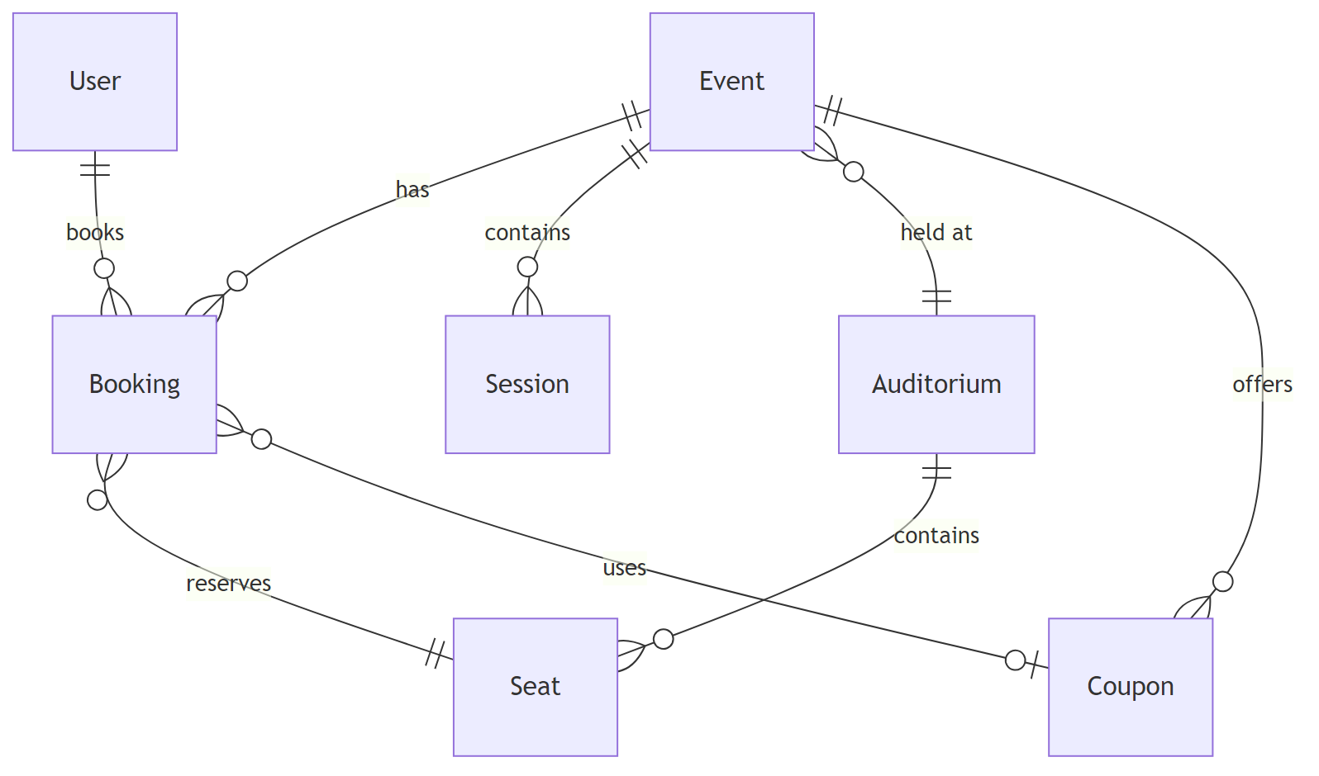

5.2 Location Hierarchy
Cities contain colleges, which contain auditoriums. Each auditorium defines a seat grid with configurable dimensions, gaps, and stage placement. Seats belong to built-in types (standard, VIP, accessible, aisle) or admin-defined custom seat types.
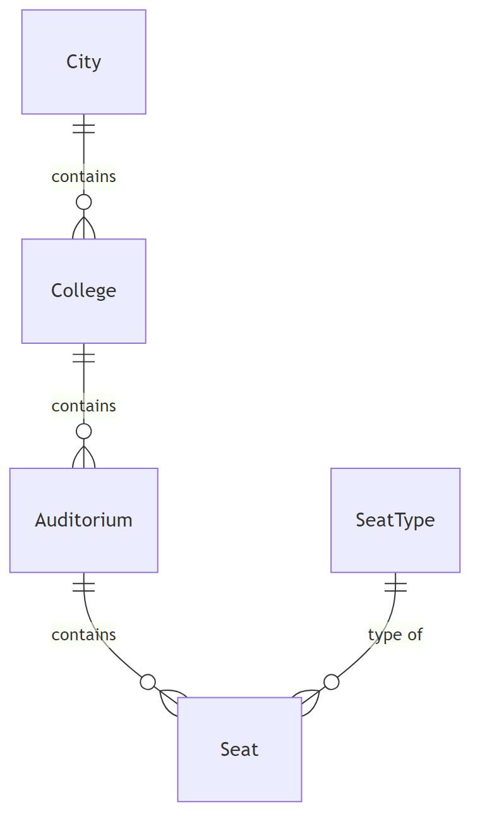

5.3 Content and Engagement
Sessions hold immutable talk content: title, description, speakers, agenda items, and recordings. Polls provide real-time audience interaction during sessions. Feedback is collected per event after attendance.
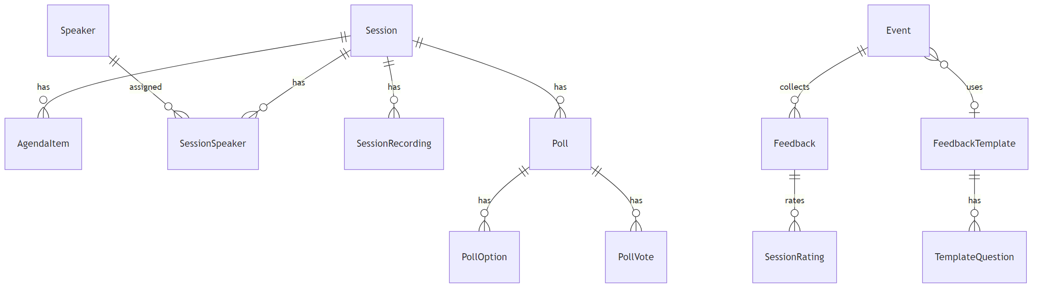

5.4 Operations and Communications
Events support add-ons, breaks, alerts, waitlists, ticket sharing, newsletters, and audit logging. Uploaded images and gallery images store binary data in the database.
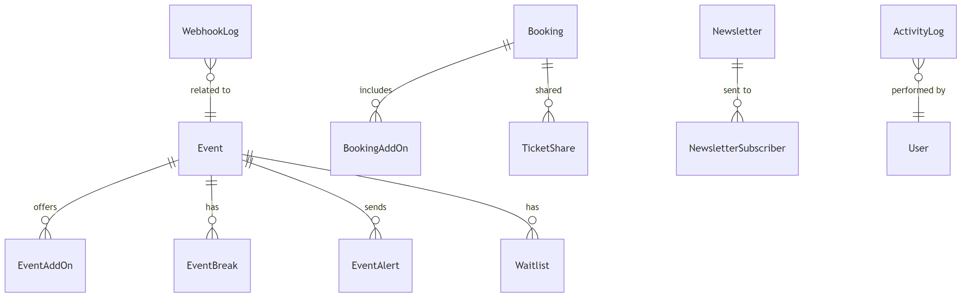

5.5 Users Table
The users table stores account credentials, encrypted PII, and role flags. Email, username, full name, and phone are stored as Fernet ciphertext via a custom EncryptedStr TypeDecorator. Companion HMAC-SHA256 hash columns enable exact-match lookups without decrypting every row.
Column | Type | Constraints | Description
id | Integer | PK | Auto-increment primary key
email | EncryptedStr (Text) | Not null | Fernet-encrypted email address
username | EncryptedStr (Text) | Not null | Fernet-encrypted username
full_name | EncryptedStr (Text) | Nullable | Fernet-encrypted display name
email_hash | String(64) | Unique, indexed | HMAC-SHA256 of normalised email
username_hash | String(64) | Unique, indexed | HMAC-SHA256 of normalised username
password_hash | String(255) | Nullable | bcrypt hash (null for OAuth users)
oauth_provider | String(30) | Nullable | OAuth provider name (e.g. “google”)
oauth_id | String(255) | Nullable | Provider-issued user ID
phone | EncryptedStr (Text) | Nullable | Fernet-encrypted phone number
college | String(300) | Nullable | College affiliation
discipline | String(100) | Nullable | Academic discipline
domain | String(100) | Nullable | Tech domain of interest
year_of_study | Integer | Nullable | Current year of study
is_admin | Boolean | Default False | Administrator role flag
is_supervisor | Boolean | Default False | Supervisor role flag
supervisor_college_id | Integer FK | Nullable | College scope for supervisors
created_at | DateTime | Default now_ist | Account creation timestamp

5.6 Events Table
The events table is the central scheduling and pricing entity. Each event groups multiple sessions, links to a venue, defines tiered pricing, and stores certificate branding fields.
Column | Type | Constraints | Description
id | Integer | PK | Auto-increment primary key
name | String(300) | Not null | Event title
description | Text | Nullable | Event description
banner_url | String(500) | Nullable | Banner image URL
college_id | Integer FK | Nullable | Associated college
auditorium_id | Integer FK | Nullable | Venue
start_date | Date | Nullable | Event start date
end_date | Date | Nullable | Event end date
price | Numeric(10,2) | Not null, default 0 | Standard seat price
price_vip | Numeric(10,2) | Nullable | VIP seat price
price_accessible | Numeric(10,2) | Nullable | Accessible seat price
processing_fee_pct | Numeric(5,2) | Nullable, default 0 | Processing fee percentage
custom_prices | JSON | Nullable | Per-seat-type custom pricing
status | String(20) | Default “draft” | draft, published, or completed
cert_* | Various | Nullable | 9 certificate branding fields
feedback_template_id | Integer FK | Nullable | Linked feedback template
created_at | DateTime | Default now_ist | Creation timestamp

5.7 Sessions Table
Sessions hold talk content within an event. Each session has a title, speaker, duration, and optional ordering. Sessions own agenda items, speaker assignments, recordings, and polls.
Column | Type | Constraints | Description
id | Integer | PK | Auto-increment primary key
event_id | Integer FK | Cascade delete | Parent event
speaker_id | Integer FK | Set null on delete | Primary speaker profile
title | String(300) | Not null | Session title
speaker_name | String(200) | Not null | Speaker display name
description | Text | Nullable | Session description
banner_url | String(500) | Nullable | Banner image URL
duration_minutes | Integer | Default 30 | Session duration
start_time | DateTime | Nullable | Scheduled start time
order | Integer | Default 0 | Display order within event
recording_url | String(500) | Nullable | Legacy recording URL
is_recording_public | Boolean | Default False | Legacy recording visibility
created_at | DateTime | Default now_ist | Creation timestamp

5.8 Bookings Table
The bookings table tracks the full lifecycle of a seat reservation, from initial hold through payment, Razorpay integration, coupon application, check-in, and potential refund.
Column | Type | Constraints | Description
id | Integer | PK | Auto-increment primary key
user_id | Integer FK | Not null | Booking owner
event_id | Integer FK | Set null on delete | Target event
seat_id | Integer FK | Not null | Reserved seat
payment_status | String(20) | Default “hold” | hold, paid, refunded, cancelled
booking_ref | String(20) | Unique | Auto-generated reference (hex)
ticket_id | String(36) | Unique, nullable | UUID ticket identifier
qr_code_data | Text | Nullable | Base64 QR code PNG of ticket
booking_group | String(36) | Indexed, nullable | Group ID for multi-seat bookings
group_qr_data | Text | Nullable | Base64 QR code PNG of group
amount_paid | Float | Default 0 | Amount paid for the seat
refund_amount | Float | Nullable | Refund amount after cancellation
cancellation_fee | Float | Nullable | Fixed fee deducted (100)
checked_in | Boolean | Default False | Attendance confirmed
checked_in_at | DateTime | Nullable | Check-in timestamp
invoice_number | String(30) | Indexed, nullable | Generated invoice number
razorpay_order_id | String(50) | Nullable | Razorpay order identifier
razorpay_payment_id | String(50) | Nullable | Razorpay payment identifier
razorpay_signature | String(128) | Nullable | Razorpay payment signature
refund_id | String(50) | Nullable | Razorpay refund identifier
refund_status | String(30) | Nullable | Razorpay refund status
refund_processed_at | DateTime | Nullable | Refund completion timestamp
coupon_id | Integer FK | Nullable | Applied coupon
held_until | DateTime | Nullable | Hold expiry time
booked_at | DateTime | Default now_ist | Booking creation timestamp
is_shared_ticket | Boolean | Default False | Whether ticket was shared
original_user_id | Integer | Nullable | Original owner before share

5.9 Auditoriums Table
Auditoriums define physical venues with configurable seat grid dimensions, gaps, stage positioning, and entry/exit markers.
Column | Type | Constraints | Description
id | Integer | PK | Auto-increment primary key
name | String(200) | Not null | Auditorium name
college_id | Integer FK | Nullable | Parent college
location | String(300) | Not null | Location description
description | Text | Nullable | Additional details
total_rows | Integer | Not null, default 10 | Seat grid row count
total_cols | Integer | Not null, default 15 | Seat grid column count
stage_cols | Integer | Nullable | Stage width in columns
stage_offset | Integer | Default 0 | Stage starting column
stage_label | String(100) | Default “Stage” | Stage display label
row_gaps | Text | Nullable | JSON array of gap row indices
col_gaps | Text | Nullable | JSON array of gap column indices
layout_config | JSON | Nullable | Full layout configuration
entry_exit_config | JSON | Nullable | Entry/exit markers

5.10 Supporting Models Summary
Speakers store a name, title, bio, photo URL, email, and optional user_id link. Speakers can be invited via time-limited invite_token values.
SessionSpeaker is a many-to-many junction linking sessions to speakers with a role field (primary or guest) and ordering.
AgendaItem stores ordered items within a session with title, speaker name, duration, and description.
SessionRecording stores video recording URLs with title, public flag, and ordering per session.
Seat represents individual grid positions with row/column numbers, label, type, and active flag. SeatType defines admin-created custom seat categories with name, colour, icon (emoji), and optional price.
City and College form a geographic hierarchy with active flags for soft deletion.
Coupon provides event-scoped discount codes with percentage or fixed amount, usage limits, and validity windows.
Waitlist tracks users waiting for sold-out events with optional priority grant and expiry.
Poll, PollOption, and PollVote support multiple choice, yes/no, rating, and text poll types with one-vote-per-user enforcement.
Feedback and SessionRating collect post-event ratings and comments. FeedbackTemplate, TemplateQuestion, FeedbackResponse, and QuestionResponse support structured feedback with configurable question types.
EventAddOn and BookingAddOn define paid add-ons purchasable during checkout.
EventBreak stores schedule breaks with timing and ordering.
EventAlert enables admins to push notifications to event attendees.
TicketShare manages ticket transfer tokens with email, claim tracking, and expiry.
Newsletter and NewsletterSubscriber support email campaigns with HTML content and subscriber management.
Testimonial stores student quotes for the home page. NewsletterSubscriber (in the same module) is a simple email list.
UploadedImage and GalleryImage store binary image data in the database with content type metadata and session/ordering.
ActivityLog records admin actions with actor, action type, entity, and details.

6 Security Architecture
TechTrek implements defence in depth across encryption, authentication, authorisation, CSRF protection, and HTTP security headers.

6.1 PII Encryption
Personally identifiable information (email, username, full name, phone) is encrypted at rest using Fernet symmetric encryption. The EncryptedStr TypeDecorator on the User model transparently encrypts values on write and decrypts on read. Since encrypted values cannot be used in SQL WHERE clauses, companion email_hash and username_hash columns store HMAC-SHA256 digests of the normalised (lower-cased, stripped) plaintext for exact-match lookups.
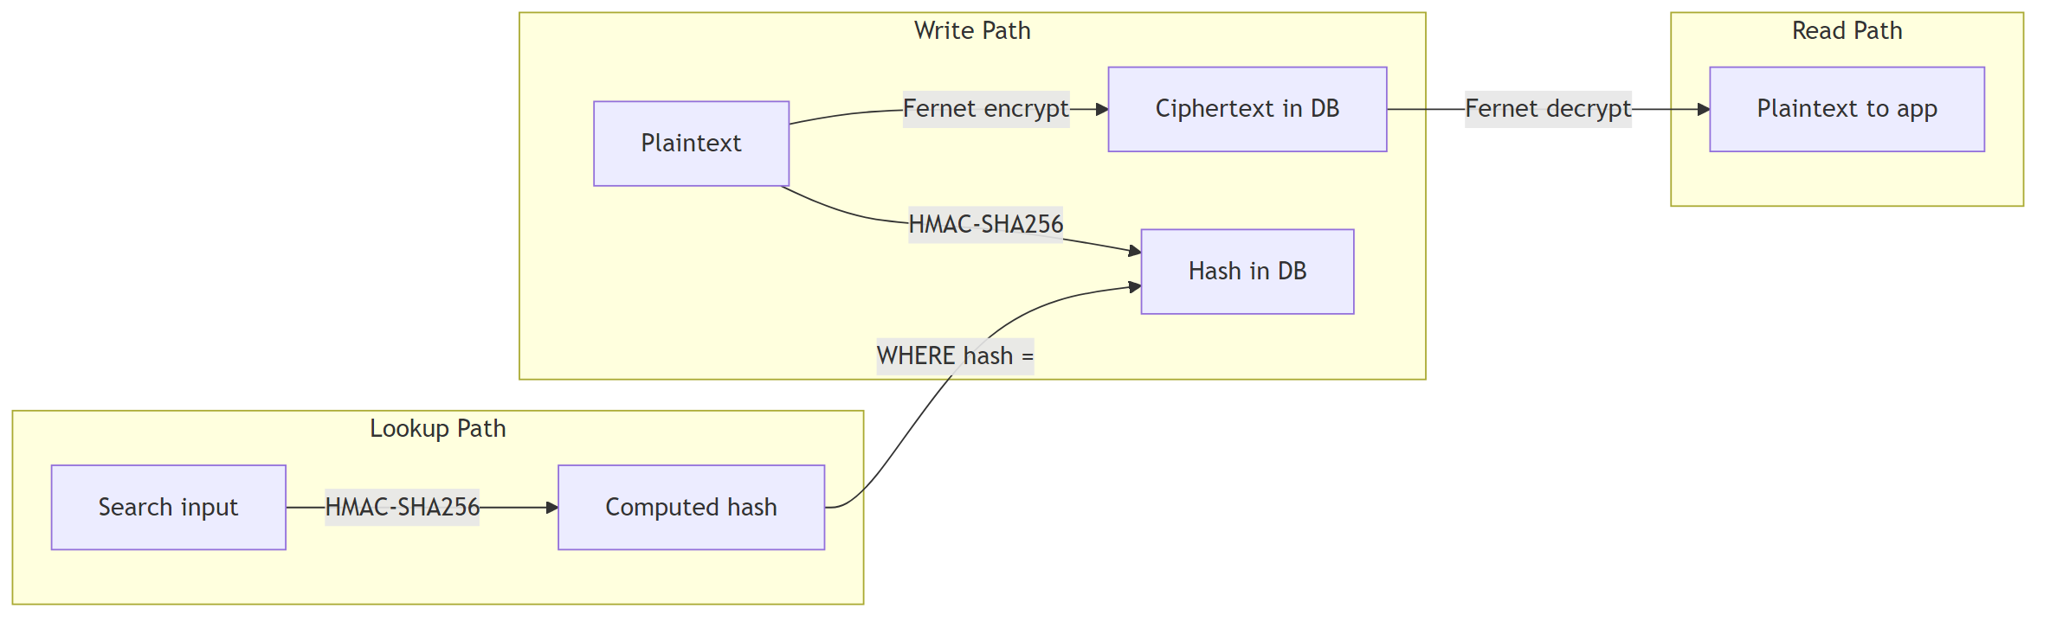
The Fernet key (FIELD_ENCRYPTION_KEY) is validated at startup. The decrypt_field function falls back to returning the raw value if decryption fails, enabling graceful handling of legacy plaintext rows during migration.

6.2 Authentication
TechTrek supports two authentication methods:
Password authentication uses bcrypt for hashing. Registration enforces strong password rules (minimum length, complexity). Login accepts username or email, performs an HMAC lookup to find the user, and verifies the password with bcrypt.checkpw(). On success, user_id is stored in the Starlette session cookie, which is signed with SECRET_KEY, scoped to SameSite=lax, and restricted to HTTPS in production.
Google OAuth uses Authlib to register a Google OAuth client when GOOGLE_CLIENT_ID and GOOGLE_CLIENT_SECRET are configured. The OAuth callback creates or links a user account.
Password reset uses itsdangerous.URLSafeTimedSerializer to generate time-limited tokens sent via email.
Speaker invites use random 64-character tokens with expiry timestamps. When a speaker accepts an invite link, their user account is linked to the speaker profile.

6.3 Authorisation Model
The application enforces four authorisation levels through FastAPI dependency functions.
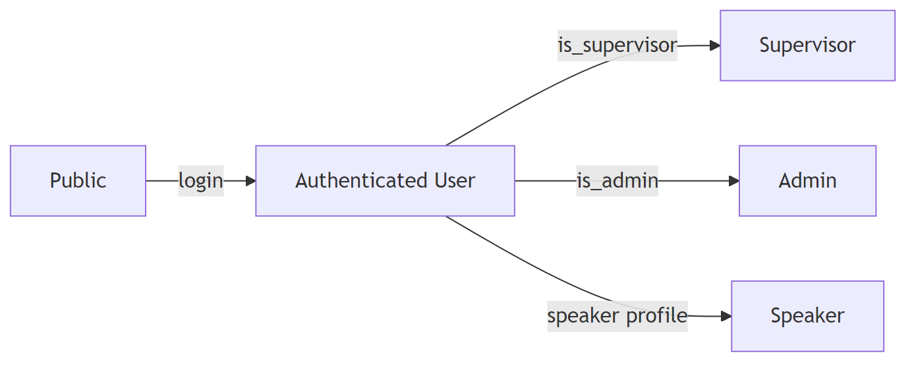
Level | Guard | Access
Public | None | Browse events, view tickets, newsletter
User | require_auth() | Book seats, manage bookings, feedback
Supervisor | is_supervisor check | College-scoped check-in
Admin | require_admin() | Full CRUD, user management, settings
Speaker | Speaker.user_id link | Edit own sessions, manage polls, profile
AuthRedirect is a custom exception that triggers a 303 redirect to /auth/login?next=<original_path>, preserving the intended destination through login and registration flows.

6.4 CSRF Protection
CSRF tokens are generated per session using secrets.token_hex(32) and stored in the session cookie. The csrf_protection router dependency enforces token verification on all unsafe HTTP methods (POST, PUT, PATCH, DELETE). JSON requests with Content-Type: application/json are exempt because they are protected by the SameSite=lax cookie policy combined with session authentication.

6.5 Security Headers
A custom SecurityHeadersMiddleware attaches defensive headers to every response:
Header | Value
X-Content-Type-Options | nosniff
X-Frame-Options | DENY
X-XSS-Protection | 1; mode=block
Referrer-Policy | strict-origin-when-cross-origin
Permissions-Policy | camera=(self), microphone=(), geolocation=()
Strict-Transport-Security | max-age=31536000; includeSubDomains (production only)
HSTS is only sent when debug is False to avoid interfering with HTTP development servers.

7 Backend Architecture

7.1 Entry Point
The application is created in app/main.py as a FastAPI instance named application (aliased as app for Uvicorn). Configuration proceeds in this order:
- SecurityHeadersMiddleware is added first so headers apply to all responses including errors.
- SessionMiddleware is configured with the SECRET_KEY, SameSite=lax, https_only in production, and a 24-hour max_age.
- Static files are mounted at /static from app/static/.
- All models are imported to register them with SQLAlchemy, then Base.metadata.create_all() bootstraps tables.
- Seven routers are included: auth, public, booking, admin, supervisor, speaker, webhook.
- Exception handlers are registered for AuthRedirect (303 redirect), 404 (custom template), and 500 (custom template).
- A lifespan context manager starts the feedback_task_loop() background task, which runs process_pending_feedback() every 15 minutes.
Additional root-level routes serve the service worker at /service-worker.js (with Service-Worker-Allowed: / header) and the offline fallback page at /offline.
API documentation (Swagger UI) is available at /api/docs only when debug=True.

7.2 Configuration
All settings are defined in app/config.py using pydantic_settings.BaseSettings with automatic .env file loading. A model_validator enforces that SECRET_KEY is at least 32 characters and FIELD_ENCRYPTION_KEY is a valid 44-character Fernet key.
Setting | Type | Default | Description
database_url | str | postgresql+psycopg2://... | Database connection string
secret_key | str | (required) | Session cookie signing key (min 32 chars)
debug | bool | True | Enables Swagger docs, disables HSTS
field_encryption_key | str | (required) | Fernet key for PII encryption
hold_timeout_minutes | int | 5 | Seat hold duration
priority_window_hours | int | 24 | Waitlist priority access window
razorpay_key_id | str | “” | Razorpay API key
razorpay_key_secret | str | “” | Razorpay API secret
admin_bootstrap_email | str | “” | Email that gets admin on registration
company_name | str | “TechTrek Pvt Ltd” | Invoice company name
company_address | str | “123 Tech Park, …” | Invoice company address
company_gstin | str | “29AABCT1234F1ZH” | GST identification number
company_pan | str | “AABCT1234F” | PAN number
company_email | str | “billing@techtrek.in” | Billing contact email
company_phone | str | “+91 80 1234 5678” | Billing contact phone
gst_rate | float | 18.0 | GST percentage for invoices
smtp_host | str | “” | SMTP server (empty = skip emails)
smtp_port | int | 587 | SMTP port
smtp_user | str | “” | SMTP username
smtp_password | str | “” | SMTP password
smtp_from_email | str | “noreply@techtrek.in” | Sender email
smtp_from_name | str | “TechTrek” | Sender display name
base_url | str | “https://192.168.10.82:8000” | Public URL for email links
google_client_id | str | “” | Google OAuth client ID
google_client_secret | str | “” | Google OAuth client secret
babel_default_locale | str | “en” | Default locale
babel_default_timezone | str | “Asia/Kolkata” | Default timezone

7.3 Dependencies
FastAPI dependency functions in app/dependencies.py provide shared functionality injected into route handlers:
Dependency | Purpose
get_db() | Yields a request-scoped SQLAlchemy session, closed after the request
get_current_user() | Reads user_id from the session cookie and returns the User or None
require_auth() | Same as above but raises AuthRedirect if not logged in
require_admin() | Requires login and is_admin=True
flash(request, message, category) | Stores a flash message in the session
get_flashes(request) | Pops and returns all pending flash messages
template_ctx(request, **kwargs) | Builds the standard Jinja2 context: user, flashes, CSRF token, speaker flag, pending feedback banners, published event count, Google SSO availability
The template_ctx function queries pending feedback stubs for the current user on every page load, enabling a banner that prompts users to complete feedback and download certificates.

7.4 Services Layer
Nine service modules encapsulate business logic:
Booking Service (app/services/booking.py) – Core booking operations:
Function | Purpose
get_seat_map(db, event_id, auditorium_id) | Returns seat availability. A seat is “taken” if it has a paid booking or an active hold.
hold_seats(db, user_id, event_id, seat_ids) | Cancels existing holds, creates new bookings with held_until set to now + 5 minutes. Uses IntegrityError handling for concurrency.
confirm_payment(db, user_id, event_id, ...) | Promotes holds to paid, generates ticket IDs and QR codes, assigns booking groups, applies coupons, creates invoice numbers, sends confirmation emails.
cancel_booking_user(db, booking_id, user_id) | Applies a fixed cancellation fee of 100, computes refund, initiates Razorpay refund, sends cancellation email.
cancel_group_bookings(db, group_id, user_id) | Cancels all bookings in a group with refund.
validate_coupon(db, code, event_id) | Validates coupon by code, event scope, date, and usage limits.
apply_coupon_to_price(total, coupon) | Applies percentage or fixed discount to total.
Razorpay Service (app/services/razorpay.py) – Payment gateway integration:
Function | Purpose
create_order(amount_paise, receipt) | Creates a Razorpay order with INR currency and auto-capture
verify_payment(order_id, payment_id, signature) | Verifies HMAC-SHA256 payment signature
verify_webhook_signature(body, signature, secret) | Verifies webhook request signature
process_refund(payment_id, amount_paise) | Issues a partial refund via Razorpay API
Email Service (app/services/email.py) – Transactional HTML emails via SMTP for signup confirmation, booking confirmation, cancellation, password reset, ticket sharing, certificate readiness, and newsletter delivery. If smtp_host is empty, emails are silently skipped.
Invoice Service (app/services/invoice.py) – Generates PDF invoices using ReportLab with company branding, GST calculations, booking details, and optional logo loaded from site settings.
Certificate Service (app/services/certificate.py) – Generates attendance certificate PDFs with event branding, attendee name, dates, and configurable styling from event certificate fields.
Feedback Service (app/services/feedback.py) – Background task loop (feedback_task_loop) that runs every 15 minutes. For events past their end date, it creates Feedback stub rows for checked-in attendees who have not yet been notified and emails them certificate download links.
Poll Events Service (app/services/poll_events.py) – In-memory pub/sub using asyncio.Queue. Provides subscribe/publish keyed by (session_id, event_id) for real-time poll result updates, and subscribe_user/publish_to_users for per-attendee poll notifications. Messages are JSON-serialised dicts. QueueFull is silently swallowed.
Activity Log Service (app/services/activity_log.py) – Persists ActivityLog rows recording admin actions with actor, action type, target entity, and details.
OAuth Service (app/services/oauth.py) – Registers a Google OAuth client via Authlib when credentials are configured.

7.5 Routers Overview
Router | Prefix | Guard | Responsibility
auth | /auth | Public | Login, register, OAuth, profile, password reset, speaker invite
public | (none) | Public + CSRF | Home, events, sessions, schedule, recordings, tickets, polls API, SSE streams, newsletter, feedback, image serving
booking | /booking | User + CSRF | Seat selection, hold, checkout, payment, confirmation, my bookings, cancellation, waitlist, certificates, invoices
admin | /admin | Admin + CSRF | Dashboard, cities/colleges/auditoriums/speakers CRUD, sessions, events, bookings, check-in, waitlist, users, schedule, settings, feedback, newsletters, event management hub
supervisor | /supervisor | Supervisor | College-scoped dashboard, bookings, schedule, check-in
speaker | /speaker | Speaker | Dashboard, sessions list, schedule calendar, session editing, polls, profile
webhook | (none) | Signature | Razorpay webhook handler

8 API Endpoints Reference
All endpoints return server-rendered HTML via Jinja2 templates unless noted as JSON or SSE. Form submissions use POST with 303 redirect. Auth levels: P = Public, U = User, S+ = Supervisor or Admin, A = Admin, Sp = Speaker.

8.1 Auth Router (/auth)
Method | Path | Auth | Description
GET/POST | /auth/login | P | Login form; authenticates by username or email; preserves ?next= redirect
GET/POST | /auth/register | P | Registration with strong password validation; preserves ?next=
POST | /auth/verify-password | U | JSON: re-verify password for sensitive operations
GET/POST | /auth/profile | U | View and update profile fields
GET | /auth/speaker-invite/{token} | P | Accept speaker invite; links user to speaker profile
GET | /auth/google | P | Initiate Google OAuth flow
GET | /auth/google/callback | P | Google OAuth callback; create or link account
GET/POST | /auth/forgot-password | P | Request password reset email
GET/POST | /auth/reset-password/{token} | P | Reset password with timed token
GET | /auth/logout | P | Clear session and redirect to home

8.2 Public Router (no prefix)
Method | Path | Auth | Description
GET | / | P | Home page with upcoming events and testimonials
POST | /newsletter | P | Subscribe email to newsletter
GET | /sessions | P | List sessions with search, sort, and filters
GET | /sessions/{id} | P | Session detail with speakers, agenda, pricing
GET | /events | P | List published events
GET | /events/{id} | P | Event detail page
GET | /recordings | U | Session recordings (gated to ticket holders)
GET | /schedule | P | Public schedule view
GET | /schedule/export-pdf | P | PDF export of schedule
GET | /ticket/{ticket_id} | P | View single ticket with QR code
GET | /tickets/group/{group_id} | P | View group ticket
POST | /ticket/{id}/share | U | Share ticket via email (JSON)
POST | /ticket/{id}/claim | U | Claim a shared ticket (JSON)
GET | /terms | P | Terms and conditions page
GET/POST | /feedback/{event_id} | U | Event feedback form
POST | /feedback/{event_id}/dismiss | U | Dismiss feedback prompt
GET | /polls/{poll_id}/display | P | Standalone poll presentation view
GET | /sessions/{id}/polls/active | U | Active poll data (JSON)
POST | /sessions/{id}/polls/{poll_id}/vote | U | Submit poll vote (JSON)
GET | /sessions/{id}/polls/stream | U | SSE stream for poll result updates
GET | /user/poll-notifications/stream | U | SSE stream for per-user poll notifications
GET | /api/schedule | P | Schedule data (JSON)
GET | /uploads/{image_id} | P | Serve uploaded image bytes from DB
GET | /newsletter/unsubscribe/{token} | P | Unsubscribe from newsletter

8.3 Booking Router (/booking)
Method | Path | Auth | Description
GET | /booking/event/{id}/select | U | Interactive seat selection page
POST | /booking/event/{id}/hold | U | Hold selected seats for 5 minutes
GET | /booking/event/{id}/checkout | U | Checkout page with pricing breakdown
POST | /booking/event/{id}/apply-coupon | U | Apply coupon code (JSON)
POST | /booking/event/{id}/toggle-addon | U | Toggle add-on selection (JSON)
POST | /booking/event/{id}/create-order | U | Create Razorpay order (JSON)
POST | /booking/event/{id}/verify-payment | U | Verify Razorpay payment (JSON)
POST | /booking/event/{id}/pay | U | Free event checkout
GET | /booking/event/{id}/confirmation | U | Booking confirmation with QR codes
GET | /booking/my | U | My Bookings dashboard
GET | /booking/detail/group/{group_id} | U | Group booking detail
GET | /booking/detail/{booking_id} | U | Single booking detail
POST | /booking/cancel/{booking_id} | U | Cancel with refund
POST | /booking/cancel-group/{group_id} | U | Cancel group with refund
POST | /booking/waitlist/{event_id} | U | Join event waitlist
GET/POST | /booking/certificate/{booking_id} | U | Certificate with feedback gate
GET | /booking/certificate/{booking_id}/download | U | Download certificate PDF
GET | /booking/invoice/group/{group_id} | U | Download group invoice PDF
GET | /booking/invoice/booking/{booking_id} | U | Download single invoice PDF
GET | /booking/invoice/{event_id} | U | Download event invoice PDF

8.4 Admin Router (/admin)
The admin router provides comprehensive management. Key endpoint groups:
Group | Endpoints | Description
Dashboard | GET /admin/ | Stats: users, bookings, revenue, check-ins
Cities | CRUD + toggle + delete | Geographic cities management
Colleges | CRUD + delete | Educational institutions
Auditoriums | CRUD + GET/POST .../layout | Venues with visual seat designer
Seat Types | CRUD | Custom seat categories with icons and pricing
Speakers | CRUD + delete-check + invite | Speaker profile management
Sessions | List, new, edit, delete | Sessions with recordings and poll management
Events | List, new, edit, delete, coupons | Events with certificate preview
Bookings | List, CSV export, cancel, invoice, refund | Booking management with Razorpay refunds
Check-in | GET/POST /admin/checkin | QR scan and manual ticket verification
Waitlist | List + delete | Waitlist management
Users | List, CSV export, toggle admin/supervisor | User role management
Schedule | Calendar view | All events schedule
Activity Log | List | Admin action audit trail
Settings | GET/POST | Platform branding (logo, company details)
Feedback | List + toggle featured | Feedback moderation
Feedback Templates | CRUD | Structured feedback question templates
Newsletters | CRUD + send + preview + upload | Email newsletter campaigns
Image Upload | POST | Upload images for content
Event Management Hub | /admin/event-management/{id}/... | Per-event: bookings, check-in, waitlist, polls, feedback, alerts

8.5 Supervisor Router (/supervisor)
Method | Path | Auth | Description
GET | /supervisor/ | S+ | College-scoped dashboard with stats
GET | /supervisor/bookings | S+ | Search and filter bookings
GET | /supervisor/schedule | S+ | Schedule for college events
GET/POST | /supervisor/checkin | S+ | QR scan and manual check-in (scoped to college)

8.6 Speaker Router (/speaker)
Method | Path | Auth | Description
GET | /speaker/ | Sp | Dashboard with stats and navigation
GET | /speaker/sessions | Sp | List sessions with booking counts
GET | /speaker/schedule | Sp | Month/week calendar with event detail popovers
GET/POST | /speaker/sessions/{id}/edit | Sp | Edit session content and agenda
GET | /speaker/sessions/{id}/polls | Sp | Manage polls for a session
POST | /speaker/sessions/{id}/polls | Sp | Create a new poll
POST | /speaker/polls/{id}/toggle | Sp | Toggle poll active/inactive
POST | /speaker/polls/{id}/close | Sp | Close a poll
POST | /speaker/polls/{id}/delete | Sp | Delete a poll
GET/POST | /speaker/profile | Sp | Edit speaker profile
POST | /speaker/upload-image | Sp | Upload profile or content image

8.7 Webhook Router
Method | Path | Auth | Description
POST | /webhooks/razorpay | Signature | Verifies Razorpay webhook signature; logs payload; processes refund status updates

9 Key Business Flows

9.1 Paid Booking Flow
The complete payment flow involves seat selection, temporary holds, Razorpay order creation, client-side payment, server-side verification, and confirmation with ticket and invoice generation.
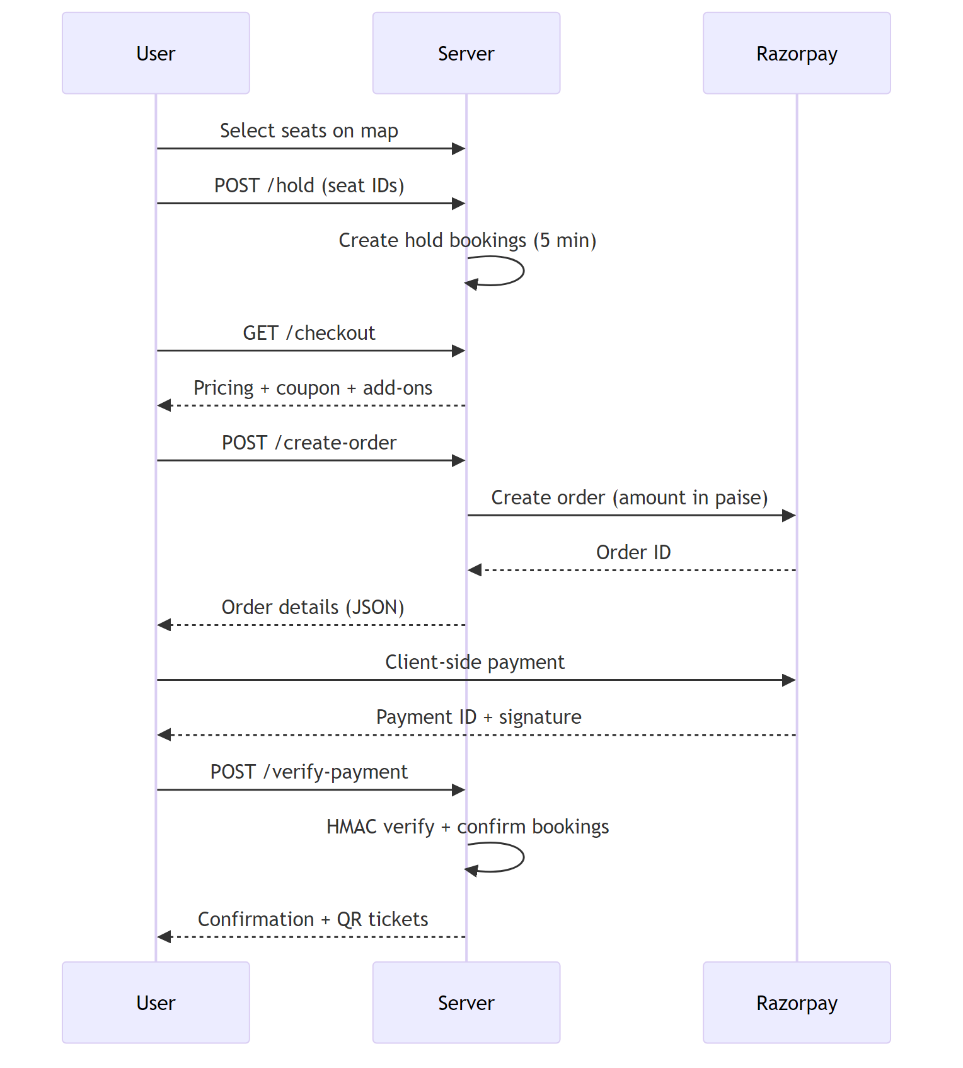

9.2 Free Booking Flow
For free events (price = 0), the user skips Razorpay. After holding seats, POST /pay directly confirms the bookings, generates ticket IDs and QR codes, and redirects to the confirmation page.

9.3 Cancellation and Refund Flow
Users or admins can cancel paid bookings. A fixed cancellation fee of 100 is deducted. If a Razorpay payment was made, a partial refund is issued. The Razorpay webhook reconciles the refund status asynchronously.

9.4 Pricing Resolution
When calculating the price for a seat, the system resolves the price based on seat type:
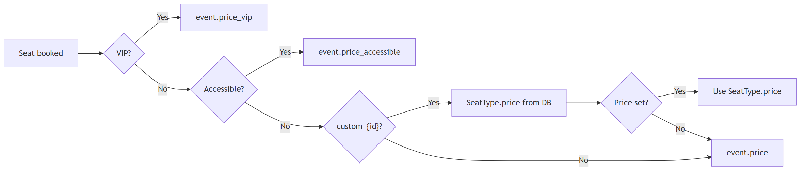
A processing fee percentage (set per event) is applied at checkout as a separate line item and included in the Razorpay order total.

9.5 Feedback and Certificate Flow
After an event ends, a background task loop creates feedback stubs for checked-in attendees and emails certificate download links. Users must complete feedback before downloading their certificate PDF.

9.6 Live Polls Flow
Speakers or admins create polls within sessions. When a poll is activated, attendees receive real-time notifications via Server-Sent Events and can vote. Results update live for all connected viewers.
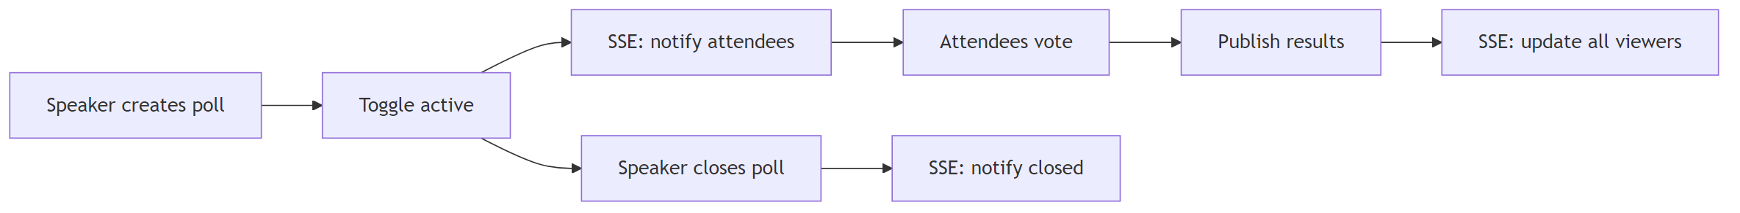
The pub/sub system uses in-memory asyncio.Queue instances keyed by (session_id, event_id) for poll results and by user_id for attendee notifications. Two SSE endpoints serve these streams: /sessions/{id}/polls/stream and /user/poll-notifications/stream.

9.7 Ticket Sharing Flow
A user can share a ticket by entering the recipient’s email. The system generates a TicketShare row with a unique token and sends an email with a claim link. The recipient logs in and claims the ticket, which transfers the booking’s user_id.

10 Frontend Architecture

10.1 Templating System
TechTrek uses 82 Jinja2 templates organised in an inheritance hierarchy across 8 directories. The root base.html provides the shared shell: navbar with mobile drawer, flash message area, main content block, footer, modal containers (feedback, QR zoom, confirmation, live poll popup), and extensive inline JavaScript for global functionality.
Directory | Templates | Purpose
templates/ | 2 | base.html (root layout), offline.html (PWA fallback)
public/ | 13 | Home, events, sessions, schedule, recordings, tickets, polls, feedback, terms, newsletter
auth/ | 5 | Login, register, forgot/reset password, profile
booking/ | 6 | Seat selection, checkout, confirmation, my bookings, detail, certificate
admin/ | 20 | Dashboard, CRUD forms, settings, bookings, users, check-in, newsletters
admin/event_management/ | 8 | Per-event hub: overview, bookings, check-in, waitlist, polls, feedback, alerts
speaker/ | 5 | Dashboard, sessions, schedule, session editor, profile, polls
supervisor/ | 4 | Base, dashboard, bookings, schedule, check-in
errors/ | 2 | 404 and 500 pages
Template blocks available for child templates: title, head_extra, content, scripts, and admin_content (for admin pages).

10.2 Design System
The visual design uses three CSS files totalling approximately 10,000 lines, built entirely with CSS custom properties for theming.
Typography uses three font families from Google Fonts:
Variable | Font | Usage
--font-display | Orbitron | Headings, hero text, brand name
--font-body | Exo 2 (dark) / DM Sans (light) | Body text, form labels
--font-mono | JetBrains Mono | Code, ticket IDs, booking refs
Dark theme (default) follows a cyberpunk aesthetic:
Token | Value | Usage
--bg-void | #010409 | Page background
--bg-primary | #0d1117 | Primary surfaces
--bg-surface | #161b22 | Cards, panels
--cyan | #00d4ff | Primary accent, links
--amber | #f59e0b | Prices, VIP elements
--violet | #8b5cf6 | User bookings
--green | #10b981 | Success states
--red | #f43f5e | Errors, sold-out
Light theme is activated via data-theme="light" on <html> and applies a newspaper/editorial aesthetic with Playfair Display and Libre Baskerville fonts, translucent white surfaces, and adjusted accents.
Layout uses a fixed 64px navbar, 1200px max-width container, and border-radius values from 4px to 20px. Responsive breakpoints at 480px, 600px, 768px, and 1024px.
Seat colours use dedicated variables: --seat-available (green), --seat-taken (grey), --seat-selected (cyan), --seat-vip (amber), --seat-accessible (purple), --seat-yours (violet).

10.3 Component Library
All components are pure CSS without a JavaScript framework:
Component | Description
Buttons | Primary, outline, amber, danger variants in small/standard/large sizes with loading state
Cards | Hover effects, image headers, status badges (available, filling up, sold out, priority only)
Forms | Styled inputs, selects, textareas, groups, rows, and action bars
Modals | Focus-trapping confirmation dialogs with keyboard dismissal
Flash Messages | Auto-dismissing notification bars (5-second timeout, fade-out)
Tables | Striped rows with action cells for admin views
Badges | Status indicators on event cards
Toasts | Programmatic notifications via window.TechTrek.showToast()

10.4 Interactive JavaScript

10.4.1 Base Template Scripts
The base.html template includes inline JavaScript providing global functionality:
- Starfield canvas – animated particle background on dark theme
- Navbar scroll – adds .scrolled class after 20px for a compact header
- Mobile navigation – hamburger menu with slide-out drawer and overlay
- Theme toggle – persists to localStorage; swaps data-theme attribute
- Flash auto-dismiss – 5-second timeout with fade-out animation
- Scroll reveal – IntersectionObserver triggers entrance animations on .reveal elements
- Form loading – submit buttons get .btn-loading with spinner to prevent double-submission
- Confirm modal – data-confirm attribute triggers a dialog with focus trap; exposed as window.TechTrek.confirmAction()
- Toast API – window.TechTrek.showToast(message, type) for programmatic notifications
- QR zoom – click ticket QR images to enlarge in a modal
- Admin sidebar – mobile toggle for the admin sidebar with overlay
- Tom Select – CDN-loaded searchable <select> enhancement applied globally unless data-no-tomselect
- Service worker – registration and PWA install prompt handling
- Live poll popup – SSE listener for /user/poll-notifications/stream that shows poll popups and event alerts

10.4.2 Standalone Modules
seat-picker.js powers interactive seat selection on the booking page. Initialised with seat data, pricing tiers, and layout config from the server, it renders a grid with row labels (A-Z), column numbers, and visual gaps. Users click seats to toggle selection with live price summaries. Includes ARIA accessibility and responsive viewport scaling.
seat-designer.js is the admin auditorium layout editor. Provides paint tools for seat types (standard, VIP, accessible, aisle, eraser) with click-and-drag interaction, row/column fill, center aisle creation, stage width adjustment, and gap toggling. Exports layout as JSON via hidden form fields.
image-upload.js handles file selection, multipart POST to upload endpoints, and URL/preview population.
gallery-upload.js extends image upload with multi-image support, drag-and-drop reordering, and hidden comma-separated ID synchronisation.

10.5 PWA Elements
- manifest.json defines the app name, theme colour, display mode, and icon paths
- service-worker.js caches listed static assets and provides an offline fallback for HTML navigations
- Install prompt handling in base.html with a deferred beforeinstallprompt event

10.6 Client-Server Communication
Mechanism | Used For
Full-page GET | Most screens; HTML rendered with Jinja2 context
HTML form POST | Login, registration, feedback, booking hold, check-in, admin CRUD
fetch + JSON | Coupons, add-ons, Razorpay order/verify, poll CRUD/vote, ticket share/claim, newsletter preview
EventSource (SSE) | Live poll results and attendee poll/alert notifications
Razorpay Checkout | Client-side payment modal loaded from Razorpay CDN
Multipart upload | Image and gallery uploads via FormData POST
Session cookie | Authenticates all requests (same-origin, auto-sent)

11 Database Migrations

11.1 Alembic Setup
The project uses Alembic for schema versioning. The configuration lives in alembic.ini and alembic/env.py, which imports settings.database_url from app/config and Base.metadata from app/database as the target metadata.
The alembic/versions/ directory contains 24 migration revision files, numbered from 0001 through the most recent additions. These migrations track the full evolution of the schema from the initial tables through major structural changes.

11.2 Migration Highlights
PII encryption migration (0004_encrypt_pii_fields.py) is a substantial data migration that widens User columns to Text (for ciphertext), drops old unique constraints on plaintext columns, adds email_hash and username_hash columns, and re-encrypts existing rows using app.crypto.
Other significant migrations add events tables, polls, feedback templates, ticket sharing, event add-ons, event breaks, session speakers, gallery images, and event alerts.

11.3 Startup Fallback
On every application startup, app/main.py runs Base.metadata.create_all(bind=engine) after importing all models. This ensures tables exist even if Alembic has not been run, which is useful for fresh development environments. The seed.py script similarly tries alembic upgrade head first and falls back to create_all on failure.
For production deployments, both deploy.py and deploy.sh run alembic upgrade head as part of the deployment pipeline to apply pending migrations.

12 Testing

12.1 Test Infrastructure
Tests live in the tests/ directory and use pytest with Starlette’s TestClient. The test database is a SQLite file (test_techtrek.db) with foreign keys enabled via a connection listener.
Environment variables (DATABASE_URL, SECRET_KEY, FIELD_ENCRYPTION_KEY) are set before any application module is imported so that Settings validation passes. A session-scoped fixture creates all tables at the start of the test suite and drops them afterward.
The client fixture overrides get_db to inject the test session, ensuring database operations share the same transaction as test assertions.

12.2 Session Cookie Forging
The admin_session helper forges a valid Starlette session cookie by base64-encoding a JSON payload containing user_id and csrf_token, then signing it with itsdangerous.TimestampSigner using the test SECRET_KEY. This allows tests to simulate authenticated requests without going through the login flow.

12.3 Data Factories
The conftest.py module provides factory functions for creating test data:
Factory | Creates
make_user(db, ...) | User with encrypted fields and HMAC hashes
make_college(db, ...) | College with auto-created City
make_auditorium(db, ...) | Auditorium with auto-created College
make_event(db, ...) | Event with configurable pricing and status
make_session(db, ...) | Session linked to event
make_testimonial(db, ...) | Active testimonial
make_feedback(db, ...) | Feedback with auto-created user and event
make_speaker(db, ...) | Speaker with optional user link
make_recording(db, ...) | Session recording

12.4 Test Coverage
File | Coverage Area
test_public_pages.py | Home page, events list, session detail, schedule, recordings
test_admin_pages.py | Admin dashboard, bookings, sessions, speakers, recordings, check-in
test_feedback.py | Feedback form rendering, submission, and dismissal
Tests cover both authenticated and unauthenticated scenarios, admin and non-admin access, and edge cases such as missing data.

13 Deployment

13.1 Production Deployment (Python)
deploy.py is a single-file deployment runner that:
- Checks Python version (3.11+ required)
- Installs dependencies from requirements.txt
- Validates .env configuration (SECRET_KEY, DATABASE_URL, FIELD_ENCRYPTION_KEY)
- Runs alembic upgrade head to apply pending migrations
- Starts the production Uvicorn server (multi-worker)
The script handles Windows terminal encoding (UTF-8 reconfiguration for PowerShell compatibility).

13.2 Production Deployment (Bash)
deploy.sh provides a Linux-oriented alternative:
- Creates or activates a Python virtual environment (3.9+ minimum)
- Installs dependencies via pip
- Runs Alembic migrations
- Starts Uvicorn with optional --service flag for daemonisation

13.3 Development Server
run.py is a convenience launcher for local development:
- Sets default SECRET_KEY and DEBUG=True if not already set
- Detects certs/cert.pem and certs/key.pem for optional HTTPS
- Runs uvicorn.run("app.main:app", ...) on port 8000
- Falls back to HTTP if USE_HTTP=1 or certificates are not found
Self-signed TLS certificates can be generated with scripts/gen_cert.py using the cryptography library.

13.4 Environment Variables
All configuration is managed via a .env file in the project root. Required variables for production:
Variable | Required | Description
SECRET_KEY | Yes | Session signing key (minimum 32 characters)
FIELD_ENCRYPTION_KEY | Yes | Fernet key for PII encryption (44-char base64)
DATABASE_URL | Yes | PostgreSQL connection string
RAZORPAY_KEY_ID | For payments | Razorpay API key
RAZORPAY_KEY_SECRET | For payments | Razorpay API secret
SMTP_HOST | For emails | SMTP server hostname
SMTP_USER / SMTP_PASSWORD | For emails | SMTP credentials
GOOGLE_CLIENT_ID / GOOGLE_CLIENT_SECRET | For OAuth | Google OAuth credentials
ADMIN_BOOTSTRAP_EMAIL | Recommended | Email that gets admin on first registration
BASE_URL | Recommended | Public URL for email links and certificates

14 Appendix

14.1 Dependencies
The requirements.txt file lists 20 Python packages (unpinned):
Package | Role
fastapi | Web framework
uvicorn[standard] | ASGI server with libuv event loop
sqlalchemy | ORM and database toolkit
psycopg2-binary | PostgreSQL database driver
jinja2 | Template engine
python-multipart | Form and file upload parsing
bcrypt | Password hashing
itsdangerous | Signed tokens for password reset and invites
python-dotenv | .env file loading
pydantic-settings | Type-safe configuration with validation
qrcode[pil] | QR code image generation
razorpay | Razorpay payment gateway SDK
reportlab | PDF generation for invoices and certificates
babel | Internationalization extraction tooling
alembic | Database migration framework
cryptography | Fernet encryption and TLS certificate generation
authlib | OAuth 2.0 client (Google sign-in)
slowapi | Rate limiting (listed but not yet wired)
pytest | Test framework
httpx | HTTP client for tests and seed script

14.2 Seed Data
The seed.py script populates the database with demonstration data in four phases:
- Database setup – runs Alembic migrations or create_all
- Core data – creates cities, colleges, auditoriums with seat layouts, speakers, and admin/user accounts
- Events and sessions – creates multi-session events with agenda items, pricing, and published status
- Simulated bookings – uses an HTTP client to drive the booking flow, simulating real user interactions including seat selection, payment, and check-in
Default test accounts:
Username | Email | Password | Role
admin | admin@techtrek.dev | admin123 | Admin
alice | alice@example.com | user123 | User
bob | bob@example.com | user123 | User

