Name: Amal S. Thundiyil

UID: 2020400066

Batch: IT-D

Scilab No. : 5

Title: **Gauss Elimination Method**

**Program 1**: Write a scilab code to solve the following set of equations in terms of x, y, z by using gauss elimination method

x + y + z = 3, x + 2y + 3z = 0, x + 3y + 2z = 3

**Code:**

**clc;**

**clear all;**

**a = [1, 1, 1; 1, 2, 3; 1, 3, 2];**

**disp(a);**

**b = [3; 0; 3];**

**disp(b);**

**c = [a b];**

**disp(c);**

**n = 3;**

**for i = 1:n;**

**if c(i, i) == 0**

**c(i, :) = c(i, :);**

**else**

**c(i, :) = c(i, :) / c (i, i);**

**end**

**disp(c);**

**for j = 1:n-1**

**if i + j < n + 1**

**c(i + j, :) = c(i + j, :) - c(i + j, i) * c(i, :);**

**end**

**end**

**end**

**disp(c);**

**z = c(3,4);**

**y = c(2,4) - c(2,3) * z;**

**x = c(1,4) - c(1,3) * z - c(1,2) * y;**

**printf("x = ");**

**disp(x);**

**printf("y = ");**

**disp(y);**

**printf(" z = ");**

**disp(z);**

**Output:**

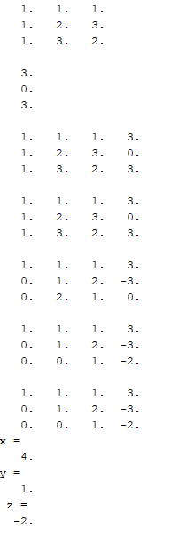

**Program 2**: Write a scilab code to solve the following set of equations in terms of x, y, z and w by using gauss elimination method

**Code:**

**clc;**

**clear all;**

**a = [2 1 0 1; 5 -4 1 0; 3 0 2 0; 1 1 -1 1];**

**disp(a);**

**b = [2; 1; -2; 1];**

**disp(b);**

**c = [a b];**

**disp(c);**

**n = 4;**

**for i = 1:n;**

**if c(i, i) == 0**

**c(i, :) = c(i, :);**

**else**

**c(i, :) = c(i, :) / c (i, i);**

**end**

**disp(c);**

**for j = 1:n-1**

**if i + j < n + 1**

**c(i + j, :) = c(i + j, :) - c(i + j, i) * c(i, :);**

**end**

**end**

**end**

**disp(c);**

**w = c(4, 5);**

**z = c(3, 5) - w * c(3, 4);**

**y = c(2, 5) - w * c(2, 4) - z * c(2, 3);**

**x = c(1, 5) - w * c(1, 4) - z * c(1, 3) - y * c(1, 2);**

**printf("x = ");**

**disp(x);**

**printf("y = ");**

**disp(y);**

**printf(" z = ");**

**disp(z);**

**printf("w = ");**

**disp(w);**

**Output:**

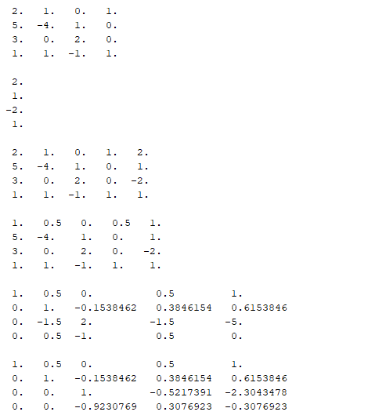

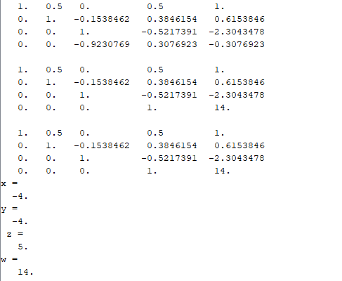

**Program 3**: Write a scilab code to solve the following set of equations in terms of x1, x2, x3, x4 by using gauss elimination method

**Code:**

**clc;**

**clear all;**

**a = [4 1 1 1; 1 5 2 1; 2 -3 3 2; 3 1 -1 5];**

**disp(a);**

**b = [2.4; 0.7; 3.5; 2.7];**

**disp(b);**

**c = [a b];**

**disp(c);**

**n = 4;**

**for i = 1:n;**

**if c(i, i) == 0**

**c(i, :) = c(i, :);**

**else**

**c(i, :) = c(i, :) / c (i, i);**

**end**

**disp(c);**

**for j = 1:n-1**

**if i + j < n + 1**

**c(i + j, :) = c(i + j, :) - c(i + j, i) * c(i, :);**

**end**

**end**

**end**

**disp(c);**

**x4 = c(4, 5);**

**x3 = c(3, 5) - x4 * c(3, 4);**

**x2 = c(2, 5) - x4 * c(2, 4) - x3 * c(2, 3);**

**x1 = c(1, 5) - x4 * c(1, 4) - x3 * c(1, 3) - x2 * c(1, 2);**

**printf("x1 = ");**

**disp(x1);**

**printf("x2 = ");**

**disp(x2);**

**printf("x3 = ");**

**disp(x3);**

**printf("x4 = ");**

**disp(x4);**

**Output:**

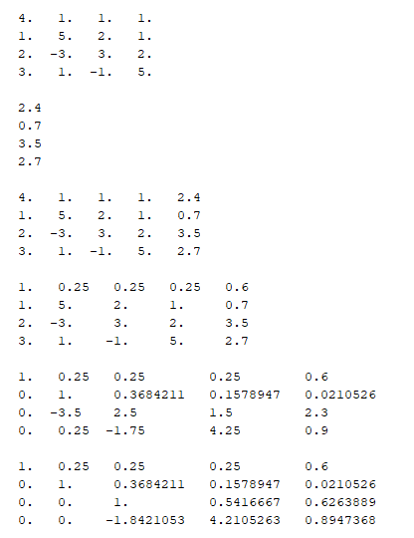

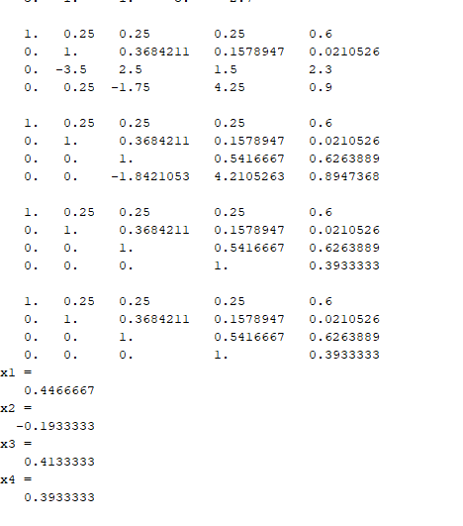

**Program 4**: Write a scilab code to solve the following set of equations in terms of x, y, z by using gauss elimination method

**Code:**

**clc;**

**clear all;**

**a = [2 1 -1; -3 -1 2; -2 1 2];**

**disp(a);**

**b = [8; -11; -3];**

**disp(b);**

**c = [a b];**

**disp(c);**

**n = 3;**

**for i = 1:n;**

**if c(i, i) == 0**

**c(i, :) = c(i, :);**

**else**

**c(i, :) = c(i, :) / c (i, i);**

**end**

**disp(c);**

**for j = 1:n-1**

**if i + j < n + 1**

**c(i + j, :) = c(i + j, :) - c(i + j, i) * c(i, :);**

**end**

**end**

**end**

**disp(c);**

**z = c(3,4);**

**y = c(2,4) - c(2,3) * z;**

**x = c(1,4) - c(1,3) * z - c(1,2) * y;**

**printf("x = ");**

**disp(x);**

**printf("y = ");**

**disp(y);**

**printf(" z = ");**

**disp(z);**

Output:

