**____________________________________________________**

**CONTENTS**

**____________________________________________________**

**____________________________________________________**

**WHO WE ARE**

**____________________________________________________**

***Open the file*** *who_we_are.html* ***to edit the page.***

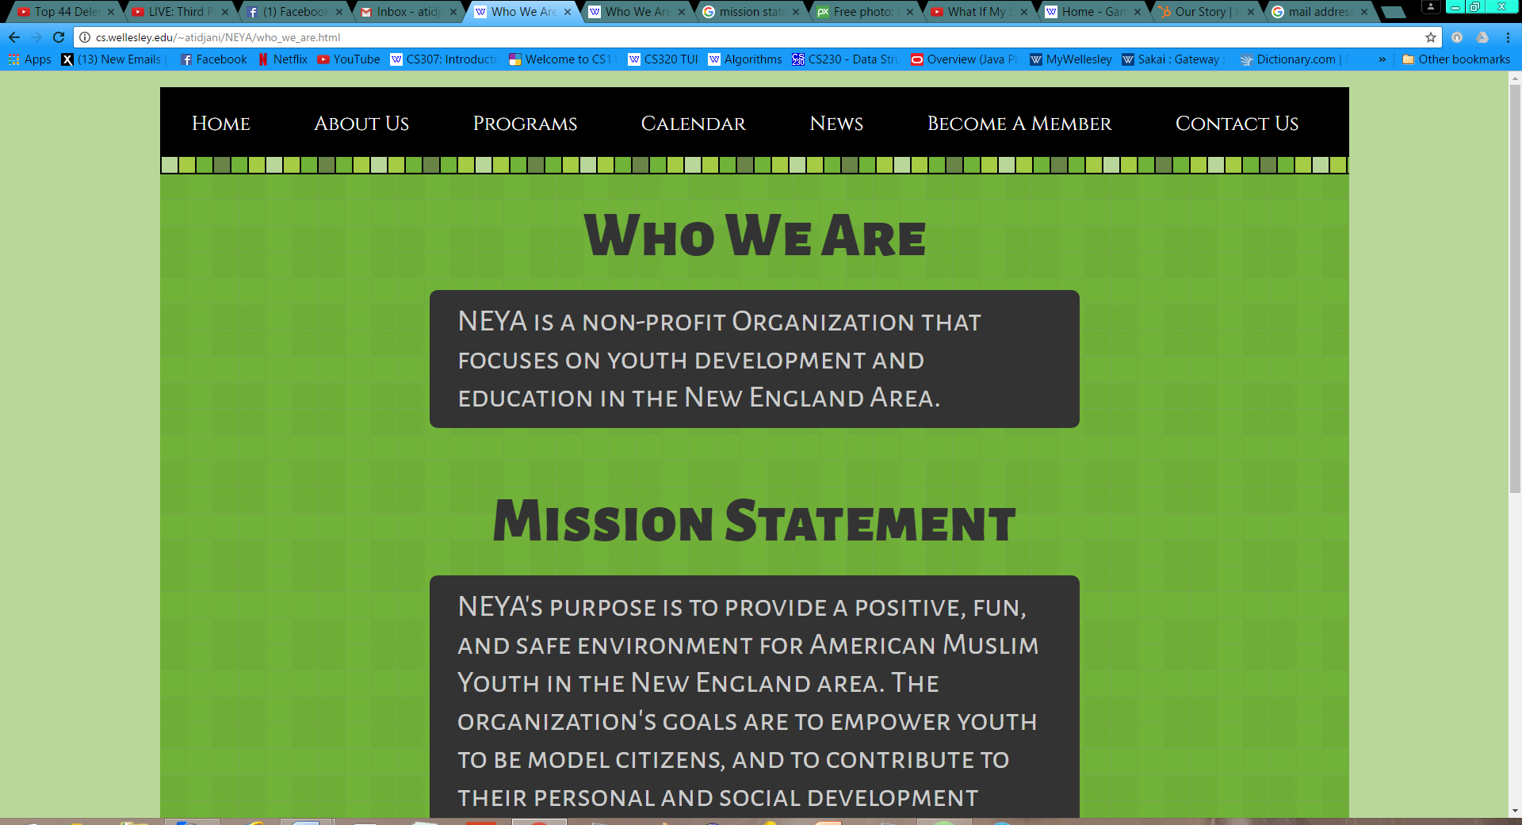

* **UPDATE TITLE 1:**

1. Open the file *who_we_are.html*
2. Go to *line 46*, which should look something like this:

<h1> Who We Are </h1>

1. Change the highlighted region to the new title. Do NOT delete the

> and < surrounding the title!

* **UPDATE “WHO WE ARE” TEXT:**

1. Go to *line 48*. You’ll notice a paragraph element spanning

*lines 48-51:*

<p class = "text">

NEYA is a non-profit...

the New England Area.

</p>

1. Modify or completely replace the text in the highlighted region

(*lines 49-50*). There is no cap on word count; your text can span multiple lines.

* **UPDATE TITLE 2:**

1. Go to *line 53*, which should look something like this:

<h1> Mission Statement </h1>

1. Change the highlighted region to the new title. Do NOT delete the

> and < surrounding the title!

* **UPDATE “MISSION STATEMENT” TEXT:**

1. Go to *line 55*. You’ll notice a paragraph element spanning

*lines 55-61:*

<p class = "text">

NEYA’s purpose is to provide...

Youth in the New...

...

...

...

</p>

1. Modify or completely replace the text in the highlighted region

(*lines 56-60*). There is no cap on word count; your text can span multiple lines.

**____________________________________________________**

**OUR STORY**

**____________________________________________________**

***Open the file*** *our_story.html* ***to edit the page.***

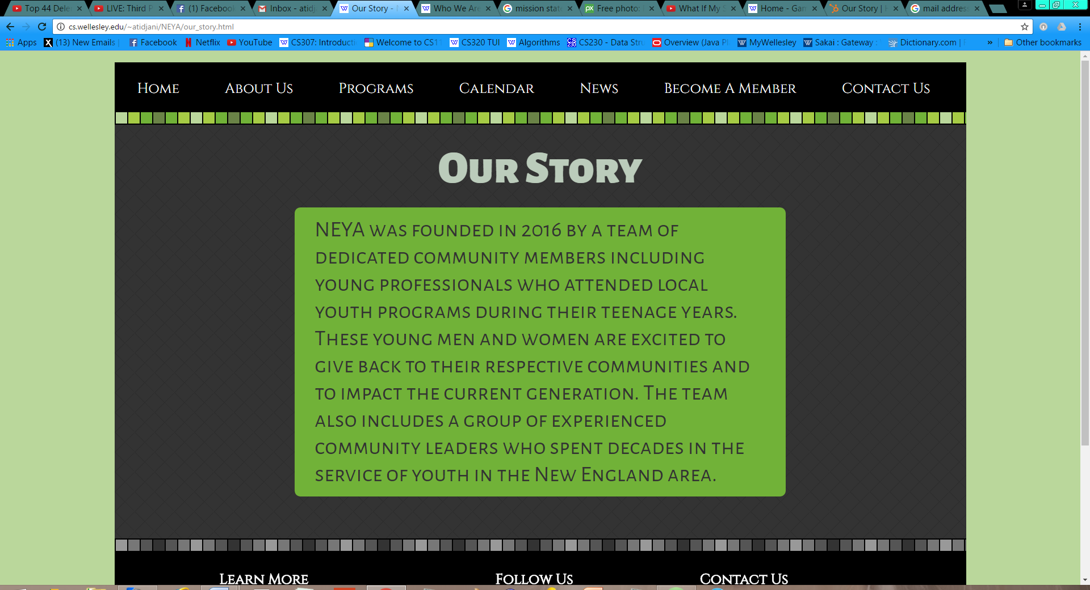

* **CHANGE “OUR STORY” TITLE:**

1. Open the file *who_we_are.html*
2. Go to *line 46*, which should look something like this:

<h1> Our Story </h1>

1. Change the highlighted region to the new title. Do NOT delete the

> and < surrounding the title!

* **UPDATE “OUR STORY” TEXT:**

1. Go to *line 48*. You’ll notice a paragraph element spanning

*lines 48-54:*

<p>

NEYA was founded...

who attended local...

...

...

</p>

1. Modify or completely replace the text in the highlighted region

(*lines 49-53*). There is no cap on word count; your text can span multiple lines.

**____________________________________________________**

**PROGRAMS**

**____________________________________________________**

***Open the file*** *programs.html* ***to edit the page.***

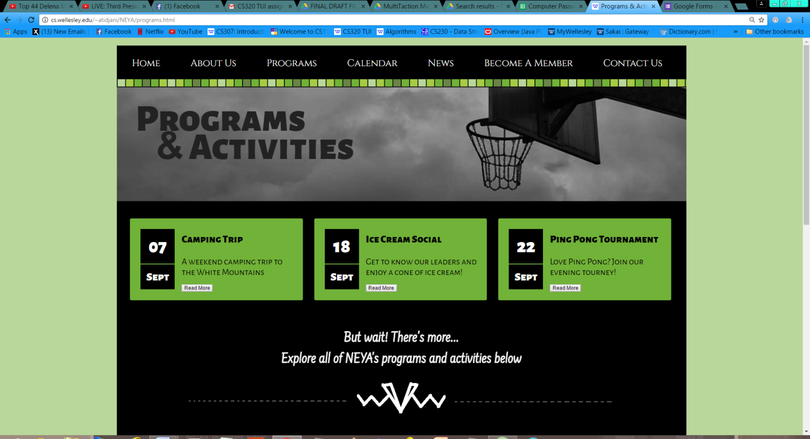

**UPDATE EVENT 1:**

* **CHANGING DATE:**

1. Open the file *programs.html*
2. To change the day number, scroll to *line 55,* which should read something similar to the following:

<p class = "day date">07</p>

1. Change the numbers in the highlighted region to reflect the new day number. Do NOT delete the > and < surrounding the number!
2. To change the month, go to *line 56,* which should read something similar to the following:

<p class = "month date">Sept</p>

1. Change the highlighted region to reflect the new month. Do NOT delete the > and < surrounding the month!

* **CHANGING EVENT NAME / DESCRIPTION:**

1. To change the event name, scroll to *line 61* which should read something similar to the following

<h3>Camping Trip</h3>

1. Change the highlighted region to reflect the new event name. Do NOT delete the > and < surrounding the name!
2. To change the event description, go to *line 62,* which should something similar to the following:

<p> A weekend camping trip to the.... </p>

1. Change the highlighted region to reflect the new event description. Keep the description as concise as possible to avoid formatting issues!

* **ADDING GOOGLE FORM LINK:**

1. Go to *line 63,* which should look something like this:

<a class = "event_btn" href =

“https://www.google.com/forms/about/">SIGN UP!</a>

1. Change the highlighted region to include the new Google form link. Make sure the new URL is between the quotation marks!

**UPDATE EVENT 2:**

* **CHANGING DATE:**

1. Open the file *programs.html*
2. To change the day number, scroll to *line 71,* which should read something similar to the following:

<p class = "day date">18</p>

1. Change the numbers in the highlighted region to reflect the new day number. Do NOT delete the > and < surrounding the number!
2. To change the month, go to *line 72* which should read as follows:

<p class = "month date">Sept</p>

1. Change the highlighted region to reflect the new month. Do NOT delete the > and < surrounding the month!

* **CHANGING EVENT NAME / DESCRIPTION:**

1. To change the event name, scroll to *line 77* which should read something similar to the following:

<h3>Ice Cream Social</h3>

1. Change the highlighted region to reflect the new event name. Do NOT delete the > and < surrounding the name!
2. To change the event description, go to *line 78* which should read something similar to the following:

<p> Get to know our leaders... </p>

1. Change the highlighted region to reflect the new event description. Keep the description as concise as possible to avoid formatting issues!

* **ADDING GOOGLE FORM LINK:**

1. Go to *line 79,* which should look something like this:

<a class = "event_btn" href =

“https://www.google.com/forms/about/">SIGN UP!</a>

1. Change the highlighted region to include the new Google form link. Make sure the new URL is between the quotation marks!

**UPDATE EVENT 3:**

* **CHANGING DATE:**

1. Open the file *programs.html*
2. To change the day number, scroll to *line 87,* which should read something similar to the following:

<p class = "day date">22</p>

1. Change the numbers in the highlighted region to reflect the new day number. Do NOT delete the > and < surrounding the number!
2. To change the month, go to *line 88,* which should read as follows:

<p class = "month date">Sept</p>

1. Change the highlighted region to reflect the new month. Do NOT delete the > and < surrounding the month!

* **CHANGING EVENT NAME / DESCRIPTION:**

1. To change the event name, scroll to *line 93,* which should read something similar to the following:

<h3>Ping Pong Tournament</h3>

1. Change the highlighted region to reflect the new event name. Do NOT delete the > and < surrounding the name!
2. To change the event description, go to *line 78* which should read something similar to the following:

<p> Love Ping Pong? Join our evening... </p>

1. Change the highlighted region to reflect the new event description. Keep the description as concise as possible to avoid formatting issues!

* **ADDING GOOGLE FORM LINK:**

1. Go to *line 79,* which should look something like this:

<a class = "event_btn" href =

“https://www.google.com/forms/about/">SIGN UP!</a>

1. Change the highlighted region to include the new Google form link. Make sure the new URL is between the quotation marks!

**____________________________________________________**

**CALENDAR**

**____________________________________________________**

***This section discusses updating NEYA’s calendar. You do not need to open or edit any code files. All modifications will be done through Google Calendar.***