PYTHON PROGRAMMING - LAB EXERCISE 6
Laptop Specification Analysis Using Streamlit
Student Name: Amal Abraham | Registration No.: 2647207
2MCA-B | Python Programming (MCA411-2)

1. Domain and Dataset Description
This project develops an interactive dashboard for exploring laptop specifications. The selected dataset contains 1,303 laptop records and 10 columns: laptop ID, company, product, laptop type, screen size, screen resolution, CPU, RAM, memory and GPU. It includes 19 companies and 6 laptop categories. The selected CSV does not contain a price column; therefore, the application focuses on hardware specifications and does not perform price analysis.
Dataset quality check: 1,303 records, 10 original columns and 0 missing values in the supplied columns.

2. Application Features
- Sidebar filters: company, laptop type, RAM range and screen-size range.
- Dynamic KPIs: filtered laptop count, total RAM, average RAM and average screen size.
- Grouped summaries: laptop counts by company and by laptop type.
- Visualizations: company-wise bar chart, average RAM by screen-size line chart, and screen-size versus RAM scatter plot.
- Layout: four tabs (Dataset Overview, Data Analysis, Visualizations and Insights), columns, containers and expanders.
- The selected filters are applied to the KPIs, tables, charts and insights.

3. Application Screenshots
Replace each marked area with a screenshot captured from the running Streamlit application. Capture the full browser window where possible so the dashboard layout and sidebar are visible.
Figure 1. Dashboard and KPI overview
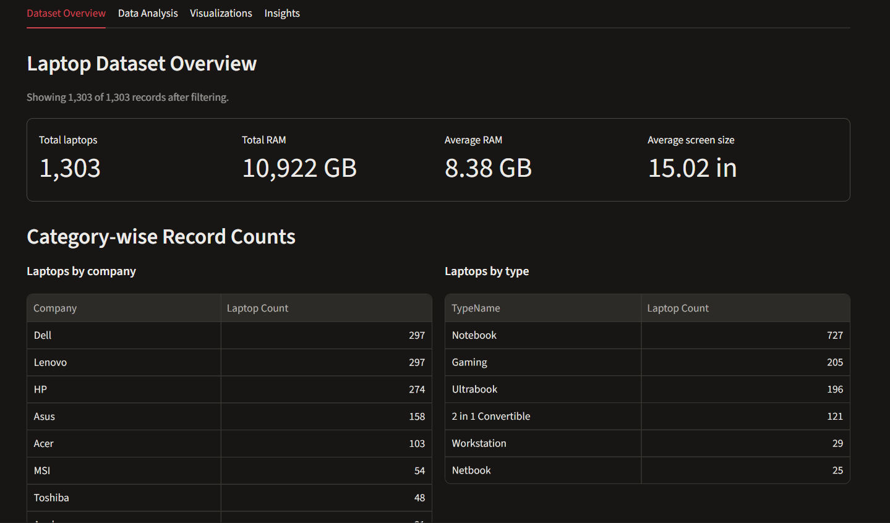

Figure 2. Sidebar filters
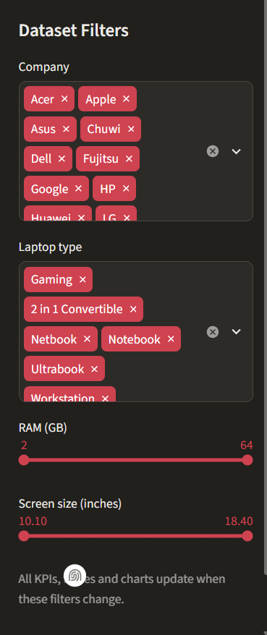

Figure 3. Visualizations
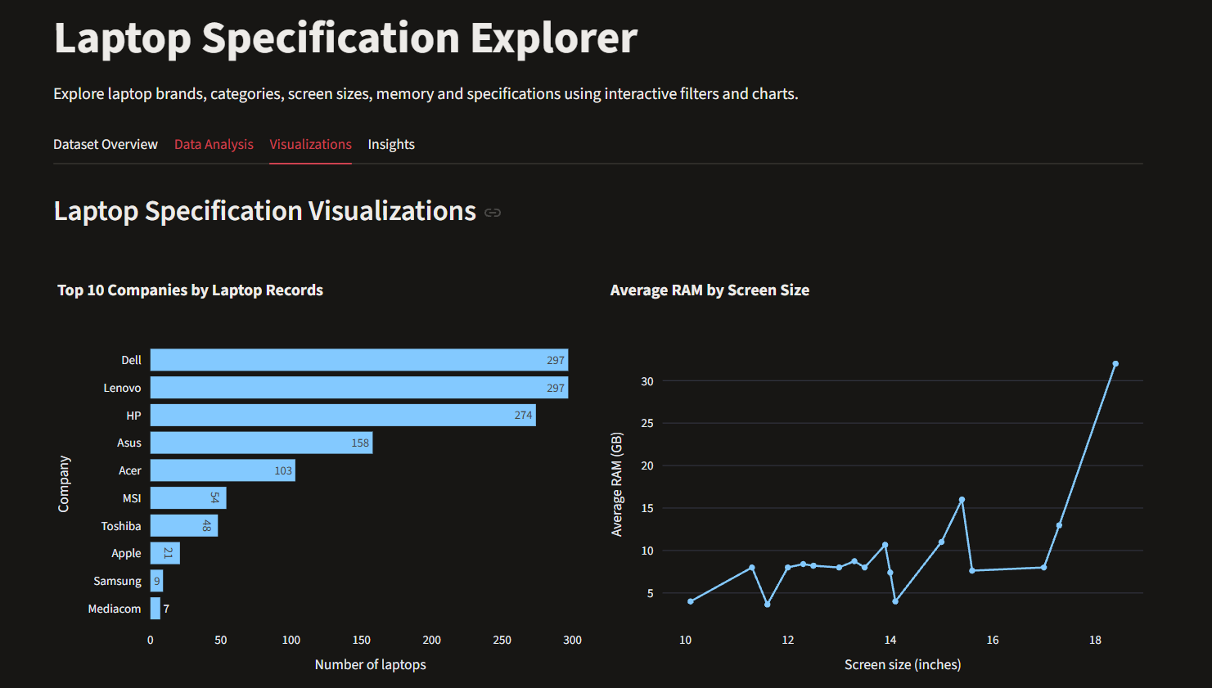
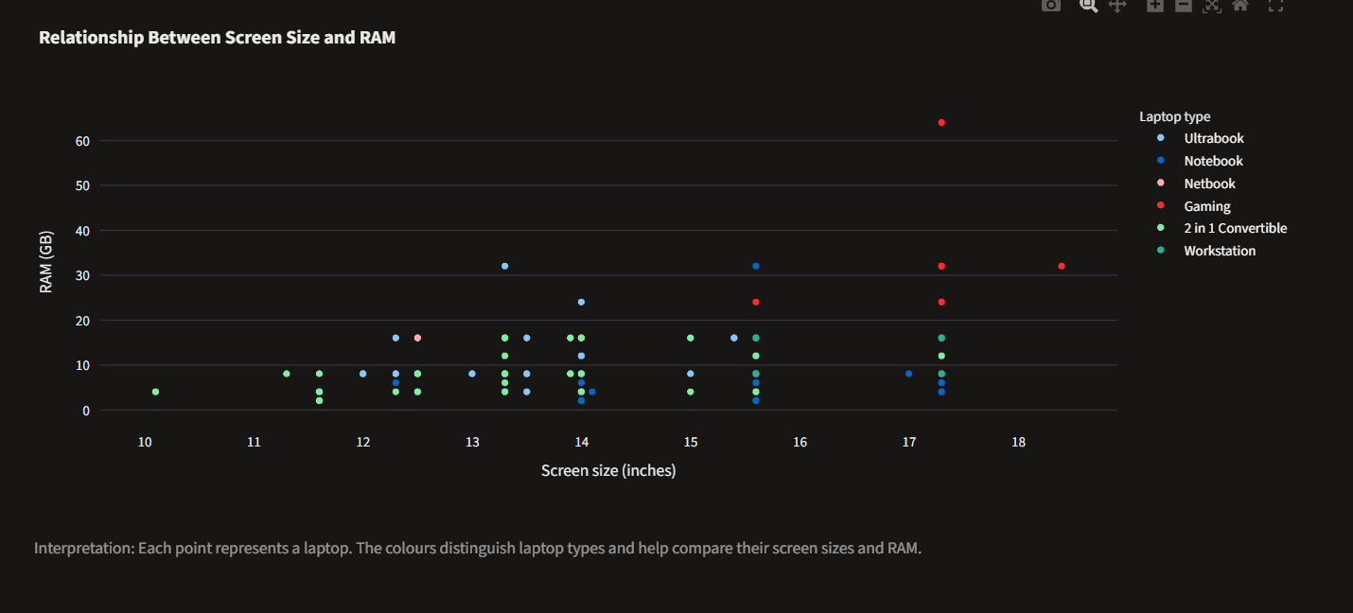
Figure 4. Analysis and insights sections
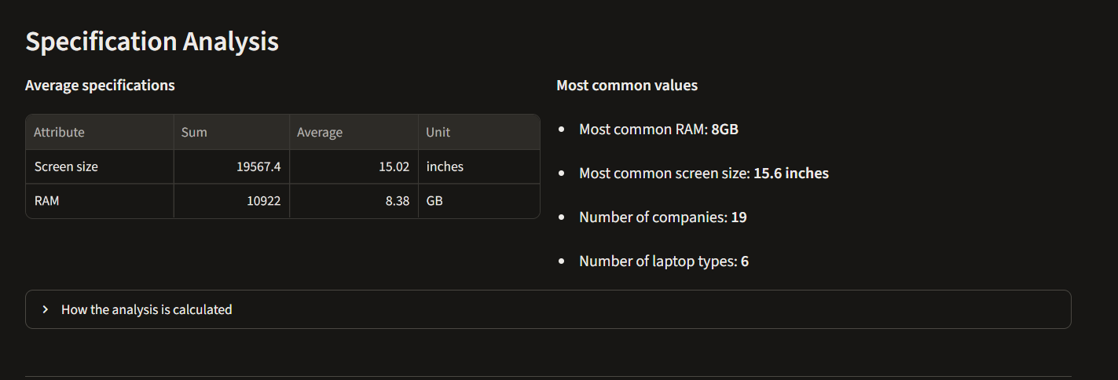
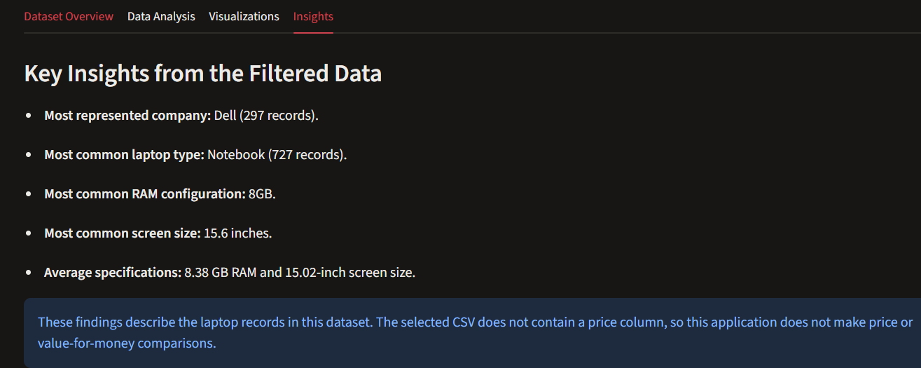

4. Key Observations and Analytical Results
- Dell and Lenovo are tied as the most represented companies, with 297 records each. HP follows with 274 records.
- Notebook is the largest laptop category, with 727 records out of 1,303.
- 15.6 inches is the most common screen size (665 records), and 8GB is the most common RAM configuration (619 records).
- The average screen size is 15.02 inches and the average RAM is 8.38 GB. Across the dataset, the sums are 19,567.4 inches and 10,922 GB RAM.
- The charts help compare brand representation and show how RAM varies across screen sizes. Screen-size groups have different record counts, so averages from small groups should be interpreted carefully. The scatter plot shows individual laptops by screen size and RAM, with colours identifying laptop types.

4.1 Chart Previews from the Dataset
The following figures are generated directly from the supplied CSV and match the chart topics used in the application.
Figure 5. Laptop records by company
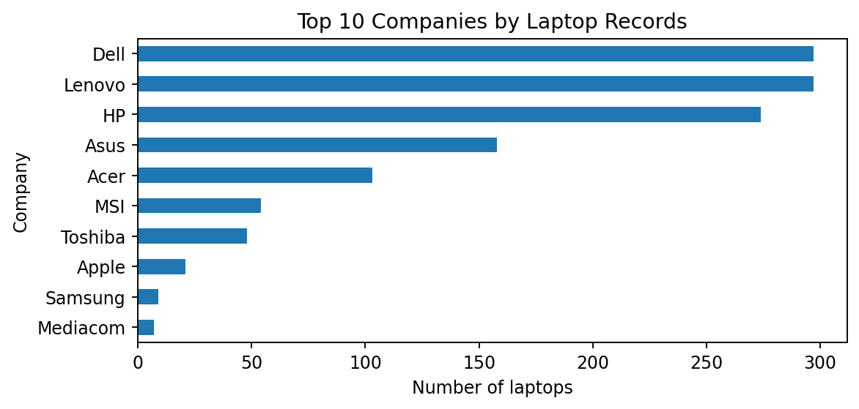
Figure 6. Average RAM by screen size
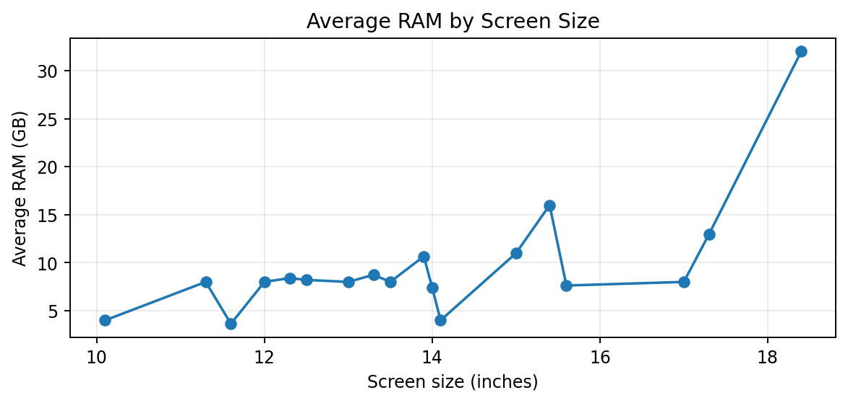
Figure 7. Screen size and RAM by laptop type
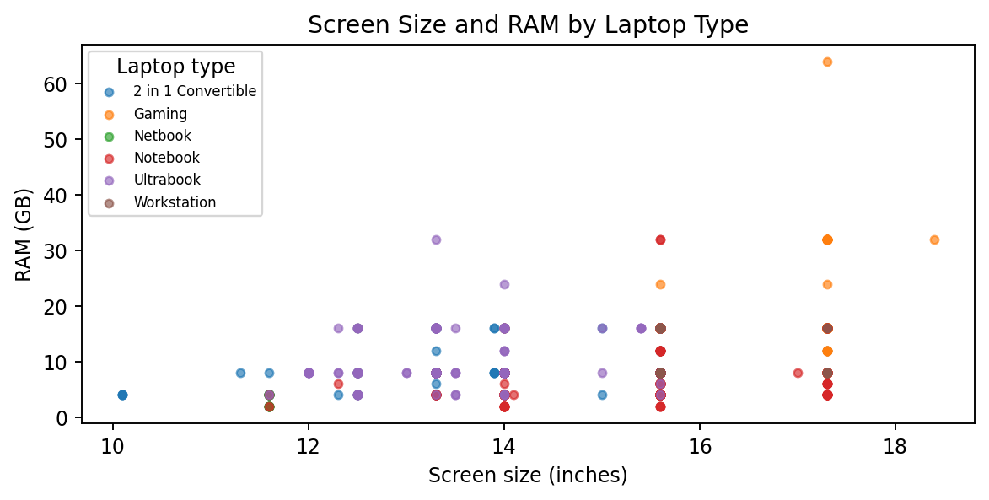

5. Deployment URL
Streamlit Community Cloud deployment: TO BE ADDED AFTER DEPLOYMENT. The public URL must be copied here after the application is deployed and tested.

6. Conclusion
The Laptop Specification Explorer provides a simple way to examine laptop brands, categories and hardware specifications. Interactive filters make it possible to focus on selected records, while the KPIs, grouped summaries and three chart types help identify patterns in the data. The dashboard demonstrates data loading, filtering, grouping, calculation, visualization and Streamlit layout components in one application.

