REWORK
1 . HOME
Welcome to NCVSTC
Navigating Careers Through Skill & Vocational Education
NCVSTC – National Council for Vocational Skill Technology Council is a Statutory Autonomous Body and Non-Governmental Organization established under Article 29 & 30(1) of the Constitution of India and incorporated under the Ministry of Corporate Affairs, Government of India.
NCVSTC is dedicated to promoting accessible, affordable, and career-oriented vocational education through Online, Open, and Distance Learning systems. The council focuses on empowering students, youth, and working professionals with industry-relevant skills, professional training, and employment-oriented education across India and Asia.

Empowering Skills • Building Careers • Transforming Futures
Our Achievements
- 100+ Career-Oriented Courses
- 500+ Authorized Study Centres
- 50,000+ Students Successfully Trained
- 25+ State Programme Offices
- 15+ Years of Academic Excellence

🎓 Programmes Offered
NCVSTC offers a wide range of:
- Certificate Programmes
- Diploma Courses
- Advanced Diploma Courses
- Degree & Post Graduate Programmes
- Skill Development & Vocational Training
Learning Modes
- Online Education
- Open Learning
- Distance Education
- Industry-Oriented Skill Training

📢 Latest Announcements
- Admissions Open for Academic Year 2026–27
- Examination Schedule Released for March/April Session
- New Skill Development Training Batches Commencing Soon
- Online Certificate Verification Facility Available
- Internship & Apprenticeship Applications Open
- Placement Assistance and Career Guidance Support Available

🏛️ Our Training Network
NCVSTC operates through an extensive academic and vocational network designed to provide quality education and professional training opportunities.
Training Categories
- Vocational Training Providers (VTP)
- Community Colleges (CC)
- Industrial Training Institutions (ITI)
- Skill Training Institutions (STI)
- Skill & Basic Training Programmes (STP & BTP)

About NCVSTC
NCVSTC Vocational Education Council works towards creating a skilled, employable, and self-reliant generation through quality vocational education and professional development initiatives.
The council supports skill enhancement, entrepreneurship, and employment-focused training programmes aligned with evolving industry requirements. Through modern teaching methodologies and technology-enabled learning, NCVSTC ensures students gain practical knowledge, professional competence, and career readiness.
Our certification and verification systems are designed to support educational progression, professional recognition, and employment opportunities in private sectors, multinational companies, industries, and international employment environments.

🌍 Vision & Commitment
NCVSTC is committed to delivering modern, technology-driven, and skill-focused education that prepares students to meet global employment standards and emerging industry demands.
We aim to:
- Promote practical and industry-integrated education
- Develop employability and entrepreneurship skills
- Encourage innovation, professionalism, and lifelong learning
- Provide equal access to vocational education across rural and urban communities
- Create responsible, skilled, and future-ready professionals
By integrating technology, quality training systems, and professional mentorship, NCVSTC continues to contribute towards national skill development and sustainable career growth.

💼 Career Development & Placement Support
NCVSTC maintains strong industrial partnerships and collaborations with leading manufacturing companies, service industries, corporate organizations, and training partners to provide:
- Career Guidance & Counseling
- Placement Assistance
- Internship Opportunities
- Apprenticeship Programmes
- Industry Exposure & Skill Development
Our dedicated Career & Placement Cell works continuously to connect trained candidates with employment opportunities across multiple sectors.

🚀 Join the Future of Skill Education
NCVSTC welcomes students, institutions, trainers, and industry partners to become part of a growing mission focused on education, employability, innovation, and nation-building through skill development.

2. ABOUT US
Empowering Skills. Transforming Futures.

NCVSTC – National Council for Vocational Skill Technology Council is an autonomous vocational education and skill development organization committed to creating industry-ready professionals through quality education, practical training, and career-oriented programmes.

Established with the vision of strengthening vocational and technical education in India, NCVSTC works towards bridging the gap between academic learning and employability skills. The council promotes accessible, affordable, and skill-based education for students from rural, remote, and economically weaker communities.

NCVSTC is associated with various national skill development initiatives and focuses on empowering youth through modern vocational programmes, professional certifications, entrepreneurship development, and technology-driven learning systems. The organization continuously works to introduce innovative education methodologies aligned with current industry standards and workforce demands.

With a strong network of study centres, training institutions, and academic partners across the country, NCVSTC has successfully contributed to building a skilled workforce equipped for emerging career opportunities in India and abroad.

Our Strength
25+ Years of Academic & Skill Development Excellence
100+ Career-Oriented Courses
500+ Training & Study Centres
50,000+ Students Empowered
Our Educational Perspective

India’s education system has evolved from traditional knowledge-sharing methods to structured modern learning models. However, the growing demand for employability and practical skills has created the need for a more industry-focused education system.

NCVSTC believes that skill-based and vocational education is the key to sustainable career development and national growth. By integrating practical exposure, technology, innovation, and professional training, the council aims to prepare students for real-world employment, self-employment, and entrepreneurship opportunities.

Our Commitment

NCVSTC is dedicated to:

Promoting quality vocational and technical education
Enhancing employability through practical skill training
Supporting lifelong learning and professional development
Encouraging innovation, entrepreneurship, and industry collaboration
Providing equal educational opportunities for all sections of society
“Skill Education is the Foundation for Self-Reliance and Sustainable Growth.”

3. VISSION
To enhance vocational education by developing industry-oriented courses, modern training methods, and advanced learning technologies aligned with current labour market demands.
To strengthen the quality of skill development through teacher training, programme evaluation, and continuous improvement in vocational education systems.
To promote innovation, collaboration, and professional growth by supporting vocational institutions, encouraging research initiatives, and expanding participation in skill development networks.

4. MISSION
To provide innovative and simplified educational frameworks in formal and informal learning systems that support lifelong skill development and career growth.
To build strong national and international collaborations while creating centres for educational excellence, consulting, and recognition of informal learning.
To ensure high-quality vocational and technical education by developing professional networks, promoting industry-relevant training, and empowering student success.
5. ORGANIZATION CHART.
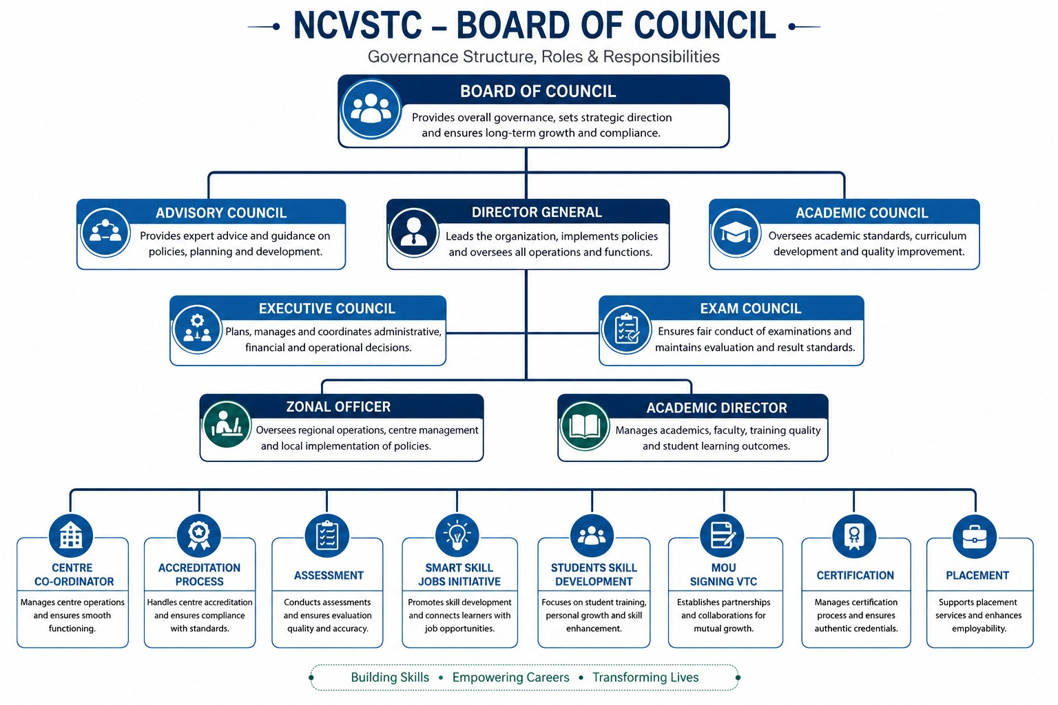

6. Branches - Removed
7. DIRECTOR MESSAGE.
Message from NCVSTC
Welcome to NCVSTC – Navigating Career for Vocational Skill Technology Council.
India has immense human potential, and skill development plays a vital role in transforming this strength into national progress. NCVSTC is committed to empowering youth through industry-relevant vocational education, certified training programmes, and professional skill development initiatives aligned with current market needs.

Our mission is to help students discover their talents, enhance employability, and build successful careers through quality education and practical training. By coordinating with vocational training centres across the country, NCVSTC ensures standardized training, quality assessment, and nationally aligned skill programmes.

We encourage students to participate actively in our courses and development initiatives to build confidence, knowledge, and career opportunities. NCVSTC remains dedicated to creating a skilled, self-reliant, and future-ready workforce for the nation.

8.OFFICE - Removed
9. GOVERNMENT PROJECT
🏛️ Skill Development Initiative Programs
NCVSTC actively collaborates with various Government of India ministries, departments, and national skill missions to implement vocational education, employment generation, and entrepreneurship development programmes across the country.
Our initiatives are focused on empowering youth, women, rural communities, minorities, and economically weaker sections through industry-oriented skill training and livelihood opportunities.
Associated Ministries & National Bodies
Ministry of Skill Development & Entrepreneurship (MSDE)
Ministry of MSME
Directorate General of Training (DGT)
Ministry of Labour & Employment
NITI Aayog
National Skill Development Initiatives

Major Skill Development Projects
DDU-GKY – Deen Dayal Upadhyaya Grameen Kaushalya Yojana
PMKVY – Pradhan Mantri Kaushal Vikas Yojana
NULM – National Urban Livelihoods Mission
Rural Skill Development Programmes
Women Empowerment through Vocational Training
Youth Entrepreneurship Development Initiatives
Apprenticeship Training Programmes (NCVT MIS)
Industry-Integrated Placement Linked Training.

OUR OBJECTIVE
To create a skilled, employable, and self-reliant workforce by delivering quality vocational education, practical training, certification, and placement support aligned with national skill development goals.

10. CAREER AND PLACEMENT

The Career & Placement Cell of NCVSTC is dedicated to preparing students for successful careers through industry-oriented training, professional guidance, and placement support. The cell conducts structured training programmes focused on employability skills, communication, corporate etiquette, interview preparation, personality development, and workplace readiness to bridge the gap between education and industry expectations.

NCVSTC has established strong industrial tie-ups and active engagement with leading manufacturing companies, service industries, corporate organizations, and business sectors across India. These collaborations enable the council to provide career guidance, industry exposure, internship opportunities, and placement assistance for trained candidates in various sectors.

Key Objectives
Prepare students with industry-relevant professional and employability skills
Provide career counseling and placement-oriented training support
Connect students with employment opportunities through industrial partnerships
Develop confidence, professionalism, and workplace readiness among candidates
Placement Assistance Offered
Career guidance and placement preparation for all eligible candidates
Interview scheduling and employer connections based on candidate skill levels
Coordination with industries and recruiters until successful placement
Support in securing suitable employment opportunities and career growth

💡 Entrepreneurship Development Cell

The Entrepreneurship Development Cell encourages students to become self-employed professionals, innovators, and future entrepreneurs by promoting entrepreneurial thinking, business awareness, and leadership skills.

The cell organizes awareness programmes, industrial interactions, project guidance sessions, and business development activities that help students understand startup opportunities, project planning, funding support, and market-oriented business practices.

Key Objectives
Promote entrepreneurship and self-employment opportunities
Guide students in project preparation and business planning
Create awareness about financial assistance, subsidies, and bank funding
Facilitate interaction with successful entrepreneurs and industry experts
Main Functions
Organize entrepreneurship awareness and motivational programmes
Conduct interactive sessions with successful business leaders
Provide guidance on project finance, subsidies, and startup support
Arrange industrial visits and industry interaction programmes for practical exposure

11. CERTIFICATE OF ORG – Removed
12 . PROGRAMES – Removed complately.

1.Resources - hide
11.Examination - hide
12 .Verification - hide

