**PROPERTY MANAGEMENT APPLICTION USING SALESFORCE (DEVELOPER)**

|  |  |
| --- | --- |
| **Date** |  |
| **Team ID** | LTVIP2023TMID00443 |
| **Project Name** | Property management application using saleforce developer |
| **Team Leader** | Amalakanti Vasu |
| **Team Size** | 1 |

# 1.INTRODUCTION:

1.1.Overview:

Are you new to Salesforce? Not sure exactly what it is, or how to use it? Don’t know where you should start on your learning journey? If you’ve answered yes to any of these questions, then you’re in the right place. This module is for you.

Welcome to Salesforce! Salesforce is game-changing technology, with a host of productivity- boosting features, that will help you sell smarter and faster. As you work toward your badge for this module, we’ll take you through these features and answer the question, “What is Salesforce, anyway?”

**1.2.Purpose:**

Salesforce is your customer success platform, designed to help you sell, service, market, analyze, and connect with your customers.

Salesforce has everything you need to run your business from anywhere. Using standard products and features, you can manage relationships with prospects and customers, collaborate and engage with employees and partners, and store your data securely in the cloud.

So what does that really mean? Well, before Salesforce, your contacts, emails, follow-up tasks, and prospective deals might have been organized something like this:

[https://youtu.be/r9EX3lGde5](https://youtu.be/r9EX3lGde5k)

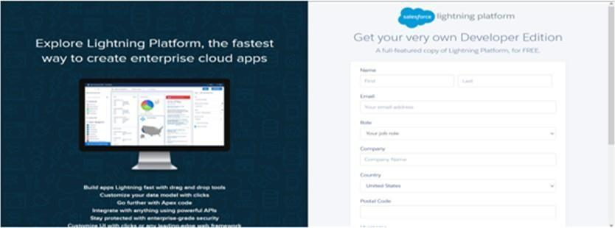

# 2.PROBLEM DEFINATION & DESIGNING THINKING:



**3.RESULT**:

|  |  |  |
| --- | --- | --- |
| **Object Name** | **Fields in the Objects** | |
| **Field Label** | **Data Type** |
| **Enquiry** | City | Picklist |
| Lead number | Auto number |
| Industrial | Picklist |
| **Property** | Customer name | Formula |
| Commercial | Picklist |
| Industrial | Picklist |
| Commercial | Picklist |
| **loan** | Due date for loan payment | Date |
| Due time for loan payment | time |
| Loan id | Auto number |
| Interest rate | Currency |

# 4.ACTIVITY AND SCREENSHORTS:

## Milestone -1

# 

(fig-3 creating a salsesforce developer organisation)

## Milestone -2

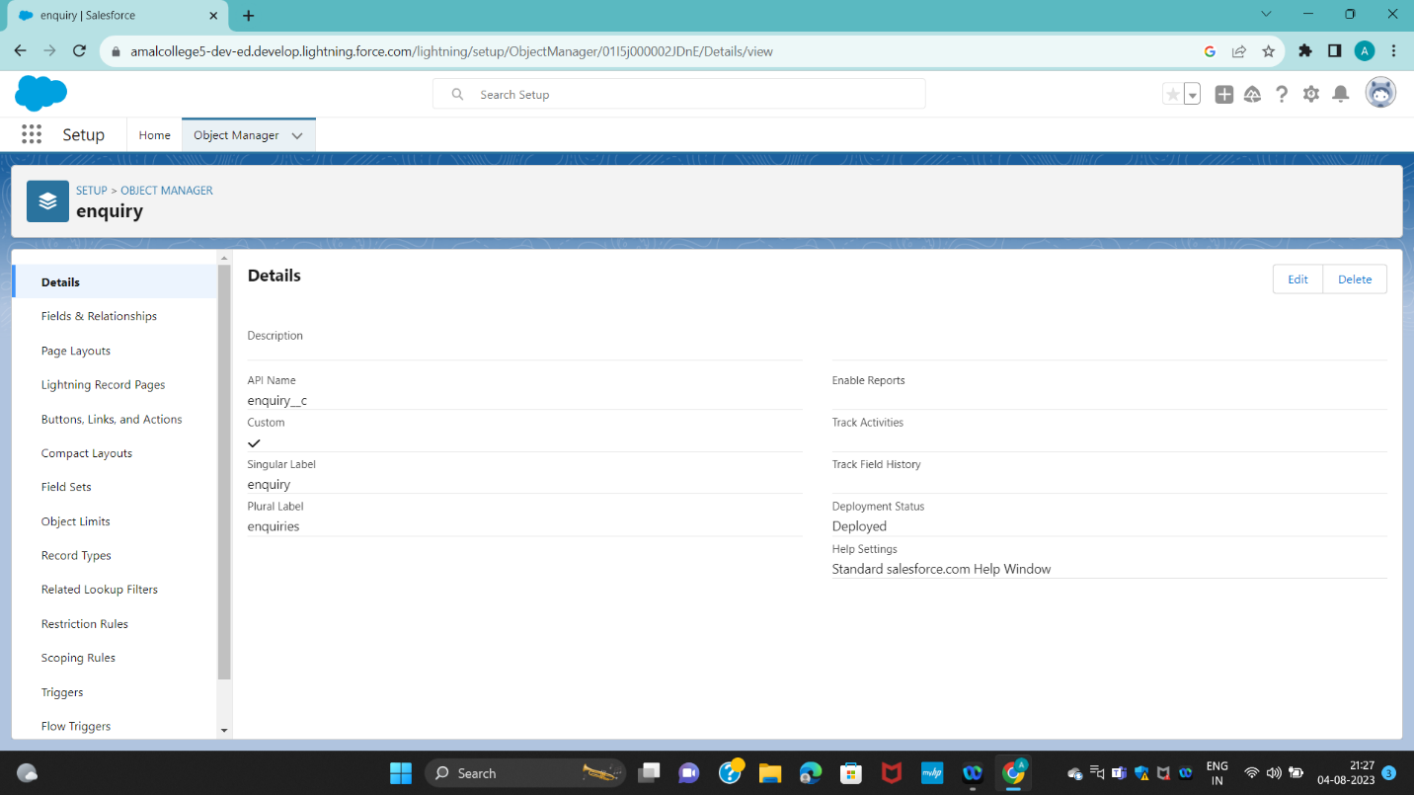

(fig-4 creation of object)

## Milestone -3

(fig-5 creation of tabs)

# Milestone -4

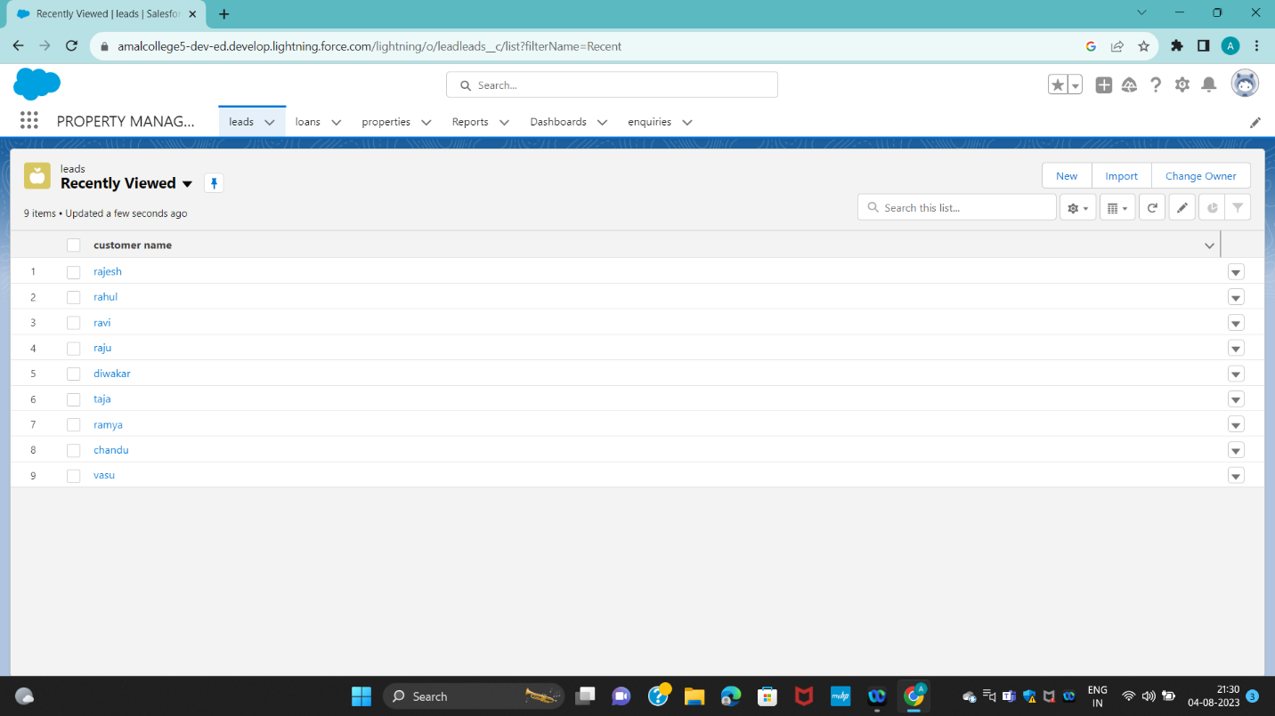

(fig-6 creation of property managementt app)

# Milestone-5 -5

(fig-7 creation of fields and relationship)

Milestone -6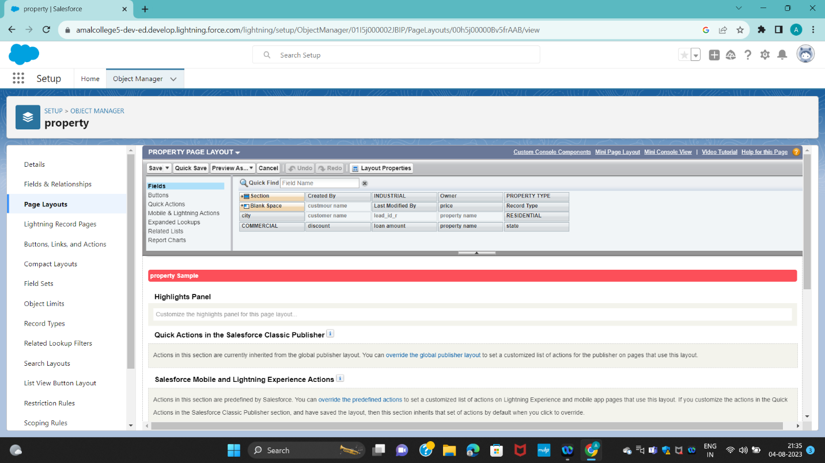

(fig -8 Page layots)

Milestone-7 -7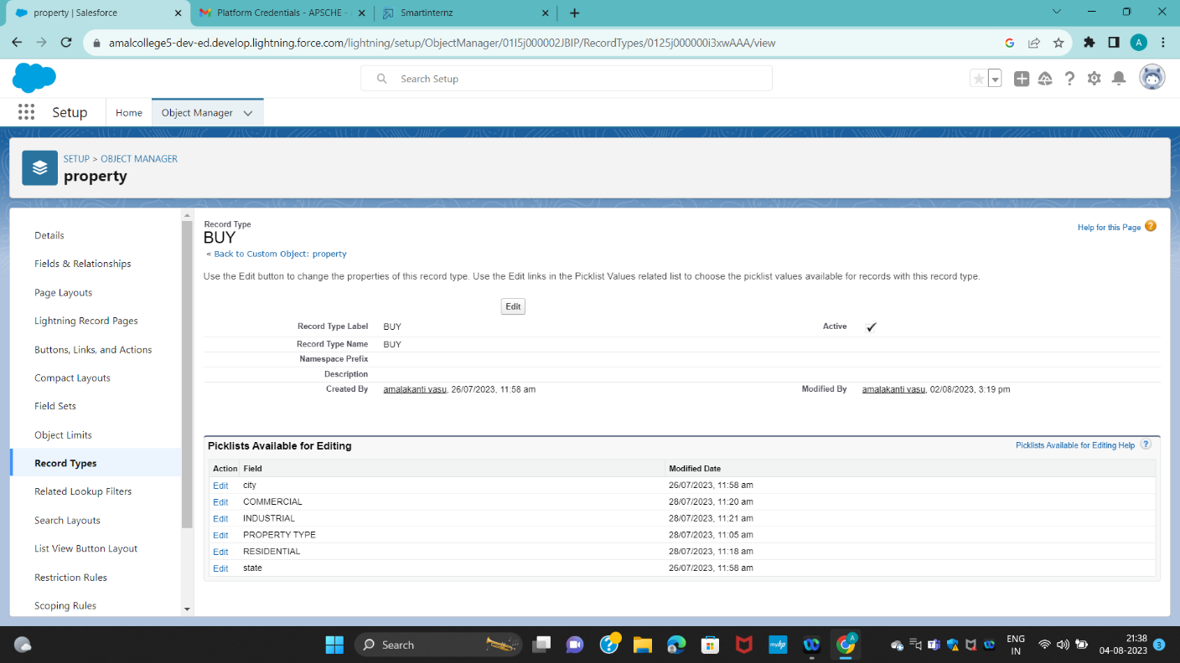

(fig-9 Record type)

Milestone -8

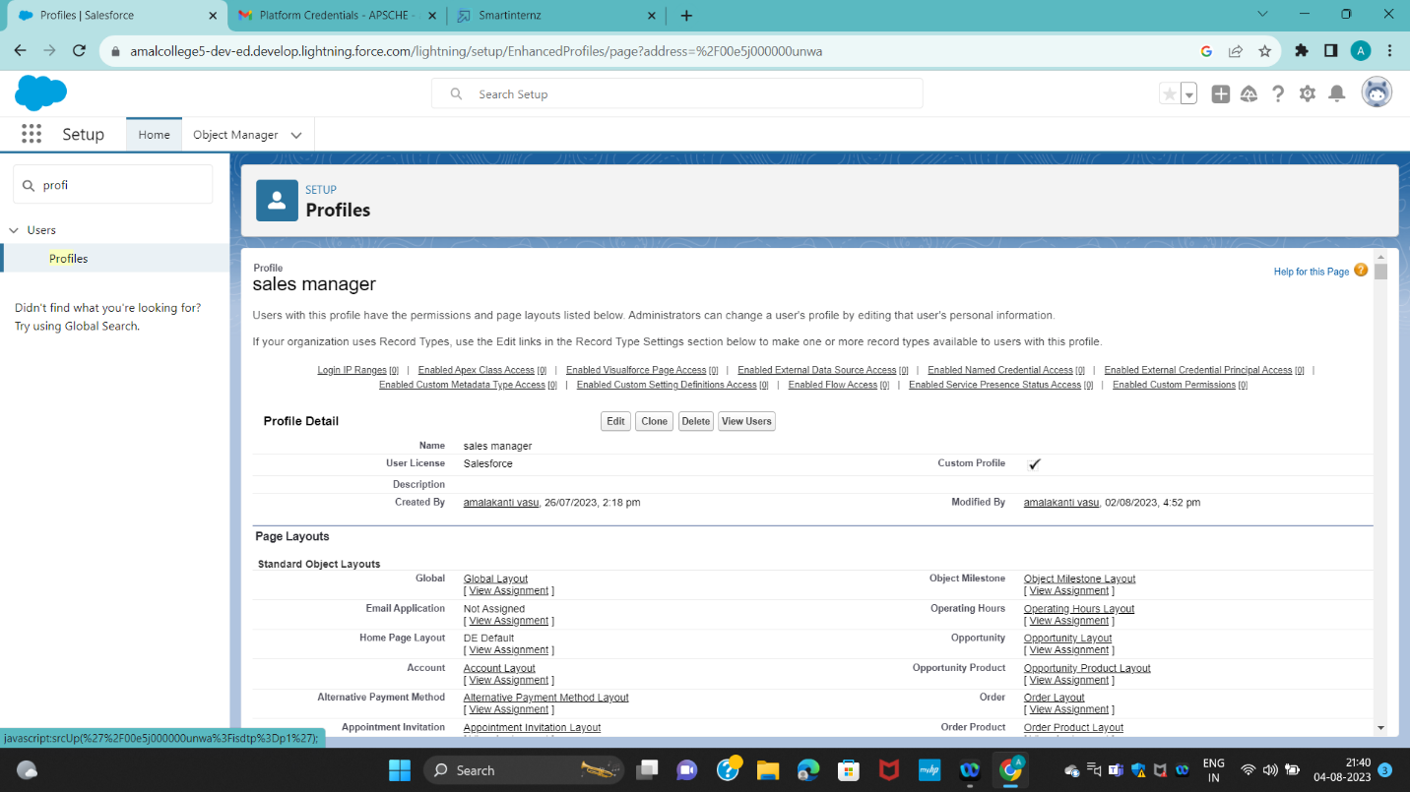

(fig-10 Profiles)

Milestone -9

(fig-11 creating a record )

Milestone -10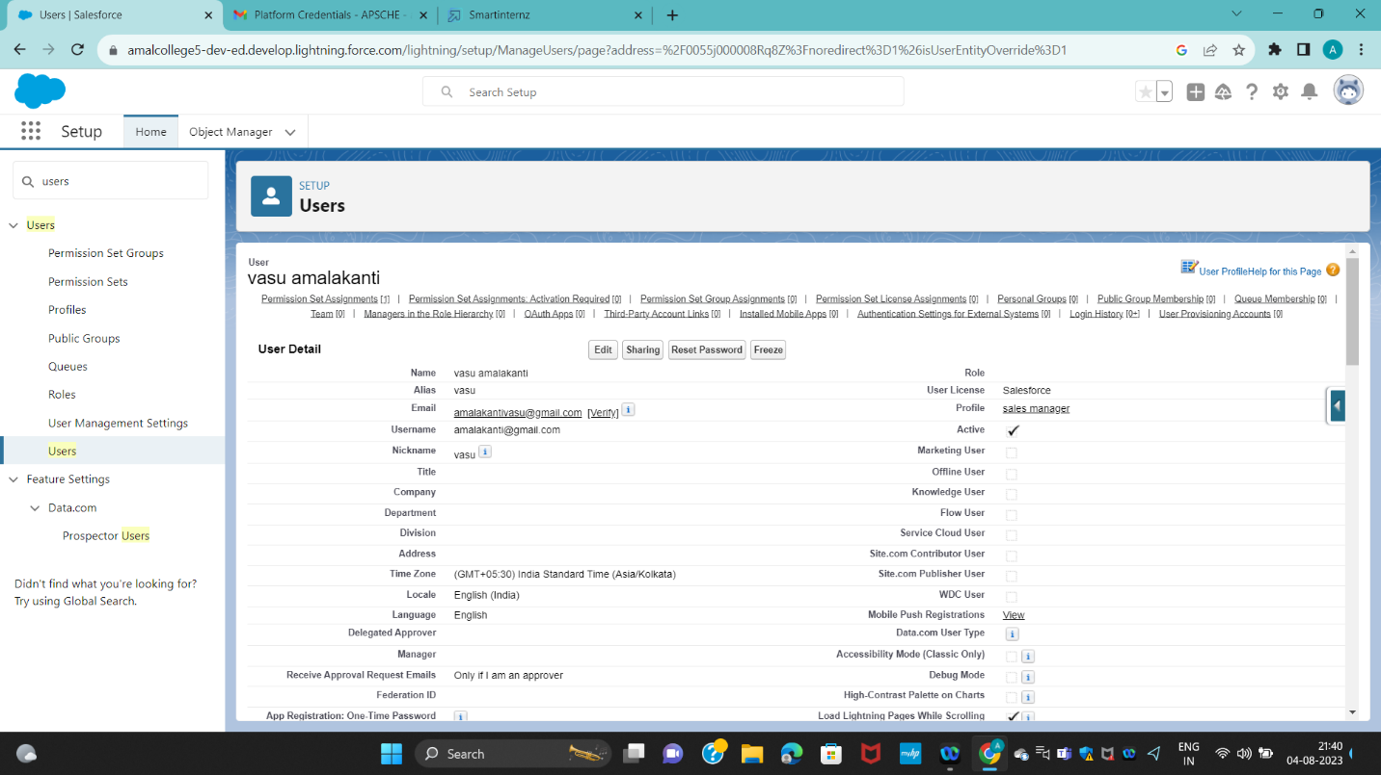

(fig-Users)

Milestone -11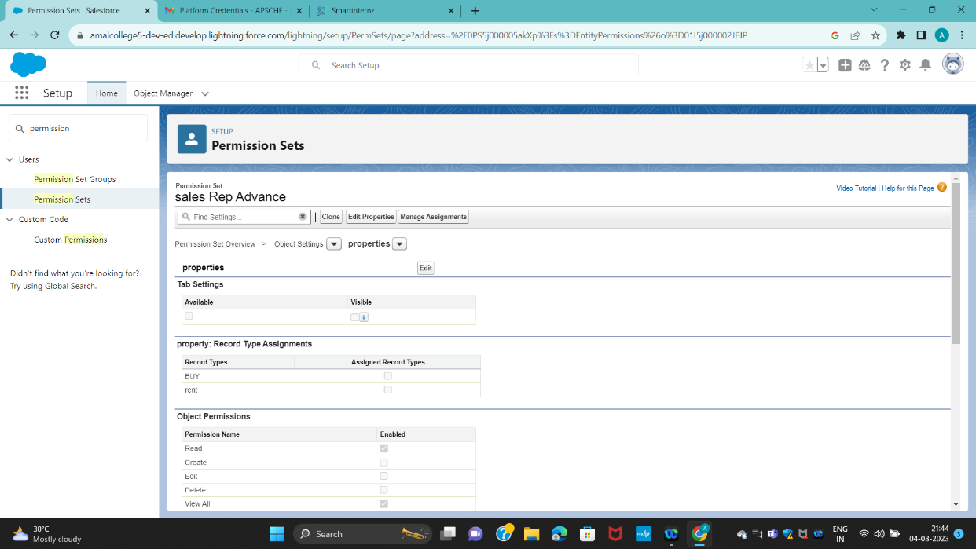

(fig-13 Permision sets)

Milestone -12

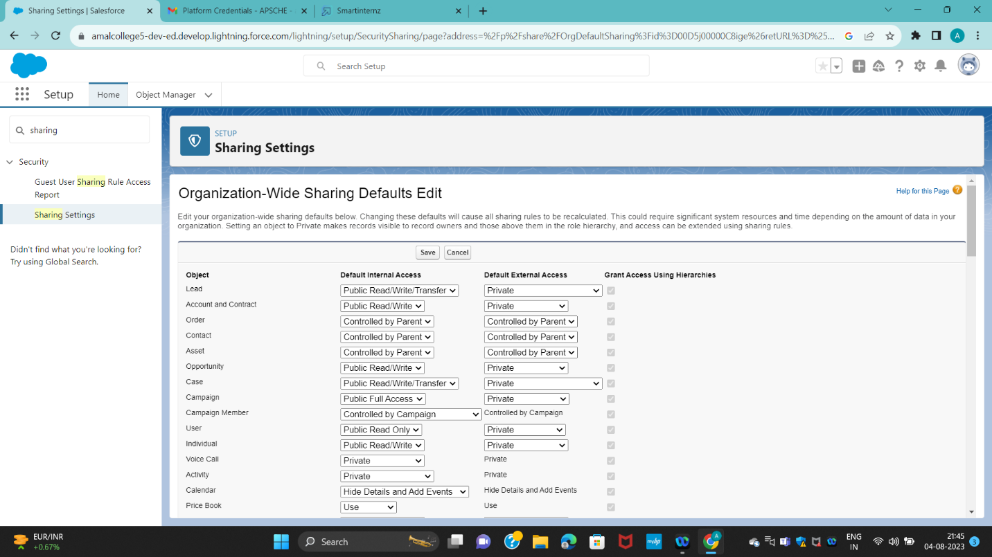

(set up for OWD)

Milestone13 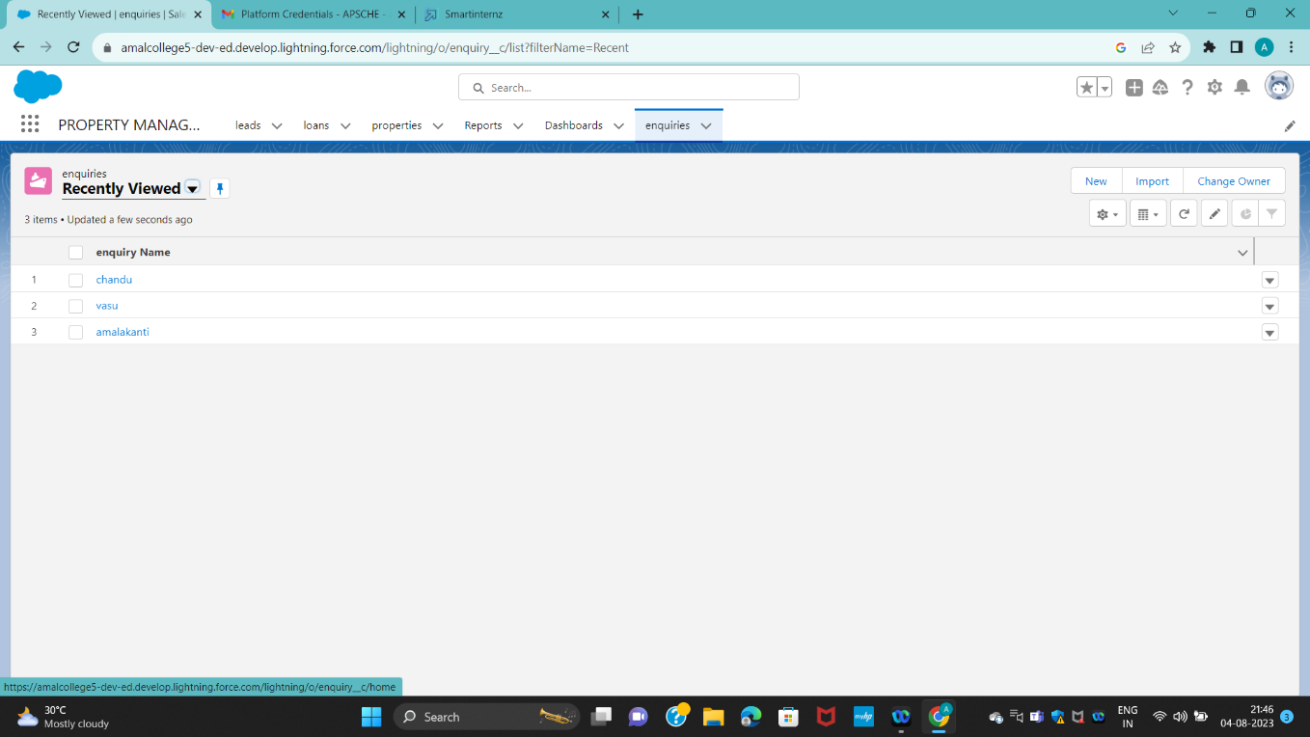

(User Adoption)

Milestone14 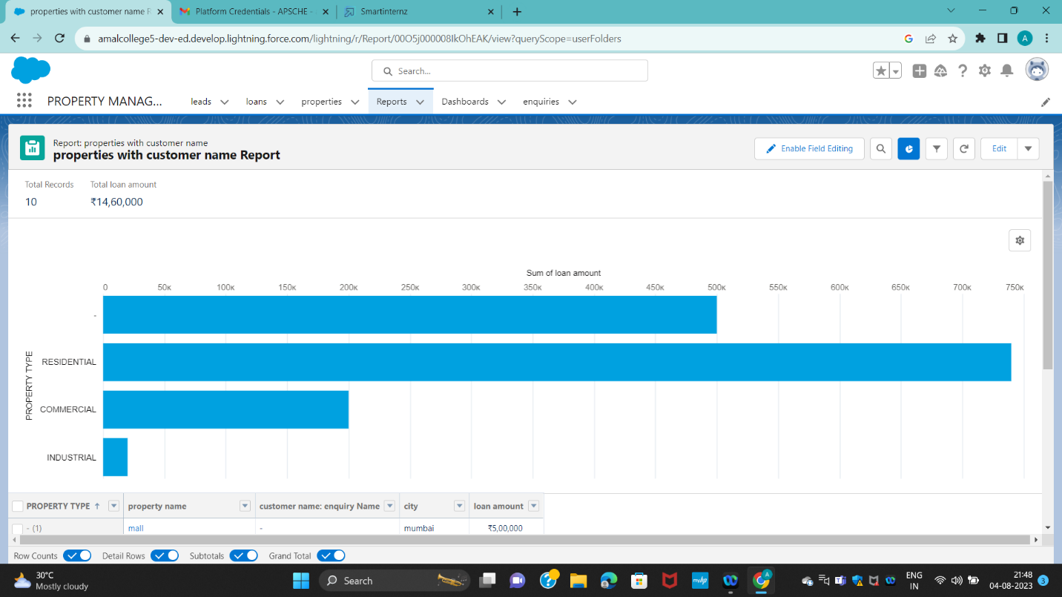

(Report)

Milestone15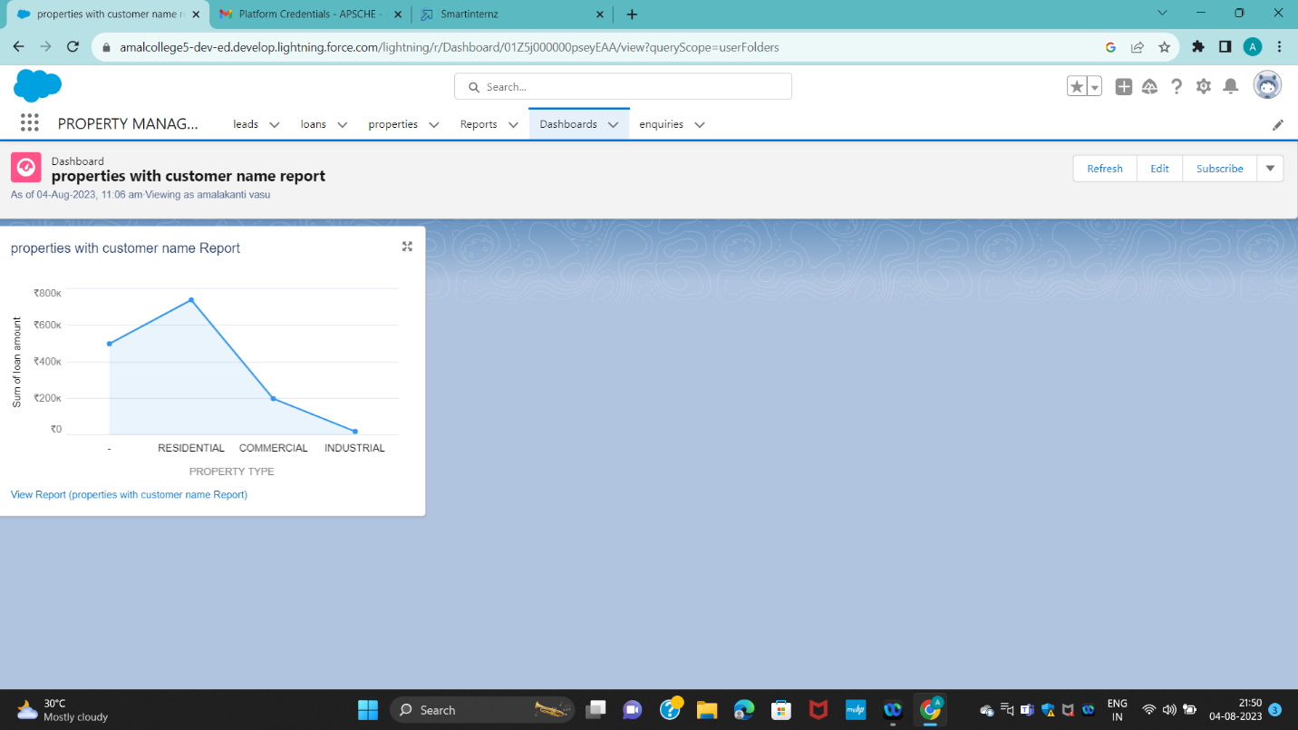

(Dashboards)

Milestone16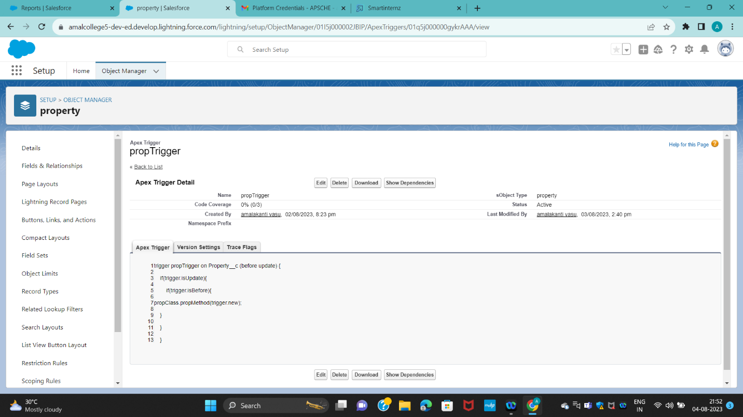

(Apex Triggers)

# 6.ADVANTAGES:

* Multiple events at the same time
* Job Instability
* Experience requirements
* Time away from family and friends

# 7.DISADVANTAGES:

* Scheduling issues-avoided.
* It needs to through multiple screen to process transaction
* It is possible that the cost of integrating it can exceed the cost of the software itself.

# 8.CONCLUSION:

To enhance efficiency of the app.

# 9.FUTURE SCOPE:

In the 21st century each and every field is computerized and all works are done by using the modern technologies so it has a good future

# 10TRAILHEAD PROFILE PUBLIC URL:+

Team Lead: https://www.salesforce.com/trailblazer/amalakantivasu3991

Team Member: https://www.salesforce.com/trailblazer/amalakantivasu3991