**Description:**

Created a Spring Boot-based web application that exposes RESTful web services APIs for create and retrieve operations on a MySQL database

**TASK 1 & 2:**

**Created a table employee in employeedatabase:**

**Inserted values using SQL Query and retrieved values using select query**

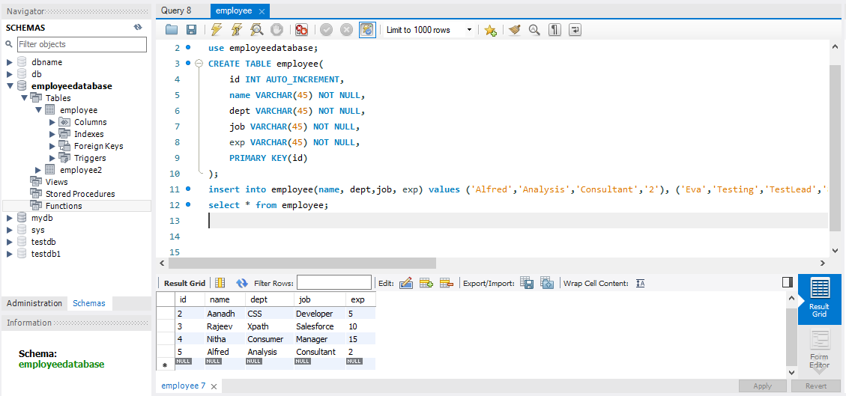

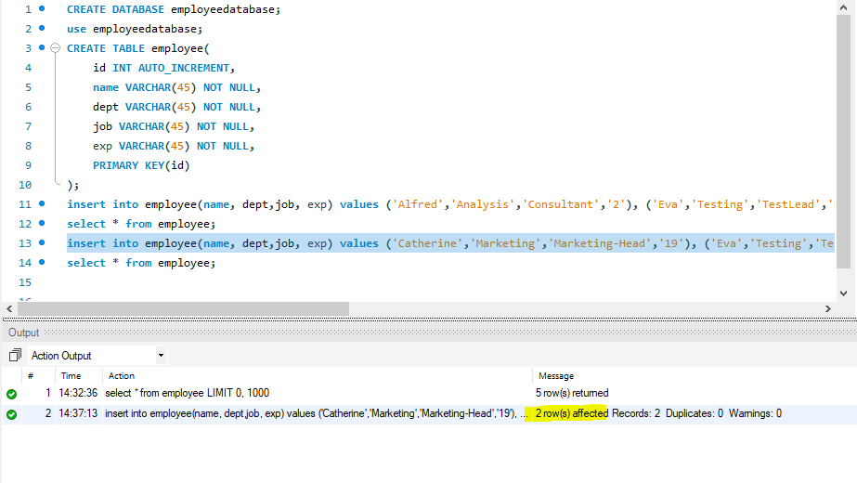

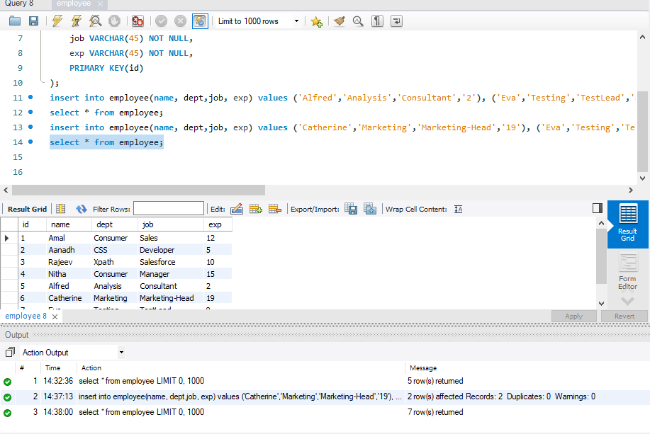

**TASK 3 & 4:**

**Created a Spring Boot-based web application that exposes RESTful APIs to clients.**

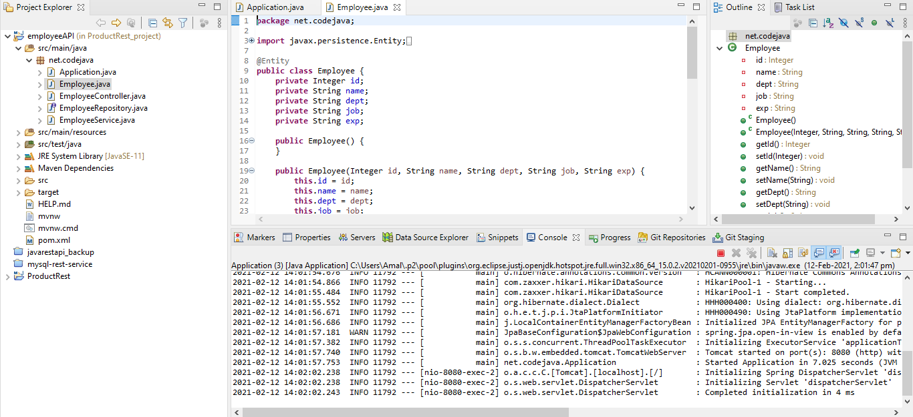

**Retrieving values using POSTMAN:**

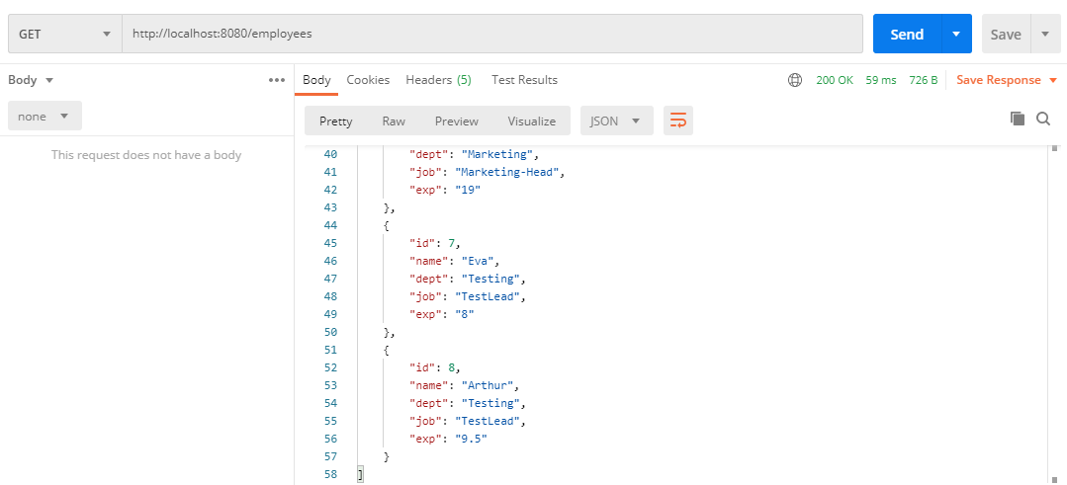

**Inserting values into table through using RestAPI Interface POST Method:**

**Before insertion:**

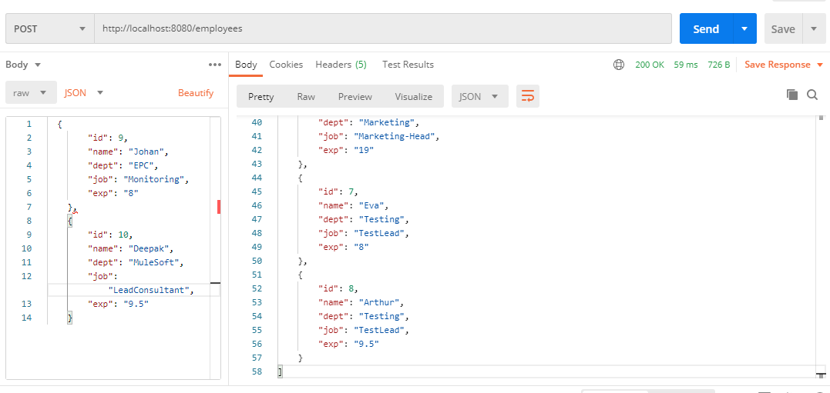

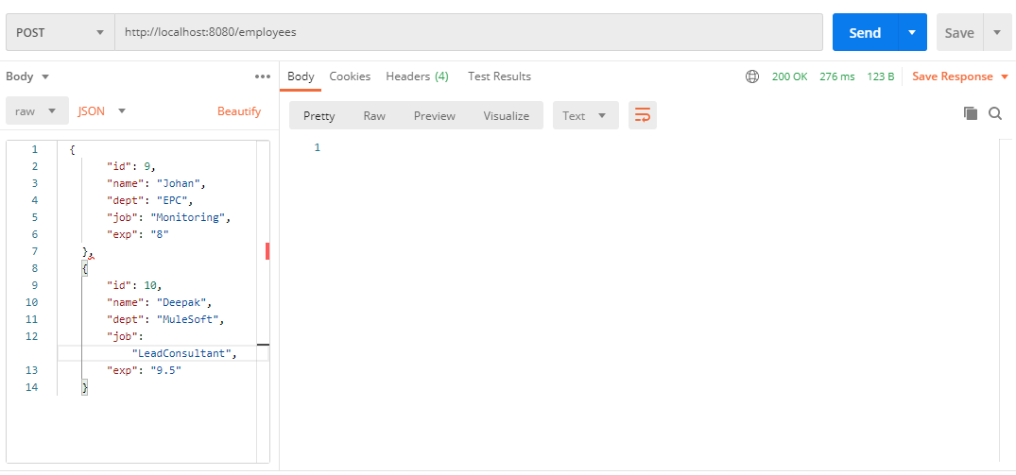

**After insertion retrieving the values using GET:**

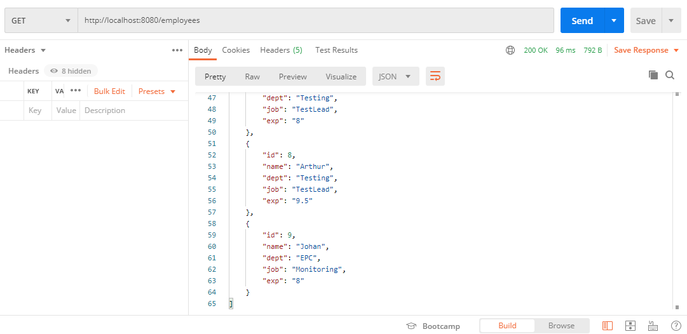

**Values inserted through POSTMAN getting reflected in MYSQL database:**

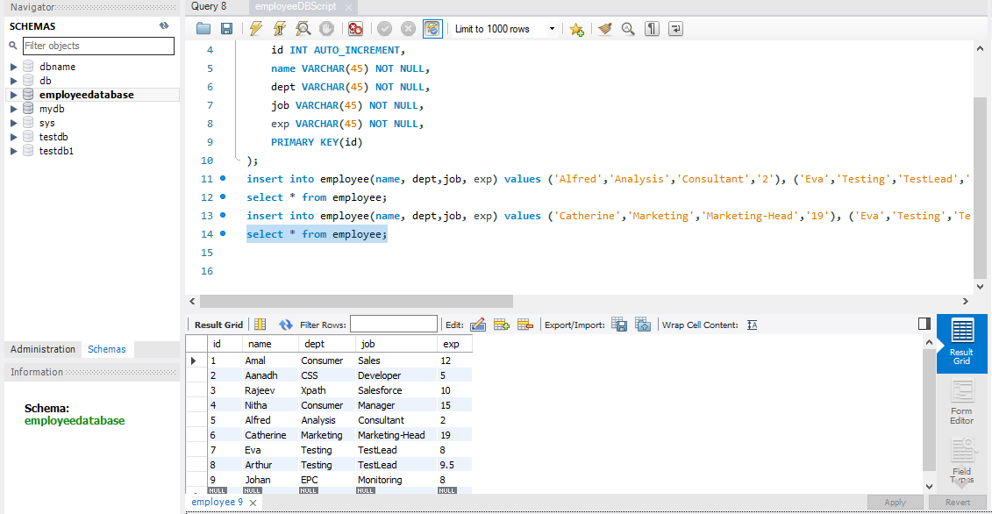

**Get values based on ID:**

