CRICBUZZ-API INTEGRETION- STREAMLIT APP
INTRODUCTION
A multi-page Streamlit web application for an interactive cricket dashboard, integrating live data from a hypothetical Cricbuzz API and utilizing a PostgreSQL database for additional data management.Cricbuzz Live Stats Dashboard
Features:
Live Scorecards: Real-time updates on ongoing matches (from API).
Statistics Visualization: Interactive charts for player statistics.
Custom SQL Query Interface: Execute SQL queries against the PostgreSQL database.
Admin CRUD Operations: Manage data entries in the database.
APPROACH
Utilised PyCharm for creation of streamlit app. Created necessary folders and pages for separate requirements as shown in the image.
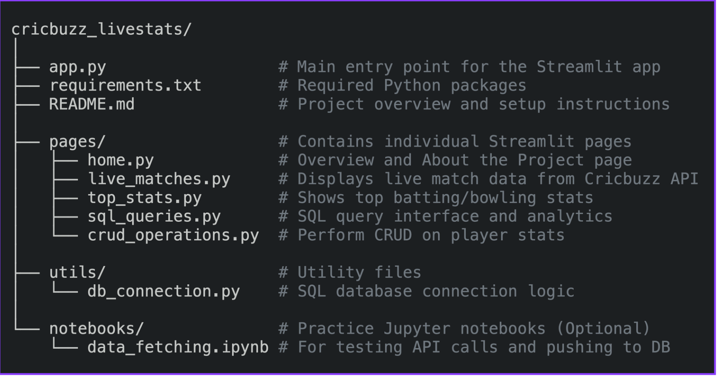

Key Development Steps
- API Integration
  - Utilize Cricbuzz Cricket API via RAPIDAPI
  - Implement Python's requests library for data fetching
  - Handle real-time match data, player stats, and series information
- Interactive Dashboard
  - Multi-page web application using Streamlit
  - Home page - introduction to the dashboard
  - Live scorecards and recent match scorecard
  - Player Info and statistics
  - Custom SQL query interface
  - Administrative CRUD operations
- SQL Database Integration
  - PostgreSQl for database query analysis
  - Centralized connection handling in utils/db_connection.py
  - Optimized queries for performance
- CRUD Operations
  - Form-based UI for data manipulation
  - Add, update, and delete player records

