Reference:

Glavna:

<http://www.cnx-software.com/2017/03/12/how-to-control-your-air-conditioner-with-raspberry-pi-board-and-anavi-infrared-phat/>

<https://raspberrypi.stackexchange.com/questions/31644/lirc-unable-to-load-module>

<https://raspberrypi.stackexchange.com/questions/50873/lirc-wont-transmit-irsend-hardware-does-not-support-sending>

<http://www.raspberry-pi-geek.com/Archive/2015/10/Raspberry-Pi-IR-remote>

## Shematics

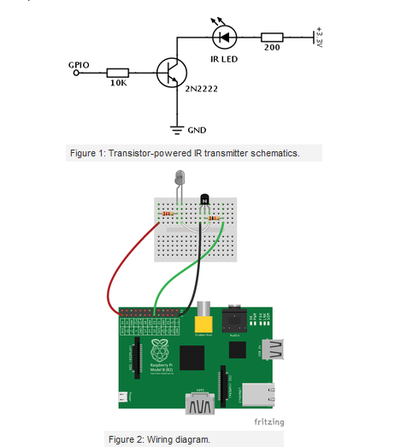

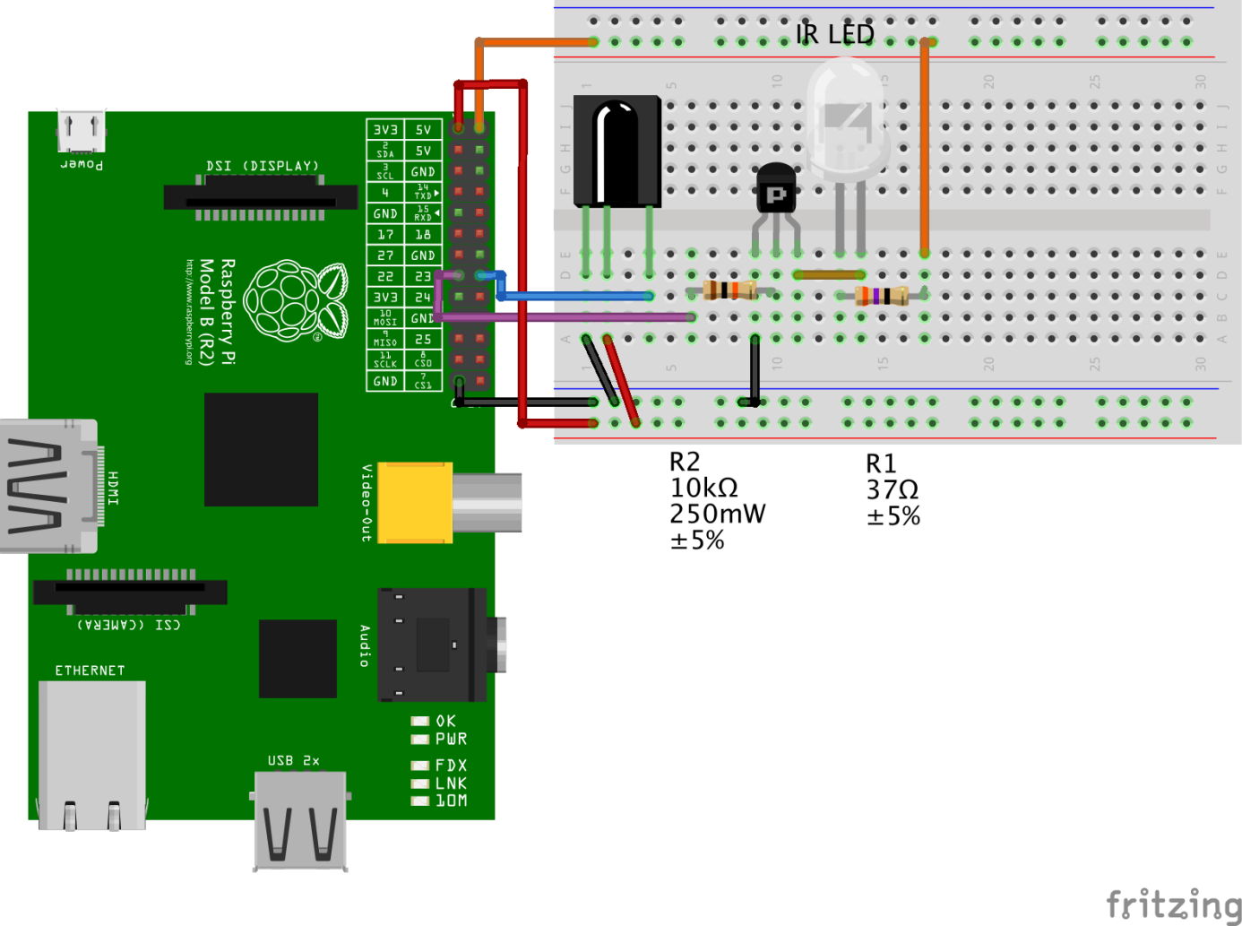

Uputa:

Python blink skripta za test spajanja. Probati s običnom ledicom infracrvena ledica s može provjeriti ako se snima kamerom

01 #!/usr/bin/python

02 import RPi.GPIO as GPIO

03 import time

04 GPIO.setwarnings(False)

05 GPIO.setmode(GPIO.BCM)

06 GPIO.setup(22, GPIO.OUT)

07 while True:

08 GPIO.output(22, True)

09 time.sleep(1)

10 GPIO.output(22, False)

11 time.sleep(1)

Postupak:

1. sudo apt-get install lirc
2. sudo nano /etc/modules

Tu dodati na kraj

lirc_dev

lirc_rpi gpio_in_pin=23 gpio_out_pin=22

1. sudo nano /etc/lirc/hardware.conf

# /etc/lirc/hardware.conf

#

# Arguments which will be used when launching lircd

LIRCD_ARGS=""

#Don't start lircmd even if there seems to be a good config file

#START_LIRCMD=false

#Don't start irexec, even if a good config file seems to exist.

#START_IREXEC=false

#Try to load appropriate kernel modules

LOAD_MODULES=true

# Run "lircd --driver=help" for a list of supported drivers.

DRIVER="default"

# usually /dev/lirc0 is the correct setting for systems using udev

DEVICE="/dev/lirc0"

MODULES="lirc_dev"

# Default configuration files for your hardware if any

LIRCD_CONF=""

LIRCMD_CONF=""

1. sudo nano /boot/config.txt (na kraj dodati)

dtoverlay=lirc-rpi:gpio_out_pin=22,gpio_in_pin=23

1. sudo reboot
2. Osnovne naredbe
   1. sudo lircd --device /dev/lirc0 //Ako nece radi treba kreirati datotreku
   2. sudo /etc/init.d/lirc restart //restart servisa
   3. sudo /etc/init.d/lirc status //Status servisa
   4. mode2 -d /dev/lirc0 //Probing
   5. sudo nano /etc/lirc/lircd.conf //config file
   6. irsend SEND_ONCE LG_MKJ40653807 KEY_POWER //Slanje komande

## Postupak skeniranja

### Samo preview

sudo /etc/init.d/lirc stop

mode2 -m -d /dev/lirc0

Buildanje configa

mode2 -m -d /dev/lirc0 > lircd-haier-ac.conf

¸

Then we need to edit our lircd-haier-ac.conf file manually:

# LIRCD File for Haier Aircon

#

begin remote

name achaier

flags RAW_CODES

eps 30

aeps 100

ptrail 0

repeat 0 0

gap 28205

begin raw_codes

name off

3050 3017 3050 4281 599 1677

570 557 578 1678 579 686

574 586 548 1681 577 561

573 1809 574 1682 597 1672

575 558 577 688 571 563

571 588 547 560 574 690

579 554 580 553 603 1693

544 1823 570 557 577 582

552 555 579 1834 549 559

576 557 577 588 567 679

580 553 571 1684 574 1682

576 689 570 563 572 561

573 561 573 691 599 1670

578 1678 580 553 571 694

576 1679 578 1678 580 579

545 1816 577 1685 594 1669

579 1677 570 694 576 584

550 558 576 1684 574 685

574 560 574 559 607 540

574 691 578 555 579 554

570 563 576 688 576 557

578 555 580 554 600 701

579 1676 572 562 572 1689

569 714 576 557 577 1679

579 1677 571 562 604

name on

3052 3040 3025 4287 593 1698

549 557 577 1679 579 686

573 560 573 1688 571 557

578 1809 573 1683 597 1672

575 590 544 715 544 563

571 562 573 561 573 1813

580 553 571 563 608 1687

544 1817 577 556 578 555

579 555 579 1809 574 558

576 557 577 557 598 679

581 553 570 1685 573 1688

571 688 570 563 572 562

572 587 547 692 598 1671

577 1684 574 553 571 694

575 1681 577 1678 580 553

581 1812 571 1680 599 1669

578 1678 580 685 574 565

569 559 575 1680 578 687

572 561 573 560 606 541

572 693 582 551 578 555

579 554 570 695 575 557

577 557 577 556 599 703

577 1683 575 553 571 1685

573 716 574 559 575 1680

end raw_codes

end remote

Note that you need to delete the first “big number” from each captured command. For example, I had to delete “4989552” from the first capture of the power key. If you want full control, you’ll need to record all keys. You may want to read [lircd.conf manual](http://www.lirc.org/html/lircd.conf.html) to understand parameters like aep or aeps. I used the default values, but in case it does not work for you, or works unreliably, you may have to adjust them, possibly from data obtained using an oscilloscope. I did not have such problem, and copied the file to /etc/lirc/lircd.conf: brisati sve vece brojeve

|  |  |
| --- | --- |
|  | sudo cp lircd-haier-ac.conf /etc/lirc/lirc.conf |