**Designing Blocks:**

What is my app name?

Calculator App

Which logo do I select?

What will be the application of my app?

To solve complicated math problems quickly

How many screens will I use?

2 screens

Make a list of how many buttons, labels, or other visible components I will use.

Screen1= 2 text box, 5 label, 6 buttons, 1 horizontal arrangement, 1 vertical arrangement

First= 1 vertical arrangement, 2 labels, 1 button

Make a list of how many nonvisible components I will use.

None

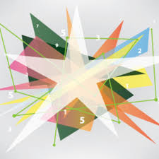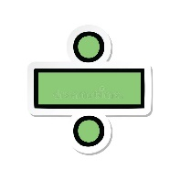Select best media like video, pictures, mp3

Rename all the components

First screen:

* Button1=go_to_calculator

Screen1:

* Textbox1= number_1
* Button2=plus
* Button3=minus
* Button4=multiply
* Button5=divide
* Button6=power_of
* Textbox2= number_2
* Button7=reset

What will be the color of my component, text will be bold or not, you will mention it in properties?

First screen=cyan

Textbox1=light green, text in black

Textbox2=light green, black text

Answer=black text

Reset= red background, white text

**Programming Blocks:**

Make a separate heading for each screen document.

Screen 1

First

What will my components do?

Plus, minus, multiply, divide, power_of: choose operation

Textbox1, textbox2: insert number

Answer: changes to answer of equation

Reset: clears the numbers

Go_to_calculator: changes screen to calculator

What conditional statement will I use?

I will use 6 when do