

The Plastic SCM guide for the Office plugin

Release version 4.1

Plastic SCM **Office Plugin**

© 2006-2012 Codice Software

Warning and Disclaimer

Every effort has been made to make this book as complete and as accurate as possible, but no warranty or fitness is implied. The information provided is on an “as is” basis. The author and the publisher shall have neither liability nor responsibility to any person or entity with respect to any loss or damages arising from the information contained in this book.

Trademarks

All terms mentioned in this book that are known to be trademarks or service marks have been appropriately capitalized. Codice Software cannot attest to the accuracy of this information. Use of a term in this book should not be regarded as affecting the validity of any trademark or service mark.

**Contents**

1 Introduction 1

2 Office plugin installation 2

2.1 Requirements 2

2.2 Installation 2

3 How to use the plugin 4

3.1 Before starting… 4

3.2 Basic Plastic SCM concepts 4

3.3 Workflow 5

3.4 Operations summary 5

3.5 Comparing revisions 6

**About this guide**

This guide describes the procedures associated with the Plastic SCM plugin for Office.

**Audience**

This guide is targeted to Plastic SCM users that work everyday with documents and text processors, as well as developers and people who write documentation, memorandums etc., assuming familiarity with Plastic SCM, office suites and operating system concepts.

**Online documentation**

Besides this document and the rest of the guides, Plastic SCM provides online reference throughout its different client frontends.

On the command line interface, both Windows and Linux, this reference can be obtained with the command:

cm help

For extended information on a specific command, type:

cm help *command*

The graphical interface provides online reference through the Help menu.

**Documentation errors**

If you find any problem in this guide or any other part of the online reference, please report it using the following email address:

[support@codicesoftware.com](mailto:support@codicesoftware.com)

# 

# Introduction

The Plastic SCM plugin for Office is compatible with Microsoft Office 2003 (**Word** and **Excel**) and Microsoft Office 2007 (**Word**, **Excel** and **PowerPoint**).

This guide will help you to work with the plugin for Office in case you are using Office 2007. The differences between the plugin for this version and the plugin for Office 2003 are minimal; basically these differences consist of aesthetic issues.

The Plastic SCM integration with Microsoft Office lets you to easily manage revisions of Word, Excel and PowerPoint documents. As your work in the documents progresses, you store new versions of them in the Plastic SCM server by *checking in*. The versions created in this way can be easily reviewed and compared, eliminating the need to enable “track changes” inside the documents.

# Office plugin installation

## Requirements

The Plastic SCM plugin for Office requires Microsoft .NET Framework 3.5 to run. Normally this component is installed by Office itself. Just in case the .NET framework is not installed on your machine, you can download it from this location:

<http://www.microsoft.com/downloads/details.aspx?familyid=333325FD-AE52-4E35-B531-508D977D32A6&displaylang=en>

## Installation

The Plastic SCM plugin for Office is part of the Plastic SCM Full installer. Start the installer and select the Office plugin. In the component selection, make sure the “Office 2003” or “Office 2007” check is selected, depending on the version of Office that you have installed. The Plastic SCM client is required as well and will be selected automatically.

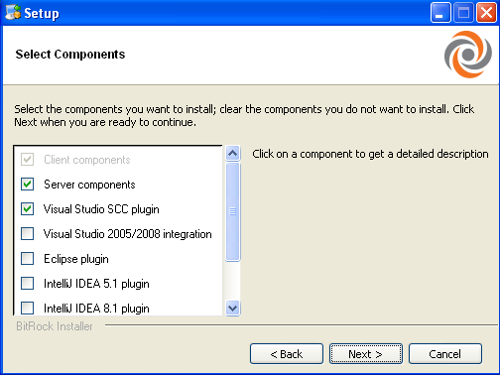

Figure 1: List of components to install with Plastic SCM

**Notes**: These checkboxes will be disabled if the installer does not detect an Office 2003 or Office 2007 installation on the machine.

Once the client has been installed, the plugin is registered automatically the first time Word, Excel or Powerpoint are launched. A dialog like the following will be displayed:

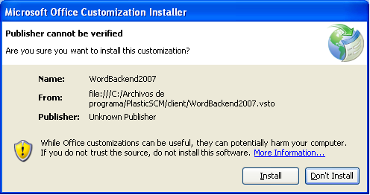

Figure 2: Installation of the Plastic SCM plugin for Office

After clicking on ‘Install’ the plugin will be registered and you will be able to use Plastic SCM from Microsoft Office.

To get further information about how to install Plastic SCM, see the Administrator’s Guide and the User’s Guide.

# How to use the plugin

## Before starting…

Before using the Plastic SCM plugin inside Office applications, you need to ensure that:

* Plastic SCM client and Office integration have been installed in the computer.
* The Plastic SCM client is configured to connect to a Plastic SCM server and there is a workspace created that contains the folder where documents to version are located.

For more details about how to install and setup a workspace, please refer to the Plastic SCM Introduction guide.

Once the client is installed and a workspace setup, you can use the Plastic SCM plugin for office to add documents to Plastic SCM and create versions.

## Basic Plastic SCM concepts

Before using the plug-in, let’s review some basic Plastic SCM concepts needed to properly operate it.

* Repository: this is the place where the versions of documents are stored. It is located in the Plastic SCM server.
* Plastic SCM server: this is normally a computer other than yours where your administrator has installed a Plastic SCM server service.
* Workspace: this is the folder in your computer that holds your documents. It contains **one** specific version at a time of each document that has been *added* to the repository. For instance, you can create a workspace in the folder “My documents” using the Plastic SCM GUI client.
  + You can have as many workspaces as needed.
* Check-in: this is the operation to save a new version in the repository.

## Workflow

Your normal workflow to version documents in the repository will be something like this:

* You create a document in Word, Excel or Powerpoint.
* Save it in a folder that is inside a Plastic SCM workspace
* You “Add” the document to the repository (using the “Add” button in the plug-in panel). When you add it, you are actually saving the first version of the document in the Plastic SCM repository (i.e. in the server).
* You make changes on the document. When you are happy with your changes, you *check-in* to save a new version in the repository. Versions of the document help you track the changes to the document.
* When needed, you compare the different versions to see what has changed.

## Operations summary

The Plastic SCM plugin for Office appears as a panel in the right side of Word, Excel and Powerpoint. Figure 1 shows this panel in action:

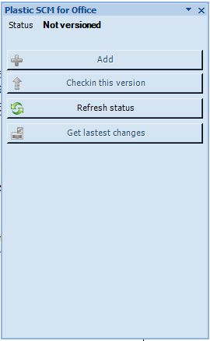

Figure : Plastic SCM plugin in Office 2007.

Plastic SCM controls versions of documents once they are *added* to the repository. This is done with the “Add” button and needs to be done only once. Note that for adding a document to the repository, it has to be inside a workspace that you need to create using the Plastic SCM GUI client (this operation is normally done only once and is not available inside the Office plug-in). For more details, please refer to the Plastic SCM Introduction guide.

Once a document has been added, the panel enables some options and displays a list of the versions of the document (only one, since it has been just added). Figure 2 summarizes the contents of the panel and the available actions:



Figure : Plastic SCM Office plug-in

## Comparing revisions

It is possible to compare any two versions of the current document using the buttons at the bottom of the plug-in panel.

* To compare the current document with the previous version in the repository, click “diff with current version”.
* To compare any two versions, select them in the versions list and click “Compare revisions”.
  + To select two revisions in the list, click the first version and then, holding the Ctrl key, click on the second version. Then click “Compare revisions”.