**Name**: Hui Shi **Hopkins ID**: B5F2C6

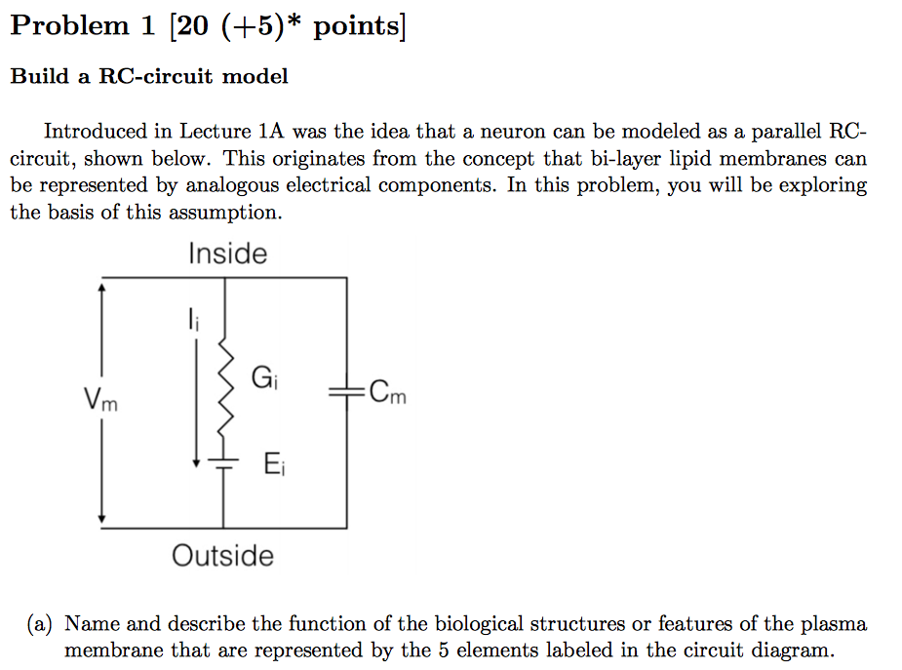

***Ans:***

$V_{m}$ represents the membrane potential and is the difference between the inner membrane potential and the outer membrane potential

$G_{i}=\frac{1}{R_{i}}$ represents the channel conductance for ionic specie i or the ease of ion to flow through the channel

EI is the electrical potential that drives concentration gradient, specific for ionic specie i

Cm is the membrane capacitance or the ability for a membrane to separate charge.

Ii  is the current existed because of the charged ion move into or out of the membrane.





***Ans:***

Apply the Nernst equation, we learn that the equilibrium potential is

$$E_{i}=\frac{RT}{zF}ln\frac{{\left[Na^{+}\right]}_{out}}{{\left[Na^{+}\right]}_{in}}=\frac{\frac{8.314472J}{K*mol}*(273.15+20)K}{\frac{96485C}{mol}}*\ln\left(\frac{440*{10}^{-3}M}{50*{10}^{-3}M}\right)=0.0549V$$

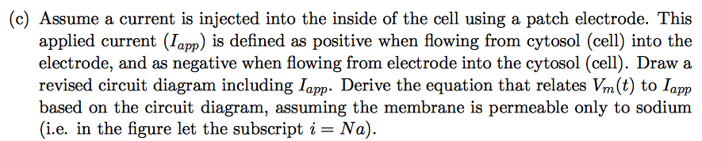

***Ans:***

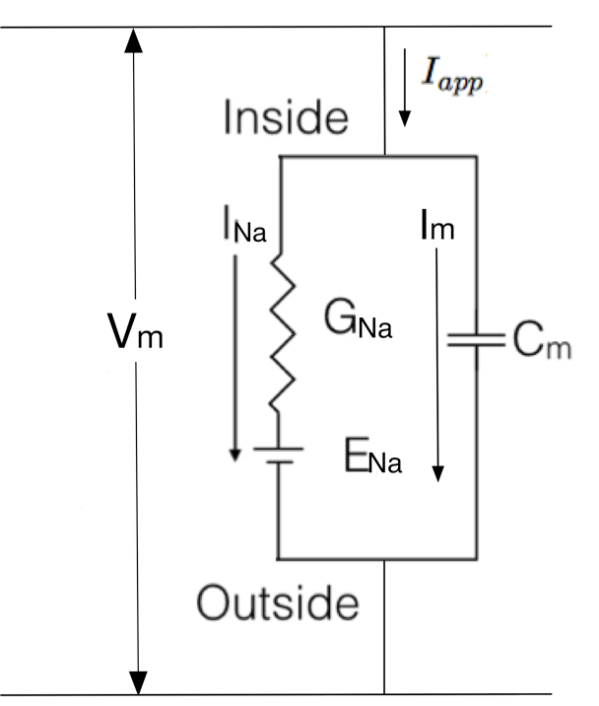

This question requires us to apply Kirchhoff’s current law and Ohm’s law to solve for the dynamic equation of Vm(t) as a result of Iapp(t):

Ohm’s Law: Vm=IR

Capacitor: $I_{m}=C_{m}*\frac{δV_{m}}{δt}$

KCL: $\sum{I_{in}}=\sum{I_{out}}$

Define $I_{app}≠0 ∀ t>t_{0}$

Apply KCL: $I_{app}=I_{m}+I_{Na}$

where $I_{m}=C_{m}*\frac{δ\left(V_{m}-E_{Na}\right)}{δt}=C_{m}*\frac{δ\left(V_{m}\right)}{δt}$

$I_{Na}=G_{Na}*(V_{m}-E_{Na})$

Therefore, $G_{Na}*V_{m}+C_{m}*\frac{δV_{m}}{δt}=G_{Na}*E_{Na}+I_{app}$

$$\frac{{G_{Na}*V}_{m}}{C_{m}}+\frac{δV_{m}}{δt}=\frac{G_{Na}*E_{Na}}{C_{m}} +\frac{I_{app}}{C_{m}}$$

$$\frac{δV_{m}}{δt}=\frac{G_{Na}*E_{Na}}{C_{m}} +\frac{I_{app}}{C_{m}}-\frac{{G_{Na}*V}_{m}}{C_{m}}$$

$$\frac{C_{m}}{G_{Na}\left(E_{Na}-V_{m}\right)+I_{app}}δV_{m}=δt$$

Taking integral on both side:

$$\int{\frac{C_{m}}{G_{Na}\left(E_{Na}-V_{m}\right)+I_{app}}δV_{m}}=\int{δt}$$

$\text{C}$ 𝑚𝐺𝑁𝑎 $\text{E}$ 𝑁𝑎−𝑉𝑚+𝐼𝑎𝑝𝑝𝛿𝑉𝑚=𝛿𝑡

$$-\frac{C_{m}}{G_{Na}}ln⁡(G_{Na}(E_{Na}))$$

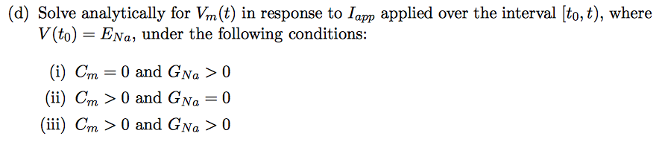

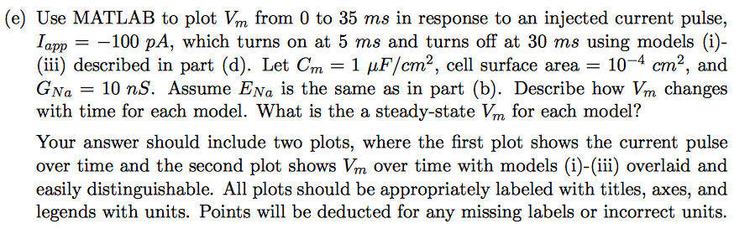

(f) Describe at least one response from a real neuron that cannot be accounted for by the above models. How would you change the model in order to capture this behavior?

