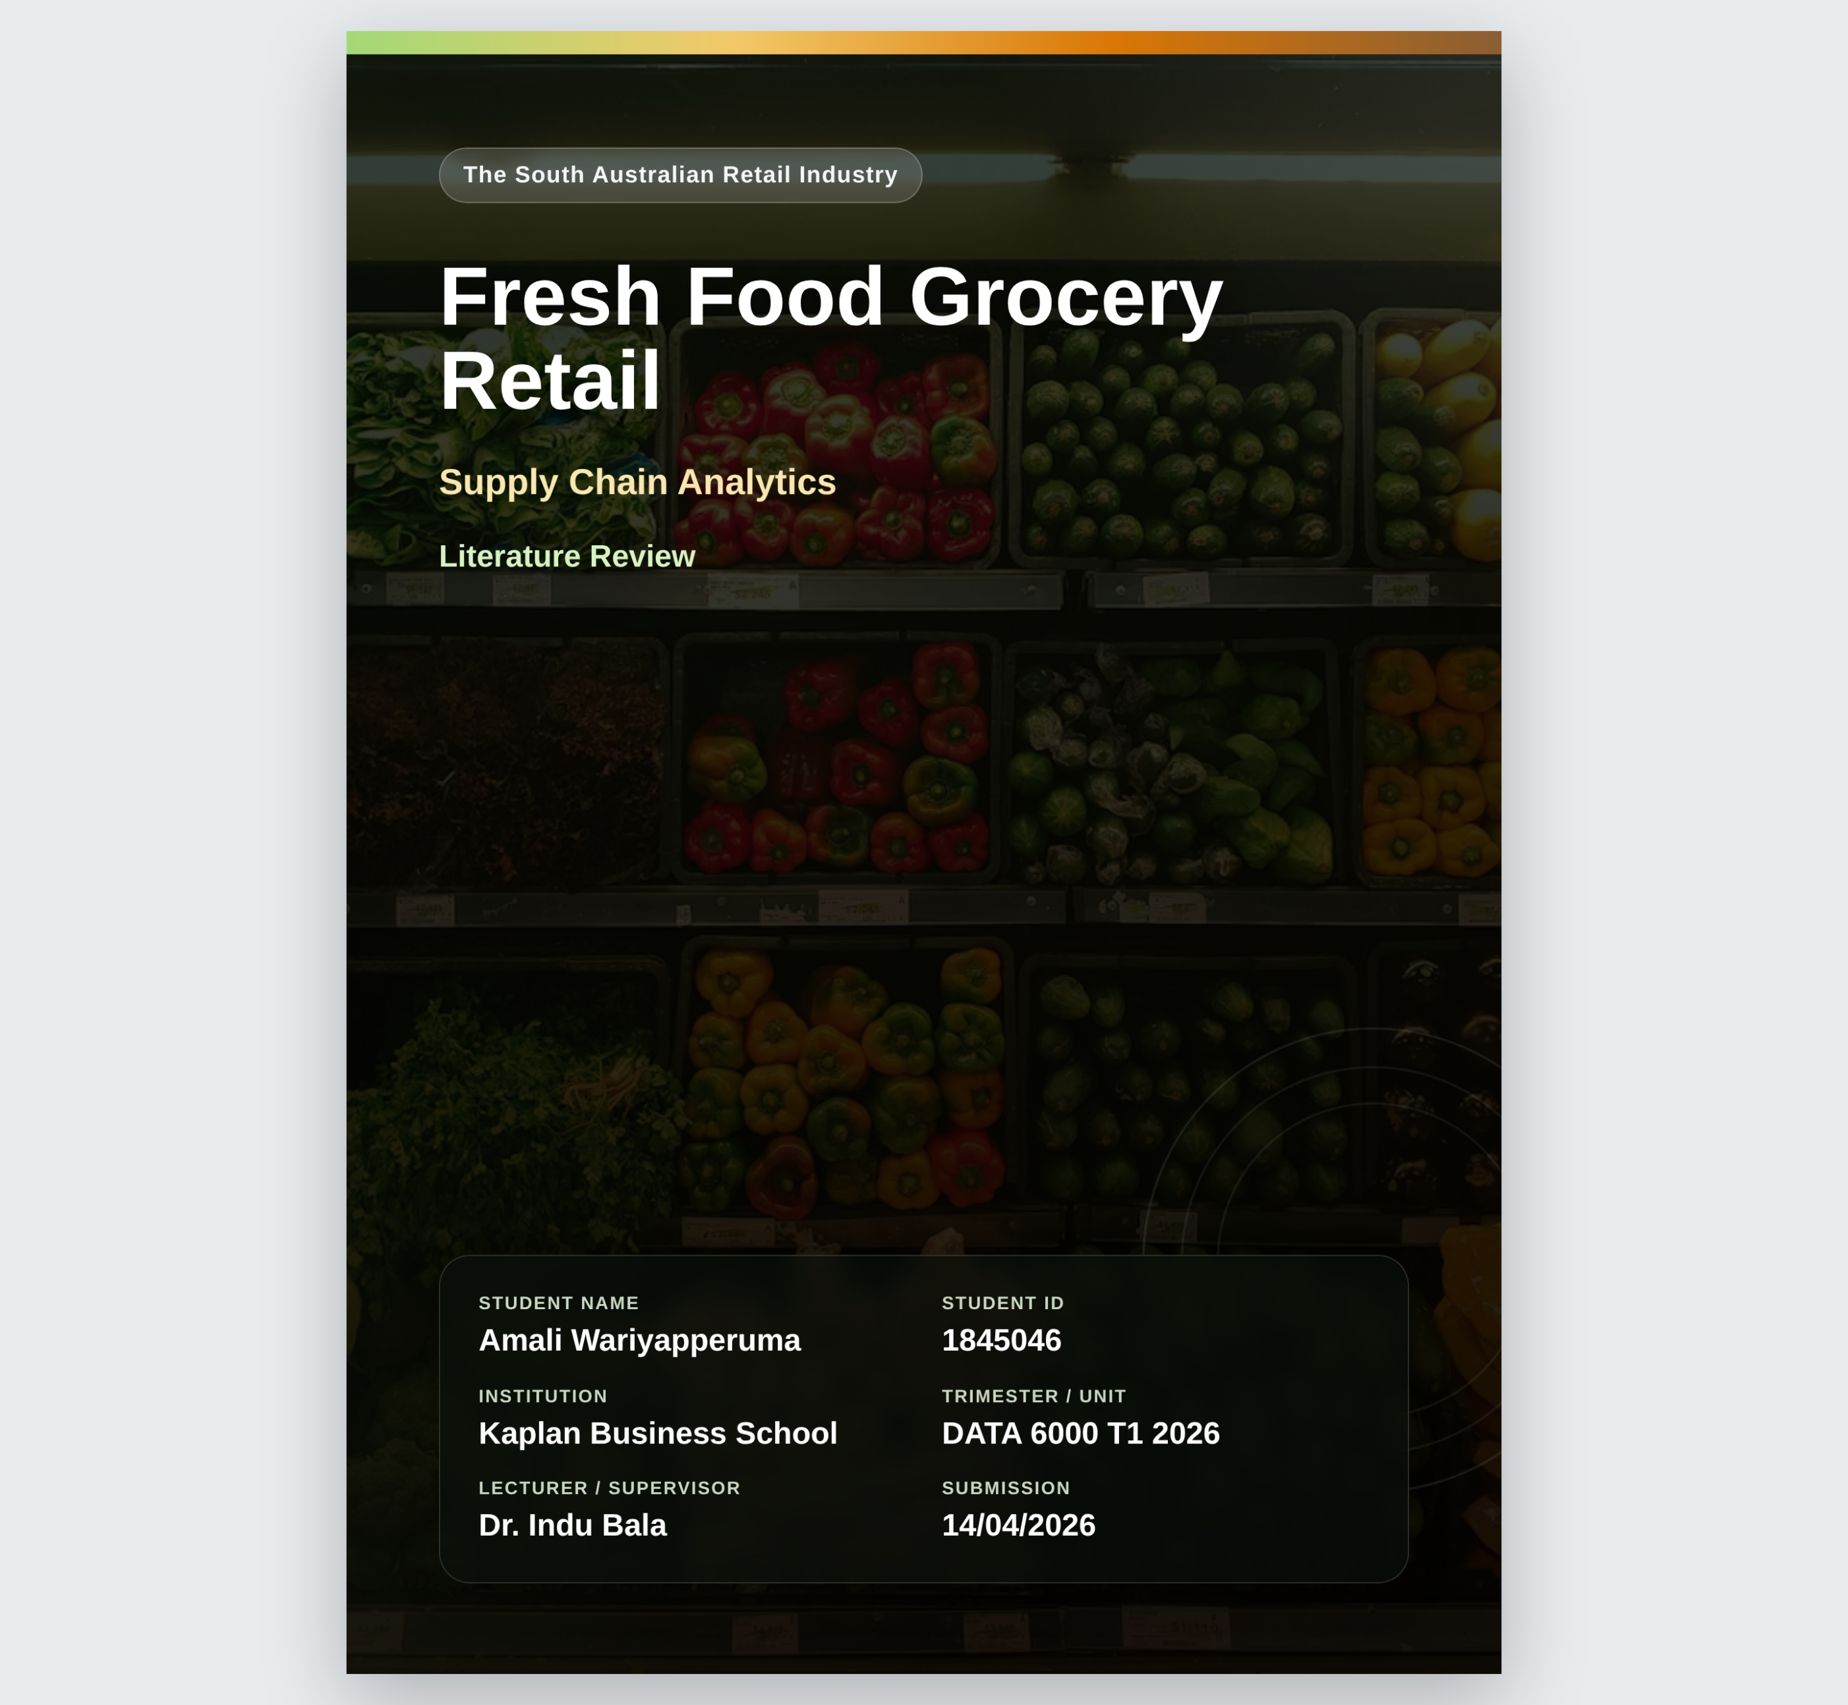

Table of Contents

Table of Figures 3
Executive Summary 4
The South Australian Retail Industry 4
Significant Players in SA Retail 5
Challenges in the SA Retail Industry 6
Serving Price-Sensitive Customers Without Crushing Margins 6
Unstable Fresh-Food Supply from SA Weather and Drought Conditions 7
Rising Retail Crime and Store-Safety Pressure in Adelaide Shopping Centres 8
Existing Analysis and Methodologies 9
Retail Pricing, Demand Forecasting and Margin Analytics 9
Unstable Fresh-Food Supply - Climate Analytics 10
Retail Crime Detection and Predictive Security Analytics 11
Data Sources 12
Selecting a Business Problem 13
The Proposed Approach 14
References 15

Table of Figures

Figure 1.0: Australian retail market turnover and annual growth 2020–2025 (source: ABS Retail Trade, 2025) ………………………………………………………………………………………………………....5
Figure 2.0: Key players in the South Australian retail industry (source: ACCC Supermarket Inquiry, 2025) …………………………………………………………………………………………………………………….5
Figure 3.0: CPI price change vs total horticulture production in SA 2020–2023…………….…….6
Figure 4.0: Annual rainfall vs vegetable production in SA 2020–2023, showing strong inverse relationship (R = −0.931) …………………………………………………………………………………………………...8
Figure 5.0: SA retail shoplifting offences trend 2020–2024 (source: ABS Recorded Crime - Victims, 2024; SA Police Crime Statistics, 2025) ………………………………………………………………….9
Figure 6.0: SARIMA vs LSTM forecasting accuracy comparison in retail SCM (source: Falatouri et al., 2022) ………………………………………………………………………………………………………………….….10
Figure 7.0: Conceptual framework for climate-driven food supply chain disruption in Australia (source: Malik et al., Nature Food, 2022) ……………………………………………..…..…….11
Figure 8.0: AI-driven retail theft deterrence market growth 2024–2032 (source: SNS Insider, 2025) …………………………………………………………………………………………………………………...………….12
Figure 9.0: SA rainfall, horticulture production, CPI price change and retail crime offences across 2020–2023 (sources: Bureau of Meteorology 2026; Australian Bureau of Statistics 2025; SA Police Crime Statistics 2025) …………………………………………………………………….…………13
Figure 10.0: Proposed approach for forecasting fresh food supply disruptions in SA retail (2020–2023 data) ………………………………………………………………………………………………….…………15

Executive Summary
The South Australian retail industry faces unpredictability from price sensitivity, climate-driven fresh food supply instability, and rising retail crime. Even with a robust national retail turnover of AUD 551 billion in 2025¹, supplier continuity, store safety, and profits continue to be challenges for SA retailers.

The retail sector in South Australia has suffered from:
- Price-sensitive customers and margin pressure
- Unstable fresh-food supply due to weather and drought
- Rising retail crime and store-safety pressure

To foresee disruptions in the fresh food supply, this study suggests correlation, regression, and ARIMA forecasting using SA rainfall, CPI, and horticultural data.

The South Australian Retail Industry
One of the biggest professions in South Australia is retail, which includes supermarkets, grocery stores, and shopping malls in Adelaide and surrounding areas. The national retail market is expected to reach a valuation of AUD 551 billion in 2025 and increase at a compound annual growth rate of 3.1% until 2035.² In June 2025, SA's monthly growth was 0.7%. ³
Since 2022, the industry has encountered considerable challenges. At a peak of 9.2%, inflation reduced consumer purchasing power and compressed margins. Retail insolvencies increased 14.2% year over year until December 2024, while KPMG's Retail Health Index dropped to −1.73 in mid-2024.⁴⁻⁵
For retailers in SA, three interrelated issues are especially significant.
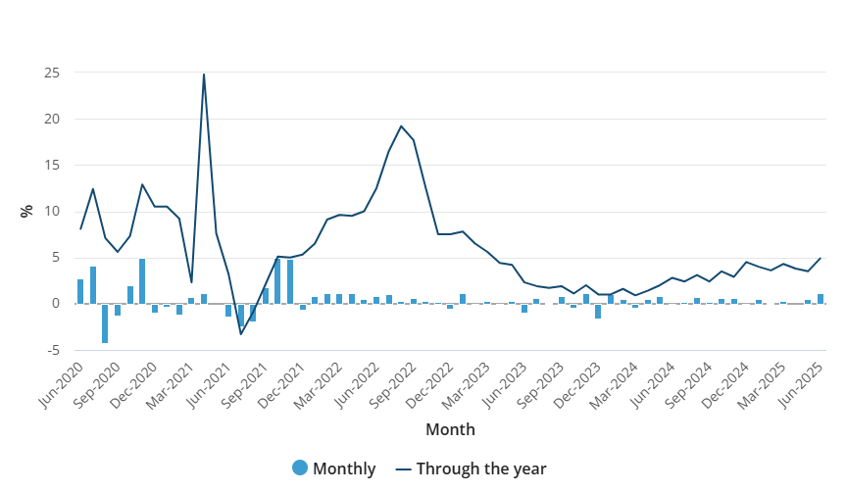
Figure 1.0: Australian retail market turnover and annual growth 2020–2025 ¹
“Retailers are currently weathering a perfect economic storm where consumer spending is down at the same time wages, manufacturing and operating costs are up.” ⁴

Significant Players in SA Retail

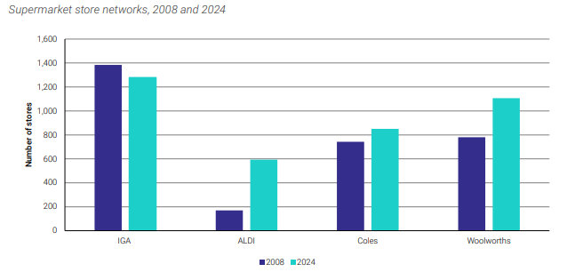
Figure 2.0: Key players in the South Australian retail industry ²
Woolworths and Coles dominate SA retail; however locally owned Foodland has a notable presence. While Westfield and the Adelaide Central Market serve as important retail hubs, ALDI's low-cost expansion increases pricing pressure.

Challenges in the SA Retail Industry
SA retailers have identified three key challenges shaping strategy in 2025:
- Serving very price-sensitive customers without crushing margins
- Unstable fresh-food supply from SA weather and drought conditions
- Rising retail crime and store-safety pressure in Adelaide shopping centres

Serving Price-Sensitive Customers Without Crushing Margins
South Australian consumers are among Australia’s most price-conscious shoppers. While salaries, energy, and logistics costs increased, the 2022 CPI surge to 9.2% pushed demand toward less expensive options, reducing margins. According to the ACCC's 2024-2025 supermarket investigation, smaller SA operators continued to be concerned about pricing transparency.²
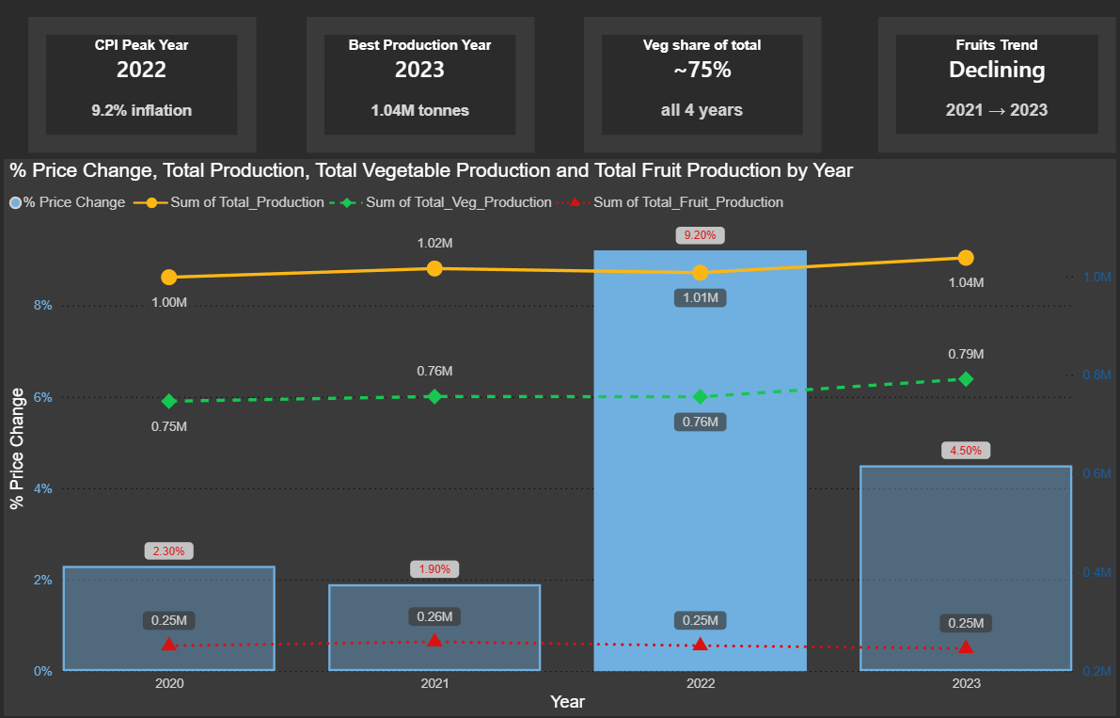
Figure 3.0: CPI price change vs total horticulture production in SA 2020-2023

Unstable Fresh-Food Supply from SA Weather and Drought Conditions
The Adelaide Hills, McLaren Vale, and Barossa Valley are three of SA's horticultural areas that provide a substantial portion of the state's fresh produce. In 2023-2026, rainfall was below average at all 64 SA rainfall sites, with deficits in the Barossa Valley reaching 44.9% below long-term norms.⁶ Southern Australia's cool-season rainfall is expected to decrease even further, according to the Climate Council.⁷
Fresh fruit and vegetable prices increased by 43% and 33%, respectively, during the drought of 2005-2007.⁷ The dataset analysis shows a significant negative correlation (R = −0.931) between SA rainfall and vegetable production, suggesting that the industry is irrigation-dependent. This means that the biggest danger to retail supply is extended drought and input cost pressure.

“SA farmers across the Barossa Valley and Adelaide Hills are grappling with the worst drought in years, expected to send food prices higher.” ⁸

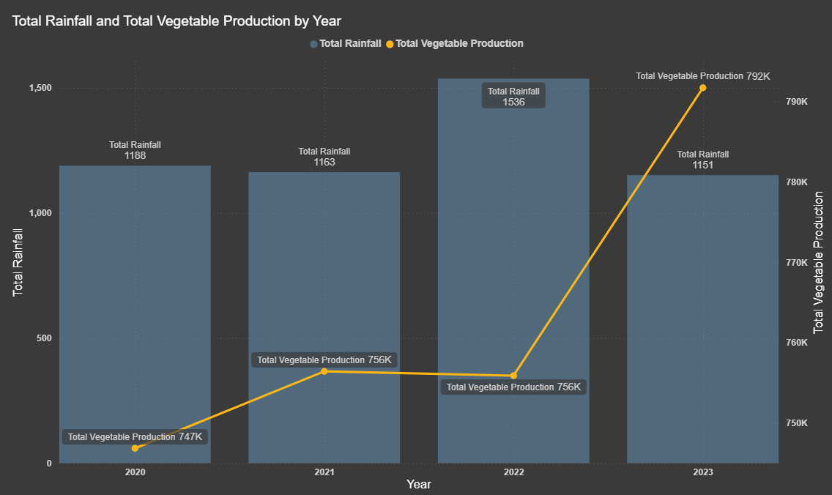Figure 4.0: Annual rainfall vs vegetable production in SA 2020–2023, showing strong inverse relationship (R = -0.931)

Rising Retail Crime and Store-Safety Pressure in Adelaide Shopping Centres
In 2024, the ABS reported 595,660 theft victims nationwide, the highest number in 21 years, with 45% occurring in retail establishments.⁹ Over the course of 18 months, shoplifting crimes increased by 31% in SA and 86% in Glenelg.¹⁰ With 80% of SA retail employees reporting hostility, violent retail crime increased by 66% year over year, exacerbating margin pressures.¹¹

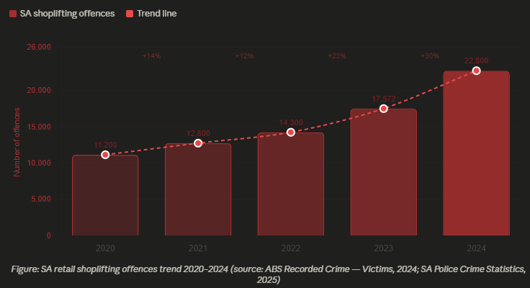

Figure 5.0: SA retail shoplifting offences trend 2020–2024 ²⁴

Existing Analysis and Methodologies
More research has investigated analytics in relation to all three business issues. No previous study has forecasted disruptions in the retail fresh food supply by combining SA rainfall, CPI, and horticultural data.

Retail Pricing, Demand Forecasting and Margin Analytics
According to Sidabutar and Firmansyah, neural networks outperformed ARIMA and linear regression in retail sales forecasting, achieving the lowest RMSE.¹² A Research done by Falatouri discovered that in retail supply chain forecasting, LSTM outperformed SARIMA in capturing temporal dependencies, despite the fact that both models ignored weather and inflation factors.¹³ In high-seasonality datasets, Ganguly and Mukherjee shown that Random Forest and XGBoost perform better than conventional regression.¹⁴

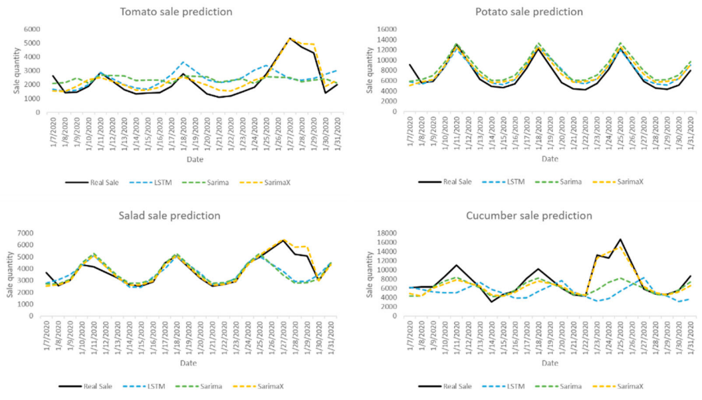
Figure 6.0: SARIMA vs LSTM forecasting accuracy comparison in retail SCM ¹³

Unstable Fresh-Food Supply - Climate Analytics
Although their paradigm ignored retail CPI implications, according to Malik in Nature Food measured how climatic disasters cascade across Australian food supply chains, finding that the fruit and vegetable industries are most adversely affected.¹⁵ After reviewing 1,526 publications, Balogh discovered that the majority stop at primary production and don't go on to retail price.¹⁶ For Australian rainfall forecasting, Islam and Imteaz shown that ANN and Random Forest perform better than linear regression; according to Bhatt indicated that ARIMA is frequently employed for agricultural yield prediction.¹⁷⁻¹⁸ Neither looked at the relationship between SA rainfall and retail prices, as seen here by R = -0.931.

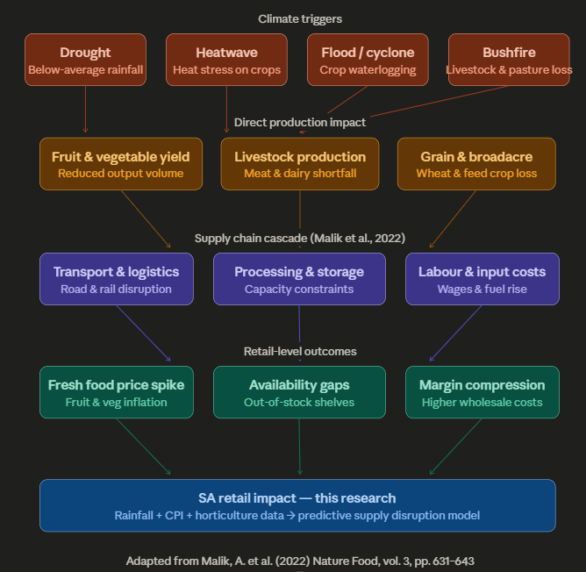
Figure 7.0: Conceptual framework for climate-driven food supply chain disruption in Australia ¹⁵

Retail Crime Detection and Predictive Security Analytics
According to Nazir improved on CNN methods by proposing shoplifting detection utilizing YOLOv5, Deep Sort, and LSTM.¹⁰ Retail theft prevention powered by AI was estimated to be worth USD 2.43 billion in 2024 and is expected to grow to USD 7.82 billion by 2032.¹⁹

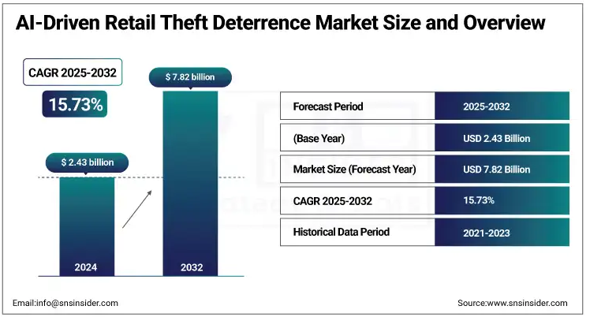Figure 8.0: AI-driven retail theft deterrence market growth 2024-2032 ¹⁹

Data Sources
The proposed data sources include:
- https://www.bom.gov.au/climate/data/
- https://www.abs.gov.au/statistics/industry/agriculture/value-agricultural-commodities-produced-australia/latest-release
- https://www.abs.gov.au/statistics/economy/price-indexes-and-inflation/consumer-price-index-australia/latest-release
- https://www.abs.gov.au/statistics/economy/finance/monthly-household-spending-indicator/latest-release
- https://www.abs.gov.au/methodologies/monthly-household-spending-indicator-methodology/jul-2025?utm_source=chatgpt.com
- https://archive.ics.uci.edu/dataset/502/online+retail+ii
- https://data.sa.gov.au/data/dataset/crime-statistics

These data sources offer retail transaction data from 2020 to 2023, SA station-level rainfall records, horticultural production numbers, the Consumer Price Index, and crime information from the SA Police.
Figure 9.0 below uses to show the relationship between SA rainfall, horticultural production, and CPI price change.

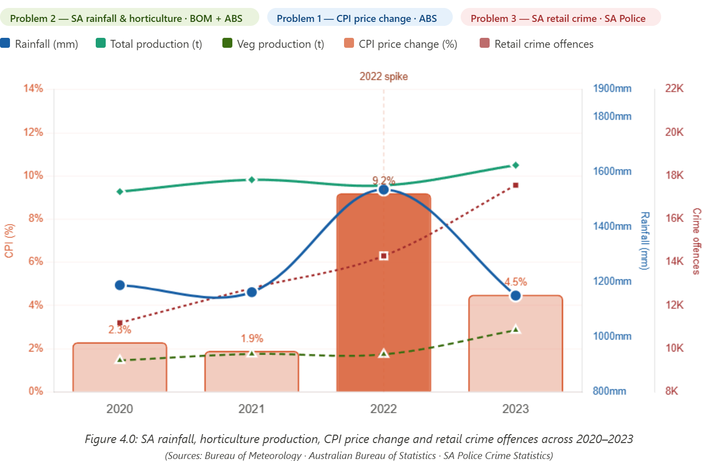

Figure 9.0: SA rainfall, horticulture production, CPI price change and retail crime offences across 2020-2023 ²⁰⁻²⁴

Selecting a Business Problem
This initiative chooses Problem 2 - Unstable fresh-food supply from SA weather and drought conditions as its main emphasis out of the three business concerns that were identified.
Problem 2 was chosen because no previous analysis combined SA rainfall, CPI, and horticulture data to predict retail supply disruptions at the SA level, and the 2020-2023 dataset offers direct quantitative evidence (R = -0.931 between SA rainfall and vegetable production).

Reasons for not choosing Problem 1: Although consumer price sensitivity is a major issue, it has been extensively researched and does not have a distinct SA-specific dataset that would yield a novel analytical contribution.
Reasons for not choosing Problem 3: To create a useful prediction model within the parameters of this research, retail crime analytics requires real-time CCTV and spatial crime data that is not publicly available at the SA precinct level.

The Proposed Approach
No prior research has forecasted retail supply disruption using a single framework that integrates SA rainfall, CPI, and horticultural data. The goal of this project is to:
1. To determine the correlations between SA annual rainfall, changes in CPI prices, and horticultural production quantities, use multiple linear regression and Pearson correlation (2020-2023).
2. Create predictive supply disruption indicators for SA merchants using ARIMA forecasting to project rainfall and horticultural production outside of the dataset.
3. Visualize these correlations using Power BI to aid with retail planning and decision-making.
4. Verify the approach's uniqueness and pinpoint research gaps by comparing it to the body of existing literature.
Since these datasets have never been examined collectively in the context of Australian retail, this method is novel. Rainfall and vegetable production have a strong negative association (R = -0.931), which is useful for purchasing fresh food during dry spells.

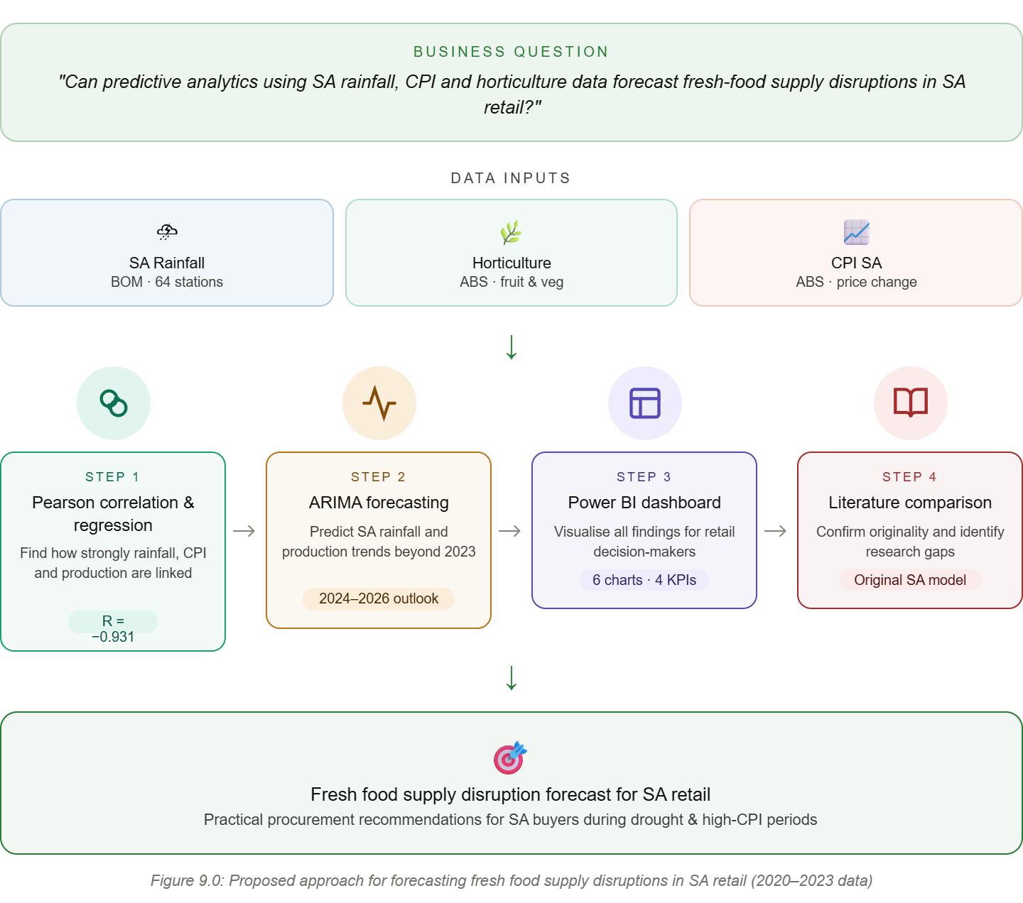
Figure 10.0: Proposed approach for forecasting fresh food supply disruptions in SA retail (2020-2023 data)

References
- Australian Bureau of Statistics 2025, Retail Trade, Australia, June 2025, ABS, Canberra, viewed 01 April 2026, https://www.abs.gov.au/statistics/industry/retail-and-wholesale-trade/retail-trade-australia/latest-release.
- Australian Competition and Consumer Commission 2025, Supermarkets Inquiry Final Report, ACCC, Canberra, 21 March 2025, viewed 26 March 2026, https://www.accc.gov.au/inquiries-and-consultations/finalised-inquiries/supermarkets-inquiry-2024-25/final-report.
- Australian Retailers Association 2025, Retail Theft & Crime, ARA, viewed 02 April 2026, https://www.retail.org.au/retail-crime.
- KPMG Australia 2025, Australian Retail Outlook 2025, KPMG, Sydney, viewed 02 April 2026, https://kpmg.com/au/en/home/insights/2024/02/australian-retail-outlook.html.
- Inside Retail Australia 2025, 'Australian retail in 2025: key trends, challenges and opportunities', Inside Retail Australia, 11 February 2025, viewed 02 April 2026, https://insideretail.com.au.
- Bureau of Meteorology 2026, South Australia Annual Climate Summary and Climate Data Online, Australian Government, viewed 02 April 2026, https://www.bom.gov.au/climate/current/annual/sa/summary.shtml.
- Climate Council of Australia 2021, Feeding a Hungry Nation: Climate Change, Food and Farming in Australia, Climate Council, Sydney, viewed 05 April 2026, https://www.climatecouncil.org.au/resources/foodsecurityreport2015/.
- Farmers for Climate Action 2025, Climate Change Costs at the Checkout, 14 May 2025, viewed 12 April 2026, https://farmersforclimateaction.org.au.
- Australian Bureau of Statistics 2025, Recorded Crime — Victims, 2024, ABS, Canberra, viewed 08 April 2026, <https://www.abs.gov.au/statistics/people/crime-and-justice/recorded-crime-victims/latest-release\>.
- Nazir, S, Yousaf, M H, Nebhen, J & Velastin, S A 2023, 'Suspicious behaviour detection with temporal feature extraction for shoplifting crime prevention', Sensors, vol. 23, no. 13, p. 5811.
- Safehands Security Services 2025, Why Businesses in Adelaide Are Rethinking Their Security Strategy in 2025, viewed 07 April 2026, https://www.safehandssecurityservices.com.au.
- Sidabutar, I & Firmansyah, M 2023, 'A comparison of forecasting accuracy of linear regression, ARIMA, and neural network models', Journal of Business Analytics, vol. 6, no. 2, pp. 1–14.
- Falatouri, T, Darbanian, F, Brandtner, P & Udokwu, C 2022, 'Predictive analytics for demand forecasting — a comparison of SARIMA and LSTM in retail SCM', Procedia Computer Science, vol. 200, pp. 993–1003.
- Ganguly, P & Mukherjee, I 2024, Enhancing Retail Sales Forecasting with Optimised Machine Learning Models, arXiv:2410.13773, viewed 12 April 2026, https://arxiv.org/abs/2410.13773.
- Malik, A, Li, M, Lenzen, M, Moran, D, Geschke, A & Foran, B 2022, 'Impacts of climate change and extreme weather on food supply chains cascade across sectors and regions in Australia', Nature Food, vol. 3, pp. 631–643.
- Balogh, J M, Jámbor, A & Babu, S C 2024, 'Assessing the vulnerability of food supply chains to climate change-induced disruptions', Science of the Total Environment, viewed 10 April 2026, https://doi.org/10.1016/j.scitotenv.2024.011860.
- Islam, M S & Imteaz, M A 2025, 'Deterministic rainfall forecasting using machine learning for the wet period in the Northern Territory of Australia', Earth Science Informatics, February 2025, pp. 1–18.
- Bhatt, S, Bhatt, A, Patel, R & Bhatt, S 2024, 'Transforming agricultural productivity with AI-driven forecasting', MDPI AgriEngineering, vol. 6, no. 4, pp. 1–22.
- SNS Insider 2025, AI-Driven Retail Theft Deterrence Market Size, Share & Growth Report 2032, SNS Insider, viewed 06 April 2026, https://www.snsinsider.com/reports/ai-driven-retail-theft-deterrence-market-7929.
- Monash Business School ACRS 2025, Consumer Deviance Spotlight Report, Australian Consumer and Retail Studies, Monash University, Melbourne, October 2025.
- Mordor Intelligence 2025, Australia Retail Industry Size, Analysis, Trends 2025–2031, Mordor Intelligence, viewed 06 April 2026, https://www.mordorintelligence.com/industry-reports/retail-industry-in-australia.
- Australian Bureau of Statistics 2025, Value of Agricultural Commodities Produced, Australia 2022–23, ABS, Canberra, viewed 12 April 2026, <https://www.abs.gov.au/statistics/industry/agriculture/value-agricultural-commodities-produced-australia/latest-release\>.
- Australian Bureau of Statistics 2025, Consumer Price Index, Australia, ABS, Canberra, viewed 13 April 2026, <https://www.abs.gov.au/statistics/economy/price-indexes-and-inflation/consumer-price-index-australia/latest-release\>.
- South Australia Police 2025, Crime Statistics South Australia, SA Government, Adelaide, viewed 13 April 2026, <https://data.sa.gov.au/data/dataset/crime-statistics\>.

