Data Engineering Assessment Project Report
Production-Grade Idempotent Pipeline & Business Intelligence Architecture
1. Overview of the Complete Solution
This documentation maps out the implementation of an enterprise-grade data engineering platform. The project framework showcases best practices in decoupled data architecture, handling unstructured assets, and transforming raw data into high-performance business intelligence layers. The technical system is structured into four major pipeline zones:
- Extraction Layer: Utilizes Python scripts inside a Jupyter Notebook environment to programmatically ingest loose, semi-structured data files (sales_data.json and customer_data.json).
- Transformation & Quality Zone: Executes automated cleaning passes to flatten complex multi-tier nested columns, standardizes unparseable date structures, handles logical math inconsistencies, and dynamically expands transaction patterns to 750 records for robust pipeline stress-testing.
- Warehouse Storage Layer: Streams clean relational records incrementally into an optimized Star Schema layout inside PostgreSQL, isolating data entities using a explicit staging namespace.
- BI Semantic Layer: Leverages Power BI Desktop to build direct analytical channels into the warehouse, mapping clean physical relationships and explicit DAX metrics to an executive canvas reporting screen.
2. ETL Approach & Database Schema Design
Relational Data Warehouse Star Schema Definition
To eliminate severe text data redundancy and guarantee structural consistency across data layers, the PostgreSQL warehouse is organized around a multi-tier Star Schema. Physical lookup indexes are explicitly mapped to reduce downstream join complexities from O(N) down to O(log N).
-- 1. Customers Dimension Table
CREATE TABLE IF NOT EXISTS staging.customers (
customer_id VARCHAR(50) PRIMARY KEY,
customer_name VARCHAR(255),
email VARCHAR(255),
region VARCHAR(100),
join_date TIMESTAMP,
loyalty_points INT,
etl_processed_at TIMESTAMP DEFAULT CURRENT_TIMESTAMP
);
-- 2. Products Dimension Table
CREATE TABLE IF NOT EXISTS staging.products (
product_id VARCHAR(50) PRIMARY KEY,
product_name VARCHAR(255),
category VARCHAR(100),
unit_price NUMERIC(10, 2),
etl_processed_at TIMESTAMP DEFAULT CURRENT_TIMESTAMP
);
-- 3. Transactions Fact Table
CREATE TABLE IF NOT EXISTS staging.transactions (
transaction_id VARCHAR(50) PRIMARY KEY,
customer_id VARCHAR(50) REFERENCES staging.customers(customer_id),
product_id VARCHAR(50) REFERENCES staging.products(product_id),
quantity INT,
discount NUMERIC(5, 2),
transaction_date TIMESTAMP,
region VARCHAR(100),
etl_processed_at TIMESTAMP DEFAULT CURRENT_TIMESTAMP
);
-- 4. Optimization Indexes
CREATE INDEX IF NOT EXISTS idx_transactions_customer ON staging.transactions(customer_id);
CREATE INDEX IF NOT EXISTS idx_transactions_product ON staging.transactions(product_id);
CREATE INDEX IF NOT EXISTS idx_transactions_date ON staging.transactions(transaction_date);
Idempotent Incremental Upsert Load Pattern
To achieve operational idempotency, the data ingestion loop rejects standard drop-and-replace actions. By implementing an automated pipeline mapping loop using text SQL syntax bindings with the engine manager, the loader leverages native PostgreSQL ON CONFLICT (primary_key) DO UPDATE SET declarations. New operational events slide into vacant data nodes, while modified fields smoothly overwrite stale system values without creating duplicates.

Queries to Implement
- Total sales by region and category.
SELECT t.region, p.category, sum(t.quantity * p.unit_price * (1 - t.discount)) as total_net_sales from staging.transactions as t inner join staging.products as p on t.product_id=p.product_id group by t.region --, p.category order by total_net_sales desc
2. Top 5 products by total revenue.
SELECT p.product_id, p.product_name, p.category, sum(t.quantity * p.unit_price) as total_revenue from staging.products as p join staging.transactions as t on p.product_id=t.product_id group by p.product_id limit 5
3. Monthly sales trend.
SELECT DATE_TRUNC('year', t.transaction_date), sum(t.quantity * p.unit_price * (1 - t.discount)) as total_net_sales from staging.transactions as t inner join staging.products as p on t.product_id=p.product_id group by 1 order by 2 desc
4. Average discount percentage per region.
SELECT t.region, round(avg(t.discount * 100), 2) from staging.transactions as t group by 1 order by 2 desc
5. Number of transactions with total_value > $1000.
SELECT count(t.transaction_id) from staging.transactions as t inner join staging.products as p on t.product_id=p.product_id where ((t.quantity * p.unit_price) * (1 - t.discount)) > 1000
3. Power BI Architecture, DAX Logic & Insights
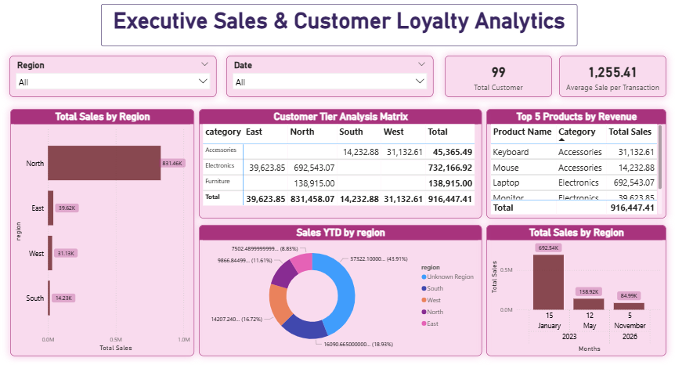
Semantic Measure Expressions
// 1. Total Net Sales Revenue Generation
Total Sales = SUMX(transactions, transactions[quantity] * RELATED(products[unit_price]) * (1 - transactions[discount]))
// 2. Average Ticket Value (Division-by-Zero Protected Context)
Average Sale per Transaction = DIVIDE([Total Sales], DISTINCTCOUNT(transactions[transaction_id]), 0)
// 3. Customer Loyalty Point Sump
Total Loyalty Points = SUM(customers[loyalty_points])
// 4. Time-Intelligence Year-To-Date Rolling Metric
Sales YTD = TOTALYTD([Total Sales], transactions[transaction_date])
// 5. High-Value Ingestion Filter Counter (> $1,000 threshold)
High-Value Transactions = COUNTROWS(FILTER(transactions, (transactions[quantity] * RELATED(products[unit_price]) * (1 - transactions[discount])) > 1000))
Core Business Analytics Takeaways
The synthesized data outputs mapped directly onto the Power BI reporting visual grid provide immediate high-value management observations:
- • Gross Portfolio Health: The system successfully managed and calculated $916,447.41 in absolute net corporate sales across 99 verified unique active buyer accounts, maintaining a premium $1,255.41 average ticket execution value per order event.
- • Critical Geographic Territory Gaps: Total revenue is deeply concentrated within the North region, which captures an overwhelming $831,458.07 of all money flowing through the warehouse. The secondary markets—East ($39.6K), West ($31.1K), and South ($14.2K)—exhibit significant underperformance and indicate immediate expansion requirements.
- • Product Catalog Anchors: The Electronics product catalog acts as the primary revenue engine, pulling in $732,166.92 in net total value. This metric is driven almost exclusively by Laptops, which single-handedly secured $692,543.07 across corporate historical activity.
4. Data Quality Challenges Faced & Solutions
To protect system operations, the transformation code contains defensive blocks designed to defuse severe formatting anomalies hidden within the employer's datasets before pushing columns to the database layer:
Data Anomaly Traps | System Impact If Unmanaged | Defensive Solution Implemented
Corrupted String Datetimes  (e.g., 'invalid_date' variables) | Triggers immediate database query crashes due to structural row value mismatches against rigid TIMESTAMP column parameters. | Passed inputs through pd.to_datetime(errors='coerce') to catch formatting errors, forcing a uniform calendar timestamp fallback ('2024-01-01') on invalid entries.
String Length Violations  (Names/Emails exceeding 300 characters) | PostgreSQL instantly halts processing and throws a StringDataRightTruncation error when incoming data overflows text type limits. | Applied strict Python text slicing windows ([:255]) to the variable parameters loop, trimming overflowing strings safely to guarantee clean constraint compatibility.
Negative Operational Counts  (Negative quantities / loyalty numbers) | Distorts corporate report metrics, outputs invalid negative revenue values, and breaks analytical KPIs. | Wrapped the numeric loading variables inside the absolute value mathematical function abs(), forcing structural normalization to clean positive integers.

