Installing Jenkins:

We need to run the below script to install the jenkins

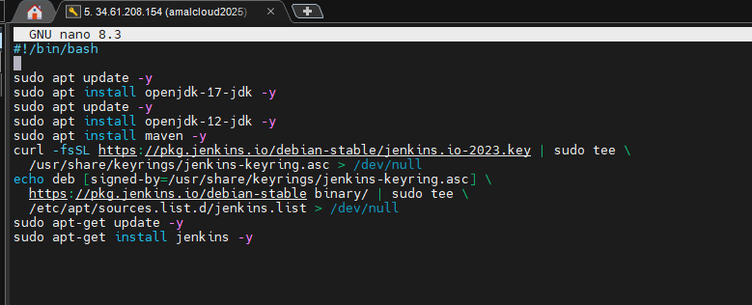

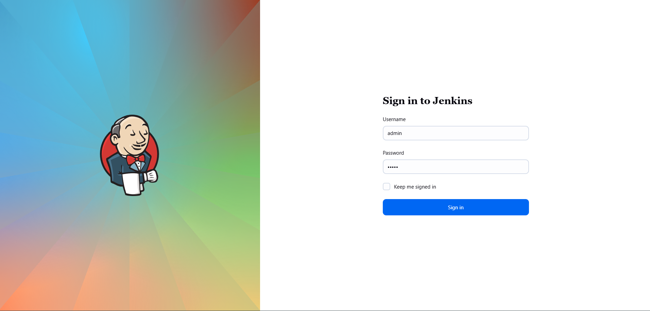

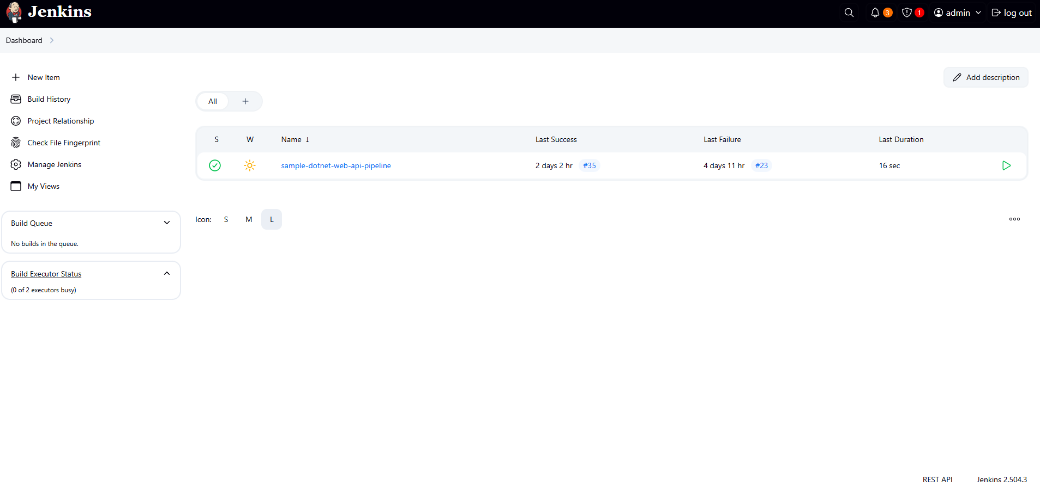

Creating User:

To Create User, we need to go to **Manage Jenkins -> Users**

* Click **Create User**
* Fill in:
  + Username
  + Password
  + Full name
  + Email
* Click **Create User**

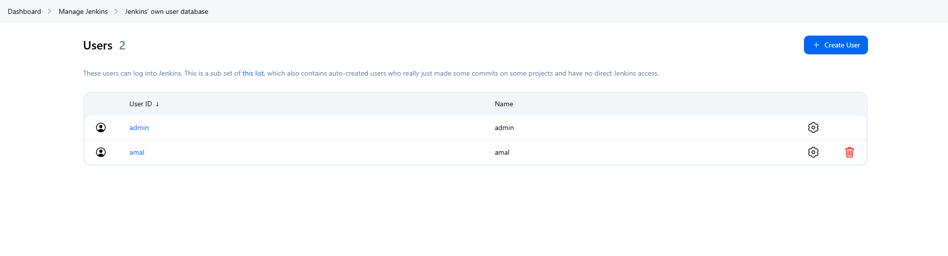

Create User Groups:

1. Install the Role-Based Strategy Plugin

* Go to **Manage Jenkins > Manage Plugins**
* Under the **Available** tab, search for: Role-based Authorization Strategy
* Click **Install without restart**

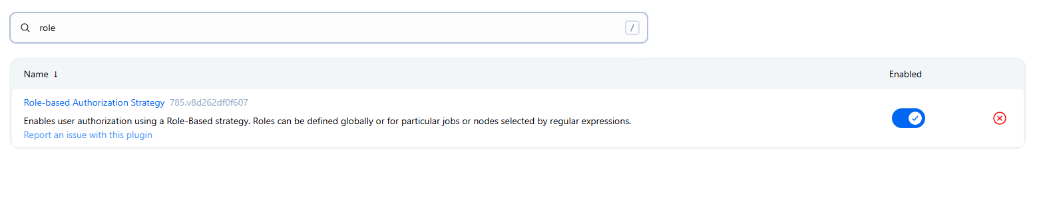

Enable Role-Based Security

* Go to **Manage Jenkins > Configure Global Security**
* Under **Authorization**, select:

Role-Based Strategy

* Click **Save**

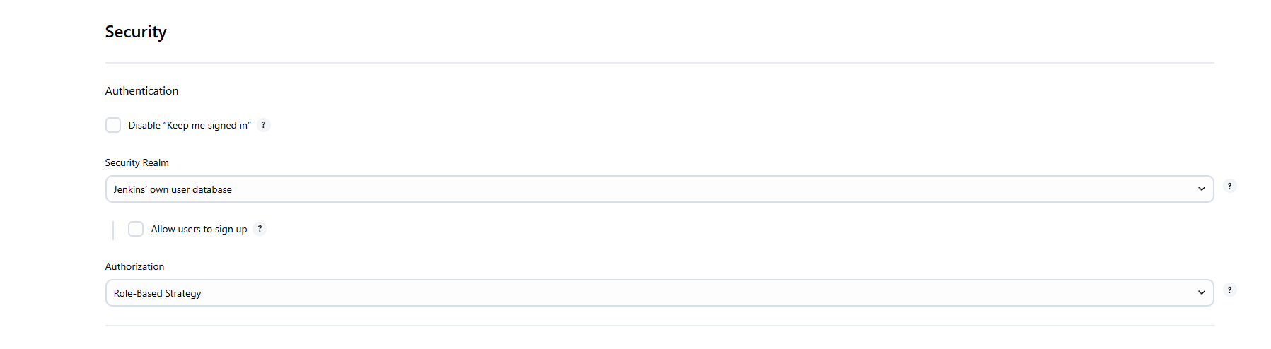

3. Create Roles (User Groups)

* Go to **Manage Jenkins > Manage and Assign Roles > Manage Roles**
* Under **Role to add**, type a name
* Click **Add**
* Assign permissions to each role by checking boxes
* Click **Save**

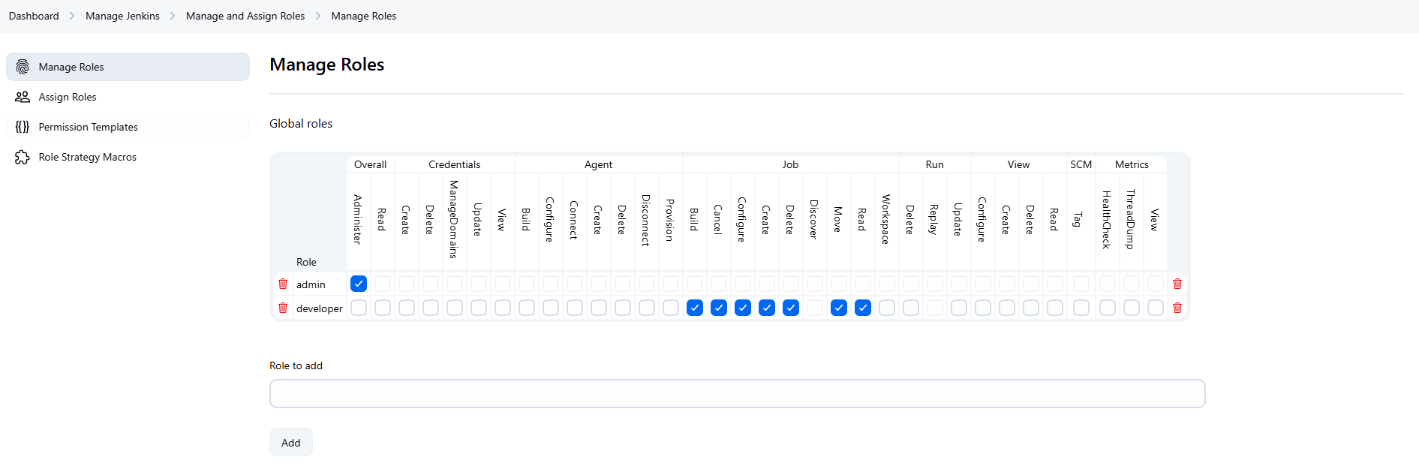

4. Assign Users to Roles

* Go to **Manage Jenkins > Manage and Assign Roles > Assign Roles**
* Under **User/group to add**, type the username
* Click **Add**
* Check the box for the role(s) you want to assign to that user
* Click **Save**

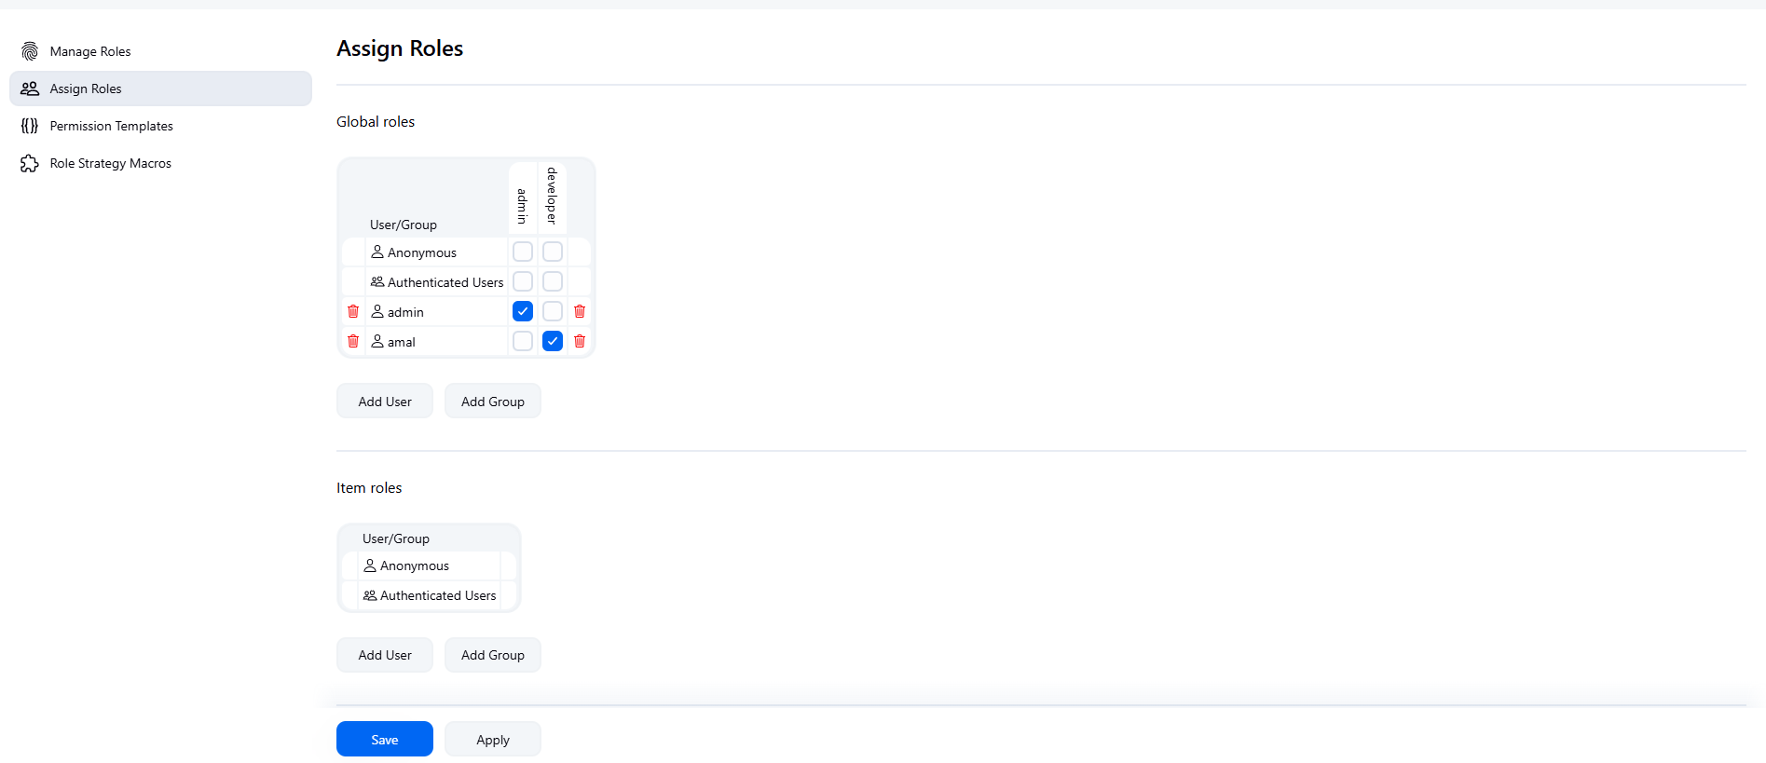

Creating Projects

* From the Jenkins Dashboard, click New Item.
* Enter a name for your pipeline project - **sample-dotnet-web-api-pipeline**
* Select Pipeline as the project type.
* Click OK to proceed to the next step.



Define the pipeline script

* On the configuration page, scroll down to the Pipeline section.
* Enter the Pipeline code directly into the Script text area.
* Save the project and then trigger a build

