Create a Simple .net core API

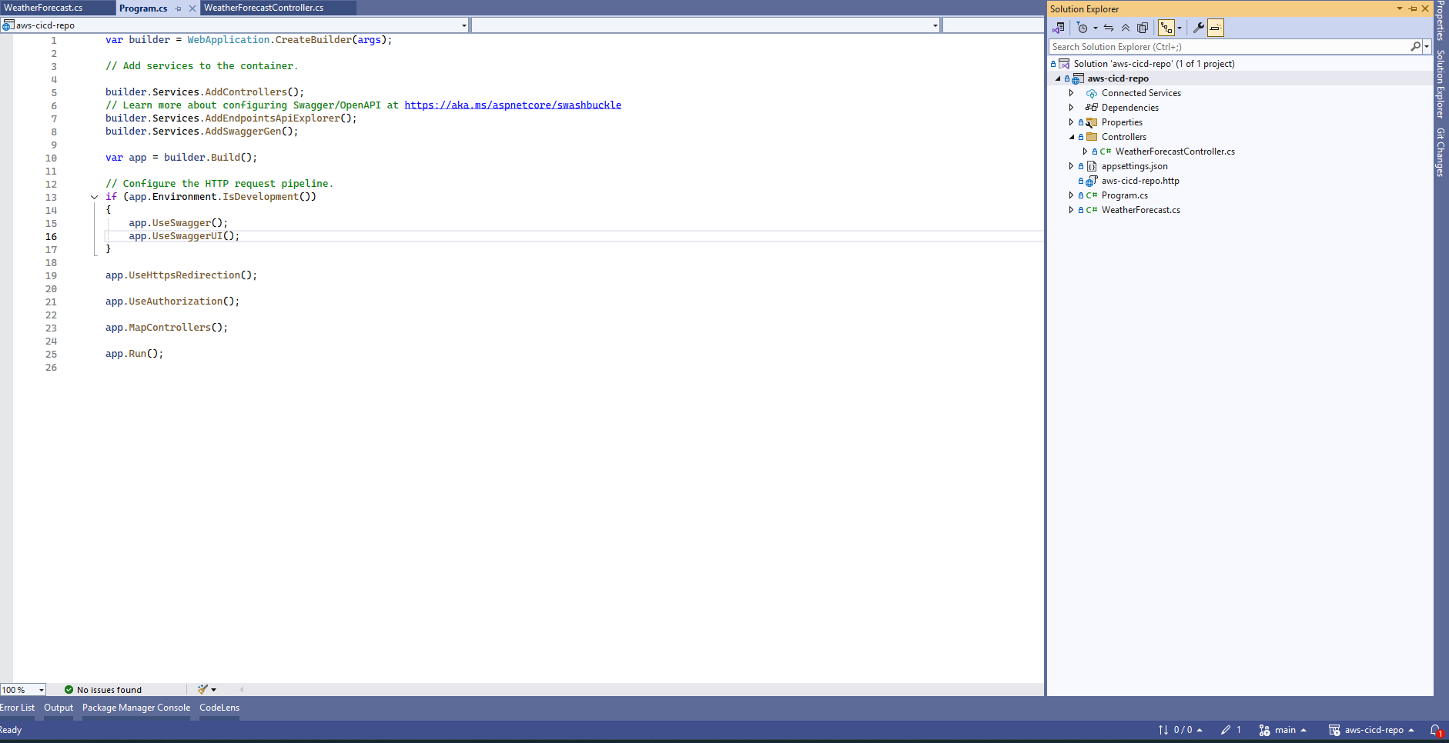

Push to GitHub

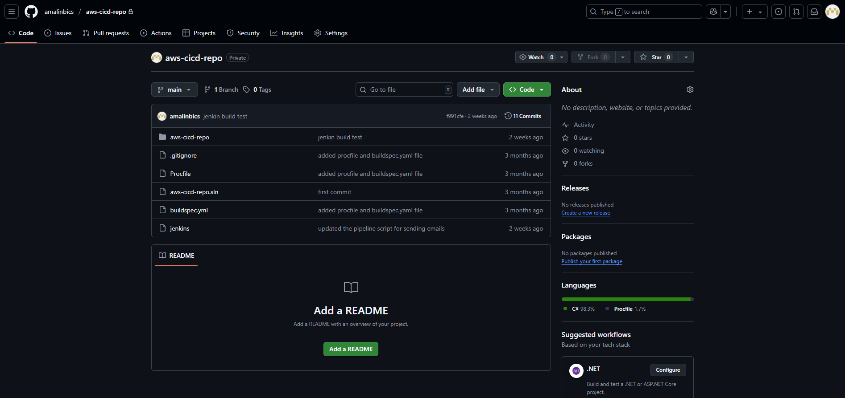

Installing Jenkins:

We need to run the below script to install the jenkins

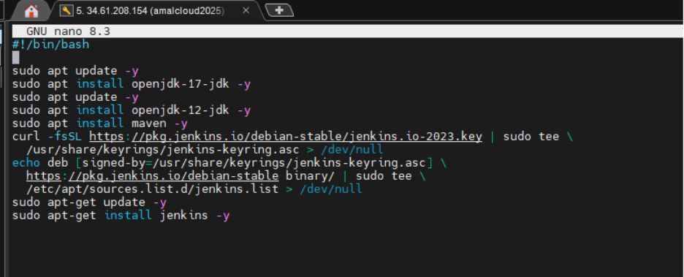

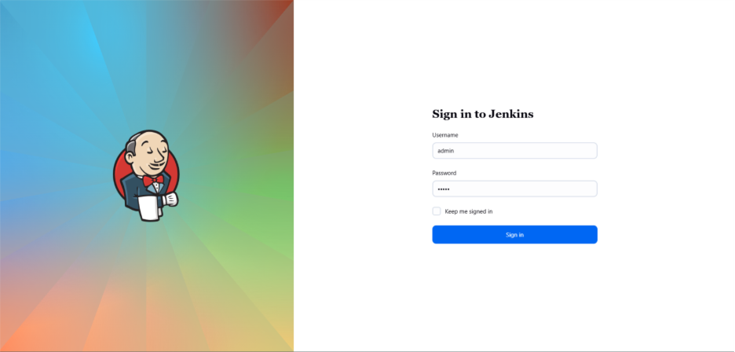

Create a Pipeline Project

* From the Jenkins Dashboard, click New Item.
* Enter a name for your pipeline project - **sample-dotnet-web-api-pipeline**
* Select Pipeline as the project type.
* Click OK to proceed to the next step.



Define the pipeline script

* On the configuration page, scroll down to the Pipeline section.
* Enter the Pipeline code directly into the Script text area.

pipeline

{

agent any

environment {

GITHUB_CRED = credentials('github-cred')

DEPLOY_SERVER = credentials('deployment-server')

DEPLOY_PATH = "/var/www/myapp"

}  
stages {  
 stage('Checkout') {  
 steps {  
 git url: '<https://github.com/amalinbics/aws-cicd-repo.git>',  
 branch: 'main',  
 credentialsId: 'github-cred'  
 echo 'Checkout success'  
 }  
 }  
 stage('Restore'){  
 steps {  
 sh 'dotnet restore'  
 echo 'Restore success'  
 }  
 }  
 stage('Build') {  
 steps {  
 sh 'dotnet build -c Release'  
 echo 'Build success'  
 }  
 }  
 stage('Publish') {  
 steps {  
 sh 'dotnet publish -c Release -o publish'  
 echo 'Publish success'  
 }  
 }  
 stage('SSH Connectivity'){  
 steps{  
 sshagent(['ssh-tf-server']) {  
 sh 'ssh ${DEPLOY_SERVER} "echo Connected!"'  
 }  
 }  
 }  
 stage('Deploy') {  
 steps {  
 sshagent(['ssh-tf-server']) {  
 sh """  
 ssh $DEPLOY_SERVER 'mkdir -p $DEPLOY_PATH'  
 scp -r publish/* $DEPLOY_SERVER:$DEPLOY_PATH  
 ssh $DEPLOY_SERVER 'sudo /bin/systemctl restart kestrel-myapp.service'  
 """  
 }  
 }  
 }  
}  
post {  
 always {  
 emailext(  
 to: '[amalinbics@gmail.com](mailto:amalinbics@gmail.com)',  
 subject: "Build ${currentBuild.fullDisplayName}: ${currentBuild.currentResult}",  
 body: """<pre>${env.JOB_NAME} #${env.BUILD_NUMBER}  
 Status: ${currentBuild.currentResult}  
 URL: ${env.BUILD_URL}  
 </pre>"""  
 )  
 echo 'Email sent'  
 }  
}

}

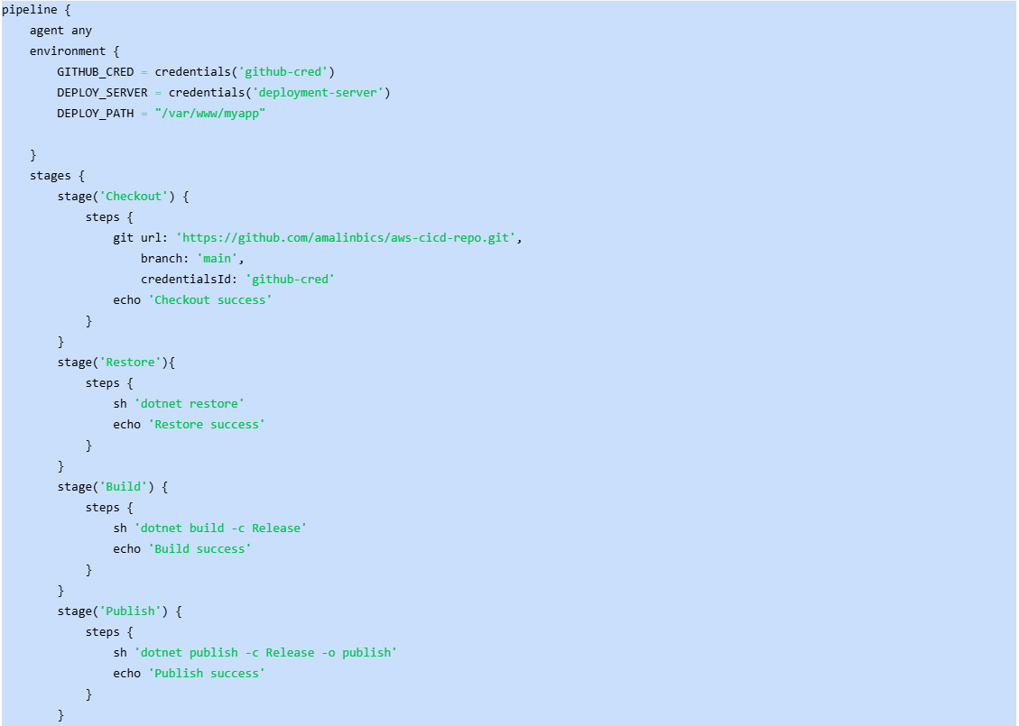

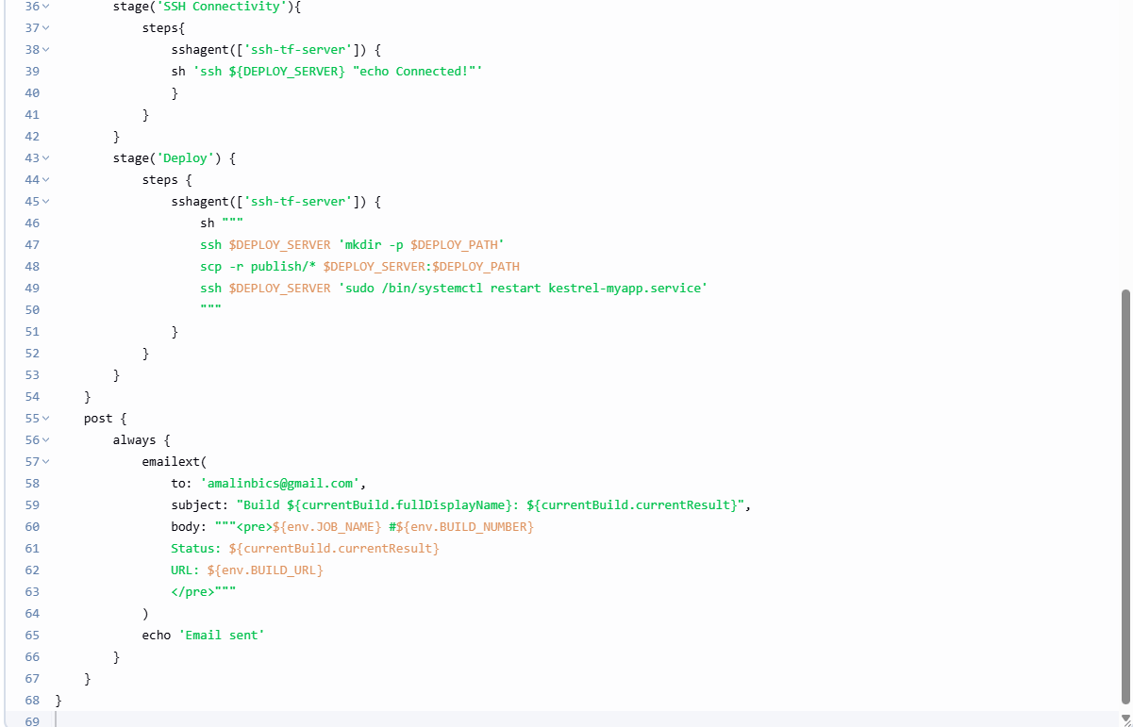

* Under **Build Triggers**, check: GitHub hook trigger for GITScm polling

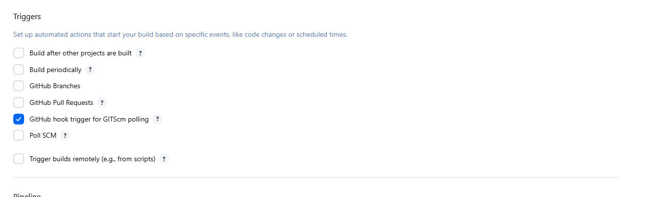

Enable GitHub Webhook

1. Go to your GitHub repo → Settings → Webhooks.
2. Add webhook:

* Payload URL: http:/34.61.208.154/:8080/github-webhook/
* Content type: application/json
* Trigger: Just the push event

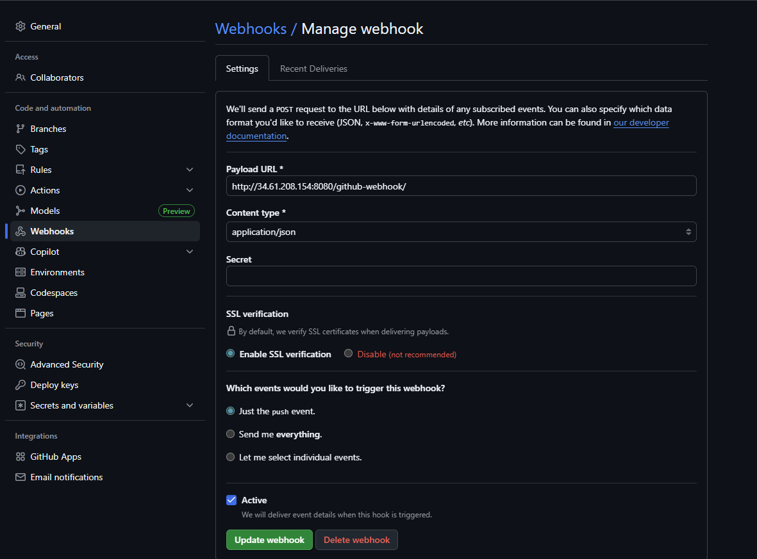

Configure Email Notifications

1. In Jenkins, go to **Manage Jenkins → Configure System**.
2. Scroll to **Email Notification**:
   1. SMTP server: smtp.gmail.com
   2. Select the credentials that we have created under credential .

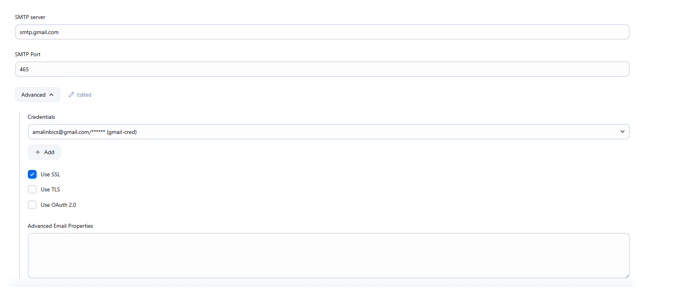

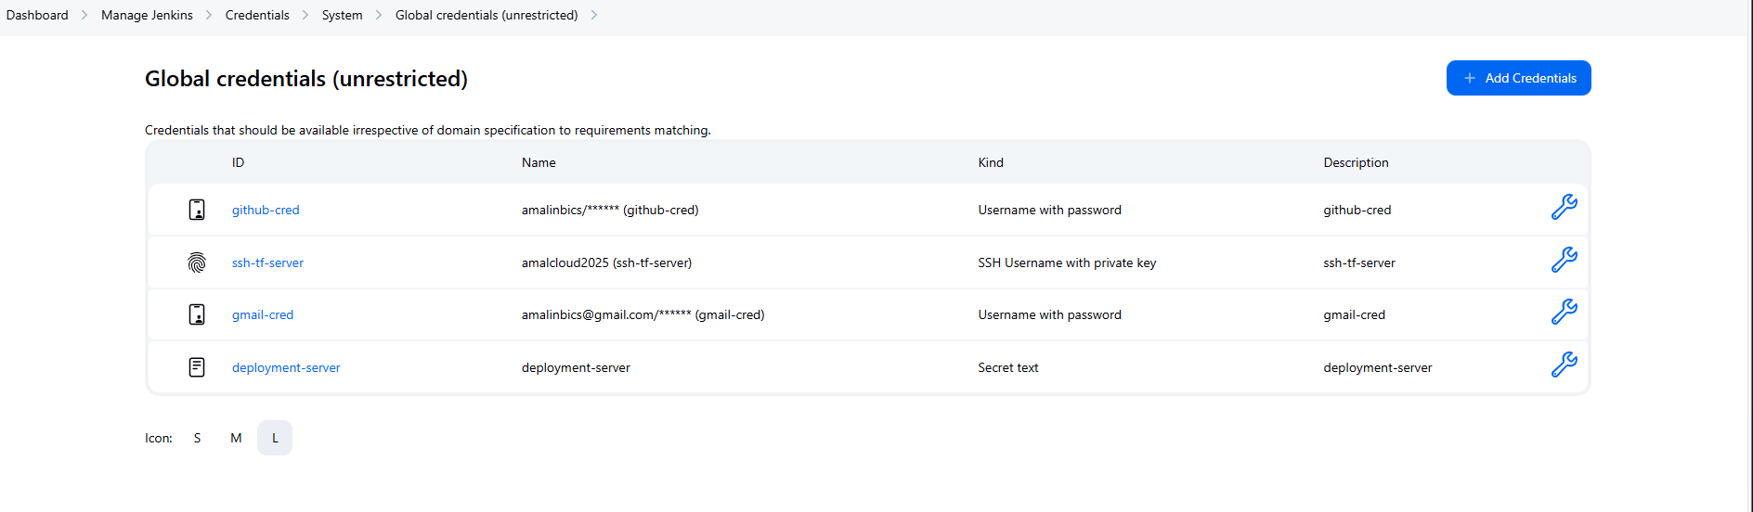

Commit a change to repo to trigger the build

