Setup minikube

1. Install docker

#!/bin/bash

# Add Docker's official GPG key:

sudo apt-get update

sudo apt-get install ca-certificates curl

sudo install -m 0755 -d /etc/apt/keyrings

sudo curl -fsSL https://download.docker.com/linux/ubuntu/gpg -o /etc/apt/keyrings/docker.asc

sudo chmod a+r /etc/apt/keyrings/docker.asc

# Add the repository to Apt sources:

echo \

"deb [arch=$(dpkg --print-architecture) signed-by=/etc/apt/keyrings/docker.asc] https://download.docker.com/linux/ubuntu \

$(. /etc/os-release && echo "${UBUNTU_CODENAME:-$VERSION_CODENAME}") stable" | \

sudo tee /etc/apt/sources.list.d/docker.list > /dev/null

sudo apt-get update

# Install Docker packages

sudo apt-get install docker-ce docker-ce-cli containerd.io docker-buildx-plugin docker-compose-plugin

# Adding Docker Group and User

sudo groupadd docker

sudo usermod -aG docker $USER

newgrp docker

./setup-repo/setup/docker-setup.sh

docker -v

1. Install Minikue

curl -LO <https://github.com/kubernetes/minikube/releases/latest/download/minikube-linux-amd64>

sudo install minikube-linux-amd64 /usr/local/bin/minikube && rm minikube-linux-amd64

minikube start

1. Install Kubuctl

curl -LO "https://dl.k8s.io/release/$(curl -L -s https://dl.k8s.io/release/stable.txt)/bin/linux/amd64/kubectl"

curl -LO "https://dl.k8s.io/release/$(curl -L -s https://dl.k8s.io/release/stable.txt)/bin/linux/amd64/kubectl.sha256"

sudo install -o root -g root -m 0755 kubectl /usr/local/bin/kubectl

1. Creating Namespace

kubectl create namespace dev

kubectl get ns

kubectl config set-context --current --namespace=dev

1. Creating Deployment

kubectl create deployment nginx-depl --image=nginx

kebectl get deployment - list all deployment

kubectl get po – list all pods

kubectl get replicaset – list all replica sets

kubectl logs nginx-depl-68c944fcbc-svtdn – get logs

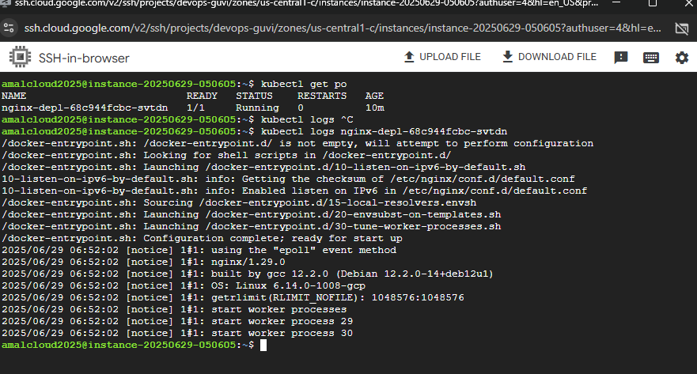

kubectl describe pod nginx-depl-68c944fcbc-svtdn – get additional information about pod

kubectl expose deployment nginx-depl --type=LoadBalancer --port=8080 -exposing deployment

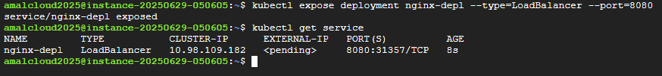

kubectl delete deployment nginx-depl - delete deployment

Kubectl delete ns dev – delete namespace

