Install Terraform

- run below script to install Terraform

#!/bin/bash

sudo apt update && sudo apt install -y wget gnupg software-properties-common

wget -O- https://apt.releases.hashicorp.com/gpg | \

gpg --dearmor | sudo tee /usr/share/keyrings/hashicorp-archive-keyring.gpg > /dev/null

echo "deb [signed-by=/usr/share/keyrings/hashicorp-archive-keyring.gpg] https://apt.releases.hashicorp.com $(lsb_release -cs) main" | \

sudo tee /etc/apt/sources.list.d/hashicorp.list

sudo apt update

sudo apt install terraform

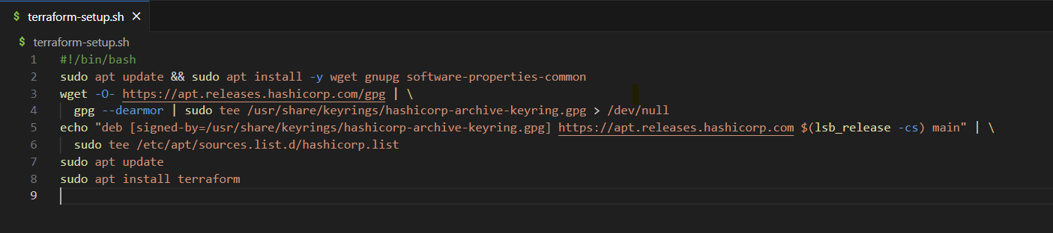

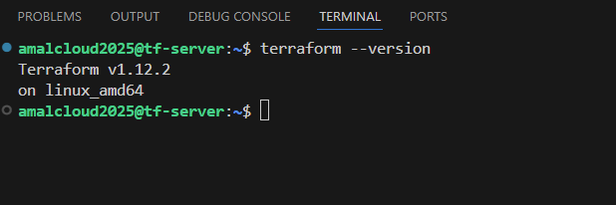

Install aws cli

Run the below script to install aws cli and configure it.

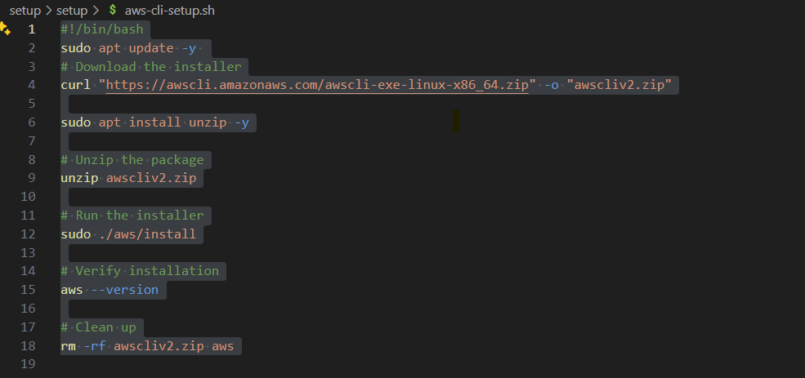

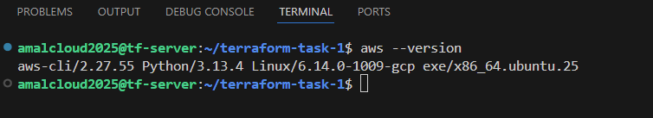

Terraform

**Main.tf**

provider "aws" { region = var.region }

provider "aws" { alias = "us" region = var.region_us }

resource "aws_key_pair" "web-server_key" { key_name = var.key_name public_key = file(var.public_key_path) }

resource "aws_key_pair" "web-server_us_key" { provider = aws.us key_name = var.key_name public_key = file(var.public_key_path) }

resource "aws_security_group" "web_sg" { name = "allow_http_ssh" description = "Allow SSH (22) and HTTP (80)"

ingress { from_port = 22 to_port = 22 protocol = "tcp" cidr_blocks = ["0.0.0.0/0"] }

ingress { from_port = 80 to_port = 80 protocol = "tcp" cidr_blocks = ["0.0.0.0/0"] }

egress { from_port = 0 to_port = 0 protocol = "-1" cidr_blocks = ["0.0.0.0/0"] } }

resource "aws_security_group" "web_sg_us" { provider = aws.us name = "allow_http_ssh" description = "Allow SSH (22) and HTTP (80)"

ingress { from_port = 22 to_port = 22 protocol = "tcp" cidr_blocks = ["0.0.0.0/0"] }

ingress { from_port = 80 to_port = 80 protocol = "tcp" cidr_blocks = ["0.0.0.0/0"] }

egress { from_port = 0 to_port = 0 protocol = "-1" cidr_blocks = ["0.0.0.0/0"] } }

resource "aws_instance" "web_server_mumbai" { ami = var.ami instance_type = var.instance_type key_name = aws_key_pair.web-server_key.key_name vpc_security_group_ids = [aws_security_group.web_sg.id] associate_public_ip_address = true

tags = { Name = "mumbai-server" } }

resource "aws_instance" "web_server_us" { provider = aws.us ami = var.ami_us instance_type = var.instance_type key_name = aws_key_pair.web-server_us_key.key_name vpc_security_group_ids = [aws_security_group.web_sg_us.id] associate_public_ip_address = true tags = { Name = "us-server" } }

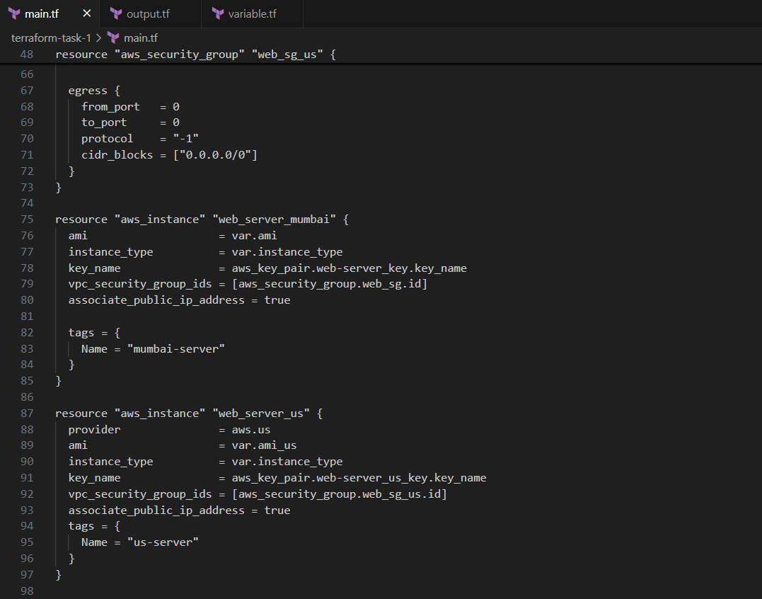

**Variable.tf**

variable "region" { type = string default = "ap-south-1" }

variable "region_us" { type = string default = "us-east-2" }

variable "key_name" { type = string default = "web-server-key" }

variable "public_key_path" { type = string default = "~/.ssh/id_rsa.pub" }

variable "ami" { type = string default = "ami-0f918f7e67a3323f0" }

variable "ami_us" { type = string default = "ami-0d1b5a8c13042c939" }

variable "instance_type"{ type = string default = "t2.micro" }

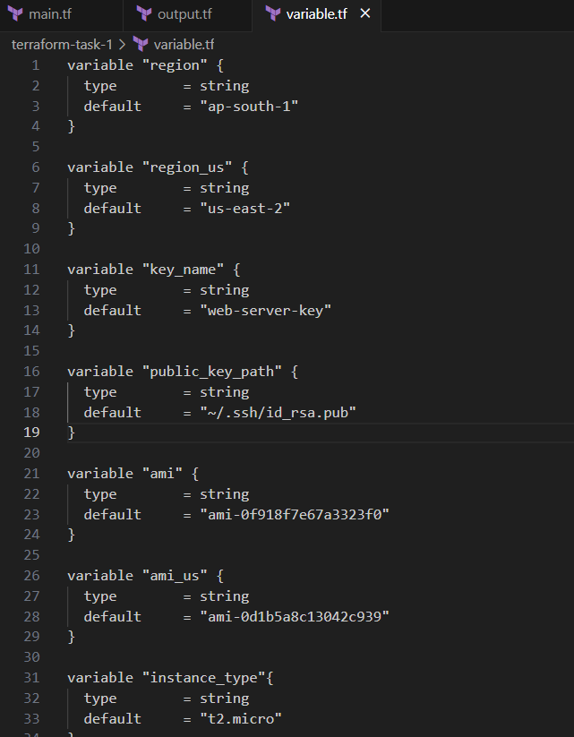

**Output.tf**

output "web-server-public_ip_mumbai" { value = aws_instance.web_server_mumbai.public_ip }

output "web-server-public_ip_us" { value = aws_instance.web_server_us.public_ip }

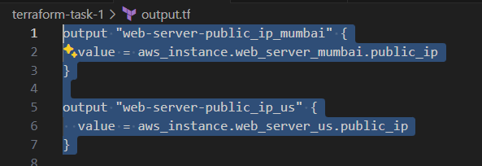

**Deploying**

terraform init

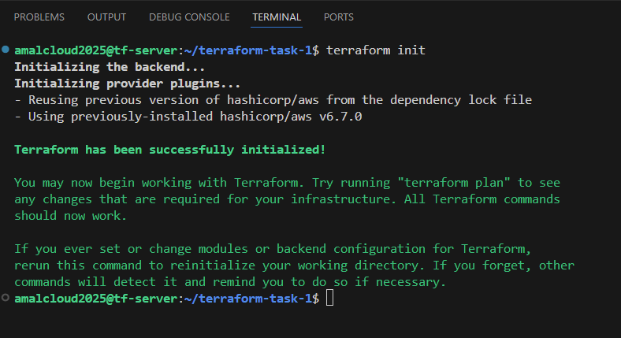

terraform plan

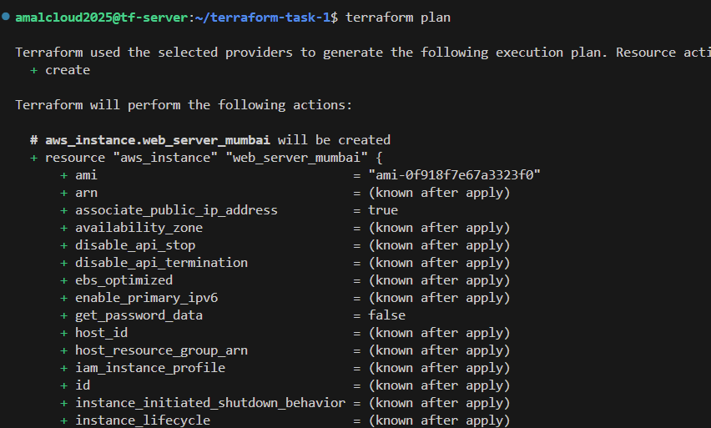

terraform apply

