Microsoft Azure Modern Application Architecture
Complete Setup Explanation, Data Flow, Security, Reliability and Deployment Guidance
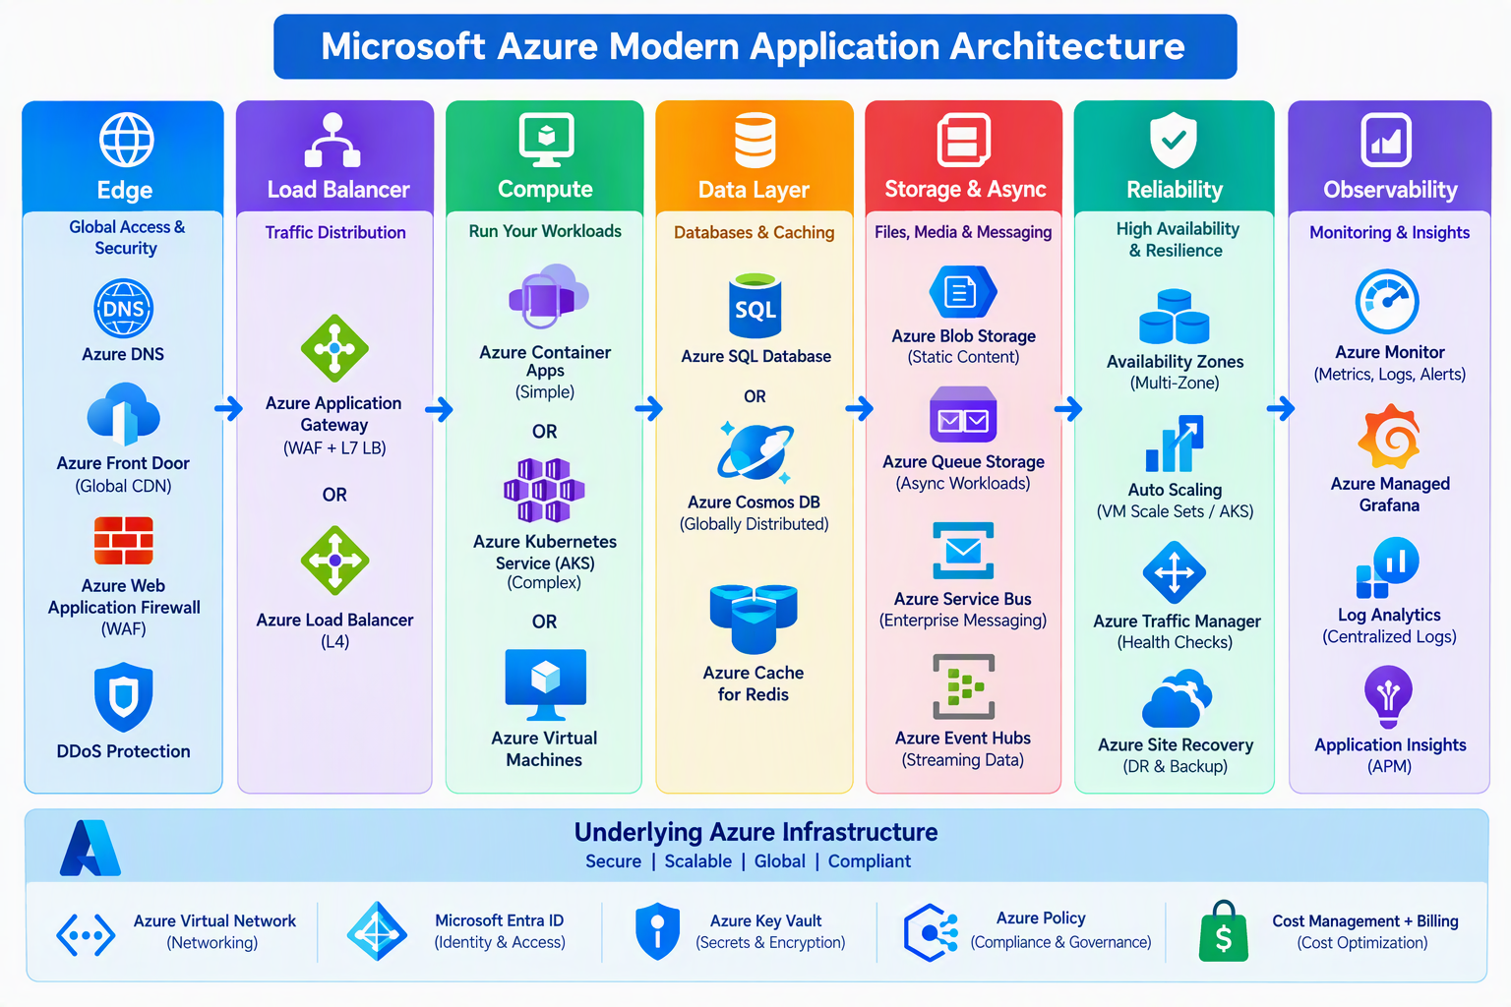
Prepared as a practical Azure reference guide
Architecture in one line: Users enter through Azure DNS and Azure Front Door, traffic is protected and load-balanced, applications run on Container Apps, AKS, or VMs, data is stored in managed databases and storage, messages decouple workloads, and Azure Monitor provides end-to-end visibility.

1. Architecture Overview
The diagram represents a layered, production-oriented Azure architecture. Each layer has a specific responsibility. Separating responsibilities reduces coupling, improves security, allows independent scaling, and makes failures easier to isolate.
Layer | Azure components | Responsibility
Edge | Azure DNS, Azure Front Door, Web Application Firewall, DDoS Protection | Name resolution, global entry point, acceleration and protection before traffic reaches the application.
Load balancing | Application Gateway or Azure Load Balancer | Distribute regional traffic and remove unhealthy backend instances.
Compute | Azure Container Apps, AKS or Azure Virtual Machines | Execute APIs, web applications, microservices and background workers.
Data | Azure SQL Database or Cosmos DB, Azure Managed Redis | Persist business data and provide low-latency caching.
Storage and asynchronous processing | Blob Storage, Queue Storage, Service Bus, Event Hubs | Store files and decouple producers from consumers using queues or event streams.
Reliability | Availability Zones, autoscaling, health checks, retries, Traffic Manager, Site Recovery | Keep the platform available during load spikes, instance failures or regional disruption.
Observability | Azure Monitor, Log Analytics, Application Insights, Managed Prometheus and Grafana | Collect metrics, logs and traces, display dashboards and trigger alerts.
Foundation | Virtual Network, Microsoft Entra ID, Key Vault, Azure Policy, Cost Management | Networking, identity, secrets, governance and financial control.

2. End-to-End Request Flow

1. DNS resolution
A user requests the application domain. Azure DNS returns the public endpoint, commonly Azure Front Door.

2. Global edge processing
Azure Front Door terminates TLS, applies routing and caching rules, checks origin health, and sends the request to the nearest healthy application origin. Front Door WAF blocks common web attacks and custom rule violations.

3. Regional ingress
Application Gateway performs regional Layer 7 routing by hostname, URL path, headers and health. If only TCP or UDP balancing is needed, Standard Load Balancer is used instead.

4. Application processing
Container Apps offers simpler managed container hosting. AKS is used when Kubernetes APIs and advanced orchestration are required. Virtual Machines support legacy or OS-dependent workloads.

5. Data access
The application reads or writes relational data in Azure SQL Database, globally distributed NoSQL data in Cosmos DB, and frequently accessed temporary data in Azure Managed Redis.

6. Static and asynchronous work
Images, documents and static assets are stored in Blob Storage. Long-running work is placed on Queue Storage or Service Bus. High-volume event streams are sent to Event Hubs.

7. Telemetry
Application Insights captures request traces and dependencies. Azure Monitor and Log Analytics centralize metrics and logs. Managed Prometheus and Grafana support cloud-native monitoring.
Key principle: The user-facing request should not wait for slow background jobs. Put those jobs on Service Bus or Queue Storage and process them with scalable workers.

3. Edge and Security Layer

Azure DNS
Hosts public DNS records and can also host private DNS zones for internal name resolution.
- Use aliases or CNAME records to direct the application domain to Front Door.
- Private DNS zones resolve private endpoints inside linked virtual networks.
- DNS TTL influences how quickly DNS-based failover is observed by clients.

Azure Front Door
A globally distributed Layer 7 entry service for HTTP and HTTPS. It provides anycast access, TLS termination, acceleration, caching and global origin routing.
- Use origin groups with health probes and priority or weight settings.
- Premium is preferred when Private Link to supported origins or advanced WAF capabilities are required.
- Front Door is global; Application Gateway is regional.

Web Application Firewall
Inspects HTTP/S traffic using managed rules and custom rules.
- Start with Detection mode to review false positives, then move to Prevention mode.
- Use OWASP managed rules, rate limiting, IP restrictions and bot protection as required.
- Send WAF logs to Log Analytics and alert on blocked attack spikes.

Azure DDoS Protection
Adds enhanced network-layer DDoS protection and telemetry for protected public IP resources in virtual networks.
- The Azure platform provides baseline infrastructure protection.
- Use DDoS Network Protection for critical virtual networks or DDoS IP Protection for selected public IPs.
- DDoS protection does not replace WAF because the two protect different layers.

4. Load Balancing and Compute
Decision | Choose | Reason
Global HTTP/S routing | Azure Front Door | Global edge entry, acceleration, WAF and origin failover.
Regional HTTP/S routing | Application Gateway WAF_v2 | Path/host routing, TLS termination, private backends and regional WAF.
Regional TCP/UDP | Standard Load Balancer | High-performance Layer 4 load balancing.
Simple containers | Azure Container Apps | Managed revisions, ingress, KEDA autoscaling and lower Kubernetes operational effort.
Complex Kubernetes platform | Azure Kubernetes Service | Kubernetes APIs, operators, service mesh options, advanced networking and node control.
Legacy or OS-specific workload | Azure Virtual Machines / VM Scale Sets | Full OS control and compatibility with non-containerized software.

Azure Container Apps setup
- Create a Container Apps environment, preferably integrated with a virtual network for controlled traffic.
- Deploy container images from Azure Container Registry using managed identity.
- Configure external or internal ingress, target port, secrets, CPU and memory.
- Set minimum replicas to at least 2 for continuously available production APIs where supported by the design.
- Add HTTP concurrency, CPU, memory or queue-based KEDA scaling rules.
- Use revisions for blue-green or percentage-based traffic rollout.

AKS setup
- Use a private cluster for sensitive production environments when operational tooling can reach the private API.
- Create separate system and user node pools, spread node pools across availability zones, and enable the cluster autoscaler.
- Deploy at least two or three pod replicas for important services and define readiness/liveness probes plus Pod Disruption Budgets.
- Use Microsoft Entra integration, Azure RBAC or Kubernetes RBAC, workload identity, Key Vault CSI and network policies.
- Use a deliberate IP plan before deployment because pod and service address ranges are difficult to change later.

5. Data Layer

Azure SQL Database
Use Azure SQL Database when the application needs a relational schema, SQL transactions, joins, constraints and Microsoft SQL compatibility. Select vCore-based compute, configure backup retention, use private endpoints, and review zone redundancy and geo-replication according to the RTO and RPO.

Azure Cosmos DB
Use Cosmos DB for globally distributed key-value or document workloads requiring elastic horizontal scale and low latency. The partition key is the most important design decision. A weak key creates hot partitions, throttling and uneven cost. Monitor request units, 429 throttling, latency and storage.

Azure Managed Redis
Redis reduces database load by caching frequently requested data, storing short-lived sessions and supporting distributed coordination. Use cache-aside logic: check cache, read the database on a miss, then populate the cache with a sensible expiration. The database remains the authoritative source.
Data selection rule: Choose the database from the application data model and consistency requirements. Do not select Cosmos DB only because global scale sounds attractive, and do not use Redis as the only copy of business data.

6. Storage and Asynchronous Processing
Service | Use it for | Important design points
Azure Blob Storage | Static websites, images, documents, backups and object data | Use private endpoints unless public access is intentional. Enable versioning, soft delete, lifecycle rules and appropriate LRS/ZRS/GRS/GZRS redundancy.
Azure Queue Storage | Very simple, high-scale background work queues | Lower feature set; application manages more behavior. Design idempotent consumers and poison-message handling.
Azure Service Bus | Enterprise queues and publish/subscribe messaging | Use queues/topics, subscriptions, dead-letter queues, sessions, duplicate detection and managed identity. Premium supports stronger isolation and private networking.
Azure Event Hubs | Telemetry and high-throughput event streaming | Plan partitions and consumer groups. Use Capture to archive streams to storage. Kafka-compatible endpoint supports many Kafka clients.

Example asynchronous flow
A user uploads a file to Blob Storage. The API writes a message to Service Bus and immediately returns a tracking ID. A background Container App or AKS worker consumes the message, scans or transforms the file, writes the status to the database, and emits telemetry. Failed messages move to the dead-letter queue after the configured delivery attempts.

7. Reliability, High Availability and Disaster Recovery
Control | What it protects against | Implementation
Availability Zones | Datacenter or zone failure inside one Azure region | Use zone-redundant gateways and databases; distribute VM/AKS capacity across zones.
Autoscaling | Traffic or queue-depth changes | Scale compute using CPU, requests, concurrency, queue length or custom metrics. Set safe minimums and maximums.
Health probes | Failed or non-ready instances | Front Door/Application Gateway probes; Kubernetes readiness/liveness/startup probes; application health endpoints.
Retries and circuit breakers | Transient dependency failures | Use bounded exponential backoff with jitter only for transient and safe/idempotent operations. Open a circuit during persistent failures.
Traffic Manager / Front Door origin routing | Regional endpoint failure | Route clients or HTTP traffic to a healthy secondary region. Front Door normally fits HTTP/S applications better.
Azure Site Recovery | VM-based regional disaster recovery | Replicate supported VMs and orchestrate failover. It is not the main DR mechanism for PaaS databases or Kubernetes state.
Backup and restore testing | Deletion, corruption and ransomware scenarios | Configure service-native backups, soft delete/immutability where needed, and regularly perform restore tests.
RTO and RPO: RTO is the maximum acceptable recovery time. RPO is the maximum acceptable data loss measured in time. These targets determine whether the design needs zone redundancy, geo-replication, active-passive, or active-active deployment.

8. Observability

Azure Monitor
The umbrella platform for Azure metrics, logs, alerts and operational insights.

Log Analytics
The query and retention platform for centralized logs. Use KQL queries, workbooks and alert rules. Configure diagnostic settings on platform services.

Application Insights
Application performance monitoring for requests, dependencies, exceptions, traces, availability tests and distributed correlation. OpenTelemetry is recommended for modern instrumentation.

Managed Prometheus and Azure Managed Grafana
Prometheus-compatible metric collection and PromQL dashboards, particularly useful for AKS and cloud-native workloads.
- Create alerts for availability, latency, error rate, saturation, throttling, dead-letter growth and certificate expiration.
- Route alert notifications through Action Groups to email, Teams/webhooks, ITSM or automation.
- Control cost with diagnostic filters, sampling, table plans and retention policies.
- Build service-level indicators for availability and latency, then define measurable SLOs.

9. Underlying Azure Foundation
Foundation service | Role | Production guidance
Azure Virtual Network | Private network boundary and routing | Use hub-spoke design when centralized firewall, DNS, VPN/ExpressRoute or shared services are required. Separate application, data and gateway subnets.
Microsoft Entra ID | Human and workload identity | Use managed identities for Azure service access, RBAC with least privilege, MFA and Conditional Access for administrators.
Azure Key Vault | Secrets, keys and certificates | Use managed identity, private endpoints, RBAC, soft delete and purge protection. Avoid secrets in source code or pipeline YAML.
Azure Policy | Governance and compliance guardrails | Audit or deny noncompliant resources, enforce tags/locations/SKUs, require diagnostic settings and deploy security configurations at scale.
Microsoft Defender for Cloud | Security posture and workload protection | Review recommendations, regulatory compliance posture, vulnerability findings and threat alerts.
Cost Management + Billing | Budgets, allocation and optimization | Apply tags, budgets and anomaly alerts; track reserved capacity/savings plans, idle resources, log ingestion and data egress.

10. Recommended Production Implementation Sequence
1. Define non-functional requirements: expected requests per second, data volume, latency target, regions, compliance, RTO, RPO and budget.
2. Create management groups/subscriptions, naming and tagging standards, budgets, Azure Policy assignments and role separation.
3. Build hub-spoke networking, DNS, private endpoints, routing and firewall controls.
4. Deploy Key Vault, managed identities, Azure Container Registry and CI/CD workload identity federation.
5. Deploy the selected compute platform: Container Apps for simpler needs or AKS for Kubernetes requirements.
6. Deploy databases, Redis, Blob Storage and messaging with private connectivity, backups and diagnostic settings.
7. Configure Application Gateway if regional Layer 7 ingress is needed, then Front Door, WAF, custom domains and certificates.
8. Instrument applications with OpenTelemetry/Application Insights and configure Azure Monitor alerts and dashboards.
9. Perform load, resilience, failover, backup-restore and security testing before production approval.
10. Release gradually using revisions, canary/blue-green deployment, health validation and rollback criteria.

11. Practical Baseline Recommendation
For a typical modern production web application, use Azure DNS, Azure Front Door Premium with WAF, Azure Container Apps with at least two replicas, PostgreSQL Flexible Server or Azure SQL with zone-redundant HA, Azure Managed Redis, Blob Storage, Service Bus Premium, private endpoints, managed identities, Key Vault, Azure Monitor, Log Analytics and Application Insights. Select AKS only when Kubernetes-specific control justifies the additional operational responsibility.
Final caution: The diagram is a reference architecture, not a mandatory shopping list. Use only the components required by the workload. Every extra component adds cost, security surface and operational responsibility.

12. Hindi Quick Summary
User ka request sabse pehle Azure DNS aur Azure Front Door par aata hai. Front Door global routing, caching aur WAF protection deta hai. Regional routing ke liye Application Gateway aur non-HTTP traffic ke liye Azure Load Balancer use hota hai. Application Container Apps, AKS ya Virtual Machines par run hoti hai. Relational data Azure SQL mein, globally distributed NoSQL data Cosmos DB mein, aur fast cache Azure Managed Redis mein rakha jata hai. Files Blob Storage mein aur background jobs Service Bus ya Queue Storage mein jate hain. Availability Zones, autoscaling, health checks, retries aur secondary region reliability improve karte hain. Azure Monitor, Log Analytics, Application Insights, Prometheus aur Grafana monitoring provide karte hain. Identity ke liye Entra ID, secrets ke liye Key Vault aur governance ke liye Azure Policy use hoti hai.

